**Inside this issue:**

Notes from the President

Member Feature

Military Trivia

Guest Speaker

Membership

Board of Directors/Officers

Working Committees

Meetings/Events Calendar

Announcement Corner

Books/Articles Published by Mbrs.

From the Editor

Light Side

Trivia Answer

**Notice:**

If you have moved or changed your address, PLEASE notify us immediately! Contact: Dave Lyons, Membership Chair

E-mail: [Snoyldavid@centurylink.net](mailto:Snoyldavid@centurylink.net)

Phone:  303 690 8776

###### COPYRIGHT NOTICE: In accordance with Title 17 U.S.C. Section 107, any copyrighted material in this newsletter is distributed under fair use without profit or payment to those who have expressed a prior interest in receiving the included information for nonprofit use and educational purposes only.

**Facebook: Vietnam Veterans of America Chapter 1106**

***Editor’s Note:***

This version of the newsletter is in Microsoft Document (.DOCX) format so that the links will work. Put your cursor over the link, depress your Control Key (ctrl) and depress your left mouse button and it will take you to the listed link position. PDF format, the links will not work.

The comments and editorial input does not necessarily reflect the opinion of the membership of our chapter. I would appreciate any feedback that you might have, items you liked or if you find offensive or derogatory in anyway. ([bobrotruck73@gmail.com](mailto:bobrotruck73@gmail.com)) Thank you for allowing me to be your editor.

***Notes from the President***

Lee White

As 2021 comes to a close, I want to thank all the VVA Chapter 1106 Members, our Board of Directors, and Officers for all of their support.

2021 was a challenging year, but our chapter persevered and accomplished many activities and events.

Highlights of 2021:

1. Continued having our meeting using Zoom until June when we were able to meet in person.
2. Quilts of Valor in March.
3. Memorial Day events in May.
4. Clothing drive in June.
5. Chapter picnic in August.
6. Poppy drives in October and November.
7. Fundraisers with Texas Roadhouse.
8. Christmas luncheon in December.
9. Membership continues to grow.

***HAPPY THANKSGIVING***

***MERRY CHRISTMAS***

***LOOKING FORWARD TO 2022***

***Member Feature***

Michael Tarby, Jr. – Army – 1961 – 1981 (Highest paygrade Enlisted – Staff Sergeant, Officer – Major)

My Awards and Commendation: Silver Star, Bronze Star W/V Device & 4th Oak Leaf Cluster, Army Commendation Meal W/V Device & 2d Oak Leaf Cluster, Meritorious Service Medal w/3d Oak Leaf Cluster, Air Medal, Armed Forces Reserve Medal, Good Conduct Medal Clasp Bronze 3 Loops, National Defense Service Medal, Vietnam Service Medal w/1 Silver Star, Republic of Vietnam Staff Service Medal 1st Class, Republic of Vietnam Civil Actions Medal 1st Class, Republic of Vietnam Campaign Medal, Republic of Vietnam Cross of Gallantry w/Palm Unit Citation, Valorous Unit Award, Combat Infantry Badge, Parachutist Badge, Jungle Expert Badge. I was born on Christmas Eve in New York City (Brooklyn), December 24, 1942, and completed High School and College while in the Military. Served in the US Army for 20 years and the U.S. Postal Service 26 years. Kingsley my dog provides exercise by forcing me to walk him 2-4 miles daily; in addition, I snow ski each year (easy runs only). I was stationed in Germany – 2nd Armored Cavalry, Korea – 2nd Infantry Division, Vietnam – Troop C, 2nd Squadron 4th Cavalry, 1st Infantry Division – Big Red One and Mac V, Japan – G1, Fort Benning, GA, Fort Knox, KY, Camp Drum, NY, Fort Hood, TX. My MOS – 1203 & 1204 – Tank and Armored Recon Commander. My Most memorable experiences during my years of service was getting married 1963 in Phenix City AL to Mary Ann and the birth of my two sons: John and Adam and tears of happiness when landing and getting off flight from Vietnam at Travis AFB and knowing I made it!

Chapter 1106 has be served me by providing issues on benefits and health issues. My recommendations for the chapter are: To have small groups gather for discussions on selected topics of interest, and: Travel events to both military and non-military activities.

.

***Military Trivia***

**PMS** Click here for end of the Newsletter Trivia Answer

***September Guest Speaker –*** Mary Haddon, President, Rocky Mountain Honor Flight

Mission: As part of the national Honor Flight Network, our goal is to provide Veterans of the Rocky Mountain Region with an all-expense paid trip to Washington D.C.to visit the monuments and memorials dedicated to their service. Priority is given to WWII Veterans and Veterans who are terminally ill, but we accept application for veterans of all service eras.

Visit: [www.rockymountainhonorflight.org](http://www.rockymountainhonorflight.org)

***October Guest Speaker -*** Nickie Bell – CCSD Assistant Superintendent

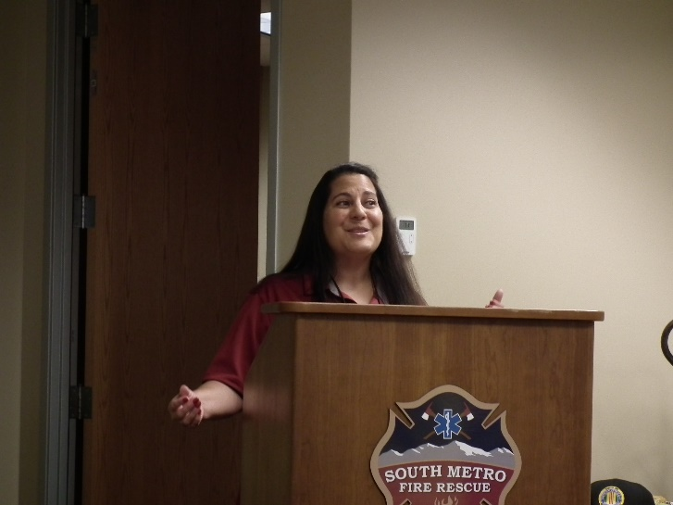

The rest of the October guests that treated us to a wonderful breakfast before the meeting started! Thank you, Cherry Creek School District for honoring us!!!

(LtoR): Nickie Bell, Christy Everson, Melissa Lyubenko, Larry Bull, Robert Bell (Nickie's husband)

Tom Werzyn trying to decide on 4 or 6 donuts!!

Drinks, fruit, and more!!!

(Editor’s note: First time ever seeing Larry Bull do some real work!!!!)

***Membership!*** (As of 10/16/2021)

VVA      170

AVVA      42

T0TAL:  212

**VVA**

Harry Montgomery ARMY

Edward Seiler AIR FORCE

**AVVA**

Jane Brown

Shay Davis

***Board of Directors/Officers***

Lee White – President

Dave Lyons – Vice-president

Mike Huber – Treasurer

Secretary – Milt Omoto

Board Members – Patti Ehline, Tom Werzyn, Ron Smith, John Vargas, Joe Plant, Rev. Garry Turks, Joe Dempsey.

***Special Chapter Positions***

AVVA Liaison to chapter Board of Directors – Litta Plant-Schaper

Chaplain – Rev. Garry Turks

Chapter Historian – John Vargas

Database/Audio – Jack Hunter

Government Affairs – Tony Nickerson

Sergeant-at-Arms – Dan Green

Chapter Nurse – Patti Ehline

Email Blaster – Bob Rotruck

***Working Committees***

* Agent Orange/PTSD: Patti Ehline
* Color Guard: Tony Nickerson (Command Sergeant),

Dave Lyons, Dan Green, Clarence Rebolledo, Robert Senatore, Ron Smith

* Event Coordinator: Ron Smith – Chair, Lee White
* Fundraising/Grants: Milt Omoto – Chair, Lee White
* Marketing/Media/Events: Tom Werzyn
* Membership: Dave Lyons – Chair, Lee White, Litta Plant-Schaper (AVVA Roster Updates)
* Mental Health: Patti Ehline, Warren Harrison, Joe Plant
* Name Tags: Litta Plant-Schaper
* Newsletter Editor: Bob Rotruck
* Promotional Items: Leann Stelzer, Joe Dempsey, Ita Dempsey
* Refreshments: Walt Leuci, Dave Lyons
* Scholarship Program: Jim Marcille – Chair, Gary Weston, Lou Grounds, Tom Werzyn
* Social: John Vargas
* Speakers Bureau Tom Werzyn – Chair, Bob Mallin, Dave Lyons
* Veteran Emergency Assistance Committee: Joe Plant, Dave Lyons, Dan Green, Lee White
* Voices for Veterans: Warren Harrison, Patti Ehline, Joe Plant
* Webmaster: Bob Rotruck
* Women Veterans: Patti Ehline

**Meetings/Events Calendar - 2021**

November 6 - VVA Chapter 1106 Monthly Meeting

November 10 - Texas Roadhouse Fundraiser

November 11- Veterans Day - Texas Roadhouse Fundraiser

November 13 - POPPY DRIVES

November 17 - Voices For CO Veterans Meeting

November 25 - HAPPY THANKSGIVING

November 27 - VVA Chapter 1106 Board Meeting (Zoom)

December 4 - VVA Chapter 1106 Monthly Meeting

December 11 - VVA CO State Council Meeting (Castle Rock)

December 18 - VVA Chapter 1106 CHRISTMAS LUNCHEON/PARTY

December 25 - MERRY CHRISTMAS

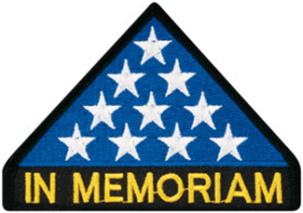

***In Memoriam***

**VVA Chapter 1106 Tribute**

Submitted by John Vargas

On Saturday, September 4, 2021, our Chapter held a solemn ceremony for the 13 American Soldiers killed by a suicide bomber outside the Hamid Karzai Airport Kabul, Afghanistan. They were part of Operation Freedom Sentinel. A non-combatant evacuation operation!

All attending members stood with their heads bowed and in silence as Ron Smith read each name aloud. After each name was read John Vargas tolled a bell in honor and reembrace.

*Sgt. Johanny Rosario Pichardo 25, of Lawrence Massachusetts (Marine/Female)

*Sgt. Nicole L. Gee 23, of Sacramento, California (Marine/Female)

*Staff Sgt. Darin T. Hoover, 31, of Salt Lake City, Utah (Marine)

*Cpl. Hunter Lopez, 22, of Indio California (Marine)

*Cpl. Daegan W. Page, 23, of Omaha, Nebraska (Marine)

*Cpl. Humberto A. Sanchez, 22, of Logansport, Indiana (Marine)

*Lance Cpl. David L. Espinoza, 20, of Rio Bravo, Texas (Marine)

*Lance Cpl. Jared M. Schmitz 20, of St. Charles, Missouri (Marine)

*Lance Cpl. Rylee J. McCollum, 20, of Jackson, Wyoming (Marine)

*Lance Cpl. Kareen M. Nikoui, 20 of Norco, California (Marine)

*Corpsman Maxton W. Soviak, 22, of Berlin Heights, Ohio (Navy)

* Staff Sgt. Ryan C. Knauss 23, of Corryton, Tennessee (Army)

After the 13 were honored, the Reverend Gary Turks asked for and received a moment of silence. Our hearts and prayers are with each one of them and their friends and families. May that all Rest in Peace.



As of: 8/16/2021

Total Funeral Homes Visited - 2,510

Cremains Found – 26,147

Veterans Cremains Identified – 5,617

Veterans Interred – 5,014

***Events:***

**VVA Colorado State Council**

The Colorado State Council of the VVA was presented with a 30-year recognition award by Region 9 Director Dick Southern at the September 11th Council meeting. The award recognizes the long-standing presence of VVA in Colorado.

From left to right: Dave Lyons (1106) Dick Southern, Stan Paprocki (1071) and Tom Dowell (1075)

**POW/MIA News**

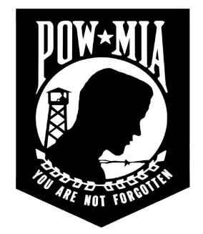Extracted from The New York Times

With Undersea Robots, an Air Force Navigator, lost since 1967 is found! A recovery mission off Vietnam’s coast showed how advances in technology have given new reach to the Pentagon’s search for American war dead.

On a July morning in 1967, two American B-52 bombers collided over the South China Sea as they approached a target in what was then South Vietnam. Seven crew members escaped, but rescue units from the Air Force, Navy and Coast Guard were unable to find six other men, including a navigator from New York, Maj. Paul A. Avolese. It wasn’t until last year that scientists scanning the seafloor found one of the B-52s and recovered Major Avolese’s remains.

“It was very humbling to be diving a site that turned out as hallowed ground and realizing that maybe we were in a position to help bring closure back to families that had been missing this lost aviator,” said Eric J. Terrill, one of two divers who descended to the wreck.

Scientists say the recovery highlights a shift in the Pentagon’s ability to search for personnel still missing from the Vietnam War. For decades, such efforts have mainly focused on land in former conflict zones. But in this case, American investigators looked at an underwater site near Vietnam’s long coastline, using high-tech robots. Their use of that technology is part of a larger trend. Robotic underwater and surface vehicles are “rapidly becoming indispensable tools for ocean science and exploration,” said Rear Adm. Nancy Hann, who manages a fleet of nine aircraft and 16 research and survey vessels for the National Oceanic and Atmospheric Administration. “They have proven to be a force multiplier when it comes to mapping the seafloor, locating and surveying wrecks and other sunken objects, and collecting data in places not easily accessed by ships and other vehicles,” Admiral Hann said.

**Vietnam Veterans Memorial Fund (VVMF)**

On Veterans Day 1996, the Vietnam Veterans Memorial Fund (VVMF) unveiled a replica of the Vietnam Veterans Memorial in Washington, D.C., designed to travel to communities throughout the United States. Since its dedication, The Wall That Heals has been displayed at nearly 700 communities throughout the nation, spreading the Memorial’s healing legacy to millions.

Bringing The Wall home to communities throughout our country allows the souls enshrined on the Memorial to exist once more among family and friends in the peace and comfort of familiar surroundings. The traveling exhibit provides thousands of veterans who have been unable to cope with the prospect of facing The Wall to find the strength and courage to do so within their own communities, thus allowing the healing process to begin.

The main components of The Wall That Heals are The Wall replica and the mobile Education Center.

Note submitted by: Tom Werzyn

Over this past, 2021 Labor Day Weekend, The Wall That Heals, the ¾ size, traveling replica of the Vietnam Veterans Memorial, in Washington D.C., was displayed in Carmichael Park in Brighton, CO. It was the only visit to Colorado for The Wall in 2021. A number of members of VVA chapter 1106 participated in the volunteer efforts to provide security and support for the display. Dave Lyons and Tom Werzyn were part of the “dawn patrol”, providing support and comradeship in the wee hours of every morning the display was in operation. They also participated in the wreath-laying during the opening ceremonies on Friday evening. A number of other members of the chapter were in evidence throughout the time the Wall was on display, both as volunteers and as visitors. A couple of men holding flowers

Tom Werzyn and Dave Lyons

After its visit to Brighton, the exhibit was moving on to Farmington, NM; the next stop on the 2021 US tour, with approximately 35 community visits across the country this year.

From Dave Lyons: Pat Surrena, Chapter Founding Member, his name is on the memorial wall that travels with “The Wall That Heals”

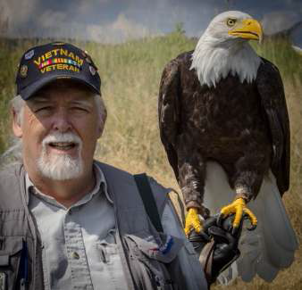

And, on a related note-- in a hushed, pre-dawn conversation, the un-named -and indirectly quoted- City Manager for the city of Brighton, CO, did - with a smug degree of satisfaction, opine that .. “Yes indeed, the Carmichael Park area did in fact breed an award-winning, Olympic quality strain of uber-hungry mosquitos; of that she was quite proud!!!

(L/R: Tom Werzyn, Dave Lyons, Jose Gonzales (Chap 1071)

**CCSD did it Again!**

We thank you dearly for all of your hard work and effort to honor our military veterans, active duty, and first responders! Everything was great from the meal to the program, to the game and the final whistle!

Thanks Huey Pilot and Crew (Bell UH-1 Iroquois)!

CCD School Kids having a ball checking things out!

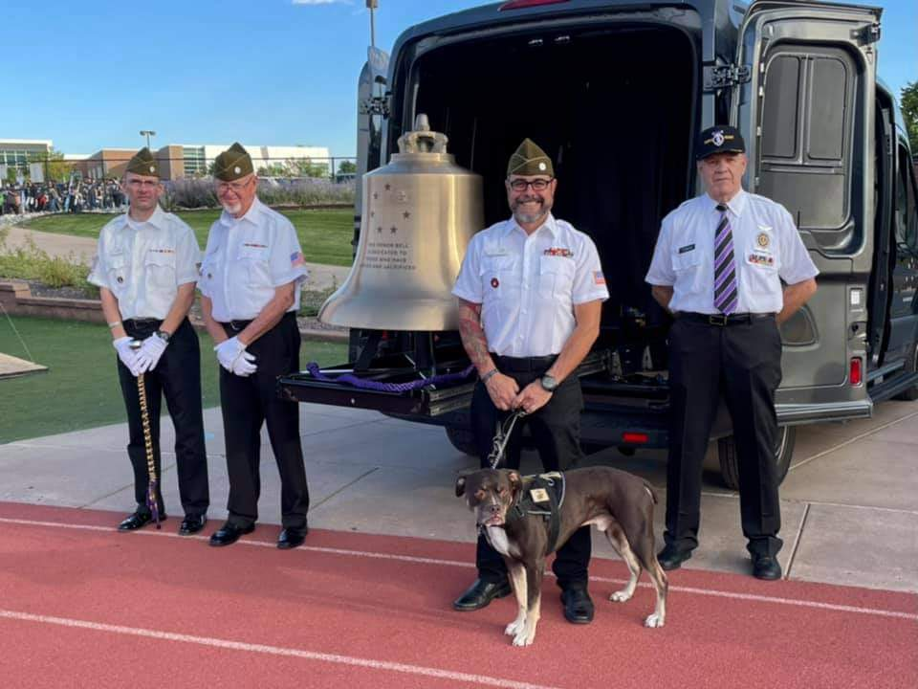

(LR) 2 Honor Bell Volunteers, Chris Boyer, Executive Director of the Honor Bell and former Marine with his service dog, Noodle, and our own John Vargas bell toller!!

Go NAVY beat ARMY ((Editor: I had to say that!)

Missing Man Table Presentation

Quilt of Valor presented to Rev. Gary Turks!

**Quilts of Valor**

Do citizens know the pain of war?

Have they ever had to keep score?

Of the terror and fear that many have seen,

Their mind seems to never come clean.

They live with horror in their brain,

So many have seen war’s blood stain.

They come home with war’s trauma,

Some want to drown their memory in a sauna.

But there is a group that knows how to ease the pain,

They have a gift that soaks up the memory of a blood stain.

And give relief to those that still shake,

It is far better than a fresh piece of cake.

It’s called a quilt, made with love for you,

From cloth that absorbs the tears you do.

A design that makes so much pain go away,

Just wrap yourself in it for a few hours a day.

And comfort comes into your body,

Far better than an alcohol hot toddy.

And each day, the pain starts to ease,

The comfort of the quilt is like smooth seas.

And then you think of the maker of the quilt,

And know that they have relieved your guilt.

Thank you quilt maker for removing the strain,

My body is losing the memories of pain.

Quilts of Valor, you have removed my stressing,

May God continue your work with His blessing!

God bless you and God bless America!

ROTRUCK - 2018

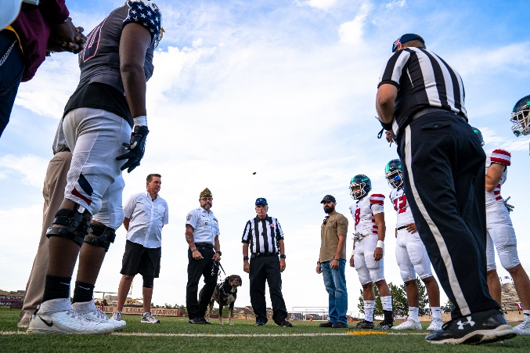

Pre-game coin toss!

ACTION!!!

Huey – Departing! HoooYaa!!!

**October 9th Poppy Drive**

We raised some serious bucks and many thanks to those that volunteered to burn up in the hot sunshine!!!

LZ 1 - $1899.00. THANK YOU from Lee White

LZ 2 - $1122.00

LZ 3 - $1665.21

LZ 5 - $809.72

GRAND TOTAL: $5495.93

Highlands Ranch Crew

L to R: Joe Dempsey, John Vargas, Milt Omoto

(Editor: I guess nobody else took any pictures! I know I didn’t! Signed: Stupid)

**ARLINGTON NATIONAL CEMETERY TOMB OF THE UNKNOWN SOLDIER**

**CENTENNIAL COMMEMORATION EVENTS**

2021 marks the centennial of one of the nation’s most important shrines: the Tomb of the Unknown Soldier. One hundred years ago, on November 11, 1921, the United States laid to rest a fallen American hero. In com-bat, he lost not only his life, but also his identity.

Originally interred in France, where he fell in battle, the World War I Unknown Soldier was returned home to be buried in a tomb at Arlington National Cemetery. Other locations for the tomb were considered. How-ever, Congress selected Arlington, the nation’s premier military cemetery, as the place to construct a tomb in which to bury the Unknown, and to enshrine the memory of all those who have given their lives in service to the United States.

Since 1921, the Tomb has been a place to honor service and sacrifice. It has been - and continues to be - both a site of mourning and a site of commemoration. Arlington National Cemetery and the United States Army are proud to maintain and guard this sacred site, a symbol of the nation’s shared sacrifice.

Charles “Ray” Alexander Jr., Superintendent, Arlington National Cemetery, said: “Our dedicated team has worked for years to prepare for the public to pay their respects at the Tomb in November 2021. This year’s events will include a ceremony during which visitors may place flowers onto the Tomb Plaza. This will be the first time in many years that the public will be allowed to walk across the Tomb Plaza and honor the Unknowns at their gravesite.”

Throughout this year, Arlington National Cemetery will hold events leading up to the centennial ceremony on November 11, 2021. The public will be able to experience and participate in the commemorative events in many ways, both at the cemetery and virtually.

Additional information and resources are available at several websites:

• Download TUS100 Resource Guide.pdf (arlingtoncemetery.mil)

• Education Program:

https://education.arlingtoncemetery.mil

• Society of the Honor Guard/Centennial (TUS100) (tombguard.org)

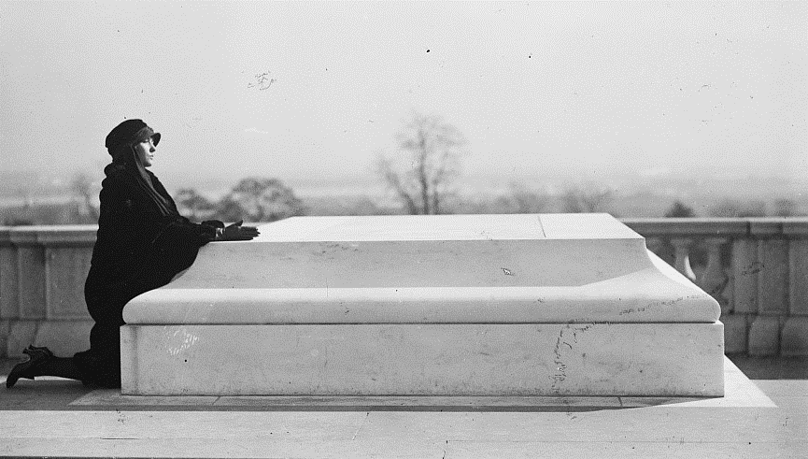

A woman mourns at the Tomb of the Unknown Soldier in 1922. Thousands of American families lost loved ones in World War I, many of whom remained missing or unidentified. (Library of Congress)

**Danny Dietz Memorial Tile Dedication**

Military Order of the Purple Heart (MOPH) Chapter 1041 (Arvada) dedicated a tile at the Highlands Ranch Veterans Monument to honor Danny P. Dietz Jr. on August 30, 2021. Both MOPH and VVA Chapter 1106 members were present. A certificate and replica tile were presented to the mother and brother of Danny Dietz. Danny was a Navy SEAL who was awarded the U.S. Navy's second highest decoration, the Navy Cross, along with the Purple Heart, for his actions during the War in Afghanistan. The Veterans Monument is located at 9292 South Ridgeline Blvd. in Highlands Ranch.

Cindy (Mother) and Eric (Brother) of Danny Dietz

Danny Dietz, Jr. Plaque

**Danny Dietz Military Awards:**

U.S. military decorations:

Navy Cross

Purple Heart

Navy and Marine Corps Commendation Medal

Navy and Marine Corps Achievement Medal

Combat Action Ribbon

National Defense Service Medal with bronze service star

Afghanistan Campaign Medal with bronze star

Global War on Terrorism Expeditionary Medal

Global War on Terrorism Service Medal

Navy Sea Service Deployment Ribbon

Naval Special Warfare Insignia (SEAL)

Navy and Marine Corps Parachutist Insignia

**Vietnam War Commemorative Lapel Pin Presentation**

Suzanne Segona presented ten pins at the September meeting.

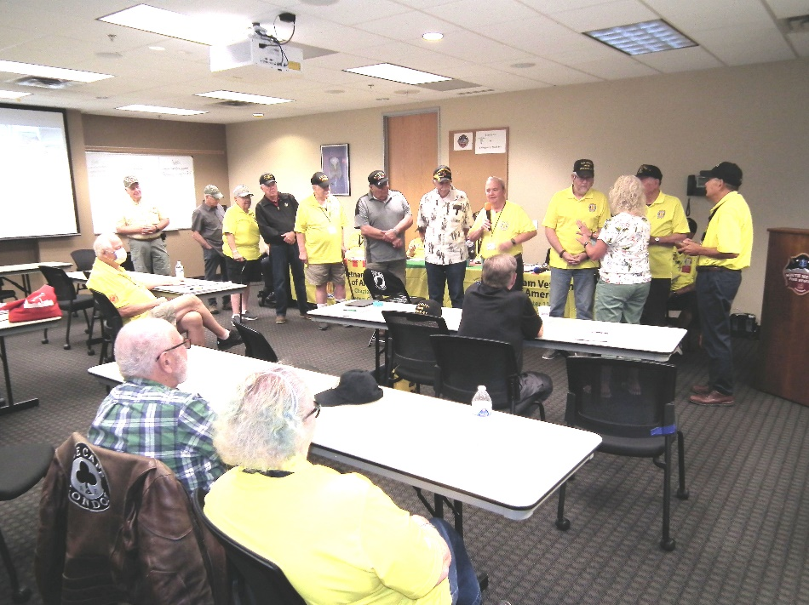

(Editor: Sorry I can’t tell you all of the names!)

***Books/Articles***

**When we didn’t have “fake” news!**

**Priceless! God's Wife**

Submitted by Dave Lyons

IT WILL KNOCK YOUR SOCKS OFF

I especially liked number 5!

Author and lecturer Leo Buscaglia once talked about a contest he was asked to judge. The purpose of the contest was to find the most caring child. The winner was:

1. A four-year-old child, whose next-door neighbor was an elderly gentleman, who had recently lost his wife. Upon seeing the man cry, the little boy went into the old Gentleman's' yard, climbed onto his lap, and just sat there. When his mother asked him what he had said to the neighbor, the little boy just said, 'Nothing, I just Helped him cry.'

2. Teacher Debbie Moon's first graders were discussing a picture of a family. One little boy in the picture had a different hair color than the other members. One of her students suggested that he was adopted. A little girl said, 'I know all about Adoption, I was adopted.' 'What does it mean to be adopted?', asked another child. 'It means', said the girl, 'That you grew in your mommy's heart instead of her tummy!'

3. On my way home one day, I stopped to watch a Little League baseball game that was being played in a park near my home. As I sat down behind the bench on the first- base line, I asked one of the boys what the score was 'We're behind 14 to nothing,' he answered with a smile. 'Really,' I said. 'I have to say you don't look very discouraged.' 'Discouraged?', the boy asked with a Puzzled look on his face... 'Why should we be discouraged? We haven't been up to bat yet.'

4. Whenever I'm disappointed with my spot in life, I stop and think about little Jamie Scott. Jamie was trying out for a part in the school play. His mother told me that he'd set his heart on being in it, though she feared he would not be chosen. On the day the parts were awarded, I went with her to collect him after school. Jamie rushed up to her, eyes shining with pride and excitement. 'Guess what, Mom,' he shouted, and then said those words that will remain a lesson to me....'I've been chosen to clap and cheer.'

5. An eyewitness account from New York City , on a cold day in December, some years ago: A little boy, about 10-years-old, was standing before a shoe store on the roadway, barefooted, peering through the window, and shivering with cold. A lady approached the young boy and said, 'My, but you're in such deep thought staring in that window!' 'I was asking God to give me a pair of shoes,' was the boy's reply. The lady took him by the hand, went into the store, and asked the clerk to get half a dozen pairs of socks for the boy. She then asked if he could give her a basin of water and a towel. He quickly brought them to her. She took the little fellow to the back part of the store and, removing her gloves, knelt down, washed his little feet, and dried them with the towel. By this time, the clerk had returned with the socks. Placing a pair upon the boy's feet, she purchased him a pair of shoes. She tied up the remaining pairs of socks and gave them to him. She patted him on the head and said, 'No doubt, you will be more comfortable now.' As she turned to go, the astonished kid caught her by the hand, and looking up into her face, with tears in his eyes, asked her: 'Are you God's wife?'

**Inner Peace**

Submitted by Lou Zoghby – WWII Vet

If you can start the day without caffeine,

If you can always be cheerful, ignoring aches and pains,

If you can resist complaining and boring people with your troubles,

If you can eat the same food every day and be grateful for it,

If you can understand when your loved ones are too busy to give you any time,

If you can take criticism and blame without resentment,

If you can conquer tension without medical help,

If you can relax without alcohol,

If you can sleep without the aid of drugs,

Then You Are Probably

The Family Dog!

Handle every stressful situation like a dog.

If you can't eat it or play with it, pee on it and walk away.

***Light Side***

**Senior Parachute Club**

Submitted by John Vargas

Yesterday my daughter emailed me again, asking why I didn't do something useful with my time. "Like sitting around the pool, drinking wine isn't a good thing?" I asked.

Talking about my "doing something useful" seems to be her favorite topic of conversation. She is "only thinking of me," she said, and suggested I go down to the Senior Center and hang out with others my age. So, I did and when I got home, I decided to play a prank on her.

I sent her an email saying that I had joined the Senior Parachute Club. She replied, "Are you nuts? You're 75-years-old and now you're going to start jumping out of airplanes?" I told her that I even had a Membership Card and e-mailed a copy to her. Immediately, she telephoned me and yelled, "Good grief, Dad, where are your glasses?! This is a membership to a Prostitute Club, not a Parachute Club." “Oh dear, am I in trouble," I said, "I signed up and prepaid for five jumps a week!” The line went dead**. Life as a senior citizen may not be getting any easier, but it sure can be fun.**

**Jewish Humor**

Submitted by Lou Zoghby, WWII Veteran

Leo Rosten, the great Jewish writer, and authority on Jewish humor, listed as one of the characteristics of Jewish humor, revenge over the oppressor by the use of guile or circumstance.

This is such a story:

Moshe was sitting at the bar staring at his drink when a large, trouble-making biker steps up next to him, grabs his drink and gulps it down in one swig and menacingly says, “Thanks Jew Boy, whatcha going to do about it?" Moshe burst into tears. "Come on, man," the biker says, "I didn't think you'd CRY. I can’t stand to see a man crying. What’s your problem?"

"This is the worst day of my life," Moshe says. "I'm a complete failure. “I was late to a meeting and my boss fired me. When I went to the parking lot, I found my car had been stolen and I don't have any insurance. I left my wallet in the cab I took home. I found my wife in bed with the postman and then my dog bit me. “So, I came to this bar to work up the courage to put an end to it all. I buy a drink; drop a capsule in and sit here watching the poison dissolve; then you show up and drink the whole thing!

“But enough about me, how's your day going?"

***Trivia Answer***

**Upcoming Events of Interest**

*Date of Revision: June 7, 2021*

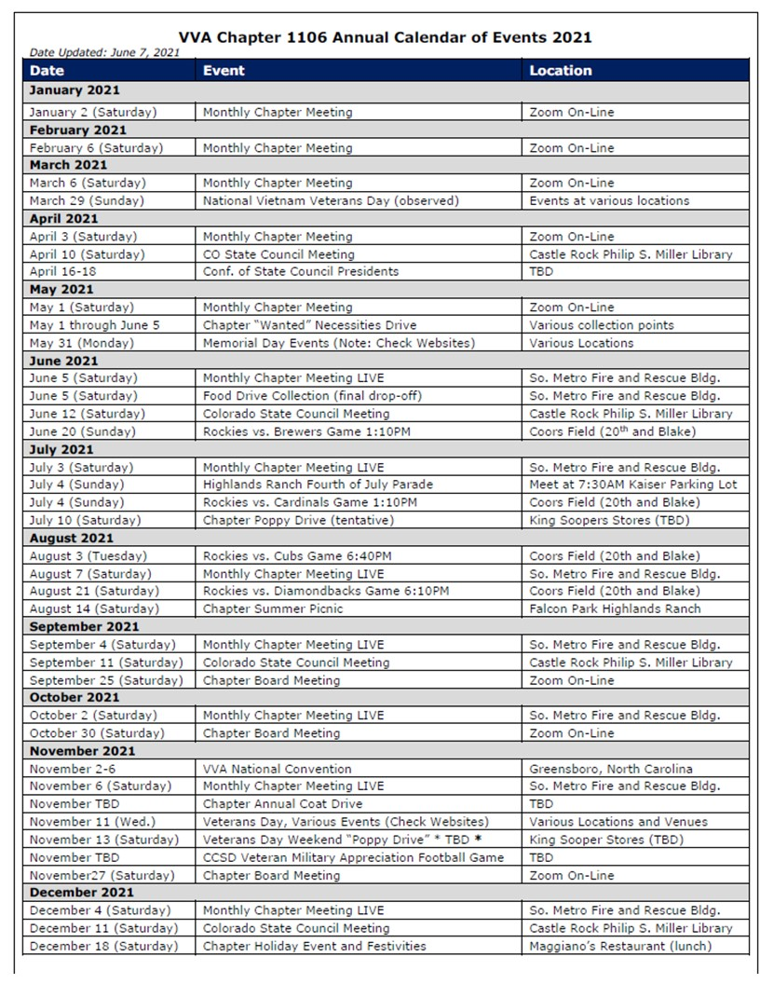

**FRIENDS OF CHAPTER 1106**

|  |  |
| --- | --- |
| **South Metro Denver Fire & Rescue**  9195 E Mineral Ave  Centennial, CO 80112 | **Logo  Description automatically generatedTexas Roadhouse**  **11205 S. Parker Road**  **Parker, CO 80134** |
| **Spradlin Printing, Inc.**  11903 S. Parker Road Parker, CO 80134 |  |
| American Family Insurance  3989 E. Arapahoe Road #20  Centennial, CO 80122  720-361-0155 | A FULL-SIZE REPLICA OF THE HONOR BELL  **The Honor Bell Foundation**  PO Box 1432  Englewood CO 80150  720.282.9182  [www.honorbell.org](http://www.honorbell.org/) |
| 9137 E Mineral Cir Ste 100  Englewood, CO 80112-3422 | Logo of The Home Depot  **Home Depot Foundation**  8477 S Yosemite St  Lone Tree, CO 80124 |
| King Soopers logo.svg  King Soopers  9551 S. University Blvd., Highlands Ranch, CO 80126 | Veteran & Family Resource HubQualified Listeners:  PO Box 563  Dacono, CO 80514  Tel: 720-600-0860 |
| https://scontent.fapa1-2.fna.fbcdn.net/v/t31.0-8/10575197_682186265194110_4051472928662048560_o.jpg?oh=2630b186dcf3a20f1d7fc8fa25e0a5ba&oe=5A17C4AB  **Military Order of Purple Heart**, Chapter 1041, Arvada, CO | ZILLOW GRO**UP**  10771 E. Easter Ave  Centennial CO 80112 |
| 99 Inverness Drive - #275 Ennglewood, CO  Text  Description automatically generated C-303-653-5020  O-303-779-1420  [www.printconnection.com](http://www.printconnection.com)  [troy@ printconnection.com](mailto:troy@%20printconnection.com) | PARKER MEDICAL  S**UP**PLY STORE  9845 S Parker Rd  . Parker, CO 80134  303-840-4444 |