**Inside this issue:**

Notes from the President

[Member Feature](#Memberfeature)

[Military Trivia](#Militarytrivia)

[Guest Speaker](#Guestspeaker)

[Membership](#Membership)

[Board of Directors/Officers](#Boardofdirectors)

[Working Committees](#Workingcommittees)

[Meetings/Events Calendar](#Meetingsevents)

[Announcement Corner](#Announcementcorner)

[Books/Articles Published by Mbrs.](#Booksarticles)

[From the Editor](#Fromtheeditor)

[Light Side](#Lightside)

[Trivia Answer](#Triviaanswer)

**Events**

Saturday, Sept 2nd – Chapter monthly meeting South Metro Fire & Rescue Building

Saturday, Oct 9th, 2017 - Chapter 1106 Monthly Meeting South Metro Fire & Rescue Building

The Board of Director’s meeting will follow 30 minutes following the regular mtg.

Next CO State Council meeting September 9th.

***Editor’s Note:***

**Notice:**

If you have moved or changed your address, PLEASE notify us immediately! Contact: Lee White, Membership Chair

E-mail: <mailto:flyboy51@q.com>

Phone:  303-519-2252

###### COPYRIGHT NOTICE: In accordance with Title 17 U.S.C. Section 107, any copyrighted material in this newsletter is distributed under fair use without profit or payment to those who have expressed a prior interest in receiving the included information for nonprofit use and educational purposes only.

This version of the newsletter is in Microsoft Document (.docx) format so that the links will work. Put your cursor over the link, depress your Control Key (ctrl) and depress your left mouse button and it will take you to the listed link position. PDF format, the links will not work.

***Notes from the President***

Lee White

**Cemetery Watchmen**

My friend Kevin and I are volunteers at a national cemetery in Oklahoma and put in a few days a month in a 'slightly larger' uniform. Today had been a long, long day and I just wanted to get the day over with and go down to Smokey's and have a cold one. Sneaking a look at my watch, I saw the time, 16:55. Five minutes to go before the cemetery gates are closed for the day. Full dress was hot in the August sun. Oklahoma summertime was as bad as ever--the heat and humidity at the same level--both too high.

I saw the car pull into the drive, '69 or '70 model Cadillac Deville, looked factory-new. It pulled into the parking lot at a snail's pace. An old woman got out so slow I thought she was paralyzed; she had a cane and a sheaf of flowers--about four or five bunches as best I could tell.

I couldn't help myself. The thought came unwanted, and left a slightly bitter taste: 'She's going to spend an hour, and for this old soldier, my hip hurts like hell and I'm ready to get out of here right now!' But for this day, my duty was to assist anyone coming in.

Kevin would lock the 'In' gate and if I could hurry the old biddy along, we might make it to Smokey's in time.

I broke post attention. My hip made gritty noises when I took the first step and the pain went up a notch. I must have made a real military sight: middle-aged man with a small pot gut and half a limp, in marine full-dress uniform, which had lost its razor crease about thirty minutes after I began the watch at the cemetery. I stopped in front of her, halfway up the walk. She looked up at me with an old woman's squint.

“Ma'am, may I assist you in any way?”

She took long enough to answer. “Yes, son. Can you carry these flowers? I seem to be moving a tad slow these days.”

“My pleasure, ma'am.” (Well, it wasn't too much of a lie.)

She looked again. “Marine, where were you stationed?”

“Vietnam, ma'am. Ground-pounder. '69 to '71.”

She looked at me closer. “Wounded in action, I see. Well done, Marine. I'll be as quick as I can.”

I lied a little bigger: “No hurry, ma'am.”

She smiled and winked at me. “Son, I'm 85-years-old and I can tell a lie from a long way off. Let's get this done. Might be the last time I can do this. My name's Joanne Wieserman, and I've a few Marines I'd like to see one more time.”

“Yes, ma 'am. At your service.”

She headed for the World War I section, stopping at a stone. She picked one of the flower bunches out of my arm and laid it on top of the stone. She murmured something I couldn't quite make out. The name on the marble was Donald S. Davidson, USMC: France 1918. She turned away and made a straight line for the World War II section, stopping at one stone. I saw a tear slowly tracking its way down her cheek. She put a bunch on a stone; the name was Stephen X. Davidson, USMC, 1943. She went up the row a ways and laid another bunch on a stone, Stanley J. Wieserman, USMC, 1944. She paused for a second and more tears flowed. “Two more, son, and we'll be done.”

I almost didn't say anything, but, “Yes, ma'am. Take your time.”

She looked confused. “Where's the Vietnam section, son? I seem to have lost my way.”

I pointed with my chin. “That way, ma'am.”

“Oh!' she chuckled quietly. “Son, me and old age ain't too friendly.”

She headed down the walk I'd pointed at. She stopped at a couple of stones before she found the ones she wanted. She placed a bunch on Larry Wieserman, USMC, 1968, and the last on Darrel Wieserman, USMC, 1970. She stood there and murmured a few words I still couldn't make out and more tears flowed.

“OK, son, I'm finished. Get me back to my car and you can go home.”

“Yes, ma'am. If I may ask, were those your kinfolk?”

She paused. “Yes, Donald Davidson was my father, Stephen was my uncle, Stanley was my husband, Larry and Darrel were our sons. All killed in action, all Marines.”

She stopped. Whether she had finished, or couldn't finish, I don't know. She made her way to her car, slowly and painfully. I waited for a polite distance to come between us and then double-timed it over to Kevin, waiting by the car.

“Get to the 'Out' gate quick. I have something I've got to do.” Kevin started to say something, but saw the look I gave him. He broke the rules to get us there down the service road fast. We beat her. She hadn't made it around the rotunda yet.

“Kevin, stand at attention next to the gatepost. Follow my lead.” I humped it across the drive to the other post. When the Cadillac came puttering around from the hedges and began the short straight traverse to the gate, I called in my best gunny's voice: “Tehen Hut! Present Haaaarms!” I have to hand it to Kevin; he never blinked an eye-full dress attention and a salute that would make his DI proud. She drove through that gate with two old worn-out soldiers giving her a send-off she deserved, for service rendered to her country, and for knowing duty, honor and sacrifice far beyond the realm of most. I am not sure, but I think I saw a salute returned from that Cadillac.

Instead of 'The End,' just think of 'Taps.' As a final thought on my part, let me share a favorite prayer: “Lord, keep our servicemen and women safe, whether they serve at home or overseas. Hold them in your loving hands and protect them as they protect us.” Let's all keep those currently serving and those who have gone before in our thoughts. They are the reason for the many freedoms we enjoy. **'In God We Trust.'** If we ever forget that we're one nation under God, then we will be a nation gone under!

(Submitted to Lee by VVA Chapter 1106 member Peggy Kelly)

***“******Member Feature”***

Paul Seppo, USN

(Note from Editor: Very well written even for a “Yeoman”☺)

After reading my DD214N I thought I was drafted (inducted) but actually I enlisted! Under date inducted reads (NA). My date of entry 26 AUG 69 - 12 FEB 73 discharged. I received a 6 month early out at the time Admiral Zumwalt was Chief Of Naval Operations (CNO). I went to boot camp in Orlando Florida which was brand new at the time. From there I went to CYN "A" SCOL 19 JAN - 27 FEB 70 in Norfolk VA. My first duty station was in San Miguel Philippines OCT 69 - MAR 71. I was a communications yeoman (CYN) my rank E-3. My MOS Was sending Top Secret messages to the ships off the coast of Vietnam via teletype machines through huge antennas. I had a Top Secret Clearance (TSC) working with the radio men and Communication Technicians (CT'S). Before I left the Philippines, I changed my rate from Communications Yeoman (CYN) to Yeoman (YN) because I didn't like shift work even though we had 12 section duty 4 days on 8 days off! I think because of my rate change I found myself on Admiral Staff Duty and got orders to go to San Diego, CA for my next duty station. An enlisted man hardly ever gets orders to get Admiral Staff Duty. I was with COMFIRSTFLT. I was on three ships. The first one was the U.S.S Providence (CLG-6) a real Admiral Staff Ship a guided missile cruiser on the stern and 6 inch guns with wooden decks. This ship was called to Vietnam so my next ship was the U.S.S. Eldorado an old cruiser, not fast. My last ship was the U.S.S. Blueridge a communication ship with antenna's all around and a big flat deck. This ship was converted to and aircraft carrier a few years later. One incident on the U.S.S. Eldorado I had to take a Quarter Masters watch for three hours in the early morning and steer the ship that was scary because I couldn't see anything out in the open sea. But I didn't hit anything I was glad not to do that again! I finally made E-4 YN3 a third class petty officer a month before I was discharged. One more incident for 38 days I was scraping rust off ships in mothballs hanging from scaffolding waiting for my 6 month early out what a way to go out of the service. When I look back I did enjoy my time serving my country!

***Military Trivia***

What does **BOHICA** mean! – Answer at the [end of the Newsletter](#Triviaanswer).

***Special Guest***

Frank Griggs, founder of Veteran’s Puppy for Life Organization (VPFLO) honored our chapter with the story of how he created this wonderful organization that is helping veterans with PTSD. He had his dog there that helped and inspired him out of total depression and withdrawal from society to be able to create his dream. The VPFLO motto: "Helping to Heal Wounded Souls...

One Puppy at a Time!"

Words from VPFLO website: *Veterans living with PTSD live in a grey world filled with anxiety, depression, hyper-vigilance, isolation, addictions, or anger. Many times not knowing or realizing why? Normally with veterans their PTSD is from combat situations. The war may be over physically, but not so in their mind. Even with treatment PTSD is still there daily. PTSD truly is an invisible wound. Veteran's Puppy for Life Organization was founded to provide these veterans with a puppy when it is eight weeks old, which will become their service dog eventually. The goal is to help them focus their attention on the puppy and not on themselves. In a word does it work, "yes"!*

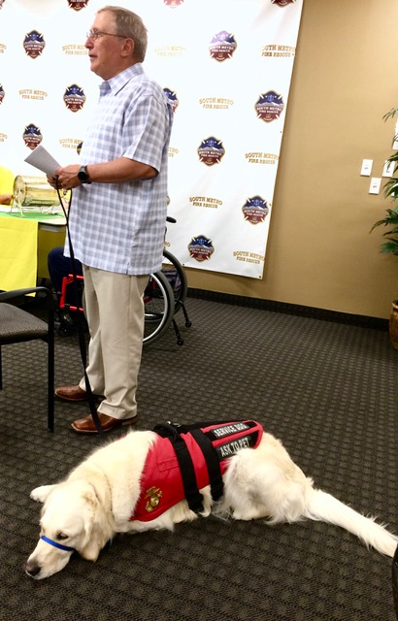

Frank with his life saver!

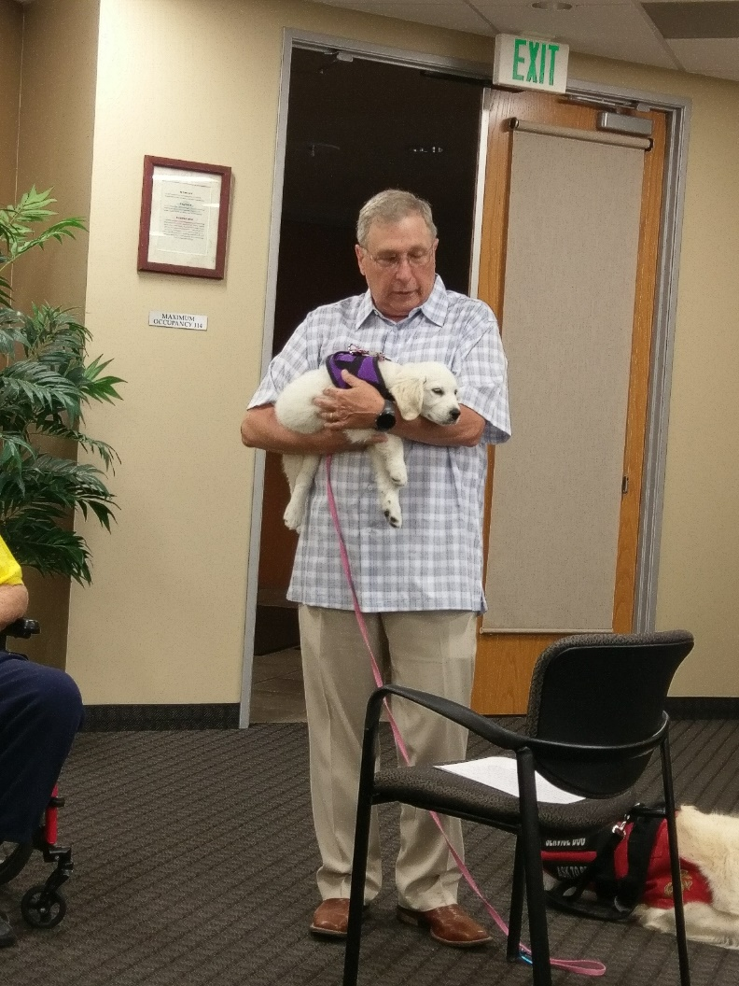

A candidate puppy that will help make a veteran’s life worth living.

Visit <www.vetpuppyforlife.org> for more info.

***Membership Milestone the Century Mark!!!!***

VVA Chapter 1106 Membership: 81 (8-18-2017)

AVVA: 21

Total: 102

Welcome new VVA Member: Donna Chaney

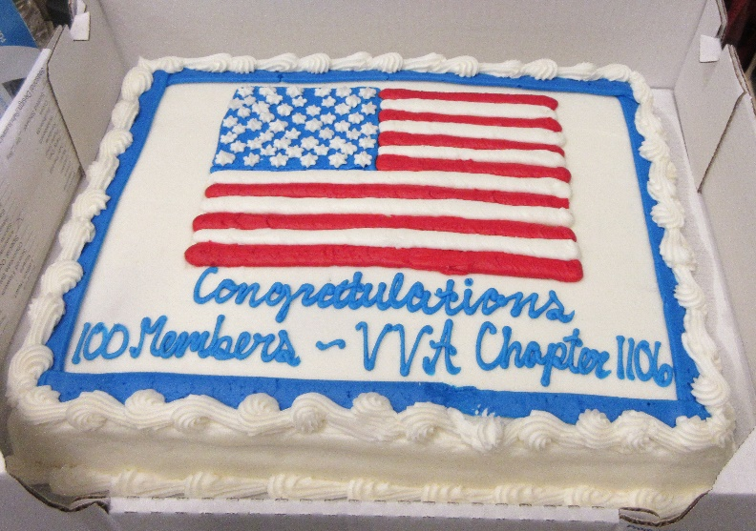

***Board of Directors/Officers***

Lee White - President

Bob Easter - Vice-president

Joe Plant - Treasurer

Hazel Simeon - Secretary

Board Members - Milt Omoto, Patti Ehline, Paul Seppo, Dave Lyons

***Working Committees***

(Folks are needed to fill some spots!)

Sergeant-at-Arms – John Vargas

Agent Orange/PTSD - **OPEN**

Membership - Lee White

Membership outreach – Dave Lyons

Mental Health: Patti Ehline, Warren Harrison

Newsletter Editor - Bob Rotruck

Fundraising/Grants - Milt Omoto

Marketing/Media/Events – Tom Werzyn

POW/MIA – Mike Messenger

Webmaster – Robert Senatore

Women Veterans - Patti Ehline

Scholarship Program - Hazel Simeon, Bob Easter, Joe Langran, Bob Rotruck, John Vargas, Mike Karsh, Glen Payne, Jim Marcille, Tom Werzyn

Veteran Emergency Assistance Committee - Joe Plant, Bob Rotruck, Lee White, Dave Lyons

Speakers Bureau – Bob Easter, Glen Payne, Bob Mallin, Mike Messenger, Roger Lanphier, Tom Werzyn

Social - **OPEN**

***Meetings/Events Calendar - 2017***

Saturday, September 2, 2017 - VVA Chapter 1106 Monthly Meeting, South Metro Fire & Rescue Building

Saturday, September 9, 2017 - Colorado State Council Quarterly Meeting

Saturday, September 23, 2017 - VVA Chapter 1106 Fall Picnic - Heather Gardens

Saturday, October 7, 2017 - VVA Chapter 1106 Monthly Meeting, South Metro Fire & Rescue Building

Saturday, October 14, 2017 - Journey to WWII National Aviation Museum, Colorado Springs

Wednesday/Saturday, October 18-21, 2017 - Colorado State Council's President Conference, Silver Spring, MD

**Region 8/9 Pre-Convention Meeting**

The meeting was held Saturday, June 24th at the Holiday Inn off Tower Road. The meeting was well attended by our Chapter. The event was put together by Region 9 Director, Dick Southern. Several officials from National were present including National President, John Rowan.

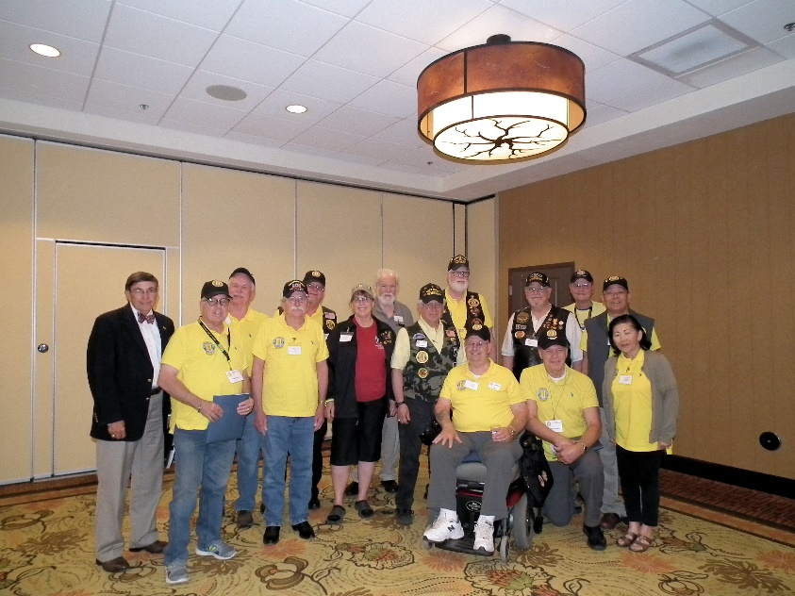

Far left, Wayne Reynolds, VVA National Treasurer and rear center, John Rowan, VVA National President. The rest of the folks are 1106 members and all **good looking**!!!!!

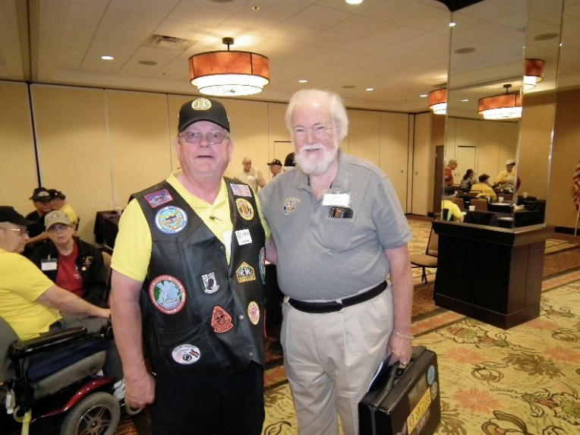

Lee and John Rowan

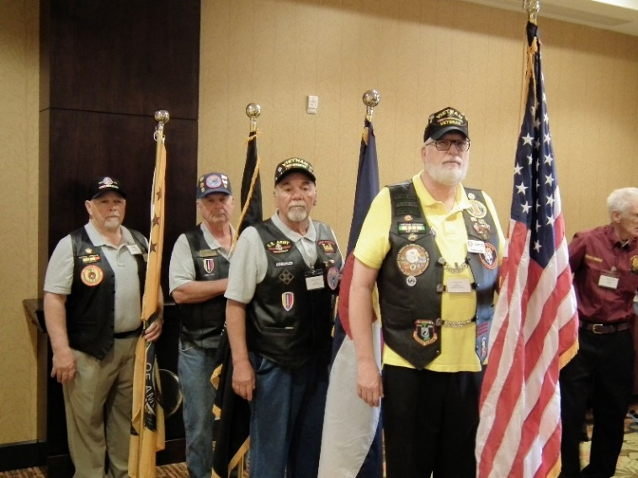

Color Guard

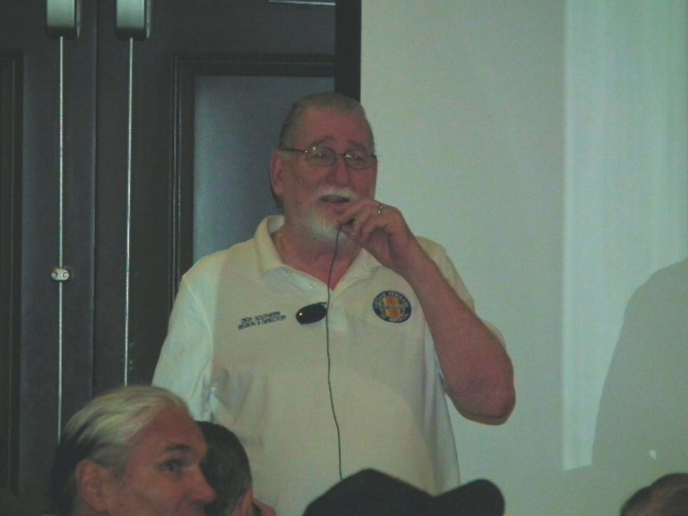

Region 9 Director, Dick Southern

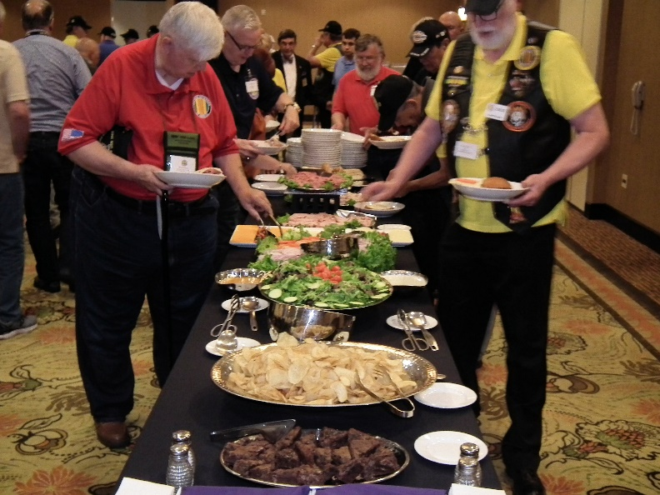

Forty dollar sandwich, homemade chips, and brownies with little Colorado green chunks in them so we were very happy minutes later!!!!



**MISSING IN AMERICA PROJECT**

**NATIONWIDE PROGRESS AS OF 8/16/2017**

Total Funeral Homes Visited - 2,117

Cremains Found - 15,160

Veterans Cremains Identified - 3,465

Veterans Interred - 3,176

[www.miap.us](http://www.miap.us)

**Scholarship Speakers – July 1 MTG**

Three of the winners of the chapter scholarships were able to attend the July meeting and read their essays to the chapter. Recipient Spencer Huhn declined the scholarship because he had been awarded a free ride scholarship from his college, but we were rewarded with a delivery of his fine essay. Recipient Grace Atwell was not able to attend our meeting.

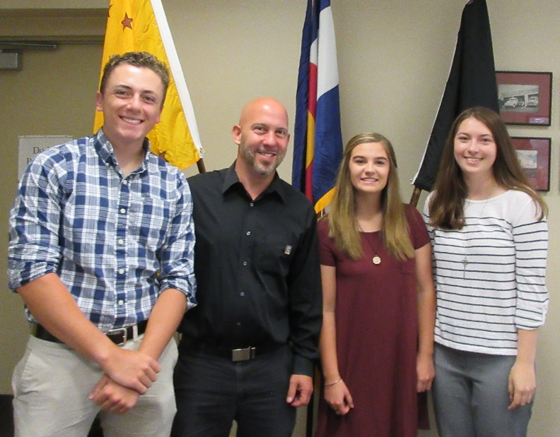

(L/R) SPENCER KUHN, graduate of Rock Canyon HS, Highlands Ranch, CO, BRIAN KARSH – $1,000 Scholarship donor, ANNA SCHIAVONE, graduate of Regis HS, Denver, CO, ELLIE HOUSEWORTH, graduate of Ponderosa HS, Parker, CO

The chapter members were very attentive as the winners read their essays!

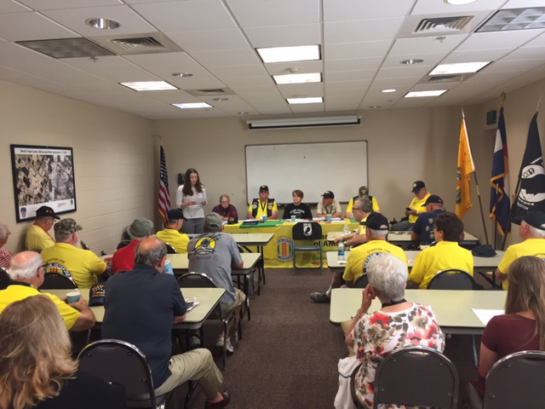

Ellie Houseworth reading her essay.

**Highlands Ranch July 4th Parade**

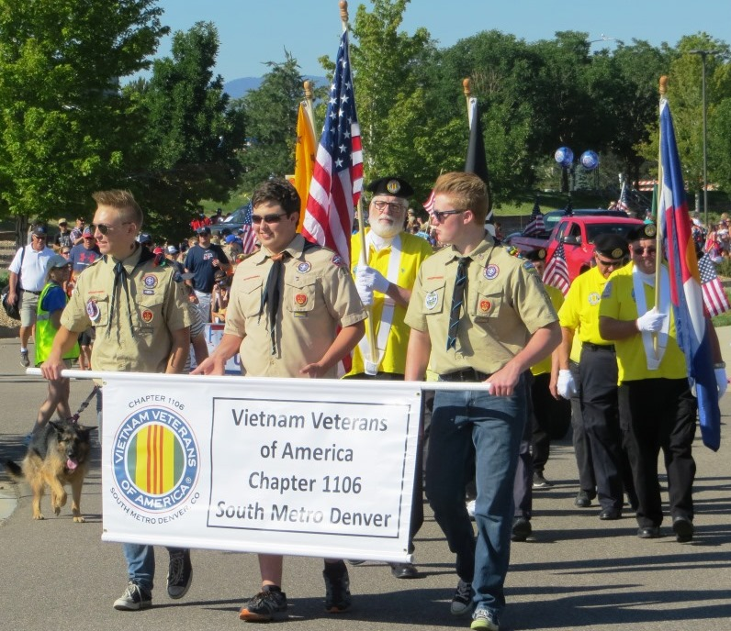

Boy Scouts from Troop 780 display our banner.

L/R Zander Scarborough, Luke Nelson, Ean Orr

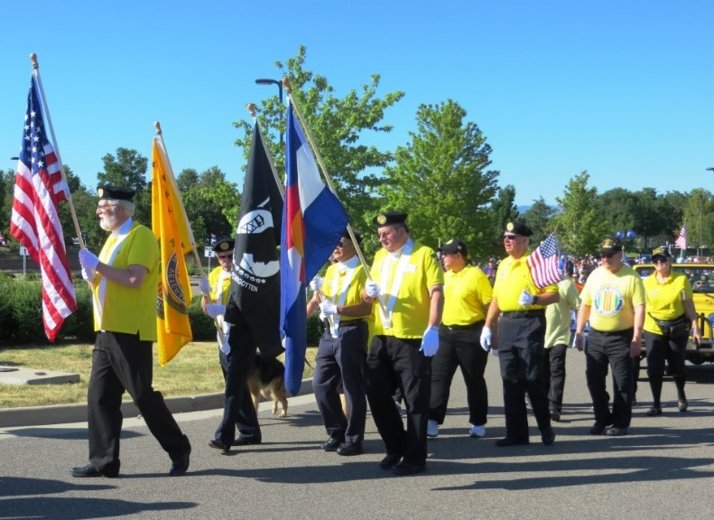

Each marching in perfect step separately!!!!

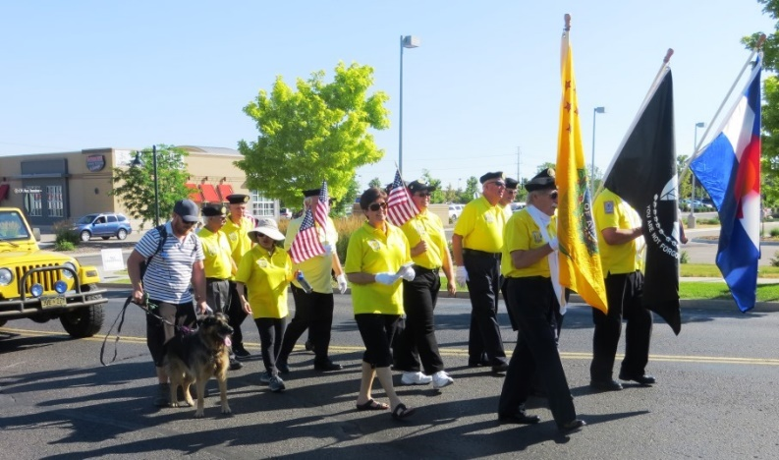

Watch out for the occasional droppings from the stern of a horse!!

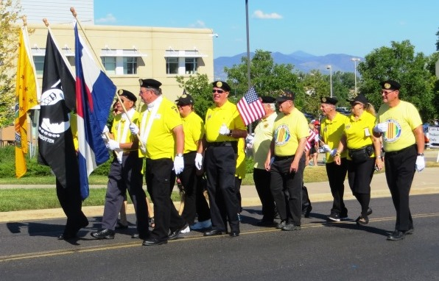

Gunner Bob calling cadence, “Hair-lip, hair-lip!!!”

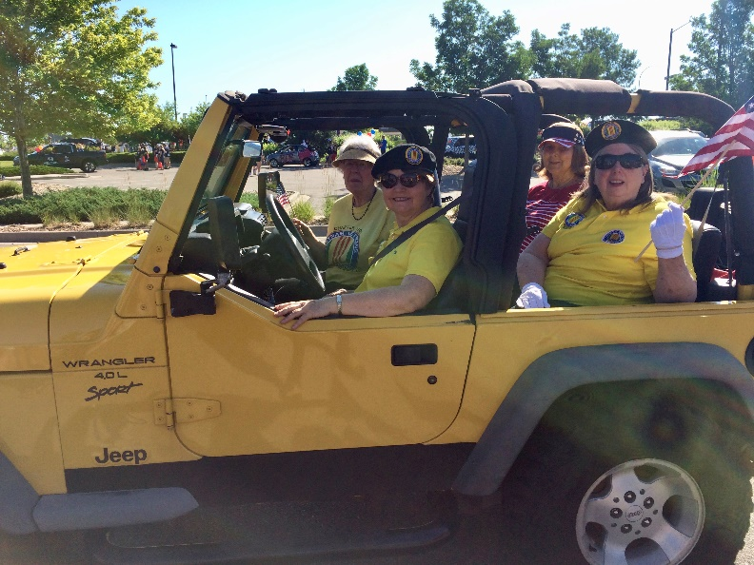

Hazel bringing up the rear in her yellow Jeep!

**Soldier Stone – A trip to remember!!**

August 19, 2017, twenty-one veterans, spouses, family, and friends visited this virtually unknown memorial hidden away on top of a mountain in southwest Colorado. It is not publicized nor glorified with road signs. It is a solemn place of remembrance to all the countries who sacrificed to participate in a war against evil. We all felt honored to have participated on this wonderful trek.

Attendees: Lee White, Bob & Barbara Rotruck, Tom & Valerie Werzyn, Milt & Chris Omoto, John Williams & Diane Graham, Roger Lanphier brother Phil Lanphier, Suzanne Segona and friend Joe Natividad, Dave & Dee Lyons, Wendell & Mary Wallace, Hazel Simeon granddaughter Victoria, Sonny Gorsuch, Patti Ehline

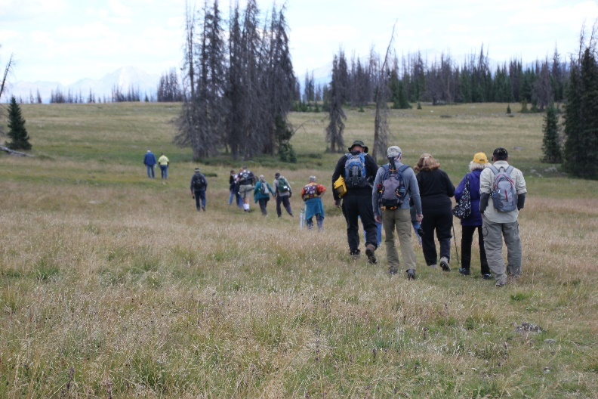

Photo by Tom Werzyn - In route to Soldier Stone Memorial (some were faster than others).

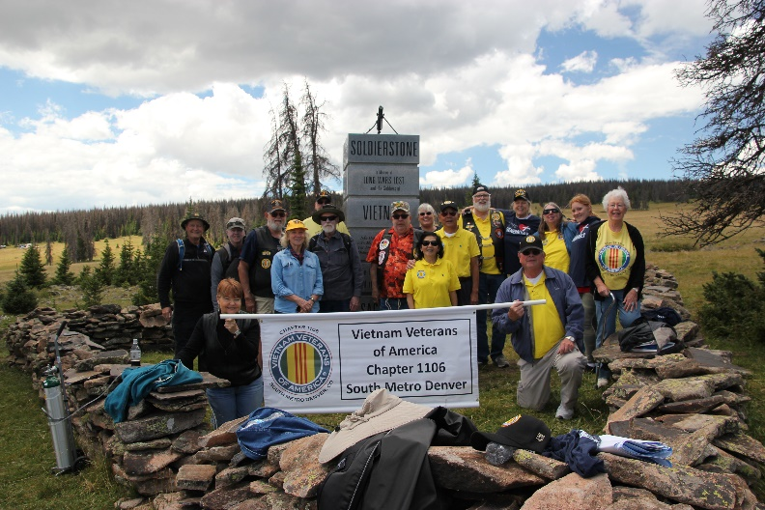

Photo by Tom Werzyn - A gathering of honor! It is hard to see in this small picture, but just to the left of the last guy (Rotruck) way back on the left is where the vehicles were parked!!! Nice hike!

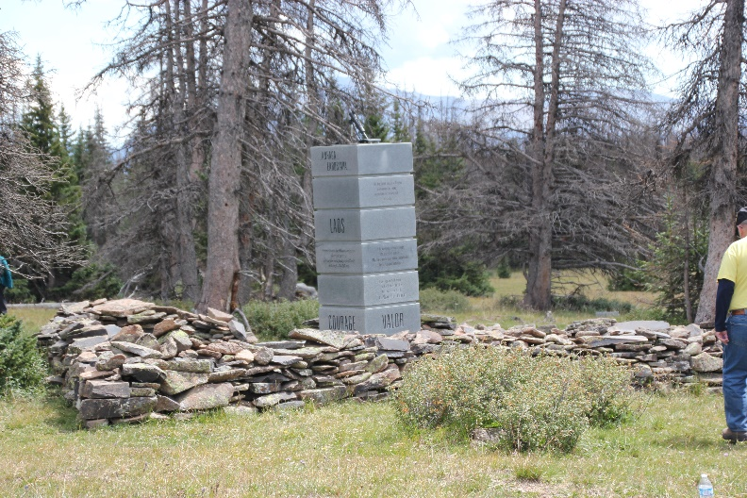

Photo by Tom Werzyn - A serene place to honor those that gave all!

<http://hiddencolorado.kunc.org/soldierstone/>

**Gold Star Family**

From the July Patriot Reader Newsletter. St. Augustine, FL



The term Gold Star family is a modern reference that comes from the Service Flag. These flags/banners were first flown by families during World War I. The flag included a blue star for every immediate family member serving in the armed forces of the United States, during any period of war or hostilities in which the armed forces of the United States were engaged. If that loved one died, the blue star was replaced by a gold star. This allowed members of the community to know the price that the family had paid in the cause of freedom.

The United States began observing Gold Star Mother's Day on the last Sunday of September, in 1936. The Gold Star Wives was formed before the end of World War II. The Gold Star Lapel Button was established in August 1947.

Today, the nation recognizes the sacrifice that all Gold Star Family members make when a father, mother, brother, sister, son, daughter, or other loved one dies in service to the nation. Gold Star Mother’s and Family’s Day is the last Sunday of September and Gold Star Spouses Day is April 5. “The strength of our nation is our Army. The strength of our Army is our Soldiers. The strength of our Soldiers is our families. The Army recognizes that no one has given more for the nation than the families of the fallen.”



FOREVER FREE – GOD BLESS AMERICA

**Our Ships**

“…we all shared one thing in common. We served in ships. These ships were more than transportation. More than a naval artillery platform. More than a place to eat and sleep. They were a way of life not known anywhere else. We wore our ships proudly…The tie between a sailor and his ship is unique among the military and it is that bond that draws us together.”

Terry Miller, Executive Director, Tin Can Sailors

**Agent Orange Registry**

Contact Rod Green Phone: [719-327-5660](tel:(719)%20327-5660). Ask for Rod Green. If no answer leave message on machine with your name, number and he will call back. When he calls he’ll request: address, years of service. He will send you forms to fill & return. Then he will call back and give you appointment date to go to Golden for exam.

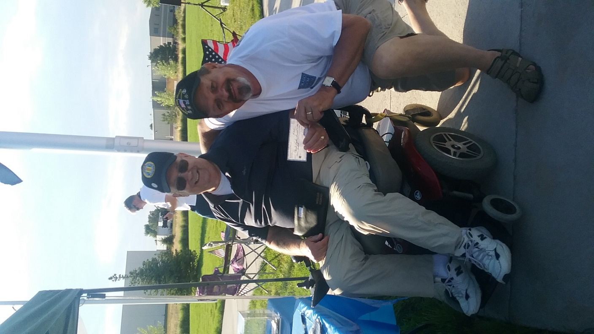

Joe Plant delivered a VVA Chapter 1106 check for $500.00 to Rick Crandall at the Colorado Freedom memorial to help pay for the vandalism damage.

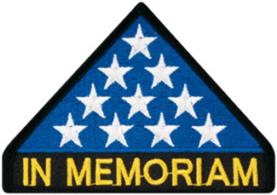

***In Memoriam***

COL Benjamin W. Eakins, USAF (RET)

Born April 15, 1924 and passed July 27, 2013. He was the father of Mary and father-in-law of Paul Seppo. He was an Eagle Scout and a West Point graduate and served five years in the Army 23 years in the Air Force. In 1992, Ben completed his lifelong goal of stepping foot on all seven continents by visiting Australia. Colonel Ben’s cremains were interred at Fort Logan National Cemetery on June 23, 2017. Several Chapter members were in attendance. RIP Colonel Eakins.

***Announcement Corner***

**Update on the Chapter Speaker Bureau**

Submitted by Bob Easter

Four meetings have been conducted between February 18 and July 22 to develop an outreach program relating to military service and personal experiences in Vietnam. Three phases were established: planning and development, implementation, review and evaluation.

The first resulted in specific protocols for solicitations (introductory meetings with high school administrators and teachers); the actual format of presentations (deliveries); and, review of audience reactions and evaluations.

Written forms have been developed for each phase, including a set of handouts for each student containing a quiz (with answers), chronological events in Vietnam, an extensive reading list, and a recommended movie list. Introductory and concluding elements have respective documents.

The second, implementation phase, will begin mid- to late-September with Mike Karsh and Jim Marcille serving as "point men," making introductions and arranging personal meetings with potential "clients" as well as gaining opportunities to "recon" their respective facilities.

The third, review and evaluation phase, will be conducted as a group to determine any necessary modifications. Presentations will be informal, conversational, and personal, within certain parameters.

In addition to the above-named participants other individuals who will serve as "trained" presenters are Roger Lanphier, Bob Mallin, Glen Payne, Tom Werzyn, and Bob Easter.

***Book/Articles Published by Members***

**At The Wall …**

By Tom Werzyn

I’ve seen them alright-

they come here at night

alone;

even in groups, couples.

Silent dampness,

whispers, flags, candles,

a prayer.

And perhaps an oath-

to remember,

or just in frustration, exasperation

at the loss of such innocence,

and each other.

You can’t tell someone

about the cold fist

behind your belt,

when you see the name

you don’t want to look for,

and can’t leave behind

without touching.

Nights are easier to take

here.

Faces, not eyes.

Starlight

reflects from the tears,

and the chiseled stone

seems to know

more about silence,

given and received,

than the flood of seekers

daily tramping, unknowing,

through

my vigil

on my own grassy knoll.

……

**Lord's Prayer**

By a 15-year-old school kid (name unknown) who got an A+ for this entry (TOTALLY AWESOME)! The Lord's Prayer is not allowed in most U.S. Public schools any more. A kid in Minnesota, wrote the following NEW School Prayer:

Now I sit me down in school

Where praying is against the rule

For this great nation under God

Finds mention of Him very odd.

If scripture now the class recites,

It violates the Bill of Rights.

And anytime my head I bow

Becomes a Federal matter now.

Our hair can be purple, orange or green,

That's no offence; it's a freedom scene.

The law is specific, the law is precise.

Prayers spoken aloud are a serious vice.

For praying in a public hall

Might offend someone with no faith at all.

In silence alone we must meditate,

God's name is prohibited by the State.

We're allowed to cuss and dress like freaks,

And pierce our noses, tongues and cheeks...

They've outlawed guns, but FIRST the Bible.

To quote the Good Book makes me liable.

We can elect a pregnant Senior Queen,

And the 'unwed daddy,' our Senior King.

It's 'inappropriate' to teach right from wrong,

We're taught that such 'judgments' do not belong...

We can get our condoms and birth controls,

Study witchcraft, vampires and totem poles...

But the Ten Commandments are not allowed,

No word of God must reach this crowd.

Its scary here I must confess,

When chaos reigns the school's a mess.

So, Lord, this silent plea I make:

Should I be shot; my soul please take!

Amen

***From the Editor!***

Written September 13, 2010 by your Editor!

**Camaraderie Can Be So Painful**

Dictionary: **camaraderie** – friendship, a feeling of close friendship and trust among a group of people.

If you are a currently a military member or a veteran, you understand the definition of this word far more than the average citizen. Police officers and firemen know this word as well. In the Navy, it is called being a shipmate and there are other special names for it in all branches of the service. But the bottom line, it is a brother/sisterhood like no other. Ninety-nine percent of military folks do not know one another when they join one of the service branches. But in boot camp or officer candidate school, a bond begins to happen literally overnight. Most times, when basic training is completed, friends are separated by military orders and sent to units and ships all over the world. Immediately, new bonds begin to take place. New brothers and sisters report into a new command and the attachment grows stronger as you work side by side.

Most everybody goes through life establishing friendships and life is not always fair because you get separated by jobs, relationships, marriages. But how does the mind handle the separation when they watch a comrade that they love and trust with their life suddenly get shot or blown apart by an unseen enemy? How do you cope with the pain of seeing your friend’s life slip away when they jumped in front to take the hit for you? Crouched over them watching their life’s blood flow from their body and the only thing you can do is pray they will make it.

Our men and women are returning home with these kinds of mental wounds in their minds and it is incumbent on every citizen of these United States to step up and say, ”Thank you!” “We are here for you and we want to help with your pain!”

Have you seen a military person at the airport or in a restaurant or on the street and taken the time to shake their hand and thank them? Just do it!



**Gold Star Mother’s Lament**

My child was not forced to go,

They didn’t do it just for show.

Deep in their heart was a calling so clear,

Oh why did you listen to it my little dear?

But a voice inside told this young adult,

There is a draw to be part of a cult.

The cult is buried deep within our soul,

To defend our great country is the goal.

And off they go to a new way of life,

A new camaraderie helps relieve the strife.

They meet other sons and daughters that heard the call,

Friends they would make and never let them fall.

But life does not always give what they deserve,

Because the calling fills them with great reserve.

To serve God and Country is the greatest gift of all,

Most give much and some give all.

And Blue Star Mothers have the sad task,

To change the star to Gold, it’s too much to ask.

And the Gold Star Banner is soiled from tears,

Because the Mother has met her worst fears.

The American Flag is presented with deep emotion,

And the memories are remembered with deep devotion.

Your child will always be in your heart of pain,

But God is there also to help and will always remain.

God Bless our American men and women who serve,

We Americans must give them all they deserve!

AMEN!

ROTRUCK - 2012

Composed for Julie Schrock after she lost her son, Marine Corporal Max Donahue, in Afghanistan.

***Light Side***

**Will Rogers – A pretty smart man!**

**(1879 – 1935)**



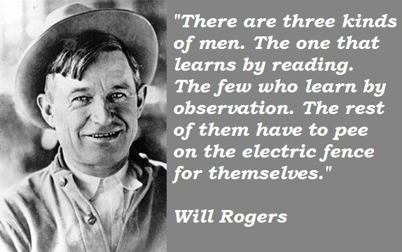



**Technology Doesn't Change One's Character**

An elderly couple had just learned how to send text messages on their new mobile phones. The wife was a romantic type and a retired English teacher of the classics. The husband a retired Navy Chief was more of a no-nonsense guy.

One afternoon the wife went out to meet a friend for coffee. She decided to send her husband a romantic text message and she wrote:

"If you are sleeping, send me your dreams. If you are laughing, send me your smile. If you are eating, send me a bite. If you are drinking, send me a sip. If you are crying, send me your tears. I love you."

The husband texted back to her: "On the toilet. Please advise."

**There’s a lesson in there**

A teenage boy had just passed his driving test and inquired of his father as to when they could discuss his use of the car.

His father said he'd make a deal with his son, "You bring your grades up from a C to a B average, study your Bible a little and get your hair cut. Then we'll talk about the car.”

The boy thought about that for a moment, decided he'd settle for the offer and they agreed on it.

After about six weeks his father said, "Son, you've brought your grades up and I've observed that you have been studying your Bible, but I’m disappointed you haven't had your hair cut."

The boy said, "You know, Dad, I've been thinking about that, and I’ve noticed in my studies of the Bible that Samson had long hair, John the Baptist had long hair, Moses had long hair, and there's even strong evidence that Jesus had long hair.”

I love the father's reply …

**"Did you also notice that they all walked everywhere they went?”**



**New Inventions**

The new BBQ invention out of West Virginia.

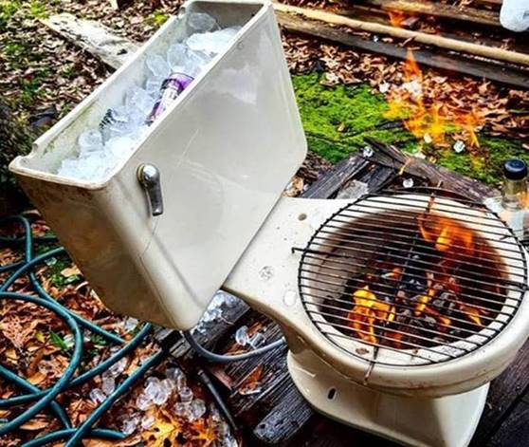

Just flush and the fire goes out!!!!

**Why Pro Sports players shouldn't reproduce.** Most are college graduates??!!

Football commentator and former player Joe Theismann, 1996: "Nobody in football should be called a genius. A genius is a guy like Norman Einstein."

Senior basketball player at the University of Pittsburgh: "I'm going to graduate on time, no matter how long it takes." (Now that is beautiful!)

Bill Peterson, a Florida State football coach: "You guys line up alphabetically by height." And, "You guys pair up in groups of three, and then line up in a circle."

Chuck Nevitt, North Carolina State basketball player, explaining to Coach Jim Valvano why he appeared nervous at practice: "My sister's expecting a baby, and I don't know if I'm going to be an uncle or an aunt." (I wonder if his IQ ever hit room temperature in January)

Frank Layden, Utah Jazz president, on a former player: "I told him, 'Son, what is it with you? Is it ignorance or apathy?' He said, 'Coach, I don't know, and I don't care.'"

New Orleans Saint RB George Rogers when asked about the upcoming season: "I want to rush for 1,000 or 1,500 yards, whichever comes first."

**Terrorist Set Free and Given a Car to get back home:**

What in the world is going on? Releasing a terrorist and giving him money and a car - what next???

*U.S. Navy releases Al Qaeda Terrorist*

I can’t believe it. The U.S. Navy announced that it has released a senior Al Qaeda Terrorist after questioning him for 27 days while being held prisoner about a U.S. aircraft carrier while in the Arabian Sea. In a humanitarian gesture, the terrorist was given $50 US and a white 1962 Ford Fairlane upon being released from custody. The photo shows the terrorist on his way home after being released by the Navy!!! Fair winds and smooth seas!!!!

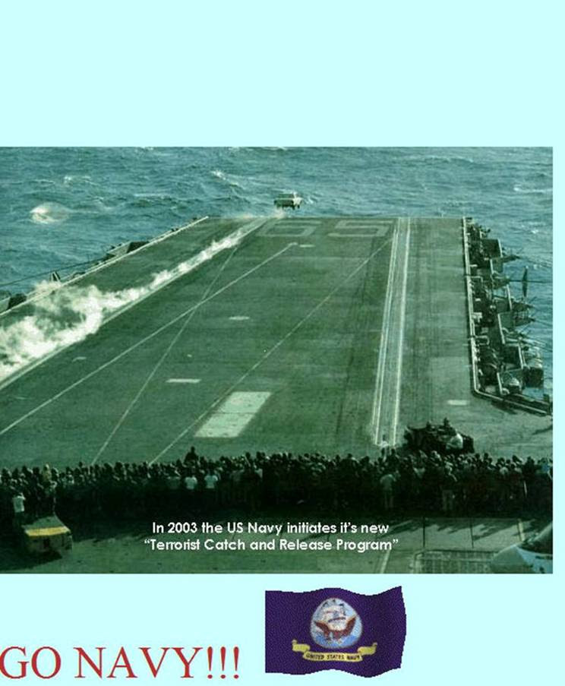



***Trivia Answer***

**BOHICA**: **B**end **O**ver **H**ere **I**t **C**omes **A**gain!

**FRIENDS OF CHAPTER 1106**

|  |  |  |
| --- | --- | --- |
| **ERC Management, LLC**  791 Southpark Dr., Suite 600  Littleton, CO 80120  [720.328.3299](tel:720.328.3299)  [www.FreddysUSA.com](http://www.freddysusa.com/) | | |
| **Caribou Coffee**  12501 E Lincoln Ave  Englewood, CO 80112  303-799-1258 | **American Legion Post 1260**  **E:\Documents\ALP1187\images\AmericanLegion_logo.jpg** | |
| Logo of The Home Depot  **Home Depot Foundation**  8477 S Yosemite St  Lone Tree, CO 80124 | **South Metro Denver Fire & Rescue**  9195 E Mineral Ave  Centennial, CO 80112 | |
| Monthly Membership Meetings VISITORS ARE ALWAYS WELCOME!   3rd Saturday of each month at 10:00a.m.   Our meetings are held at: [VFW Post 2461](http://www.vfwpost2461.com/) 1350 S Broadway, Denver, CO 80210 | [http://www.applewoodfixit.com/wp-content/themes/applewood/images/header-logo.png](http://www.ApplewoodFixIt.com)  Applewood Plumbing Heating & Electric  **Main Billing Office:** 5000 W 29th Ave.  Denver, CO 80212 **Phone:** 303-232-6611 **Fax:** 303-477-4310 **Email:** [custservice@applewoodfixit.com](mailto:custservice@applewoodfixit.com) | |
| 9137 E Mineral Cir Ste 100  Englewood, CO 80112-3422 | South Metro – Instant Imprints  6882 S. University Blvd.  Centennial, CO 80122  [303-771-2244](tel:303-771-2244) | |
| https://scontent.fapa1-2.fna.fbcdn.net/v/t1.0-9/11755678_1048713308485999_8302677469177969743_n.jpg?oh=7f29d6fe26e879d42add098d5cded1fa&oe=5A27AD2B  VFW Post 2461, 1350 S. Broadway, Denver, CO 80210 | http://www.cruisin1430.com/sites/g/files/giy711/f/KEZW_Header_Large_Logo_0.png  **STUDIO 1430 Main Office:** 4700 South Syracuse Street, Suite 1050 Denver, CO 80237 | |
| https://scontent.fapa1-2.fna.fbcdn.net/v/t31.0-8/10575197_682186265194110_4051472928662048560_o.jpg?oh=2630b186dcf3a20f1d7fc8fa25e0a5ba&oe=5A17C4AB  **Military Order of Purple Heart**, Chapter 1041, Arvada, CO | **Veteran’s Puppy for Life**  [https://scontent.fapa1-2.fna.fbcdn.net/v/t1.0-9/19060085_1943219205919091_2430547914200531885_n.jpg?oh=2442c16b113594f4bdc40eec81330246&oe=59EB9F66]( http://www.vetpuppyforlife.org)  <http://www.vetpuppyforlife.org> | |
| A FULL-SIZE REPLICA OF THE HONOR BELL  **The Honor Bell Foundation**  P.O. BOX 12400 DENVER, COLORADO 80212  720.282.9182 | Golden Corral**Golden Corral**  15775 E. Arapahoe Rd  Centennial, CO 80016 |  |