**Inside this issue:**

Notes from the President

Member Feature

Military Trivia

Guest Speaker

Membership

Board of Directors/Officers

Working Committees

Meetings/Events Calendar

Announcement Corner

Books/Articles Published by Mbrs.

From the Editor

Light Side

Trivia Answer

**Notice:**

If you have moved or changed your address, PLEASE notify us immediately! Contact: Dale Creason, Membership Chair Email [creason38sp@gmail.com](https://d.docs.live.net/b01f39d598cd0af7/Documents/2022VVANL/creason38sp@gmail.com)

Phone:  303720-2948

###### COPYRIGHT NOTICE: In accordance with Title 17 U.S.C. Section 107, any copyrighted material in this newsletter is distributed under fair use without profit or payment to those who have expressed a prior interest in receiving the included information for nonprofit use and educational purposes only.

**Facebook: Vietnam Veterans of America Chapter 1106**



***Editor’s Note:***

This version of the newsletter is in Microsoft Document (.DOCX) format so that the links will work. Put your cursor over the link, depress your Control Key (ctrl) and depress your left mouse button and it will take you to the listed link position. PDF format, the links will not work.

The comments and editorial input do not necessarily reflect the opinion of the membership of our chapter. I would appreciate any feedback that you might have, items you liked or if you find offensive or derogatory in anyway. ([bobrotruck73@gmail.com](mailto:bobrotruck73@gmail.com)) Thank you for allowing me to be your editor.

***Notes from the President*** - Dave Lyons:

Our Chapter continues to grow with new members joining on a regular basis. To our new members, welcome aboard and thanks for being part of this family. We have great speakers scheduled for our monthly Chapter meetings. They will be informative, speaking on topics that will be of interest to you. Some will be “just for fun.” The Board and committees are busy planning Chapter activities. We’ll participate in community events such as the annual Fourth of July parade, poppy drives, planning a possible field trip, Summer picnic and our end of year Holiday lunch.

I want to remind you that active involvement in Chapter 1106 means that the more you get engaged with Chapter activities, the more value you get out of the organization. I invite you to become actively involved with Chapter activities. We need more committee members to help with our many Chapter functions. I’ll continue to announce activities in which you can get engaged. I invite you to be involved. It’s only in this way that you get the most out of this Chapter.

Thank you everyone for your continued support of Chapter 1106.

***Member Feature***

Alan Jaffe – U.S. Navy 1968-73, Petty Office Second Class Electricians Mate. I was awarded the National Defense, Navy Good Conduct, Viet Nam Service, Viet Nam Campaign w/ 3 stars, Navy Unit Commendation, Navy Unit Citation. After Boot Camp, I was stationed in Viet Nam (Da Nang, Saigon, Chau Doc (Bassac River), Tan Chau (Mekong River), Rota Spain. My most memorable experience during service was leaving Viet Nam and traveling home. My recommendation for a special chapter activity is to have a Golf Tournament in the late spring or summer.

***Military Trivia***

**Anchor Clanker**

Click here for end of the Newsletter Trivia Answer

***January Guest Speaker – Rick Crandall***

Rick Crandall spoke to us about the history of the Colorado Freedom Memorial. While he was a radio host for 30 years, he got the idea in his head to create a memorial to all veterans from Colorado that had sacrificed their life on the front lines of foreign wars.

The following is a quote from the CFM website:

May 29, 2000

KEZW-AM 1430 Breakfast Club Broadcast from the Normandy-American Cemetery, France

As part of Memorial Day weekend in France, Rick Crandall, program director and Breakfast Club host on AM 1430, KEZW, in Aurora, Colorado, planned a four-hour live broadcast of his morning radio show from the Normandy American Cemetery. The broadcast, supported by the Robert R. McCormick Foundation and the American Battle Monuments Commission, was planned as a tribute to the WWII veterans of Colorado. During the planning of the broadcast Rick and his team learned there were 88 from Colorado buried at Normandy. This lead to questions, out of curiosity, about how many others must be buried in American military cemeteries around the world, and further, how many Colorado veterans had been lost in all of America's wars. During the broadcast the team at the Normandy-American cemetery brought several guests to be part of the show including a visitor from California who was seeing his brothers grave for the first time and a French woman who lives near the cemetery who remembered her father bringing wounded D-day veterans into their barn to bandage and hide from the Germans. As the broadcast at Normandy ended Rick, and his wife Diane, took one last walk through the cemetery and looked over the rows and rows of headstones and Stars of David and it was an image that Rick couldn't shake. He didn't know it then, but this day was the start of a journey that would change his life, and the life of many back home in Colorado.



Glass panels with hundreds of names honored!

The chapter honored Rick with a special VVA Chapter Challenge Coin and a donation of $500.00.

***February Guest Speaker – Heather Solberg***

Heather is the Vision Impairment Services Coordinator for the VA Visual Impairment Program (VIP). VA blind and low vision rehabilitation services and is accredited by Commission on Accreditation of Rehabilitation Facilities (CARF). If you’re a Veteran or active-duty service member who is blind or has low vision, you may be able to get advanced vision care and rehabilitation services through the VA to help you live an independent life. You can contact Heather at (303) 283-5382 for more information at the VA Hospital at 14400 E. Jewell Ave, Aurora, CO

Heather Solberg

***Membership!*** (As of 2/4/202)

VVA 187

AVVA 46

TOTAL: 226

**VVA**

**AVVA**

***Board of Directors/Officers***

Dave Lyons – President

Milt Omoto – Vice-president

Mike Huber – Treasurer

Sally Eaves – Secretary

Board Members – Patti Ehline, Tom Werzyn, John Vargas, Joe Plant, Rev. Garry Turks, Joe Dempsey, Joseph Robinson.

***Special Chapter Positions***

AVVA Liaison to chapter Board of Directors – Litta Plant-Schaper

Chaplain – Rev. Garry Turks

Chapter Historian – John Vargas

Database/Audio – Jack Hunter

Government Affairs – Tony Nickerson

Sergeant-at-Arms – Dan Green

Chapter Nurse – Patti Ehline

Email Blaster – Bob Rotruck

***Working Committees***

* Agent Orange/PTSD: Patti Ehline
* Color Guard: Dale Creason (Command Sergeant),
* Ron Smith (Asst. Command Sergeant) , Don McNeely, Dan Green, Clarence Rebolledo, Harry Montgomery, John Sheadel,
* Event Coordinator: Joseph Robinson
* Fundraising/Grants: Milt Omoto – Chair
* Information Blaster – Bob Racetrack Rotruck
* Marketing/Media/Events: Tom Werzyn
* Membership: Dale Creason – Chair, Lee White, Litta Plant-Schaper (AVVA Roster Updates
* Memorial Committee: John Vargas-Chair. Garry Turks, Joe Plant, Lee White, Alan Jaffe, Milt Omoto
* Mental Health: Patti Ehline, Warren Harrison, Joe Plant
* Name Tags: Litta Plant-Schaper
* Newsletter Editor: Bob Rotruck
* Promotional Items: Leann Stelzer, Joe Dempsey, Ita Dempsey
* Refreshments: Walt Leuci, Dave Lyons
* Scholarship Program:  Gary Weston, Chair, Jim Marcille, Litta Plant-Schaper, Mike Karsh (At-Large, Consultant)
* Social – Chairman – Vacant, Joe Plant, Tom Werzyn, and Litta Plant-Shaper
* Speakers Bureau Tom Werzyn – Chair, Bob Mallin, Dave Lyons
* Veteran Emergency Assistance: Joe Plant, Dave Lyons
* Voices for Veterans: Warren Harrison, Patti Ehline, Joe Plant
* Webmaster: Bob Rotruck
* Women Veterans: Patti Ehline

**Meetings/Events Calendar – 2022**

Mar 4, 2023 – VVA Chapter 1106 Membership Meeting

Mar 25, 2023 – VVA Chapter 1106 Board Meeting

Apr 1, 2023 – VVA Chapter 1106 Membership Meeting

Apr 29, 2023 – VVA Chapter 1106 Board Meeting

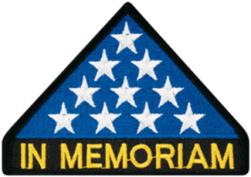

***In Memoriam***

CLIFFORD E. BUTLER

We lost a dear friend, military veteran, community minded and family man. Cliff, as he liked to be called, was born in Wirt, Oklahoma. Wirt was first called Rag Town because of the tents the oil workers lived in when the petroleum boom started. Now known as Oklahoma City. Cliff had five other siblings and the family struggled with poverty until he was old enough to enlist in the military.

He graduated high school at 16 and then enlisted in the Army. After basic was sent to Germany. He worked as a medic during the post WW II era. He met Shirlee Rowan, fell in love, and was married on June 13, 1952. A family of six Susie, Richard, Terry, Barbara, Valarie, and David. He took the opportunity to earn his bachelor’s degree in Microbiology. He then joined the Air Force and continued to earn a master’s degree at the University of Arizona in Microbiology.

During this time, he worked with every possible virus, disease, bacteria, and various illnesses. His work as a scientist was recognized across the US, he was published in numerous newspapers, scientific journals, and wrote a book that is held at the Library of Congress.

This eager beaver loved life and was always in motion. He wrote a 2,000-page book on his Genealogy. He was instrumental in the planning of Viet Nam era Veterans enjoying special lunch meetings at Wind Crest. He was a proud member of VVA 1106, Centennial Colorado. He is survived by six children, eight grandchildren and seven great grandchildren.

Our old friend was laid to rest, with full military honors, he was a Major in the Air Force, on January 5, 2023, at Ft. Logan cemetery in Colorado. A private ceremony was held in his honor at the January monthly meeting of VVA 1106. His name in on the chapter’s Memorial plaque.

Clifford “Cliff” Butler, you will remain in our hearts forever. R.I.P.

Gwendolyn Wilson

February 1, 1954 – February 9, 2023

Gwendolyn Wilson was a beloved daughter, sister, talented pastry chef, veteran, and friend. She was born in Denver, CO on February 1, 1954, to William Wilson and Lillian Rogers. Gwendolyn was one of 6 children. She was a Denver Native all of her life, graduating from North High School. Gwendolyn entered the United States Air Force in 1982, leaving in 1989 as a SSG. Gwendolyn and family were proud of her veteran status.

Gwendolyn was also a very talented pastry chef. She loved creating sweets and treats to share with her family and friends. When she was released from Active Duty with the Air Force, she took her opportunity to cultivate her talent one step further and attended Johnson and Wales University. Family and friends will miss her pastry chef talents. She will be fondly remembered by her sisters, Carolyn Rogers and Linda Wilson, nieces, nephews, cousins, extended family and friends. Gwendolyn passed away on February 9, 2023, in Denver, Colorado. She was 69 years old. A graveside service for Gwendolyn will be held Friday, February 24, 2023, at 11:30 AM at Ft. Logan National Cemetery, 4400 W. Kenyon Ave., Denver, CO 80236, Committal Shelter B. Fond memories and expressions of sympathy may be shared at www.advantagerunyan-stevenson.com for the Wilson family.



As of: 2/23/2023

Total Funeral Homes Visited – 2,593

Cremains Found – 29,199

Veterans Cremains Identified – 6,169

Veterans Interred – 5,791

***Events:***

**Forgotten Heroes Campaign**

Chapter 1106 Members Honored! At the November 19, 2022, Forgotten Heroes Campaign awards ceremony, two VVA Chapter 1106 members were honored. Bob Easter, Army Specialist Fourth Class, artillery, Vietnam War 1968-70 and Charles Smith, Army Sergeant (E-5), infantry, Vietnam War 1964-67 received their long-waited medals. Barry Fiore read each recipient’s biography. Medals were pinned on by Brigadier General David Warner. The medals and awards were presented in beautiful shadow display boxes.

Brig. General David Warner! Bob Easter

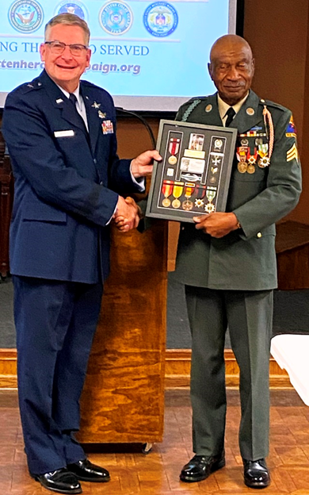

Brig. General David Warner $ Charles Smith

**Forgotten Heroes Campaign January 28, 2023**

Two members of VVA Chapter 1106 received their well-deserved military awards after many years in a formal ceremony conducted by the Forgotten Heroes Campaign. Family and friends were in attendance. Brigadier General David Warner conducted the award presentations.

Alan Jaffe served in the Navy as an Electrician’s Mate from 1968 to 1973. Gary Weston was a Navy Medical Assistant, serving from 1968 to 1972. Both are Vietnam War veterans.

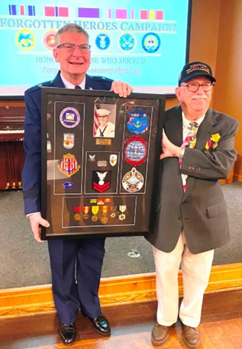

Alan Jaffe

Gary Weston

**Honors Rendered**

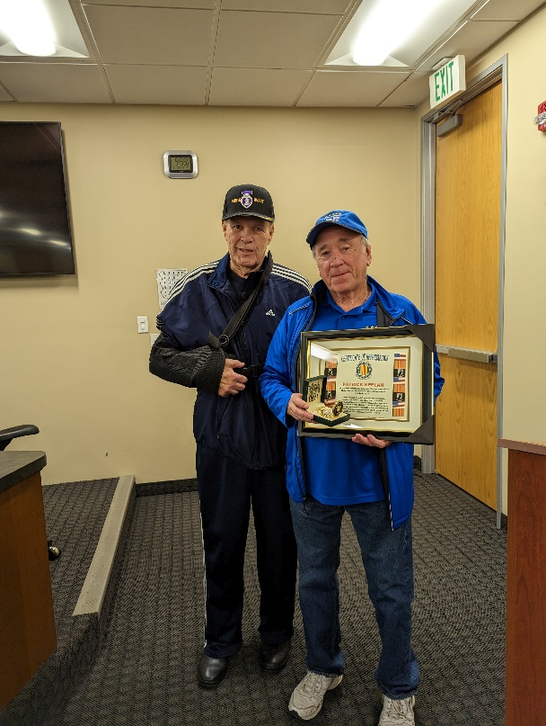

Patrick Keelan was given a Certificate of Appreciation and a special Vietnam war era pocket watch for all of his volunteer hours with the Rocky Mountain Honor Flight organization.

Walt Leuci was given a Certificate of Appreciation and a special Vietnam war pocket watch for all of his work and efforts to bring coffee and bottled water to our meetings.

**Spradlin Printing**

John Spradlin, owner of Spradlin Printing in Parker, was not able to attend our January meeting, so Lee White and I met him at his office Thursday, Jan 12th and presented him a Certificate of Appreciation and a Vietnam War pocket watch for printing the Bookmarks that were handed out at the Holiday Luncheon.

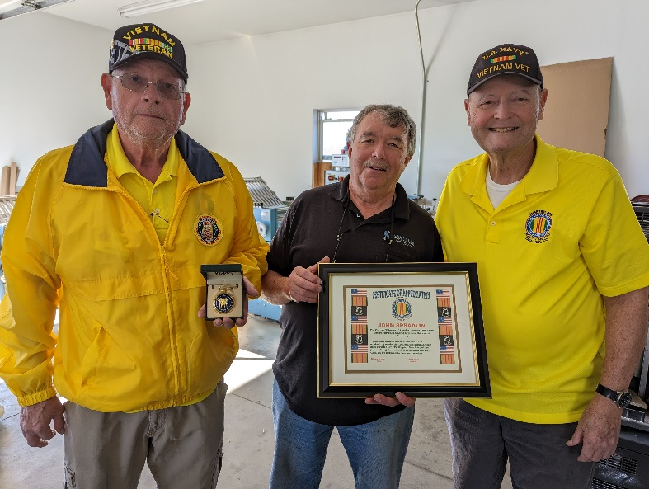

Vietnam War pocket watch!

John was a Lithographer LI2 (Petty Officer 2nd Class).He served in the Navy from August 27, 1972 - August 27, 1976. Lithographers were responsible for printing processes for the U.S. Navy.

This is a picture of his original E-5 blue uniform rating patch.

**New VA Clinic to be built in Castle Rock**

Article and photo by: Haley Lena

hlena@coloradocommunitymedia.com

VA Town Hall panel (L to R): Terri Clinton, Michael Kilmer, Michael Rohrbach, Roderick Thomas and Hugo Gutierrez-Castenada

VA Eastern Colorado Health Care System hosted a town hall at the Castle Pines Library Jan. 30 to discuss plans for the new Castle Rock VA Clinic and the expansions of the PACT Act and COMPACT Act. Looking to open in late 2024 or early 2025, the Castle Rock VA Clinic will be a 20-year lease built at the northeast corner of Prairie Hawk Drive and Dacoro Lane. The annual lease is estimated to be $1.3 million. According to the director of the VA Eastern Colorado Health Care System Michael Kilmer, the 20-year lease is a build to suit, meaning the contractor is going to take the VA’s design and build it based on the primary care model the VA wants. “The thing that makes me confident about the clinic is this is a build to suit,” said Kilmer. “The landlord can’t start collecting rent until it’s built and we take occupancy. So, you’re going to have a motivated contractor.” DCB Construction, the general contractor for the Loveland VA Clinic will build the Castle Rock VA Clinic. The clinic is currently designed for eight primary care teams. However, Kilmer said they are going to reassess as they need to integrate mental health and whole health or complementary alternative medicines such as chiropractic, acupuncture, and massage. In addition to the eight primary care teams, the total space will be 25,000 square feet and look to include a lab service. The clinic will not offer in-house eye care, a pharmacy, or a dedicated full time women's health clinic. However, there will be a women’s health fellowship. “Veterans can choose who their providers are and I’m sure we’re going to have a combination of male and female providers at that clinic and they are all required to be certified in women’s health,” Updates on the clinic will be provided through the veterans service organization, social media, the website and future town halls.

**Reports**

Joe Plant reported that our chapter assisted several area veterans in December to the tune of $5,017.00. Thanks for all of your hard work Joe.

Clarence Rebolledo announced his resignation as Chapter Secretary due to health issues. We wish him good health in the future.

We welcome Sally Ann Eaves who stepped up to be our new Chapter Secretary. Thank you, Sally.

**Books To Bill Daniels Veterans Center**

On Jan. 16th, our chapter made a donation of perhaps 100 plus books – paper-back & hard-bound – to the Bill Daniels Vet Center, in Denver; this was an accumulation of books from a number of members and was presented to Rowan Kokins, one of the administrators at the Center, by President Dave Lyons and Board member Tom Werzyn. Rowan said she was grateful for the donation and appreciated that we thought of fellow Veterans first.

LtoR: Tom Werzyn, Rowan Kokins, Dave Lyons

These books will be made available to all of the Vets who utilize the Center’s services and have the potential to be passed around far and wide, as the Veteran population at the Center tends to ebb and flow with the seasons, and with the needs of the Veterans involved.

Another good deed for our fellow Veterans, of all conflicts, of all needs and of all situations …

**Texas Roadhouse Honored**

On February 17th, President Dave Lyons and Vice President Milt Omoto presented a Chapter challenge coin in a display case to Texas Roadhouse for their continued support of Chapter 1106.

LtoR: Clint Hacker, Dave Lyons, Danna Hacker (holding the challenge coin), Milt Omoto

**Honor Bell Event**

***Books/Articles***

**Dementia, Caregiving, and Resources**

CPT Robert E. Mallin, MD, USA (FMR) SURGEON GENERAL, MOWW

**Part 3**:

The most prominent sign of dementia is decreasing cognitive functions and memory. This event can come at any time in the disease process and will remain and worsen throughout its course. Having discussed drugs and ancillary treatments in past articles, we know there is no cure. Out-of-home care will be needed at some point for physical and mental declines. Starting a program that can, as required, evolve into more physical assistance as time goes on is essential. In part #4, we will discuss some veteran’s choices and resources.

What you are looking for, at first, is an assisted living arrangement that emphasizes memory care. As time passes, the assisted living part becomes more critical. It should have the capacity to become more of a physical and/or nursing facility while supporting memory care, if possible. Such places do exist and are expensive. The national average cost for memory care in the United States is $6,935 a month, according to 2021 NIC statistics.

Finding the right place is emotional and stressful. In navigating the options for elder care, many tough questions arise, and confusion is normal. There is a difference between memory and dementia care. Though ultimately, they focus on the same thing: maintaining memory while answering to increasing physical needs.

specifics to look for

Memory care specifically focuses on memory‑related conditions. But also check for a wide range of healthcare-focused services and amenities and a degree of assisted living.

The memory care part focuses on the neurodegenerative conditions that interfere with memory, such as dementia and Alzheimer’s disease. “Dementia” is a broad term describing a decline in brain function that comes with age. “Alzheimer’s” disease is a specific neurological condition and the leading cause of dementia.

When investigating, look for a standard of care plan that entails the best you would expect from a nursing home or assisted living facility, and an individualized care plan specifically focused on memory care. The latter requires a very different professional skill set than standard elder care. Choose your care team critically. Check professional qualifications. Be sure to get other families’ contact information and use it.

Memory and physical care must provide:

· 24/7 access to medical support as needed.

· Flexible options for activities and treatments to improve memory.

· Individual and group counseling sessions focused on memory function.

· Physical activities that encourage wellness and an active lifestyle.

· Cognitive behavioral therapy must fit the individual’s unique needs.

· Physical safety features that account for mobility while reducing the risk of wandering.

· Sit in on some sessions. Memory care programs will focus on memory functions with consistent therapies and physical treatments for a fulfilling quality of life. There must be 24-hour access to these.

Memory Care with Dementia Care is much more involved

Think of memory care as the early stage of treatment. “Dementia care” takes over as the disease process advances. While memory care often works in tandem with assisted living programs, dementia care is more clinical in nature and more closely aligns with a nursing home experience. That is a safe, environment focusing on quality of life, reducing confusion, and preventing wandering. Some assisted living facilities, have memory care “neighborhoods” for dementia patients. Memory care is the fastest-growing sector of the senior housing market.

Some questions to ask when considering “Professional” over family care:

· Is the person with dementia becoming unsafe in their current home?

· Is the health of the person with dementia or my health as a caregiver at risk?

· Are the person’s care needs beyond my physical abilities?

· Am I becoming a stressed, irritable, and impatient caregiver?”

Memory care facilities have alarmed doors, elevators that require a code, and enclosed outdoor spaces to keep residents on site. Many offer tracking bracelets that give residents the freedom to explore but still allow staff to monitor their location. Making “the correct decision” is very important.

Be well. 😊

**VVA MOU with B&M: Camp LeJeune Claims**

At their last meeting, VVA’s Board of Directors approved an MOU with the private law firm Bergmann & Moore in connection with claims filed under the Camp LeJeune Justice Act (CLJA). VVA is committed to ensuring that veterans and family members considering filing claims

under the CLJA are not taken advantage of by bad actors. Accordingly, the VVA Board of Directors took two important actions:

(1) Signed a MOU with Bergmann & Moore (B&M), a trusted law firm that has an established partnership with VVA. B&M will offer screening services to VVA members, their friends, and families, to advise them as to whether filing a CLJA claim is in their best interests (because of the offset, some claimants might actually lose money depending on their VA rating relating to conditions arising from exposure to contaminated water in Camp LeJeune).

(2) Enacted the following motion: "To recognize that there are several law firms and organizations seeking to profit from the Camp LeJeune Justice Act (CLJA) at the expense of our veterans and resolve that no individual

from VVA National, State Council, or Chapter should associate, in their official capacity, with a firm seeking to solicit VVA members for CLJA cases without the express approval of VVA's Board of Directors, effective

November 10, 2022." Our Director of Communications and Marketing, Mokie Porter, has put out excellent information on VVA’s website and social media accounts. If you encounter veterans, or their family members, or friends, that may have lived in Camp Lejeune during the specified periods (for at least 30 days between August 1, 1953, and December 31, 1987), please refer them to our website: (<https://vva.org/news/the-camp-lejeune-justice-act-evaluating-andunderstanding-> the-benefits/).

Also, Marc McCabe is spearheading the effort of making sure that VVA members, claimants, friends, and family are properly informed. You can send inquiries directly to him at: [mmccabe@vetslawyers.com](mailto:mmccabe@vetslawyers.com) You can also direct people to (http://camplejeunelitigationteam.com/vva/)

and 727-742-3188. The hotline is staffed by real people.

Submitted by Tom Werzyn. Reprinted by permission from the Connection - Greater Hartford Connecticut Chapter 120

**Exercise – Things to ponder as we age!**

The inventor of the treadmill died at the age of 54 😳

The originator of gymnastics died at the age of 57 😳

The past world bodybuilding champion died at the age of 41 😳

The best soccer player in history, Maradona, died at the age of 60 😔

And then . . .

KFC inventor died at the age of 94 😊

Inventor of Nutella brand died at the age of 88 😊

Cigarette maker Winston died at the age of 102 😜

The inventor of opium died at the age of 116 in an earthquake 😜

Hennessy cognac, Irish inventor died at 98 😊

How did doctors come to the conclusion that exercise prolongs life?

The rabbit is always jumping, but it lives for only 2 years.

The turtle that doesn’t exercise at all, lives 400 years.

So . . .

Have a drink,

Take a nap,

And if you wake up, have bacon and eggs

From Lou Zoghby – WWII Vet.

Marines!

This will be a little hard to read but Chappy will really appreciate!

**The Navy Way**

The Chief noticed a new seaman one day... and barked at him, “Get over here! What’s your name?” was the first thing the Chief asked the new man.

“Paul,” the new man replied.

The Chief scowled, “Look, I don’t know what kind of bleeding-heart, liberal pansy stuff they’re teaching sailors in basic training today, but I don’t call anyone by their first name. It breeds familiarity and that leads to a breakdown in authority. I refer to my sailors by their last name only: Smith, Jones, Baker – that’s all. I am to be referred to only as Chief. Do I make myself clear?”

“YES, Chief!”

“Good! Now that we got that straight, what’s your name?”

The new man sighed and said, “Darling. My name is Paul Darling, Chief!”

“Okay…. Paul, here’s what I want you to do…..”

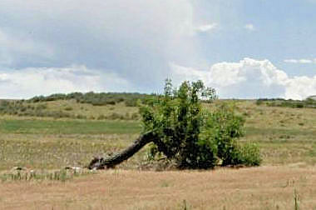

**Perseverance**

It is amazing how nature perseveres,

Like God is listening and always hears.

I thought about that when I saw that tree,

Like it was bending down on its knee.

And it made me think of our veterans so strong,

How so many are injured and still get along.

They struggle with a missing limb or two,

But look in their eyes, their faith is held true.

For God has put healing into a surgeon’s hand,

And a prosthesis is fitted that allows one to stand.

Or able to pick up a fork with such pride,

Their thanks go to God and they don’t hide.

But you know in your heart there is still much pain,

But they persevere like the cloud gives rain.

They push on to the challenges of life,

Even enduring such pain and strife.

I thank them all for their sacrifice,

To defend our country, they rolled the dice.

Some return with wounds we can’t see,

But they persevere for you and me.

I try to thank everyone I find,

I see in their eyes, they read my mind.

They know we are brothers in spirit,

But the thanks, they still love to hear it.

Thank you for all you have given,

And we’ll persevere as long as we’re liven’!

God bless them all!!! AMEN

ROTRUCK – ‘15

**Light Side**



BANANA PEAL

**The Haircut**

A man was getting a haircut prior to a trip to Rome. He mentioned the trip to the barber, who responded, “Why would anyone want to go there. It’s crowded and dirty and full of Italians. You’re crazy to go to Rome So, how are you getting there?”

“We’re taking United,” was the reply. “We got a great rate!"

“United!” exclaimed the barber. “That’s a terrible airline. Their planes are old, their flight attendants are ugly and they’re always late. So, where are you staying in Rome?”

“We’ll be at the downtown International Marriott.”

“That dump! That’s the worst hotel in Rome. The rooms are small, the service is surly and they’re overpriced. So, what are you going to do when you get there?"

”We’re going to go to see the Vatican and we hope to see the Pope."

“That’s rich,” laughed the barber. “You and a million other people trying to see him. He’ll look the size of an ant. Boy, good luck on this lousy trip of yours. You’re going to need it!”

A month later, the man again came in for his regular haircut. The barber asked him about his trip to Rome.

“It was wonderful,” explained the man. “Not only were we on time in one of United’s brand-new planes, but it was overbooked, and they bumped us up to first class. The food and wine were wonderful, and I had a beautiful young stewardess who waited on me hand and foot. And the hotel! Well, it was great! They’d just finished a $25 million remodeling job and now it’s the finest hotel in the city. They were overbooked too, so they apologized and gave us the presidential suite at no extra charge!”

“Well, “muttered the barber. “I know you didn’t get to see the Pope.”

“Actually, we were quite lucky, for as we toured the Vatican, a Swiss Guard tapped me on the shoulder and explained that the Pope likes to meet some of the visitors, and if I’d be so kind as to step into his private room and wait, the Pope would personally greet me. Sure enough, five minutes later, the Pope walked in. As I knelt down, he spoke to me.”

“What did he say."

“He said, ‘Where’d you get that shitty haircut ?”

From Lou Zoghby – WWII Vet



**2022 Darwin Awards**

Yes, it's that magical time of year again when the Darwin Awards are bestowed, honoring the least evolved among us.

Here are the glorious winners:

When his .38 caliber revolver failed to fire at his intended victim during a hold-up in Long Beach, California would-be robber James Elliot did something that can only inspire wonder. He peered down the barrel and tried the trigger again. This time it worked.

The honorable mentions:

The chef at a hotel in Switzerland lost a finger in a meat cutting machine and after a little shopping around, submitted a claim to his insurance company. The company expecting negligence sent out one of its men to have a look for himself. He tried the machine, and he also lost a finger The chef's claim was approved.

A man who shoveled snow for an hour to clear a space for his car during a blizzard in Chicago returned with his vehicle to find a woman had taken the space. Understandably, he shot her.

After stopping for drinks at an illegal bar, a Zimbabwean bus driver found that the 20 mental patients he was supposed to be transporting from Harare to Bulawayo had escaped. Not wanting to admit his incompetence, the driver went to a nearby bus stop and offered everyone waiting there a free ride. He then delivered the passengers to the mental hospital, telling the staff that the patients were very excitable and prone to bizarre fantasies. The deception wasn't discovered for 3 days.

An American teenager was in the hospital recovering from serious head wounds received from an oncoming train. When asked how he received the injuries, the lad told police that he was simply trying to see how close he could get his head to a moving train before he was hit.

A man walked into a Louisiana Circle-K, put a $20 bill on the counter, and asked for change. When the clerk opened the cash drawer, the man pulled a gun and asked for all the cash in the register, which the clerk promptly provided. The man took the cash from the clerk and fled, leaving the $20 bill on the counter. The total amount of cash he got from the drawer $15.

[If someone points a gun at you and gives you money, is a crime committed?]

Seems an Arkansas guy wanted some beer pretty badly. He decided that he'd just throw a cinder block through a liquor store window, grab some booze, and run. So, he lifted the cinder block and heaved it over his head at the window. The cinder block bounced back and hit the would-be thief on the head, knocking him unconscious. The liquor store window was made of Plexiglas. The whole event was caught on videotape.

As a female shopper exited a New York convenience store, a man grabbed her purse and ran. The clerk called 911 immediately, and the woman was able to give them a detailed description of the snatcher. Within minutes, the police apprehended the snatcher. They put him in the car and drove back to the store. The thief was then taken out of the car and told to stand there for a positive ID. To which he replied, yes, officer, that's her. That's the lady I stole the purse from.

The Ann Arbor News crime column reported that a man walked into a Burger King in Ypsilanti, Michigan at 5 A.M., flashed a gun, and demanded cash. The clerk turned him down because he said he couldn't open the cash register without a food order. When the man ordered onion rings, the clerk said they weren't available for breakfast... The frustrated gunman walked away.

[*A 5-STAR STUPIDITY AWARD WINNER]

When a man attempted to siphon gasoline from a motor home parked on a Seattle Street by sucking on a hose, he got much more than he bargained for. Police arrived at the scene to find a very sick man curled up next to a motor home near spilled sewage. A police spokesman said that the man admitted to trying to steal gasoline, but he plugged his siphon hose into the motor home's sewage tank by mistake. The owner of the vehicle declined to press charges saying that it was the best laugh he'd ever had, and the perp had been punished enough!

In the interest of bettering mankind, please share these with friends and family... unless of course one of these individuals by chance is a distant relative or long-lost friend. In that case, be glad they are distant and hope they remain lost.

Remember... They walk among us, and they can reproduce! And they Vote!

Submitted by John Vargas

Submitted by John Vargas

**The injustice of old age!**

Three old Grandmas were sitting on a bench outside the nursing home when an old Grandpa walked by.

One of the old Grandmas yelled out, ‘Hey, we bet we can tell exactly how old you are!’

The old man said, ‘ There is no way you can guess my age!’

One of the grandmas said, ‘Sure we can! Just drop your pants and undershorts and we can tell your exact age.’

Embarrassed, but anxious to prove they couldn’t do it, he dropped his drawers.

The Grandmas asked him to first turn around a couple of times and then jump up and down several times.

Determined to prove them wrong, he did it.

Then they all said in unison, ‘You’re 87-years-old!’

Standing with his pants down around his ankles, the old gent asked, ‘How in the world did you guess my age?’

Slapping their knees, high-fiving and grinning from ear to ear, the three old ladies happily crowed…..

‘We were at your birthday party yesterday!’

From Lou Zoghby – WWII Vet

**Thoughts!**

Every box of raisins is a tragic tale of grapes that could have been wine.

They say we can have gatherings with up to eight people without issues. I don't even know eight people without issues.

Theme parks can snap a crystal-clear picture of you on a roller coaster going 70 mph, but bank cameras can't get a clear shot of a robber standing still.

Dear paranoid people who check behind their shower curtains for murderers . . . if you do find one, what's your plan?

The more I get to know people, the more I realize why Noah only let animals on the ark.

Facial recognition software can pick a person out of a crowd, but the vending machine at work can't recognize a dollar bill with a bent corner.

When all this pandemic stuff is over, I still plan to wear a mask. It hides the perpetual look of annoyance I have for most people.

I never make the same mistake twice. I do it like, five or six times, you know, to make sure.

Someone just honked to get me out of my parking space faster, so now I just have to sit here until both of us are dead.

My train of thought derailed. There were no survivors.

If you see someone buying candy, popcorn and a soda at the movies, they must be a drug dealer. There's no other explanation for that type of income.

After a year of this pandemic, I'm either going out for ice cream or to commit a felony. I'll decide in the car.

I know it's time to clean out my purse when my car assumes it's an extra passenger who isn't wearing a seat belt.

Dr. Oz says rubbing coffee grounds on your naked body will get rid of cellulite. Apparently you can't do this in Starbucks. And now the cops are here.

In the 1950s I fell off my bike and hurt my knee. I'm telling you this now because we didn't have social media then.

Some people seem to have aged like fine wine. I aged like milk ... I got sour and chunky.

Dear Sneeze: If you're going to happen, happen. Don't just put a stupid look on my face and then leave.

Vegetarians live up to nine years longer than meat-eaters. Nine horrible, worthless, bacon less years.

Submitted by Joe Dempsey

**GOVERNMENT NOTICE:**

To help save the economy, the Government will announce next month that the Immigration Department will start deporting seniors instead of illegals in order to lower Social Security and Medicare costs older people are easier to catch and will not remember how to get back home. Be sure to send this notice to your relatives and friends so they'll know what happened to you. I started to cry when I thought of you. Then it dawned on me…

I'll see you on the bus.

Submitted by Dave Lyons

***Trivia Answer***

**Anchor Clanker -** (U.S. Marine Corps) Reference to U.S. Navy Sailors (pejorative).

(U.S. Navy) Any Chief Petty Officer, whose insignia is an anchor.!

**Upcoming Events of Interest**

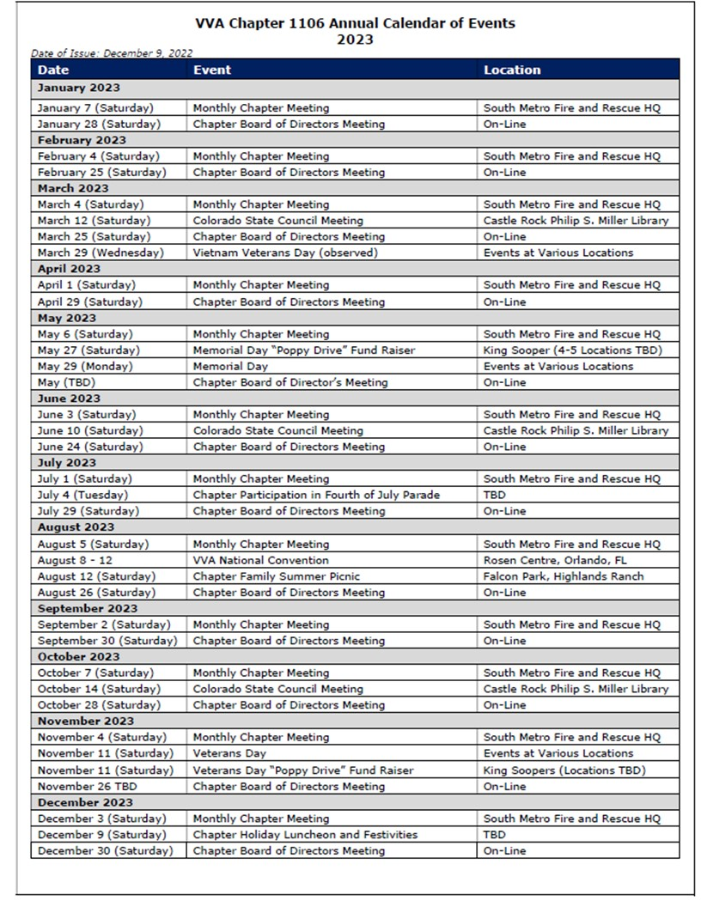

**FRIENDS OF CHAPTER 1106**

|  |  |
| --- | --- |
| **South Metro Denver Fire & Rescue**  9195 E Mineral Ave  Centennial, CO 80112 | **A picture containing text  Description automatically generatedTREA: The Enlisted Association - HQ**  **Phone - (303) 752-0660**  **12200 E. Briarwood Avenue, Suite 250, Centennial CO 80112** |
| **Spradlin Printing, Inc.**  11903 S. Parker Road Parker, CO 80134 | Text  Description automatically generated  Alycia Carmin  PO Box 233  Kersey, CO 80644  (970) 352 8802 |
| 3989 E. Arapahoe Road #20  Centennial, CO 80122  720-361-0155 | A FULL-SIZE REPLICA OF THE HONOR BELL  **The Honor Bell Foundation**  PO Box 1432  Englewood CO 80150  720.282.9182  [www.honorbell.org](http://www.honorbell.org/) |
| 9137 E Mineral Cir Ste 100  Englewood, CO 80112-3422 |  |
| King Soopers logo.svg  King Soopers  9551 S. University Blvd., Highlands Ranch, CO 80126 | Veteran & Family Resource HubQualified Listeners:  PO Box 563  Dacono, CO 80514  Tel: 720-600-0860 |
| https://scontent.fapa1-2.fna.fbcdn.net/v/t31.0-8/10575197_682186265194110_4051472928662048560_o.jpg?oh=2630b186dcf3a20f1d7fc8fa25e0a5ba&oe=5A17C4AB  **Military Order of Purple Heart**, Chapter 1041, Arvada, CO | **CHERRY CREEK SCHOOL DISTRICT**  Text  Description automatically generated  4700 South Yosemite Street  Greenwood Village, CO 80111 |
|   **President**  Dale Goulette  cell 303-547-7850  2212 Diamond Creek Drive, Colorado Springs, CO, 80921  dalegoulette@rockymountainhonorflight.org | PARKER MEDICAL  S**UP**PLY STORE  9845 S Parker Rd  . Parker, CO 80134  303-840-4444 |
| **ERC Management, LLC**  791 Southpark Dr., Suite 600  Littleton, CO 80120  [720.328.3299](tel:720.328.3299)  [www.FreddysUSA.com](http://www.freddysusa.com/) | |
| **Logo, company name  Description automatically generatedTexas Roadhouse**  11205 S. Parker Road, Parker, CO 80134  **THANK YOU FOR**  **REACHING OUT AND**  **HELPING VETERANS** | |