**Inside this issue:**

Notes from the President

[Member Feature](#Memberfeature)

[Military Trivia](#Militarytrivia)

[Guest Speaker](#Guestspeaker)

[Membership](#Membership)

[Board of Directors/Officers](#Boardofdirectors)

[Working Committees](#Workingcommittees)

[Meetings/Events Calendar](#Meetingsevents)

[Announcement Corner](#Announcementcorner)

[Books/Articles Published by Mbrs.](#Booksarticles)

[From the Editor](#Fromtheeditor)

[Light Side](#Lightside)

[Trivia Answer](#Triviaanswer)

**Events**

Saturday, Nov 4th – Chapter monthly meeting South Metro Fire & Rescue Building

Saturday, Dec 2nd, 2017 - Chapter 1106 Monthly Meeting South Metro Fire & Rescue Building

The Board of Director’s meeting will follow 30 minutes following the regular mtg.

[Christmas Party – Dec. 16th](#Christmas).

Next CO State Council meeting December 9th 2017

***Editor’s Note:***

**Notice:**

If you have moved or changed your address, PLEASE notify us immediately! Contact: Lee White, Membership Chair

E-mail: <mailto:flyboy51@q.com>

Phone:  303-519-2252

###### COPYRIGHT NOTICE: In accordance with Title 17 U.S.C. Section 107, any copyrighted material in this newsletter is distributed under fair use without profit or payment to those who have expressed a prior interest in receiving the included information for nonprofit use and educational purposes only.

This version of the newsletter is in Microsoft Document (.docx) format so that the links will work. Put your cursor over the link, depress your Control Key (ctrl) and depress your left mouse button and it will take you to the listed link position. PDF format, the links will not work.

***Notes from the President***

Lee White

As I hear the wind blow, and the leaves changing color and falling at a rapid pace, I realize that the end of 2017 is coming to a close. Our VVA Chapter 1106, with the support of so many members, had a very successful year in supporting our fellow veterans in need. I wish every member, their family, and friends a Happy Thanksgiving, and a very Merry Christmas.

Again, thanks so much for all the hard work that the "Working Committees" accomplished. You are awesome!!

Until next year.

**Our Military – Military Towns**

Eglin Air Base Joint Command located near Ft. Walton, Florida, Is presently the largest Military Complex in the world and encompasses a large contingent of Air Force units, Naval Warfare units, and the 7th Army Special Forces, and 6th Army Rangers. My home is exactly 5 miles outside the main gate of Eglin AFB. Most folks in the USA don't live in a Military Town, with lots of guys in uniform walking the streets and jets overhead daily. They go on with their lives unaware of what a Military Town is all about. And that's OK. but I want to share with you what it's like to live in a Military Town. We see guys in uniform all the time, we have state of the art, high performance aircraft in the air nearby all day long We hear the SOUND OF FREEDOM when an F-22, or F-35 streaks over the house ..... and we read in the local paper, some times daily, but at least weekly, of the loss of one of our own in combat in the Middle East. And that is what brings me to the reason for this email.

Staff Sergeant Mark DeAlencar was 37 years old, had a family and was a Green Beret with the 7th Army Special Forces stationed here in the Fort Walton area. He was killed on April 8, 2017 while fighting Islamic State in eastern Afghanistan. In

January of this year, he was deployed for the second time to Afghanistan. He promised his adopted daughter, Octavia, that he would be home for her High School Graduation He didn't make it. But she went to graduation anyway. And in the audience were eighty (80) US 7th Army Special Forces soldiers from her dad’s unit in full Parade Dress Uniform. Additionally, they brought THEIR FAMILIES to be with them, as well. And as Octavia ascended the steps to the stage to receive her diploma THEY ALL SILENTLY STOOD UP. And when she was presented her diploma they ALL CHEERED, CLAPPED. WHISTLED ….and YES CRIED. Everyone in attendance then stood up and cried and cheered. Octavia had graduated and yes she had lost her Dad but she had 80 other DADS to stand there with her and take his place. I just wanted to share this moment with you ..... and remind you that THIS IS WHAT IT'S LIKE TO LIVE IN A MILITARY TOWN. THIS is the real America we all love ..... and I'm proud to be part of it. May God bless our men in uniform and their families who give so much!

***“******Member Feature”***

**Leslie (Sonny) Alan Gorsuch**

I gave twenty years to the U.S. Army June 28, 1965 – August 28, 1985 and retired as a Staff Sergeant (E-7) in the Logistics field. My military service awards are: Army Commendation Medal w/Oak Leaf Cluster, Army Achievement Medal, Good Conduct Medal w/Silver Star, National Defense Medal, Vietnam Service Medal w/eight Battle Stars, Korea Defense Medal, NCO Professional Development Medal, Army Service Ribbon, Overseas Service Ribbon w/3 devices, Vietnam Campaign Medal, Meritorious Service Ribbon w/2 Oak Leaf Clusters, Vietnam Cross of Gallantry w/Palm, Vietnam Civil Actions Unit Citation w/Palm. My most memorable experiences in my career finding my wife and son and seeing the last show Bob Hope put on in Vietnam. One of the things that I have garnered as a member of our chapter that meets my needs is there is always a shoulder to lean on! Thank you!

***Military Trivia***

What does **1D1øT Form** mean! – Answer at the [end of the Newsletter](#Triviaanswer).

***Special Guests - September***

Our first special guests were South Metro Fire & Rescue, Vince Turner, Fire Chief, along with Laura Larson, Division Assistant Support Services where Lee presented a plaque of appreciation for allowing our chapter to meet in the South Metro’s wonderful facility.

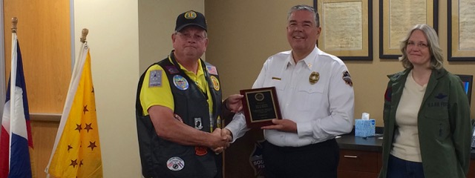

**Denver Public Library**

Lisa Flavin, Reference Librarian at the Denver Public Library was the second guest and gave a presentation of the facility and services provided at the library as well as the upcoming Vietnam War special tribute area. She asked if any member would like to donate any artifacts they may have.

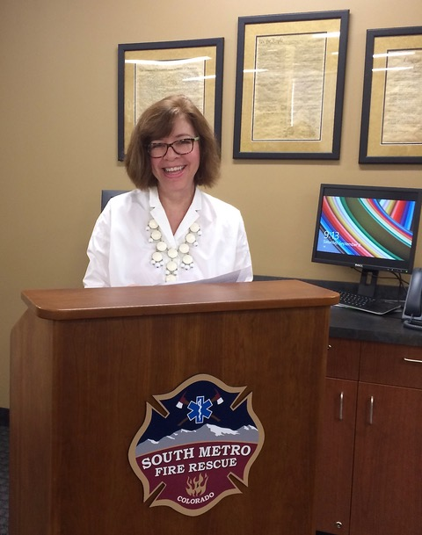

**Neil Yorker - WWII Veteran**

Neil was our third guest at the August meeting. Neil served with the 10th mountain Division, 87 Regiment, first deployed to Kiska (but the enemy had left the island) then to the Italian Alps where they saw action. He is 95 years young and lives with his son and daughter-in-law in Highlands Ranch. Bronze Star and Purple Heart recipient. Thanks Milt for bringing this inspiring young man to speak to us.

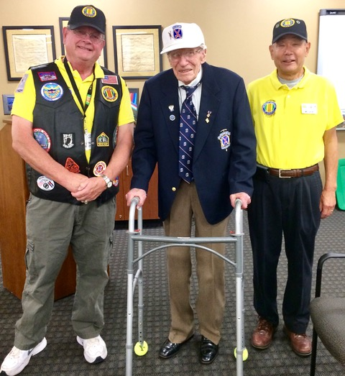

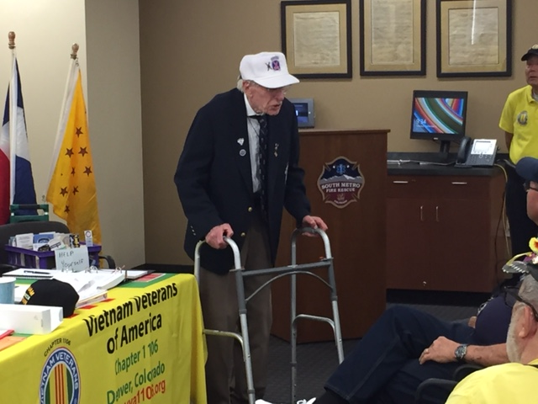

**Veteran's Puppy For Life**

Our fourth quest from Veteran's Puppy For Life, Frank Griggs, Our chapter donated $500.00 to his great cause.

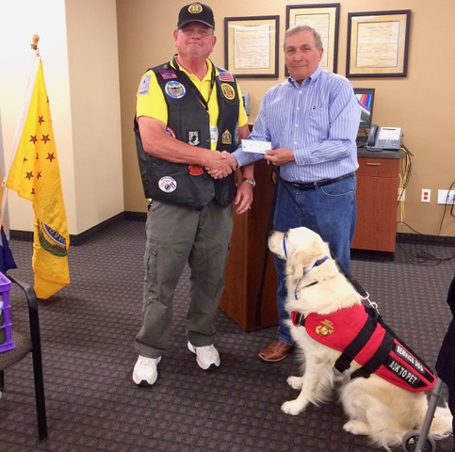

***Guest Speaker – October***

Geoffrey P. Smith, Psy.D, Administrative Director, Inpatient Mental Health Services, Denver VA Dr. Smith gave us some very interesting details about PTSD and treatments that are now provided by the VA.

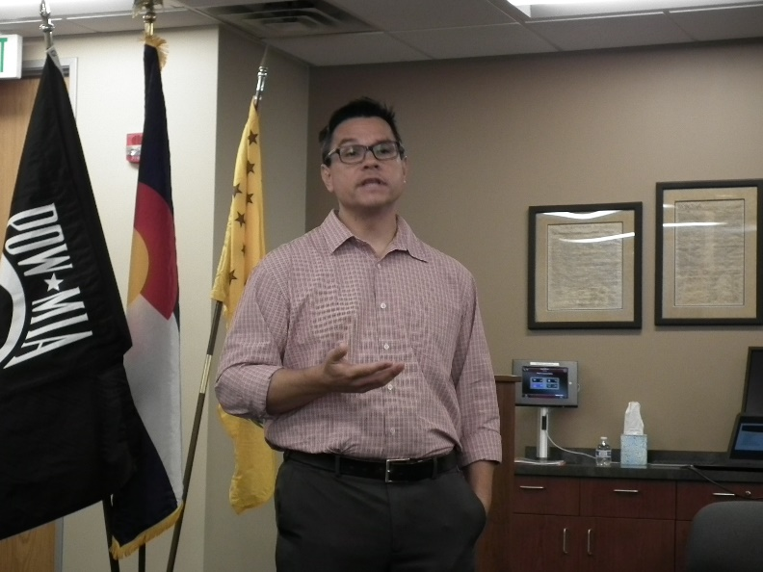

Geoffrey P. Smith, Psy.D,

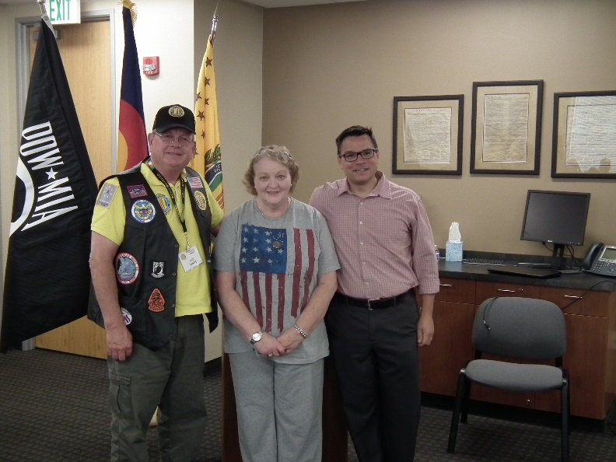

Center: Chapter member Donna Chaney who works with Dr. Smith at the Denver VA.

***Membership***

VVA Chapter 1106 Membership: 90 (10-23-2017)

AVVA: 21

Total: 111

Welcome new VVA Member: Ken Jones, Ted Hanfelder, Roy Echols, Alvin Arrowood, Carroll (Lee) Skiles, Larry Durham, John Holland, Steve Robertson, Richard Callan

***Board of Directors/Officers***

Lee White - President

Bob Easter - Vice-president

Joe Plant - Treasurer

Hazel Simeon - Secretary

Board Members - Milt Omoto, Patti Ehline, Paul Seppo, Dave Lyons, Tom Werzyn

***Working Committees***

(Folks are needed to fill some spots!)

Sergeant-at-Arms – John Vargas

Agent Orange/PTSD - **OPEN**

Membership - Lee White

Membership outreach – Dave Lyons

Mental Health: Patti Ehline, Warren Harrison

Newsletter Editor - Bob Rotruck

Fundraising/Grants - Milt Omoto

Marketing/Media/Events – Tom Werzyn

POW/MIA – Gary Meyers

Webmaster – Robert Senatore

Women Veterans - Patti Ehline

Scholarship Program - Hazel Simeon, Bob Easter, Joe Langran, Bob Rotruck, John Vargas, Mike Karsh, Glen Payne, Jim Marcille, Tom Werzyn

Veteran Emergency Assistance Committee - Joe Plant, Bob Rotruck, Lee White, Dave Lyons

Speakers Bureau – Bob Easter, Glen Payne, Bob Mallin, Roger Lanphier, Tom Werzyn

Social – John Vargas, Barry Fiore, Glen Payne

***Meetings/Events Calendar - 2017***

• Wednesday, November 1, 2017 – 23rd. Annual Veterans Salute, Wings Over The Rockies, Aurora, Co

• Saturday, November 4, 2017 - VVA Chapter 1106 Monthly Meeting, South Metro Fire & Rescue Building

• Friday, November 10, 2017 – Ben Franklin Academy Veterans Program, Highlands Ranch, Co

• Saturday, November 11, 2017 – Poppy Drive, King Soopers,Aurora & Castle Rock (3 Locations)

• Thursday, November 23, 2017 – Thanksgiving

• Saturday, December 2, 2017 - VVA Chapter 1106 Monthly Meeting, South Metro Fire & Rescue Building

• December 9, 2017 State Council Meeting

• Saturday, December 16, 2017, 11:00AM-1:00PM VVA Chapter 1106 Holiday Christmas Luncheon – Golden Corral



**MISSING IN AMERICA PROJECT**

**NATIONWIDE PROGRESS AS OF 10/18/2017**

Total Funeral Homes Visited - 2,148

Cremains Found - 15,500

Veterans Cremains Identified - 3,512

Veterans Interred - 3,211

[www.miap.us](http://www.miap.us)

***Special Gift***

A magnificent handmade patriotic gift was presented to the chapter from Linda Hulette and had this editor in tears at the beauty and workmanship in that quilt. Thank you from all of us for sharing your beautiful gift!

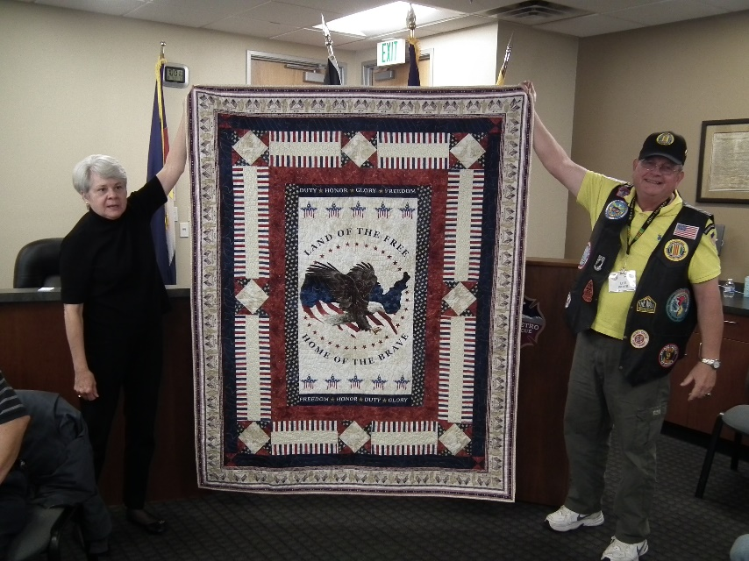

Linda Hulette with Lee

**Lapel Pin**

Vietnam 50 year anniversary lapel pin presentation by Suzanne Segona.

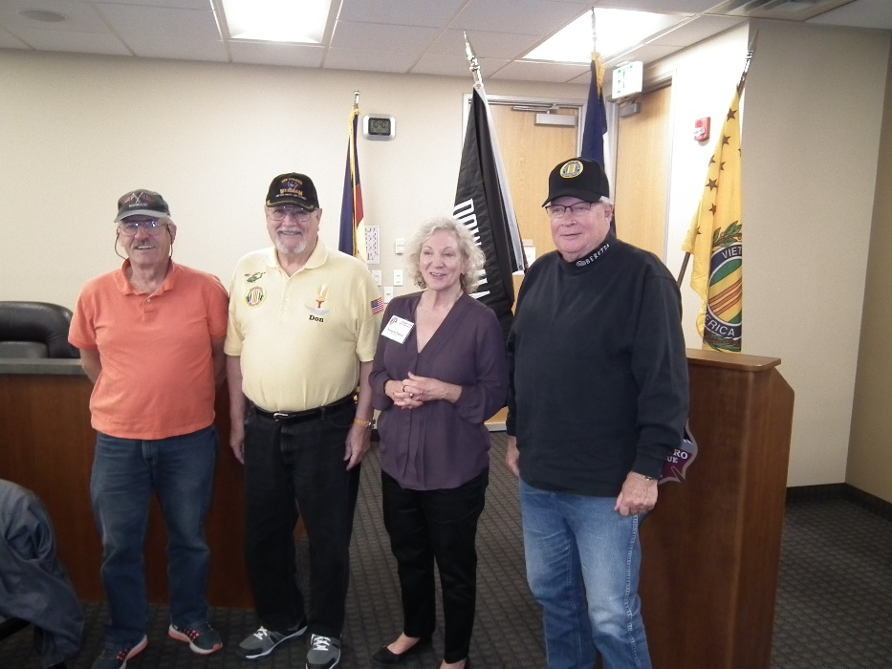

Steven Robertson, Don McNeely, Lee Skiles

**Heroes**

From Tom Werzyn

What I want to say is that these guys are the ones that come to our meetings, hike to Soldier Stone, dig a little deeper into their pocket to help another in need, bring the truck, bring the boat, stand tall with our Flag! These are the men who bled, so the rest of us don't have to fear our next day... When a sincere "thank you" is enough to fuel each one of us to push on and continue the mission - whatever and whenever...

Written by: Caymen Sartin and John Hulon

Let this sink in for a minute.....Hundreds and hundreds of small boats pulled by countless pickups and SUVs from across the South are headed for Houston. Almost all of them driven by men. They're using their own property, sacrificing their own time, spending their own money, and risking their own lives for one reason: to help total strangers in desperate need.

Most of them are by themselves. Most are dressed like the redneck duck hunters and bass fisherman they are. Many are veterans. Most are wearing well-used gimme-hats, t-shirts, and jeans; and there's a preponderance of camo. Most are probably gun owners, and most probably voted for Trump.

These are the people THE LEFT LOVES TO HATE, the ones Maddow mocks. The ones Maher and Olbermann just \*KNOW\* they're so much better than.

These are The Quiet Ones. They don't wear masks and tear down statues. They don't, as a rule, march and demonstrate. And most have probably never been in a Whole Foods.

But they'll spend the next several days wading in cold, dirty water; dodging gators and water moccasins and fire ants; eating whatever meager rations are available; and sleeping wherever they can in dirty, damp clothes. Their reward is the tears and the hugs and the smiles from the terrified people they help. They'll deliver one boatload, and then go back for more.

When disaster strikes, it's what men do. Real men. Heroic men. American men. And then they'll knock back a few shots, or a few beers with like-minded men they've never met before, and talk about fish, or ten-point bucks, or the benefits of hollow-point ammo, or their Ford F-150.

And the next time they hear someone talk about "the patriarchy", or "male privilege", they'll snort, turn off the TV and go to bed.

In the meantime, they'll likely be UP AGAIN BEFORE DAWN. To do it again. Until the helpless are rescued. And the work's done. They're unlikely to be reimbursed. There won't be any medals. They won't care. They're heroes. And it's what they do.

**Chapter Picnic**

It was a little chilly, but better than a 50 knot wind blowing the food off the table and upsetting plates!!! Thanks to Lee and his daughter Wendy. for all of their hard work getting things ready!

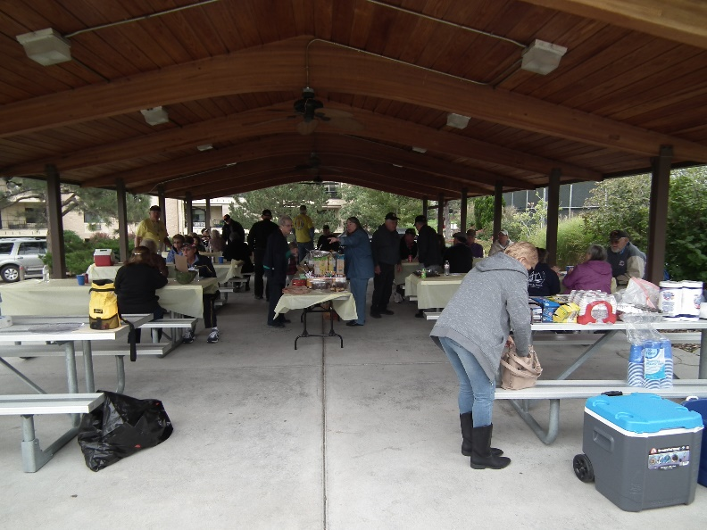

Almost chow time!!!

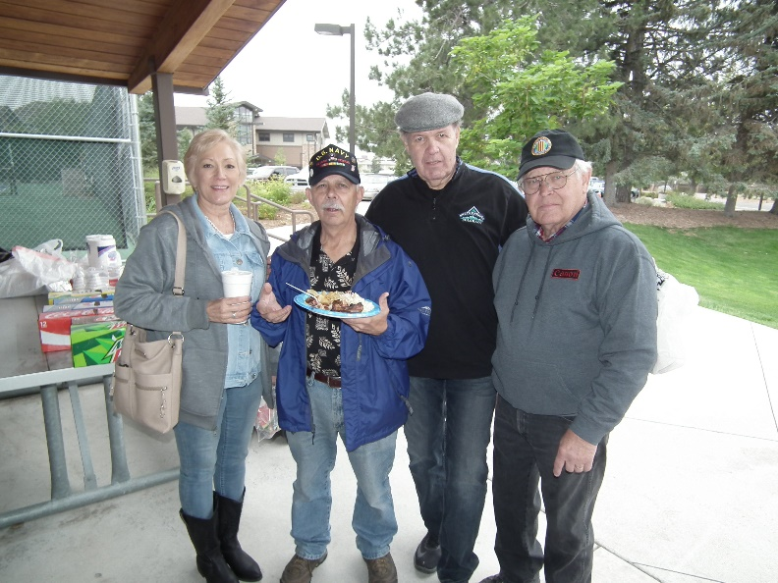

One beautiful lady and three ugly mugs!

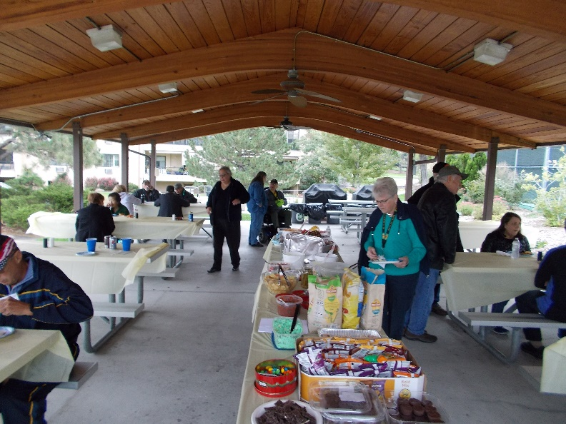

The “chow line”!!

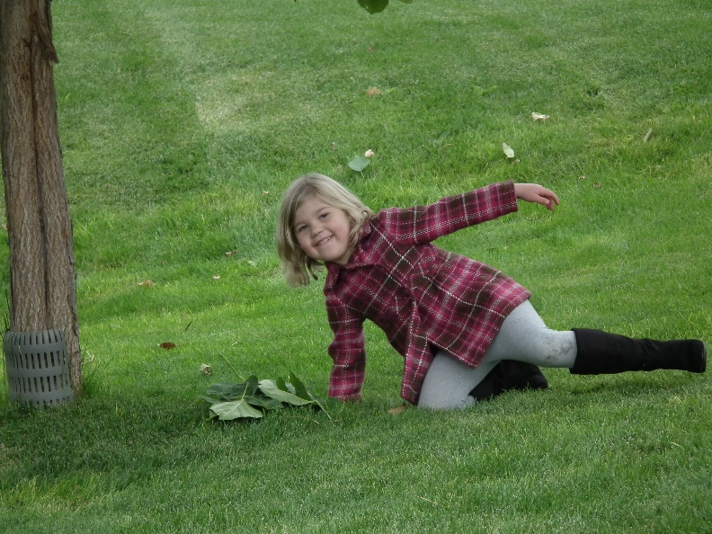

She had more fun than anybody!!!

**WWII Museum Chapter Trek**

Saturday, October 14, 2017 eighteen members of our chapter visited the National WWII Aviation Museum in Colorado Springs. It was very impressive the work that the 100+ volunteers have done to create this wonderful tribute to those that flew and maintained those aircraft.

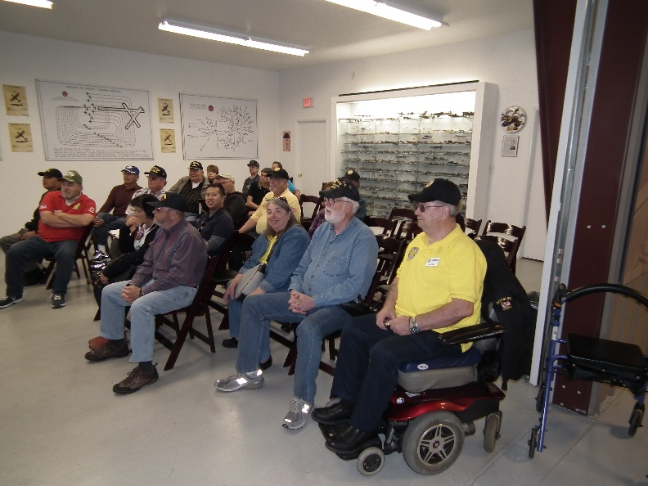

Introduction to the museum!

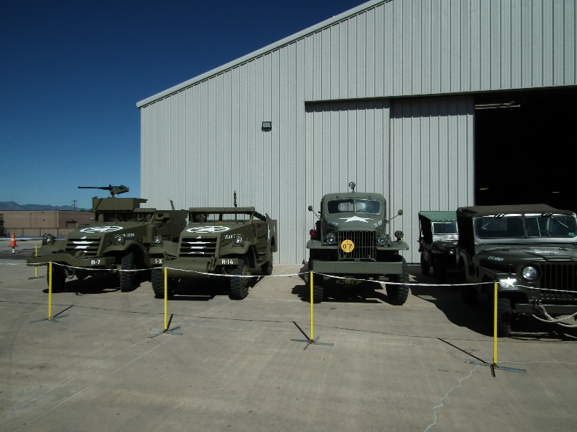

More than just airplanes!

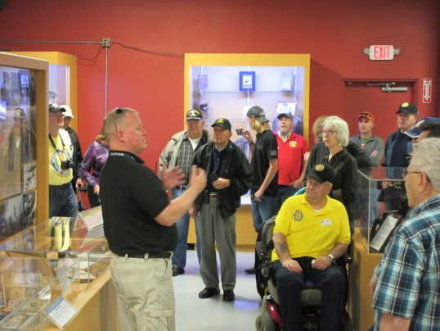

The museum guide giving us information!

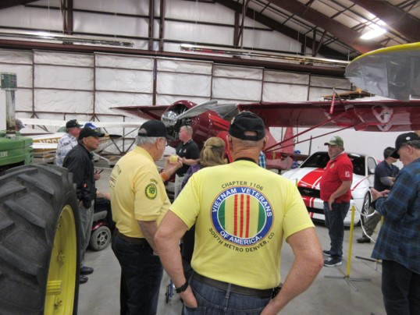

First stop on the tour!

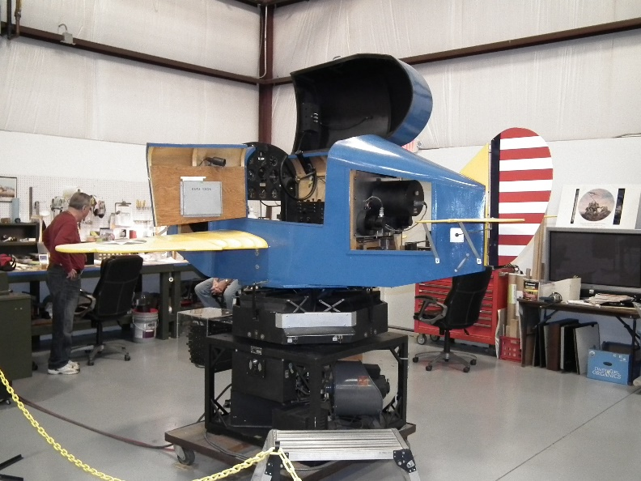

Link Trainer got many pilots their first flight!

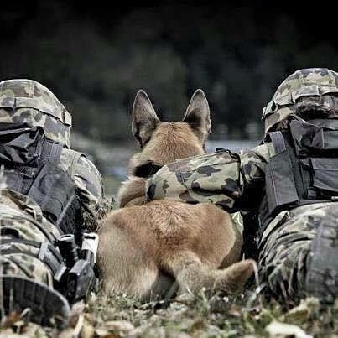

IT’S GOOD TO HAVE A CLOSE FRIEND

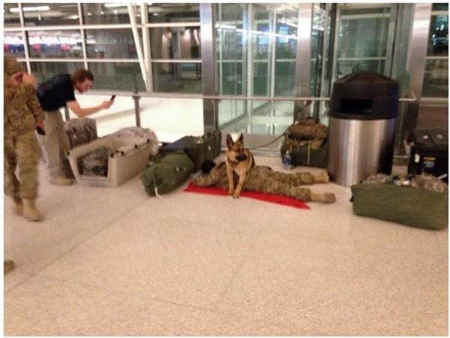

Picture of a soldier sleeping during an airport layover with his canine partner. There is no measure of loyalty greater than that shown here.

Sleep soundly soldier. A worthy goal in life is to be as good a person as your dog thinks you are!

God bless our Military men and women and God Bless America!

**NFL National Anthem**

There's nothing more to say or add that this photo doesn't already say a thousand times better! Tell all the overpaid protesters in the NFL to put on this uniform. Then they might understand why we stand.

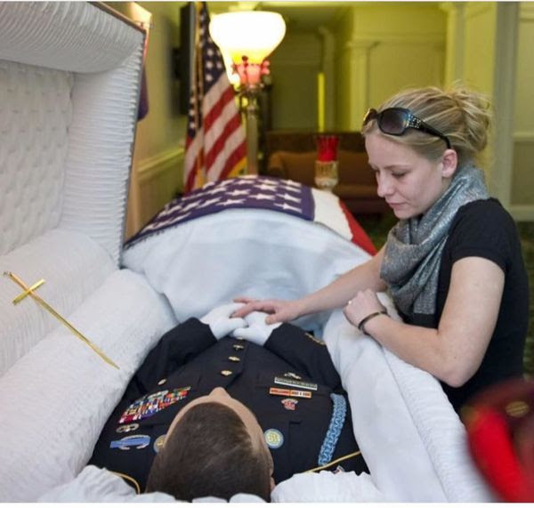

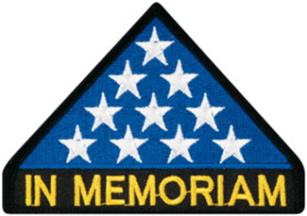

***In Memoriam***

We mourn the passing of Mike Karsh’s Mother on October 11. RIP

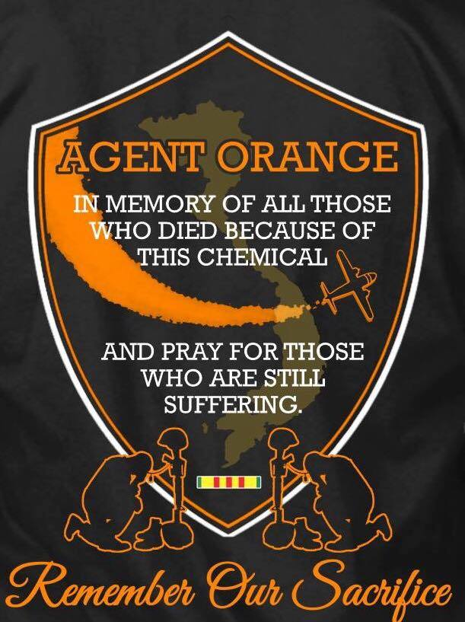

***Announcement Corner***

**Annual Christmas Party** Saturday, December 16th, 11:00Am – 1:00PM at the Golden Corral, 15775 E. Arapahoe Road, Centennial. Open to family and friends.

***Book/Articles Published by Members***

**Sharing the Foxhole**

by JA Vargas

On a sunny, clear pre-autumn afternoon, I drove to a local eatery to meet with Mike Messenger. Mike is the current President of Rolling Thunder Chapter 1 Colorado, Lifetime Member of Vietnam Veterans of America Chapter 1106, and Home Board President and lifetime member of South Denver VFW Post 2461. Rolling Thunder is a National organization which consists of veterans and patriots whose mission it is to lobby Washington to continue their efforts to bring home America’s MIA’s from all wars and to support our returning Veterans and their families. While Rolling Thunder is not a motorcycle club, most members are Patriots that enjoy riding.

Mike is a pleasant man with a very interesting history which includes Linda, his wife of 34 years, 2 daughters, 5 Grandchildren and 5 Great Grandchildren. He was born in Milwaukee Wisconsin. As a child, Mike’s family moved to Gilbert, LA and his Grandfather’s cotton farm. Mike and his brother’s Bob and Russ attended local schools in Gilbert which proved to be quite a challenge. This was 1953 and even though his Grandfather was a local resident and a pillar of the community, the boys were labeled as being from the “North” and brought on confrontations in school (almost daily) and to further add insult, they were “asked” to ride in the back of the school bus. A true education of the American South in the 1950’s.

Mike’s family eventually moved back to Wisconsin and he grew up in a middle class neighborhood in Milwaukee. After high school, he joined the US Air Force in September of 1963. Mike’s original intent was to join the Coast Guard and excitedly presented this fact to his father who quickly encouraged him to re-think his choice and join the Air Force instead. Mike’s father was an Army/Air Corp WWII Veteran. Taking the wise advice from Pop, Mike choose the Air Force. The Air Force chose his career as a Military Policeman, or Air Policeman as they were referred to in 1963.

Mike’s first assignment was to McChord AFB in Tacoma Washington. This installation is now known as Joint Base Lewis-McChord. Having spent nearly two years there in Law Enforcement and base security, Mike was reassigned to Ent AFB in Colorado Springs, the current site of the Olympic Training Center. Mike met and married a local girl shortly after receiving orders to Cam Rahn Bay, South Vietnam in March of 1966.

While in Vietnam, Mike’s younger brother Russ, Spec 4 US Army, volunteered for Vietnam and was sent to Long Binh. In the early hours of New Year’s Eve 1966, Russ was able to catch a flight to Cam Rahn and the brothers spent New Year’s Eve and the 1st week of 1967 together. Great memories for Mike as his brother, who survived Tet, was killed in a car accident shortly after returning home in 1969 by a drunken driver. He left Vietnam in March of 1967 and returned to civilian life. Mike raised two daughters, Jacqueline and Jodell, with his first wife and made Colorado their lifelong home. Unfortunately, Mike and his first wife separated and Mike moved on. Mike was employed by Hewlett-Packard in 1981. He joined the HP bowling league where he met his lovely Wife Linda. In 1994 Hewlett-Packard relocated both of them to the HP Business Center in Denver where they reside today.

Mike’s passion for motorcycling led him to find other two wheel enthusiasts shortly after arriving in Denver. They joined the Free Wheelers Gold Wing Riders Club and eventually found riders within HP and started the Meridian Touring Club. Having participated in many rides and with a variety of organizations, Mike came across Rolling Thunder Chapter 1. Mike enjoyed riding with the group, supported their mission and he became a member. Through Mike’s excitement for Rolling Thunder, he was able to motivate other members of the Meridian Touring Club to join.

Mike’s leadership potential showed early in his membership and he quickly moved up in the organization. He was elected as a Chapter Board Member, served as Vice President and eventually elected President. Mike was recently elected to his third term. A tribute to his people, patriotic and organizational skills!

Mike has elevated the Chapter’s participation in community events and was instrumental in taking the Missing Man Table Ceremony to a professional level. Mike is committed to represent and promote his chapter and brand in Colorado and throughout the National organization. With the help from chapter members Gary and Karen Myers, chapter members and with the support of many friends, the chapter was able to purchase and dedicate TWO POW\*MIA Chairs of Honor; one in Colorado Springs at the Sky Sox Stadium and the second at South Denver Post VFW Post 2461. Hi vision and goal is place the POW\*MIA Chair of Honor in Denver’s Professional Sports Venues.

We will miss you Mike and your lovely bride Linda terribly. Mike’s Passion, Patriotism and Dedication to all American Veterans, serves as an example for all of us to follow. Mike you are leaving us with the gratitude of all the men and women of VVA Chapter 1106 and will forever “Remain Our Brother”

\*Facts and dates provided by Mike Messenger

**Thomas T. Sprinkle …**

Written by: Tom Werzyn

As I sat, and continued to watch

Mr. Burns tell the rest of us about his war-

the one he researched and chronicled

and recorded and culled the photographs for

and talked to the survivors about

what went down;

so we could all see how he made his story

maybe

tell our story

in a hundred small ways.

He walked through Washington,

Hanoi, Saigon, hometowns,

and other places,

pulling pages from the books

of history; some were good,

some not so.

Quotes from the players, from the leaders

on both sides.

I stayed with it,

all the way to the last hour

of the last part of the last show-

with ten minutes to go-

when my world fell in.

His camera guy

panned up across one

of the sun-glowed panels

of our black granite Wall

and slowed,

on the one name that meant to me

more than the others.

“Jesus..” is the word that came-

as much a prayer as a curse, more a question

than exclamation.

How the hell did he find my friend, pause

and point him out to the nation of watchers,

of veterans who had stayed with the story

as we’d stayed with our war.

Remembered.

We’d sat together, S & W, in the back, right corner

of every classroom we shared,

every course we were forced to take,

every teacher we endeavored to fluster

and pester

in each of our last 6 grades

of public schools there at home.

Our mothers shared the particular honor

of having sons off to the war-

even a war unwanted and unsupported

by most of the others;

they knew each other,

met and spoke. Enjoyed each other

as much as can be done while waiting

for us.

I walked home unhurt;

Off the plane and back into life and the world.

Tom was boxed and carried- and preceded

by the starched sergeant and somber captain

with words of corporate grief stitched

into that letter no one wanted.

Tom’s mother never again spoke

to my mother, after those Army visitors

took her heart away.

Respect for the situation

prevented mom from reaching out;

and, I would wager, a large measure

of unworded, unshareable sorrow

as well served to extend the distance

only war can bring

between.

Seeing his name, so prominently featured,

brought me so far back, so quickly

to so many things

so many days

so many years

ago.

In an instant, a three second image

-today’s electric attention span-

out of hours of commentary,

absolutely leveled me.

At the time

I don’t believe either of us knew

of the other’s service,

that our paths would separately twine

in that jungle war.

Jesus …

**“This is the end, my friend,**

**my beautiful friend,**

**the end …”**

lyrics so telling that I can’t not hear them

over and over and believe and understand

what they mean to all of us

who shared

that war.

……

**Darkness at Sea**

When a sailor leaves home for the open ocean,

There are usually many tears and deep emotion.

The ships make ready to pull away from the piers,

Loved ones left behind in a sea of tears.

The Bos'n pipes his mournful tune,

"The ship is underway" is heard too soon.

You stand on the deck, watch the pier grow smaller,

You think you could see her if you were only taller.

And soon enough, the shore fades away,

The sun is dipping low near the close of the day.

When the sun goes down far out at sea,

All I could do was think of you and me.

That last parting kiss was still fresh on my lips,

Why do men leave home on these mighty ships?

And now darkness is here, the sun has gone down,

All I do is think of us and wear my brow in a frown.

The daylight I can take for the business at hand,

Much work to be done and watches to stand.

But then there are times when all is quiet and still,

For a moment to be close to her I would nearly kill.

I'm a prisoner of my thoughts on this ship of steel,

I want her in my arms close, her warm body to feel.

I stare at the moon and I see there her vision,

Why did I ever make this sailing decision?

Days become weeks and weeks to a year,

Thank God it won't be long 'til I hold you my dear.

But sailors are destined for weeks and months out to sea,

So I pray her guardian angel will watch over her for me.

But until the painfully slow time goes by for us,

I will do the best job I can in daylight and darkness.

ROTRUCK – ‘94

***From the Editor!***

Written September 29, 2010 by your Editor!

**The Pain Never Stops**

Try to think of a situation in your life when you have cut your finger with a knife or some other sharp object. Now consider that the wound festers and never heals. It hurts constantly and just never gets any better. No matter what kind of pain medication you take, the pain never stops. It is incessant. You try prescription drugs, alcohol, medical marijuana, hypnosis, but nothing stems the pain and the wound never goes away. You’ve prayed, you’ve cried, you’ve cussed, you’ve blamed somebody else, and you’ve blamed everybody else, and still no relief.

Now you begin to understand the pain and heartache that a parent or spouse is going through when they have lost their loved one who voluntarily joined the military service to serve their country. You watched them grow up or you fell in love with them and became life partners and now they are gone. Physically they are not here, but in our hearts and minds, they are present every day and night for the rest of our lives. Our hearts are breaking with sadness and pain and nothing provides relief. You’ve had counseling and friends and family have come to your side. Your spiritual advisor, pastor, priest, or other religious person has tried to bring you comfort, but the pain just persists as you keep asking yourself why? Why did my son, daughter, husband, wife have to join the military. Why did they solemnly swear to God that they would support and defend the Constitution of the United States against all enemies, foreign and domestic; that they would bear true faith and allegiance to the same?

Nowhere in that oath does it say that you will die and cause pain for your loved ones the rest of their lives. The oath does not say that a pain pill will be provided your family in the event that you meet your demise on the battlefield and their pain will instantly be relieved. Life for our beloved military personnel doesn’t work that way. When that military stranger arrives at your front door and says, “It is with deep regret,” the wound is created. Nothing will ever close it until the day you join them in heaven. Life is not fair! The pain never stops. God bless our military men and women and God bless America.

**Serious Question**

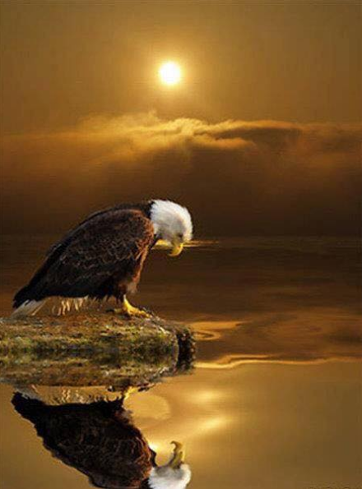

Is the wonderful country I love and represent falling apart with hatred and hostility?

**Taya Kyle (Chris Kyle’s widow) has spoken!**

(Editor’s note: I hope this doesn’t offend any of my readers, but I feel this really says a lot to the NFL and our country. I have verified the validity of this article!)

Dear NFL,

You were doing your part to bring people together and heal the world. That’s really how healing works. We heal by loving each other and leading by example; showing people what is possible when we love each other just as we are and not only recognize our differences but celebrate them and look at how we can use them together to make us jointly better than our separate parts. You were doing your part celebrating each other based on skills, talent and a joint vision without regard to color and religion.

You were doing your part and we were doing ours. We showed up cheering and groaning together to as one. We talked in the concession lines and commiserated and celebrated our team together. Did it ever occur to you that you and we were already a mix of backgrounds, races and religions? We were already living the dream you want, right in front of you.

Your desire to focus on division and anger has shattered what many people loved most about the sport. Football was really a metaphor for our ideal world –different backgrounds, talents, political beliefs and histories as one big team with one big goal - to do well, to win, TOGETHER.

You are asking us to abandon what we loved about togetherness and make choices of division. Will we stand with you? Will we stand with our flag? What does it mean? What does it mean if we buy a ticket or NFL gear? What does it mean if we don’t? It is the polar opposite of the easy togetherness we once loved in football.

It was simple – we loved you and you loved us – with all of our races, religions, different backgrounds and politics. Simplicity in a crazy world was pretty awesome.

You dear NFL, have taken that. You have lost me here.

If you ever want to get off your knees and get to work on building bridges, let me know. I have found screaming about the problems in service marriages or even standing in silence in front of them, hasn’t healed even one of them. On the other hand, funding the Chris Kyle Frog Foundation, building a team and rolling up my sleeves to get in the trenches during my “off time” -volunteering there outside of my paying jobs - has proven to make real change.

You have a lot of strong guys, I am sure in the off season a lot of them could build some pretty big bridges if they care enough to do the hard work. That would involve getting off their knees and getting to work though. I can do it while I raise two kids as their only parent and work through the greatest pain of my life, let’s see if they can do it for the issues they say they care so much about.

Go Longhorns and Sic ‘em …

Sincerely, Taya

***Light Side***

**The Aisle Seat**

Two Radical Arab Terrorists boarded a flight out of London. One took a window seat and the other sat next to him in the middle seat. Just before takeoff, a U.S. Marine sat down in the aisle seat. After takeoff, the Marine kicked his shoes off, wiggled his toes and was settling in when the Arab in the window seat said, “I need to get up and get a coke.”

“Don't get up,” said the Marine. “I'm in the aisle seat; I'll get it for you.”

As soon as he left, one of the Arabs picked up the Marines shoe and spat in it. When the Marine returned with the coke, the other Arab said, “That looks good, I'd really like one, too.”

Again, the Marine obligingly went to fetch it. While he was gone the other Arab picked up the Marines other shoe and spat in it. When the Marine returned, they all sat back and enjoyed the flight.

As the plane was landing, the Marine slipped his feet into his shoes and knew immediately what had happened. He leaned over and asked his Arab neighbors, “Why does it have to be this way?” “How long must this go on? This fighting between our nations? This hatred? This animosity? This spitting in shoes and pissing in cokes?”

**THE FEW. THE PROUD. THE MARINES.**

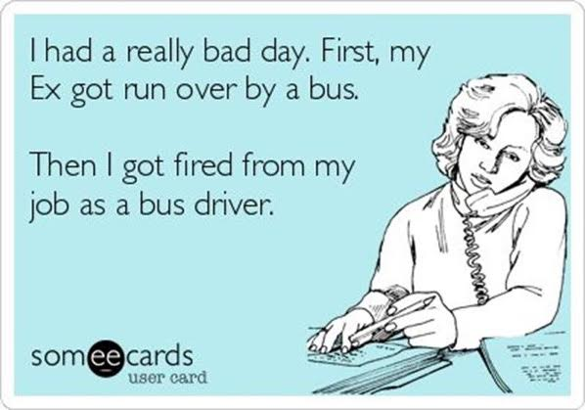

**Five Horses**

(Note: Editor is not taking the blame for this. It was submitted by John Vargas!!)

This is too beautiful not to share!

**Five Horses Is Her Name.** This is mythical and deep. Truly beautiful... A man asked an American Indian, “What is your wife's name?”

He replied, "She is called Five Horses".

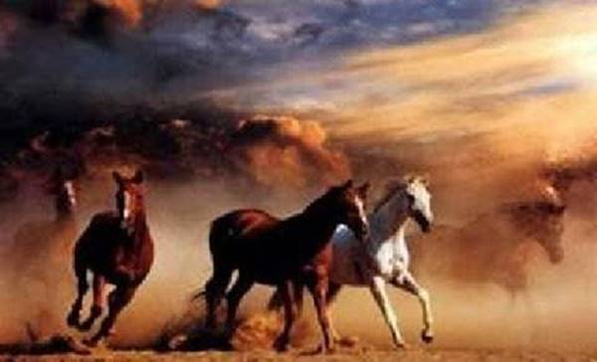

The man said, "That's an unusual name for your wife. What does it mean?"



The Old Indian answered, "It old Indian Name. It means.............

NAG NAG NAG NAG NAG!"

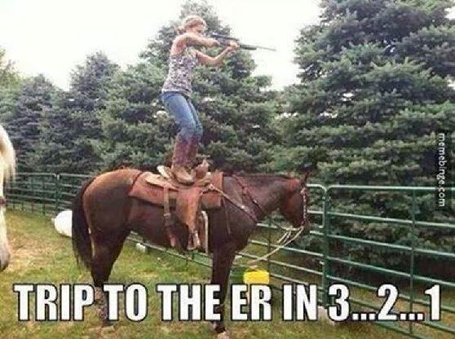





**Pre-school Test**

I already knew I was dumber than the fifth graders...But now it's the Pre-choolers!! A PRE-SCHOOL TEST FOR YOU! Which Way is the bus below traveling? To the left or to the right?



Can't make up your mind? Look carefully at the picture Again. Still don't know? Pre-schoolers all over the United States were shown this picture and asked the same question. 92% of the preschoolers gave this answer: "The bus is traveling to the left."

When asked, "Why do you think the bus is traveling to the left?"

They answered: "Because you can't see the door to get on the bus."

How do you feel now??? I know, me too. Have a nice day! Personally, I think the reason why we answer incorrectly is "WE WALKED FIVE MILES TO SCHOOL BAREFOOT ON GRAVEL ROADS AND THROUGH 5 FEET OF SNOW IN THE WINTER!"

**Early Memorial Day Remembrance!**

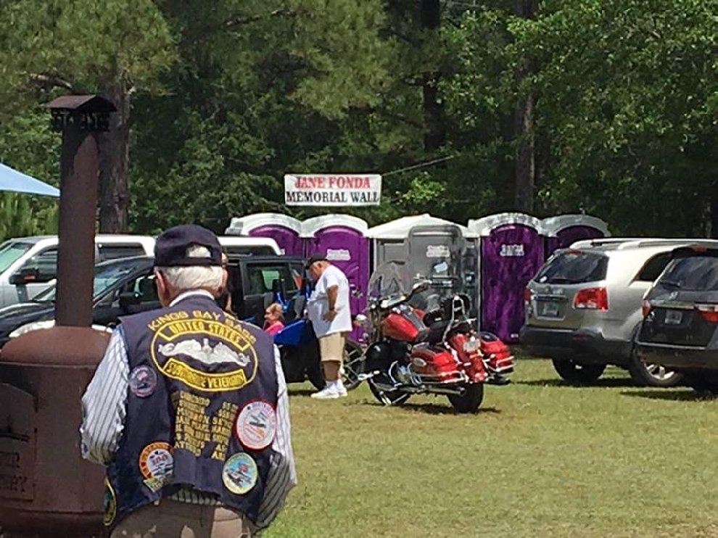



***Trivia Answer***

**1D1øT Form** - (USAF/USMC) Idiot form. A non-existent form that ignorant airmen/marines are sent to find. Usually they are new to their unit.**UNITED STATES NAVY BIRTHDAY**

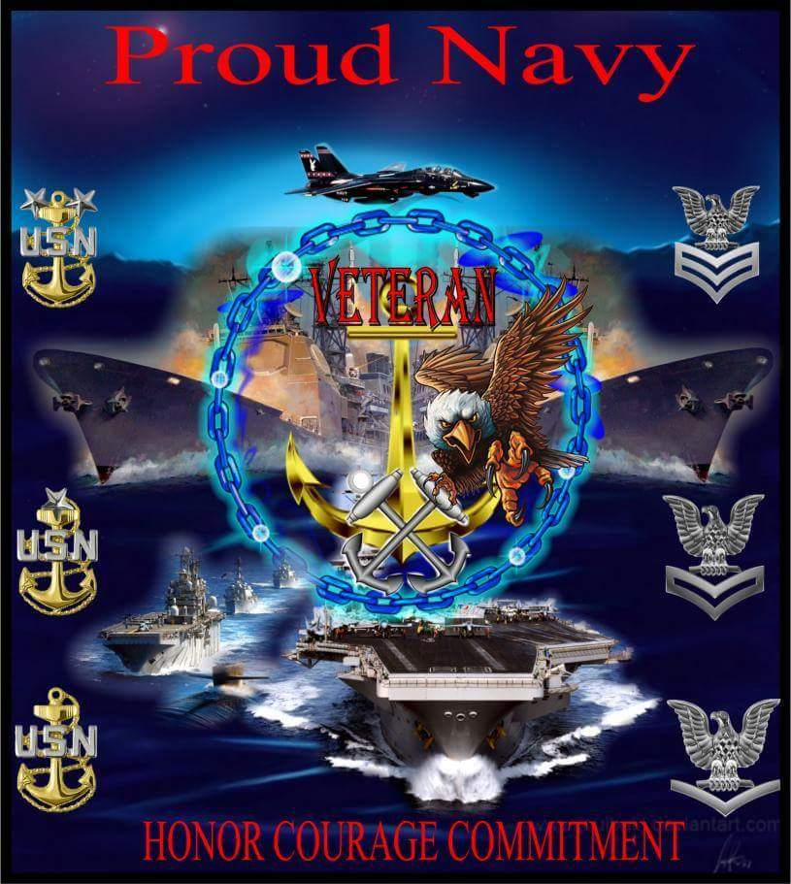

October 13 marks the birthday of the U.S. Navy, which traces its roots back to the early days of the American Revolution. On October 13, 1775, the Continental Congress established a naval force, hoping that a small fleet of privateers could attack British commerce and offset British sea power.

Warning, the following is religious in nature. You may be offended! However, I was very touched when I received this from a friend in my email. The Editor!

**Touch Me**

A drunk man in an Oldsmobile they said had run the light

That caused the six-car pileup on 109 that night.

When broken bodies lay about and blood was everywhere,

The sirens screamed out eulogies, for death was in the air

A mother, trapped inside her car, was heard above the noise,

Her plaintive plea near split the air oh, God, please spare my boys!

She fought to loosen her pinned hands; she struggled to get free,

But mangled metal held her fast in grim captivity.

Her frightened eyes then focused on where the back seat once had been,

But all she saw was broken glass and two children's seats crushed in.

Her twins were nowhere to be seen; she did not hear them cry,

And then she prayed they'd been thrown free, oh, God, don't let them die!

Then firemen came and cut her loose, but when they searched the back,

They found therein no little boys, but the seat belts were intact.

They thought the woman had gone mad and was traveling alone,

But when they turned to question her, they discovered she was gone.

Policemen saw her running wild and screaming above the noise

In beseeching supplication, please help me find my boys!

They're four years old and wear blue shirts; their jeans are blue to match.

One cop spoke up, ''They're in my car, and they don't have a scratch.

They said their daddy put them there and gave them each a cone,

Then told them both to wait for Mom to come and take them home.

I've searched the area high and low, but I can't find their dad.

He must have fled the scene, I guess, and that is very bad.”

The mother hugged the twins and said, while wiping at a tear,

“He could not flee the scene, you see, for he's been dead a year.”

The cop just looked confused and asked, “Now, how can that be true?”

The boys said, ''Mommy, Daddy came and left a kiss for you.

He told us not to worry and that you would be all right,

And then he put us in this car with the pretty, flashing light.

We wanted him to stay with us, because we miss him so,

But Mommy, he just hugged us tight and said he had to go.

He said someday we'd understand and told us not to fuss,

And he said to tell you, Mommy, he's watching over us.”

The mother knew without a doubt that what they spoke was true,

For she recalled their dad's last words, “I will watch over you.”

The firemen's notes could not explain the twisted, mangled car,

And how the three of them escaped without a single scar.

But on the cop's report was scribed, in print so very fine,

An angel walked the beat tonight on Highway 109.

Author unknown!

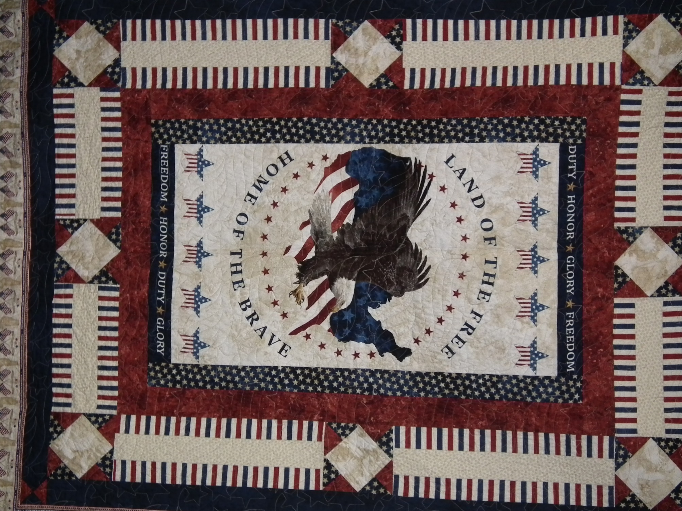

**What a mighty God we serve!!!** This cross was put up on this mountain many years ago to honor the veterans of World War II. These pictures were taken during the Southern California fires. It is the last picture that is so awesome. This must have been really something for those fire fighters who witnessed it...

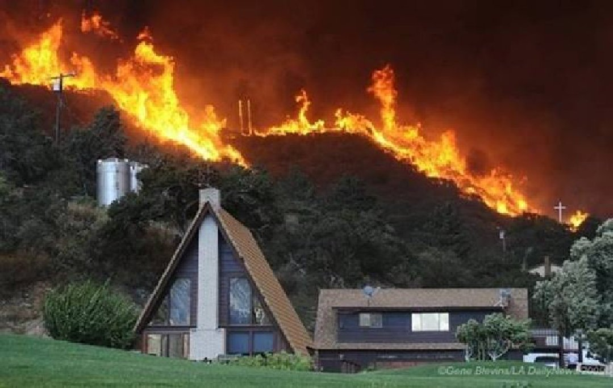 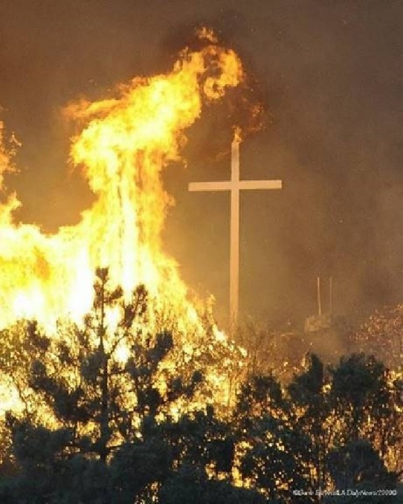

Cross in lower right side.

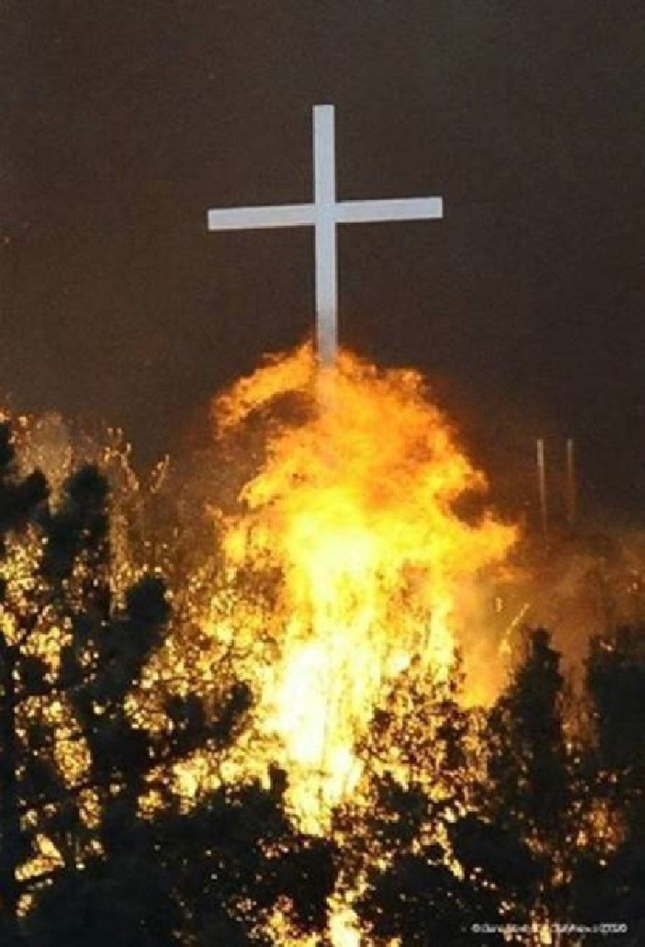 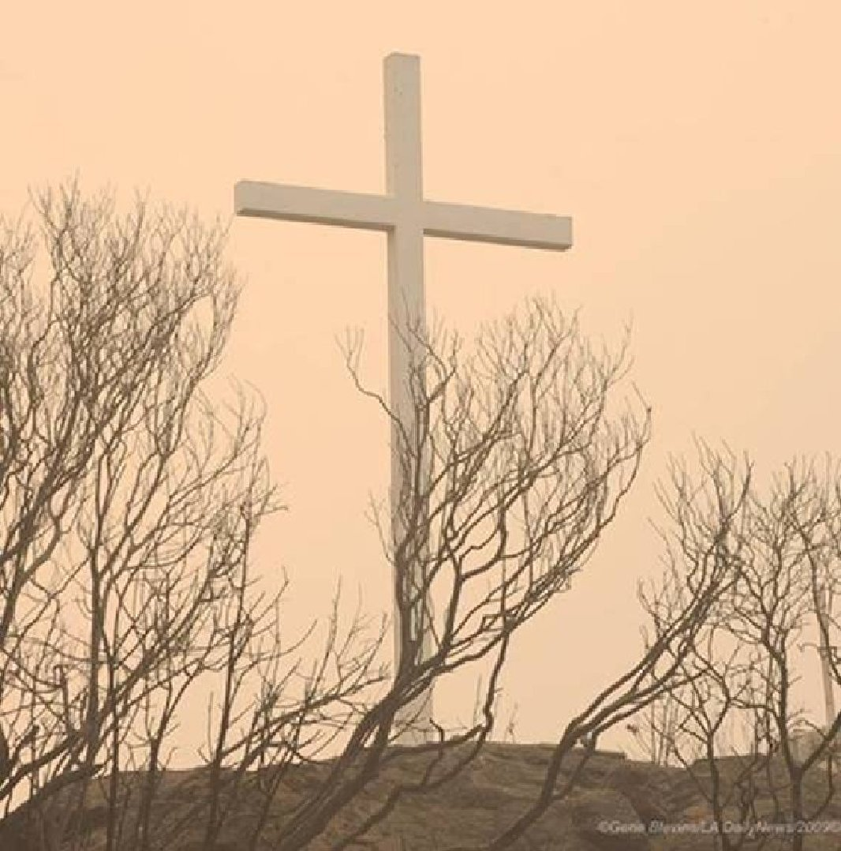

Even the fire fighters that were near the cross as it was surrounded with flames, said it was going to be destroyed. The next day, Gene Blevins (photographer) went back to the scene to get some more shots. He saw that the cross was not even touched or scorched from the heat. IF THAT DOESN'T MAKE YOU THINK, I don't know what will! May God's richest and best be yours always! EDITOR!

**FRIENDS OF CHAPTER 1106**

|  |  |
| --- | --- |
| **ERC Management, LLC**  791 Southpark Dr., Suite 600  Littleton, CO 80120  [720.328.3299](tel:720.328.3299)  [www.FreddysUSA.com](http://www.freddysusa.com/) | |
| **Caribou Coffee**  12501 E Lincoln Ave  Englewood, CO 80112  303-799-1258 | **American Legion Post 1260**  **E:\Documents\ALP1187\images\AmericanLegion_logo.jpg** |
| **Spradlin Printing, Inc.**  11903 S. Parker Road Parker, CO 80134 | **South Metro Denver Fire & Rescue**  9195 E Mineral Ave  Centennial, CO 80112 |
| Monthly Membership Meetings VISITORS ARE ALWAYS WELCOME!   3rd Saturday of each month at 10:00a.m.   Our meetings are held at: [VFW Post 2461](http://www.vfwpost2461.com/) 1350 S Broadway, Denver, CO 80210 | [http://www.applewoodfixit.com/wp-content/themes/applewood/images/header-logo.png](http://www.ApplewoodFixIt.com)  Applewood Plumbing Heating & Electric  **Main Billing Office:** 5000 W 29th Ave.  Denver, CO 80212 **Phone:** 303-232-6611 **Fax:** 303-477-4310 **Email:** [custservice@applewoodfixit.com](mailto:custservice@applewoodfixit.com) |
| 9137 E Mineral Cir Ste 100  Englewood, CO 80112-3422 | South Metro – Instant Imprints  6882 S. University Blvd.  Centennial, CO 80122  [303-771-2244](tel:303-771-2244) |
| https://scontent.fapa1-2.fna.fbcdn.net/v/t1.0-9/11755678_1048713308485999_8302677469177969743_n.jpg?oh=7f29d6fe26e879d42add098d5cded1fa&oe=5A27AD2B  VFW Post 2461, 1350 S. Broadway, Denver, CO 80210 | http://www.cruisin1430.com/sites/g/files/giy711/f/KEZW_Header_Large_Logo_0.png  **STUDIO 1430 Main Office:** 4700 South Syracuse Street, Suite 1050 Denver, CO 80237 |
| https://scontent.fapa1-2.fna.fbcdn.net/v/t31.0-8/10575197_682186265194110_4051472928662048560_o.jpg?oh=2630b186dcf3a20f1d7fc8fa25e0a5ba&oe=5A17C4AB  **Military Order of Purple Heart**, Chapter 1041, Arvada, CO | **Veteran’s Puppy for Life**  [https://scontent.fapa1-2.fna.fbcdn.net/v/t1.0-9/19060085_1943219205919091_2430547914200531885_n.jpg?oh=2442c16b113594f4bdc40eec81330246&oe=59EB9F66]( http://www.vetpuppyforlife.org)  <http://www.vetpuppyforlife.org> |
| Logo of The Home Depot  **Home Depot Foundation**  8477 S Yosemite St  Lone Tree, CO 80124 | Golden Corral  **Golden Corral**  15775 E. Arapahoe Rd  Centennial, CO 80016 |
| A FULL-SIZE REPLICA OF THE HONOR BELL  **The Honor Bell Foundation**  P.O. BOX 12400 DENVER, COLORADO 80212  720.282.9182 |  |