**Inside this issue:**

Notes from the President

Member Feature

Military Trivia

Guest Speaker

Membership

Board of Directors/Officers

Working Committees

Meetings/Events Calendar

Announcement Corner

Books/Articles Published by Mbrs.

From the Editor

Light Side

Trivia Answer

**Notice:**

If you have moved or changed your address, PLEASE notify us immediately! Contact: Dave Lyons, Membership Chair

E-mail: [Snoyldavid@centurylink.net](mailto:Snoyldavid@centurylink.net)

Phone:  303 690 8776

###### COPYRIGHT NOTICE: In accordance with Title 17 U.S.C. Section 107, any copyrighted material in this newsletter is distributed under fair use without profit or payment to those who have expressed a prior interest in receiving the included information for nonprofit use and educational purposes only.

**Facebook: Vietnam Veterans of America Chapter 1106**

***Editor’s Note:***

This version of the newsletter is in Microsoft Document (.DOCX) format so that the links will work. Put your cursor over the link, depress your Control Key (ctrl) and depress your left mouse button and it will take you to the listed link position. PDF format, the links will not work.

The comments and editorial input does not necessarily reflect the opinion of the membership of our chapter. I would appreciate any feedback that you might have, items you liked or if you find offensive or derogatory in anyway. ([bobrotruck73@gmail.com](mailto:bobrotruck73@gmail.com)) Thank you for allowing me to be your editor.

***Notes from the President***

Lee White

**HAPPY NEW YEAR!!**

2021 is now in our rear-view mirror. Thank goodness!!

I’m excited and look forward to a great year in 2022 for our chapter.

We will continue with all the committees/programs that were very successful in 2021 and will investigate a couple of additional programs. We have briefly discussed becoming more involved with the Veteran Treatment Court, JROTC Programs, along with conducting a “Flag Retirement Ceremony”.

The possibility of a couple “field trips” come to mind, maybe the National Museum of Aviation in Colorado Springs or the “SAC Museum” in Nebraska.

2022 is also election year that will be held in April. Anyone interested in stepping up for a position is encouraged to do so. More information on elections coming in March.

**BEST WISHES FOR A HEALTHY-SAFE 2022**

***Member Feature***

Louis Grounds – SSgt – U.S. Army – 1967-68. I was awarded the Purple Heart, Army Commendation Medal, Bronze Star. I served with the 3rd Battalion, 8th Infantry, 4th Division in Pleiku, Vietnam. My MOS was 11B Army Infantrymen which is the main land combat force and known as “Eleven Bravo.” The incredibly important role in the U.S. Army is responsible for defending the country through real-life combat. Soldiers also act in the mobilization of vehicles, weaponry, troops, and more. My most memorable experience was that I survived the Battle of Hill 724 and several other smaller battles in the Central Highlands. I worked with Mike Karsh and Jim Marcille on the Scholarship Committee in 2020 season and really enjoyed. I signed up for the November 13th poppy drive with Tom Werzyn. I am a retired Mechanical Engineer, and my wife has a Home Health Care business, and we frequently deliver meds, wheelchairs, etc. to the elderly and she has 42 care providers.

***Military Trivia***

**Band Aid** Click here for end of the Newsletter Trivia Answer

***November Guest Speakers –*** **Debbie Osborne – Executive Director The Enlisted Association - The mission of TREA:** The Enlisted Association is to enhance the quality of life for uniformed services enlisted personnel, their families and survivors - including active components, Reserves, and National Guard, and all retirees; to stop the erosion of earned benefits through our legislative efforts, to maintain our esprit de corps, dedication and patriotism, and to continue our devotion and allegiance to God and Country.

Founded in 1963 in Colorado Springs by Air Force retirees, George Skonce and Dean Sorrell, the organization was awarded a Charter from Congress in 1992. There are currently 27 active Chapters in the United States. [www.trea.org](http://www.trea.org)

Debbie Osborne, Deb Oelschig, Rev. Garry Turks, Douglas Osborne

**Jessie Ipock, Veterans Administration HUD-VASH Program:** The HUD-Veterans Affairs Supportive Housing (HUD-VASH) program combines HUD’s Housing Choice Voucher (HCV) rental assistance for homeless Veterans with case management and clinical services provided by the Department of Veterans Affairs (VA). VA provides these services for participating Veterans at VA medical centers (VAMCs), community-based outreach clinics (CBOCs), through VA contractors, or through other VA designated entities. Congress has appropriated additional funding for new HUD-VASH vouchers every year since 2008: Jessie was invited by Joe Plant to speak about the VA’s HUD-VASH to which our Chapter

partners with to support veterans who experience homelessness. The program’s priority is to

provide housing to homeless veterans and get them off the streets. Our Chapter gets four to six

calls monthly to work with HUD-VASH to provide emergency funds for housing rent, utility

payment and food. The VA program typically provides support from one to four months of direct

support.

Jessie Ipock

***December Guest Speaker –* Derek Mullner – Executive Director Elementary Education – Cherry Creek School District**

Spoke briefly and then made a wonderful financial donation from CCSD of **~**$1,600 dollars as well as being responsible for securing the wonderful room for our Dec 4th Meeting.

Tom Werzyn receiving the donation!

One view of our meeting room!

Another view of our meeting room!

***Membership!*** (As of 12/15/2021)

VVA 172

AVVA 42

TOTAL: 214

**VVA**

Hurley(Jack) Hayden - USMC

Murry Sallenbach - ARMY

Guillermo (Bill) Frausto AIR FORCE

**AVVA**

Frances Fernandes

***Board of Directors/Officers***

Lee White – President

Dave Lyons – Vice-president

Mike Huber – Treasurer

Secretary – Milt Omoto

Board Members – Patti Ehline, Tom Werzyn, Ron Smith, John Vargas, Joe Plant, Rev. Garry Turks, Joe Dempsey.

***Special Chapter Positions***

AVVA Liaison to chapter Board of Directors – Litta Plant-Schaper

Chaplain – Rev. Garry Turks

Chapter Historian – John Vargas

Database/Audio – Jack Hunter

Government Affairs – Tony Nickerson

Sergeant-at-Arms – Dan Green

Chapter Nurse – Patti Ehline

Email Blaster – Bob Rotruck

***Working Committees***

* Agent Orange/PTSD: Patti Ehline
* Color Guard: Tony Nickerson (Command Sergeant),

Don McNeely, Dan Green, Clarence Rebolledo, Robert Senatore, Ron Smith, John Sheadel

* Event Coordinator: Ron Smith – Chair, Lee White
* Fundraising/Grants: Milt Omoto – Chair, Lee White
* Marketing/Media/Events: Tom Werzyn
* Membership: Dave Lyons – Chair, Lee White, Litta Plant-Schaper (AVVA Roster Updates)
* Mental Health: Patti Ehline, Warren Harrison, Joe Plant
* Name Tags: Litta Plant-Schaper
* Newsletter Editor: Bob Rotruck
* Promotional Items: Leann Stelzer, Joe Dempsey, Ita Dempsey
* Refreshments: Walt Leuci, Dave Lyons
* Scholarship Program:  Gary Weston, Chair   Jim Marcille - Lou Grounds - Mike Karsh (At-Large, Consultant)
* Social – John Vargas, Chair - Tom Werzyn - Joe Dempsey - Milt Omoto - Clarence Rebolledo
* Speakers Bureau Tom Werzyn – Chair, Bob Mallin, Dave Lyons
* Veteran Emergency Assistance Committee: Joe Plant, Dave Lyons, Dan Green, Lee White
* Voices for Veterans: Warren Harrison, Patti Ehline, Joe Plant
* Webmaster: Bob Rotruck
* Women Veterans: Patti Ehline

**Meetings/Events Calendar - 2021**

January 1, 2022 - HAPPY NEW YEAR!!

January 8, 2022 - VVA Chapter 1106 Membership Meeting

January 29, 2022 - VVA Chapter 1106 Board Meeting (Zoom))

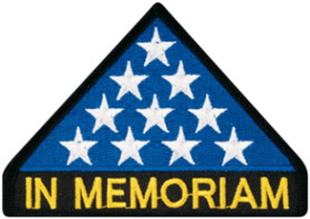

***In Memoriam***

**Michelle Mallin**

From Dr. Bob Mallin – October 20th, 2021

Today the fall leaves are starting to drop, the geese are returning in numbers...and God’s earthly plan for my daughter, Michelle, is over...She left her trial of pain and suffering from a rare form of cancer (Sarcoma, actually) after a 5-year battle yesterday, October 19, 2021...Her birthday was to be the 22nd of October.

She took her first breath on October 22, 1969...during a commercial break on the Marcus Welby TV show...She like me was a big baby...close to 10lbs even...Her Mom was 5' 1/2" tall. A C-section was planned but as the Obstetrician and I were in the brake room he said "OK after the commercial. We’ll check again"...and she got born at that time!!

The next (almost) 52 years were full, events ...divorces...dedications to family...And at one point her husband Dean dropped from heaven and was her saint for some years forward through literally "in sickness and in health"...A great blessing for her...and me too... When in Colorado...at least, Michell was constantly devoted too dollars ...and projects...raising hundreds of thousands for them...She was cofounder of the HONOR BELL FOUNDATION...that honors the fallen at final services...Perhaps my greatest contribution from Army service is that it opened the gate for her for her veteran's work...There is so much more...There is so many lives that she touched...a light has gone out on Earth...and we pray one has gone on in a higher place...Love from her and me to you / Be well / Bob

CELEBRATION OF LIFE

MICHELLE MALLIN

“HAPPINESS NEVER DECREASES BY BEING SHARED” – BUDDHA

*AND THAT’S WHAT MICHELLE PRACTICED DAILY!*

Michelle and I met when the Honor Bell was a thought in progress between her and Lou. He was a member of MOPH 1041 and asked that we brain-storm along with them. Immediately, I noticed that Michelle was a no nonsense driven lady with a plethora of forward-thinking ideas. You know the results of *their* dream “forged from honor” a 1000 lb. bronze bell casted along with artifacts from 12 local deceased veterans. A few years later i had the pleasure of having breakfast and interviewing Michelle for an article called “The Citizen Heroes.” And yes, this was the beginning of a beautiful friendship!

Michelle was originally from, Syosset New York and for a short time lived in Alaska. While in high school, she was considered a nerd. Just so happened that the team captain and star quarterback needed special tutoring to pass his science labs and other academic topics. Michelle stepped forward and helped him all the way to graduation. He nicknamed her “Lou.” Lou the nerd was never bullied. She graduated with an MS degree from the State University at Albany, New York. Later she earned a degree in publishing from Pace University.

The military runs in her family. Her father, Dr. Mallin, was awarded a Purple Heart and Bronze Star. Her very loyal husband, Dean, was in the Navy and currently works at the VA Medical Center in Denver.

At one point, my wife was probably thinking that Michelle was the other woman in my life. Kathleen constantly heard about Michelle. Oh, another tid-bit – somehow, she found the time to house canines, in her home for soldiers that were overseas until they returned.

One of my fondest and last memories was when three couples (Rich and June Eisenberg, Dean and Michelle and Kathleen and I met at the Bagle Deli. Rich is currently battling cancer and that’s why they aren’t here that evening. They send their love and sympathies to the family. At that dinner, not one word of illness was spoken. We just talked, laughed, and argued about what was best to eat. When I got home that evening there was an email (you guessed it – from Michelle) with at least 20 other restaurants to visit. I’ll leave you with this quote from John Quincy Adams that also describes Michelle.

“If your actions inspire others to dream more, learn more, do more, you are a leader”

MICHELLE MALLIN

“A SUNBEAM OF PRIDE”

REST IN PEACE MY FRIEND

Submitted by: John Vargas



As of: 8/16/2021

Total Funeral Homes Visited - 2,510

Cremains Found – 26,147

Veterans Cremains Identified – 5,617

Veterans Interred – 5,014

***Events:***

**Fund Raiser at Texas Roadhouse**

On Veterans Day, Chapter members Lee White, Dave Lyons and Milt Omoto were busy at Texas Roadhouse Parker. While restaurant employees handed out free meal vouchers to veterans and active military as they drove through the parking lot, Chapter members handed out information about VVA Chapter 1106 and membership applications. We also accepted donations. Texas Roadhouse promoted veterans the entire month of November with a variety of ways for the Chapter to raise funds.

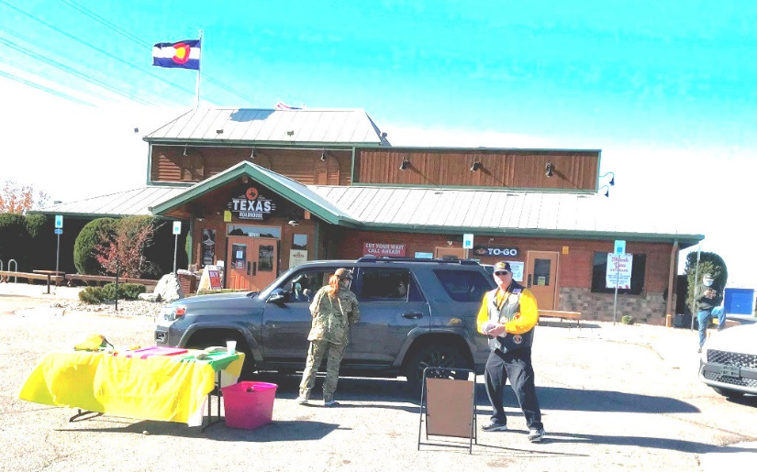

**Veterans Day Poppy Drive**

A big thank you for all members who participated.

Landing Zone 1 $1190.81

Landing Zone 2 $1343.65

Landing Zone 3 $1901.31

Landing Zone 4 $2690.62

Landing Zone 5 $1421.91

**Drum roll: Grand Total: $8548.30**

LZ1 - Centennial Lead: Ron Smith

LZ2 - Aurora Lead: Dave Lyons

LZ3 - Aurora Lead: Tom Werzyn

LZ4 - Parker Lead: Lee White

LZ5 - Highlands Ranch Lead: Milt Omoto

LZ4 – Parker King Soopers

L to R: Bill Pine, Bob Brown, Bob Rotruck, Dale Creason

L to R: Gary Weston, Lee White, Ted Hanfelder, not shown in picture: Jim Henderson

LZ1

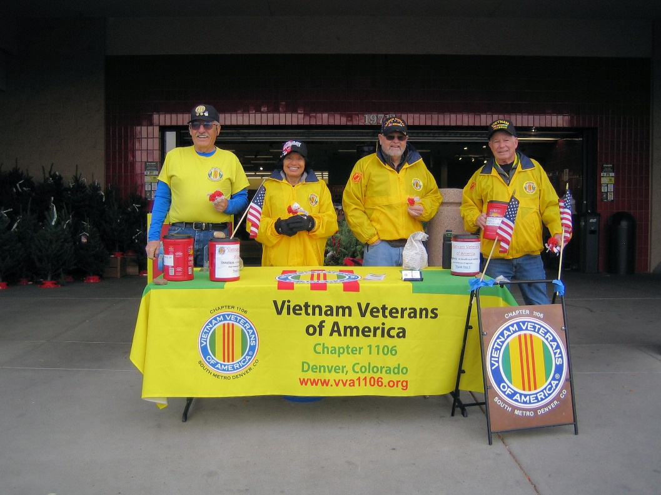

LtoR: Steve Robertson, Jai Smith, Ron Smith, Dan Green

**Quilts of Valor**

Submitted by John Vargas

Honoring a good man and Veteran. At a CCSD QOV Ceremony, Richard Lewis was honored.

**Suzanne Segona presented more Vietnam War Commemorative pins to members at the December meeting.**

Presentation of Commemorative pins

**The Wall in the Fall**

Submitted by Suzanne Segona

**2021 Christmas Extravaganza**

December 18th, our Chapter has a bang-up Christmas get together with over 100 attendees! Lots of fellowship, programs, awards, giveaways, and closing with some beautiful music from Christine Omoto. Thank you all for attending and thank you Social Committee for all of your hard work putting it all together!!

Master of Ceremonies: Tom Werzyn

Venue at Maggiano's Little Italy

Venue at Maggiano's Little Italy

Member of the Year to Jack Hunter

AVVA Member of the Year to Litta Plant-Schaper

Chapter Recognition Award to Larry Bull, Cherry Creek School District Director of Athletics and Activities

(Editor: My apology for the blurred picture, but Larry asks me to do that to avoid FBI recognition! ☺☺☺☺)

Guest Speaker: CMSGT Lisa Perry, Buckley National Guard

Cristine Omoto singing her heart out to us!!

**ALERT!**

BREAKING NEWS: U.S. Marine Corps Headquarters has issued orders today to Master Gunnery Sergeant S. Claus, recalling him to active duty, with a RNLTD of 24 Dec 2021. MGySgt. Claus, known to use the alias “Saint Nicholas”, “Kris Kringle”, “Father Christmas”, or simply “Santa”, is a reserve Marine with 1,745 years of service.

He specializes as a tactical operator of the next generation DEC-25B, Cargo Airborne Delivery (CAnDY) Carrier. The DEC-25B is contractor-modified and fully equipped with Cargo Antlered Navigation Equipment Sensors (CANES). It has also been retrofitted with eight high-powered, air-cooled Rangifer Tarandus carrot-fed generators. As a single seat cargo delivery platform, it is capable of vertical delivery of high-value items, take-off and landing without pilot-controlled lighting (PCL). These unique specifications, coupled with the additional Public Affairs skill sets possessed by Master Gunny Claus, classify the entire deployable package as a low-density, high-demand (LD/HD) asset. Also recalled, were MSgts Dasher and Dancer, GySgts Prancer and Vixen, SSgts Comet and Cupid, Cpl. Donner, and PFC Blitzen (recently selected for LCpl.) PFC Rudolph is also authorized to report for duty; however, he must first successfully complete his Phase II SERE Training, which he has failed three times due to a medical condition related to his nose. Although the above Marines are on orders for only 24 hours, it is anticipated that they will submit a travel claim for 24,901 miles at .56/mile, using a POV. Suitable Government transportation is not available. As a special operations unit, each member is granted a high level of uniform flexibility, as well as relaxed grooming standards. Per diem has been modified to include large quantities of hot cocoa and cookies. Government travel card use has been authorized. And he will be in a Toys For Tots distribution center near you. Check your local Toys For Tots chapter or visit https://www.toysfortots.org /locate/default.aspx?nType=1 for the nearest location to you.

S/F

***Books/Articles***

**Flying Ladders**

Submitted by Joe Dempsey

Captain Lawrence R. Adams braved overwhelming enemy fire multiple times to rescue a Force Recon Team off the jungle floor, by dangling a ladder out the back of his helicopter.

In January 1969, team Forefather from 1st Force Recon was trapped in the jungle. One helicopter swooped in for an emergency extraction but was shot up so bad it had to crash land back at base. Captain Adams and his crew volunteered to take over the extract. Marines rigged up a cable ladder, never before used by Marines in combat. Adams dangled the ladder out the back of his CH-46, 80 feet above the ground. NVA on a hill above the extract site had a level shot straight at the chopper. Five Marines made it onto the ladder before Adams took off. He didn’t know three more were still on the ground. He dropped off the five and returned to the scene. Enemy fire shot the helicopter out of the area twice before he established a hover on the third attempt. The three Marines made it onto the ladder, and Adams pulled away back to base.

For his unwavering resolve and bold initiative rescuing the entire team from certain death, as well as his crew aboard the chopper, Adams was nominated for the Medal of Honor. The award was downgraded to the Navy Cross. Other Marines involved in the “Flying Ladder” mission were awarded 2 Silver Stars and 2 Purple Hearts. Adams served one tour in Vietnam. In that time, he flew over 1,000 missions and 600 flight hours. In addition to the Navy Cross, he earned a Silver Star, 2 Distinguished Flying Crosses, and 50 Air Medals (yes 50).

“The Flying Ladder: Emergency Extractions and the Lifesaver from the Sky” is and award-winning piece of journalism, Written by the Editor of BZO. Check it out at the below link:

<https://bzohistory.com/flying-ladder/>

**Chapter Member gets back Stolen Medals**

Submitted by: Milt Omoto

Chapter member Gary Steinhoff received military medals that were stolen from him years ago. The Forgotten Heroes Campaign conducted the research and secured the medals for Gary. The medals were presented by Brigadier General David Warner at a formal ceremony on October 30, 2021, and include the National Defense Service Medal, the Vietnam Service Medal, and Vietnam Campaign Medal. Gary also was awarded the Navy Meritorious Unit Commendation Ribbon.

If you were awarded medals as documented on your Form DD-214 but never received them, or lost them, contact Chapter member Barry Fiore at (303) 507-6034. Chapter member Barry is a member of the Forgotten Heroes Campaign

**NATIONAL LAO-HMONG MEMORIAL**

Submitted by: Milt Omoto

In 1961, while the Vietnam War was going on, another war was also waged. This war was known as the “Secret War” and took place in Laos. The countries involved in the Secret War were the U.S., Thailand, Laos, and North Vietnam. The U.S. needed a way to help the fight against communism in Laos. The U.S. CIA recruited the Laotian Hmong and trained, paid, and provided military weapons to them; for the purpose of engagement in guerrilla warfare against the North Vietnamese. Hmong soldiers rescued downed American pilots from enemy territories and defended American outposts in Laos. They also attacked many North Vietnamese convoys that were using the Ho Chi Minh trail, which crossed Northern Laos from North Vietnam into South Vietnam.

30,000 Hmong and 728 Americans and their allies died during the Secret War. When the U.S. withdrew its troops from South Vietnam in 1975, they also withdrew the training teams, military weapons, and financial support from Laos and the Hmong. 10,000 Hmong managed to escape to refugee camps in Thailand and eventually emigrated to the U.S. and other friendly countries. 90,000 stayed behind and suffered the consequences. In Colorado, about 3,000 people of Lao-Hmong descent live, work, and take pride in being U.S. citizen.

The National Lao-Hmong Memorial Foundation of Colorado was formed to establish a compelling memorial that honors the service and sacrifices of the “Lao-Hmong people” (Lao, Hmong, Lue, U-Mien, and Thi Dam), during and following the U.S Secret War in Laos. It will be located in Westminster, Colorado, adjacent to the U.S. Armed Forces Tribute Garden at the City Park, East of U.S. 36 on 104th Avenue between Christopher Fields and Big Dry Creek and is expected to be completed towards the end of 2022.

Recently, a memorial design unveiling event was held at the Broomfield Regional Airport on October 2, 2021. Larry Peterson of VVA Chapter 1075 (Colorado Springs) attended the event. An Air Force Vietnam War veteran, Larry spent time in 1971 at the Nakohn Phanom Royal Thai AFB supporting Lao-Hmong pilot training on the T-28. He also did 123 combat missions on an AC-130 gunship supporting Hmong ground forces in Operation Barrel Roll (Northern Laos). Larry shared the following pictures of the event.

You can learn more at:

<www.lao-hmongmemorial.org>

The Lao Hmong Memorial Design Event

Young Ladies in Traditional Dress

**Wonderful Piece of Work**

Powerful: Joshua Dyer (aged 14) was tasked at school to write a poem for Remembrance Day.

An hour later (without any help) he produced this.

**ONE THOUSAND MEN ARE WALKING**

One thousand men are walking

Walking side by side

Singing songs from home

The spirit as their guide

They walk toward the light milord

They walk towards the sun

They smoke and laugh and smile together

No foes to outrun

These men live on forever

In the hearts of those they saved

A nation truly grateful

For the path of peace they paved

They march as friends and comrades

But they do not march for war

Step closer to salvation

A tranquil steady corps

The meadows lit with golden beams

A beacon for the brave

The emerald grass untrampled

A reward for what they gave

They dream of those they left behind

And know they dream of them

Forever in those poppy fields

There walks one thousand men

Joshua Dyer 2019 (aged 14)

**Lest we forget**

**Hotel Scam**

Submitted by LCOL Dave Pruett, USMC (RET)

(This is one I might even have fallen for!)

Creativity wow.!! This is one of the best scams I’ve heard about. You arrive at your hotel and check in at the front desk. Typically, when checking in, you give the front desk your credit card (for any charges to your room) and they don't retain the card. You go to your room and settle in.

The hotel receives a call, and the caller asks for (as an example) room 620 - which happens to be your room.

The phone rings in your room. You answer and the person on the other end says the following: 'This is the front desk. When checking in, we came across a problem with your charge card information. Please re-read me your credit card numbers and verify the last 3 digits numbers at the reverse side of your charge card.'

Not thinking anything wrong, since the call seems to come from the front desk you oblige. But actually, it is a scam by someone calling from outside the hotel. They have asked for a random room number, then ask you for your credit card and address information. They sound so professional, that you think you are talking to the front desk.

If you ever encounter this scenario on your travels, tell the caller that you will be down to the front desk to clear up any problems. Then, go to the front desk or call directly and ask if there was a problem. If there was none, inform the manager of the hotel that someone tried to scam you of your credit card information, acting like a front desk employee.

This was said to have been initially sent by someone who has been duped and is still cleaning up the mess.

ANYONE traveling should be aware of this one!

Editor: Amazing picture of Lee White serving in the Coast Guard in WWII.

***Light Side***

**Who is 80+?**

Submitted by CAPT Dick Petrucci, USN (RET)

You think you have lived to be 80 plus and know who you are. Then along comes someone and blows it all to hell!

An old Marine Pilot sat down at the Starbucks, still wearing his old USMC flight jacket and ordered a cup of coffee. As he sat sipping his coffee, a young woman sat down next to him. She turned to the pilot and asked, Are you a real pilot?

He replied, 'Well, I've spent my whole life flying planes, first Stearmans, then the early Grumman’s... flew a Wildcat and Corsair in WWII, and later in the Korean conflict, Banshees and Cougars. I've taught more than 260 people to fly and given rides to hundreds, so I guess I am a pilot, and you, what are you?

She said, 'I'm a lesbian. I spend my whole day thinking about naked women. As soon as I get up in the morning, I think about naked women. When I shower, I think about naked women. When I watch TV, I think about naked women. It seems everything makes me think of naked women.'

The two sat sipping in silence.

A little while later, a young man sat down on the other side of the old pilot and asked:

"Are you a real pilot?"

He replied, 'I always thought I was, but I just found out I'm a lesbian.'

**A little church humor!**

**7 REASONS NOT TO MESS WITH CHILDREN**

Submitted by Dave Lyons

A little girl was talking to her teacher about whales.

The teacher said it was physically impossible for a whale to swallow a human because even though it was a very large mammal its throat was very small.

The little girl stated that Jonah was swallowed by a whale.

Irritated, the teacher reiterated that a whale could not swallow a human; It was physically impossible.

The little girl said, 'When I get to heaven, I will ask Jonah'.

The teacher asked, 'What if Jonah went to hell?'

The little girl replied, 'Then you ask him'.

A Kindergarten teacher was observing her classroom of children while they were drawing. She would occasionally walk around to see each child's work. As she got to one little girl who was working diligently, she asked what the drawing was.

The girl replied, 'I'm drawing God.'

The teacher paused and said, 'But no one knows what God looks like'.

Without missing a beat, or looking up from her drawing, the girl replied, 'They will in a minute'.

A Sunday school teacher was discussing the Ten Commandments with her five- and six-year-olds. After explaining the commandment to 'Honor' thy Father and thy Mother, she asked, 'Is there a commandment that teaches us how to treat our brothers and sisters?'

Without missing a beat one little boy (the oldest of a family) answered, 'Thou shall not kill.'

One day a little girl was sitting and watching her mother do the dishes at the kitchen sink. She suddenly noticed that her mother had several strands of white hair sticking out in contrast on her brunette head. She looked at her mother and inquisitively asked, 'Why are some of your hairs white, Mum?'

Her mother replied, 'Well, every time that you do something wrong and make me cry or unhappy,

one of my hairs turns white.'

The little girl thought about this revelation for a while and then said, 'Mummy, how come ALL of grandma's hairs are white?'

The children had all been photographed, and the teacher was trying to persuade them each to buy a copy of the group picture. 'Just think how nice it will be to look at it when you are all grown up and say, 'There's Jennifer, she's a lawyer,' or 'That's Michael, He's a doctor.'

A small voice at the back of the room rang out, 'And there's the teacher, she's dead.'

A teacher was giving a lesson on the circulation of the blood. Trying to make the matter clearer, she said, 'Now, class, if I stood on my head, the blood, as you know, would run into it, and I would turn red in the face.'

'Yes,' the class said.

'Then why is it that while I am standing upright in the ordinary position the blood doesn't run into my feet?'

A little fellow shouted, 'Cause your feet ain't empty'.

The children were lined up in the cafeteria of a Catholic Elementary School for lunch.

At the head of the table was a large pile of apples.. The nun made a note, and posted on the apple tray:

'Take only ONE . God is watching.'

Moving further along the lunch line, at the other end of the table was a large pile of chocolate chip cookies.

A child had written a note, 'Take all you want. God is watching the apples'.

Submitted by Joe Dempsey

**Hot coffee**

 I was eating breakfast with my  10-year-old Granddaughter, and I asked her, “What day is tomorrow?"

Without skipping a beat, she said, "It's Presidents Day!"

She's smart, so I asked her, "What does Presidents Day mean?" I was waiting for something about Obama, Bush, Clinton, or Trump etc.

She replied, "Presidents Day is when the President steps out of the White House and, if he sees his shadow, we have another year of Bullshit."

You know, it hurts when hot coffee spurts out your nose.

**John Vargas took a “selfie” on Halloween!!!!!!!**

***Trivia Answer***

**Band-Aid** -- A Vietnam-era term for a medic.

**Upcoming Events of Interest**

*Date of Revision: xxxx*

**FRIENDS OF CHAPTER 1106**

|  |  |
| --- | --- |
| **South Metro Denver Fire & Rescue**  9195 E Mineral Ave  Centennial, CO 80112 | **A picture containing text  Description automatically generatedTREA: The Enlisted Association - HQ**  **Phone - (303) 752-0660**  **12200 E. Briarwood Avenue, Suite 250, Centennial CO 80112** |
| **Spradlin Printing, Inc.**  11903 S. Parker Road Parker, CO 80134 | Text  Description automatically generated  Alycia Carmin  PO Box 233  Kersey, CO 80644  (970) 352 8802 |
| 3989 E. Arapahoe Road #20  Centennial, CO 80122  720-361-0155 | A FULL-SIZE REPLICA OF THE HONOR BELL  **The Honor Bell Foundation**  PO Box 1432  Englewood CO 80150  720.282.9182  [www.honorbell.org](http://www.honorbell.org/) |
| 9137 E Mineral Cir Ste 100  Englewood, CO 80112-3422 |  |
| King Soopers logo.svg  King Soopers  9551 S. University Blvd., Highlands Ranch, CO 80126 | Veteran & Family Resource HubQualified Listeners:  PO Box 563  Dacono, CO 80514  Tel: 720-600-0860 |
| https://scontent.fapa1-2.fna.fbcdn.net/v/t31.0-8/10575197_682186265194110_4051472928662048560_o.jpg?oh=2630b186dcf3a20f1d7fc8fa25e0a5ba&oe=5A17C4AB  **Military Order of Purple Heart**, Chapter 1041, Arvada, CO | **CHERRY CREEK SCHOOL DISTRICT**  Text  Description automatically generated  4700 South Yosemite Street  Greenwood Village, CO 80111 |
| 99 Inverness Drive - #275 Ennglewood, CO  Text  Description automatically generated C-303-653-5020  O-303-779-1420  [www.printconnection.com](http://www.printconnection.com)  [troy@ printconnection.com](mailto:troy@%20printconnection.com) | PARKER MEDICAL  S**UP**PLY STORE  9845 S Parker Rd  . Parker, CO 80134  303-840-4444 |
|   **Mary Haddon – President**  1201 Williams St #18A  Denver, CO 80218  720-217-3235 |  |