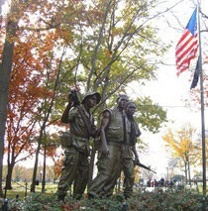
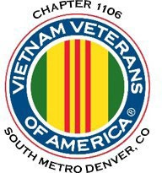
“Welcome Home”

NEWSLETTER
Jan-Feb 2024 – VOL 10 NO 1

Editor’s Note:
The comments and editorial input do not necessarily reflect the opinion of the membership of our chapter. Please contact Mark Nickell at mnickell2004@msn.com with any feedback regarding the contents of this publication.
Board of Directors/Officers
Dave Lyons – President Milt Omoto – Vice-president Mike Huber – Treasurer Sally Eaves – Secretary
Inside this issue:
Board of Directors/Officers Working Committees Notes from the President Member Feature
Military Trivia Guest Speaker Membership
Meetings/Events Calendar Events
Books/Articles Published by Members. From the Editor
Light Side Trivia Answer
Board Members – Patti Ehline, Tom Werzyn, John Vargas, Joe Plant, Rev. Garry Turks, Joe Dempsey, Joseph Robinson.
Special Chapter Positions
AVVA Liaison to chapter Board of Directors – Litta Plant- Schaper
Chaplain – Rev. Garry Turks Chapter Historian – John Vargas Database/Audio – Jack Hunter Government Affairs – Tony Nickerson Sergeant-at-Arms – Dan Green Chapter Nurse – Patti Ehline
Email Blaster – Jack Hunter
Notice:
If you have moved or changed your address, PLEASE notify us immediately! Contact: Dale Creason, Membership Chair Email creason38sp@gmail.com Phone: 303-720-2948
COPYRIGHT NOTICE: In accordance with Title 17 U.S.C. Section 107, any copyrighted material in this newsletter is distributed under fair use without profit or payment to those who have expressed a prior interest in receiving the included information for nonprofit use and educational purposes only.

Working Committees
- Agent Orange/PTSD: Patti Ehline
- Color Guard: Dale Creason (Command Sergeant),
- Ron Smith (Asst. Command Sergeant) , Don McNeely, Dan Green, Clarence Rebolledo, Harry Montgomery, John Sheadel,
- Event Coordinator: Joseph Robinson
- Fundraising/Grants: Milt Omoto – Chair
- Information Blaster – Jack Hunter
- Marketing/Media/Events: Tom Werzyn
- Membership: Lee White – Chair, Litta Plant-Schaper (AVVA Roster Updates
- Memorial Committee: John Vargas-Chair. Garry Turks, Joe Plant, Lee White, Alan Jaffe, Milt Omoto
- Mental Health: Patti Ehline, Warren Harrison, Joe Plant
- Name Tags: Litta Plant-Schaper
- Newsletter Editor: Mark Nickell
- Promotional Items: Leann Stelzer, Joe Dempsey, Ita Dempsey
- Refreshments: Walt Leuci, Dave Lyons
- Scholarship Program: Gary Weston, Chair, Litta Plant- Schaper, Mike Karsh (At-Large, Consultant)
- Social – Chairman – Vacant, Joe Plant, Tom Werzyn, and Litta Plant-Shaper
- Speakers Bureau Tom Werzyn – Chair, Bob Mallin, Dave Lyons
- Veteran Emergency Assistance: Joe Plant, Dave Lyons
- Voices for Veterans: Warren Harrison, Patti Ehline, Joe Plant
- Webmaster: Mark Nickell Women Veterans: Patti Ehline

Notes from the President - Dave Lyons:
Happy New Year! And, welcome to our first newsletter for 2024. I am looking forward to our monthly Membership meetings to see all of you attend and our Chapter activities planned for the year. The Chapter Board continues to find and schedule guest speakers who will provide information of interest and relevance to our veteran members. In addition, we are beginning to plan membership activities for the year, including outing events, the summer picnic and end of year Holiday Lunch.

We also continue to plan activities that will require some of your time and effort, including our Poppy Drives in May and November, periodic food and clothing drives, and volunteer activities. We’ve had good participation from you. Thank you.

We are fortunate to have a very active membership. We have nineteen Standing Committees that include the Color Guard, Scholarship Committee, the Veterans Emergency Assistance Program, and Speaker’s Bureau to name a few. Thank you to all who engage and support in these committees.

Finally, please continue to stay in touch with each other. Thank you to our “Buddy Callers” who regularly call on members and their families. I urge each of you to also regularly check on those you know, even if you’re not a buddy caller. As our Chaplain “Chappy” Turks reminds us at every meeting, “Chapter 1106 needs you, and you need Chapter 1106.”
Have a blessed and great year!
Dave Lyons, President Chapter 1106
Member Feature
Chapter Chaplain Garry (“Chappy”) Turks was awarded the prestigious Chapel of Four Chaplains’ Legion of Honor Bronze Medallion at the January Membership meeting. This award is presented to those who continually perform selfless acts of service to the community, nation and humanity without regard to race, religion or creed, which was so dramatically exemplifies by the Four Chaplains. Chaplain Chappy is well deserving of this award.

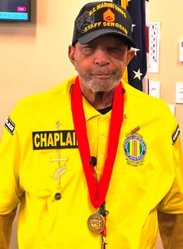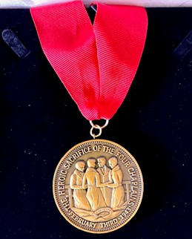
Chaplain Gary Turks Legion of Honor Bronze Medallion

February 3 every year is in recognition of the four Army chaplains who acted in the spirit of heroic sacrifice and humanitarianism onboard the sinking USAT Dorchester in 1943.

To learn more about the Chaple of Four Chaplains, go to: https://fourchaplains.org/

Editor's Note: This award was made possible by the efforts of Milt Omoto -Vice President VVA1106. He provided the documentation required by the National Foundation for making the decision to recognize Gary Turks.

January Meeting Events
Chapter member Dr. Bob Mallin was awarded a Chapter appreciation certificate and Vietnam War memorial pocket watch. Bob has continuously supported the Chapter and the veteran community with his generosity and kindness. Bob served as a field medical officer in Vietnam.
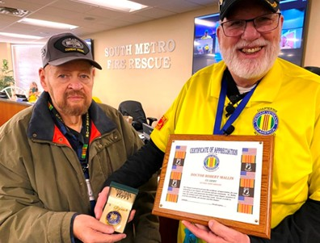
Dr. Bob Mallin and Chapter President Dave Lyons

January Meeting Guest Speaker
Our January Membership meeting guest presenter was Roderick Thomas, Director, Fort Logan National Cemetery. Roderick spoke on the new expansion project at Fort Logan (there will be enough internment land to the year 2070) and on veteran internment statistical data for the state of Colorado. Currently they are interring about 18% of veterans who pass away each year, which is a low number, because many veterans don’t know they qualify for veteran burial benefits. He also stressed the importance of end-of-life planning for veterans, spouses and family members.
Member Bio for January Meeting
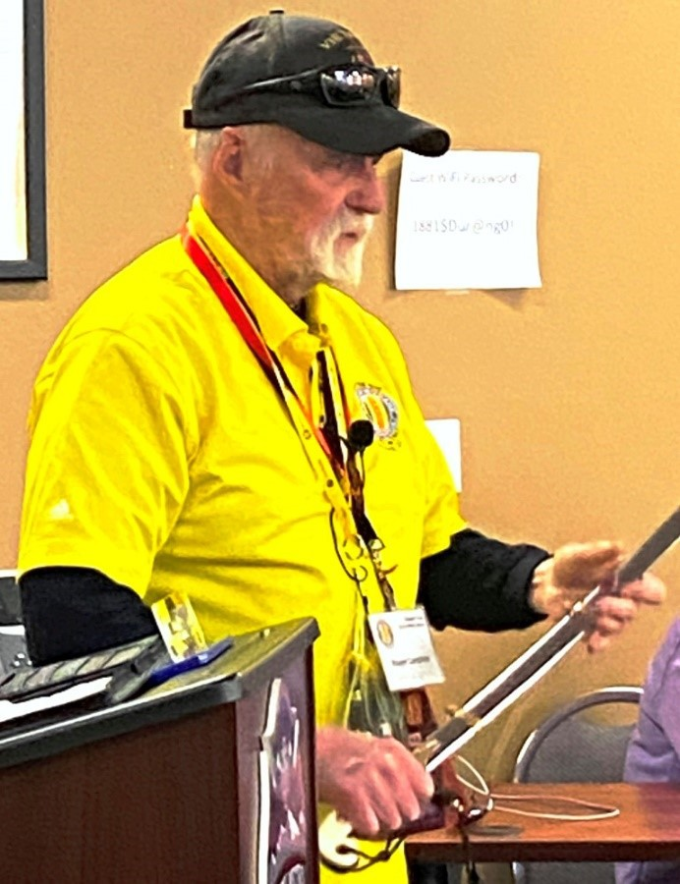
Our January Membership meeting member bio was presented by Roger Lanphier, US Marine Corps. Roger was commissioned a Second Lieutenant after OCS and proudly displayed his officer's saber. Roger was platoon leader for a number of units including a Battalion Landing unit. Thank you Roger for sharing.

Roger Lanphier

Roderick Thomas

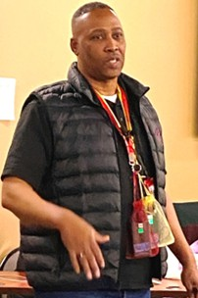
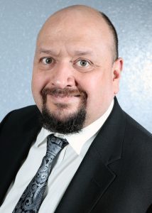
Josh Medina
Membership! (As of 11/30/2023) VVA 203
AWA 44
TOTAL: 247
New Members:

February Meeting Guest Speaker
Our February Meeting guest speaker was Arapahoe County VSO, Josh Medina. Josh provided an overview of the PACT ACT & general informational items of interest to veterans. He also fielded several questions from the Membership. Josh is also Regional Vice President for Arapahoe County United Veterans Coalition of Colorado

His office can be reached at 303-738-8045 or veteranservices@arapahoegov.com with questions. If someone is looking to volunteer, you can get in contact with Josh directly at: Jmedina@arapahoegov.com.
Veterans residing outside of Arapahoe County can go to https://vets.colorado.gov/services/county- veterans-service-offices to find additional VSO locations.
Military Trivia
What doses the term "Roof Stomp" mean?
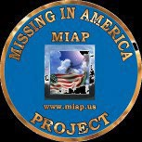

As of: 4/19/2023
Total Funeral Homes Visited – 2,622 Cremains Found – 29,894 Veterans Cremains Identified – 6,344 Veterans Interred – 5,959

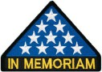

In Memoriam
Leo Max Greunke June 16, 1941-February 9, 2024

Leo was born in Jefferson City, Missouri. He met his future wife Anna Lee Greunke (Velte) at Trinity Lutheran Church as a young boy only to become reacquainted with her in High School. The pair were married at Trinity on December 29th, 1963 and in the fall of 1964, relocated to Denver, Colorado.

In 1966 Leo joined the Air Force and was sent to Gulfport, Mississippi, Misawa, Japan and ultimately Danang, Vietnam in 1969 where he served in the 6924th Security Squadron. Leo was sent home after duty to meet his 7 month old son for the first time. Shortly after, their son Michael was born in 1970 followed by their daughter LeAnn in 1978.

Leo spent his career as superintendent of the Commerce City Grain Elevator where where he enjoyed the rigor and pace of the environment and made may lifetime friends along the way.

He was an active participant in The Veterans of Foreign Wars, Vietnam Veterans Group, and American Legion.

Leo passed away unexpectedly at the age of 82 on Friday February 9th at Sky Ridge Medical Center after an acute battle with heart failure.

Letters To The Editor

Chapter Meeting Roundtable
Just before the closing of each chapter meeting, President David Lyons, kindly reminds the attending members present and on Zoom, that its open for comments/suggestions. Better known as our “Roundtable” discussion. This is your opportunity to voice any comments non-political or and no religious opinions. Suggestions are welcome! We just ask that you remain diligent with your time, knowing that others may also have something to contribute. We may not have the answers but will do the research and get back to you! If you would like to recommend any type of change, please have at least one
solution.

Net, net, I encourage you to Speak Up! We can only continue to grow if we are all on the same page!

Submitted By
John Vargas

Question on our current meeting site
One of our members suggested that we try to find another meeting location because we’re outgrowing our current meeting site.

Response:
South Metro Fire has been extremely generous by providing a facility with easy access and ample parking. Yes, at times we may run short on seating. But, we have asked, and thank you to all who complied, by bringing a chair.

In the past, we have had other sites. However, they were very temporary and did not meet our needs. As a Chapter member, if you have a purposed new meeting location, please inform our Board and we promise to look at the site.

It must have:
- Easy access including handicap access
- Ample Parking
- Adhere to our first Saturday of the mornings (0800-1200) schedule.
- Ample space for tables to accommodate our audio team, Litta-Zoom camera, VVA/AVVA Information, coffee/snacks, and Chapter apparel
- Ample space for 10 plus Board members
- Microphones for Board members and speaker Just as important is COST. Currently we pay don’t pay anything.
Submitted By John Vargas

Articles and Events

Annual Holiday Luncheon
By J Vargas
What can I say but “Thank You.” I was truly humbled by your favorable post luncheon feedback. Once again, the Maggiano’s banquet team provided outstanding service. A special thanks to Tawatha and Ms. “Energy”, Karen Lohner.
So many of you to thank! Our Master of Ceremonies (Tom Werzyn) was his usual self! Funny, in control and set the stage. Cannot forget Milt Omoto. He made my tasks a bit easier with all his quiet preparations. The many-many volunteers that gave, gifts and cash donations to assist with anyone that needed meal assistance. Those of you who gave a very valuable gift “Your Time.”
Our VIP guest speaker, Ms. Terri Clinton, Public Affairs Officer for the VA here in Denver, Colorado. She was outstanding! Her, personal accounts of her career were very impressive and informative. Mark Stallins, the Navy Man with his impressive trumpet and beautiful sounds. He, without hesitation, volunteered and treated the audience with his renditions of the of the Star- Spangled Banner, Taps and the Navy fight that didn’t help the Navy! *Army beat Navy for the Commanders Trophy that day. Mark has been seen by many early risers at Ft. Logan visiting gravesites and playing Taps and at many interments.
Carson Lemon, my son-in-law, who with cat-like instincts, leaped from his seat and saved Old Glory from tumbling to the ground behind the podium. An unpleasant incident at a Veterans affair averted. And yes, young man, we noticed. Thank you!

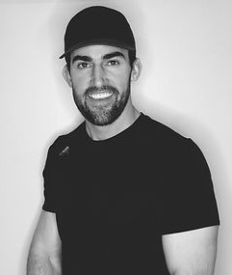
(Carson is a Sport Performance Trainer)

Congratulations to all the award winners! It was a wonderful holiday luncheon – Thanks to YOU!

The White Binders
By J Vargas
In July of 2022 a dedicated group of VVA 1106 members established a Chapter Memorial Committee. You know them well. VP Milt Omoto, Rev. Joseph Plant, Rev Garry Turks, former chapter President Lee White, and John Vargas (Chair). The Plan Your Legacy White Binder was born.

Our..Mission..Statement
To lessen the amount of time and to assist with all required paperwork -documentation to properly handle the “ins and outs” of a hero’s death. To provide ample contact information during this emotional process and lessen the stress.

The importance of contents of this Plan Your Legacy binder was openly talked about by Roderick Thomas, Director of Ft Logan Cemetery, and Jean Eisenberg (Rich Eisenberg’s widow) during our January meeting. With the assistance of our own combat nurse Patti Ehline, Mrs. Eisenberg was able to get her benefits with 3 to 4 weeks! Unheard of in VA circles.

*Note: We will be assembling more binders in February. Contact any member of this committee if you would like one. Great price – FREE! You can also get additional information on our Chapter website.

More About Holiday Lunch
Several members of the Chapter’s Social Committee presented Karen Lohner, Baquet Coordinator at Maggiano’s Little Italy, with several appreciation gifts for her outstanding work and support in making our Holiday Lunch a success. The Committee also presented Chef Harold Nguyen with an appreciation plaque.
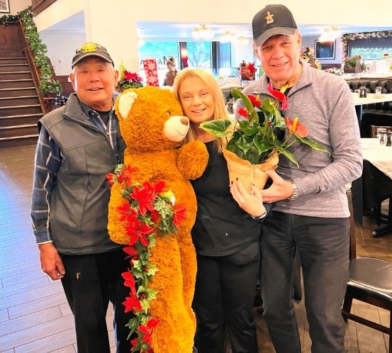
L to R: Milt Omoto, Karen Lohner, John Vargas

Texas Roadhouse
Texas Roadhouse Parker awarded Chapter 1106 with
70 $25 Gift Cards for our participation during the Veterans Day fundraiser. Chapter members assisted restaurant staff in handing out free meal vouchers to veterans and active military as they drove through the parking area on Veterans Day.
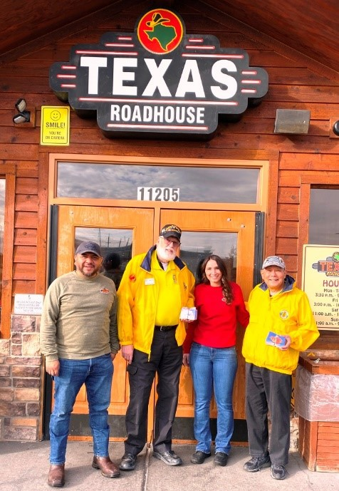
L to R: Israel (Restaurant Mgr), Dave, Serena, Milt

Winter Coat Drive
Our Chapter’s winter coat and food drive was a huge success. Items donated by Chapter members were collected and consolidated by member Nurse Patti. She also received a $250 grant from Thrivent Financials to purchase additional clothing. Patti delivered all items to the Volunteers Of America Bill Daniels Veteran Services Center in Denver. The center provides services to veterans in need including clothing and food. Thank you to all who donated.
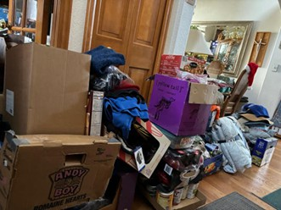
A sample of items collected at Patti’s house

Castle Rock VA Clinic Groundbreaking
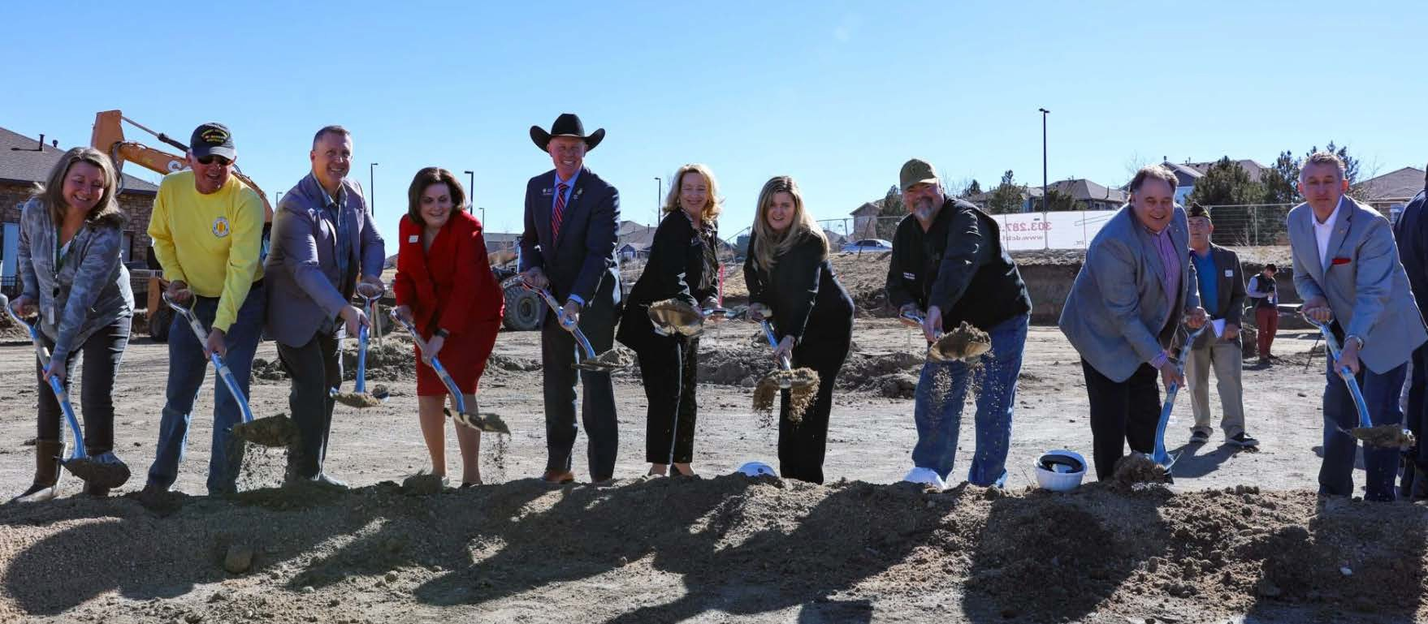
Pictured: Darcy Hoffman, Douglas County Veterans Service Office; Gary Weston, Douglas County Veterans Service Office; Max Brooks, Town of Castle Rock; Commissioner Lora Thomas, Douglas County; Rep. Anthony Hartsook, Colorado House of Representatives District 44; Rep. Lisa Frizell, Colorado House of Representatives District 45; Deborah Mulvey, City of Castle Pines; Commissioner George Teal, Douglas County; Mayor Jason Gray, Town of Castle Rock; Tim Dietz, Town of Castle Rock (photo courtesy of Douglas County)

VA Eastern Colorado Health Care System (ECHCS) hosted a groundbreaking ceremony Thursday, Feb. 1, for the soon-to- be-built VA outpatient clinic at the corner of Prairie Hawk Drive and Dacoro Lane in Castle Rock. The County’s 20,000 Veterans will have access to all the services found at other regional VA Medical Centers including primary care and physical therapy options, at a location convenient to them. The new facility is expected to be open in mid-February 2025.
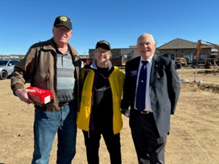
LtoR: Ted Handfelder, Patti Ehline, Joe Dempsey (not pictured: Bob Brown)
Military Trivia Answer
"Roof Stomp" is an Air Force tradition where airmen welcome new commanders or celebrate special occasions by banging on the commander’s roof, windows, and doors.
The commander then opens the door to welcome in the group for refreshments. In recent years, some airmen have modified the tradition to a “porch stomp.”

VVA Household Goods Program
VVA Chapters in Colorado, including Chapter 1106, are fortunate to have the Household Goods Program. As you can see from this map, only 14 states have this program. The Chapter receives monthly checks from VVA National as a result, providing a steady income source for us

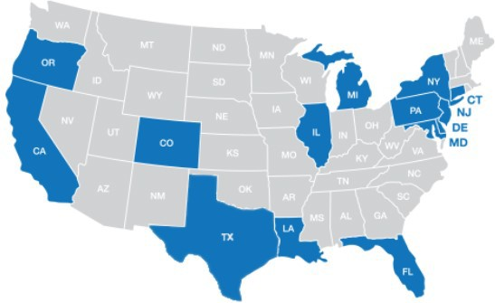
Acceptable Items
Acceptable items for donation include clothing, shoes, household items (dishes, glasses, small appliances, bedding, etc.), toys, electronics, books, small furnishings (see the website for more information). No TV, large furniture, large appliances. They only accept items that are small and light enough for one person (the driver) to easily lift and carry.
Note: For more than 25 bags/boxes/items, call 800-775-8387 and press 4 to speak to an agent.
To Schedule
To schedule a pickup, logon to https://pickupplease.org/donation-program/

If you prefer to drop off your donation, the two closest locations are:

  - Mile High Thrift, 2085 S. Sheridan Blvd, Denver, CO 80227
  - Donation Bin, 9198 Alameda Blvd, Lakewood, CO 80226
  - There is also: Mile High Thrift, 650 Malley Dr. in Northglenn Or Call: 888-518-VETS to schedule
How it Works

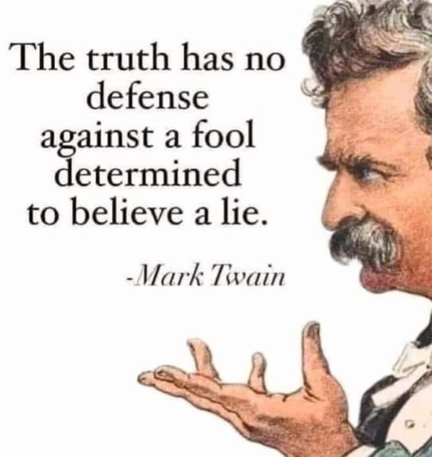

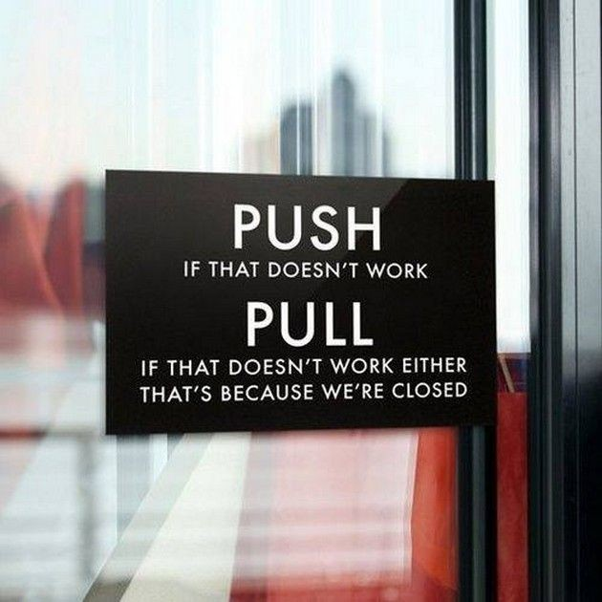

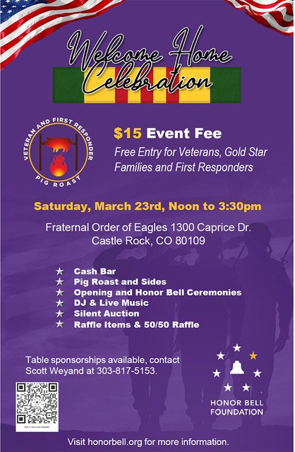

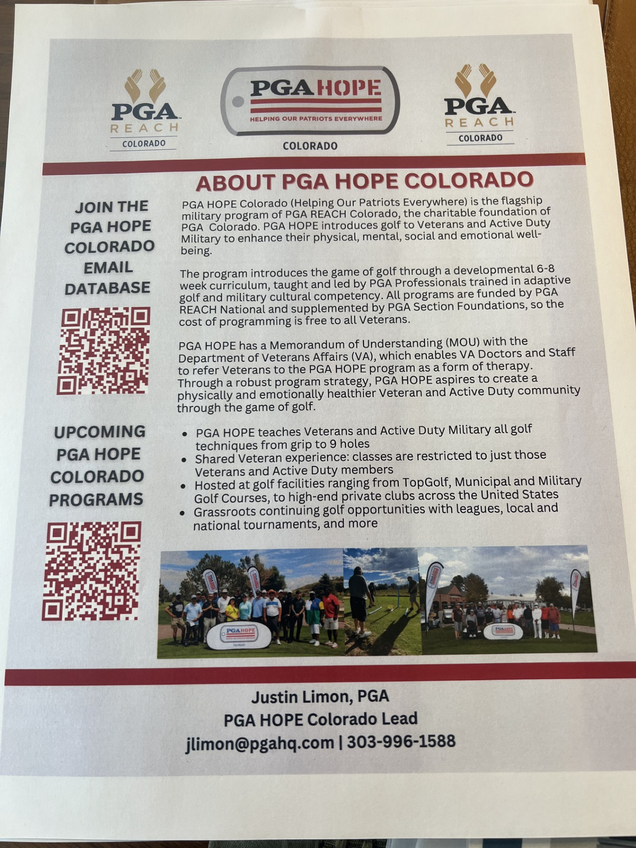

VVA Chapter 1106 Annual Calendar of Events

2024

Date of Issue: December 16, 2023
Date | Event | Location
January 2024
January 6 (Saturday) | Monthly Chapter Meeting | South Metro Fire and Rescue HQ
January 27 (Saturday) | Chapter Board of Directors Meeting | On-Line
February 2024
February 3 (Saturday) | Monthly Chapter Meeting | South Metro Fire and Rescue HQ
February 24 (Saturday) | Chapter Board of Directors Meeting | On-Line
March 2024
March 2 (Saturday) | Monthly Chapter Meeting | South Metro Fire and Rescue HQ
March 9 (Saturday) | Colorado State Council Meeting | Castle Pines Library
March 29 (Friday) | Vietnam Veterans Day (observed) | Events at Various Locations
March 30 (Saturday) | Chapter Board of Directors Meeting | On-Line
April 2024
April 6 (Saturday) | Monthly Chapter Meeting | South Metro Fire and Rescue HQ
April 27 (Saturday) | Chapter Board of Directors Meeting | On-Line
May 2023
May 4 (Saturday) | Monthly Chapter Meeting | South Metro Fire and Rescue HQ
May (TBD) | Chapter Board of Directors Meeting | On-Line
May 25 (Saturday) | Memorial Day “Poppy Drive” Fund Raiser | King Sooper (4-5 Locations TBD)
June 2024
June 1 (Saturday) | Monthly Chapter Meeting | South Metro Fire and Rescue HQ
June 8 (Saturday) | Colorado State Council Meeting | Castle Pines Library
June 29 (Saturday) | Chapter Board of Directors Meeting | On-Line
July 2024
July 4 (Thursday) | Chapter Participation in Fourth of July Parade | Highlands Ranch
July 6 (Saturday) | Monthly Chapter Meeting | South Metro Fire and Rescue HQ
July 27 (Saturday) | Chapter Board of Directors Meeting | On-Line
August 2024
August 3 (Saturday) | Monthly Chapter Meeting | South Metro Fire and Rescue HQ
August 20 - 24 | VVA National Leadership Conference | Reno, NV
August 10 (Saturday) | Chapter Family Summer Picnic | Falcon Park, Highlands Ranch
August 31 (Saturday) | Chapter Board of Directors Meeting | On-Line
September 2024
September 7 (Saturday) | Monthly Chapter Meeting | South Metro Fire and Rescue HQ
September 28 (Saturday) | Chapter Board of Directors Meeting | On-Line
October 2024
October 5 (Saturday) | Monthly Chapter Meeting | South Metro Fire and Rescue HQ
October 12 (Saturday) | Colorado State Council Meeting | Castle Pines Library
October 26 (Saturday) | Chapter Board of Directors Meeting | On-Line
November 2024
November 2 (Saturday) | Monthly Chapter Meeting | South Metro Fire and Rescue HQ
November 9 (Saturday) | Veterans Day “Poppy Drive” Fund Raiser | King Soopers (Locations TBD)
November 11 (Monday) | Veterans Day | Events at Various Locations
November 30 (Saturday) | Chapter Board of Directors Meeting | On-Line
December 2024
December 7 (Saturday) | Monthly Chapter Meeting | South Metro Fire and Rescue HQ
December 14 (Saturday) | Chapter Holiday Luncheon and Festivities | TBD
December 28 (Saturday) | Chapter Board of Directors Meeting | On-Line

Upcoming Events of Interest

