

**Inside this issue:**

Notes from the President

[Member Feature](#Memberfeature)

[Military Trivia](#Militarytrivia)

[Guest Speaker](#Guestspeaker)

[Membership](#Membership)

[Board of Directors/Officers](#Boardofdirectors)

[Working Committees](#Workingcommittees)

[Meetings/Events Calendar](#Meetingsevents)

[Announcement Corner](#Announcementcorner)

[Books/Articles Published by Mbrs.](#Booksarticles)

[From the Editor](#Fromtheeditor)

[Light Side](#Lightside)

[Trivia Answer](#Triviaanswer)

***Editor’s Note:***

**Notice:**

If you have moved or changed your address, PLEASE notify us immediately! Contact: Lee White, Membership Chair

E-mail: <mailto:flyboy51@q.com>

Phone:  303-519-2252

###### COPYRIGHT NOTICE: In accordance with Title 17 U.S.C. Section 107, any copyrighted material in this newsletter is distributed under fair use without profit or payment to those who have expressed a prior interest in receiving the included information for nonprofit use and educational purposes only.

This version of the newsletter is in Microsoft Document (.docx) format so that the links will work. Put your cursor over the link, depress your Control Key (ctrl) and depress your left mouse button and it will take you to the listed link position. PDF format, the links will not work.

The comments and editorial input does not necessarily reflect the opinion of the membership of our chapter. I would appreciate any feedback that you might have, items you liked or if you find offensive or derogatory in anyway. ([bobrotruck73@gmail.com](mailto:bobrotruck73@gmail.com)) Thank you for allowing me to be your editor.

***Notes from the President***

Lee White

New Colorado State Council Officers!

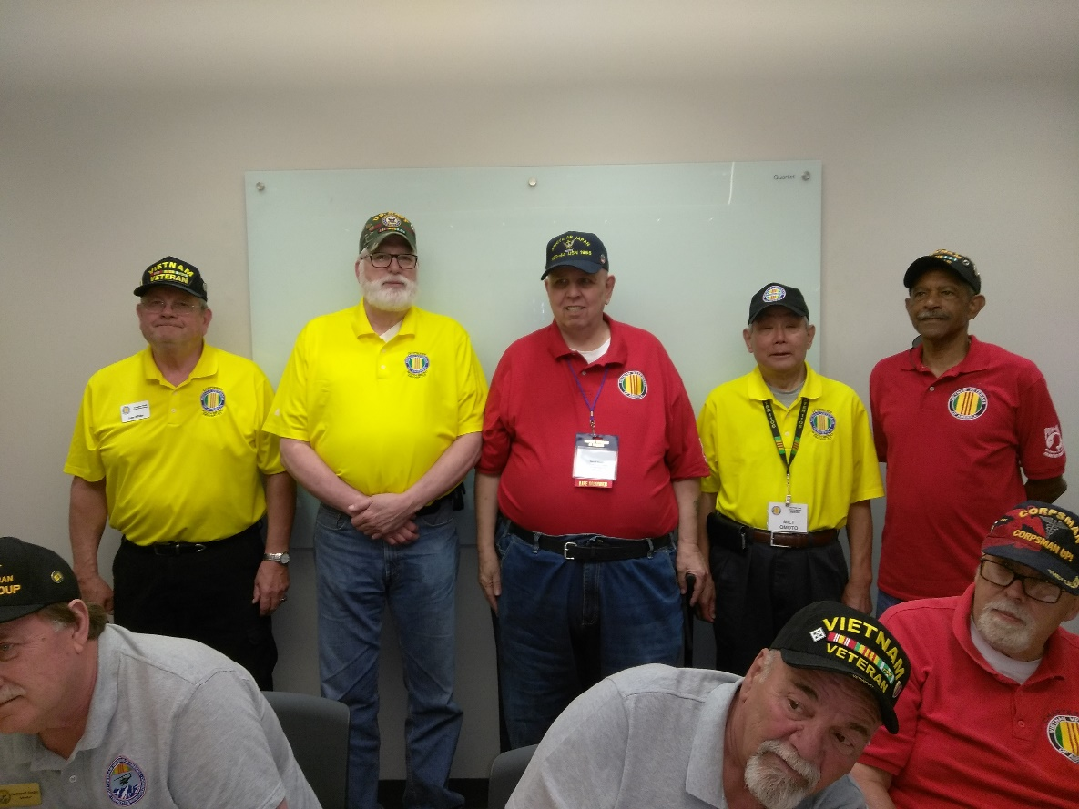

L/R: Lee White, President, Stan Paprocki, 1st. Vice President, (not shown), David Lyons, 2nd. Vice President, David Ramey, Treasurer, Milton Omoto, Secretary

**"The 4th of July"**

By Jackly Wingfield

As the fireworks

Burst around in

Circles and all the

Different designs, the

Evening gets longer, So cheers

For all the

Good times we've had.

I wouldn't trade them for anything. It's

Just so bitter sweet.

Kids having the time of their lives,

Lost in time.

Memories in the making.

Noises of the summer.

Overwhelming excitement in the air.

Patriotism, the red, white, and blue.

Quick little moments fly by.

Relatives and friends having a blast.

Smells of good ole homemade cooking. Just some

Toasting and traditions along the way.

Unbelievable love and sacrifice.

Visioning every night like this one.

Water balloons flying in the air.

Expectations of the night, blown away.

Yelling and singing every word to every song.

Zoned in on honor and enjoying life on the 4th of July.

***“******Member Feature”***

Ted Hanfelder, Staff Sergeant, U.S. Air Force – 1973-1979. I was assigned to Edwards AFB, California and Rickenbacker AFB, Ohio. I was awarded the Air Force Commendation Medal and Air Force Systems Command Master Crew Chief. In addition to my Crew Chief duties, I was an aircraft Maintenance Specialist (Reciprocating Engines). I worked temporarily on the F-14/F-15 project until it was cancelled by President Carter and F-16 and A-10 projects. These planes are still being used today working with Air Force test pilots and text programs. The test programs was very exciting work. I feel that the chapter is doing a great job supporting veterans and their families and I am proud to be a member.

***Military Trivia***

What branch of service was charged with exploring and mapping America? See answer at the [end of the Newsletter](#Triviaanswer).

***May Guest Speaker***

Heather Reck, MS, LPC, CCTP – Mental Health Therapist from Brite Beginnings spoke to our chapter about equine assisted psychotherapy and grief recovery and has proven to provide significant help to military veterans, police officers and firemen with PTSD issues.

Heather is the Niece of Bob and Barbara Rotruck. She and her fiancé live on a small wooded ranch near the town of Elbert. It is an extremely peaceful location and just visiting the property with all of the animals (domestic and wild) can give anybody relief from and any kind of mental anguish. Heather invited any chapter member to just come to Brite Beginnings location and leave your worries behind. Contact Heather at: 720-648-2654, email: [heather@brite-beginnings.com](mailto:heather@brite-beginnings.com). Visit her website at: <www.brite-beginnings.com>.

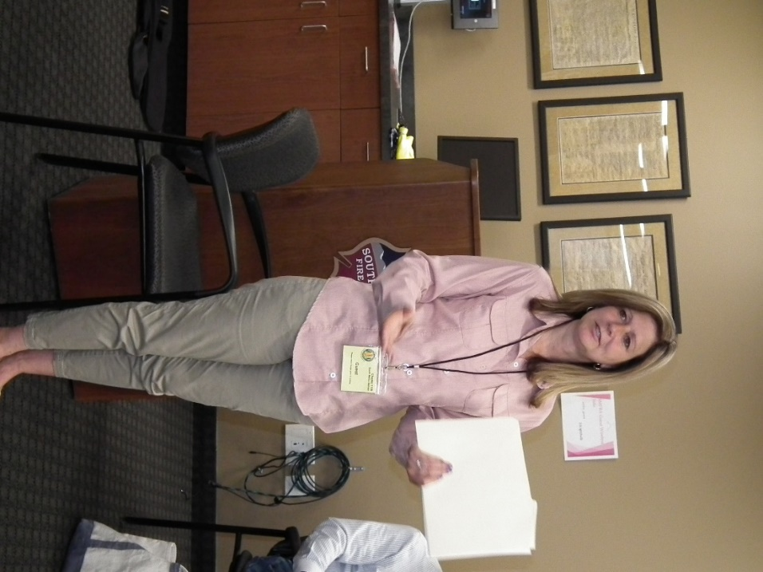

***June Guest Speaker***

Alycia Carmin, Colorado Coordinator for the Quilts of Valor Foundation spoke about the wonderful work being done to honor and help veterans. The mission of the Quilts of Valor Foundation is to cover service members and veterans touched by war with comforting and healing Quilts of Valor. Quilts of Valor Foundation began in 2003 with a dream, literally a dream. Founder Catherine Roberts’ son Nat was deployed in Iraq. According to Catherine:

The beginning: “The dream was as vivid as real life. I saw a young man sitting on the side of his bed in the middle of the night, hunched over. The permeating feeling was one of utter despair. I could see his war demons clustered around, dragging him down into an emotional gutter. Then, as if viewing a movie, I saw him in the next scene wrapped in a quilt. His whole demeanor changed from one of despair to one of hope and wellbeing. The quilt had made this dramatic change. The message of my dream was: Quilts = Healing”

Following Alycia’s presentation, she presented a quilt to our President, Lee White! Lee was very touched, but our membership applauded the presentation knowing the amount of time and energy Lee has done for our Chapter and the VVA. Visit: <www.qovf.org>

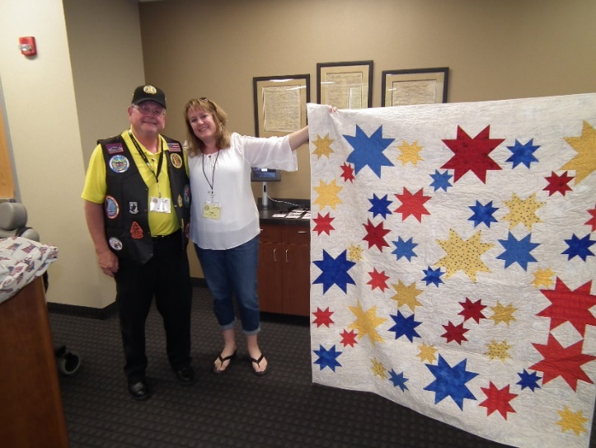

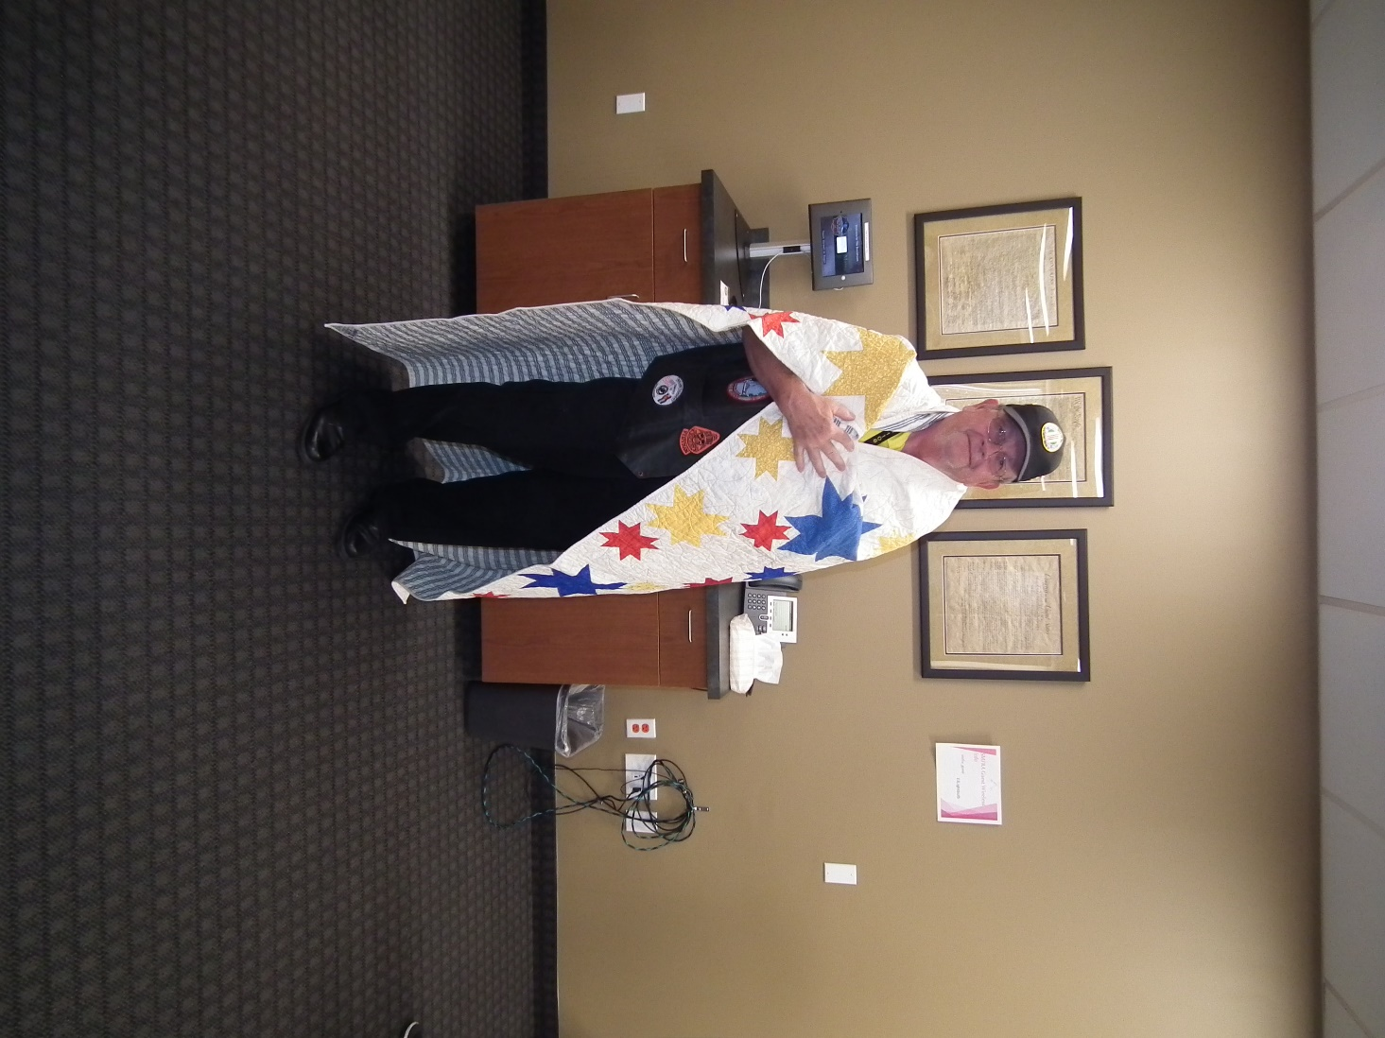

**Joe Plant Surprise**

Quilt of Valor presentation!

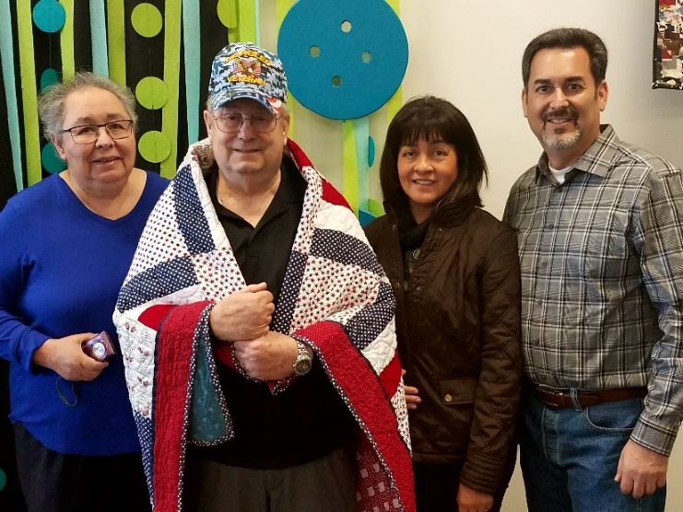

***Membership!***

VVA Chapter 1106 Membership: (6-15-2018)

VVA - 113

AVVA - 33

Total: 136

**Welcome New Members:**

John Sheadel

***Board of Directors/Officers***

Lee White - President

Bob Easter - Vice-president

Joe Plant - Treasurer

Glen Payne - Secretary

Board Members - Milt Omoto, Patti Ehline, Dave Lyons, Tom Werzyn

John Vargas - Sergeant-at-Arms

***Working Committees***

Agent Orange/PTSD - Patti Ehline

Membership - Dave Lyons – Chair, Lee White, Tom Werzyn

Mental Health: Patti Ehline, Warren Harrison

Newsletter Editor - Bob Rotruck

Fundraising/Grants - Milt Omoto

Marketing/Media/Events – Tom Werzyn

POW/MIA – Gary Meyers

Webmaster – Robert Senatore, Bob Rotruck

Women Veterans - Patti Ehline

Scholarship Program - Mike Karsh – Co-Chair, Jim Marcille – Co-Chair, John Vargas, Glen Payne

Veteran Emergency Assistance Committee - Joe Plant, Bob Rotruck, Lee White, Dave Lyons

Speakers Bureau – Bob Easter, Glen Payne, Bob Mallin, Roger Lanphier, Tom Werzyn

Social – John Vargas, Barry Fiore, Glen Payne, Milt Omoto, Hazel Simeon

Government Affairs – Tony Nickerson

***Meetings/Events Calendar - 2018***

* June 23rd - Pueblo Weisbrod Aircraft Museum - Chapter field trip.
* July 4th Highlands Ranch Parade
* July 7th - VVA Chapter 1106 Monthly Meeting
* August 4th - VVA Chapter 1106 Monthly Meeting
* August 11th - VVA Chapter 1106 Summer Family Picnic
* August 18th & 19th – Chapter trip to Grand Junction Western Slope Vietnam Memorial
* August 26th -  Colorado Rockies Baseball Game
* September 8th – State Council Meeting

**An Afternoon at the Ballgame**

Submitted by: Milt Omoto

Our Chapter along with the Forgotten Heroes Campaign, and the American Legion sponsored the attendance of twelve veterans and two spouses to a Rockies game on June 3, 2018. All these veterans are receiving some type of treatment from the Veterans Administration. A majority were Iraq veterans, many with three tours of duty. They are part of the VA’s PTSD treatment program and in various stages of completion. One veteran shared that after returning to civilian life, he finally realized that he has PTSD and was convinced to enroll in the VA’s class. He was apprehensive to start the class. We assured him that he will be in a very supportive and positive environment.

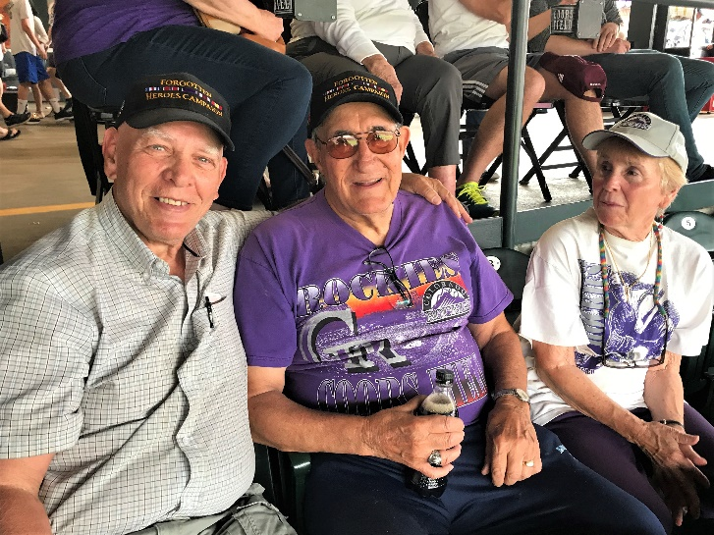

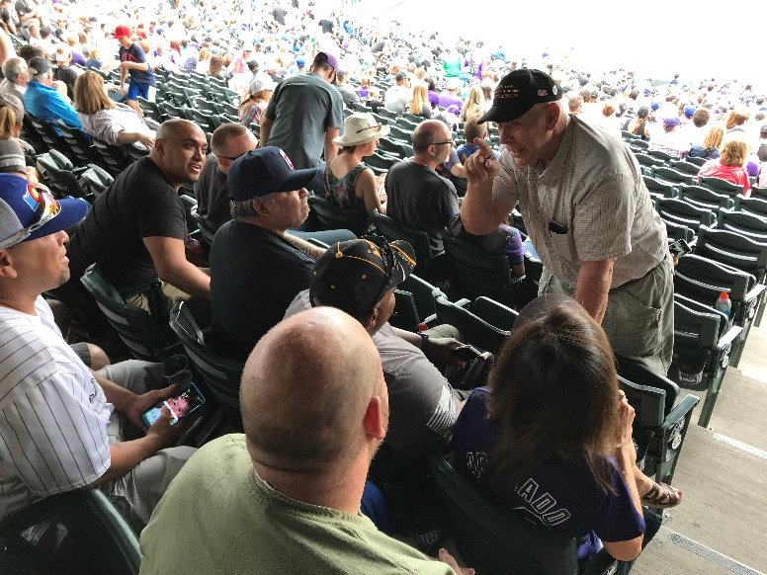

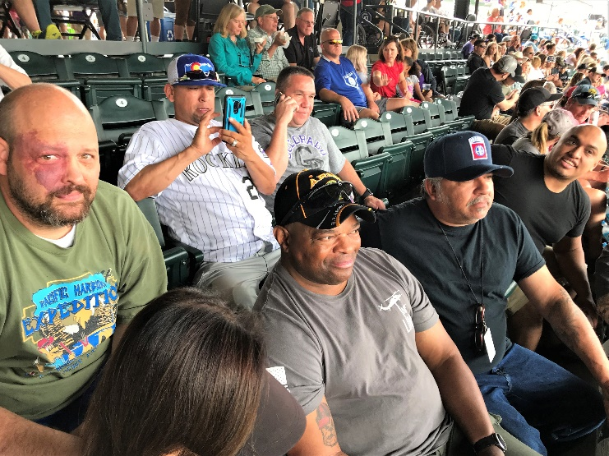

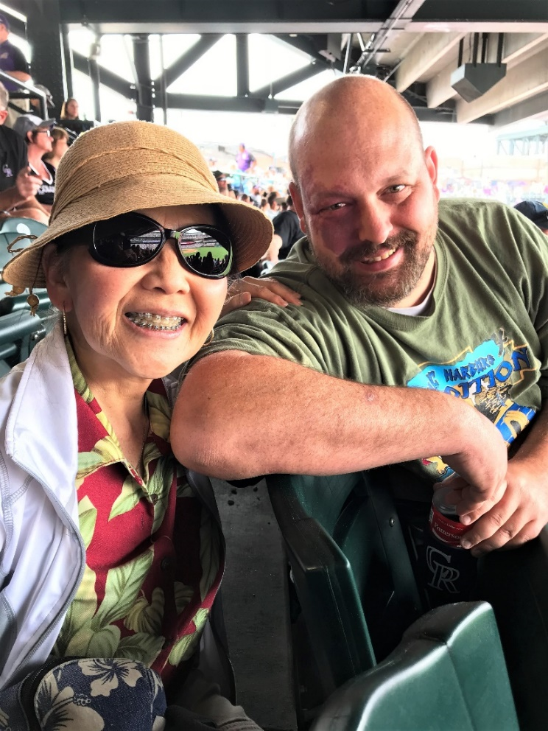

It was great to see these veterans enjoy an afternoon at the ballgame! Thanks to all Chapter members and partner veteran groups who made this possible. Oh, and the Rockies lost to the LA Dodgers, 12-7.

**Citizen Hero**

Author: John Vargas

Michelle Mallin

I first met Michelle about four years ago when the Honor Bell was just the dream of a couple of members from Purple Heart Chapter 1041. At the time, she was handling the marketing duties for the Danny Dietz foundation. What she heard that day, from Lou Olivera and others, peaked her immediate interest!



First, let’s get to know a few tidbits about this dedicated lady! Michelle is originally from Syosset, New York. For a short period of her life, she lived in Alaska before returning to the mainland. While in high school, she was considered a “Nerd.” However, the quarterback and captain of the football team needed special tutoring to pass his science labs and other academia topics. Up stepped Michelle helping him all the way towards graduation. He nicknamed her “Lou.” As a result, Lou was the nerd that no one bothered! She graduated with an M.S degree from the State University at Albany and later received a degree in Publishing from Pace University. Her father and stepfather are both Army military veterans. Her father was awarded the Purple Heart and the Bronze Star. Her stepfather is a well decorated, and now a retired NYC Transit Officer. Her husband, Dean, was in the Navy for six years and currently works at the VA Medical Center in Denver.

She has 19-year-old twins, two older sons and three beautiful grandchildren.

Michelle has been in the non-profit sector for over 20 years and is the owner of MGM Solutions in Highlands Ranch, Colorado. MGM is a consulting firm offering event planning, fundraising, and project management services. Over the years, she has organized a myriad of events!

As a founding partner of the HB here in Denver, Michelle met constantly and often late into the night to help develop the mission, scope and long range plans. Michelle is a true visionary! She met with countless families of fallen veterans and obtained awards that were eventually casted into the Honor Bell. She was also instrumental in the decision process and design of the customized van that carries and houses the Honor Bell.

The rewards of those long days and nights all came together on May 21, 2016, when the HB was on its way to its new home from the foundry with volunteers and various law enforcement escorts. The HB made seven stops; the first was at American Park for the Cincinnati Reds Military Appreciation Day. After a few stops along the way, the HB caravan was met by the local media, Patriot Guard Riders and Rolling Thunder along with members of VVA Chapter 1106, at the Medal of Honor Memorial in Pueblo. It is now filling the atmosphere at Ft. Logan with warm sounds honoring our deceased veterans and their families.

Not too long ago, we were privy to her medical condition. Michelle developed a rare strain of Cancer and had to retire from her post. As, she continues to fight her illness Michelle works tirelessly at the HB Foundation on local presentations, fundraisers and always lobbying for a person to Toll the Honor Bell.

This was only a glimpse into the well-rounded life of Michelle Mallin. A patriot, a mother, a volunteer and innovator who purses living with a “Never, Never Quit” attitude. We are elated and proud to name Michelle Mallin, “Citizen Volunteer”.

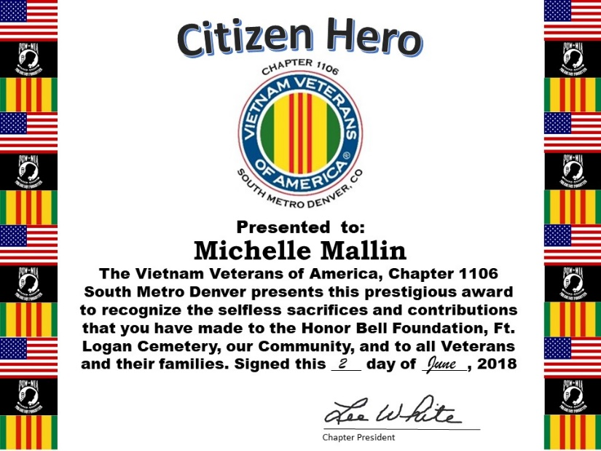

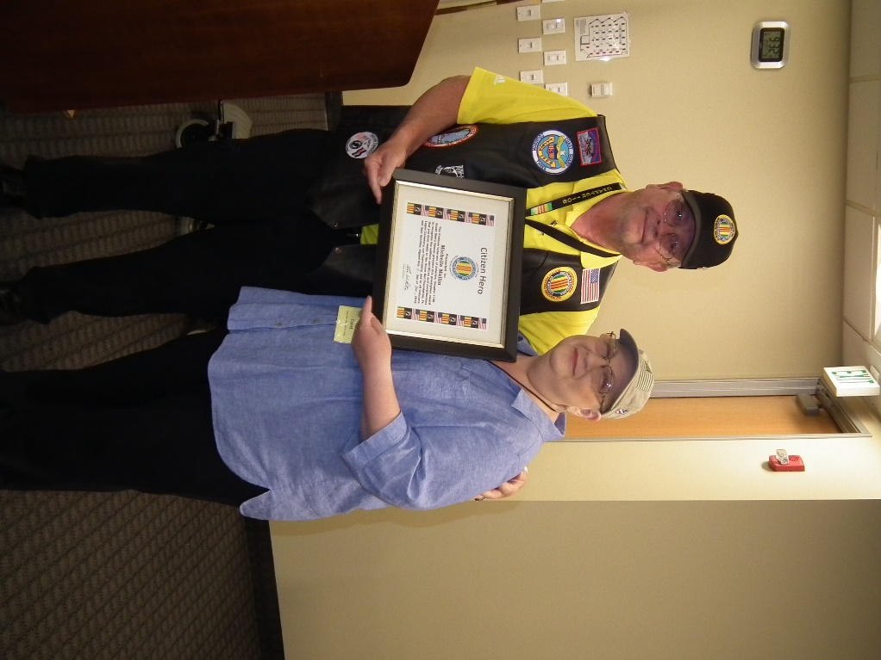

Lee presenting Citizen Award to Michelle at June meeting.

***In Memoriam***

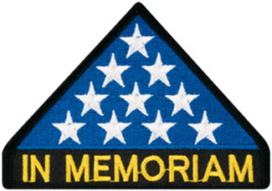

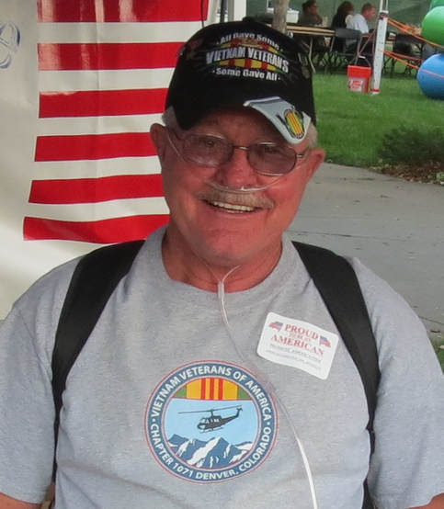

Dan Dietz May 5, 1952 - April 28, 2018. - Founding Member, Past Treasurer, of VVA Chapter 1071. The Chapters first meeting was on October 1, 2012 and Dan was there as one of the founding members and was the first Treasurer of the Chapter. Dan's unselfish contributions and dedication has helped make Chapter 1071 the great success that it is today. Our prayers and thoughts go out to his family.



As of: 6/18/2018

Total Funeral Homes Visited - 2,237

Cremains Found - 16,785

Veterans Cremains Identified - 3,815

Veterans Interred - 3,547

**History Test**

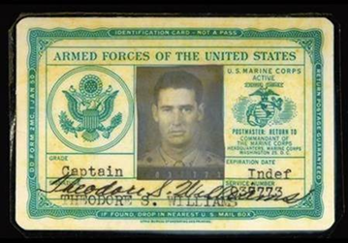

Do you know this Marine? See end of newsletter for the answer or [click here](#WhoKnew).

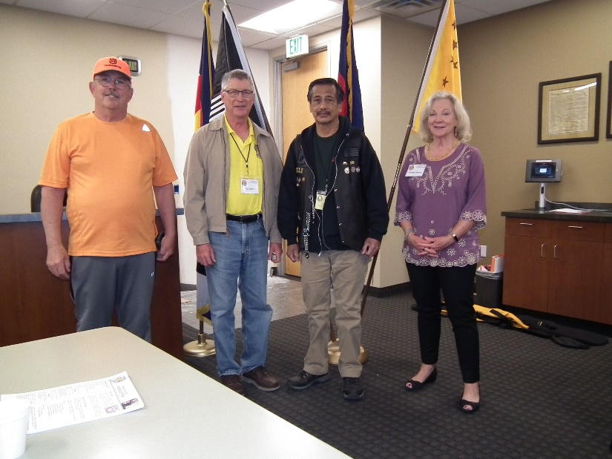

Suzanne Sigona presented the 50th Vietnam War Anniversary pin to (L/R): John Sheadel, David Woods, Clarence Rebolledo

**Poppies - Another great fundraiser!**

The five Landing Zones did very well again at King Soopers stores. Thank you King Soopers for allowing our chapter this opportunity to remind the public of Memorial Day and the sacrifice so many of our brothers and sisters have made for the United States of America.

LZ1 – Iliff & Buckley, Aurora - $523.00

LZ2 – Buckley & Quincy, Aurora - $679.70

LZ3 – Smokey Hill & Himalaya, Centennial - $642.74

LZ4 – Parker - $1,116.13

LZ5 – Castle Rock - $938.43

GRAND TOTAL: $3,919.00

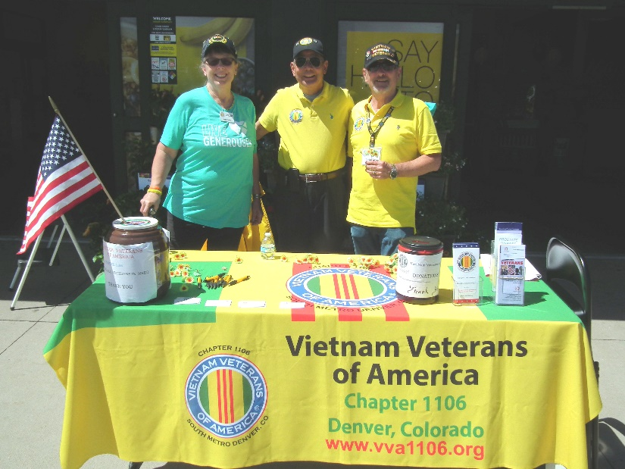

Double doors, Castle Rock – Patti Ehline, Milt Omoto, Tom Frey

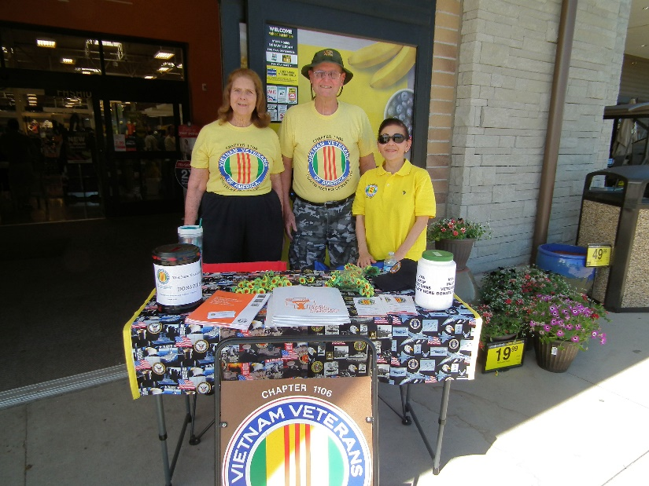

Single Door, Castle Rock – Barbara and Bob Rotruck, Chris Omoto

***Announcement Corner***

***Books/Articles Published by Members***

**The 4th of July**

From Roger Lamphier

So - take a few moments, while enjoying your 4th of July holiday, and silently thank these patriots. It’s not much to ask, for the price they paid. Remember, freedom is never free!!

Have you ever wondered what happened to the 56 men who signed our Declaration of Independence??

Five signers were captured by the British as traitors, and were tortured before they died. Twelve had their homes ransacked and burned. Two lost their sons, who were serving in the Revolutionary Army; another had two sons captured. Nine of the 56 fought, and died from wounds, or hardships, of the Revolutionary War. They signed, and they pledged their lives, their fortunes and their sacred honor.

What kind of men were they?

Twenty four were lawyers and jurists. Eleven were merchants, nine were farmers and large plantation owners; men of means, well educated. But, they signed the Declaration of Independence knowing full well that the penalty would be death if they were captured.

Carter Braxton, of Virginia, a wealthy planter and trader, saw his ships swept from the seas by the British Navy. He sold his home and properties to pay his debts and died in rags.

Thomas McKean was so hounded by the British that he was forced to move his family almost constantly. He served in the Congress without pay, and his family was kept in hiding. His possessions were taken from him, and poverty was his reward.

Vandals and soldiers looted the properties of Dillery, Hall, Clymer, Walton, Gwinnett, Heyward, Ruttledge and Middleton.

British General Cornwallis had taken over the Nelson home for his headquarters. Nelson quietly urged George Washington to open fire. The home was destroyed, and Nelson died bankrupt.

Francis Lewis had his home and property destroyed. The enemy jailed his wife and she died within a few months.

John Hart was driven from his wife’s bedside as she was dying. Their 13 children fled for their lives. His fields and his gristmill were laid to waste. For more than a year he lived in forests and caves, returning home to find his wife dead and his children vanished. A few weeks later he died from exhaustion and a broken heart. Norris and Livingston suffered similar fates.

Such were the stories and sacrifices of the American Revolution. These were not wild-eyed, rabble-rousing ruffians. They were soft-spoken men of means and education, but they valued liberty more. Standing tall, straight and unwavering, they pledged:

**“…for the support of this declaration, with firm reliance on the protection of the divine providence, we mutually pledge to each other, our lives, our fortunes and our sacred honor.”**

They gave you and me a free and independent America. The history books never told you lot about what happened in the Revolutionary War. We didn’t just fight the British; we were British subjects at that time and we fought our own government!

Some of us take these current liberties for granted, but we shouldn’t.

**Remember this Lady?**

**Did you take her advice?**

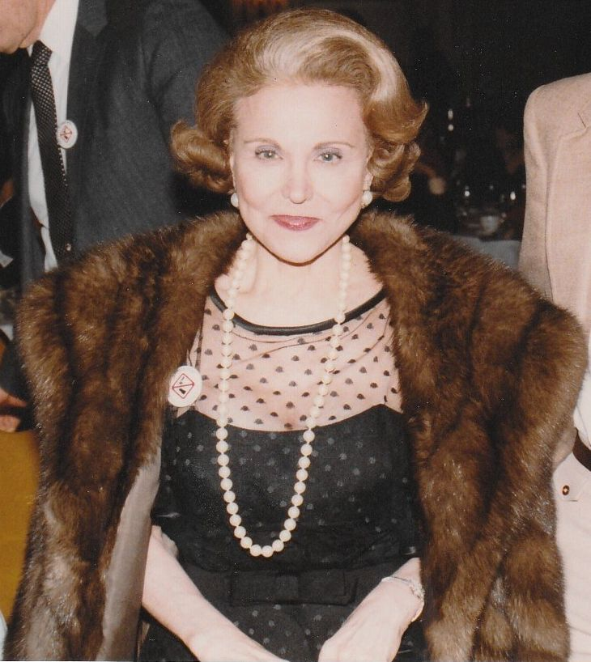

Yes, it is Ann Landers, Syndicated Columnist, (her editorial name)!

**Dear Ann:** I am an inner city English teacher and my students are reading *George Orwell’s 1984*. I am having a difficult time explaining communism, socialism and fascism without giving a full-blown, time-consuming history lesson. I recalled you printed a humorous column some time ago explaining these concepts. Will you please print it again? I’m sure it will kick-start a lively classroom discussion. **A – Teacher in Mississippi.**

**Dear Mississippi Teacher:** Thank you for asking. It’s an “oldie” but a “goldie”. Here it is:

**Socialism:** You have two cows. Give one cow to your neighbor.

**Communism:** You have two cows. Give both cows to the government and they might give you some milk.

**Fascism:** You have two cows. Give all the milk to the government and the government sells it.

**Nazism:** You have two cows. The government shoots you and takes both cows.

**Anarchism:** You have two cows. Keep both of the cows, shoot the government agent and steal another cow.

**Capitalism:** You have two cows. Sell one cow and buy a bull.

**Surrealism:** You have two giraffes. The government makes you take harmonica lessons.

(Editor: I’m glad I have that straight now!)

**Flag Etiquette**

Some things you may not know or remember!

The U.S. Flag Code formalizes and unifies the traditional ways in which we give respect to the flag, also contains specific instructions on how the flag is not to be used.

The following is a list of do’s and don’ts associated with Old Glory, the U.S. Flag.

When displaying the flag, DO the following:

* Display the U.S. flag from sunrise to sunset on buildings and stationary flagstaffs in the open. When a patriotic effect is desired the flag may be displayed 24-hours a day if properly illuminated during the hours of darkness.
* When placed on a single staff or lanyard, place the U.S. Flag above all other flags.
* When flags are displayed in a row, the U.S. flag goes to the observer’s left. Flags of other nations are flown at same height. State and local flags are traditionally flown lower.
* When used during a marching ceremony or parade with other flags, the U.S. Flag will be to the observer’s left.
* On special days, the flag may be flown at half-staff. On Memorial Day it is flown at half-staff until noon and then raised.
* When flown at half-staff, should be first hoisted to the peak for an instant and then lowered to the half-staff position. The flag should be again raised to the peak before it is lowered for the day. By "half-staff" is meant lowering the flag to one-half the distance between the top and bottom of the staff.
* When the flag is displayed over the middle of the street, it should be suspended vertically with the union (blue field of stars) to the north in an east and west street or to the east in a north and south street.
* When placed on a Podium the flag should be placed on the speaker’s right or the staging area. Other flags should be placed to the left.
* When displayed either horizontally or vertically against a wall (or other flat surface), the union (blue field of stars) should be uppermost and to the flag's own right, that is, to the observer's left.
* When displayed in a window it should be displayed in the same way -- with the union or blue field to the left of the observer in the street.
* When the flag is displayed on a car, the staff shall be fixed firmly to the chassis or clamped to the right fender.
* When the flag is used to cover a casket, it should be so placed that the union is at the head and over the left shoulder. The flag should not be lowered into the grave or allowed to touch the ground.

When saluting the flag DO the following:

* All persons present in uniform (military, police, fire, etc.) should render the military salute. Members of the armed forces and veterans who are present but not in uniform may render the military salute.
* All other persons present should face the flag and stand at attention with their right hand over the heart, or if applicable, remove their headdress with their right hand and hold it at the left shoulder, the hand being over the heart.

When stowing or disposing of the flag, DO the following:

* Fold in the traditional triangle for stowage, never wadded up.
* The VFW offers the following instructions for properly disposing of a worn flag:
* The flag should be folded in its customary manner.
* It is important that the fire be fairly large and of sufficient intensity to ensure complete burning of the flag.
* Place the flag on the fire.
* The individual(s) can come to attention, salute the flag, recite the Pledge of Allegiance and have a brief period of silent reflection.
* After the flag is completely consumed, the fire should then be safely extinguished and the ashes buried.
* Please make sure you are conforming to local/state fire codes or ordinances.

Quick list of Flag Etiquette Don’ts:

* Don’t dip the U.S. Flag for any person, flag, or vessel.
* Don’t let the flag touch the ground.
* Don’t fly flag upside down unless there is an emergency.
* Don’t carry the flag flat, or carry things in it.
* Don’t use the flag as clothing.
* Don’t store the flag where it can get dirty.
* Don’t use it as a cover.
* Don’t fasten it or tie it back. Always allow it to fall free.
* Don’t draw on, or otherwise mark the flag.
* Don’t use the flag for decoration. Use bunting with the blue on top, then white, then red.

**The Veteran’s Creed**

Sent by Henry Bohne – Korean War Navy Veteran and former Douglas County Veterans Services Officer

Each element of the Creed is rooted in shared military tenets, the missions of participating veterans and military service organizations, and in the altruistic ethos of veterans themselves. It is also meant to remind Americans that the principles and values veterans learned in the military – integrity, leadership, teamwork, selfless service – can greatly benefit our country.

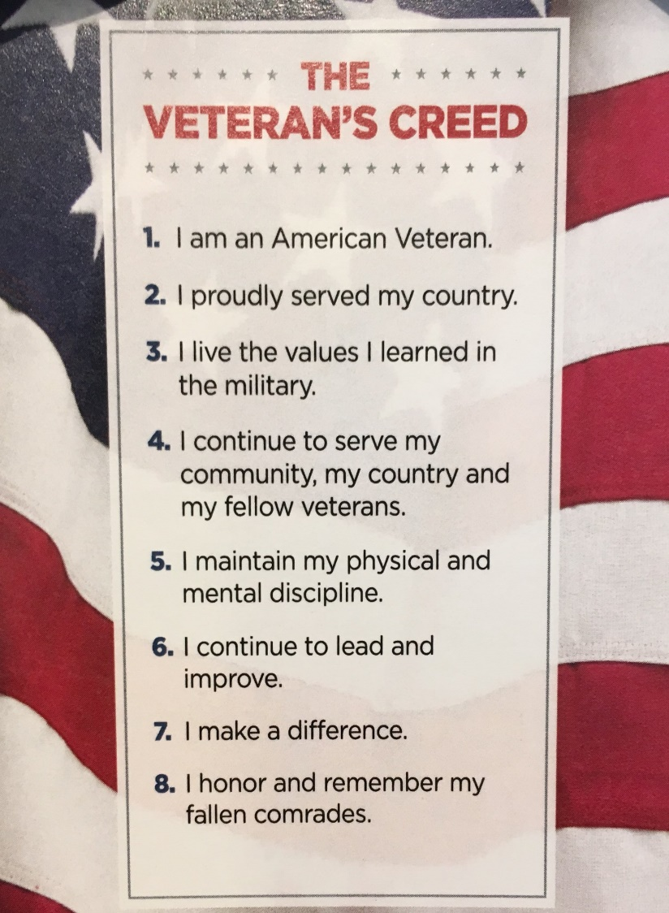

***From the Editor***

**From the desk of The Landlocked Sailor**

Bob Rotruck, CWO3, USN (RET)

**Living with fear**

We Americans all live with some level of fear every day, but we don’t let it overcome our ability to persevere and thus live a fairly normal life. If every time we got into our automobile, we became blinded by the fear that some driver was going to do something stupid and we would end up dead, we eventually would quit driving. Consider the fear of food poisoning; would we ever eat out at a restaurant again? How about a little exercise? Oh my, what If I have a heart attack! Living in fear can eventually strangle us to the point where we become a recluse. Unfortunately, this level of fear does happen to some people, but by in large, the majority of us just don’t let it take a complete hold over our lives.

Now consider the mother, father, spouse that watches their loved one go off to join the military. Initially, they know that they are going to take basic training somewhere in the United States. The percentage of fatal accidents in military boot camps is negligible. The same is true for more advanced training. But now it is time to deploy. Going to Alaska or Hawaii – not a problem? Going to Iraq or Afghanistan, now there is the far more serious potential of being in harm’s way. Will I ever see my son, daughter, husband, or wife again? They are going to a place of eminent danger; living amongst people that want them out of their country. If they leave in a metal body container, good! They won’t be back!

How do we live with that kind of fear in our hearts? Every day, the possibility exists that a knock will be heard at the front door. A military person will be there in their dress uniform with a forlorn look on their face. The news will be crushing and your heart wants to stop. Your mind says this is a dream and no, this cannot be happening to me. My son, my child, my life mate, has been taken away because they voluntarily joined the military to defend our country as thousands in the past have done for this country. How can you go on? How do we go on living with this fear? It is not easy! Most of us are blessed with loving family members and dear friends that come immediately to our side to offer comfort and words of assurance that their loved one did not die in vain. They gave everything to defend our United States and our wonderful way of life. Please NEVER FORGET and stand with pride of the ultimate sacrifice that our young men and women are making every day for our freedom!

Memorial Day – 2018 – MIA

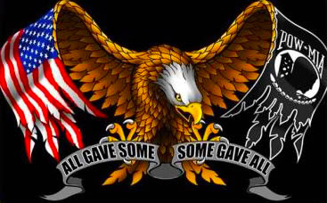

**Bring them Home**

Almighty God bring them home,

Their spirit too long has roamed.

They never hid from their country’s bidding,

Their devotion to serve wasn’t kidding.

Off they went, never a thought of no return,

Little did they know their life would take a turn.

Saying goodbye to family and friends was tough,

Giving all that they could should be enough.

But when they were left behind at war’s end,

They knew their country would never bend.

To find us missing in action and alone,

The search will never miss an unturned stone.

And every day that passes by for families in grief,

They keep hoping the day will come with relief.

Of the news their loved one has been found,

And relief in their heart will now abound.

Families’ can now find relief in tears,

Even though the news held their fears.

To finally have closure of the fate of their loved one,

Will allow them to honor the service they’ve done.

We must never forget those who gave their all,

And bring them home to honor their call!

ROTRUCK - 2018

**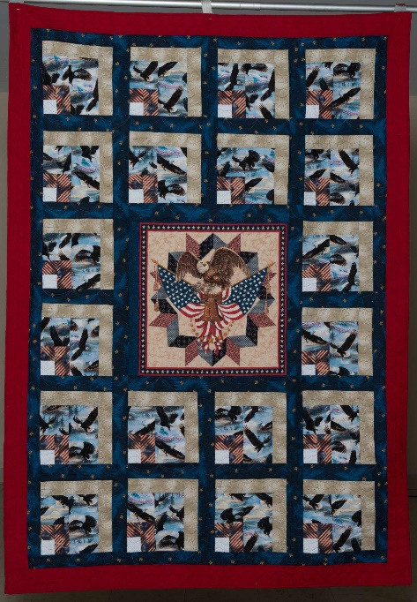**

**Quilts of Valor**

Do citizens know the pain of war?

Have they ever had to keep score?

Of the terror and fear that many have seen,

Their mind seems to never come clean.

They live with horror in their brain,

So many have seen war’s blood stain.

They come home with war’s trauma,

Some want to drown their memory in a sauna.

But there is a group that knows how to ease the pain,

They have a gift that soaks up the memory of a blood stain.

And give relief to those that still shake,

It is far better than a fresh piece of cake.

It’s called a quilt, made with love for you,

From cloth that absorbs the tears you do.

A design the makes so much pain go away,

Just wrap yourself in it for a few hours a day.

And comfort comes into your body,

Far better than an alcohol hot toddy.

And each day, the pain starts to ease,

The comfort of the quilt is like smooth seas.

And then you think of the maker of the quilt,

And know that they have relieved your guilt.

Thank you quilt maker for removing the strain,

My body is losing the memories of pain.

Quilts of Valor, you have removed my stressing,

May God continue your work with His blessing!

God bless you and God bless America!

ROTRUCK - 2018

**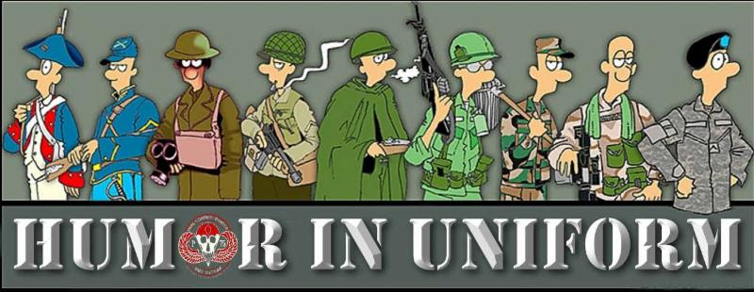**

**Helpful Texan**

As the bus stopped and it was her turn to get on, she became aware that her skirt was too tight to allow her leg to come up to the height of the first step of the bus.

So, a little more embarrassed, she once again reached behind her to unzip her skirt a little more, and for the second time attempted the step. Once again, much to her chagrin, she could not raise her leg. With a little smile to the driver, she again reached behind to unzip a little more and again was unable to take the step.

About this time, a large Texan who was standing behind her picked her up easily by the waist and placed her gently on the step of the bus.

She went ballistic and turned to the would-be Samaritan and yelled, ‘How dare you touch my body! I don’t even know who you are!’

The Texan smiled and drawled, ‘Well, ma’am, normally I would agree with you, but after you unzipped my fly three times, I kinda figured we was friends.’

**Some of Phyllis Diller's best!**

* As your beauty fades, so will his eyesight.
* Housework can't kill you, but why take a chance?
* Cleaning your house while your kids are still growing up is like shoveling the sidewalk before it stops snowing.
* The reason women don't play football is because 11 of them would never wear the same outfit in public.
* Best way to get rid of kitchen odors: Eat out.
* A bachelor is a guy who never made the same mistake once.
* I want my children to have all the things I couldn't afford. Then I want to move in with them.
* Most children threaten at times to run away from home. This is the only thing that keeps some parents going.
* Any time three New Yorkers get into a cab without an argument, a bank has just been robbed.
* We spend the first twelve months of our children's lives teaching them to walk and talk and the next twelve years telling them to sit down and shut up.
* Burt Reynolds once asked me out. I was in his room.
* What I don't like about office Christmas parties is looking for a job the next day.
* The only time I ever enjoyed ironing was the day I accidentally got gin in the steam iron.
* His finest hour lasted a minute and a half.
* Old age is when the liver spots show through your gloves.
* My photographs don't do me justice -they look just like me.
* Tranquilizers work only if you follow the advice on the bottle - keep away from children.
* I asked the waiter, 'Is this milk fresh?' He said, 'Lady, three hours ago it was grass.'
* The reason the golf pro tells you to keep your head down is so you can't see him laughing.
* You know you're old if they have discontinued your blood type.

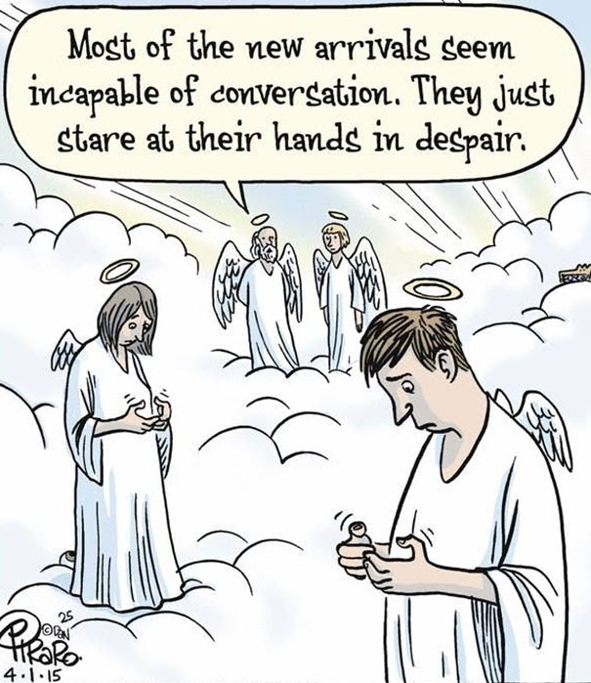

**Aging!**

Submitted by John Vargas

(Editor: I photo shopped the cartoon so the face didn’t look like John Vargas!!!)

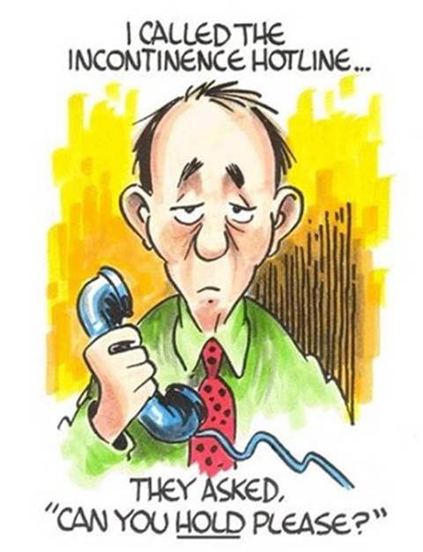

**THE HAIRCUT**

Blessed are those that can give without remembering, and take without forgetting.

One day a florist went to a barber for a haircut. After the cut, he asked about his bill, and the barber replied, 'I cannot accept money from you, I'm doing community service this week.' The florist was pleased and left the shop.

When the barber went to open his shop the next morning, there was a 'thank you' card and a dozen roses waiting for him at his door. Later, a cop comes in for a haircut, and when he tries to pay his bill, the barber again replied, 'I cannot accept money from you, I'm doing community service this week.' The cop was happy and left the shop. The next morning when the barber went to open up, there was a 'thank you ' card and a dozen donuts waiting for him at his front door!

Then a Congressman came in for a haircut, and when he went to pay his bill, the barber again replied, 'I cannot accept money from you. I'm doing community service this week.' The Congressman was very happy and left the shop.

The next morning, when the barber went to open up, there were a dozen Congressmen lined up waiting for a free haircut.

And that, my friends, illustrates the fundamental difference between the citizens of our country and the politicians who run it.

As Ronald Reagan said:

**“BOTH POLITICIANS AND DIAPERS NEED TO BE CHANGED OFTEN AND FOR THE SAME REASON!”**

**Giving Up!**

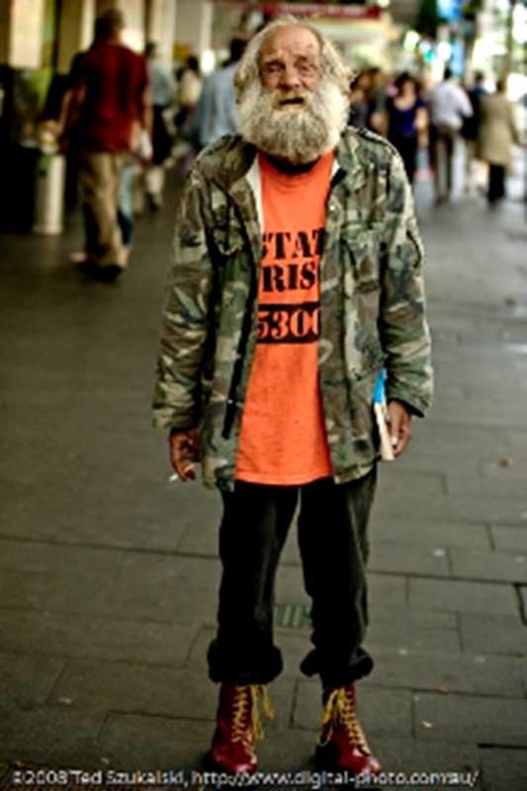

A man was walking down the street when he was accosted by a particularly dirty and shabby-looking homeless man who asked him for a couple of dollars for dinner. The man took out his wallet, extracted ten dollars and asked, "If I give you this money, will you buy some beer with it instead of dinner?"

"No, I had to stop drinking years ago," the homeless man replied.

"Will you spend this on green fees at a golf course instead of food?" the man asked.

"Are you NUTS!" replied the homeless man. "I haven't played golf in 20 years!"

"Well," said the man, "I'm not going to give you money. Instead, I'm going to take you home for a hot shower and a terrific dinner cooked by my wife."

The homeless man was astounded. "Won't your wife be furious with you for doing that?

The man replied, "That's okay. It's important for her to see what a man looks like after he has given up drinking and golf."

**Gotta love Service Dogs**

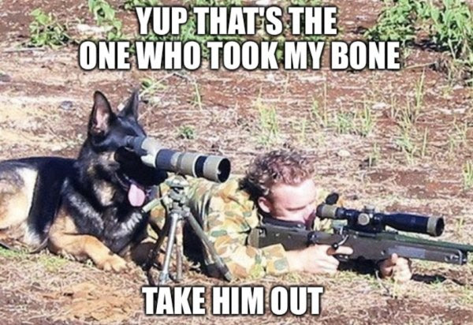

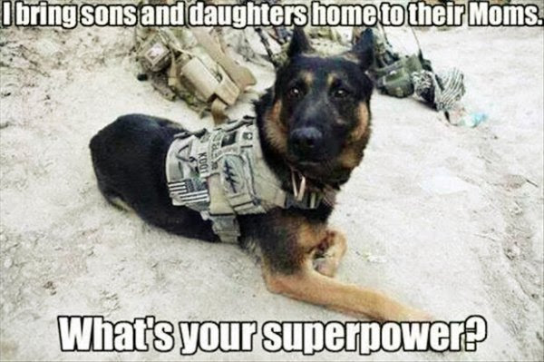

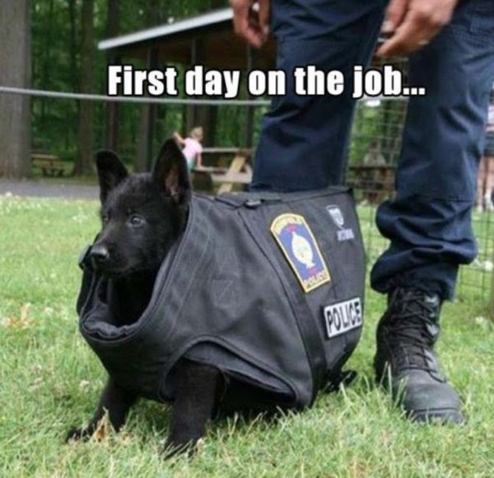

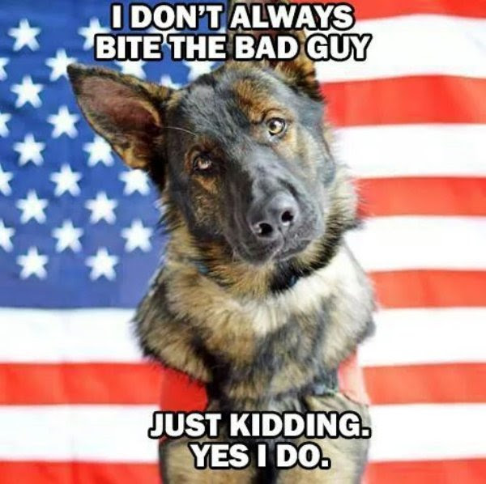

**Talking Dog**

A guy is driving around the back woods of Montana and he sees a sign in front of a broken down shanty-style house: 'Talking Dog for Sale’

He rings the bell and the owner appears and tells him the dog is in the backyard. The guy goes into the backyard and sees a nice looking Labrador retriever sitting there.

'You talk?' he asks.

'Yep,' the Lab replies.

After the guy recovers from the shock of hearing a dog talk, he says 'So, what's your story?'

The Lab looks up and says, 'Well, I discovered that I could talk when I was pretty young. I wanted to help the government, so... I told the CIA. In no time at all they had me jetting from country to country, sitting in rooms with spies and world leaders, because no one figured a dog could eavesdrop.'

'I was one of their most valuable spies for eight years running... But the jetting around really tired me out, and I knew I wasn't getting any younger so I decided to settle down. I signed up for a job at the airport to do some undercover security, wandering near suspicious characters and listening in. I uncovered some incredible dealings and was awarded a batch of medals. 'I got married, had a mess of puppies, and now I'm just retired.'

The guy is amazed. He goes back in and asks the owner what he wants for the dog.

'Ten dollars,' the guy says.

'Ten dollars? This dog is amazing! Why on earth are you selling him so cheap?'

'Because he's a bullsh\*\*ter. He's never been out of the yard'.

**New Corvette**

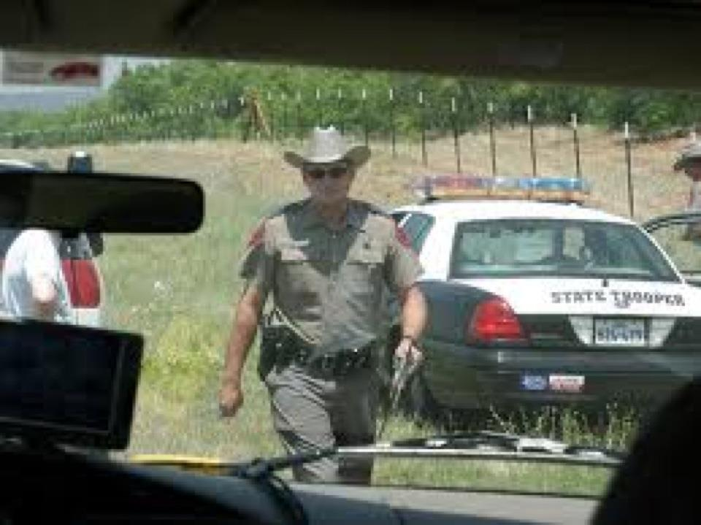

A senior citizen drove his brand new Corvette convertible out of the dealership. Taking off down the road, he floored it to 80 mph, enjoying the wind blowing through what little gray hair he had left. "Amazing," he thought as he flew down I-94, pushing the pedal even more. Looking in his rear view mirror, he saw a state trooper behind him, lights flashing and siren blaring. He floored it to 100 mph, then 110, then 120. Suddenly he thought, "What am I doing? I'm too old for this," and pulled over to await the trooper's arrival. Pulling in behind him, the trooper walked up to the Corvette, looked at his watch, and said, "Sir, my shift ends in 30 minutes. Today is Friday. If you can give me a reason for speeding that I've never heard before, I'll let you go."

The old gentleman paused. Then he said, "Years ago, my wife ran off with a State trooper. I thought you were bringing her back."

"Have a good day, sir," replied the trooper.

***Trivia Answer***

The U.S. Army was in charge of exploring and mapping America. The Lewis and Clark Expedition was an all Army affair. Army officers were the first Americans to see such landmarks as Pike's Peak and the Grand Canyon.

**How about this for a “WHO KNEW” history lesson?**



When asked to name the greatest team he was ever on, Ted Williams said: "The US Marines." Ted Williams was John Glenn's wingman flying F-9Fs in Korea.

The Boston Red Sox slugger who wore No. 9 as a major leaguer, was assigned to an F-9 Panther jet as a pilot. Ted flew a total of 39 combat missions in Korea. He was selected by his commander John Glenn (later the astronaut, senator, and 'septuagenarian’) to fly as Glenn's wingman.

While flying an air strike on a troop encampment near Kyomipo, Williams' F-9 was hit by hostile ground fire. Ted commented later: "The funny thing was I didn't feel anything. I knew I was hit when the stick started shaking like mad in my hands. Then everything went out, my radio, my landing gear, everything. The red warning lights went on all over the plane." The F-9 Panther had a centrifugal flow engine and normally caught fire when hit the tail would literally blow off most stricken aircraft. The standard orders were to eject from any Panther with a fire in the rear of the plane. Ted's aircraft was indeed on fire, and was trailing smoke and flames. Glenn and the other pilots on the mission were yelling over their radios for Williams to get out.

However, with his radio out, Williams could not hear their warnings and he could not see the condition of the rear of his aircraft. Glenn and another Panther flown by Larry Hawkins came up alongside Williams and lead him to the nearest friendly airfield. Fighting to hold the plane together, Ted brought his Panther in at more than 200-MPH for a crash landing on the Marsden-matted strip. With no landing gear, dive brakes, or functioning flaps, the flaming Panther jet skidded down the runway for more than 3000 feet. Williams got out of the aircraft only moments before it was totally engulfed in flames. Ted Williams survived his tour of duty in Korea and returned to major league baseball.

**Newsletter articles/stories/photos**

Any articles, stories and/or photos submitted for the newsletter must be received by the cutoff date which for our newsletter is the 20th of the month preceding publication. Photos must be accompanied by text which describes the event, names, dates, credits and any other pertinent facts so our readers understand the story behind the photo(s). Due to space availability, the editor reserves the right to include or exclude information or photos for a given two month period of publication.

**FRIENDS OF CHAPTER 1106**

|  |  |
| --- | --- |
| **ERC Management, LLC**  791 Southpark Dr., Suite 600  Littleton, CO 80120  [720.328.3299](tel:720.328.3299)  [www.FreddysUSA.com](http://www.freddysusa.com/) | |
| **Panera Bread**  9579 S. University Blvd. Highlands Ranch, CO 80126  720-348-1112 | **American Legion Post 1260**  **E:\Documents\ALP1187\images\AmericanLegion_logo.jpg** |
| **Spradlin Printing, Inc.**  11903 S. Parker Road Parker, CO 80134 | **South Metro Denver Fire & Rescue**  9195 E Mineral Ave  Centennial, CO 80112 |
| Monthly Membership Meetings VISITORS ARE ALWAYS WELCOME!   3rd Saturday of each month at 10:00a.m.   Our meetings are held at: [VFW Post 2461](http://www.vfwpost2461.com/) 1350 S Broadway, Denver, CO 80210 | [http://www.applewoodfixit.com/wp-content/themes/applewood/images/header-logo.png](http://www.ApplewoodFixIt.com)  Applewood Plumbing Heating & Electric  **Main Billing Office:** 5000 W 29th Ave.  Denver, CO 80212 **Phone:** 303-232-6611 **Fax:** 303-477-4310 **Email:** [custservice@applewoodfixit.com](mailto:custservice@applewoodfixit.com) |
| 9137 E Mineral Cir Ste 100  Englewood, CO 80112-3422 | South Metro – Instant Imprints  6882 S. University Blvd.  Centennial, CO 80122  [303-771-2244](tel:303-771-2244) |
| King Soopers logo.svg  King Soopers  9551 S. University Blvd., Highlands Ranch, CO 80126 | http://www.cruisin1430.com/sites/g/files/giy711/f/KEZW_Header_Large_Logo_0.png  **STUDIO 1430 Main Office:** 4700 South Syracuse Street, Suite 1050 Denver, CO 80237 |
| https://scontent.fapa1-2.fna.fbcdn.net/v/t31.0-8/10575197_682186265194110_4051472928662048560_o.jpg?oh=2630b186dcf3a20f1d7fc8fa25e0a5ba&oe=5A17C4AB  **Military Order of Purple Heart**, Chapter 1041, Arvada, CO | Golden Corral  **Golden Corral**  15775 E. Arapahoe Rd  Centennial, CO 80016 |
| Logo of The Home Depot  **Home Depot Foundation**  8477 S Yosemite St  Lone Tree, CO 80124 |  |
| A FULL-SIZE REPLICA OF THE HONOR BELL  **The Honor Bell Foundation**  P.O. BOX 12400 DENVER, COLORADO 80212  720.282.9182 | **The UPS Store**  10940 S. Parker Road  Parker, CO 80134  P: 303-841-8483  F: 303-841-8685  E: store1548@theupsstore.com |