**Inside this issue:**

Notes from the President

[Member Feature](#Memberfeature)

[Military Trivia](#Militarytrivia)

[Guest Speaker](#Guestspeaker)

[Membership](#Membership)

[Board of Directors/Officers](#Boardofdirectors)

[Working Committees](#Workingcommittees)

[Meetings/Events Calendar](#Meetingsevents)

[Announcement Corner](#Announcementcorner)

[Books/Articles Published by Mbrs.](#Booksarticles)

[From the Editor](#Fromtheeditor)

[Light Side](#Lightside)

[Trivia Answer](#Militarytrivia)

**Notice:**

If you have moved or changed your address, PLEASE notify us immediately! Contact: Dave Lyons, Membership Chair

E-mail: [Snoyldavid@centurylink.net](mailto:Snoyldavid@centurylink.net)

Phone:  303 690 8776

###### COPYRIGHT NOTICE: In accordance with Title 17 U.S.C. Section 107, any copyrighted material in this newsletter is distributed under fair use without profit or payment to those who have expressed a prior interest in receiving the included information for nonprofit use and educational purposes only.

**Facebook: Vietnam Veterans of America Chapter 1106**

***Editor’s Note:***

This version of the newsletter is in Microsoft Document (.DOCX) format so that the links will work. Put your cursor over the link, depress your Control Key (ctrl) and depress your left mouse button and it will take you to the listed link position. PDF format, the links will not work.

The comments and editorial input does not necessarily reflect the opinion of the membership of our chapter. I would appreciate any feedback that you might have, items you liked or if you find offensive or derogatory in anyway. ([bobrotruck73@gmail.com](mailto:bobrotruck73@gmail.com)) Thank you for allowing me to be your editor.

***Notes from the President***

Lee White

I hope all our VVA Chapter 1106 members are doing well and safe, and of late, staying warm. According to the calendar, spring is just around the corner. (Spring equinox, March 20th.) At least I hope so.

As a chapter, we look forward to 2021 events that our members can participate in. Forthcoming will be some virtual involvement with the Vietnam War Veterans Day on Monday, March 29, 2021. Next, we hope to have our King Soopers “poppy drive” on May 29, 2021. (Memorial Day weekend)

Please stay safe and receive your COVID-19 vaccine shot when available.

***Member Feature***

**John D. Hoskinson** – U.S. Army – 6/65 to 1/71 active duty. One addition year of Reserves.

I was awarded the Air Medal, Army Commendation Medal, National Defense Service Medal, Vietnam Service Medal w/Silver Star, Vietnam Campaign Service Medal. I wore the Combat Infantry Badge, Paratrooper Wings, and Pilot Wings. My MOS was 71980 – Fixed/Rotary Wing Pilot. My most memorable tour of duty was my time with 3/103rd, 173rd Airborne Brigade as Assistant S3.

***Military Trivia***

**1MC** [Click here for end of the Newsletter Trivia Answer](#Militarytrivia)

***Jan Guest Speaker – CAROL CORDOVA***

Information submitted by: Tom Werzyn

Carol is a US Navy veteran, and a member of VVA Chapter 1071. She specializes in Veteran related mortgage instruments and concerns! She is knowledgeable of local, Colorado, and VA rules/ regulations regarding all housing financing issues. She encourages calls and questions, saying that knowledge is power. Reach out to her with your needs! Contact information for our speaker at VVA Chapter 1106 Zoom meeting: Veteran related mortgage instruments.

CAROL CORDOVA - Senior Mortgage Specialist

Equilane

3190 S Wadsworth Blvd., Ste. 200

Lakewood, CO 80227

Cell: 303-332-7350

**Feb Guest Speaker – Michael Kilmer**

It was our honor and privilege to welcome the Director of the VA Eastern Colorado Health Care System, Michael Kilmer. Director Kilmer will be our guest speaker at our next meeting on Saturday, February 6, 2021. The meeting will be held online via Zoom. The Director will cover vital information about the VA and Veterans important to you. Director Kilmer has held may vital roles in Veterans Health Administration. He most recently served more than two years as the Medical Center Director for the Western Colorado VA Health Care System in Grand Junction, Colorado. Through his commitment to serving Veterans, Michael (as he prefers to be called) has more than 15 years’ experience in VA, including various leadership roles, organizational improvement, and multi-facility operations. He has served the VA as Chief Consultant, Care Management and Social Work: Interim Director, Central Texas Health Care System; Interim Director, Amarillo VA Care System. He earned his BA in interdisciplinary Arts and Sciences from University of Washington, Tacoma, and Master of Social Work form the University of Washington Seattle. Director Kilmer is also a 15-year Veteran of the United States Coast Guard.

***Membership!*** (As of 2-18-2021)

VVA 161

AVVA 40

TOTAL: 201

No New Members since last publication

.

***Board of Directors/Officers***

Lee White – President

Dave Lyons – Vice-president

Mike Huber – Treasurer

Secretary – Milt Omoto

Board Members – Patti Ehline, Glen Payne, Tom Werzyn, Ron Smith, John Vargas, Dan Green, Joe Plant, Rev. Garry Turks

***Special Chapter Positions***

AVVA Liaison to chapter Board of Directors – Litta Plant-Schaper

Chaplain – Rev. Garry Turks

Chapter Historian – John Vargas

Database/Audio – Jack Hunter

Government Affairs – Tony Nickerson

Sergeant-at-Arms – Rob Senatore

Chapter Nurse – Patti Ehline

***Working Committees***

* Agent Orange/PTSD: Patti Ehline
* Color Guard: Jay Quiring (Command Sergeant),
* Don McNeely, Dan Green, Clarence Rebolledo, Robert Senatore, Tony Nickerson, Ron Smith, Leann Stelzer, Alexis Winemiller
* Event Coordinator: Ron Smith – Chair, Lee White, Michelle Mallin
* Fundraising/Grants: Milt Omoto
* Marketing/Media/Events: Tom Werzyn, Michelle Mallin
* Membership: Dave Lyons – Chair, Lee White, Litta Plant-Schaper (AVVA Roster Updates)
* Mental Health: Patti Ehline, Warren Harrison, Joe Plant
* Name Tags: Litta Plant-Schaper
* Newsletter Editor: Bob Rotruck
* Promotional Items: Leann Stelzer, Clarence Rebolledo
* Refreshments: Alexis Winemiller, Jason Longmore
* Scholarship Program: Mike Karsh and Jim Marcille – Co-chairs, Glen Payne, Gary Weston, Rebecca Webb, Cliff Butler, Lou Grounds, Tom Werzyn
* Social – Jim Marcille, Glen Payne, Mike Karsh, John Vargas
* Speakers Bureau Tom Werzyn – Chair, Bob Mallin, Glen Payne, Dave Lyons
* Veteran Emergency Assistance Committee: Joe Plant, Dave Lyons, Dan Green, Lee White
* Voices for Veterans: Warren Harrison, Patti Ehline, Joe Plant
* Webmaster: Bob Rotruck
* Women Veterans: Patti Ehline

**Meetings/Events Calendar - 2021**

March 6, 2021-VVA Chapter 1106 Monthly Mtg (ZOOM)

March 13, 2021-CO State Council Mtg - Castle Rock

March 20, 2021-Spring Equinox - Yeah!!!

March 27, 2021-VVA Chapter 1106 Board Mtg (ZOOM)

March 29, 2021-National Vietnam Veterans Day

April 3, 2021-VVA Chapter 1106 Monthly Mtg (ZOOM)

April 16-18, 2021- National Conference of State Council Presidents (ZOOM)



***In Memoriam***



As of: 2/18/2021

Total Funeral Homes Visited - 2,468

Cremains Found – 24,633

Veterans Cremains Identified – 5,257

Veterans Interred – 4,756

***Events:***

***Did You Know***

Each newsletter, you will see a different service branch to help you know the naming differences between the different services!

**Navy Officer Ranks**

Ensign (ENS) (01)

Lieutenant Junior Grade(LTjg) (02)

Lieutenant (LT) (03)

Lieutenant Commander (LCDR) (04)

Commander (CDR) (05)

Captain (CAPT) (06)

[Rear Admiral Lower Half](https://www.military-ranks.org/navy/rear-admiral-lower-half) (RDML) (07)

Rear Admiral (RADM) (08)

Admiral (ADM) (09)

Fleet Admiral (FADM) (010)

**Warrant Officer Ranks**

Warrant Officer 1

Chief Warrant Officer 2

Chief Warrant Officer 3

Chief Warrant Officer 4

Chief Warrant Officer 5

**Navy Enlisted Ranks**

Seaman Recruit (E1)

Seaman Apprentice (E2)

Seaman (E3)

Third Class Petty Officer(E4)

Second Class Petty Officer (E5)

First Class Petty Officer (E6)

Chief Class Petty Officer (E7)

Senior Chief Class Petty Officer (E8)

Master Chief Class Petty Officer (E9)

Command Master Class Petty Officer (E9)

Fleet of Force Master Chief Class Petty Officer (E9)

**Some inspiration for those in our chapter that are caregivers for someone in their family!**

**A Great Service**

Backpacks delivered by John Vargas and John Durant (MOPH 1041) to the Lakewood Veteran’s Court Organization at the Lakewood Police Department. These backpacks are carried by Police Officers in their cruisers and given to the homeless!

**Surprise Recognition Awards**

At our February zoom Chapter meeting, President Lee White announced a couple of VVA 1106 awards. The first was to Mike Karsh. As he read Mike’s accolades, Karen Karsh surprised him with the actual acrylic plaque.

The Chapter recognized Mike for being the Chair of the Scholarship Committee for the past four years. Through his leadership and direction, high school seniors competed for $2,000 scholarships by submitting one-thousand-word essays related to the military. The topics were very dear to our hearts, such as the Vietnam Wall, PTSD, Veteran Suicides and Veteran Healthcare. Mike was “speechless” but gathered himself long enough to thank all members of the Social Committee, the Chapter and monetary contributors for believing in this program and for all their hard work.

**Surprise Recognition Award**

The second surprise award had a three-way link connection. Castle Rock to Highlands Ranch to Austin, Texas. Lee read the inscription to the surprised recipient, Glen Payne. “You are truly appreciated for your selfless dedication as VVA Chapter 1106 Secretary, Speaker, Board Member and the on-line Electronic Communications Transcriber.” Glen was online but on a business trip in Austin, Texas. Meanwhile his lovely bride Elissa, (Highlands Ranch), displayed the actual, beautiful acrylic award.

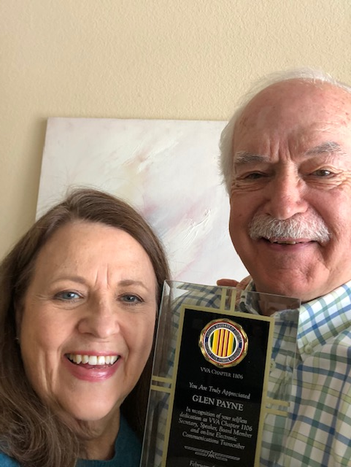

**EYE STRAIN**

From Nurse Patti

This is an excellent article about eye strain caused by working on a Computer, Tablet, and your Smart Phone for longer periods of time, especially during these “quarantine times”. I wear blue light blocking glasses over my regular glasses when I am on the computer and I think they help me. FYI, I bought mine at Target and they were not pricey. My opinion.

If you’ve ever felt like your eyes were dry and tired after a long day of staring at a computer screen – you’re not alone. Digital screens emit blue light, which can have negative consequences on your peepers, including strain, dry or watery eyes and irritated eyes. Blue light is also known to sabotage your sleep schedule because it messes with your circadian rhythm (AKA your internal clock that tells you when it’s time to sleep or be awake). Unfortunately, most of us can’t escape having to use computers, tablets, and phones in our everyday life. So how do we handle the negative consequences of digital screens? (Besides suffer in silence as we continue to type and scroll away.)

Enter blue light blocking glasses as the latest wellness trend. What are blue light glasses? Blue light blocking glasses have specially crafted lenses that are said to block or filter out the blue light given off from digital screens. The lenses claim to protect your eyes from glare and can help reduce potential damage to your retina from prolonged exposure to blue light. But are blue light glasses worth the hype?

It may surprise you, but many eye issues that are caused by digital screens aren’t due to blue light. Ophthalmologist Rishi Singh, MD says many people experience eye discomfort from digital screens, but most of the issues fall under a term called computer vision syndrome (CVS). (It’s sometimes also referred to as digital eye strain.)

CVS is a broad range of eye strain and discomfort issues. Your eyes are constantly shifting focus and moving while looking at the screen. Plus the glare and contrast can be tough on your eyes. So although you may be experiencing eye irritation from a long day working on your computer, your eye discomfort is not directly from the blue light itself. “When we stare at a digital screen or device for too long, we’re not blinking very often, which causes the cornea to become dry and irritated,” says Dr. Singh. “When we focus our eyes on something close, like a screen or even a book, our eyes are strained and contracted, which can cause eye discomfort. But if you look ahead to a distant object, our eyes relax.” So instead of running out to purchase blue light blocking glasses, Dr. Singh suggest trying these tips for your screen time instead:

* Practice the 20-20-20 rule. Every 20 minutes look at something 20 feet away for 20 seconds. (This will help your eyes relax.)
* Use eye drops throughout the day to help keep your eyes lubricated while you work at a computer.
* Sit an arm’s length (about 25 inches) away from your screen. Most people sit too close to the computer and experience eye strain.

“Unfortunately, there hasn’t been a lot of research done with blue light blocking glasses,” explains Dr. Singh. “And of those studies that have been done, they’ve been too small and it’s not the same thing we’d see in clinical practice.” Your best bet is to save your money and practice good screen habits throughout the day instead. But blue light has been shown to affect sleep, so make it a habit to turn off all digital devices at least one hour before bed.

***Announcement Corner***

None!

***Books/Articles***

**What Is Your Story?**

From the Editor

What is your story? Yes, you **all** have special stories about your time in the military, serving our country! Some are happy and some profoundly serious. I know you have stories because I hear you sharing them before and after our meetings. It is time you shared those stories with all of us. If you will just take the time to sit down at your computer or use your “smart” phone or even a pencil and paper and write your story and send or hand it to me, you will end up with a $5.00 gift card for a cup of coffee!

**A true Story to stir your heart!**

**Am I a Fireman yet?**

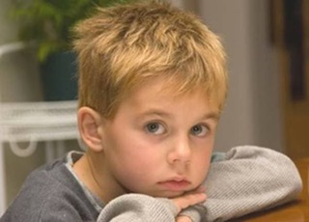

In Calgary, Alberta a 26-year-old mother stared down at her 6-year-old son, who was dying of terminal leukemia.

Although her heart was filled with sadness, she also had a strong feeling of determination.

Like any parent, she wanted her son to grow up & fulfill all his dreams. Now that was no longer possible. The leukemia would see to that. But she still wanted her son's dream to come true.

She took her son' s hand and asked, 'Billy, did you ever think about what you wanted to be once you grew up?

Did you ever dream and wish what you would do with your life?'

Mommy, 'I always wanted to be a fireman when I grew up.'

Mom smiled back and said, ‘Let's see if we can make your wish come true.'

Later that day she went to her local fire Department in Calgary, where she met Fireman Bob, who had a heart as big as Alberta.

She explained her son's final wish and asked if it might be possible to give her 6-year-old son a ride around the block on a fire engine.

Fireman Bob said, 'Look, we can do better than that. If you'll have your son ready at seven o'clock Wednesday morning, we'll make him an honorary Fireman for the whole day! He can come down to the fire station, eat with us, go out on all the fire calls, the whole nine yards!

And if you'll give us his sizes, we'll get a real fire uniform for him, with a real fire hat - not a toy - one-with the emblem of the Calgary Fire Department on it, and a yellow slicker like we wear and rubber boots.' 'They're all manufactured right here in Calgary , so we can get them fast.'

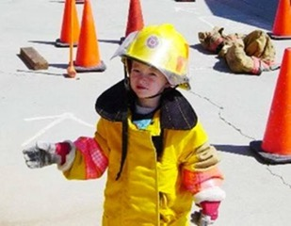

Three days later Fireman Bob picked up Billy, dressed him in his uniform and escorted him from his hospital bed to the waiting hook and ladder truck. Billy got to sit on the back of the truck and help steer it back to the fire station. He was in heaven. There were three fire calls in Calgary that day and Billy got to go out on all three calls.

He rode in the different fire engines, the Paramedic's' van, and even the fire chief's car.

He was also videotaped for the local news program.

Having his dream come true, with all the love and attention that was lavished upon him, so deeply touched Billy, that he lived three months longer than any doctor thought possible. One night all of his vital signs began to drop dramatically and the head nurse, who believed in the hospice concept - that no one should die alone, began to call the family members to the hospital. Then she remembered the day Billy had spent as a Fireman, so she called the Fire Chief and asked if it would be possible to send a fireman in uniform to the hospital to be with Billy as he made his transition.

The chief replied, 'We can do better than that. We'll be there in five minutes. Will you please do me a favor?

When you hear the sirens screaming and see the lights flashing, will you announce over the PA system that there is not a fire?' 'It's the department coming to see one of its finest members one more time. And will you open the window to his room?'

About five minutes later a hook and ladder truck arrived at the hospital and extended its ladder up to Billy's third floor open window and16 fire-fighters climbed up the ladder into Billy's room.

With his mother's permission, they hugged him and held him and told him how much they LOVED him. With His dying breath, Billy looked up at the fire chief and said, ‘Chief, am I really a fireman now?'

'Billy, you are, and The Head Chief, Jesus, is holding your hand,' the chief said with those words.

Billy smiled and said, 'I know, He's been holding my hand all day, and the angels have been singing.' He closed his eyes one last time.

**VACCINES – IMMUNIZATION**

Submitted by: Cliff Butler

Outbreak, epidemic, pandemic. Words that strike fear in the minds of humans. These dreaded medical problems have PLAGUED mankind since our arrival on this planet. To an Epidemiologist an OUTBREAK loosely refers to the rapid spread of an infectious agent in a small, confined area. An EPIDEMIC refers to the rapid spread of an infectious agent to a specific, usually larger defined area, such as a town or region. A PANDEMIC is the rapid spread of an infectious agent to an extensive area such as many countries or the entire world. So where does the Word VACCINE come from? The word VACCINE is derived from the Latin word VACCINUS which refers to CATTLE. And therein lies a story. In the late 1700 an English doctor named Edward Jenner noticed that Milk Maids, the young women who were responsible for the milking of cows in England at that time, frequently were infected with a disease from cows called cowpox that produced lesions and left scars similar to smallpox which was a raging world -wide pandemic at that time. Yet the Milk Maids were resistant to smallpox. A short version of the story is that with the parent’s permission, Dr Jenner purposely infected the son of his Gardner with exudate from a cow pox lesion. When the boy healed, Dr Jenner infected the Lad with exudate from a smallpox lesion - the young lad did not come down with smallpox. And the world had found a method of fighting infectious agents. With the evolution of our medical and scientific achievements today the production and use of vaccines has advanced far beyond early expectations saving millions of lives. Live, active, microbes (bacteria, virus, etc.) are NOT used to prepare vaccines such as the COVID vaccine. The preparation of vaccines today is a complex, time consuming, procedure. Thank you, Dr Jenner,!

**PAWS AND READ**

Submitted by: John Vargas

This new article is about Service Pals and Family. We will try to tell you their stories and perhaps something about their handlers and pet owners.

**Emotional Support Dog/Pet**

Facts submitted by Barbara Rotruck.

This story is about Cello a little guy with a big heart. “Cello” pronounced like the instrument.

Barbara and Robert (Bob) Rotruck lost their last rescue dog to \*Cushing’s disease, so they decided not to get another dog for a while. However, they realized how much they were missing not having a dog for a long period of time. They also decided on a more senior dog. So, after a year and half without a family pet, they rescued little Cello from the Denver Dachshund Rescue Center. He was 7 years and 4 months old. He had been in a home with four children all under the age of 5. They were torturing him due to the lack of parental discipline.

He loves them as much as they love him. They find Cello to be very therapeutic for them. No matter what is going on, just seeing, and cuddling with him and looking into those loving eyes brings a smile to their faces and a warmth to their hearts. Truly unconditional love! Cello loves to go for walks, car rides to his brother’s house in Parker, walk in the snow, search for critters outside, play with stuffed toys bigger than he is and have lots of snuggles. He also loves treats, such as cheese, Alpo Tbonz, snausages, etc. He expects a treat every time he comes in from going potty. He is definitely Barbara and Bob’s emotional support dog and they cannot imagine life without this little guy.

I first met Cello a couple of years ago when I visited the home of Barbara and Bob. I rang the bell and I heard loud yapping inside. Barbara welcomed me while Bob held him back. His welcome was interesting. The cuffs on my jeans now have a couple of air holes. To this day, I call Cello the “Attack Dog”. My next visit was a much more friendly welcome!

\*Cushing’s syndrome, also known as hypercortisolism, is a condition occurring when hormone cortisol levels in the body are abnormally high.

PICTURE OF CELLO (spelled like the instrument)

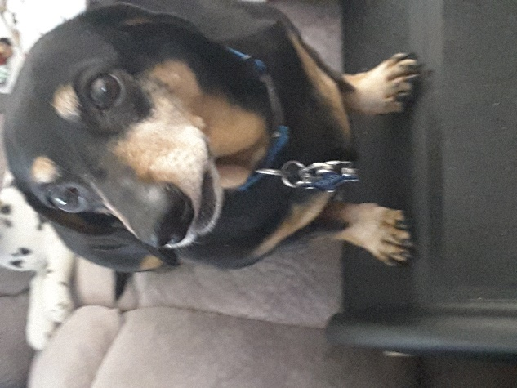

**Photo Quiz**

**Can you identify any of these Chapter Member Veterans? Answers at end of newsletter!**

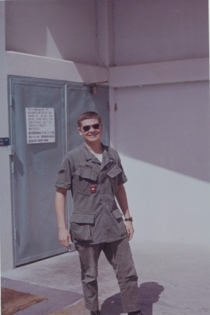

**1**

**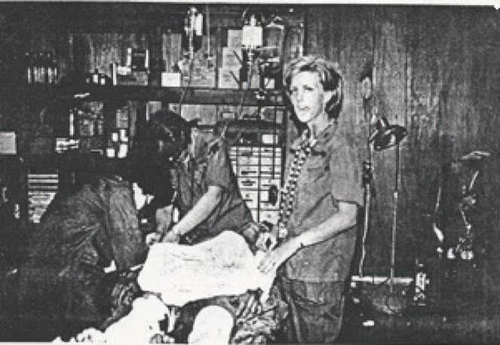**

**2**

**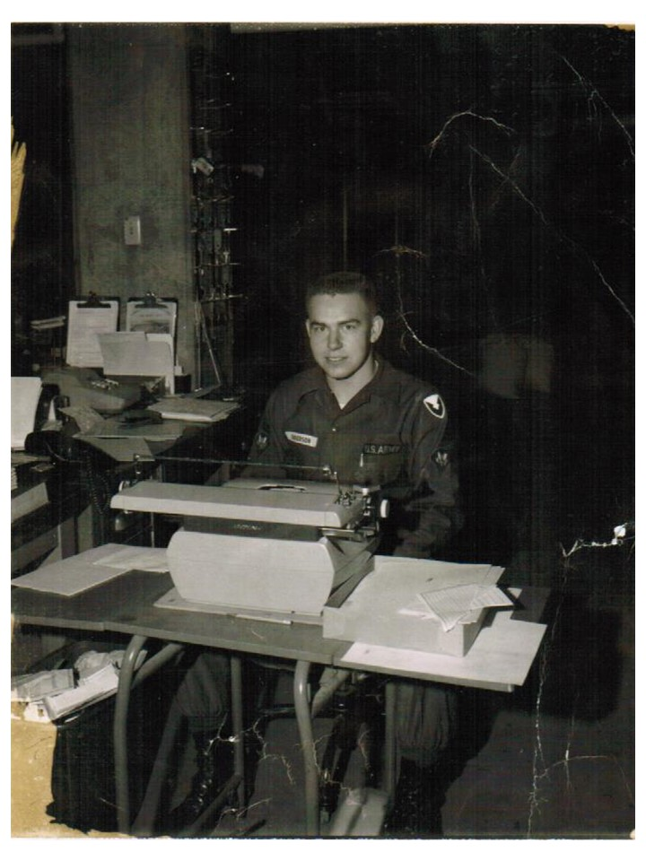**

**3**

**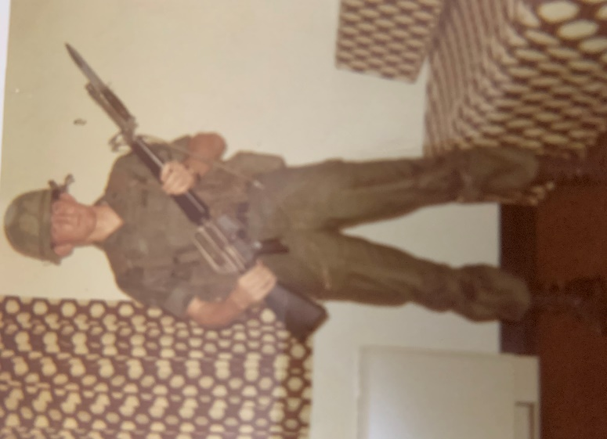**

**4**

**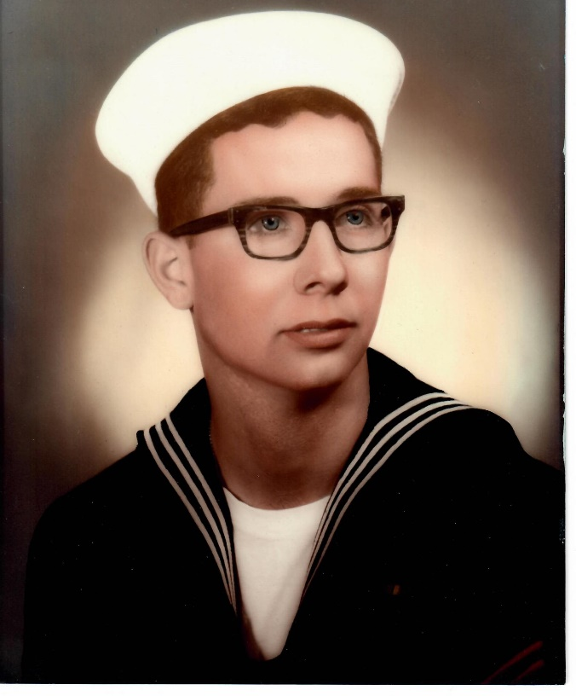**

**5**

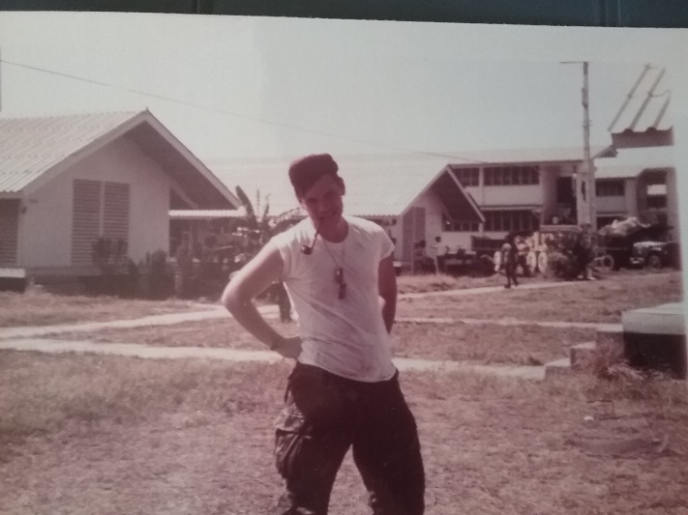

6

**Chapter Member Needs Help!**

A chapter member sent this to me (the editor) and is asking if anybody can identify the object in this photo?

Editor’s guess – Las Vegas slot machine!

**Remember Slow Food?**

Submitted by Dave Lyons

Someone asked the other day, 'What was your favorite fast food when you were growing up?'

'We didn't have fast food when I was growing up,

I informed him. All the food was slow.'

'C'mon, seriously. Where did you eat?'

'It was a place called at home,' I explained!

'Mom cooked every day and when Dad got home from work, we sat down together at the dining room table, and if I didn't like what she put on my plate I was allowed to sit there until I did like it.'

By this time, the kid was laughing so hard I was afraid he was going to suffer serious internal damage, so I didn't tell him the part about how I had to have permission to leave the table.

But here are some other things I would have told him about my childhood if I figured his system could have handled it :

Some parents NEVER owned their own house, never wore Levi’s, never set foot on a golf course, never traveled out of the country, or had a credit card.

In their later years, they had something called a revolving charge card. The card was good only at Sears Roebuck. Or maybe it was Sears & Roebuck.

Either way, there is no Roebuck anymore. Maybe he died.

My parents never drove me to soccer practice. This was mostly because we never had heard of soccer.

I had a bicycle that weighed probably 50 pounds, and only had one speed, slow.

We didn't have a television in our house until I was 6. It was, of course, black and white, and the station went off the air at midnight, after playing the national anthem and a poem about God; it came back on the air at about 6 a.m. And there was usually a locally produced news and farm show on, featuring local people.

I was 11 before I tasted my first pizza, it was called 'pizza pie.' When I bit into it, I burned the roof of my mouth and the cheese slid off, swung down, plastered itself against my chin, and burned that, too. It's still the best pizza I ever had.

I never had a telephone in my room. The only phone in the house was in the living room and it was on a party line. Before you could dial, you had to listen and make sure some people you didn't know weren't already using the line.

Pizzas were not delivered to our home. But milk was.

All newspapers were delivered by boys and all boys delivered newspapers -- my brother delivered a newspaper, six days a week. It cost 7 cents a paper, of which he got to keep 2 cents. He had to get up at 6 AM every morning.

On Saturday, he had to collect the 42 cents from his customers. His favorite customers were the ones who gave him 50 cents and told him to keep the change. His least favorite customers were the ones who seemed to never be home on collection day.

Movie stars kissed with their mouths shut. At least, they did in the movies. There were no movie ratings because all movies were responsibly produced for everyone to enjoy viewing, without profanity or violence or most anything offensive.

If you grew up in a generation before there was fast food, you may want to share some of these memories with your children or grandchildren.

Just don't blame me if they bust a gut laughing.

Growing up isn't what it used to be, is it?

MEMORIES from a friend:

My Dad is cleaning out my grandmother's house (she died in December) and he brought me an old Royal Crown Cola bottle. In the bottle top was a stopper with a bunch of holes in it. I knew immediately what it was, but my daughter had no idea. She thought they had tried to make it a saltshaker or something. I knew it as the bottle that sat on the end of the ironing board to 'sprinkle' clothes with because we didn't have steam irons. Man, I am old.

How many do you remember?

Headlight dimmer switches on the floor.

Ignition switches on the dashboard.

Heaters mounted on the inside of the fire wall.

Real iceboxes.

Pant leg clips for bicycles without chain guards.

Soldering irons you heat on a gas burner.

Using hand signals for cars without turn signals.

**Older Than Dirt Quiz:**

Count all the ones that you remember not the ones you were told about. Ratings at the bottom:

1. Blackjack chewing gum

2. Wax Coke-shaped bottles with colored sugar water

3. Candy cigarettes

4. Soda pop machines that dispensed glass bottles.

5. Coffee shops or diners with tableside jukeboxes

6. Home milk delivery in glass bottles with cardboard stoppers

7. Party lines on the telephone

8 Newsreels before the movie

9. P.F. Flyers

10. Butch wax

11. TV test patterns that came on at night after the last show and were there until TV shows started again in the morning. (there were only 3 channels... [if you were fortunate)

12. Peashooters

13. Howdy Doody

14. 45 RPM records

15. S&H green stamps

16. Hi-fi's

17. Metal ice trays with lever

18. Mimeograph paper

19. Blue flashbulb

20. Packard’s

21. Roller skate keys

22. Cork popguns

23. Drive-ins

24. Studebakers

25. Wash tub wringers

If you remembered 0-5 = You're still young

If you remembered 6-10 = You are getting older If you remembered 11-15 = Don't tell your age,

If you remembered 16-25 = You're older than dirt!

I might be older than dirt, but those memories are some of the best parts of my life.

***Light Side***

**Story of Adam & Eve's Dog**

Adam and Eve said, 'Lord, when we were in the garden, you walked with us every day. Now we do not see you anymore. We are lonesome here, and it is difficult for us to remember how much you love us.'

And God said, 'I will create a companion for you that will be with you and who will be a reflection of my love for you, so that you will love me even when you cannot see me. Regardless of how selfish or childish or unlovable you may be, this new companion will accept you as you are and will love you as I do, in spite of yourselves. And God created a new animal to be a companion for Adam and Eve. And it was a good animal and God was pleased.



And the new animal was pleased to be with Adam and Eve, and he wagged his tail.

And Adam said, 'Lord, I have already named all the animals in the Kingdom and I cannot think of a name for this new animal..' And God said, 'I have created this new animal to be a reflection of my love for you, his name will be a reflection of my own name, and you will call him DOG.



And Dog lived with Adam and Eve and was a companion to them and loved them. And they were comforted. And God was pleased. And Dog was content and wagged his tail. After a while, it came to pass that an angel came to the Lord and said, 'Lord, Adam and Eve have become filled with pride. They strut and preen like peacocks and they believe they are worthy of adoration. Dog has indeed taught them that they are loved, but perhaps too well.' And God said, I will create for them a companion who will be with them and who will see them as they are. The companion will remind them of their limitations, so they will know that they are not always worthy of adoration.' And God created CAT to be a companion to Adam and Eve.



And Cat would not obey them. And when Adam and Eve gazed into Cat's eyes, they were reminded that they were not the Supreme Beings.



And Adam and Eve learned humility. And they were greatly improved. And God was pleased. And Dog was happy.



And the Cat . . .



didn't give a rats ass one way or the other...

**A FLORIDA COURT SETS ATHEIST HOLY DAY**

In Florida, an atheist created a case against Easter and Passover Holy days. He hired an attorney to bring a discrimination case against Christians and Jews and observances of their holy days. The argument was that it was unfair that atheists had no such recognized days. The case was brought before a judge. After listening to the passionate presentation by the lawyer, the judge banged his gavel declaring, "Case dismissed!" The lawyer immediately stood and objecting to the ruling saying, "Your honor, how can you possibly dismiss this case? The Christians have Christmas, Easter, and others. The Jews have Passover, Yom Kippur and Hanukkah, yet my client and all other atheists have no such holidays..."

The judge leaned forward in his chair saying, "But you do. Your client, counselor, is woefully ignorant."

The lawyer said," Your Honor, we are unaware of any special observance or holiday for atheists."

The judge said, "The calendar says April 1st is April Fool’s Day. Psalm 14:1 states, 'The fool says in his heart, there is no God.' Thus, it is the opinion of this court, that, if your client says there is no God, then he is a fool. Therefore, April 1st is his day. Court is adjourned." You gotta love a Judge that knows his scripture!

**Winter love story**

Alan and Sandra lived on a cove at Gull Lake Alberta. It was early winter, and the lower portion of the cove had frozen over. Alan asked Sandra if she would walk across the frozen part of the cove to the general store and get him some smokes and beer. She asked him for some money, but he told her, "Nah, just put it on our tab. Old man Stacey won't mind." So, Sandra, being the good wife walked across the ice, got the smokes and beer at the store and then walked back home across the cove. When she got home with the items she said, "Alan, you always tell me not to run up the tab at Stacey's store. Why didn't you just give me some money?" Alan replied, "Well, Sandra, I didn't want to send you out there with cash when I wasn't sure how thick the ice was!" A love story like this almost brings tears to my eyes........

**The Bathtub Test**

During a visit to my doctor, I asked him, “How do you determine whether or not an older person should be put in an old age home?”

“Well,” he said, “We fill up a bathtub, then we offer a teaspoon, a teacup, and a bucket to the person and ask them to empty the bathtub.”

“Oh, I understand,” I said. “A normal person would use the bucket because it is bigger than the spoon or the teacup.”

“No,” he said, “A normal person would pull the plug. Do you want a bed near the window?”

Are you going to copy this and send it to a friend, or do you want the bed next to mine?

**Wonderfully British . . . . .**

In a train from London to Manchester, an American was berating the Englishman sitting across from him in the compartment.

"The trouble with you English is that you are too stuffy. You set yourselves apart too much. You think your stiff upper lip makes you above the rest of us.

Look at me... I'm me! I have a little Italian in me, a bit of Greek blood, a little Irish and some Spanish blood. What do you say to that?"

The Englishman lowered his newspaper, looked over his glasses and replied, "How very sporting of your mother".

Looks like Colorado!

Editor: I paid 15 cents a gallon at Naval Station, Argentia Newfoundland in 1961!

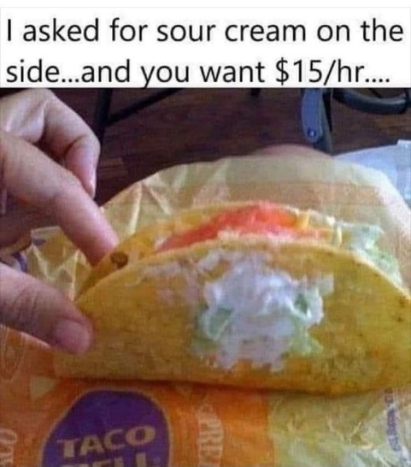

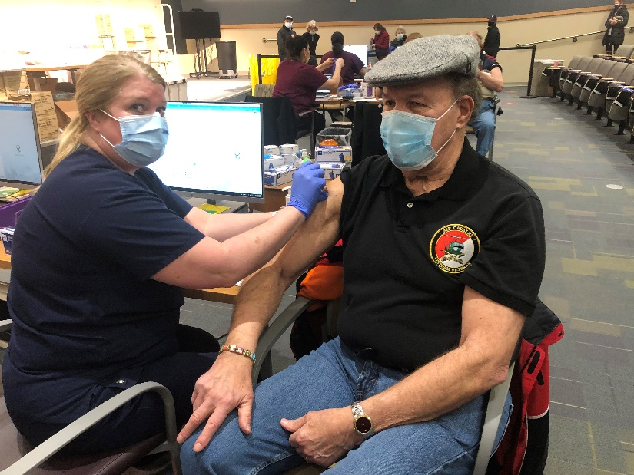

John Vargas getting COVID-19 vaccine shot. The editor photo shopped the picture to remove the tears of fear coming from his eyes and the mask covered his mouth when he screamed like a baby!!!

***Trivia Answer***

**1MC - 1 Main Circuit, shipboard public address system**

***Picture Quiz***

1. Ron Smith – Army – 1970

2. Patti Ehline – Army Nurse – 1969

3. Mort Anderson – Army – 1966

4. Ed Phillips – Army – 1971

5. Greg Goettsch – Navy – 1969

6. Joe Dempsey – Air Force – 1972

If any chapter member got all these names correct, you may ask my wife for a date face-to-face only! It is highly recommended you wear complete body armor and have a black belt in Taekwondo!! YOUR EDITOR!!!

**Upcoming Events of Interest**

*Date of Revision: November 7, 2020*

**FRIENDS OF CHAPTER 1106**

|  |  |
| --- | --- |
| **South Metro Denver Fire & Rescue**  9195 E Mineral Ave  Centennial, CO 80112 | **American Legion Post 1260**  **E:\Documents\ALP1187\images\AmericanLegion_logo.jpg** |
| **Spradlin Printing, Inc.**  11903 S. Parker Road Parker, CO 80134 |  |
| American Family Insurance  3989 E. Arapahoe Road #20  Centennial, CO 80122  720-361-0155 | A FULL-SIZE REPLICA OF THE HONOR BELL  **The Honor Bell Foundation**  PO Box 1432  Englewood CO 80150  720.282.9182  [www.honorbell.org](http://www.honorbell.org/) |
| 9137 E Mineral Cir Ste 100  Englewood, CO 80112-3422 | Logo of The Home Depot  **Home Depot Foundation**  8477 S Yosemite St  Lone Tree, CO 80124 |
| King Soopers logo.svg  King Soopers  9551 S. University Blvd., Highlands Ranch, CO 80126 | Veteran & Family Resource HubQualified Listeners:  PO Box 563  Dacono, CO 80514  Tel: 720-600-0860 |
| https://scontent.fapa1-2.fna.fbcdn.net/v/t31.0-8/10575197_682186265194110_4051472928662048560_o.jpg?oh=2630b186dcf3a20f1d7fc8fa25e0a5ba&oe=5A17C4AB  **Military Order of Purple Heart**, Chapter 1041, Arvada, CO | ZILLOW GROUP  10771 E. Easter Ave  Centennial CO 80112 |
| 99 Inverness Drive - #275 Ennglewood, CO  Text  Description automatically generated C-303-653-5020  O-303-779-1420  [www.printconnection.com](http://www.printconnection.com)  [troy@ printconnection.com](mailto:troy@%20printconnection.com) | PARKER MEDICAL  SUPPLY STORE  9845 S Parker Rd  . Parker, CO 80134  303-840-4444 |