Inside this issue:
Notes from the President
Member Feature
Military Trivia
Guest Speaker
Membership
Board of Directors/Officers
Working Committees
Meetings/Events Calendar
Announcement Corner
Books/Articles Published by Mbrs.
From the Editor
Light Side
Trivia Answer
Events
Saturday, January, 6, 2018 - Chapter Meeting
Thursday/Saturday, January 11-14, 2018 - Conference of State Council President's Meeting
Saturday, February, 3, 2018 - Chapter Meeting
S. Metro Denver Fire & Rescue Board Room 9195 E. Mineral Ave. Centennial, CO. The Board of Director’s meeting will follow 30 minutes following the regular mtg.

Next CO State Council meeting March 10, 2018.
Editor’s Note:
Notice:
If you have moved or changed your address, PLEASE notify us immediately! Contact: Lee White, Membership Chair
E-mail: mailto:flyboy51@q.com
Phone: 303-519-2252

COPYRIGHT NOTICE: In accordance with Title 17 U.S.C. Section 107, any copyrighted material in this newsletter is distributed under fair use without profit or payment to those who have expressed a prior interest in receiving the included information for nonprofit use and educational purposes only.
This version of the newsletter is in Microsoft Document (.docx) format so that the links will work. Put your cursor over the link, depress your Control Key (ctrl) and depress your left mouse button and it will take you to the listed link position. PDF format, the links will not work.

The comments and editorial input does not necessarily reflect the opinion of the membership of our chapter.

I would appreciate any feedback that you might have items you liked or if you find offensive or derogatory in anyway. (bobrotruck73@gmail.com)

Thank you for allowing me to be your newsletter editor.

Notes from the President
Lee White
HAPPY NEW YEAR!!!!!!
2017 has come to a close, so it's time to look ahead to 2018. As President of VVA Chapter 1106, I want to take this time to thank all the board members, committee members, associate members, and all the regular monthly attendees for all your support, input, and participation in making VVA Chapter 1106 so successful.

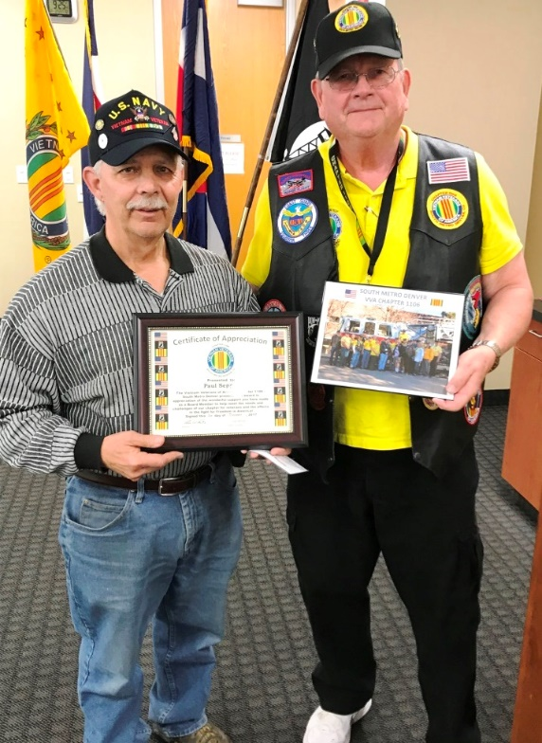
Paul Seppo steps down from his board position as he and his wife prepare to move out of state. Thank you Paul.

“Member Feature”
Roger Lanphier, Captain, USMC. Oct 1960 to December 1967. During my seven years of service I was awarded the Navy/Marine Commendation Medal with Combat V, National Defense Medal, Armed Forces Expeditionary Medal, Vietnam Service Medal w/2stars, Republic of Vietnam Campaign Medal. My duty stations: Quantico VA, Camp Lejeune NC, Vietnam 3rd Marine Div. (DaNang, ChuLai, Phu Bai), Quantico VA. My MOS’s: 0302 Infantry Officer, 0202 Combat Intelligence Officer. My several most memorable experiences:
•Christmas 1965 in a Division Bunker, I received a heavy Christmas package from my in-laws. Surprise, surprise!! There was a large motor driven shoe buffer and polisher.
•Taking 60 degree rolls in a hurricane off the coast of Cape Hatteras. The storm passed the ship at the fantastic speed of 4mph!
•Operation Harvest Moon, an air drop killed a farmer’s water buffalo. My interpreter and I walked out of the perimeter to the farmer to pay him money to buy a new buffalo. In the back of his hut were 5 black clad (looks like pajamas) young men trying not to be seen (not PFs). Sgt Ho and I walked back to the perimeter and back to work. I can say that was tense as there was!! No cover along the road and the walk took a good 15 minutes each way.
•High lining to the command ship for operational plans to invade Cuba, no maps just tracing paper with coordinates. We were to be assigned to defend the Divisions left flank against Soviet tanks with the tank Platoon Commander. They had five tanks and I had five Ontos (see photo).
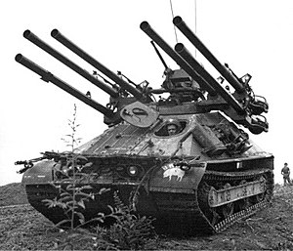
Military Trivia
What is a Benny Sugg See answer at the end of the Newsletter.

November Guest Speakers
We were pleased to have Hunter Allue and Mandy Anderson from the Denver VA Medical Center Health Care for Homeless Veterans Program speak to us about the many ways their organization is helping veterans. It was very touching to listen to their dedication and sincerity of the work they are doing for us.
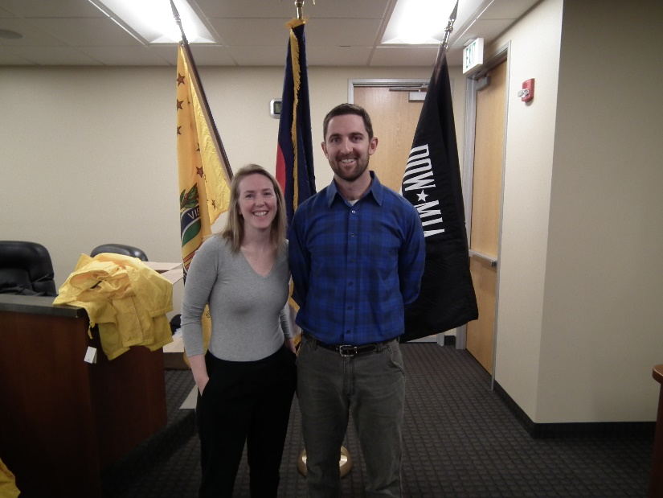
Mandy Anderson and Hunter Allue

Membership!
VVA Chapter 1106 Membership: 92 (12-2-2017)
AVVA: 22
Total: 114
VVA - Ed Aitken, Jack Paulsen, Robert Crago
AVVA - Kari Liechti

Board of Directors/Officers
Lee White - President
Bob Easter - Vice-president
Joe Plant - Treasurer
Hazel Simeon - Secretary
Board Members - Milt Omoto, Patti Ehline, Dave Lyons, Tom Werzyn

Working Committees
Sergeant-at-Arms – John Vargas
Agent Orange/PTSD - Patti Ehline
Membership - Lee White
Membership outreach – Dave Lyons
Mental Health: Patti Ehline, Warren Harrison
Newsletter Editor - Bob Rotruck
Fundraising/Grants - Milt Omoto
Marketing/Media/Events – Tom Werzyn
POW/MIA – Gary Meyers
Webmaster – Robert Senatore
Women Veterans - Patti Ehline
Scholarship Program - Hazel Simeon, Bob Easter, Joe Langran, Bob Rotruck, John Vargas, Mike Karsh, Glen Payne, Jim Marcille, Tom Werzyn
Veteran Emergency Assistance Committee - Joe Plant, Bob Rotruck, Lee White, Dave Lyons
Speakers Bureau – Bob Easter, Glen Payne, Bob Mallin, Roger Lanphier, Tom Werzyn
Social – John Vargas, Barry Fiore, Glen Payne, Milt Omoto

Meetings/Events Calendar - 2018
- Saturday, January 6, 2018 - VVA Chapter 1106 Monthly Meeting
- Thursday/Saturday, January 11-13, 2018 - Conference of State Council President's Meeting - Silver Spring, MD
- Saturday, February, 3, 2018 - VVA Chapter 1106 Monthly Meeting
- Saturday, March 3, 2018 - VVA Chapter 1106 Monthly Meeting
- Saturday, March 10, 2018 - Colorado State Council Meeting - Castle Rock, CO

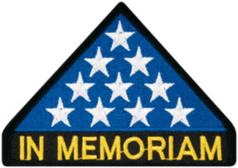
In Memoriam
VVA Chapter 1106 lifetime member, Bob Schlesier, 81 of Aurora, Colorado passed away October 11th due to lung cancer, associated with Agent Orange. He was born in New York on December 3rd 1935. He is survived by his wife, Sandra; daughter, Heidi (Jeff) of Colorado; son, Gustave (Marie) of Virginia; and 4 lovely granddaughters, Paige, Kathryn, Alysia, Alexis; and many other family members and friends. He served in a Vietnam MASH unit during the Tet offense (assisted in the operating room & flew dust off missions & was shot down twice). Bob was awarded two purple hearts and was a certified brace and limb specialist.
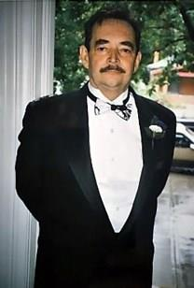
Bob was laid to rest at Ft. Logan National Cemetery on Friday, October 27th at 1:15pm.

Robert Tydingco
November 21st at Ft. Logan Cemetery, we buried our friend and Patriot SSG Robert Tydingco. He died peacefully at his Lakewood home on Monday, November 13, 2017. His wife Karen was at his bedside. The family had given me, John Vargas, the privilege of tolling the Honor Bell, 7 times, as our farewell gift. Rest in Peace Robert.

Robert was born in Guam, the largest of the Mariana Islands and a territory of the USA.
Robert was drafted into the US Army in January of 1962 and sent to Schofield Barracks Hawaii for Basic Training and to be a Helicopter Gunner on the H-21 Helo. Upon completion of training, he was sent to South Vietnam attached to MAC V supporting the Special Forces. After Vietnam, he was sent to Hawaii, Thailand for jungle training and then Germany where he received his GED. Then, to Ft. Riley Kansas to train young recruits. Not long thereafter, Robert was sent back to Vietnam, as part of an Advance Party with the 11th Armed Cav/Tank division to set up a base camp. On March 19th and 20th, 1967, typical rainy, hot and humid days, Robert and his armored tracked vehicles were conducting military operations near Bau Bang South Vietnam when they came under heavy enemy fire from recoilless rifles. His vehicle had received a direct hit to the engine compartment. The possibility of a fire was imminent but as the commander (Sgt Tydingco) refused to abandon or retreat. Instead, he directed his crew to close a gap in the perimeter that was created by an immobile tank. This was a bold move as the possibility of fire was heightened and exposed them to more intensive enemy fire. Sgt. Tydingco was seriously wounded and in pain, nevertheless he and his men effectively repelled numerous attempts by the VC. This battle lasted two days. Sgt. Tydingco’s dynamic bravery and leadership not only inspired his men but they held the attacks until reinforcements arrived and drove the remaining VC back into the jungle.

For his leadership and heroic actions Sgt. Robert A. Tydingco was awarded the Bronze Star with “V” device for Valor. He completed an eight-year Military career at Ft. Carson, Colorado with enlisted rank of SSG E6.

Our Nation, the Military, his family and our Purple Heart Chapter 1041 are honored and proud of Staff Sergeant Robert A. Tydingco for his dedication and service to this Country.
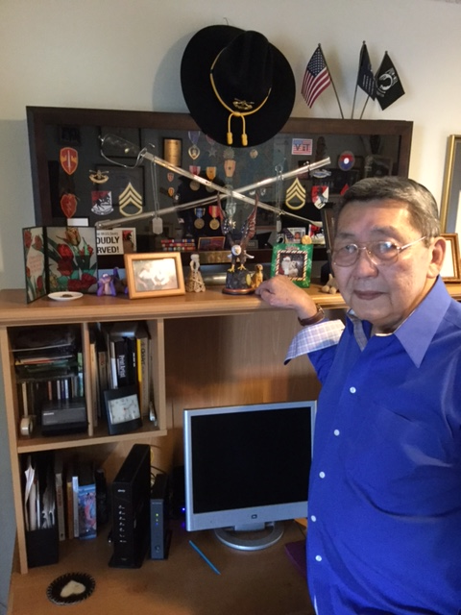
SSgt. Robert (Bob) Tydingco.
*Thank you to all that attended and in particular John Durant who gave much of his personal time to visiting Robert.
Submitted by John Vargas

National Museum of the Marine Corps
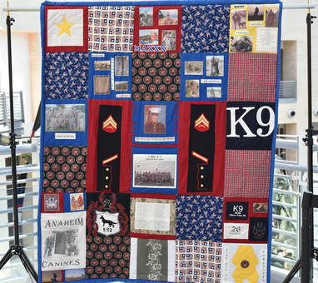
Quilt honoring the service of Cpl Max Donahue
This quilt was presented to Gold Star Mother Julie Schrock, mother of Cpl Max Donahue, a Marine Corps working dog handler, to commemorate and honor her son and recognize his service and sacrifice to his country. The quilt contains uniform items, shirts, and images collected from Marines in Donahue's platoon. Each piece of the quilt represents Max Donahue's service.

Donahue was supporting 3rd Battalion, 1st Marines (3/1), 1st Marine Division when he was severely wounded by a remotely activated improvised explosive device while conducting counter insurgency operations in Afghanistan. He was working with his patrol explosive detection dog, Fenji, a German shepherd, on 4 August 2010, when he sustained critical injuries. Cpl Donahue succumbed to his wounds and died on 7 August. Although injured, Fenji survived the blast. She would continue to serve in the Marine Corps until her retirement in 2015.

The quilt will be on display until January 2018.
Printing authorized by Julie Schrock, Max Donahue’s Mother

Aurora Veterans Salute 2017
November 1, 2017, seven of our chapter members attended the event. The speakers and entertainment were exceptional and the food was even pretty good considering feeding about 800 people.
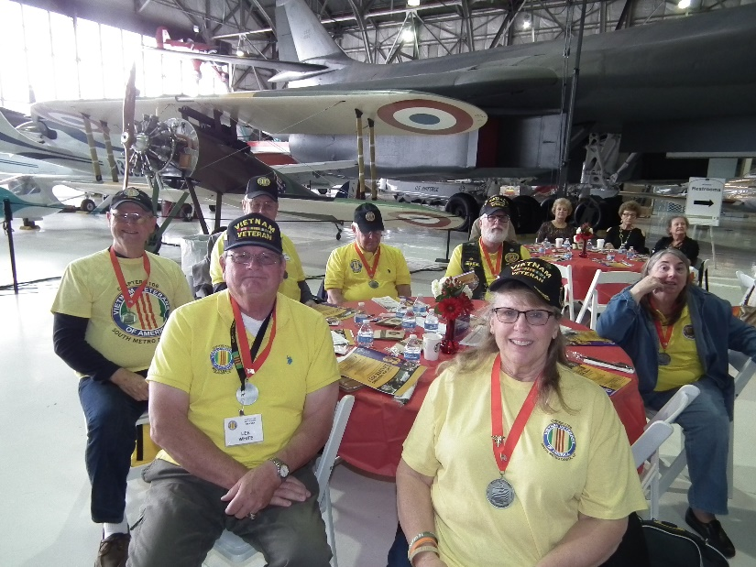
Clockwise: Patti Ehline, Lee White, Bob Rotruck, Joe Plant, Tom Werzyn, Dave Lyons, Dee Lyons
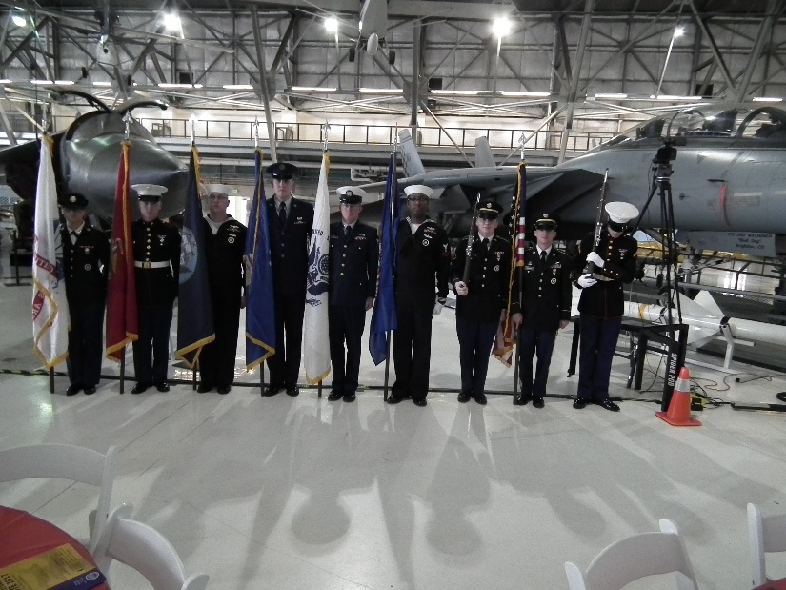
Event Color Guard
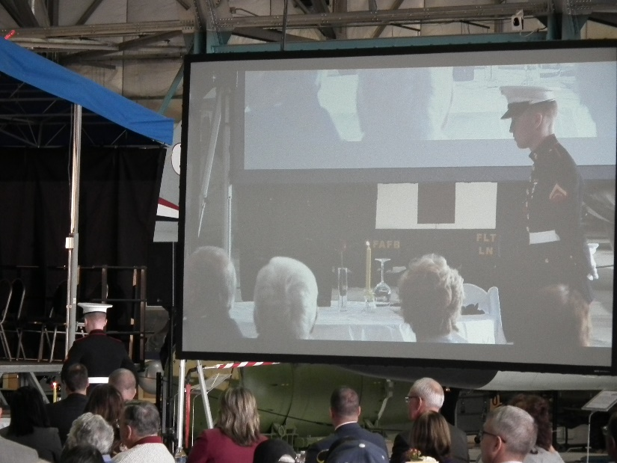
Missing Man Table
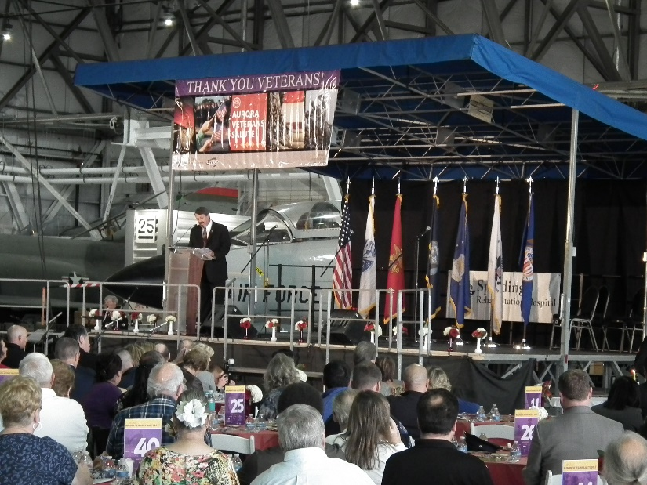
Rick Crandall – Host Narrator
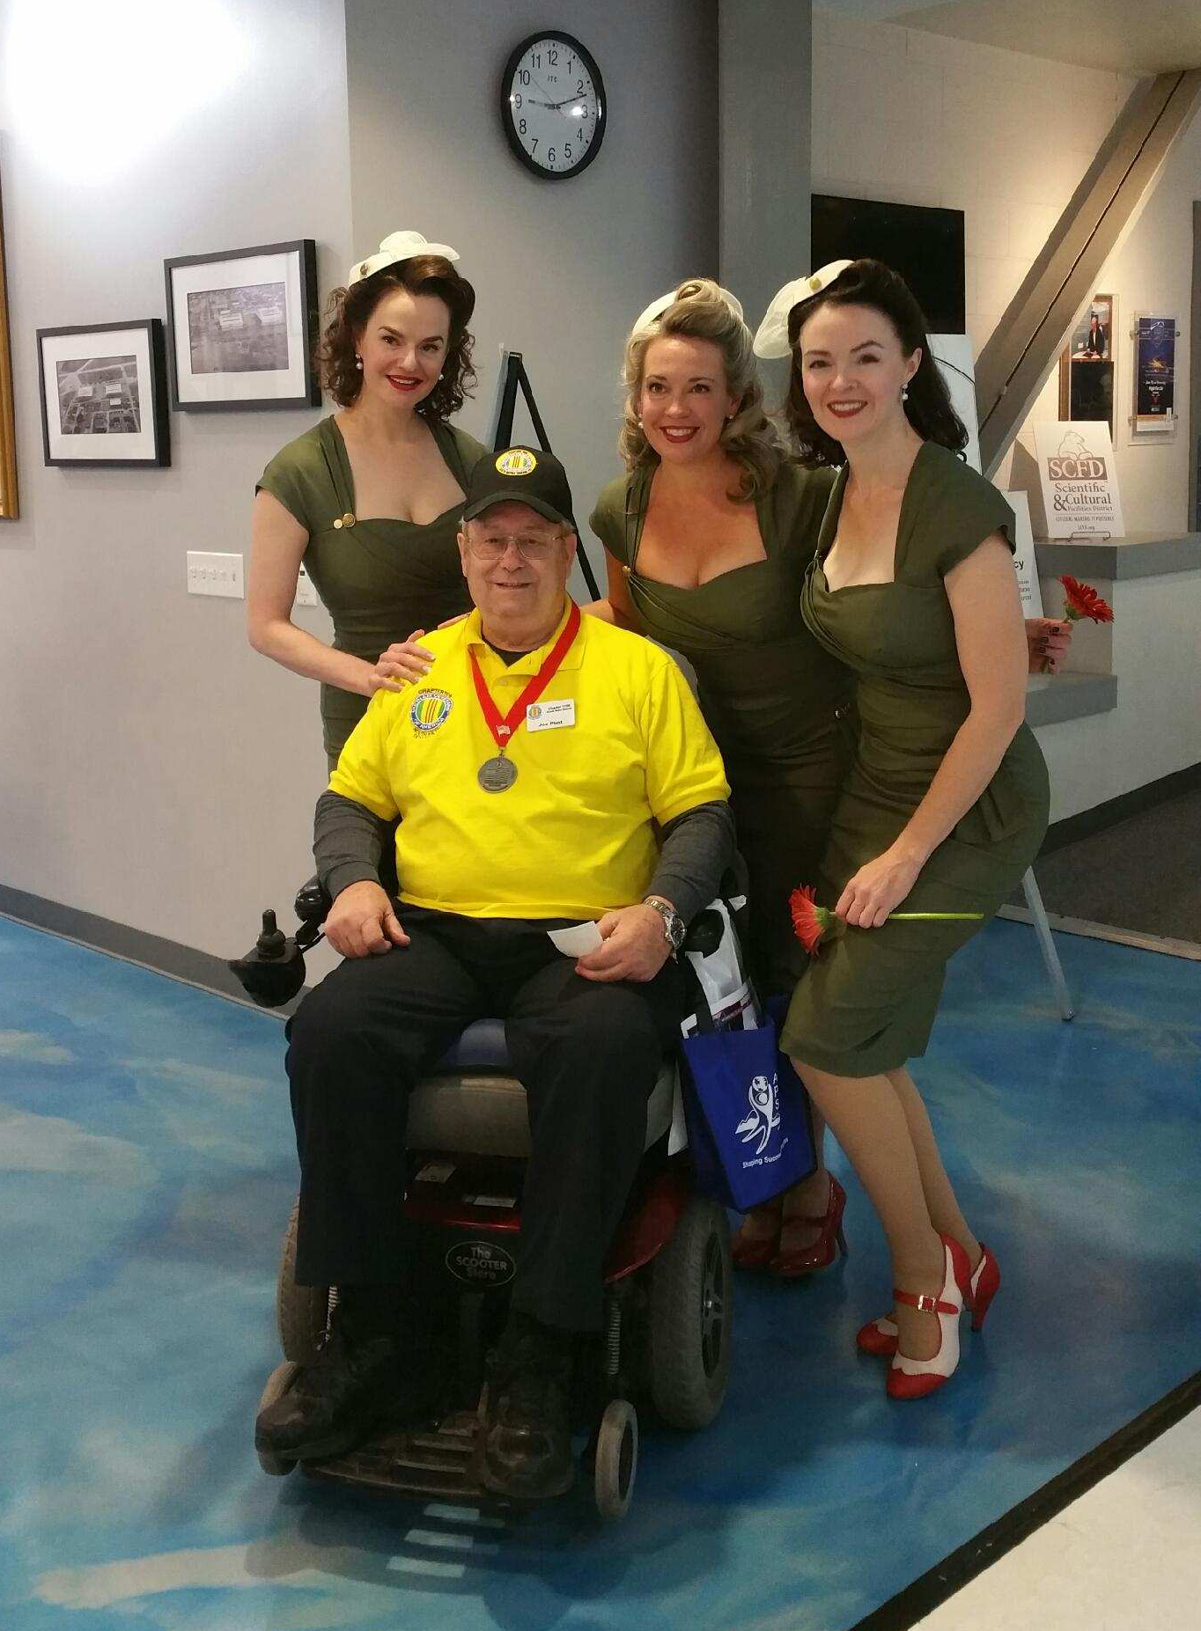
Poor Joe Plant, nobody pays attention to him except the DENVER DOLLS who entertained us at the event?

Citizens Hero Award
By John Vargas
I would like to briefly tell you about Michael Heise.

I first met Michael about five years ago while attending the Aurora Police Dept. Citizen’s Academy. We then met again while attending the Arapahoe County’s Citizen’s Academy. That’s where I learned that this mild mannered man and his wife Donna had lost two sons, at different years, to DUI. One of his sons was in the Army. Personally, I’m not sure that I could have continued a normal life after those tragedies.

Michael then became a Community Volunteer. He assisted both Police Departments on traffic and parade details, DUI Check-Points, worked in the Evidence Room assisted with internal Confidential Documents.

He was one of the faceless individuals that you see on TV, dressed in white protective gear searching garbage dumps for bodies of homicide victims. Some were children! He continues to work closely with Cops Fighting Cancer and the Blue Line. He also is trained in Mountain Rescues.

About four weeks ago he drove to Houston. After an 11-hour drive. Michael spent the next two weeks assisting hurricane victims pulling out waterlogged floors, dry wall and some electrical work. All this without any compensation!!

The last couple of weekends, you were able to find Michael and Donna outside of Costco in Aurora, loading supplies on trucks for shipments to Puerto Rico.

It’s with great pleasure and pride that VVA Chapter 1106 recognizes Mr. Michael Heise with the first “Citizens Hero” award!
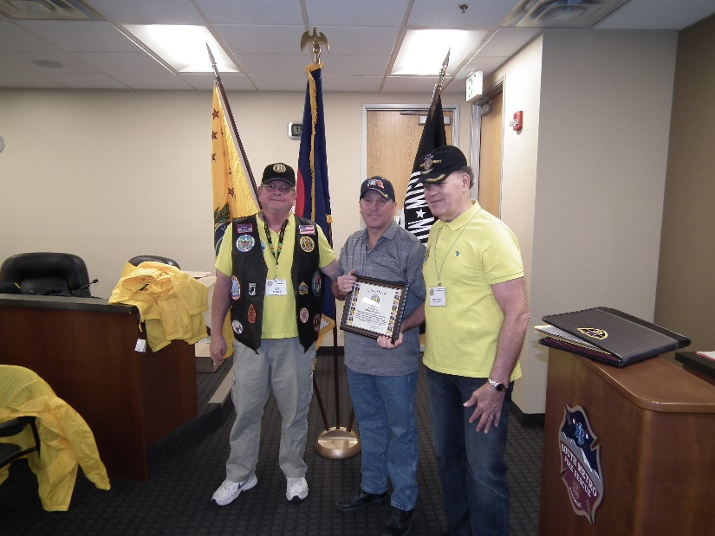
Lee presenting the Citizen Hero award to Mike Heise

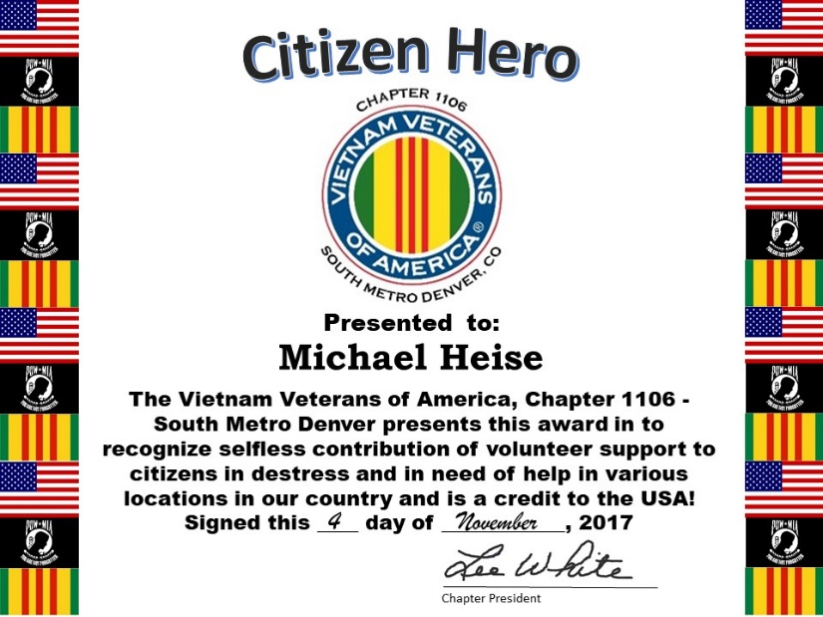

Veteran’s Day Poppy Drive
Landing Zone 1: Team Leader - Joe Plant, with team members: Dave Lyons, Dee Lyons, Sonny Gorsuch, John McMaster
Collected: $1,002.31

Landing Zone 2: Team Leader - Tom Werzyn, with team members: Jerry Liechti, Kari Liechti, Krysten Nelson, Hazel Simeon, Bob Easter
Collected: $700.93

Landing Zone 3: Team leader - Milt Omoto, with team members: Bob Rotruck, Barbara Rotruck, Lee White, Christina Omoto, Patti Ehline, Roger Lanphier, Rob Senatore
Collected: $1,043.31
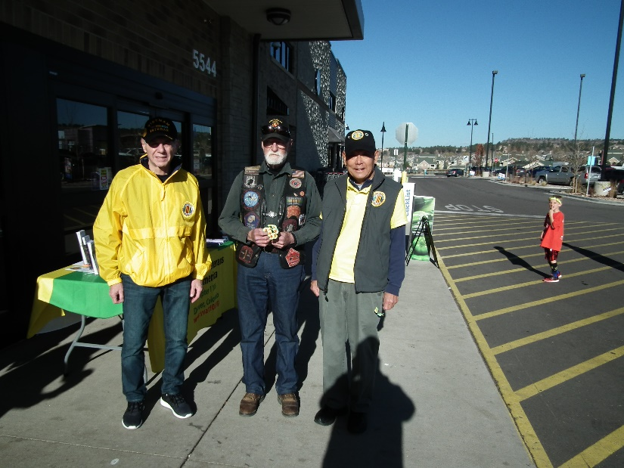

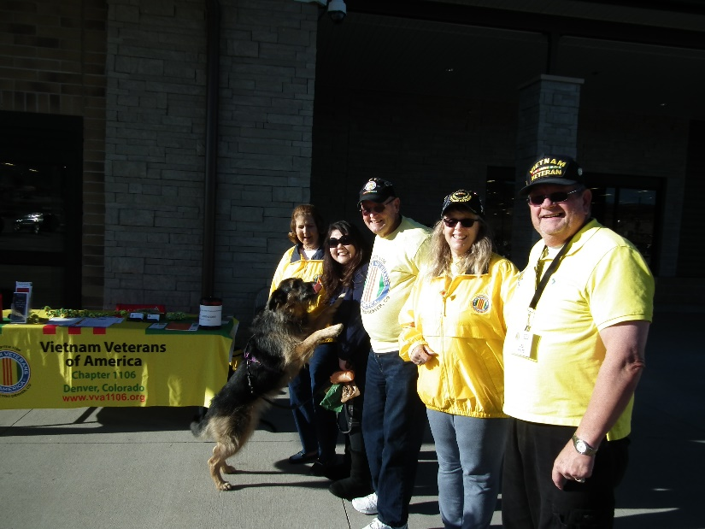

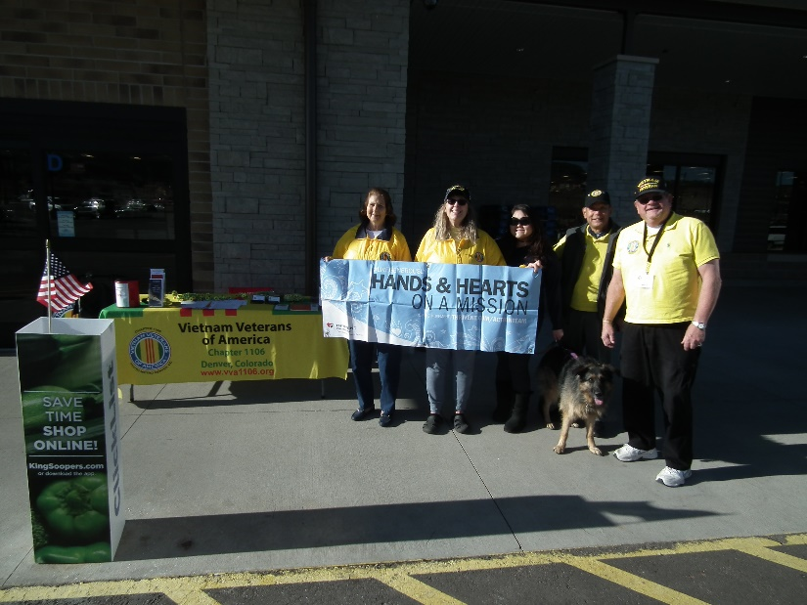

GRAND TOTAL: $2,746.55 – BRAVO ZULU

Highlands Ranch Veterans Day Celebration
Several chapter members attended the annual Highlands Ranch Veterans Day celebration on Veterans Day evening. VVA Chapter 1106 members present were Joe Langran (American Legion Post 1260 Commander and Color Guard), Bob Easter, Jack Paulsen, and Milt Omoto. TaRhonda Thomas of 9News served as the Master of Ceremonies and Colonel David Miller was the Guest Speaker. Colonel Miller is Commander of the 460th Space Wing at Buckley Air Force Base and spoke of the many varied command functions and different branch services operating out of Buckley. Patriotic music was provided by the Highlands Ranch Concert Band.
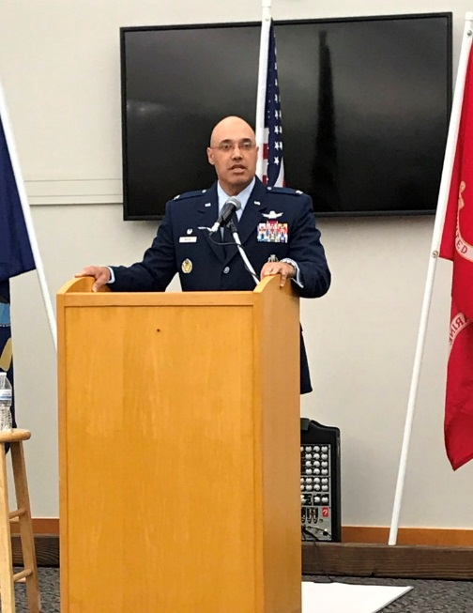
Colonel David Miller
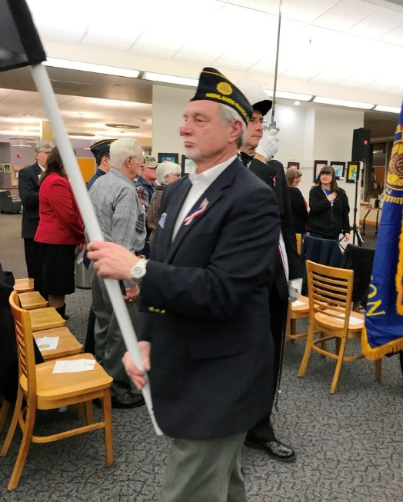
Joe Langran

Benjamin Franklin Academy
This was my third concurrent year attending the Veterans Day Tribute at Benjamin Franklin Academy, located in Highlands Ranch. It was nice to see that our VVA Chapter 1106 was well represented. As a combat Veteran, I couldn't have been honored in a better way than by school children. Chills ran through my body as I and thirty plus Veterans were greeted with a boisterous standing ovation. The assembly was filled with
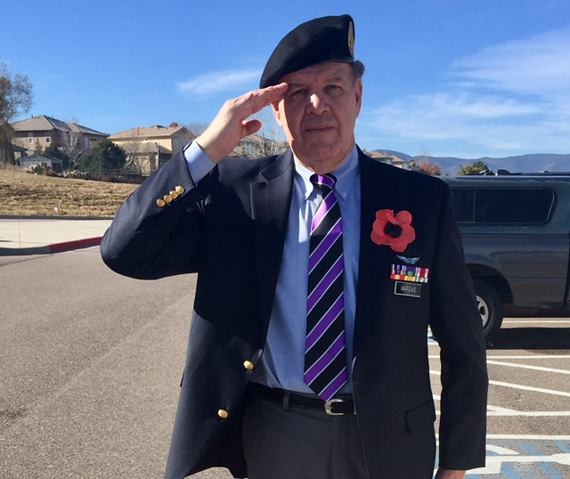
students, parents, teachers, and guests. It was difficult to fight back emotions, as we saluted our Flag and fourth graders sang military and patriotic hymns. After the tribute ended, each student had prepared "Thank You" to a Veteran card and personally handed it to each of us along with a yellow rose.

It makes me extremely proud to know that future leaders of tomorrow remembered and continue to pay tribute on Veterans Day 2017 at BFA. I was honored to have been invited and participate.

John Vargas – Chapter Sgt at Arms

Thank You Spradlin Printing, Inc.
December 13th, Lee and Bob met with John Spradlin, owner/operator of Spradlin Printing in Parker to honor him with a Certificate of Appreciation, a three year VVA membership, and a Chapter coin. John donated his service to print the Speaker’s Bureau trifold brochure. John was a Navy Lithographer 2nd Class (LI2) during the Vietnam era. He carried that knowledge and those skills to open his own business. Thanks for your service to our country and to our Vietnam Veterans of American South Metro Denver Chapter 1106!
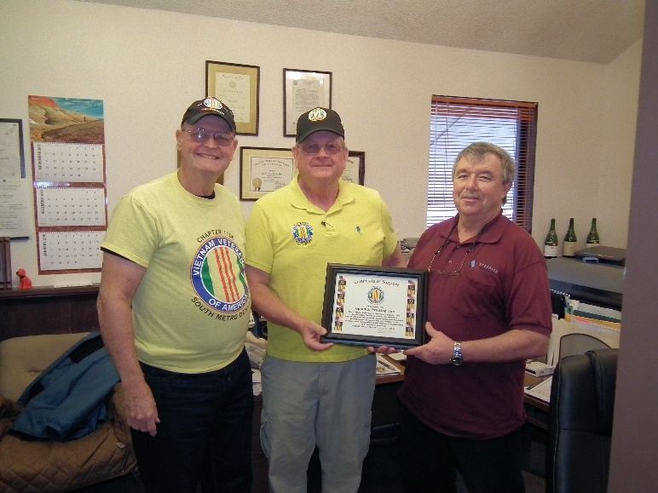
Bob, Lee, John with John’s service info on the wall above his and behind Lee

Keeping a Promise
PIEDMONT, S.C. — On New Year’s Eve 1968, just before the dawn of 1969, two Marines were holed up in a bunker in the Marble Mountains of Vietnam.
Rockets and mortars were raining down all around Master Sgt. William H. Cox and his buddy, First Sgt. James "Hollie" Hollingsworth. “Charlie (the nickname for the North Vietnamese) was really putting on a fireworks show for us,” Cox said.

As the two Marines hunkered down, they made a pact: “If we survived this attack or survived Vietnam, we would contact each other every year on New Year’s,” Cox said. For nearly five decades, Cox, who lives in Piedmont, S.C., and Hollingsworth of Hephzibah, Ga., kept their promise. And earlier this year, Cox kept another promise: He stood guard at Hollingsworth’s casket and then delivered the eulogy at his funeral.
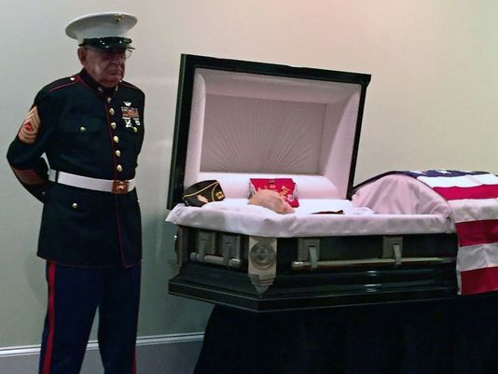
Standing guard, without his cane that the 83-year-old normally uses, Cox was paying tribute, one Marine to another. But in giving the eulogy, he fulfilled his final vow to his 80-year-old friend. When Cox learned that Hollingsworth was terminally ill, Cox traveled the 125 miles to visit. Hollingsworth asked Cox to give the eulogy at his funeral. “I said, ‘Boy, that’s a rough mission you’re assigning me to there,’ ” Cox said.

The military forges strong bonds among the men and women who serve, but for Marines, that connection is even stronger. “There’s a bond between Marines that’s different from any other branch of service. We’re like brothers,” Cox said.

The two men met on their way to Vietnam in 1968. After his service, Hollingsworth settled outside of Augusta, Ga. Cox spent 20 years in the Marine Corps and went on to receive the Distinguished Flying Cross for his service.

They served in VMO-2, a Marine helicopter squadron, where Hollingsworth was a mechanic and a door gunner, and Cox was an ordnance chief and a door gunner. They flew many combat missions together, and at the end of each mission, they had a saying, which Cox repeated at the close of Hollingsworth’s eulogy:
“Hollie, you keep ‘em flying, and I’ll keep ‘em firing.”

2017 Chapter Christmas Party/Lunch
On December 16th, our chapter members and family met at the Golden Corral in Parker for celebration of Christmas, end of year reflections, and welcoming the New Year. Does anybody need a TUMs from eating tooooo much????
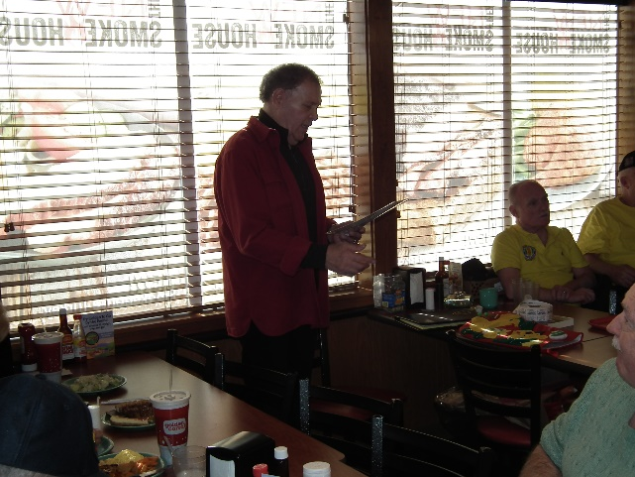
Party Planner – John Vargas – Social Committee Chair

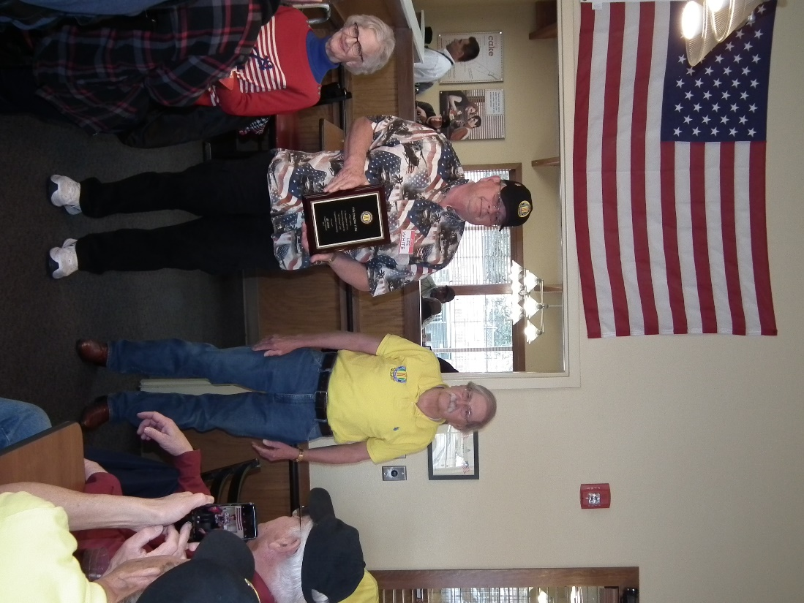
Bob Easter presenting Lee White with an appreciation plaque for his outstanding work and dedication to our chapter, the state council, and to Veterans!!!
Click here to see more pics!

ONE MINUTE, SOLDIER
One minute, soldier,
That’s all you ask of me.
I will not soil your honor
By dropping on my knee.

For one minute, soldier,
My differences aside.
While our anthem plays
I’ll think of those who died.

For one minute, soldier,
I won’t give thought of me.
Instead, for those who sacrificed,
To keep America free.

One minute, soldier,
That’s all you ask of me.
For all you have done for this country,
One minute, soldier,
That’s all you ask of me.
(c) 2017 by Jeff Sorg

SIX BOYS
Each year I am hired to go to Washington, DC, with the eighth grade class from Clinton, WI where I grew up, to videotape their trip. I greatly enjoy visiting our nation’s capital, and each year I take some special memories back with me. This fall's trip was especially memorable.

On the last night of our trip, we stopped at the Iwo Jima memorial. This memorial is the largest bronze statue in the world and depicts one of the most famous photographs in history -- that of the six brave soldiers raising the American Flag at the top of a rocky hill on the island of Iwo Jima, Japan, during WW II

Over one hundred students and chaperones piled off the buses and headed towards the memorial. I noticed a solitary figure at the base of the statue, and as I got closer he asked, 'Where are you guys from?'

I told him that we were from Wisconsin. 'Hey, I'm a cheese head, too! Come gather around, Cheese heads, and I will tell you a story.'

(It was James Bradley) who just happened to be in Washington, DC, to speak at the memorial the following day. He was there that night to say good night to his dad, who had passed away. He was just about to leave when he saw the buses pull up. I videotaped him as he spoke to us, and received his permission to share what he said from my videotape. It is one thing to tour the incredible monuments filled with history in Washington, DC, but it is quite another to get the kind of insight we received that night.)

When all had gathered around, he reverently began to speak. (Here are his words that night.)

'My name is James Bradley and I'm from Antigo, Wisconsin. My dad is on that statue, and I wrote a book called 'Flags of Our Fathers'. It is the story of the six boys you see behind me.

'Six boys raised the flag. The first guy putting the pole in the ground is Harlon Block. Harlon (Yorktown, Texas) was an all-state football player. He enlisted in the Marine Corps with all the senior members of his football team. They were off to play another type of game. A game called 'War.' But it didn't turn out to be a game. Harlon, at the age of 21, died with his intestines in his hands. I don't say that to gross you out, I say that because there are people who stand in front of this statue and talk about the glory of war. You guys need to know that most of the boys in Iwo Jima were 17, 18, and 19 years old - and it was so hard that the ones who did make it home never even would talk to their families about it.

(He pointed to the statue) 'You see this next guy? That's Rene Gagnon from New Hampshire. If you took Rene's helmet off at the moment this photo was taken and looked in the webbing of that helmet, you would find a photograph...a photograph of his girlfriend. Rene put that in there for protection because he was scared. He was 18 years old. It was just boys who won the battle of Iwo Jima. Boys. Not old men.

'The next guy here, the third guy in this tableau, was Sergeant Mike Strank from Johnstown, PA. Mike is my hero. He was the hero of all these guys. They called him the 'old man' because he was so old. He was already 24. When Mike would motivate his boys in training camp, he didn't say, 'Let's go kill some Japanese' or 'Let's die for our country' He knew he was talking to little boys. Instead he would say, 'You do what I say, and I'll get you home to your mothers.'

'The last guy on this side of the statue is Ira Hayes, a Pima Indian from Gila River Pima Indian Reservation located in the Pinal and Maricopa counties in Arizona. Ira Hayes was one of them who lived to walk off Iwo Jima. He went into the White House with my dad. President Truman told him, 'You're a hero' He told reporters, 'How can I feel like a hero when 250 of my buddies hit the island with me and only 27 of us walked off alive?'

So you take your class at school, 250 of you spending a year together having fun, doing everything together. Then all 250 of you hit the beach, but only 27 of your classmates walk off alive. That was Ira Hayes. He had images of horror in his mind. Ira Hayes carried the pain home with him and eventually died dead drunk, face down, drowned in a very shallow puddle, at the age of 32 (ten years after this picture was taken).

'The next guy, going around the statue, is Franklin Sousley from Hilltop, Kentucky. A fun-lovin' hillbilly boy. His best friend, who is now 70, told me, 'Yeah, you know, we took two cows up on the porch of the Hilltop General Store. Then we strung wire across the stairs so the cows couldn't get down. Then we fed them Epsom salts. Those cows crapped all night.' Yes, he was a fun-lovin' hillbilly boy. Franklin died on Iwo Jima at the age of 19. When the telegram came to tell his mother that he was dead, it went to the Hilltop General Store. A barefoot boy ran that telegram up to his mother's farm. The neighbors could hear her scream all night and into the morning. Those neighbors lived a quarter of a mile away.

'The next guy, as we continue to go around the statue, is my dad, John Bradley, from Antigo, Wisconsin, where I was raised. My dad lived until 1994, but he would never give interviews.

When Walter Cronkite's producers or the New York Times would call, we were trained as little kids to say 'No, I'm sorry, sir, my dad's not here. He is in Canada fishing. No, there is no phone there, sir. No, we don't know when he is coming back.' My dad never fished or even went to Canada. Usually, he was sitting there right at the table eating his Campbell's soup. But we had to tell the press that he was out fishing. He didn't want to talk to the press.

'You see, like Ira Hayes, my dad didn't see himself as a hero. Everyone thinks these guys are heroes, 'cause they are in a photo and on a monument. My dad knew better. He was a medic. John Bradley from Wisconsin was a combat caregiver. On Iwo Jima he probably held over 200 boys as they died. And when boys died on Iwo Jima, they writhed and screamed, without any medication or help with the pain.

'When I was a little boy, my third grade teacher told me that my dad was a hero When I went home and told my dad that, he looked at me and said, 'I want you always to remember that the heroes of Iwo Jima are the guys who did not come back. Did NOT come back.'

'So that's the story about six nice young boys. Three died on Iwo Jima, and three came back as national heroes. Overall, 7,000 boys died on Iwo Jima in the worst battle in the history of the Marine Corps. My voice is giving out, so I will end here. Thank you for your time.'

Suddenly, the monument wasn't just a big old piece of metal with a flag sticking out of the top. It came to life before our eyes with the heartfelt words of a son who did indeed have a father who was a hero. Maybe not a hero for the reasons most people would believe, but a hero nonetheless.

One thing I learned while on tour with my 8th grade students in DC that is not mentioned here is, that if you look at the statue very closely and count the number of 'hands' raising the flag, there are 13. When the man who made the statue was asked why there were 13, he simply said the 13th hand was the hand of God.
Author: Michael Powers

Sad Goodbye
The November meeting was the last meeting of our great friends, Mike and Linda Messenger who are moving to Arizona. Fair winds and smooth seas? We will miss you both very much.
Lee presenting a Certificate of Appreciation to Mike and Linda
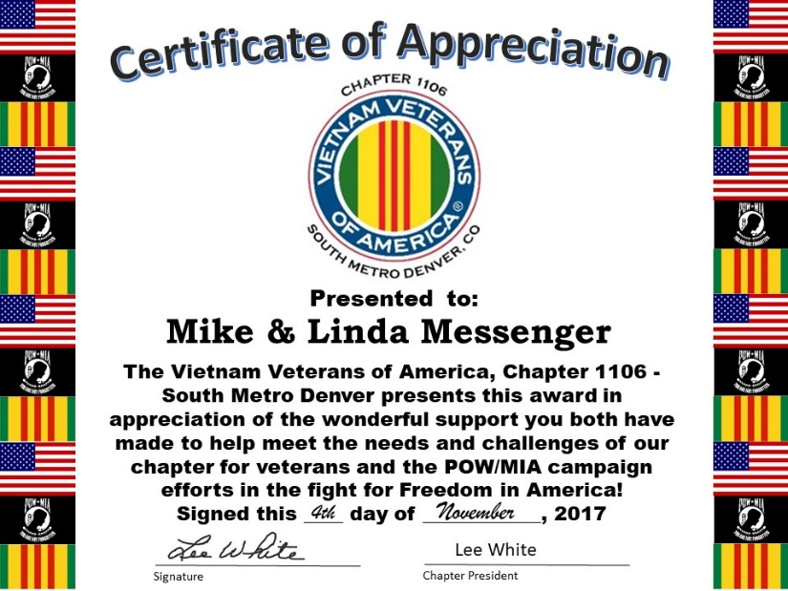

Announcement Corner
Coat Drive a Huge Success
The December meeting was the conclusion of the Coat Drive that started in November headed up by John Vargas. John commented to our chapter “Great job on short notice. Approximately 45 Coats were donated by VVA Chapter 1106. Estimated at $1,500.00.” The coats were taken to the VA two days later and were very graciously accepted by VA officials! Your donations will help a lot of Veterans stay warmer this winter. THANK YOU!!!
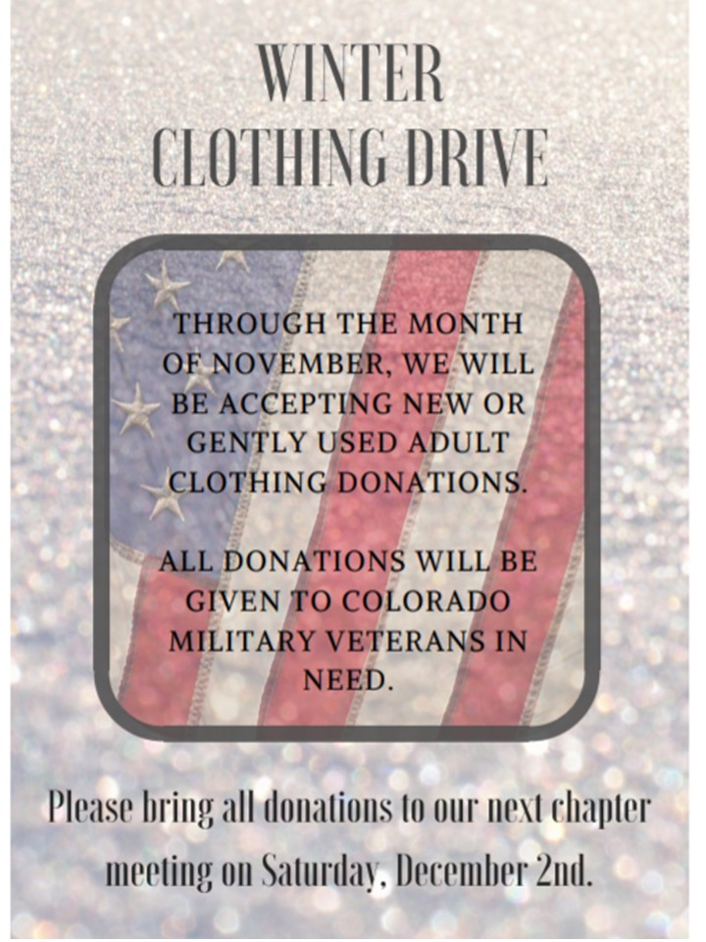
Coat drive flyer.
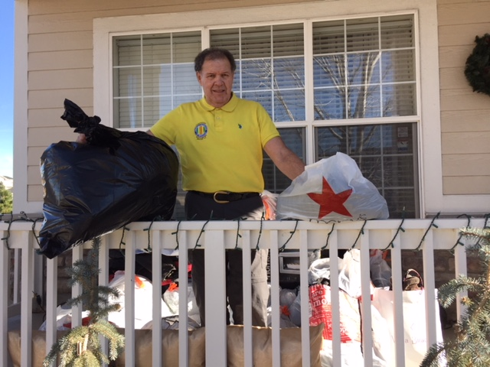
John Vargas on his front porch with bags and bags of coats for our veterans.

The Wall Christmas Tree
Suzanne Sigona designed this ornament to hang on the The Wall’s Christmas Tree. Beautiful!!!
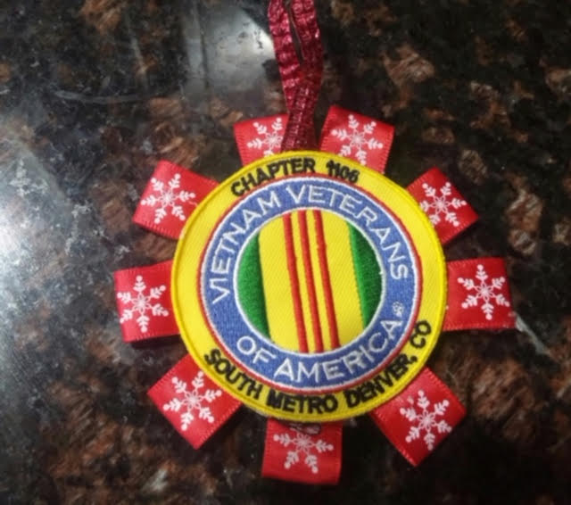

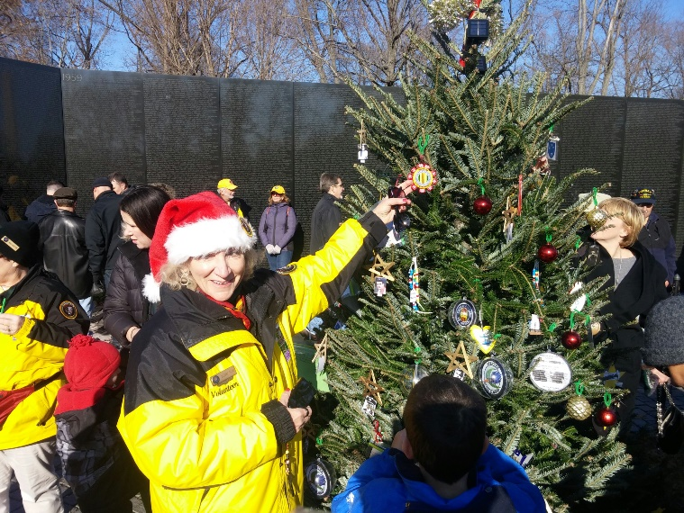
Good job! What an honor for our Chapter!

Books/Articles Published by Members
Hidden Heroes of Our Long Wars
(Note: This is an excerpt from an article in the November/December 2017 issue of the “Rand Review”)

America’s “hidden heroes” as a result of this Country’s many wars are the wives, husbands, parents, a good neighbor or a best friend who serve as caregivers to active and retired military service members. They sacrifice their time, money, jobs and even their health to support military and veterans suffering from physical disabilities, traumatic brain injuries, panic attacks and the everyday bureaucracies of American health care. These millions of military caregivers are not paid professionals but provide enormous sacrifices every day to family members and friends.

There is an estimated 4.4 million people caring for veterans of earlier eras and 1.1 million people providing veteran support post-9/11. Nearly 40 percent of caregivers meet the clinical criteria for major depression, exemplifying the strain and difficulties in providing care.

Former Senator Elizabeth Dole raised this issue at a White House press conference to introduce a coalition of nonprofit groups, political leaders and others who have committed support and to empower military caregivers. The Elizabeth Dole Foundation provides free legal and financial services to caregivers. The Foundation has also rallied caregivers to lobby Congress and the states for greater access to support programs for our Nation’s caregivers.

The Rand Corporation is an American nonprofit global policy think tank conducting research and analysis to the United States Armed Forces.

From the Editor!
From the desk of The Landlocked Sailor
Bob Rotruck, CWO3, USN (RET)
Castle Rock, CO

Young Americans!
Teenagers! Eighteen and nineteen year olds! They are in the news all of the time. They have committed a crime. It may be a minor infraction or a felony, but the bottom line is that a teenager did something bad. Fortunately for our country, they represent less than one percent of the teenage population in our country, but they make the news because the American public thrives on “bad” news.

Well what about the ninety-nine plus percent of teenagers that we don’t hear about? We are talking about the young fledgling adults that step forward and raise their right hand and swear to uphold the Constitution of the United States against all enemies, foreign and domestic as they enter military service. They volunteer and put their lives on the line so that we Americans can continue to live in the greatest country in the world in freedom.

They enter our military just boys and girls and within a few short months of training, they are now men and women, ready to do their duty. They may have come from a two parent home and had a good life. Or they may be from a life of pain and misery. From a single parent home or foster home. They may have gotten into a little trouble in their formative years, but now they are ready to cross an ocean and represent us, the American people.

But wait! None of that makes the news until they come home in a metal casket to despondent, crying loved ones who will never speak to them again. It is time for Americans to focus on the great young Americans that have done their duty. All gave some and some gave all! Let us be proud of them and show them with a handshake and a thank you!

A Mother’s Question
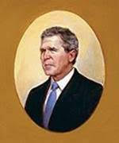
A mother asked this President... 'Why did my son have to die in Iraq?'
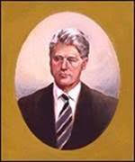
A mother asked this President... 'Why did my son have to die in Saudi Arabia?'
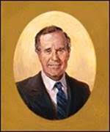
A mother asked this President... 'Why did my son have to die in Kuwait?'
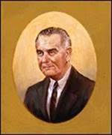
Another mother asked this President... 'Why did my son have to die in Vietnam?'
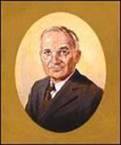
Another mother asked this President... 'Why did my son have to die in Korea?'
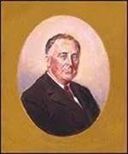
Another mother asked this President... 'Why did my son have to die on Iwo Jima?'
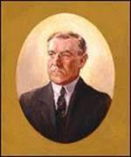
Another mother asked this President... 'Why did my son have to die on a battlefield in France?'
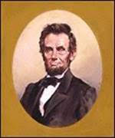
Yet another mother asked this President... 'Why did my son have to die at Gettysburg?'
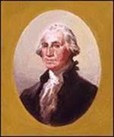
And yet another mother asked this President... 'Why did my son have to die on a frozen field near Valley Forge?'

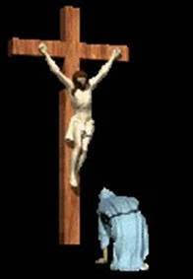
Then long, long ago, a mother asked…
'Heavenly Father... why did my Son have to die on a cross outside of Jerusalem?'

The answer is always the same... 'So that others may live and dwell in peace, happiness, and freedom.'

This was emailed to me with no author. I thought the magnitude and the simplicity was awesome.
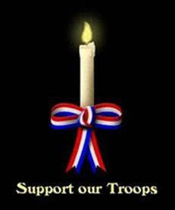
ONE FLAG
ONE LANGUAGE
ONE NATION UNDER GOD
May God Bless You ALL
Your Editor

Light Side
Signs you’re getting older!!!
Smart phones are so handy!

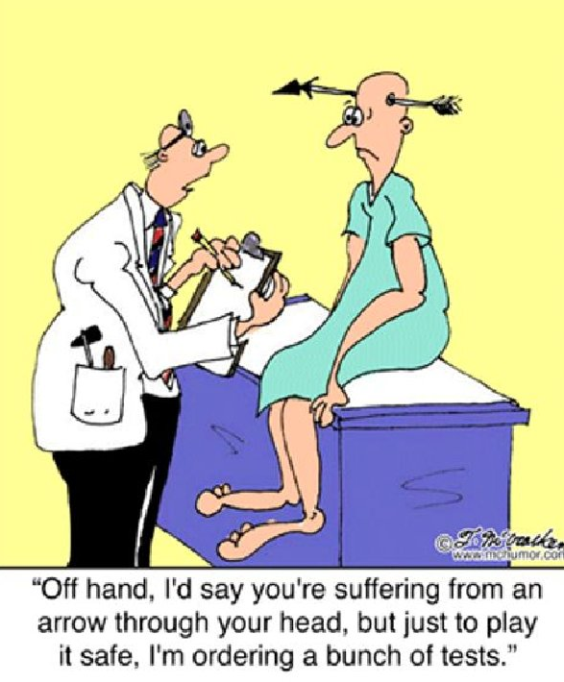
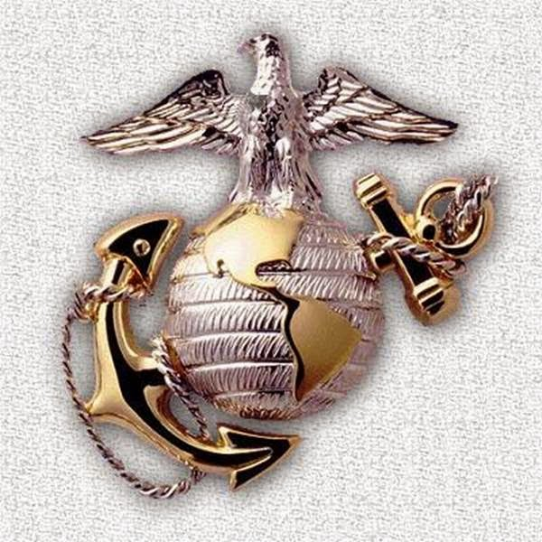
A U.S. Marine enters the Catholic Church confessional booth in Jacksonville, NC. He tells the priest, "Bless me, Father, for I have sinned. Last night, I beat the ever-living crap out of a flag burning, cop hating, anti-Trump protester."

The priest says, "My son, I am here to forgive your sins, not to discuss your community service."
Semper Fi

Editor: Glad I don’t have a “smart” phone!

COPS...Some of these are really good....
Submitted by John Vargas
These are actual comments made by 16 Police Officers. The comments were taken off actual police car videos around the country:

1. "You know, stop lights don't come any redder than the one you just went through."
2 "Relax, the handcuffs are tight because they're new. They'll stretch after you wear them a while."
3. "If you take your hands off the car, I'll make your birth certificate a worthless document."
4. "If you run, you'll only go to jail tired.
5. Can you run faster than 1200 feet per second? Because that's the speed of the bullet that'll be chasing you."(LOVE IT)
6. "You don't know how fast you were going? I guess that means I can write anything I want to on the ticket, huh?" (MY FAVORITE)
7. "Yes, sir, you can talk to the shift supervisor, but I don't think it will help. Oh, did I mention that I'm the shift supervisor?"
8. "Warning! You want a warning? O.K, I'm warning you not to do that again or I'll give you another ticket."
9. "The answer to this last question will determine whether you are drunk or not. Was Mickey Mouse a cat or a dog?"
10. "Fair? You want me to be fair? Listen, fair is a place where you go to ride on rides, eat cotton candy and corn dogs and step in monkey poop."
11. "Yeah, we have a quota. Two more tickets and my wife gets a toaster oven."
12. "In God we trust; all others we run through NCIC." (National Crime Information Center)
13. "Just how big were those 'two beers' you say you had?"
14. "No sir, we don't have quotas anymore. We used to, but now we're allowed to write as many tickets as we can."
15. "I'm glad to hear that the Chief (of Police) is a personal friend of yours. So you know someone who can post your bail."
AND THE WINNER IS....
16. "You didn't think we give pretty women tickets? You're right, we don't. Sign here."

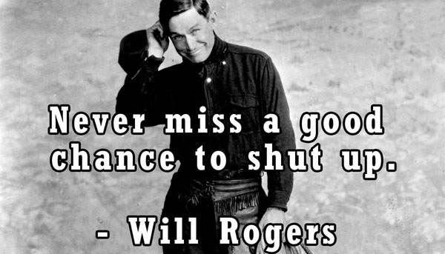

U. S. Supreme Court
The Supreme Court has ruled that there cannot be a Nativity Scene on Capitol Hill this Christmas season. This isn't for “any” religious reason. They simply have *not* been able to find Three Wise Men in the Nation's Capital. A search for a Virgin also continues. There was “no” problem, however, finding enough asses to fill the stable.

Senior’s (Chronologically Challenged Adults)
Last year I replaced all the windows in my house with those expensive, double-pane, energy-efficient kind. Today, I got a call from Home Depot who installed them. The caller complained that the work had been completed a year ago and I still hadn't paid for them.

Helloooo,........... just because I'm a Senior Citizen doesn't mean that I am automatically mentally challenged.

So, I told him just what his fast-talking sales guy told me last year that “these windows would pay for themselves in a year--- Hellooooo? It's been a year, so they're paid for,” I told him. There was only silence at the other end of the line, so I finally hung up. He never called back. I bet he felt like an idiot.

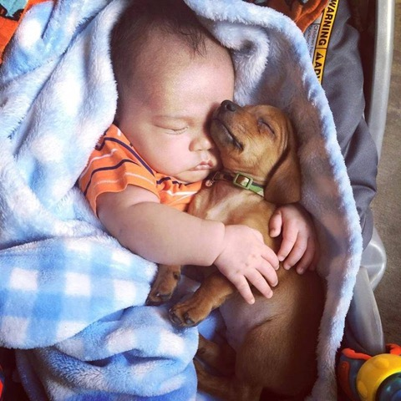
Love comes in all shapes and sizes!

Trivia Answer
Benny Sugg – Beneficial Suggestion. A document used to send up the chain of command that made some significant improvement in operations which resulted in a financial savings in man-hours.

(Editor’s note: I was ordered in 1969 aboard the USS Kitty Hawk to submit a Benny Sugg when I invented an “on-aircraft” portable tester for the ALQ-100 ECM (Electronic Counter Measures) unit. It was estimated by a group of COMNAVAIRPAC officers that if all fighter and attach squadrons had my tester, that it would save approximately $8,000.00 dollars a day in saved man-hours. Six months later back in the states, I received a Department of the Navy letter and a U.S. Treasury check (after taxes) of $350.00 – thanks!)
The National Anthem
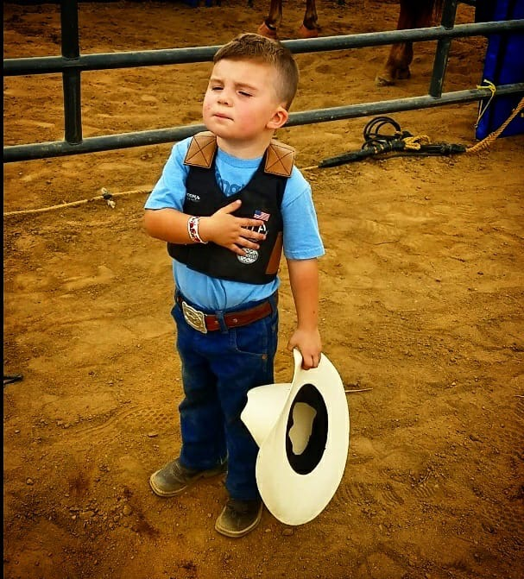
HOW IT'S DONE AT RODEOS
NO WORDS NEEDED

Christmas Party Collage
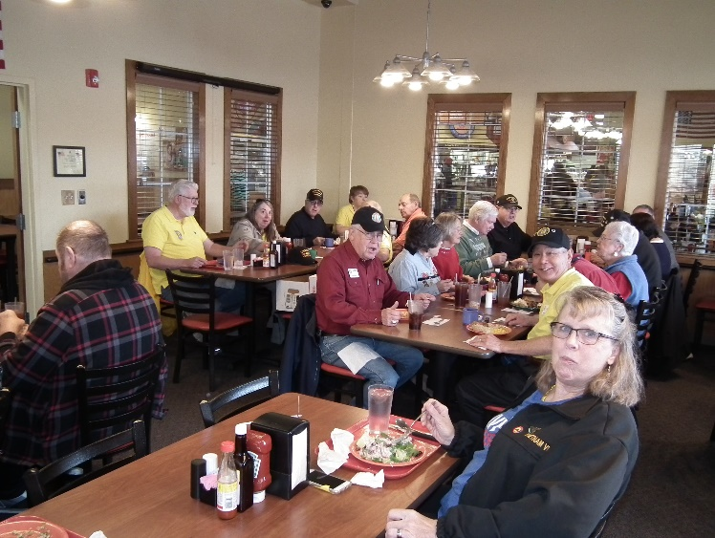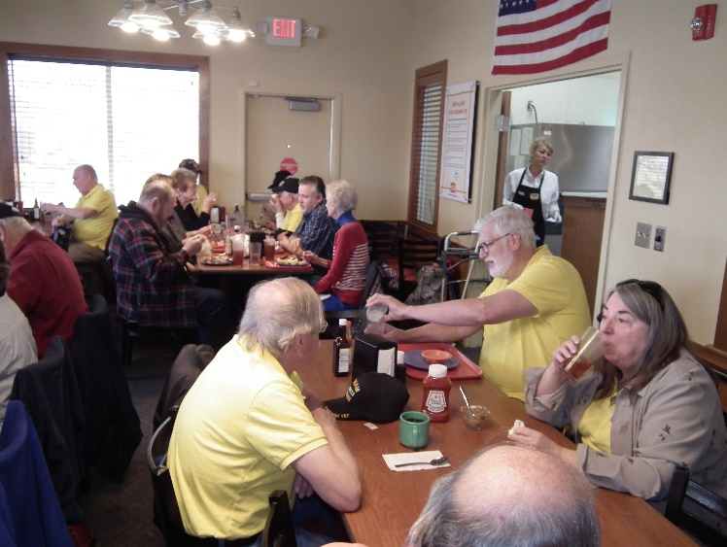

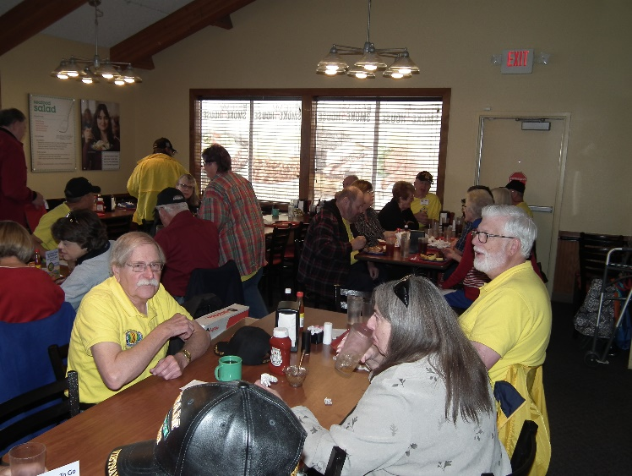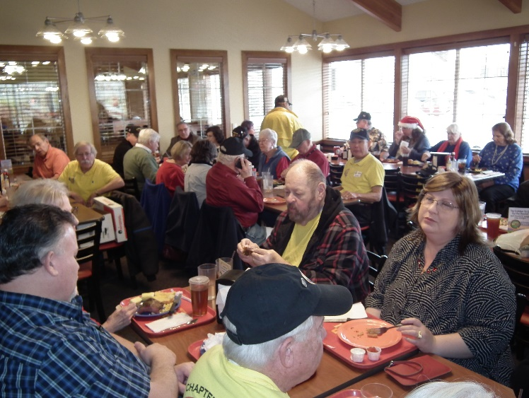

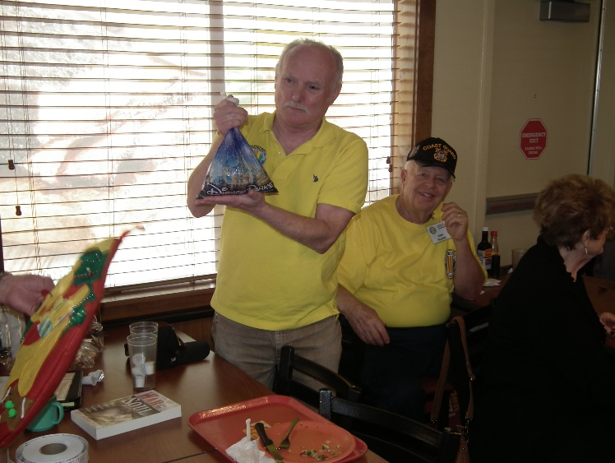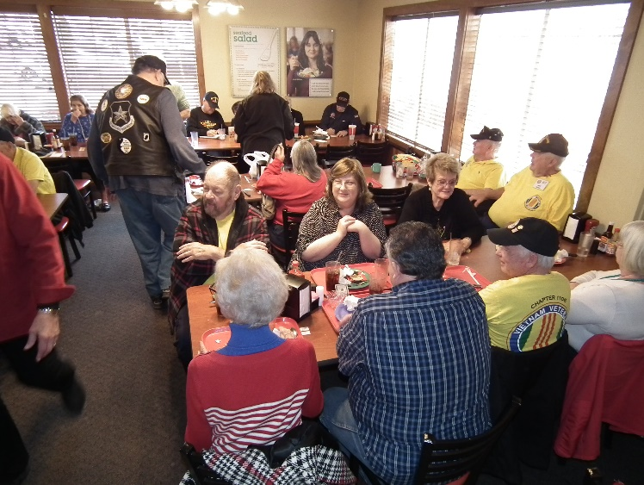

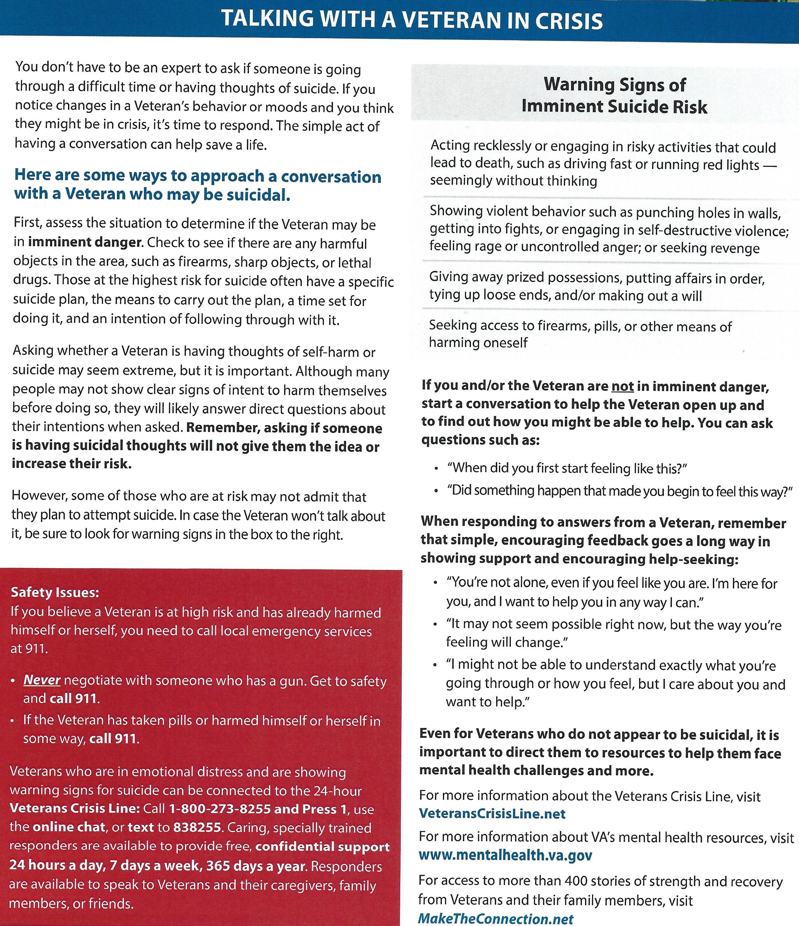

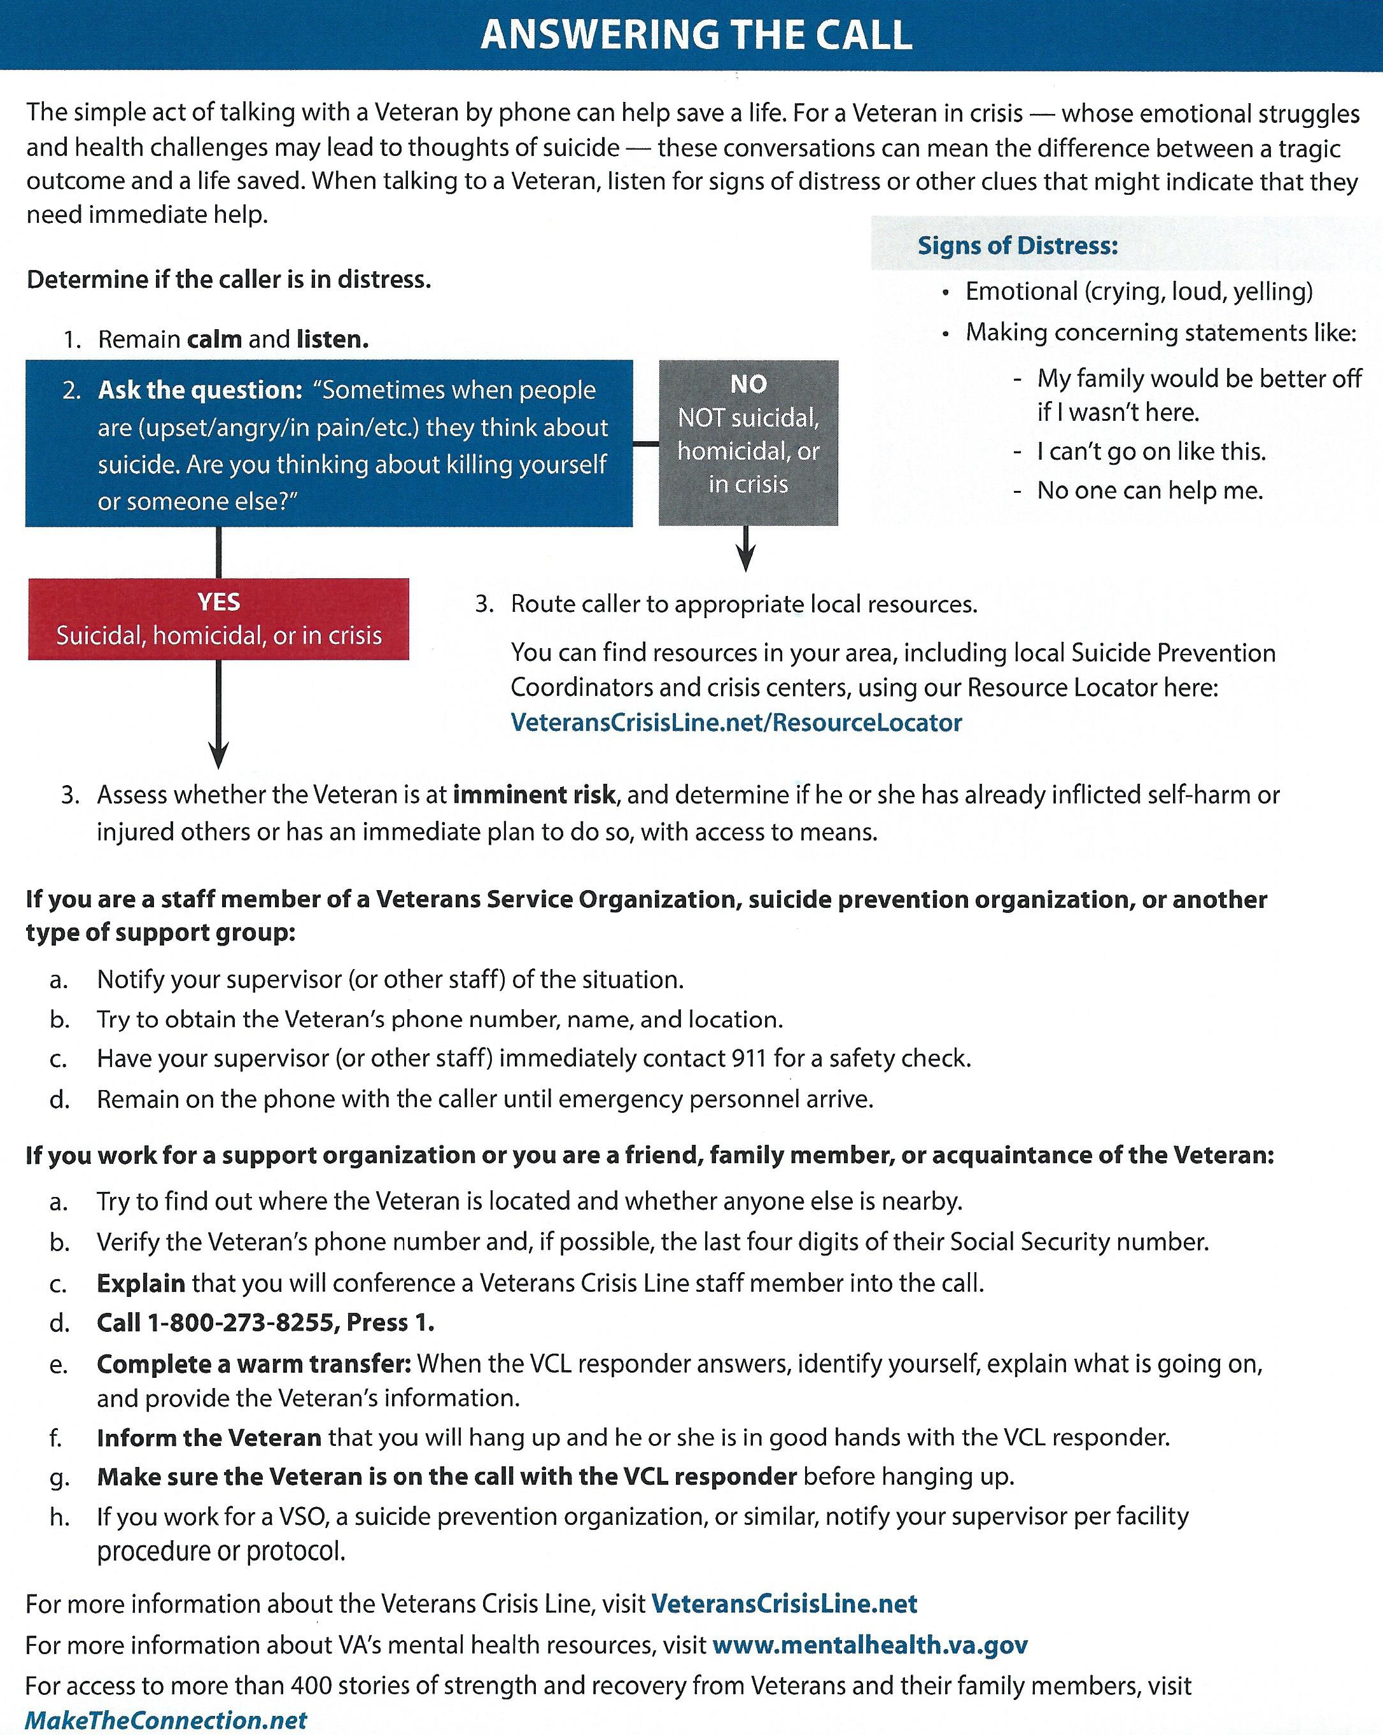

Group Picture
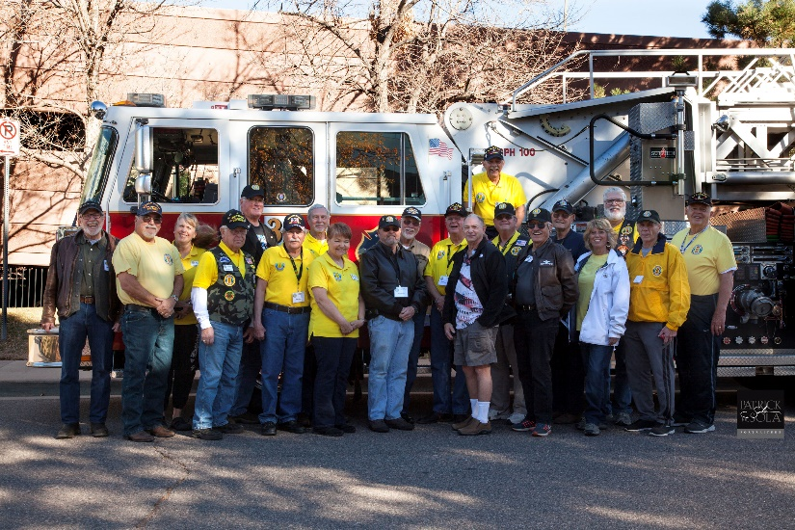
Pat Sola Photography
(Editor’s note: I didn’t realize Paul Seppo was that TALL!)

FRIENDS OF CHAPTER 1106

ERC Management, LLC
791 Southpark Dr., Suite 600
Littleton, CO 80120
720.328.3299
www.FreddysUSA.com
Caribou Coffee  12501 E Lincoln Ave  Englewood, CO 80112  303-799-1258 | American Legion Post 1260  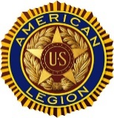
Spradlin Printing, Inc.  11903 S. Parker Road  Parker, CO 80134 | South Metro Denver Fire & Rescue  9195 E Mineral Ave  Centennial, CO 80112
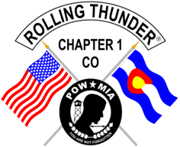  Monthly Membership Meetings  VISITORS ARE ALWAYS WELCOME!  3rd Saturday of each month at 10:00a.m.  Our meetings are held at: VFW Post 2461  1350 S Broadway, Denver, CO 80210 | Applewood Plumbing Heating & Electric  Main Billing Office: 5000 W 29th Ave.  Denver, CO 80212  Phone: 303-232-6611  Fax: 303-477-4310  Email: custservice@applewoodfixit.com
9137 E Mineral Cir Ste 100  Englewood, CO 80112-3422 | 6882 S. University Blvd.  Centennial, CO 80122  303-771-2244
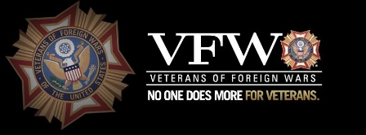  VFW Post 2461, 1350 S. Broadway, Denver, CO 80210 | STUDIO 1430 Main Office:  4700 South Syracuse Street, Suite 1050  Denver, CO 80237
Military Order of Purple Heart, Chapter 1041, Arvada, CO | Veteran’s Puppy for Life  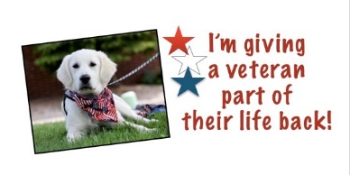  http://www.vetpuppyforlife.org
Home Depot Foundation  8477 S Yosemite St  Lone Tree, CO 80124 | Golden Corral  15775 E. Arapahoe Rd  Centennial, CO 80016
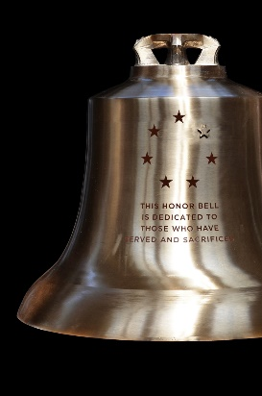  The Honor Bell Foundation  P.O. BOX 12400 DENVER, COLORADO 80212  720.282.9182 | The UPS Store  10940 S. Parker Road  Parker, CO 80134  P: 303-841-8483  F: 303-841-8685  E: store1548@theupsstore.com

