Inside this issue:
Notes from the President
Member Feature
Military Trivia
Guest Speaker
Membership
Board of Directors/Officers
Working Committees
Meetings/Events Calendar
Announcement Corner
Books/Articles Published by Mbrs.
From the Editor
Light Side
Trivia Answer
Editor’s Note:
Notice:
If you have moved or changed your address, PLEASE notify us immediately! Contact: Lee White, Membership Chair
E-mail: mailto:flyboy51@q.com
Phone: 303-519-2252

COPYRIGHT NOTICE: In accordance with Title 17 U.S.C. Section 107, any copyrighted material in this newsletter is distributed under fair use without profit or payment to those who have expressed a prior interest in receiving the included information for nonprofit use and educational purposes only.
This version of the newsletter is in Microsoft Document (.DOCX) format so that the links will work. Put your cursor over the link, depress your Control Key (ctrl) and depress your left mouse button and it will take you to the listed link position. PDF format, the links will not work.

The comments and editorial input does not necessarily reflect the opinion of the membership of our chapter. I would appreciate any feedback that you might have, items you liked or if you find offensive or derogatory in anyway. (bobrotruck73@gmail.com) Thank you for allowing me to be your editor.

Notes from the President
Lee White
As we are approaching the end of 2018, our VVA Chapter 1106 has been very active with veteran events and community activities. To highlight a few of our chapter’s accomplishments:

In January our membership committee attended a “pamvets” breakfast in Loveland and made a presentation on an additional chapter to be formed in the Loveland/Fort Collins area.

Conducted poppy drives in May and November.

Promoted Colorado Rockies baseball games to fellow veterans.

Chapter field trips to Pueblo Weisbard Aircraft Museum and visited the Vietnam Memorial and State Veteran’s Cemetery in Grand Junction/Fruita area.

Chapter members attended the national sponsored Education and Leadership Conference in Palm Springs, CA.

Our chapter was invited by the Cherry Creek School District to attend a veteran’s event and football game. More info in this newsletter.

Chapter Christmas luncheon and awards scheduled for December 15, 2018.

As President of VVA Chapter 1106, I am very proud of all our members, committees, and board members for their hard work and dedication to make our chapter so successful in 2018.

Merry Christmas and Happy New Year!!!

“Member Feature”
Ronald L. Smith, USAF, Sergeant, 1969-1975. I served in Vietnam MACV Saigon, U-Tapao, Thailand and, Iraklion, Crete, Greece with AFRTS. It is the broadcast service operated by the United States Armed Forces' American Forces Radio and Television Service (AFRTS, commonly pronounced "A-farts" for its entertainment and command internal information networks worldwide. The AFN worldwide radio and television broadcast network serves American service members, Department of Defense and other U.S. government civilians and their families stationed at bases overseas, as well as U.S. Navy ships at sea. AFN broadcasts popular American radio and television programs from the major U.S. networks. It is sometimes referred to as the Armed Forces Network. It is based at Fort George G. Meade in Maryland and is part of the Defense Media Activity. My most memorable experience was traveling the world – Southeast Asia and Europe. I want the chapter to continue excursions and the comradery of our veterans.

Military Trivia
ROAD?
Click here for end of the Newsletter Trivia Answer

Chapter Color Guard presented colors at the October meeting. Tony Nickerson – Command Sergeant, was to the left, just out of the photo!
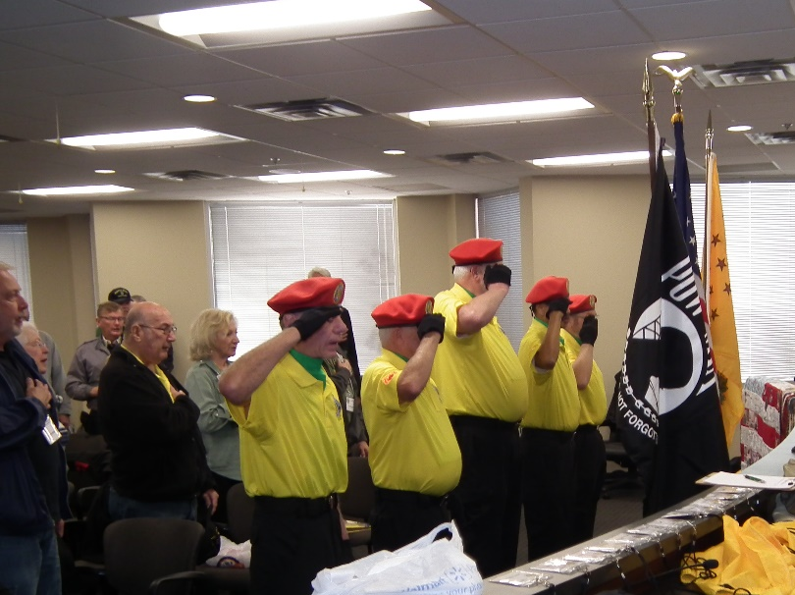

Special Guest - September
Cynthia Logan, HHD (Doctorate in Holistic Health), MSC (Masters of Science in Counseling with an emphasis on Health Promotion), BA (Bachelor of Arts in Philosophy and Quality Control Engineering) CAN (Certified Nursing Assistant). She served in the Army in 74 -75, a Vietnam Era vet and was a food inspector. She spoke to us about her passion for quadriplegics and cerebral palsy persons. With the people she has served, she has been actively involved in advocacy for disability rights. One of her first events was the sit-in during rush hour traffic at Broadway and Colfax years ago, advocating for handicapped accessible buses and sidewalks. The movement spread throughout the US and is now gaining momentum in other parts of the world. In February 2018 she was diagnosed MST PTSD. She says, “In a way it is a relief and has brought the dots of her life together.” She is on the Women Focus Group for the new Women's PTSD facility in the new Aurora VA hospital. Her main focus now is dealing with PTSD not to forget, but to integrate it into the whole of her life to find a measure of peace so that she can move forward toward a fruitful, productive retirement. Thank you Cynthia for all you are doing to help others!

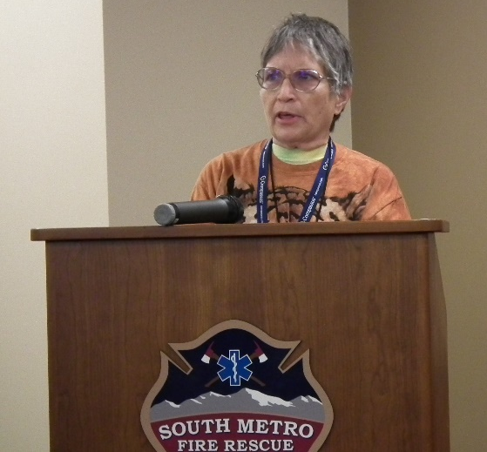
Cynthia Logan

Special Guest – October
Mat Williams, Director – Fort Logan National Cemetery Complex gave an excellent presentation of the facility and burial data as well as the qualification requirements to have a burial at Fort Logan. He answered all of the questions put forth by the attendees.
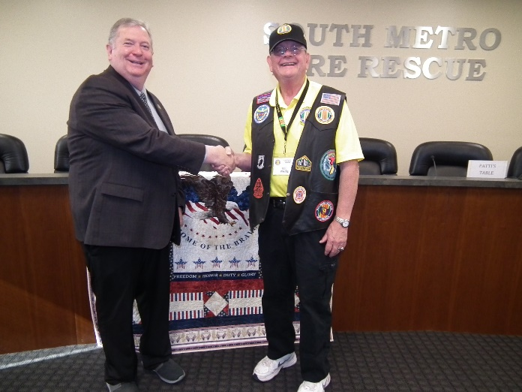
Lee presenting a VVA Challenge coin to Mat Williams.
He served six years in the U.S. Army. His tours included Martin Army Hospital at Fort Benning, Ga. and Tripler Army Medical Center in Honolulu, where he received an Army Commendation Medal. Mr. Williams earned a bachelor's degree in political science from Northern Arizona University in May 1985.

Fort Logan was named after Union General John A. Logan, commander of US Volunteer forces during the American Civil War. Fort Logan itself was established on October 31, 1887, and was in continuous use until 1946 when most of the acreage except for the cemetery was turned over to the state of Colorado. The national cemetery was created in 1950. It contains 214 acres and currently has over 124,000 interments. It was listed on the National Register of Historic Places in 2016.

Special Gift
At the October meeting a special gift presentation was given to our chapter. A POW/MIA chair was presented by Gary Teiken and Gary Meyers, both members of Rolling Thunder, Colorado Chapter 1. Gary Meyers of course, is a member of our VVA Chapter 1106 and is in charge of our POW/MIA Committee.
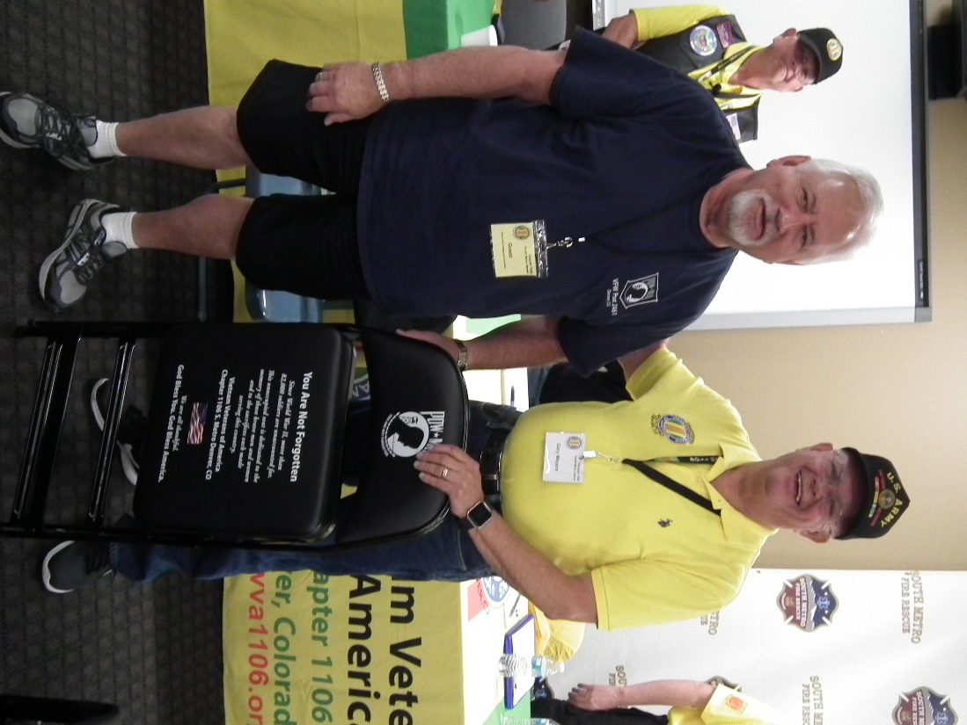
Gary Teiken and Gary Meyers
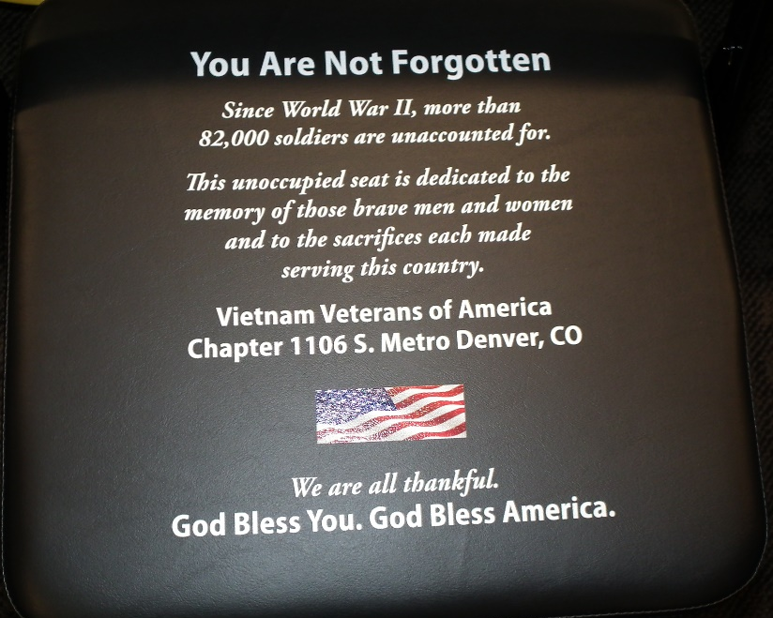
Inscription on the seat of the POW/MIA chair.

Membership!
VVA Chapter 1106 Membership: (10-10-2018)
VVA - 119
AVVA - 27
Total: 146
Welcome New Members:
Dan Wagle
Tony Croce
Gary Bentzen
Jim McGrevey
Welcome new AVVA members:
Siltham Smith
Linda Croce

Board of Directors/Officers
Lee White - President
Bob Easter - Vice-president
Joe Plant - Treasurer
Glen Payne - Secretary
Board Members - Milt Omoto, Patti Ehline, Dave Lyons, Tom Werzyn
John Vargas - Sergeant-at-Arms

Working Committees
Agent Orange/PTSD - Patti Ehline
Color Guard – Tony Nickerson - Command Sergeant, Dave Lyons, Don McNeely, Dan Green, Clarence Rebolledo, Robert Senatore, Ron Smith, Bob Larson
Membership – Dave Lyons – Chair, Lee White, Tom Werzyn
Mental Health: Patti Ehline, Warren Harrison
Newsletter Editor - Bob Rotruck
Fundraising/Grants - Milt Omoto
Marketing/Media/Events – Tom Werzyn
POW/MIA – Gary Meyers
Webmaster – Robert Senatore, Bob Rotruck
Women Veterans - Patti Ehline
Scholarship Program - Mike Karsh – Co-Chair, Jim Marcille – Co-Chair, John Vargas, Glen Payne, Hazel Simeon, Brian Karsh (supporter)
Veteran Emergency Assistance Committee - Joe Plant, Bob Rotruck, Lee White, Dave Lyons
Speakers Bureau – Bob Easter, Glen Payne, Bob Mallin, Tom Werzyn
Social – John Vargas, Barry Fiore, Glen Payne, Milt Omoto, Hazel Simeon
Government Affairs – Tony Nickerson

Meetings/Events Calendar - 2018
November 3 - VVA Chapter 1106 Monthly Membership Meeting
November 10 - Veterans Day Poppy Drive
November 22 - Thanksgiving
December 1- VVA Chapter 1106 Monthly Membership Meeting
December 8 - Co State Council Meeting - Castle Rock
December 15 - VVA Chapter 1106 Annual Christmas Luncheon & Awards
December 25 - Merry Christmas

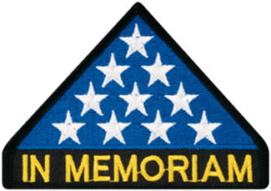

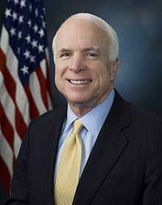
In Memoriam
Vietnam Veterans of America National President John Rowan on the Passing of Sen. John McCain

(Washington, DC)— “We are deeply saddened by the passing of our brother in arms John McCain. On behalf of Vietnam Veterans of America, we extend to the McCain family our heartfelt prayers during this sad time of loss. Sen. John McCain has led a life of unparalleled service to our nation. From his time in captivity in the Hanoi Hilton, where he endured brutal torture, to his final battle with glioblastoma, he has led by example, facing his foe with courage and strength. He is among the finest our nation has produced, living his life with integrity and honor. In his wake, we will strive to uphold the American ideals he has lived,” said John Rowan, VVA National President.
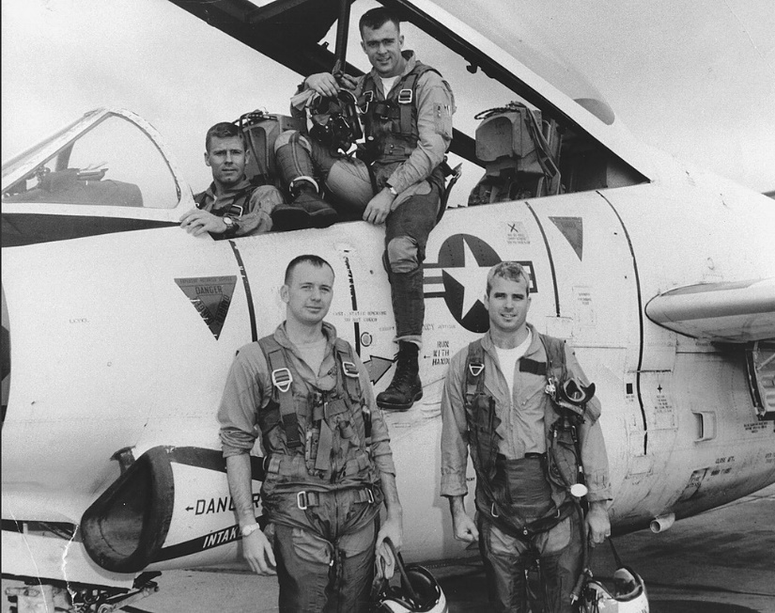
Lieutenant McCain (front right) with his squadron and T-2 Buckeye trainer, 1965

Van T Barfoot died...
Remember the guy who wouldn't take the flag pole down on his Virginia property a while back? You might remember the news story several months ago about a crotchety old man in Virginia who defied his local Homeowners Association and refused to take down the Flag pole on his property, along with the large American flag he flew on it.

Now we learn who that old man was. On June 15, 1919, Van T. Barfoot was born in Edinburg, Texas. That probably didn't make News back then.

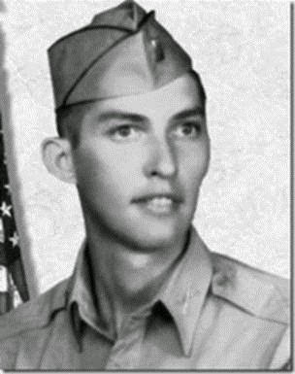
But twenty-five years later, on May 23, 1944 near Carano, Italy that same Van T. Barfoot, who had in 1940 enlisted in the U.S. Army, set out alone to flank German machine gun positions from which gunfire was raining down on his fellow soldiers. His advance took him through a minefield but having done so, he proceeded to single-handedly take out three enemy machine gun positions, returning with 17 prisoners of war. And if that weren’t enough for a day's work, he later took on and destroyed three German tanks sent to retake the machine gun positions.
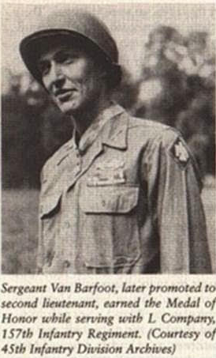
That probably didn’t make much news either, given the scope of the war, but it did earn Van T. Barfoot, who retired as a Colonel after also serving in Korea and Vietnam, a well-deserved Congressional Medal of Honor.
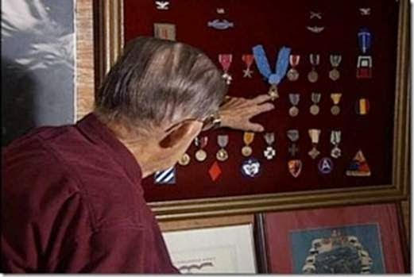
What did make News was his Neighborhood Association's Quibble with how the 90-year-old Veteran chose to fly the American flag outside his suburban Virginia home. Seems the HOA rules said it was OK to fly a flag on a house-mounted bracket, but for decorum, items such as Barfoot's 21-foot flagpole were "unsuitable". Van Barfoot had been denied a permit for the pole, but erected it anyway and was facing court action unless he agreed to take it down.

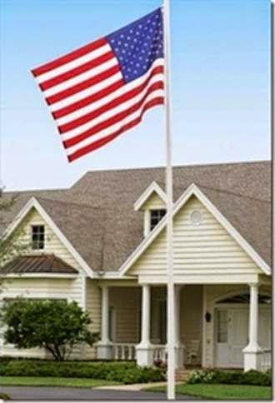
Then the HOA story made national TV and the Neighborhood Association rethought its position and agreed to indulge this aging hero who dwelt among them. "In the time I have left", he said to the Associated Press, "I plan to continue to fly the American flag without interference." As well he should. And if any of his neighbors had taken a notion to contest him further, they might have done well to read his Medal of Honor citation first. Seems it Indicates Mr. Van Barfoot wasn't particularly good at backing down.

If you read this article and don't pass it on, guess what – you need your butt kicked. I wrote this for you because I didn't want MY butt kicked!

WE ONLY LIVE IN THE LAND OF THE FREE BECAUSE OF THE BRAVE! AND, BECAUSE OF OLD MEN LIKE VAN BARFOOT!
Roy H. Autry, MBA, Ph.D.

Senior Medicare Patrol and Medicare Fraud
In Colorado, report Medicare fraud by contacting 1-800-503-5190 or dora_seniormedicarepatrol@state.co.us

MEDICARE SCAM ALERT
Scammers may call about your new Medicare card to trick you into sharing your personal information — like your current Medicare Number. Remember, Medicare will never call you uninvited or ask for your personal or private information to get your new Medicare Number and card. There are very limited situations in which Medicare can call you.

Here are 2 tips to avoid Medicare scams:

Guard your Medicare Number and card. Only give your Medicare Number to doctors, pharmacists, other health care providers, your insurers, or people you trust to work with Medicare on your behalf. Hang up on fraudsters. If someone asks for your information, for money, or threatens to cancel your health benefits if you don’t share your personal information, hang up and call us at 1-800-MEDICARE (1-800-633-4227)

New Medicare Card Coming Soon!

Protect Yourself and Your Loved Ones from Medicare Fraud

The Senior Medicare Patrol (SMP) empowers and assists Medicare beneficiaries, their families, and caregivers to prevent, detect, and report health care fraud, errors, and abuse. SMPs are here to answer your questions. Advice is free, confidential and objective. Medicare is complicated. What may seem like an error to the beneficiary may simply be the result of a misunderstanding about benefits. It may also be abuse, which involves billing Medicare for services that are not covered or are not correctly coded. The Colorado Senior Medicare Patrol is here to help, so call or email with your questions.

Frequently Asked Questions: I was billed for a service I didn't receive. What do I do?

- Contact the Colorado Senior Medicare Patrol I believe there is an error on my Medicare Bill.
- Contact the health care provider or the company that paid the bill. If they don't resolve the issue, contact the Colorado Senior Medicare Patrol What if I suspect Medicare fraud?
- Report it! Contact the Colorado Senior Medicare Patrol Somebody is trying to sell me a Medicare plan and I don't know if they're legitimate.
- Ask the caller for his or her name, company name, and callback number. You can call back later to verify the legitimacy of the source and the offer.
- Are they asking for credit card information?
- Are they asking for banking information?
- Are they asking for personal information like your Medicare or Social Security number?
- Do they say the offer is only good today? A real company will give you time to think and verify.
- Do they know something about you but ask to verify that the information is correct?

If any of these are happening, HANG UP! For these or other questions, contact us at: Colorado Senior Medicare Patrol 1560 Broadway, Suite 850 Denver, CO 80202 1-800-503-5190 or send us an email by clicking on this link: dora_seniormedicarepatrol@state.co.us

In your message or email, please include your phone number. SMPs are grant-funded projects of the federal U.S. Department of Health and Human Services (HHS), U.S. Administration for Community Living (ACL). The Colorado Senior Medicare Patrol is administered by the Colorado Division of Insurance.

Wonderful Volunteer
Submitted by John Vargas
Ms. Jodie Wiepking playing beautiful music. She is Volunteer at the VA Clinic in Golden Colorado. This is a Lever Harp (no pedals).
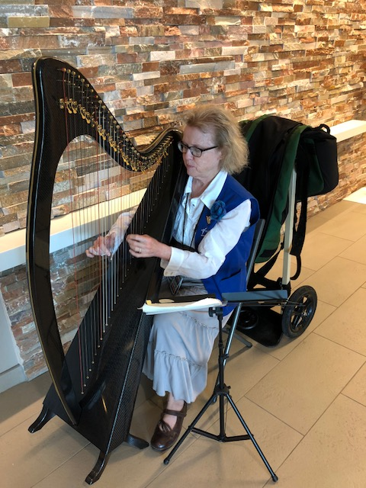
Jodie Wiepking
Announcement Corner
Denver VA Hospital Finally Opens
Our own Chaplain, Gary Turks, gave the invocation at the ribbon cutting ceremony.
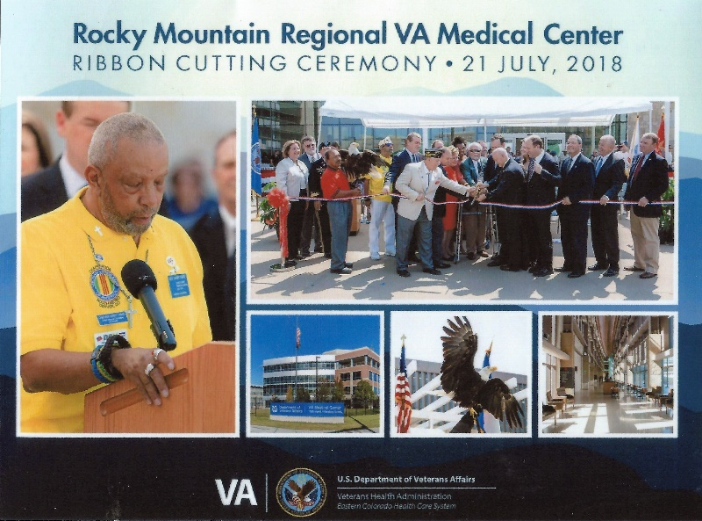

New Executive Director Named
Michelle Mallin was voted in as the new Executive Director, and will oversee overall operations for the Foundation's programs. "This promotion is bittersweet, but the support from the board and our community has been uplifting," Mallin said.
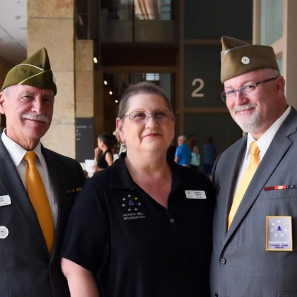

Honor Bell Events
Serving with Honor: A Volunteer Appreciation Event and Complimentary Film Series
In addition to saluting our volunteers, we will have a complimentary screening of the film, Taking Chance. In 2004, US Marine Lt. Col. Michael Strobl volunteered to provide dignified escort for the body of 19-year-old Marine Chance Phelps back to his hometown of Dubois, Wyoming. Strobl wrote an essay on his experience which was made into this poignant film. Chance’s Lance Corporal Insignia, Enlisted Dress Insignia, and his Rifle Expert badge are among the artifacts that are now a part of the Honor Bell.

The evening’s events will be emceed by Steffan Tubbs, radio host on KNUS’ American Veteran Show. Tubbs is also a producer of films including ACRONYM and 25 Steps.

Please join us on November 7th in honoring and celebrating the people who make the Honor Bell heard.

Veterans Day Event
On 11-11-18 Veterans Day and Armistice anniversary at Fort Logan. Joe Dempsey and Dave Lyons will toll the HONOR BELL for commemoration. Info on the anniversary at https://www.worldwar1centennial.org and there is a Colorado page in there. The program should be pretty huge at Logan. Program begins just before 11:00. Get there early to park.

Cherry Creek School District Military Appreciation Day – September 15, 2018 at Legacy Stadium
The CCSD held an event to honor active duty military, veterans, and families at a football event. We were honored guests for a lunch of pizza, salad, cookies and drinks at 11:00AM. Part of the check-in, we were given a free tee shirts embossed with the event and a goody bag. It was a great opportunity to interface with our fellow brothers and sisters as well as many students who came to the tables to talk to us.
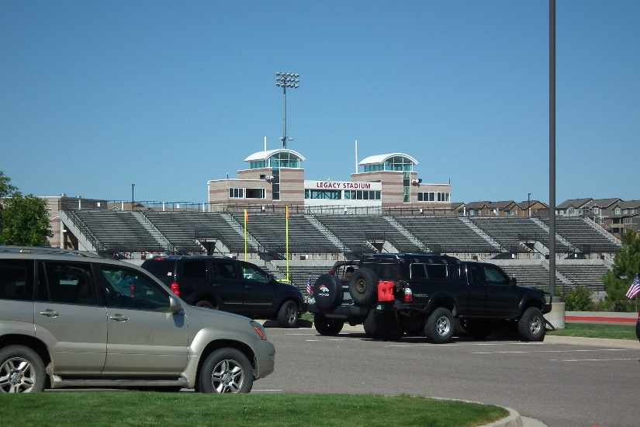
Legacy Stadium
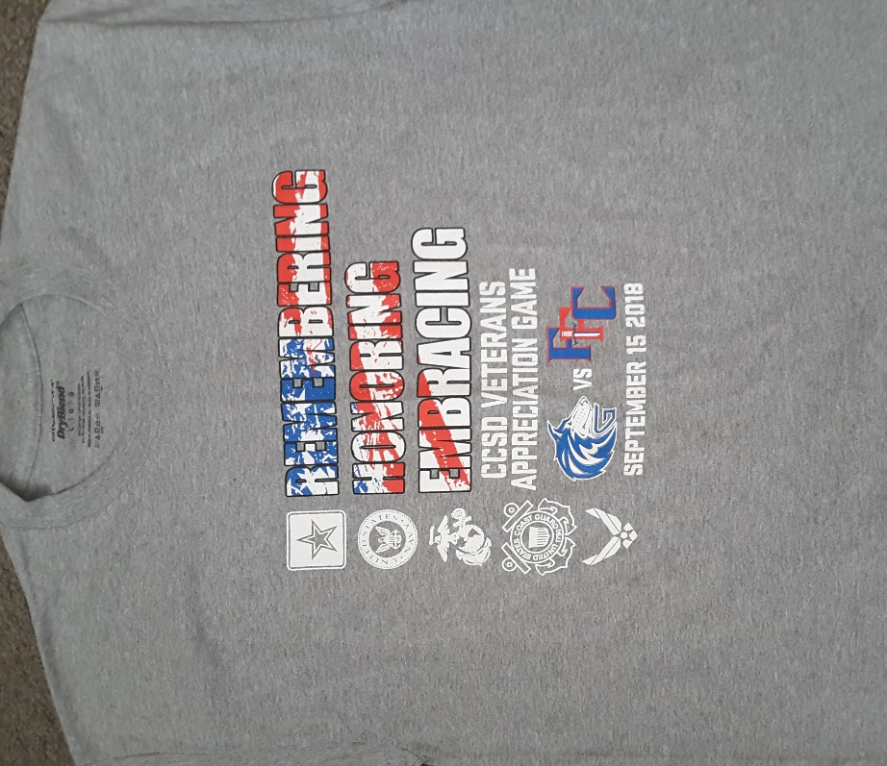
Tee Shirt given free to all veterans!
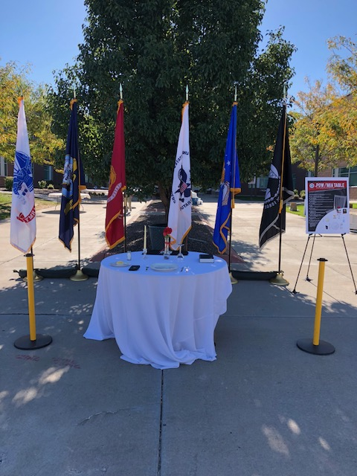
Missing Man Table presented by the Military Order of Purple Hearts Chapter 1041 - Arvada
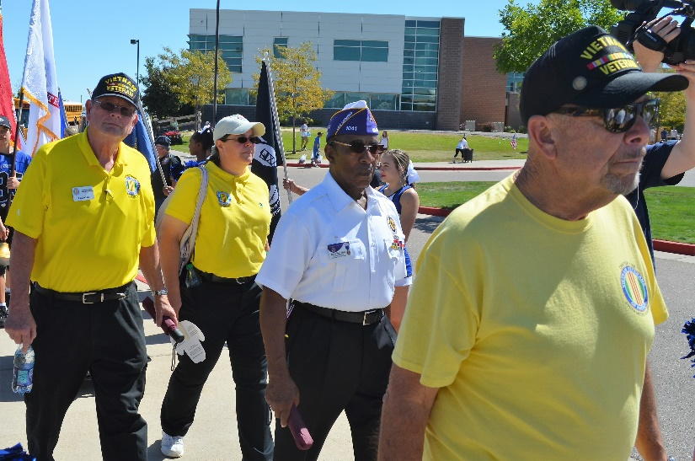
Military and Veterans walked to the stadium with cheerleaders and band members lining the sidewalk.
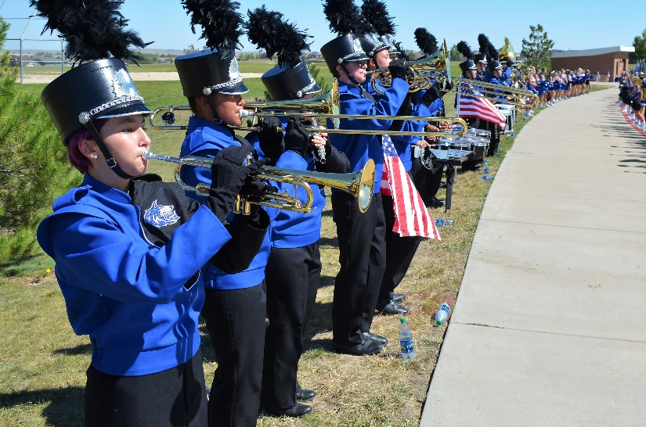
Picture courtesy: Bob Waples
Band and Cheerleaders
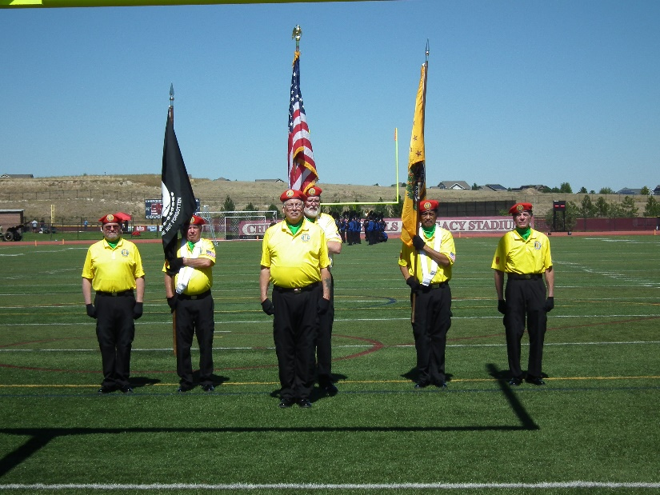
First colors presentation by our Chapter 1106 Color Guard. Pictured L to R: Ron Smith, Clarence Rebolledo, Tony Nickerson - Command Sergeant, Dave Lyons, Dan Green, Robert Senatore
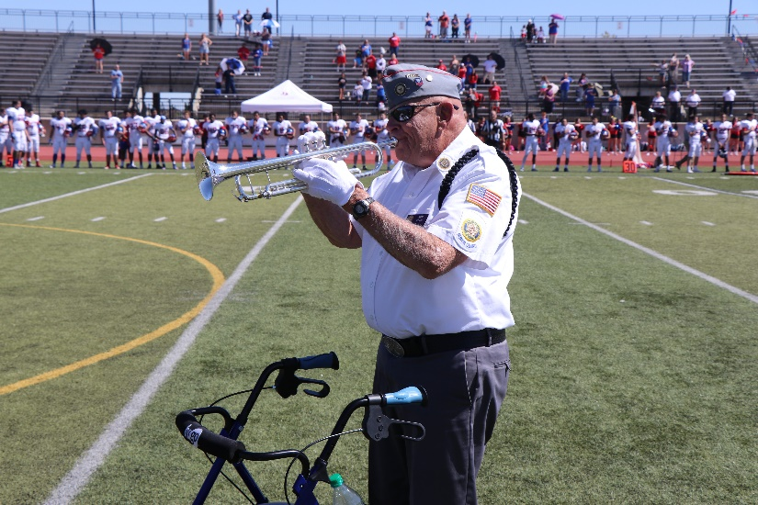
Picture courtesy: Christina Everson
Ken Reck, 84 y/o Navy Veteran played TAPS following the National Anthem.
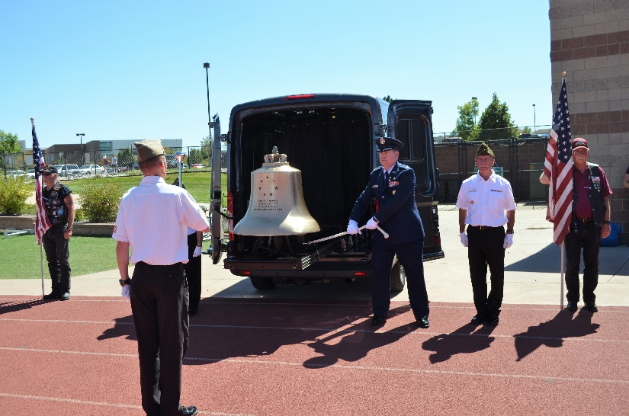
Picture courtesy: Bob Waples
The HONOR BELL was struck following the playing of TAPS

Cherry Creek School District Luncheon
Christopher Smith (Chief of Staff) John Vargas (Sgt At Arms) and Larry Bull (District Director). John presented each with a MOPH 1041 Plaque for their on-going recognition and contributions to all Veterans. 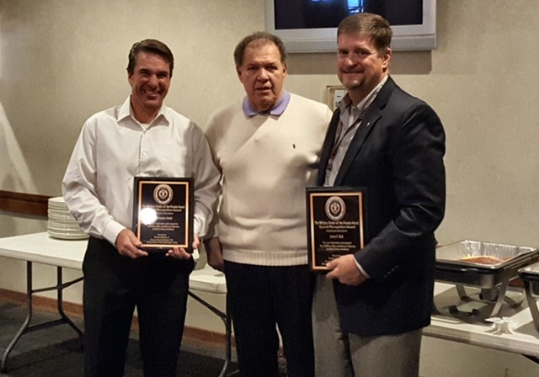

Nike wants to sell more shoes!
If you have read the constitution, you understand that Nike has every right to use Colin Kaepernick as the spokesperson for their new ad campaign. But sometimes you have to wonder if that right might have been better used. The ad:
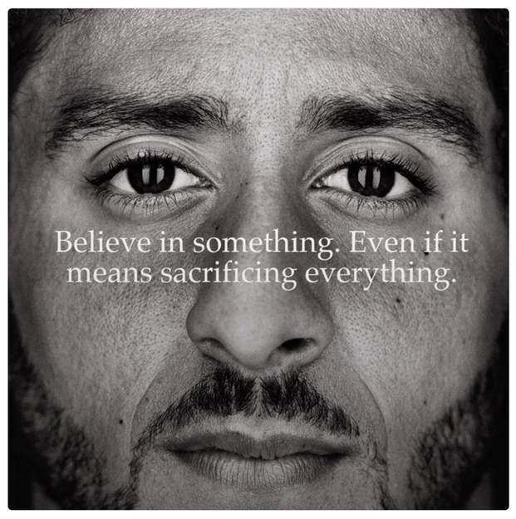
This ad would sell more shoes:
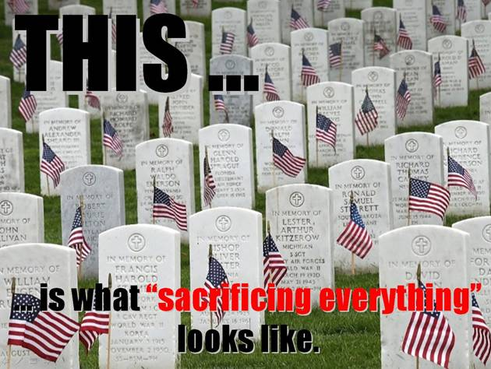
Museum Honors Dick Cole, Last Doolittle Raider
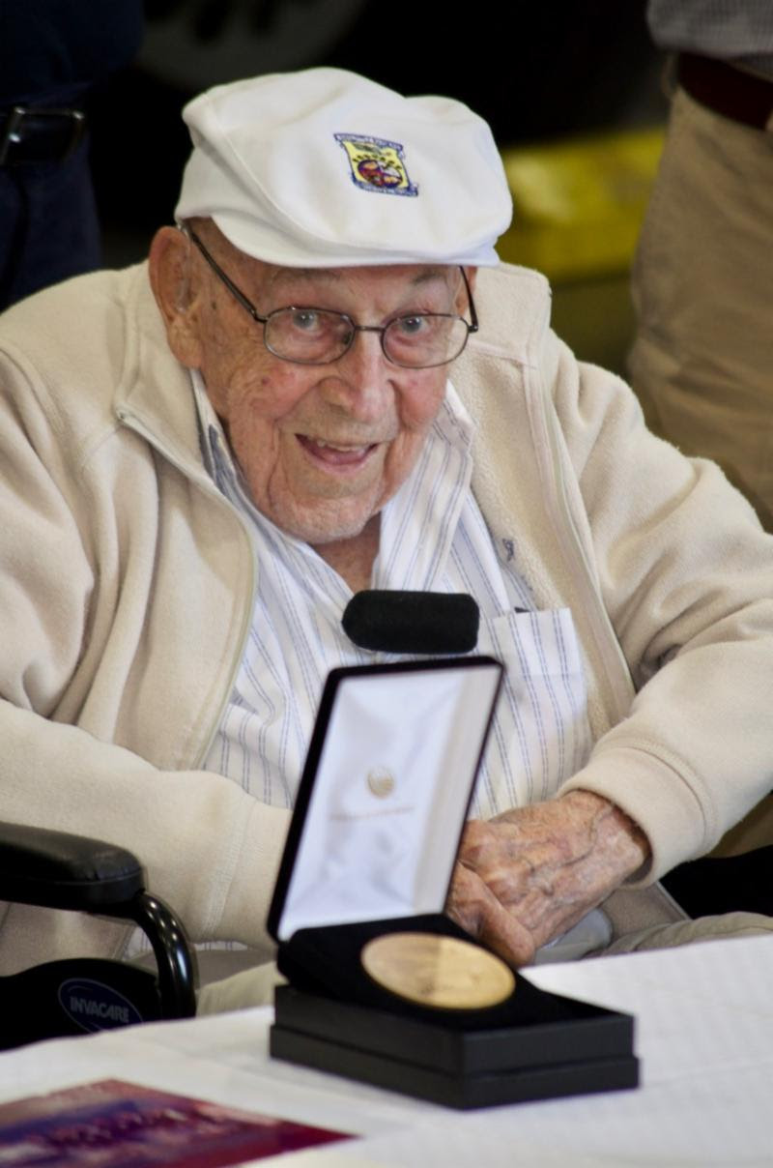
Dick Cole – Photo by Jim Klages
102-year-old retired Lieutenant Colonel Richard E. "Dick" Cole, last living member of the famous Doolittle Raid against Japan in 1942, was given a warm welcome at Westpac Restorations and the Museum on August 9. To the applause of about 200, two items were presented to the Museum in a brief ceremony, a painting by artist Robert Moak signed by 43 of the Raiders, and a copy of the Congressional Gold Medal presented to the Raiders by President Barack Obama. Dick, his daughter Cindy Cole Chal, and Jim Bower, son of Raider Bill Bower, sat before Westpac's B-25J "In the Mood," a type nearly identical to the B-25Bs that were used in the raid.

Eighty pilots, bombardiers, navigators and flight engineers, flying 16 B-25s from the carrier USS Hornet, stunned the Japanese by attacking Tokyo and other sites in Japan on April 18, 1942, just months after Japan's December 7, 1941, attack on Pearl Harbor.
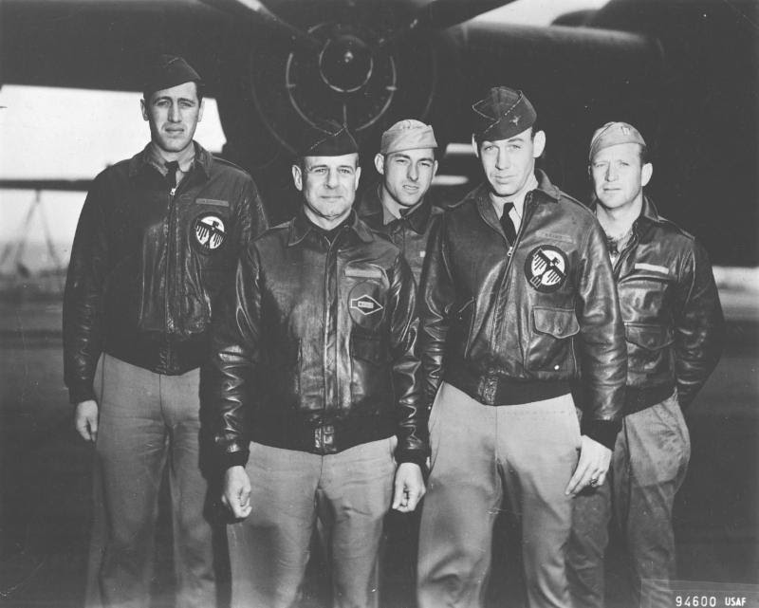
From left to right: (front row) Lt. Col. Jimmy Doolittle, pilot; Lt. Richard E. Cole, co-pilot; (back row) Lt. Henry A. Potter, navigator; SSgt Fred A. Braemer, bombardier; SSgt Paul J. Leonard, flight engineer/gunner (USAF photo)
Follow this link to read the whole story:
http://campaign.r20.constantcontact.com/render?m=1102286017538&ca=d4f87fb4-f09d-41e5-b038-eb5e701be4ac

INCOME TAX SEASON
I know it seems awfully early to think about the upcoming tax season, but several chapter members have inquired about income tax consultants. I would like to publish in the Jan/Feb newsletter some recommendations from you all (pronounced ya’ll) so I can publish a list of people in the business that charge a reasonable price and you have feel they are trustworthy to work on your taxes. Please email me info: bobrotruck73@gmail.com
Name (company name if an actual business):
Address:
Phone number:
Email:

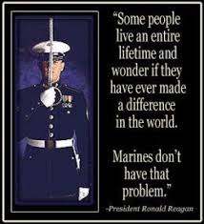

This is a personal from your editor. I am NOT watching the NFL this season!!!
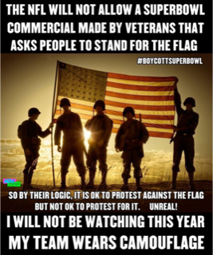

Book/Articles Published by Members
Totalitarianism
Submitted by Tom Werzyn
The totalitarian states can do great things, but there is one thing they cannot do: they cannot give the factory worker a rifle and tell him to take it home and keep it in his bedroom. That rifle hanging on the wall of the working-class flat or laborer’s cottage is the symbol of democracy. It is our job to see that it stays there.
---- George Orwell

A Fallen and Forgotten Doughboy’s Legacy
Submitted by Joe Dempsey – Chapter Member
A statue honoring him didn’t have a plaque. So I did some digging.
By M.L. Cavanaugh – May 24, 2018 6:38 p.m. ET

The closest I came to getting killed in Iraq was during the summer of 2005. I spotted an enemy fighter firing a rocket-propelled grenade right at my Humvee. Somehow he missed, but for a moment I was sure I wasn’t going home.
Whenever something like that happened, afterward came a mental flash. In my mind’s eye, I’d see my funeral or look down on my corpse. Soldiers think about mortality more than most. I still do. We also think—especially over Memorial Day weekend—about those who died on other battlefields.

Last year I found myself wondering about a statue of a World War I “doughboy” in Manitou Springs, Colo., where I now live. I found no marker or plaque, only questions. Who was he? Where did he fight?
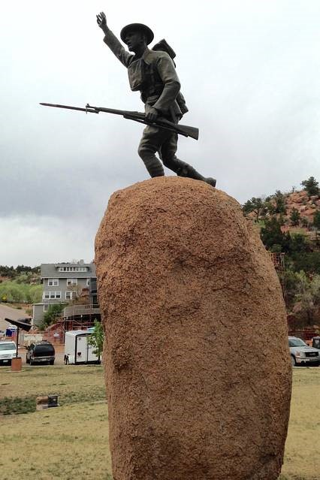
Anonymous sacrifice, I worried, was essentially forgotten sacrifice. If Americans had forgotten this doughboy, what chance does a soldier today—especially one who dies on an obscure battlefield like Niger—have to be remembered?

I started digging into records of the local historical society, old newspapers, and genealogy databases. Eventually I discovered that the statue honors Marine Pvt. George Eber Duclo, born in 1893. Eber, as he was known, was an only child who moved to Manitou Springs at age 4. He was the second-best hitter on his high-school baseball team. He won a box of cigars in a speed-walking contest.
Eber enlisted in the Marine Corps four months before the U.S. declared war in April 1917, which meant he was among the first to go “over there.” He arrived in France that summer, trained for several months, and saw combat in 1918.

The Marines were so persistent that the Germans called them “Devil Dogs.” This disciplined spirit was probably with Eber when he was killed on June 15, 1918, likely as he attacked one of the last enemy machine-gun positions at Belleau Wood, France. A boy from Manitou Springs, known for its water, drew his last breath in a place named by joining the French words “belle” and “eau,” meaning “good water.”

Eber was buried on the battlefield, but the government brought him home on Sept. 8, 1921. The funeral was “one of the largest ever held in Manitou,” according to a news report. The local American Legion post, named in Eber’s honor, held dances and took donations to fund the 7-foot bronze statue—“Over the Top to Victory”—in his honor. They placed it on a 20-ton boulder of native granite in the town’s Memorial Park. It rained at the dedication, on Memorial Day 1924.
Eber’s parents thenceforth listed two addresses: the house where they actually lived, and Memorial Park, where their only son’s memory lived on. Today the park is a place where artists create, people meet, and children play. In 2007, a woman writing in the local newspaper called it a place of “peace.”

I’ve learned that a soldier’s sacrifice doesn’t have to be known. Eber gave his life for something greater than himself. All Americans can appreciate this. When you need some solace from the rain or sun, you don’t require a plaque to feel grateful for the tree or statue you sit beneath. One hundred years after his death, Eber’s life and sacrifice still matter. I’m glad I found him.

Maj. Cavanaugh is a nonresident fellow with the Modern War Institute at West Point.

1968: Home From the War
by Joe Barrera
We were on the big jet but then they told us to get off. Quickly, we filed out of the plane and sheltered in the revetment next to the runway. The Viet Cong mortars landed some distance away. Our plane was not touched. We ran up the stairs of the Freedom Bird and took our seats again. The pilots gunned the engines and we were airborne. The men cheered when the wheels left the ground. I sat in my seat silently. My tour of duty was over but I felt a strange emotion: I felt sad--I wanted to stay in Vietnam. I wanted to keep on fighting the war. For me it was not finished. I had come up against the wall, what every combat infantryman faces. I had stood there, pushed against that wall and overcome my fear, I had done my duty. But I had not done enough. I had not gone through the wall. Yes, I had stepped into it but I had not gone far enough into the other side. I had not finished my war. I had not been true to fallen comrades. The other soldiers on the airplane didn't see it that way. They were just glad to go back to "the world." But I felt differently. "There must be something very wrong with me because I am not happy."

In Japan there was a layover. We went to the PX to buy duty-free cameras, radios, and, of course, liquor. The place was full of Marines on their way to Nam. Their uniforms were brand new, their buzz cuts very tight, their faces so young and innocent. "You'll be sorry," the other guys said to the youngsters.

It's been fifty-years but how fresh the memories. We landed at Travis Air Force Base, late at night, the end of August, 1968. We cleared Customs, dumping the Cambodian Red and other contraband in the amnesty bins. Then they took us to a big warehouse and made us take showers. After that we filed down a row of tables and senior NCO's dressed us in new Class A uniforms. They had to help us put on the Army insignia, lining it up properly. We didn't remember how to do that but nobody cared. The sergeants offered us the obligatory steak dinner. I was hungry and wanted it. But all the others loudly refused. Then buses pulled up and we were on our way to the Oakland airport. By this time the sun was up. How different "the world" looked.

In those days you could walk up to any airline counter in any airport and pay cash for a one-way ticket and nobody took you for a terrorist. I paid $80.00 for a ticket to San Antonio. Finally, it started to sink in. I was going home. In the waiting area people were sitting in what looked like school desks, the fronts fitted with single curved arms. At the ends of the arms were small black-and-white televisions. You could put a quarter in a slot and get 15 minutes of TV time. Everybody was staring intently at the TVs. I stood behind one man and looked over his shoulder. Just then on the screen I saw a policeman in a white helmet with a raised club chasing a "hippie," catching the long-haired young man and beating him mercilessly with the stick. It was a shock. I didn't know what to think. The violence sucked me in. I didn't want to but I was compelled to see it. The riot on TV was the scene outside the Democratic National Convention in Chicago. "My God," I thought, "I've been gone a year and the country is falling to pieces."

Nobody in the airport talked to me. I was a soldier in uniform and I was invisible. I may as well not have existed. People looked right through me. Later on I realized something. The myth of words and spit in airports was invented by Vietnam veterans to deal with the deep wounds our countrymen inflicted on us. Better to get spit on than to be completely shunned.

In San Antonio the small terminal was full of people. I saw a tall soldier in Army green standing in a corner. Around his neck he wore the unmistakable broad blue ribbon of the Medal of Honor. Even from a distance I recognized it. Three or four other soldiers stood around him. The crowd ignored them. I joined the soldiers. The man with the medal told us how he had saved the lives of other men in one of those forgotten Vietnam firefights, so bravely won but so uselessly fought. The profile of the ancient Greek warrior on the medal seemed to approve. The word "Valor" was inscribed above the face of the warrior. The soldier told his story very modestly. The other soldiers near him had pressed him to tell it. I listened but then I turned away, looking for home. My fellow citizens ceaselessly rushed past me, past the tall soldier wearing his nation's highest award for honor, for courage and devotion. Nobody stopped, nobody cared.

Joe Barrera, Ph.D., is a combat veteran of the Vietnam War.

From the Editor!
From the desk of The Landlocked Sailor
Bob Rotruck, CWO3, USN (RET)
Special Days
What are special days? Well, it depends on how a person defines special. Webster defines special as: 1. unusual or better - distinct, different, unusual, or superior in comparison to others of the same kind; 2. held in esteem – regarded with particular esteem or affection. At some level, if you wake up in the morning and see the green side of the grass, you’re alive and that is special. One day every year for Christians, it is the celebration of the birth of the Christ child. For many, that is very special. Anniversaries and birthdays are special.

But what about November 11th that occurs every year in the United States as it does around the world? How many of you know just off of the top of your head what is “special” about that date. Many of you do know and hold that date with great reverence. Then again, many of you don’t have a clue what that day represents. It is called Veteran’s Day! It is a day to reflect on those that have stood up for this country and defended the constitution against all enemies, foreign and domestic. All veterans gave some and some gave all! It is a day to grieve for those that gave their lives for these United States and a time to thank those that survived and carried on their lives following military service. Many of the living carry the scars from the wounds of battle, both physical and mental. Over time, scars tend to fade and so do the memories. But for those that shared the brotherhood of military service, the scar may fade, but the memories linger for a lifetime.

Some would say that recognizing Veteran’s Day is a kind of torture for those that lost loved ones or those that carry the scars. However, most would agree that it is a time to reflect and be thankful for those that sacrificed for their country. Hopefully this November 11th, if you see a man or woman wearing a ball cap or vest that says: WWII Veteran, Korean Veteran, Vietnam Veteran, or any military identification, you will take the time to say, “Thanks for your service and God bless you!” You have no idea the impact it will have on the person receiving the appreciation. God bless our veterans, active duty military, and the loved ones left behind. God bless America!

The Old Is Forever New "The greatest good we can do our country is to heal its party divisions and make them one people."—Thomas Jefferson (1801)
Lou Zoghby – WWII Veteran (Battle of the Bulge)

Not A Word Was Spoken
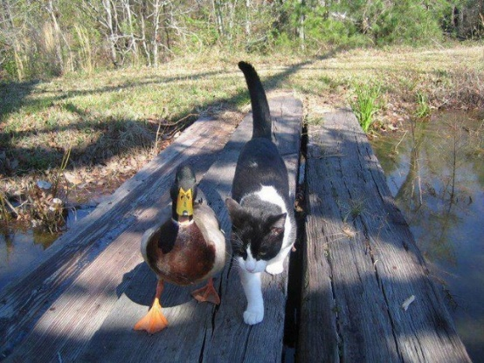
"There comes a time in your life, when you walk away from all the drama and people who create it.
You surround yourself with people who make you laugh.
Forget the bad, and focus on the good
Love the people who treat you right
And pray for the ones who don't
Life is too short to be anything but happy
Falling down is a part of life.
Getting back up is living!”

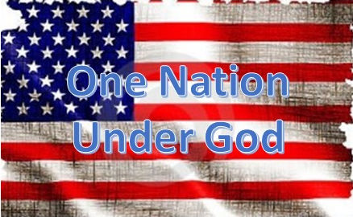
One Nation Under God
I can’t believe what has become of us,
We are fighting each over with so much fuss.
Our nation was created to be a great land,
Of freedom and opportunity as we took our stand.
Together, we have fought for this glorious space,
Like no other country, a different kind of place.
But today we are being torn apart,
By people that have never done their part.
The majority has never seen war’s pain,
They don’t begin to know the mental strain.
To defend our freedom, many have given all,
Most Americans have never witnessed a soldier fall.
They just think that everything should be free,
The latest gadgets and toys, they play with glee.
Free phones, food stamps, and medical care,
They get it all free, but don’t want to share.
God looks down on the country He built,
It’s filled with corruption up to the hilt.
Maybe it’s time for Revelation’s chaos,
So the whole country can witness such loss.
I hope and pray before my time here is gone,
That the American people will unite as one strong.
One Nation Under God is what we need,
Rather than watch it torn asunder and bleed.
GOD BLESS THE USA
ROTRUCK – ‘17
One of Maxine’s very best!!
We need to show more sympathy for these people.
They travel miles in the heat.
They risk their lives crossing a border.
They don't get paid enough wages.
They do jobs that others won't do or are afraid to do.
They live in crowded conditions among a people who speak a different language.
They rarely see their families, and they face adversity all day ~ every day.
I'm not talking about illegal emigrants ~ I'm talking about our troops!
Doesn't it seem strange that so many are willing to lavish all kinds of social benefits on illegals, but don't support our troops? Wouldn't it be great if we took the $360,000,000,000 (that's billion) we spend on illegal’s every year, and spent it on our troops!!!
Submitted by CAPT Dick Wilson, USN (RET)

Light Side
Minnesota Road work - don't cha know!
Al, a road crew supervisor in Minnesota, hired Ole to paint the yellow line down the middle of Route 32 heading up toward Bemidji. He was skeptical about hiring Ole since he didn't have any painting background. But Ole appeared enthusiastic and told Al that he really needed the job. At least his wife Lena told him so. He explained to Ole that his work day shift would be to complete 2 miles of center-line on the road. He was set up with brushes and paint and Al got him started.

After the first day, the supervisor was pleased to find that he'd painted 4 miles of road in his 8 hour shift, instead of the two expected of him. He told Ole that he did an excellent job and said how pleased he was with his progress.

On the second day, Ole completed painting just the 2 miles of road that was asked of him. Al was surprised, because on the first day, he had completed twice as much work. But he didn't say anything, since 2 miles of road was the amount that the job required anyway. He decided to just accept it, and to look forward to the next day when he was sure that Ole would pick up the pace again.

On day 3, Al was disappointed to learn that in his 8 hour shift, Ole completed painting only 1 mile of road. Ole was called to Al's office and was asked what the problem was? "On your first day, you completed 4 miles of road, on your second day 2 miles of road, and now on day 3, you were only able to complete 1 mile of road?"

"Vell," Ole replied, "I'll tell you vut is da problem, but I tought a smart man like you voot figger it out fer yerself. Every day I'm getting farder and farder avay from da paint can."

So, "I'm getting circumcised tomorrow." My friend told me that he had that done when he was a few days old.
I asked him "Does it hurt?"
He said, "Well I couldn't walk for about a year."

The Devil
Submitted by Gene Snow – Former Marine
The devil goes into a church and the congregation runs out except for one old man. The devil says to him "I'm the devil, aren't you afraid?" The old guy says "No, I married your sister!"

Bumper Stickers Seen on Military Bases:
• 101st Airborne Division- “When it comes to Combat, we care enough to send the very best”
• “When in doubt, empty the magazine”
• “Sniper – You can run, but you’ll just die tired!”
• “Machine Gunners – Accuracy By Volume”
• ” U.S. Marines – Certified Counselors to the 72 Virgins Dating Club”
• "U.S. Air Force – Travel Agents To Allah”
• “The Marine Corps – When It Absolutely, Positively Has To Be Destroyed Overnight”
• “Death Smiles At Everyone – Marines Smile Back”
• “What Do I Feel When I Kill A Terrorist? A Little Recoil”
• “Marines – Providing Enemies of America an Opportunity To Die For their Country Since 1775"
• “Life, Liberty and the Pursuit of Anyone Who Threatens It”
• “Happiness Is A Belt-Fed Weapon”
• “It’s God’s Job to Forgive Bin Laden – It was Our Job To Arrange The Meeting”
(Gen H. Norman Schwarzkopf)
• “Artillery Brings Dignity to What Would Otherwise Be Just A Vulgar Brawl”
• “One Shot, Twelve Kills–U.S. Naval Gun Fire Support”
• “My Kid Fought In Iraq So Your Kid Can Party In College and Protest”
• “A Dead Enemy Is A Peaceful Enemy – Blessed Be The Peacemakers”
• “Some people spend an entire lifetime wondering if they made a difference in the world. The US Marines don’t have that problem."

The American soldier does not fight because he hates who is in front of him; he fights because he loves who is behind him. God bless them all!

Please help with an identification!
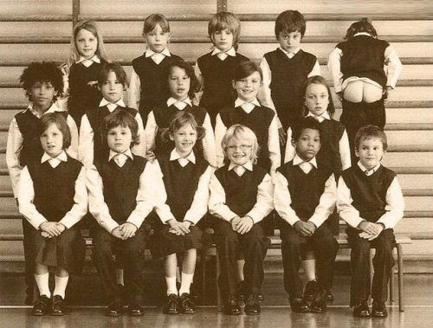
This is grade school picture of one of our chapter members.
(Editor: l am not sure of the year exactly and I don’t know who everyone is, but I am about 99% sure that you are in the back row on the right. If that’s not one of you, then send this newsletter on to someone you think it might be.)

Automobile Buffs
From Paul Witter – Freddy’s Steakburgers Construction Manager
Here's a little fact for automotive buffs, or just to dazzle your friends. The four Goldberg brothers, Lowell, Norman, Hiram, and Max, invented and developed the first automobile air-conditioner. On July 17, 1946, the temperature in Detroit was 97 degrees. The four brothers walked into old man Henry Ford's office and sweet-talked his secretary into telling him that four gentlemen were there with the most exciting innovation in the auto industry since the electric starter. Henry was curious and invited them into his office.

They refused and instead asked that he come out to the parking lot to their car. They persuaded him to get into the car, which was about 130 degrees, turned on the air conditioner, and cooled the car off immediately.

The old man got very excited and invited them back to the office, where he offered them $3 million for the patent.

The brothers refused, saying they would settle for $2 million, but they wanted the recognition by having a label, 'The Goldberg Air-Conditioner,' on the dashboard of each car in which it was installed.

Now old man Ford was more than just a little anti-Jewish, and there was no way he was going to put the Goldberg's name on two million Fords. They haggled back and forth for about two hours and finally agreed on $4 million and that just their first names would be shown. And so to this day, all Ford air conditioners show --

Lo, Norm, Hi, and Max -- on the controls.
(Editor: Didn’t expect that did you?)

Door Stopper
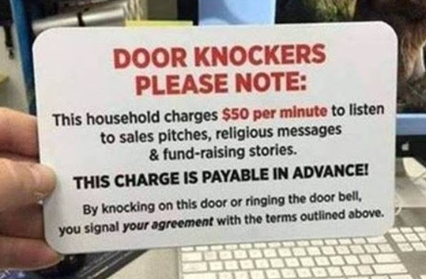

Beach Police - Tom Werzyn’s first job prior to military service!
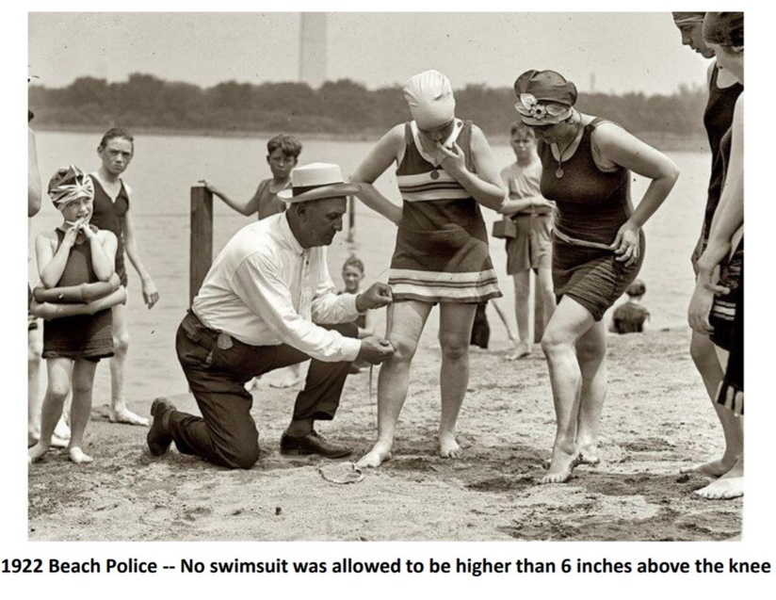
3D Printing Guns
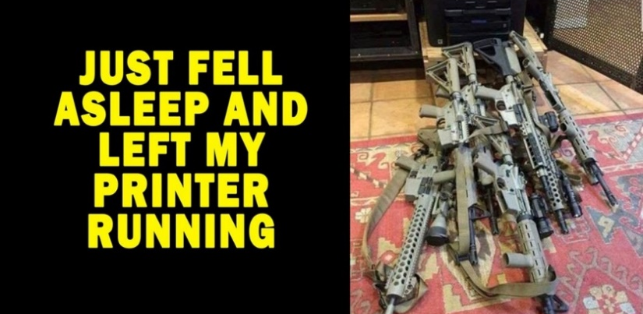

Revenge Parking

AARP- American Association of Retired People Questions and Answers from AARP Forum
Q: Where can single men over the age of 70 find younger women who are interested in them?
A: Try a bookstore, under Fiction.
Q: What can a man do while his wife is going through menopause?
A: Keep busy. If you're handy with tools, you can finish the basement. When you're done, you will have a place to live.
Q: Someone has told me that menopause is mentioned in the bible... Is that true? Where can it be found?
A: Yes. Matthew 14:92:"And Mary rode Joseph's ass all the way to Egypt
Q: How can you increase the heart rate of your over-70 year-old husband?
A: Tell him you're pregnant.
Q: How can you avoid that terrible curse of the elderly wrinkles?
A: Take off your glasses.
Q: Seriously! What can I do for these crow's feet and all those wrinkles on my face?
A: Go braless. It will usually pull them out.
Q: Why should 70-plus year old people use valet parking?
A: Valets don't forget where they park your car.
Q: Is it common for 70-plus year olds to have problems with short term memory storage?
A: Storing memory is not a problem. Retrieving it is the problem.
Q: As people age, do they sleep more soundly?
A: Yes, but usually in the afternoon.
Q: Where should 70-plus year olds look for eye glasses?
A: On their foreheads.
Q: What is the most common remark made by 70-plus year olds when they enter antique stores?
A: "Gosh, I remember these!"
SMILE, you’ve still got your sense of humor, haven't you?

A little Holy Humor for the season!
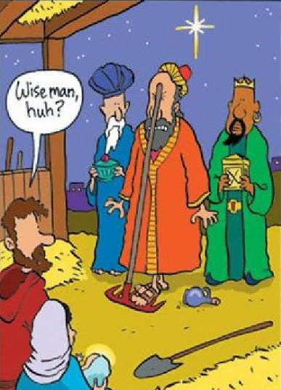

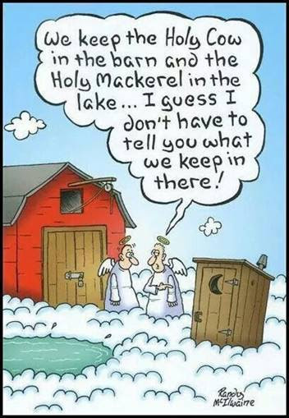

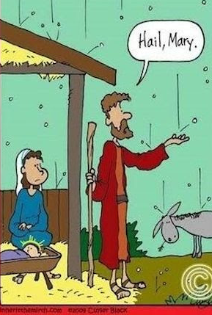

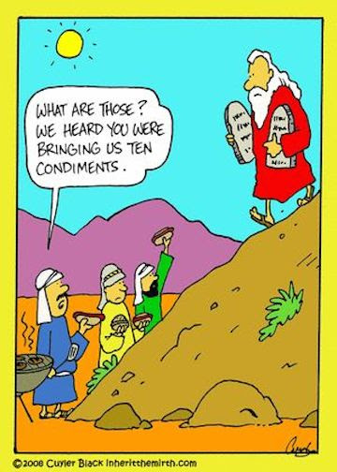

Trivia Answer
ROAD – Retired On Active Duty. Generally refers to any service member who is lazy and ineffective, typically those weeks or months away from leaving the military.

Submitted by John Vargas:
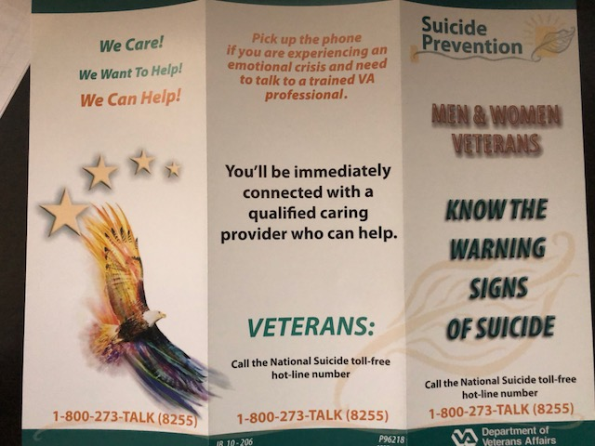
See inside of brochure next page!
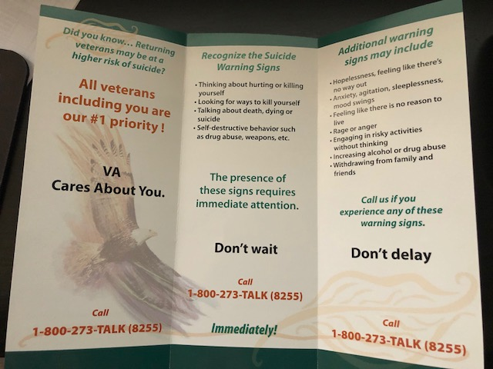

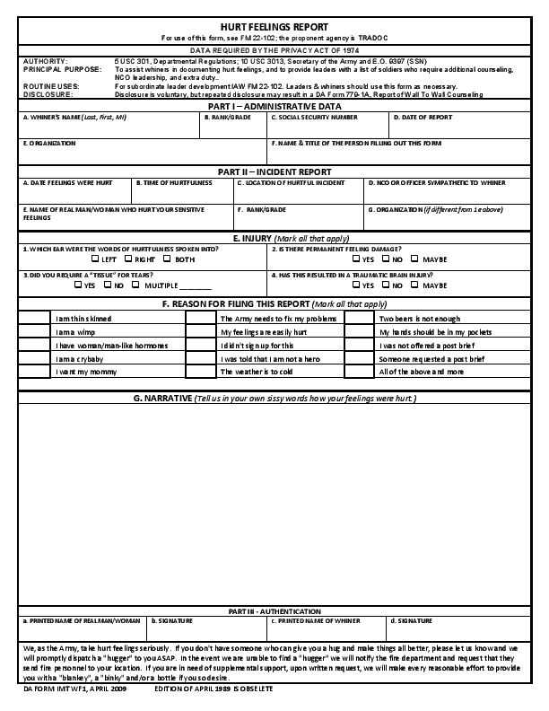
Submitted by Tom Werzyn – Tom’s daughter found this form.
FRIENDS OF CHAPTER 1106

ERC Management, LLC
791 Southpark Dr., Suite 600
Littleton, CO 80120
720.328.3299
www.FreddysUSA.com
Panera Bread  9579 S. University Blvd.  Highlands Ranch, CO 80126  720-348-1112 | American Legion Post 1260  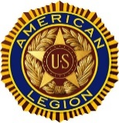
Spradlin Printing, Inc.  11903 S. Parker Road  Parker, CO 80134 | 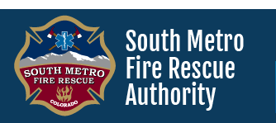  South Metro Denver Fire & Rescue  9195 E Mineral Ave  Centennial, CO 80112
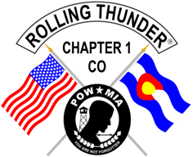  Monthly Membership Meetings  VISITORS ARE ALWAYS WELCOME!  3rd Saturday of each month at 10:00a.m.  Our meetings are held at: VFW Post 2461  1350 S Broadway, Denver, CO 80210 | 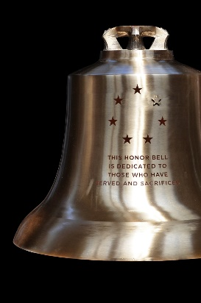  The Honor Bell Foundation  PO Box 1432  Englewood CO 80150  720.282.9182  www.honorbell.org
9137 E Mineral Cir Ste 100  Englewood, CO 80112-3422 | Home Depot Foundation  8477 S Yosemite St  Lone Tree, CO 80124
King Soopers  9551 S. University Blvd., Highlands Ranch, CO 80126 | STUDIO 1430 Main Office:  4700 South Syracuse Street, Suite 1050  Denver, CO 80237
Military Order of Purple Heart, Chapter 1041, Arvada, CO | Golden Corral  15775 E. Arapahoe Rd  Centennial, CO 80016

