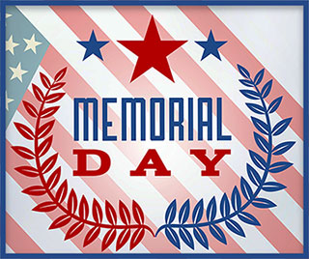

**Inside this issue:**

Notes from the President

[Member Feature](#Memberfeature)

[Military Trivia](#Militarytrivia)

[Guest Speaker](#Guestspeaker)

[Membership](#Membership)

[Board of Directors/Officers](#Boardofdirectors)

[Working Committees](#Workingcommittees)

[Meetings/Events Calendar](#Meetingsevents)

[Announcement Corner](#Announcementcorner)

[Books/Articles Published by Mbrs.](#Booksarticles)

[From the Editor](#Fromtheeditor)

[Light Side](#Lightside)

[Trivia Answer](#Triviaanswer)

**Events**

Saturday, May 5, 2018 - Chapter Meeting

Saturday, June 2, 2018 - Chapter Meeting

S. Metro Denver Fire & Rescue Board Room 9195 E. Mineral Ave. Centennial, CO. The Board of Director’s meeting will follow 30 minutes following the regular mtg.

Next CO State Council meeting June 9,2018.

***Editor’s Note:***

**Notice:**

If you have moved or changed your address, PLEASE notify us immediately! Contact: Lee White: Email: <mailto:flyboy51@q.com>

Phone:  303-519-2252

###### COPYRIGHT NOTICE: In accordance with Title 17 U.S.C. Section 107, any copyrighted material in this newsletter is distributed under fair use without profit or payment to those who have expressed a prior interest in receiving the included information for nonprofit use and educational purposes only.

This version of the newsletter is in Microsoft Document (.docx) format so that the links will work. Put your cursor over the link, depress your Control Key (ctrl) and depress your left mouse button and it will take you to the listed link position. PDF format, the links will not work.

The comments and editorial input do not necessarily reflect the opinion of the membership of our chapter. I would appreciate any feedback that you might have, items you liked or if you find offensive or derogatory in anyway. ([bobrotruck73@gmail.com](mailto:bobrotruck73@gmail.com)) Thank you for allowing me to be your newsletter editor.

***Notes from the President***

Lee White

VVA Chapter 1106 conducted its elections of Officers/Board Members on Saturday, April 7, 2018. The nominating chairman, Bob Rotruck conducted the proceedings.

The elections of Officers/Board Members are for a two-year term according to our VVA Chapter 1106 Bi-Laws.

Re-elected:

* Lee White, President
* Robert Easter, Vice President
* Joseph Plant, Treasurer
* Milt Omoto, Board Member
* Patti Ehline, Board Member
* David Lyons, Board Member
* Thomas Werzyn, Board Member

Newly elected:

* Glen Payne, Secretary
* John Vargas, Board Member

I want to take this opportunity to thank all elected Officers/Board Members for stepping up and supporting VVA Chapter 1106.

I also want to recognize Hazel Simeon, past Secretary, and founding member, for all her efforts and hard work in supporting VVA chapter 1106.

**Election of Officers and Board Members**

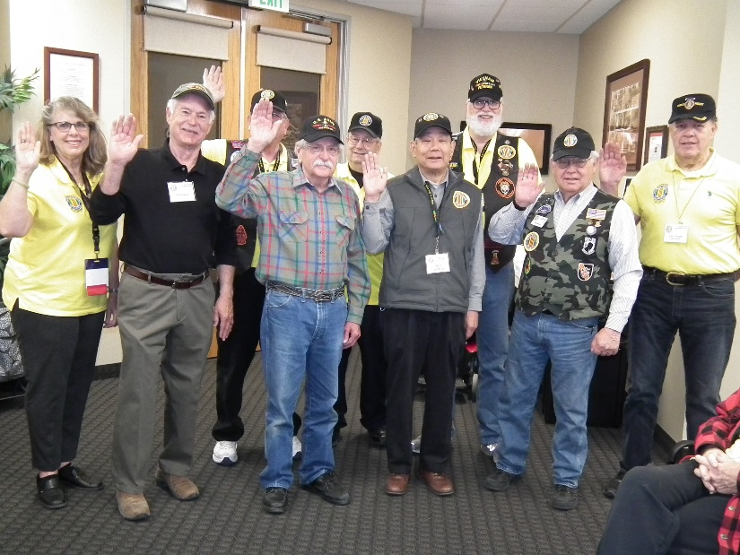

**Front row, L/R:** Pattie Ehline, Glen Payne, Bob Easter, Milt Omoto, Tom Werzyn, John Vargas

**Back row, L/R:** Lee White, Joe Plant, Dave Lyons

(**Editor’s note:** Amazing how President Lee White managed to hide behind the hand of Bob Easter. I did run this photo through the FBI facial recognition database!!!! They only got one hit based on the “WHITE” tennis shoes with the Coast Guard logo on the toe of the shoe!!! Amazing!)

***“******Member Feature”***

Jim Marcille, USA, 1st LT – Dec 1966 – Sep 1968

I graduated from Bucknell University, Lewisburg, PA June 1966 with an Army ROTC Commission, Transportation Corps.

I entered the Army on December 17 1966 as a 2ndLT and assigned to the 586th Transportation Company, 1st Logistics Command, Qhu Nhon RVN where I served until December, 1967. Primary duties during this timeframe included convoy commander for armament and supply convoys to Ahn Khe, Pleiku, Bong Son and other destinations in the central highlands.

December, 1967, our Company was transferred to Gia Le Combat Base just north of Phu Bai in I Corps. Our Mission was changed to a logistical support role exclusively for the Marines stationed between Phu Bai and the DMZ. Our armament and supply convoys were now destined for Marine combat bases like Quangos Tri, Dong Ha, Contien, Camp Carrell, the Rockpile and other destinations along the DMZ.

Stayed in I Corps serving as Platoon Leader and Executive Officer and convoy commander for the 585th until September 28, 1968 at which time I rotated back to the United States. Due to the fact that I had less than ninety days left in my military commitment, I was dismissed from active duty, thus ending my military career.

My most memorable experience was having the opportunity to be a platoon leader at the age of twenty-three which taught me valuable lessons of life which has served me well in my civilian life. My goal with our VVA Chapter is to continue to provide meaningful assistance to all veterans.

***Military Trivia***

What is a **100mph Tape** See answer at the [end of the Newsletter](#Triviaanswer).

**Court determines military burn pits caused lung disease in service members.**

Fox News: [Court determines military burn pits caused lung disease in service members](http://www.foxnews.com/world/2018/02/15/court-determines-military-burn-pits-caused-lung-disease-in-service-members.html). The thousands of U.S. military personnel and private contractors whose health was compromised by the dense black smoke of burn pits - and who were then denied proper treatment - may finally be vindicated by a recent court ruling. A judge under the U.S. Department of Labor’s Office for Workers’ Compensation Programs decreed last month that open-air burn pits -- where thousands of chemicals were released into the air after trash and other waste were incinerated at American military bases in Iraq and Afghanistan -- are connected to lung disease, Fox News has learned.

Click or copy and paste this link to see the full story.

<http://www.foxnews.com/world/2018/02/15/court-determines-military-burn-pits-caused-lung-disease-in-service-members.html>

**Pushing for Accountability...**

From Congressman Mike Coffman – February 17, 2018

Dear Friends:

As always, I appreciate the opportunity to bring you this update on what has been another busy and productive week in Washington. It is my honor to do this work on your behalf—

As a Marine Corps combat veteran, and as your representative, I have long fought to clean up the Department of Veterans Affairs (VA)—a department I view as one plagued with bureaucratic incompetence. We must ensure that our veterans receive the services that we, as a nation, promised them. Unfortunately, the shining example of VA incompetence is right here in our own backyard--the Denver Replacement Medical Center now nearing completion on the old Fitzsimons Army Medical Center site. I have written about the VA’s failures on this project multiple times. Consequently, I am proud to have led the charge to strip the VA of its future construction management authority, thus ensuring that a boondoggle like the one in Aurora, four years behind schedule and a $1 billion over budget, never happens again.

This week, my fight for accountability was no different, and like many Veterans across this nation, I had enough. After closely reviewing an IG Report regarding a European trip the VA Secretary, Dr. David Shulkin, took and when questioned about it, he and his staff lied to ethics investigators, I immediately called for his resignation. It has become clear to me that Dr. Shulkin lacks the moral authority to clean up the VA which is something that President Trump promised the American people that his administration would do. On Friday, in what I view was partly due to my efforts, his Chief of Staff announced her “retirement”. While this is a first step in the right direction, this in no way exonerates the Secretary, and my calls for accountability on behalf of Veterans and American taxpayers will continue.

**Medicare Fraud Alert**

This is pretty important to get to people with Medicare, their families and friends or adult kids who help parents with Medicare:

Have just gotten word about the newest Medicare scam.

Here's what you need to know to protect yourself, family and friends throughout the US:

Starting 4/1/18 Medicare will start a year long project to replace all current Medicare cards for beneficiaries to convert to alphanumeric ID numbers. Currently the ID number is your social security number.

First of all the new Medicare card will come to you in the mail. You don't need to request it or do anything. It will show up.

WHAT'S THE SCAM?

Somebody from "MEDICARE " will call to tell you that you are getting a new Medicare card. But until it comes you will need a temporary card. Fee for the card is between $5-50 dollars. They want personal information, bank account or credit card so they can process your temporary card.

THINGS TO REMEMBER

Medicare will never call you unless you ask them to.

Medicare does all communications by mail unless you ask them to call. Ditto for anybody saying they "work with Medicare to make sure you get everything you are entitled to."

Scammer alert: HOW TO PROTECT YOURSELF FROM THIS ONE?

* First of all spread the word. Feel free to share these notes.
* Use your answering machine to screen calls or just don't even answer a number you don't recognize.

If it has happened to you or your friends or loved ones and personal info had been given out (happens considerably more often than you think so don't feel bad or stupid) immediately take action to protect yourself against identity theft.

(Sent by Gene Crego, Arizona State Council)

***March Guest Speaker***

Ms. Sallie A. Houser-Hanfelder – Director of Eastern Colorado Health Care System and Brandy Morrison, PAO. Sallie spoke mainly on the status and terrible short comings of the new Rocky Mountain Regional VA Medical Center. (Editor: Sounds like she is kicking a\*\* and taking names!!!)

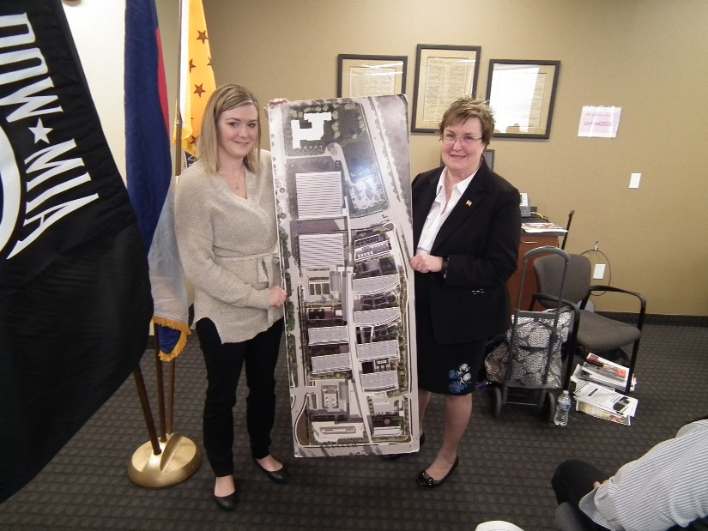

L to R: Brandy and Sallie show an aerial view of the new RMRVAMC

***Membership!***

VVA Chapter 1106 Membership: (4-12-2018)

VVA - 107

AVVA - 23

Total: 130

Welcome new members:

Daniel Graham

Thomas Frey

Michael Huber

Michael Sizemore

Jack Wright

Tony Nickerson

Dave Woods

B. J. McGee

Joseph Dempsey

***Board of Directors/Officers***

Lee White - President

Bob Easter - Vice-president

Joe Plant - Treasurer

Glen Payne - Secretary

Board Members - Milt Omoto, Patti Ehline, Dave Lyons, Tom Werzyn, John Vargas

***Working Committees***

Sergeant-at-Arms – John Vargas

Agent Orange/PTSD - Patti Ehline

Membership - Lee White, Dave Lyons, Tom Werzyn

Mental Health: Patti Ehline, Warren Harrison

Newsletter Editor - Bob Rotruck

Fundraising/Grants - Milt Omoto

Marketing/Media/Events – Tom Werzyn

POW/MIA – Gary Meyers

Webmaster – Robert Senatore, Bob Rotruck

Women Veterans - Patti Ehline

Scholarship Program - Bob Easter, Joe Langran, Bob Rotruck, John Vargas, Mike Karsh, Glen Payne, Jim Marcille, Tom Werzyn

Veteran Emergency Assistance Committee - Joe Plant, Bob Rotruck, Lee White, Dave Lyons

Speakers Bureau – Bob Easter, Glen Payne, Bob Mallin, Roger Lanphier, Tom Werzyn

Social – John Vargas, Barry Fiore, Glen Payne, Milt Omoto

***Meetings/Events Calendar - 2018***

* April 22 - Colorado Rockies vs Chicago Cubs Baseball
* May 5 - VVA Chapter 1106 Monthly Meeting
* May 26 - Memorial Day Poppy Drive
* June 2 - VVA Chapter 1106 Monthly Meeting
* June 3 - Colorado Rockies vs Los Angeles Dodgers
* June 9 - Colorado State Council Meeting
* June 23 - Road Trip - Pueblo Weisbrod Aircraft Museum

Huge turn-out for the March meeting. Not many vacant seats. Many new faces!!!

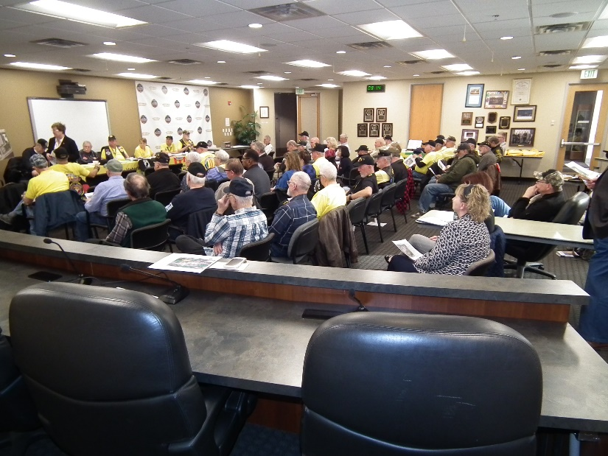

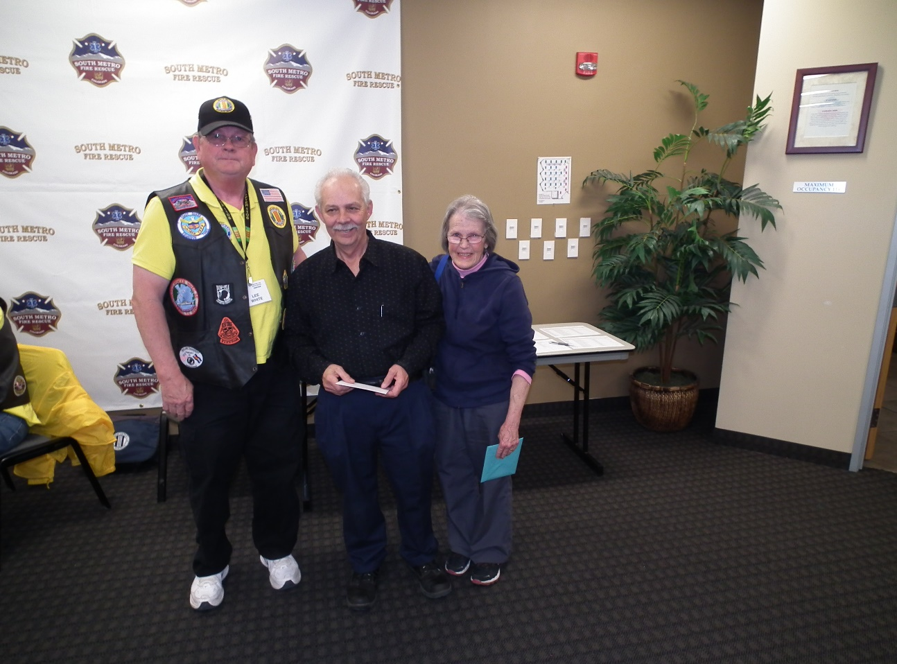

Farewell to Paul and Mary Seppo

**Certificates of Appreciation**

Certificate of Appreciation to King Soopers, 9551 S. University Avenue Highlands Ranch, CO 80126 for their support to our chapter Social Committee.

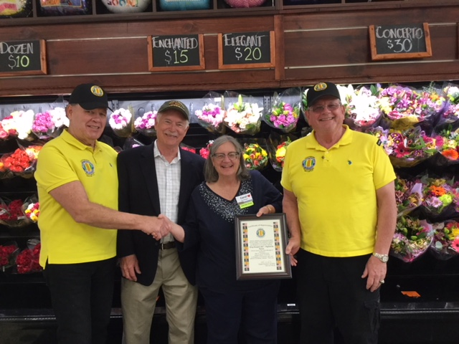

Left to right: John Vargas & Glen Payne (Social Committee), Carole Mulligan (Store Mgr.) Lee White (Chapter President)

Certificate of Appreciation to Panera Bread, 9579 S. University Blvd., Highland Ranch, CO 80126 for their support to our chapter Social Committee.

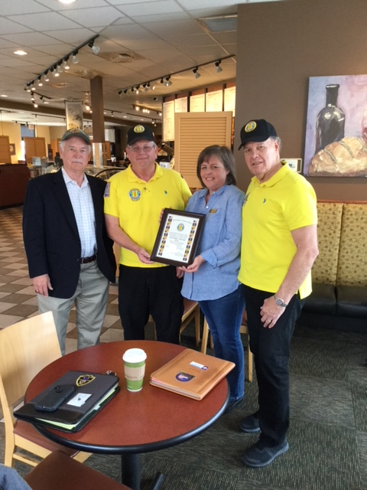

Left to right: Glen Payne, Lee White, Evette Cordell (Store Mgr.) and John Vargas

Certificate of Appreciation to Hazel Simeon for her outstanding work as Secretary for the Chapter since its beginning.

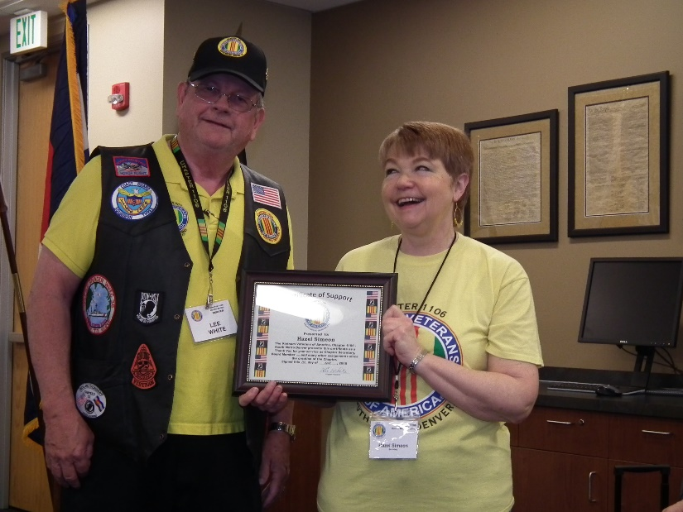

Lee presenting Hazel her certificate!

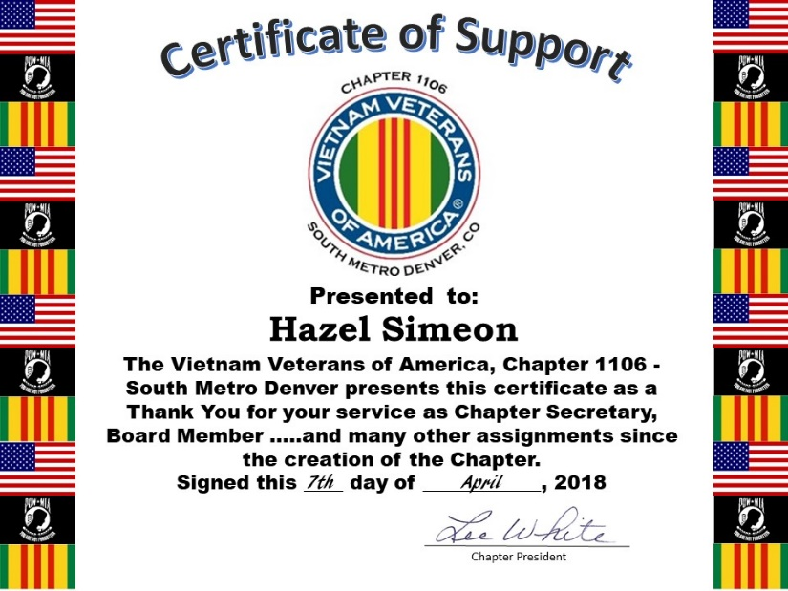

**HUMBLED**

At the April meeting, your editor was greatly humbled by all of you with the presentation of a beautiful plaque for my work in the chapter. My deepest thanks for this wonderful tribute. It is my honor to serve my brother and sister veterans!

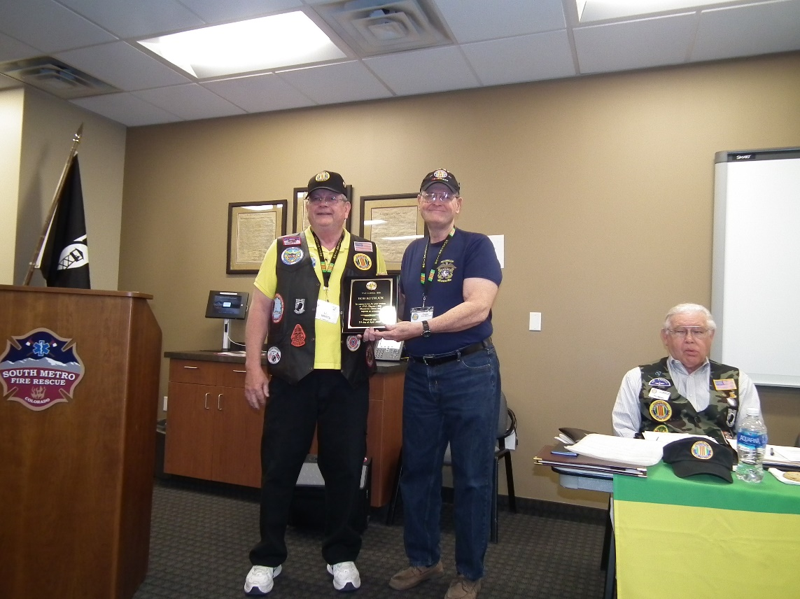

Lee presenting Bob a beautiful plaque!

At our April VVA 1106 Chapter meeting, Robert "Bob" Rotruck was recognized for his constant and outstanding contributions to our Chapter, Community and all Veterans.

This award was presented by Chapter President Lee White. Lee stated: "Bob is a credit to our Chapter and to all that meet him"

Congratulations from the Membership of VVA 1106.

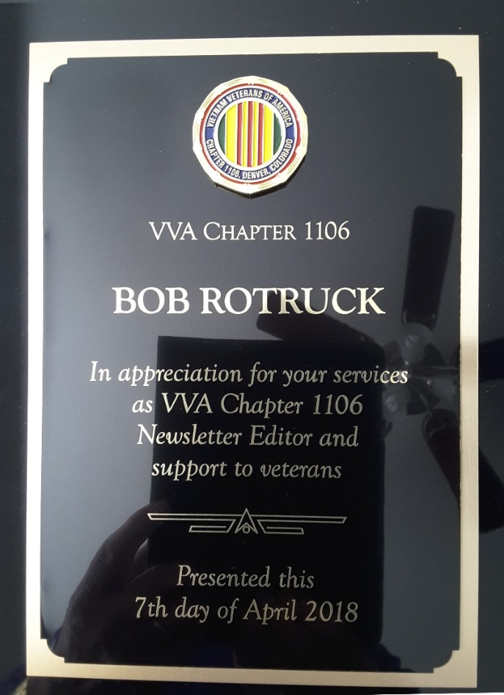

**April Meeting - More New Members**

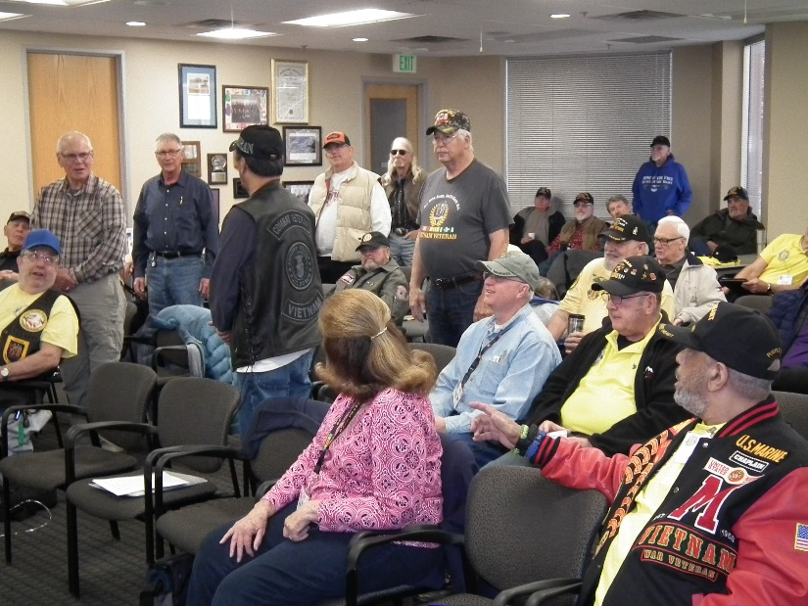

***In Memoriam***

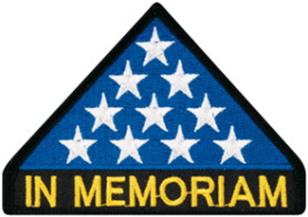

**Raymond (Ray) Alvarado**

From John Vargas:

Late yesterday (Editor: Mar 19th) I was just notified that fellow Patriot Raymond (Ray) Alvarado, life member of MOPH 1041, passed away on Sunday, March 11. He was buried at Ft. Logan yesterday with full military honors. See **Sharing The Foxhole** article from John later in this newsletter.



As of: 4/6/2018

Total Funeral Homes Visited - 2,213

Cremains Found - 16,229

Veterans Cremains Identified - 3,742

Veterans Interred - 3,428

**Really nice therapy! (Editor)**

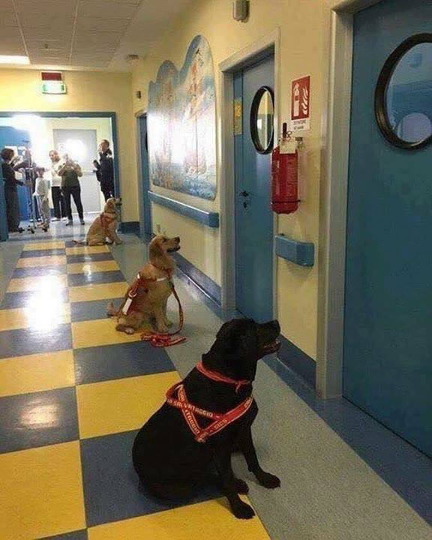

Dogs waiting to enter the hospital rooms of sick children for animal therapy. This is amazing, but somehow not surprising! If only all of us had the same feeling and caring for our fellow man!

***NATIONAL VIETNAM WAR VETERANS DAY – March 29, 2018***

U.S. Sens. Pat Toomey, R-Pa., and Joe Donnelly, D-Ind., introduced legislation in 2017 to honor Vietnam Veterans with a day on the anniversary of the withdrawal of military units from South Vietnam. President Donald Trump signed the Vietnam War Veterans Day Act on March 28, 2017, calling for U.S. flags to be flown on March 29 for those who served.

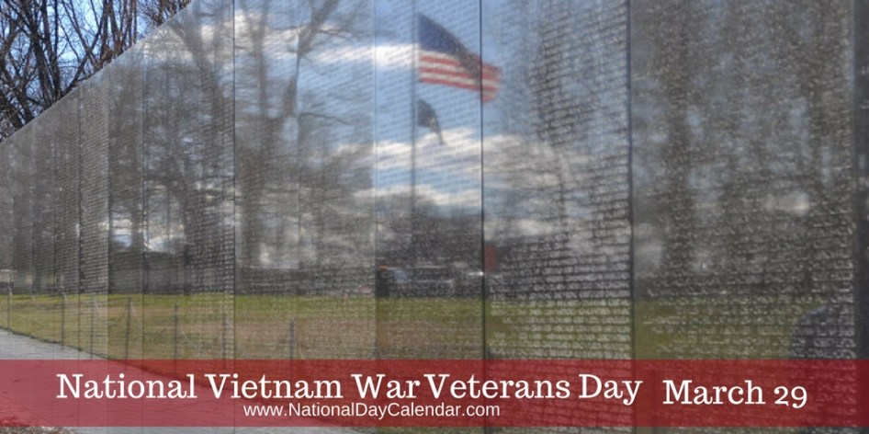

This day was remembered across our country and one of the places locally was at Fort Logan National Military Cemetery. Several Chapter members were able to attend. Our President, Lee White was one of the Honor Bell tollers. Thank you Lee for honoring us.

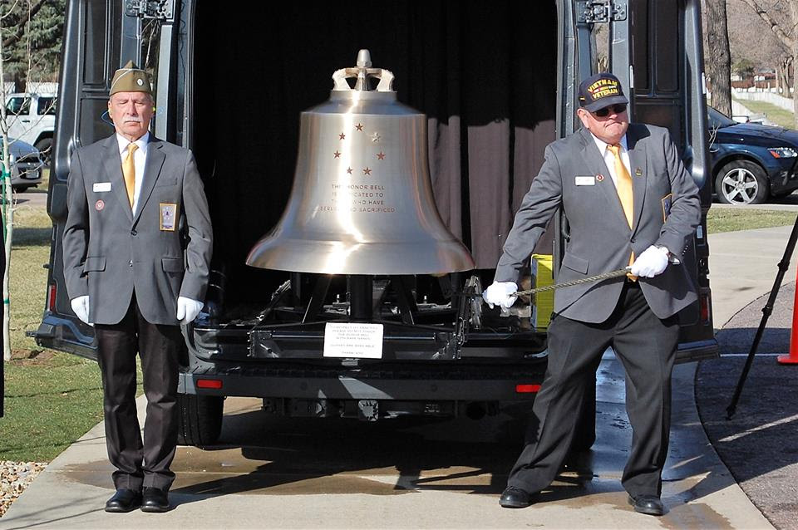

Picture courtesy of Bob Waples

**For your Information!**

ALWAYS READ THE LABELS ON THE FOODS YOU BUY--NO MATTER WHAT THE FRONT OF THE BOX OR PACKAGE SAYS, TURN IT OVER AND READ THE BACK---CAREFULLY!

With all the food ...and pet products now coming from China, it is best to make sure you read the label at the grocery store and especially Walmart when buying food products. Many products no longer show where they were made, only give where the distributor is located.

It is important to read the bar code to track its origin.

**How to read Bar Codes:** Interesting! This may be useful to know when grocery shopping, if it's a concern to you. GREAT WAY TO "BUY USA & CANADA" AND NOT FROM CHINA!!

The whole world is concerned about China-made "black hearted goods". Can you differentiate which one is made in Taiwan or China ?

If the first 3 digits of the barcode are 690 691 or 692, the product is MADE IN CHINA. 471 is Made in Taiwan .

This is our right to know, but the government and related departments never educate the public, therefore we have to RESCUE ourselves. Nowadays, Chinese businessmen know that consumers do not prefer products "MADE IN CHINA", so they don't show from which country it is made. However, you may now refer to the barcode - remember if the first 3 digits are:

690-692 ... then it is MADE IN CHINA

00 - 09 ... USA & CANADA

30 - 37 FRANCE

40 - 44 GERMANY

471 ... Taiwan

49 ... JAPAN

50 ... UK

BUY USA & CANADIAN MADE by watching for "0" at the beginning of the number. We need every boost we can get! If the government won't help us, we MUST help ourselves.

**Happy birthday, Navy Chiefs!**

On April 1, 1893, Navy General Order 409 established the rank of Chief Petty Officer.

This year, celebrates 125 years of our Chiefs’ trusted leadership, technical expertise, advising and mentorship that enable America’s combat ready naval force to be continuously flexible, more innovative, and lethal in achieving operational excellence on all domains.

Day to day for a Chief, “there are no greater words of influence than what’s written in the Creed.” It’s a timeless living document. For a Chief it sets a high bar of – daily – expectations for ones conduct and actions.

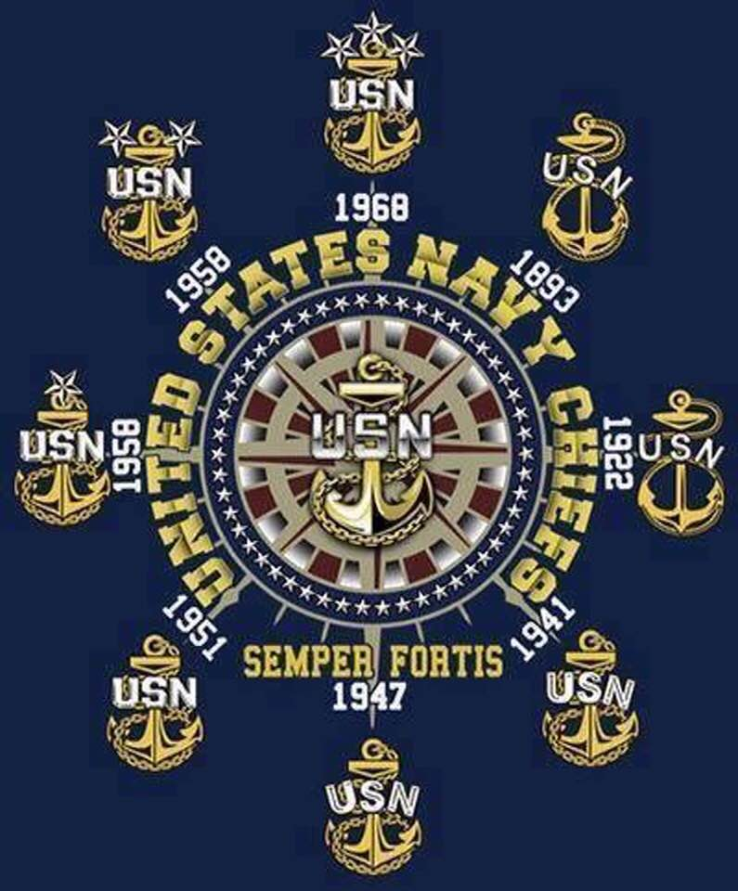

***Announcement Corner***

***Books/Articles Published by Members***

Submitted by Tom Werzyn

Foggy, foggy night…

Nights of fog,

always so deeply, coldly penetrating

into my very bones

and condensing on everything

I own.

I think some guy talked about cat feet

and fog …

this shit drops like a damn rock-

nothing, then everything

covered with a dripping funeral shroud

across this whole valley.

A greyness in the black of night

seeming to draw a scant, cold glow

from somewhere,

perhaps the stars

and our own warm breath.

Mornings of mist, white and thick

and so much on the ground

all ‘round you

so you can’t even remember

where to look

for the wire;

or the next hole on this forward line.

It’s just you and your buddy

In your hole

looking

into nothing,

on the perimeter of nowhere.

In your deepest heart, you absolutely know

Charlie is right, smack in front of you-

in beyond the wire

and the staked Claymore, connected to you

In your hole;

It’s trigger among the grenades,

on the shelf, on the edge.

All of them

silently creeping through

this damn, stinking soup that roils

with the slightest movement

anywhere.

Frigid fear

Is the thing that keeps you awake-

a total, abject terror of unseen things,

unheard things,

unexpected things,

unwanted engagement.

You’re damn sure you’ve gone deaf

straining to hear the ‘rat cans jingle;

the ones you’d hung on your piece of the wire-

your sector,

your personal early warning

alarm.

How the gawdam hell do they get in,

past the stuff we got set up

out there ?

Or

are they the fog itself- the wraiths we wait for,

crouching, shivering here, in our firing holes

with anticipation ?

Then, it’s warmer,

so quickly as the sun crawls across;

the fog, the mist, the drizzle from the trees,

breaking

and settling on all of us

moving out

to the next place to set up

and do all this digging and clearing

and placing and sighting

all over

again

for another night

in the fog …

**SHARING THE FOXHOLE**

By John Vargas

**RAY ALVARADO**

On a Littleton ridge with beautiful views of our mountains sits a happy yellow painted home belonging to Raymond (Ray) and Emily Alvarado. He has been married to Emily, his second wife, for over 51 years. The Alvarado’s have 8 children, 25 grandchildren and 33 great grandchildren.

Ray was born in Los Alamos on March 29, 1922 and shortly afterwards the family moved to Chandler Colorado, a mining town. His father died in a mining accident and he and his two brothers, John and Manuel, now 95, became orphans. At the age of 5 his uncles took him to Utah and he worked delivering lunch to the miners.

Ray and his brothers joined the Civilian Conservation Corps. He was assigned as a cook’s helper in Hugo and Limon, Colorado. He learned how to play the guitar, which followed him into his adult years as a performer.

On January 6, 1943 he reported to Ft. Logan, then to Ft. Leonard Wood and then to Ft. Knox. Ray was on the boxing team when then heavy weight champion Joe Louis came to visit and refereed a match that Ray won! As part of the 853rd Aviation Engineer Battalion he found himself onboard a British transport ship HMT Rhona. We were housed in very tight quarters on the eight deck deep in the ships bowels along with two other companies. Everything was dirty! I think the Rhona was an old slave ship.

On November 26, 1943, Ray was playing cards with his buddies when the next thing he felt was a tremendous impact. When he came to, fire, smoke and the smell of death was all around. With the strength to stay alive, trembling a still confused Ray makes it out of the 8th deck to a raft. “I looked back to see the Rhona going down amidst the fireworks of explosions from ammunition.” It was a horrible thing to be part of and witness firsthand.

After about 12 hours at sea, the USS Pioneer, using powerful searchlights, pulled many wounded survivors to safety. Ray was sent to a British hospital in Bone, Algeria. In 1950, Ray was honorably discharged from the Army with a Purple Heart.

1995, Ray received the original Veteran’s Day Proclamation signed by Gov. Mike Lowry during a ceremony in the Capitol Rotunda. His Emily and his family established “The Torch of Remembrance.”

**Interstate Highway – circa 1889**

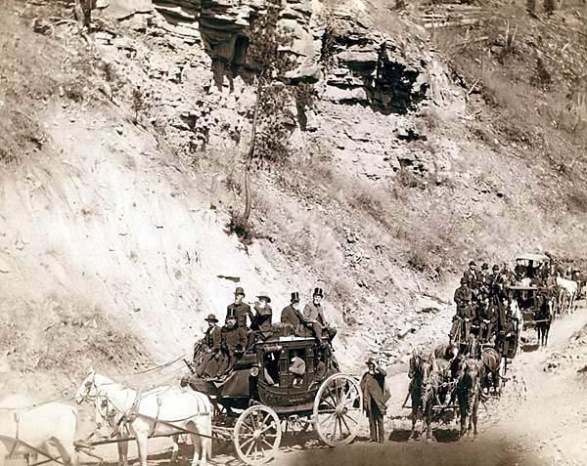

Omaha Board of Trade in Mountains near Deadwood, SD April 26, 1889. The picture was created in 1889 by John Grabill, photographer. The picture presents procession of stagecoaches loaded with passengers coming down a mountain road.

**A poem to which most older folks can relate.**

I remember the corned beef of my Childhood,

And the bread that we cut with a knife,

When the Children helped with the housework,

And the men went out to work, not the wife.

The cheese never needed a fridge,

And the bread was so crusty and hot,

The Children were seldom unhappy,

And the Wife was content with her lot.

I remember the milk from the bottle,

With the yummy cream on the top,

Our dinner came hot from the oven,

And not from a freezer; or shop.

The kids were a lot more contented,

They didn't need money for kicks,

Just a game with their friends in the road,

And sometimes the Saturday flicks.

I remember the shop on the corner,

Where biscuits for pennies were sold

Do you think I'm a bit too nostalgic?

Or is it....I'm just getting Old?

Bathing was done in a wash tub,

With plenty of rich foamy suds

But the ironing seemed never ending

As Mum pressed everyone's 'duds'.

I remember the slap on my backside,

And the taste of soap if I swore,

Anorexia and diets weren't heard of

And we hadn't much choice what we wore.

Do you think that bruised our ego?

Or our initiative was destroyed?

We ate what was put on the table

And I think life was better enjoyed.

Author, Unknown ..

If you can remember those days...

Continue to enjoy your Retirement.

**New book on the market!**

***Long Daze at Long Binh***

Authors: Steve Donovan and Fred Borchardt

This is a humorous memoir about the Vietnam War as seen through the eyes of two draftees who, like roughly 2.5 million other Americans, were sent to the war zone not as combat troops but as support personnel. The authors met on the day they were inducted in 1965 and then proceeded to follow identical paths for the next two years. This included bunking side by side for a year in South Vietnam as Army medics with the 24th Evacuation Hospital. Their stories were at times hilarious, at times horrific and at other times heart-rending. But every day was an adventure for these two young men who never knew what might be lurking around the next bend in the circuitous road of life. "Long Daze at Long Binh" is a lighthearted but highly informative look at what life was like in a combat zone where there were no front lines and no clear distinctions between friend and foe.

**David Wilson, Reviewer for Vietnam Veterans of America**

The unique structure of Long Daze—alternating the two points of view of the authors inside the chapters—gives the reader great contrast and comparison and is the main strength of this accessible and useful book. Yes, it is funny, but it is much more than that. It is a repository of facts and memories from this long-ago time. There are no clinkers or clunkers in this book. The authors get it right and they make it all interesting. Thanks, guys, for producing the best book about REMF (Rear Echelon) life in South Vietnam during this time period. Nobody will top you any time soon, if ever.

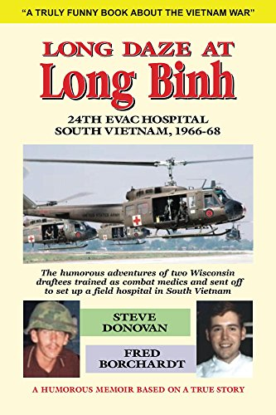

Book available on Amazon paperback or e-copy.

**Touching your heart!**

This was a picture Roger Lanphier took at Camp Lejeune in May of 2012 and felt it spoke volumes for everyone. Part of the Rolling Thunder ride in 2012.

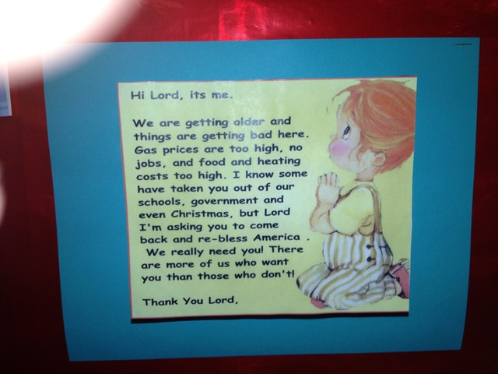

***From the Editor***

**From the desk of The Landlocked Sailor**

Bob Rotruck, CWO3, USN (RET)

**We are veterans**

We are American teenagers from big cities, small towns, and farms. We are high school and college graduates from country schools and huge universities. We are white, black, Asians, Latinos, Catholics, Protestants, Jews, atheists. We joined the Marines, Army, Navy, Air Force, Coast Guard, and Merchant Marine. We fought in World War II on the sands of Iwo Jima and watched thousands of our friends die. We were in South Korea in rice patties and watched our comrade’s step on land mines and saw their limbs torn from their bodies. We were in Vietnam at Tan Son Nhut Air Force Base loading bombs on airplanes to stop the enemy on the Ho Chi Minh Trail. We were on aircraft carriers in the Persian Gulf during the Gulf War kicking Suddam Hussein out of Kuwait. We are in Iraq where we freed people from the dictator Hussein that murdered his own people with biological warfare. We are in Afghanistan fighting terrorism on their home ground instead of in New York City, Chicago, or Los Angeles. Our souls are in the shadows of the Twin Towers. We are the American men and women that put our lives on the line for our family, our friends, and our American brothers and sisters to ensure the freedom we enjoy in our United States. We are the proud, the strong, the resilient, the trustworthy, the steadfast, and the brave. And now, we are veterans trying to put our lives back together. Don’t just remember us on November 11th, but know that we were there; 24/7/365 for you. Can you be there now for us? Please NEVER FORGET! God bless our military men and women and God bless America.

**Editor:** I got this in the email and had to share!

**THE EAGLE**

This is the kind of story you need when it seems like the world is spiraling out of control. Not many people get a picture of this proud bird snuggled up next to them! Freedom and I have been together 11 years this summer.

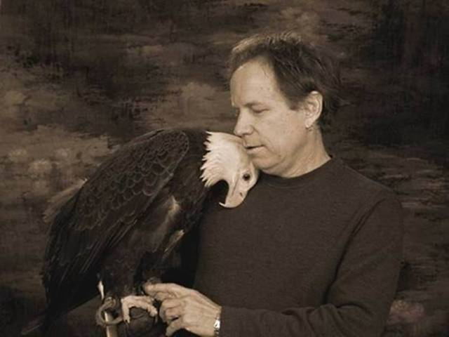

**Freedom and Jeff**

She came in as a baby in 1998 with two broken wings. Her left wing doesn't open all the way even after surgery, it was broken in 4 places. She's my baby.

When Freedom came in, she could not stand and both wings were broken. She was emaciated and covered in lice. We made the decision to give her a chance at life, so I took her to the vet's office. From then on, I was always around her. We had her in a huge dog carrier with the top off, and it was loaded up with shredded newspaper for her to lay in. I used to sit and talk to her, urging her to live, to fight; and she would lay there looking at me with those big brown eyes. We also had to tube feed her for weeks. This went on for 4-6 weeks, and by then she still couldn't stand. It got to the point where the decision was made to euthanize her if she couldn't stand in a week. You know you don't want to cross that line between torture and rehab, and it looked like death. She was going to be put down that Friday, and I was supposed to come in on that Thursday afternoon. I didn't want to go to the center that Thursday, because I couldn't bear the thought of her being euthanized; but I went anyway, and when I walked in everyone was grinning from ear to ear. I went immediately back to her cage; and there she was, standing on her own, a big beautiful eagle. She was ready to live. I was just about in tears by then. That was a very good day. We knew she could never fly, so the director asked me to glove train her. I got her used to the glove, and then to jesses, and we started doing education programs for schools in western Washington. We wound up in the newspapers, radio (believe it or not) and some TV. Miracle Pets even did a show about us.

In the spring of 2000, I was diagnosed with non-Hodgkin's lymphoma. I had stage 3, which is not good (one major organ plus everywhere), so I wound up doing 8 months of chemo. Lost the hair - the whole bit. I missed a lot of work. When I felt good enough, I would go to Sarvey Wildlife Care Center and take Freedom out for walks. Freedom would also come to me in my dreams and help me fight the cancer. This happened time and time again.

Fast forward to November 2000. The day after Thanksgiving, I went in for my last checkup. I was told that if the cancer was not all gone after 8 rounds of chemo, then my last option was a stem cell transplant. Anyway, they did the tests; and I had to come back Monday for the results. I went in Monday, and I was told that all the cancer was gone. So the first thing I did was get up to Sarvey and take the big girl out for a walk. It was misty and cold. I went to her flight and jessed her up, and we went out front to the top of the hill. I hadn't said a word to Freedom, but somehow she knew. She looked at me and wrapped both her wings around me to where I could feel them pressing in on my back (I was engulfed in eagle wings), and she touched my nose with her beak and stared into my eyes, and we just stood there like that for I don't know how long. That was a magic moment. We have been soul mates ever since we came in. This is a very special bird.

On a side note: I have had people who were sick come up to us when we are out, and Freedom has some kind of hold on them. I once had a guy who was terminal come up to us and I let him hold her. His knees just about buckled and he swore he could feel her power course through his body. I have so many stories like that.

I never forget the honor I have of being so close to such a magnificent spirit as Freedom!! Hope you enjoyed this!

(**Editor:** Does anybody need a Kleenex?)



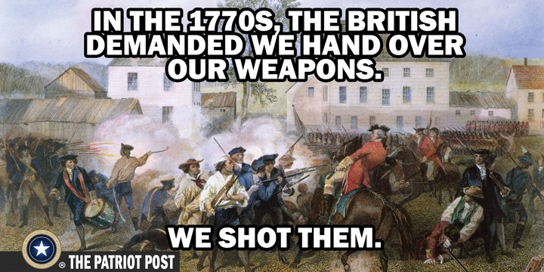

**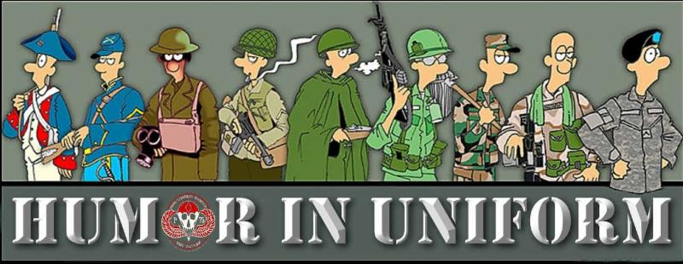**

**ISN'T IT FUN GETTING OLD?**

Submitted by Roger Lanphier

• I found this timely, because today I was in a store that sells sunglasses, and only sunglasses. A young lady walks over to me and asks, "What brings you in today?"

I looked at her, and said, "I'm interested in buying a refrigerator.” She didn't quite know how to respond.

Am I getting to be that age?

• I was thinking about how a status symbol of today is those cell phones that everyone has clipped onto their belt or purse. I can't afford one. So I'm wearing my garage door opener.

• I was thinking about old age and decided that old age is when you still have something on the ball, but you are just too tired to bounce it.

• I thought about making a fitness movie for folks my age and calling it 'Pumping Rust.'

• When people see a cat's litter box they always say, “Oh, have you got a cat?” Just once I want to say, “No, it's for company!”

• Employment application blanks always ask who is to be called in case of an emergency. I think you should write, ‘an ambulance.'

• The older you get the tougher it is to lose weight because by then your body and your fat have gotten to be really good friends.

• The easiest way to find something lost around the house is to buy a replacement.

• Did you ever notice? The Roman Numerals for forty (40) are **XL**.

• The sole purpose of a child's middle name is so he can tell when he's really in trouble.

• Did you ever notice: When you put the 2 words ' The' and ' IRS ' together it spells 'Theirs.'

• Aging: Eventually you will reach a point when you stop lying about your age and start bragging about it.

• Some people try to turn back their "odometers." Not me. I want people to know 'why' I look this way. I've traveled a long way and some of the roads weren't paved.

• You know you are getting old when everything either dries up or leaks.

• Ah! Being young is beautiful but being old is comfortable.

• Lord, keep your arm around my shoulder and your hand over my mouth.

• May you always have Love to Share, Cash to Spare, And Friends who Care

****

**Don’t mess with a cowboy!**

Submitted by Tom Weryzn

A cowboy named Bud was overseeing his herd in a remote mountainous pasture in Montana when suddenly a brand-new 2018 BMW advanced toward him out of a cloud of dust. The driver, a young man named Cliff in a Brioni® suit, Gucci® shoes, RayBan® sunglasses and YSL® tie, leaned out the window and asked the cowboy, "If I tell you exactly how many cows and calves you have in your herd, will you give me a calf?"

Bud looks at the man, who obviously is a yuppie, then looks at his peacefully grazing herd and calmly answers, "Sure, why not?"

The yuppie parks his car, whips out his Dell® notebook computer, connects it to his Apple iPhone, and surfs to a NASA page on the Internet, where he calls up a GPS satellite to get an exact fix on his location which he then feeds to another NASA satellite that scans the area in an ultra-high-resolution photo. The young man then opens the digital photo in Adobe Photoshop® and exports it to an image processing facility in Hamburg, Germany...

Within seconds, he receives an email on his Apple iPad® that the image has been processed and the data stored. He then accesses an MS-SQL® database through an ODBC connected Excel® spreadsheet with email on his Galaxy S5® and, after a few minutes, receives a response. Finally, he prints out a full-color, 150-page report on his hi-tech, miniaturized HP LaserJet® printer, turns to the cowboy and says, "You have exactly 1,586 cows and calves."

"That's right. Well, I guess you can take one of my calves," says Bud. He watches the young man select one of the animals and looks on with amusement as the young man stuffs it into the trunk of his car.

Then Bud says to the young man, "Hey, if I can tell you exactly what your business is, will you give me back my calf?"

The young man thinks about it for a second and then says, "Okay, why not?"

"You're a Congressman for the U.S. Government", says Bud.

"Wow! That's correct," says the yuppie, "but how did you guess that?"

"No guessing required." answered the cowboy. "You showed up here even though nobody called you; you want to get paid for an answer I already knew, to a question I never asked. You used millions of dollars’ worth of equipment trying to show me how much smarter than me you are; and you don't know sh\*t about how working people make a living - or about cows, for that matter. This is a herd of sheep." "Now give me back my dog."

AND THAT FOLKS IS THE PROBLEM!!

**One of Paul Bunyan’s Dress Shoes (converted)**

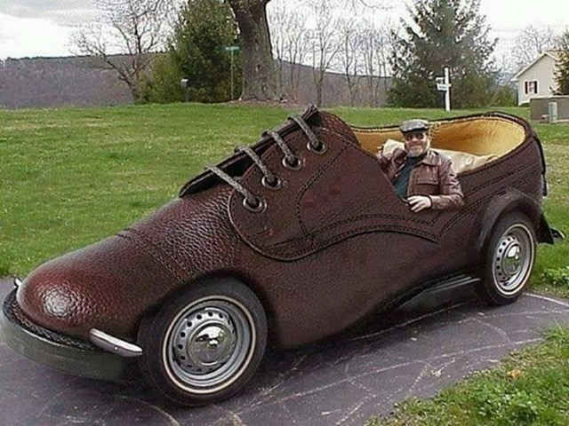

**10 year olds are too smart!**

I was eating breakfast with my 10 year old Granddaughter and I asked her, “What day is tomorrow?”

Without skipping a beat she said, “It’s Presidents Day!”

She’s smart, so I asked her “What does Presidents Day mean?” I was waiting for something about Obama, Bush or Clinton, etc.

She replied, “Presidents Day is when the President steps out of the White House and if he sees his shadow we have another year of Bullshi…t.”

You know, it hurts when hot coffee spurts out of your nose!

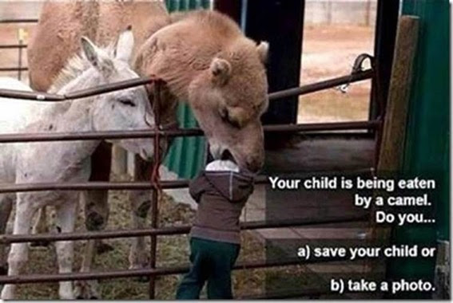

Gotta love those “smart” phones! (Editor)

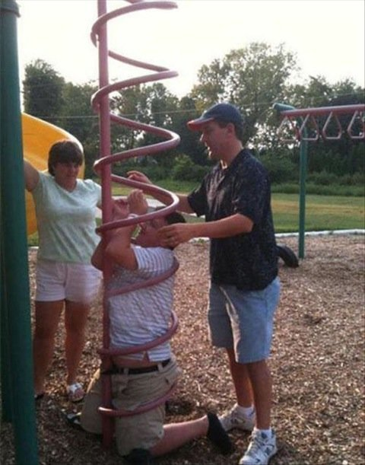

**Editor:** I think the hung up guy has a U.S. Coast Guard tattoo on his right forearm and his last name is White???!!!

**MILENNIAL MARRIAGE**

(Submitted by: John Vargas)

THE E-MAIL

Dearest Dad,

I'm coming home to get married soon, so get your check book out. I'm in love with a man who is far away from me. As you know, I'm in Australia and he lives in Scotland. We met on a dating website, became friends on Facebook, and had long chats on WhatsApp. He proposed to me on Skype, and now we've had two months of a relationship through Viber. My beloved Dad, I'd like your blessing, good wishes, and a really big wedding.

Lots of love and thanks.

Your daughter, Lilly

DAD'S RESPONSE

My Dear Lilly,

What news! I suggest that you two get married on Twitter, have fun on Tango, buy your kids on Amazon, and pay for it all through PayPal. And when you get fed up with your new husband, sell him on eBay.

Love, Your Dad

***Trivia Answer***

**100mph Tape:** Standard issue Army green duct tape. Called 100mph tape due to the belief it can withstand speeds of up to 100 mph when slapped on holes.

**Newsletter articles/stories/photos**

Any articles, stories and/or photos submitted for the newsletter must be received by the cutoff date which for our newsletter is the 20th of the month preceding publication. Photos must be accompanied by text which describes the event, names, dates, credits and any other pertinent facts so our readers understand the story behind the photo(s). Due to space availability, the editor reserves the right to include or exclude information or photos for a given two month period of publication.

**FRIENDS OF CHAPTER 1106**

|  |  |
| --- | --- |
| **ERC Management, LLC**  791 Southpark Dr., Suite 600  Littleton, CO 80120  [720.328.3299](tel:720.328.3299)  [www.FreddysUSA.com](http://www.freddysusa.com/) | |
| **Panera Bread**  9579 S. University Blvd. Highlands Ranch, CO 80126  720-348-1112 | **American Legion Post 1260**  **E:\Documents\ALP1187\images\AmericanLegion_logo.jpg** |
| **Spradlin Printing, Inc.**  11903 S. Parker Road Parker, CO 80134 | **South Metro Denver Fire & Rescue**  9195 E Mineral Ave  Centennial, CO 80112 |
| Monthly Membership Meetings VISITORS ARE ALWAYS WELCOME!   3rd Saturday of each month at 10:00a.m.   Our meetings are held at: [VFW Post 2461](http://www.vfwpost2461.com/) 1350 S Broadway, Denver, CO 80210 | [http://www.applewoodfixit.com/wp-content/themes/applewood/images/header-logo.png](http://www.ApplewoodFixIt.com)  Applewood Plumbing Heating & Electric  **Main Billing Office:** 5000 W 29th Ave.  Denver, CO 80212 **Phone:** 303-232-6611 **Fax:** 303-477-4310 **Email:** [custservice@applewoodfixit.com](mailto:custservice@applewoodfixit.com) |
| 9137 E Mineral Cir Ste 100  Englewood, CO 80112-3422 | South Metro – Instant Imprints  6882 S. University Blvd.  Centennial, CO 80122  [303-771-2244](tel:303-771-2244) |
| King Soopers logo.svg  King Soopers  9551 S. University Blvd., Highlands Ranch, CO 80126 | http://www.cruisin1430.com/sites/g/files/giy711/f/KEZW_Header_Large_Logo_0.png  **STUDIO 1430 Main Office:** 4700 South Syracuse Street, Suite 1050 Denver, CO 80237 |
| https://scontent.fapa1-2.fna.fbcdn.net/v/t31.0-8/10575197_682186265194110_4051472928662048560_o.jpg?oh=2630b186dcf3a20f1d7fc8fa25e0a5ba&oe=5A17C4AB  **Military Order of Purple Heart**, Chapter 1041, Arvada, CO |  |
| Logo of The Home Depot  **Home Depot Foundation**  8477 S Yosemite St  Lone Tree, CO 80124 | Golden Corral  **Golden Corral**  15775 E. Arapahoe Rd  Centennial, CO 80016 |
| A FULL-SIZE REPLICA OF THE HONOR BELL  **The Honor Bell Foundation**  P.O. BOX 12400 DENVER, COLORADO 80212  720.282.9182 | **The UPS Store**  10940 S. Parker Road  Parker, CO 80134  P: 303-841-8483  F: 303-841-8685  E: store1548@theupsstore.com |