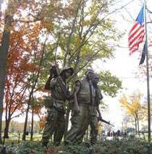
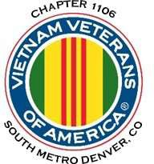
“Welcome Home”

NEWSLETTER
Nov - Dec 2023 – VOL 9 NO 6

Editor’s Note:
Notice:
If you have moved or changed your address, PLEASE notify us immediately! Contact: Jack Hunter, Email jack.hunter@comcast.net Phone: 303-797-3136

COPYRIGHT NOTICE: In accordance with Title 17 U.S.C. Section 107, any copyrighted material in this newsletter is distributed under fair use without profit or payment to those who have expressed a prior interest in receiving the included information for nonprofit use and educational purposes only.
The comments and editorial input do not necessarily reflect the opinion of the membership of our chapter. Please contact Mark Nickell at mnickell2004@msn.com with any feedback regarding the contents of this publication.
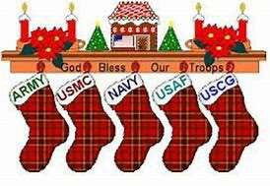

Board of Directors/Officers
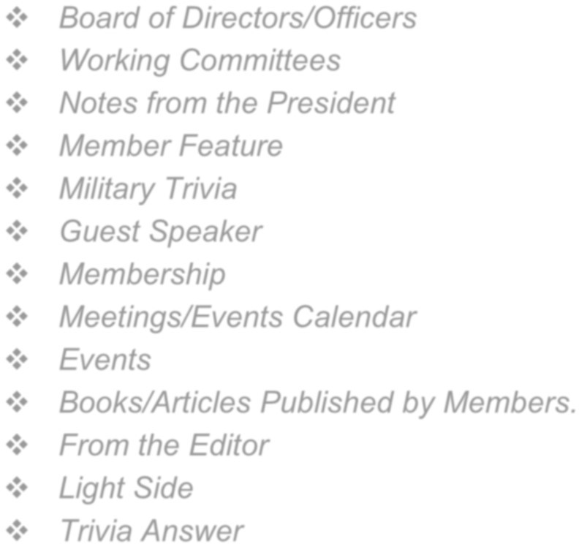
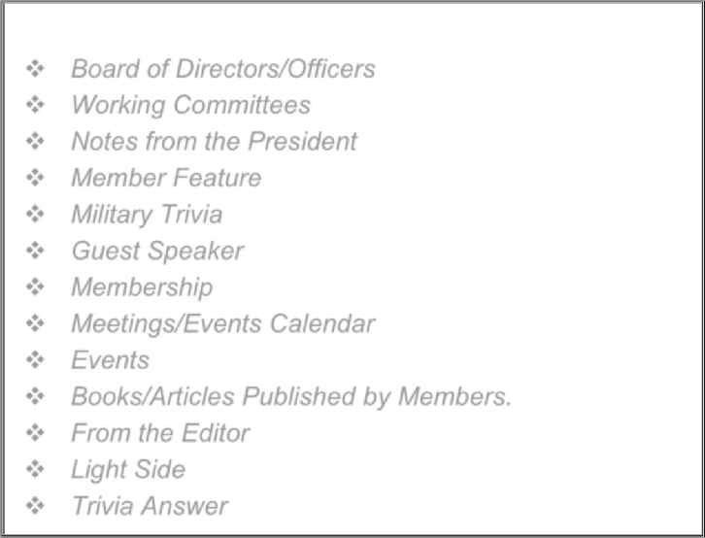
Dave Lyons – President Milt Omoto – Vice-president Mike Huber – Treasurer Sally Eaves – Secretary
Inside this issue:
Board of Directors/Officers Working Committees Notes from the President Member Feature
Military Trivia Guest Speaker Membership
Meetings/Events Calendar Events
Books/Articles Published by Members. From the Editor
Light Side Trivia Answer
Board Members – Patti Ehline, Tom Werzyn, John Vargas, Joe Plant, Rev. Garry Turks, Joe Dempsey, Joseph Robinson. Special Chapter Positions
AVVA Liaison to chapter Board of Directors – Litta Plant- Schaper
Chaplain – Rev. Garry Turks Chapter Historian – John Vargas Database/Audio – Jack Hunter Government Affairs – Tony Nickerson Sergeant-at-Arms – Dan Green Chapter Nurse – Patti Ehline
Email Blaster – Jack Hunter

Working Committees
- Agent Orange, PTSD, Veteran Physical and Mental health: Patti Ehline, Warren Harrison
- Chapter Communications: Jack Hunter, Jim Williams, Litta Plant-Schaper
- Color Guard: Dan Green and Ron Smith (shared Command Sergeants), Dave Dawson, Clarence Rebolledo, Harry Montgomery, John Sheadel, Tony Nickerson
- Donation Approval: Dave Lyons
- Event Coordinator: Joseph Robinson, Dave Lyons, Lee White
- Grants and Fundraising: Milt Omoto
- Membership Committee: Phil Snyder, Jim Blumberg, Lee White
- Memorial Committee: John Vargas, Garry Turks, Joe Plant, Lee White, Alan Jaffe, Milt Omoto
- Mental Health: Patti Ehline, Warren Harrison, Joe Plant
- Name Tags: Litta Plant-Schaper
- Newsletter and Web Site Communications: Mark Nickell
- New Member Onboarding: Dave Lyons
- Promotional Items: Joe and Ita Dempsey, Leann Stelzer,
- Refreshments: Walt Leuci, Dave Lyons
- Scholarship Program: Lou Grounds-Chair, Litta Plant- Schaper, Wayne Buser
- Social: Chairman – Vacant, Joe Plant, Tom Werzyn, and Litta Plant-Shaper
- Speakers Bureau: Tom Werzyn, Bob Mallin, Bob Easter,
Dave Lyons
- Veteran Emergency Assistance: Joe Plant, Dave Lyons, Rev. Gary Turks
- Voices for Veterans: Warren Harrison, Patti Ehline, Joe Plant
- Women Veterans: Patti Ehline

Notes from the President - Dave Lyons:
This newsletter marks the end of the 2023 year. Where did the time go? Despite challenges, we managed to accomplish a lot as a Chapter. I would like to start my message with a huge “thank you” to Mark Nickell for stepping up to be our new newsletter editor and webmaster. You will note that Mark is now the editor of this informative newsletter.
Just a brief list of Chapter accomplishments for the year:

- Our membership continued to grow as we add new regular and Associate members
- We were recognized as “Chapter of the Year” at the 2023 VVA National Convention in Orlando
- Our Social Committee again planned and organized wonderful Chapter events, our Summer picnic and end of year Holiday lunch
- As a Chapter we actively participated in community events, such as the Fourth of July parade, interaction with the public at Poppy Drives, and by attending events
- Our Chapter Color Guard was very active and continues to remain active supporting many veteran events, proudly presenting the Colors
- We had great monthly meeting speakers, and member bios were informative in learning more about each other members
- Our “Buddy Call” system maintains contact with each member to check on how they and their family are doing, and our Chaplain maintained contact with our sick and shut in members
- We awarded six $2,000 scholarship to deserving High School seniors
- Our Veterans Emergency Assistance program continued to work with the VA’s HUD-VASH program to help get homeless veterans off the streets and to stay off.

Thanks to each and every one of you, members and family, who remain part of this Chapter. I wish everyone a safe and meaningful Holiday Season! Merry Christmas, Happy Hannukah, Kwanzaa and everyone have a Happy New Year!

Please continue to stay in touch with each other.

Member Feature
Article submitted by Milt Omoto with permission from Bob Rotruck

Welcome Home Ceremony on the USS Midway Museum
On November 9, the Vietnam War Commemoration Organization (the same one that provides us with our Commemoration pins) conducted a “Welcome Home” celebration for Vietnam Veterans aboard the USS Midway Museum in San Diego. Chapter members Bob and Barabra Rotruck attended the event (they live within walking distance of the museum). The following pictures are courtesy of Bob.
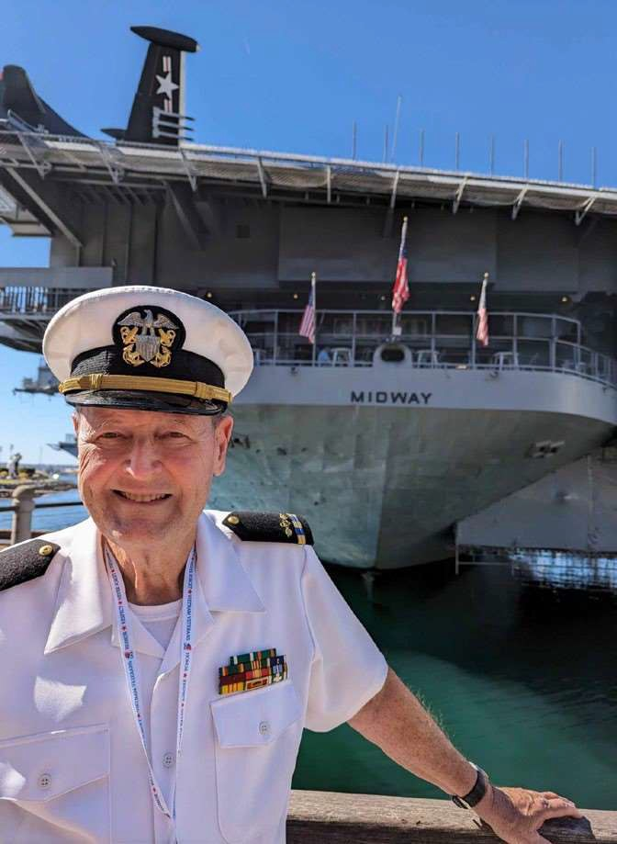
Bob at stern of the USS Midway
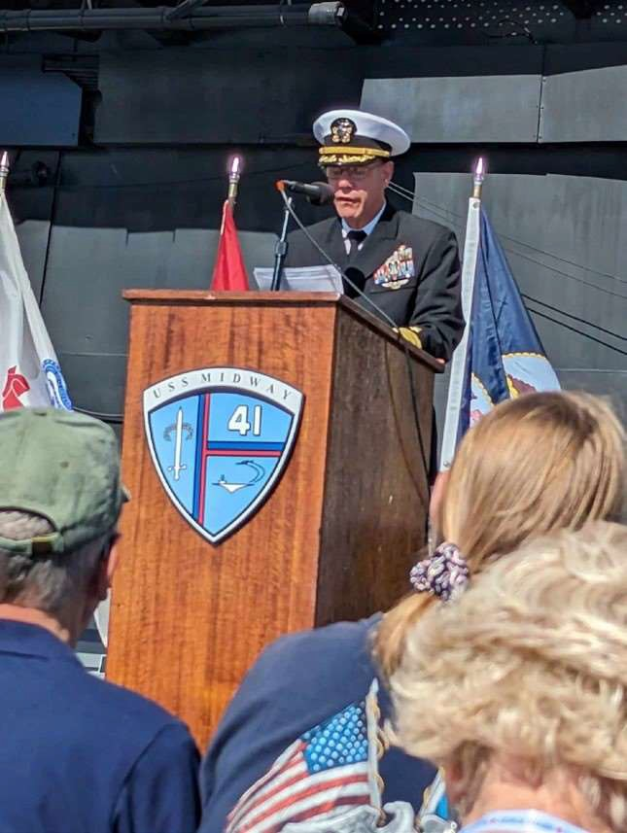
Guest Speaker Navy Commander

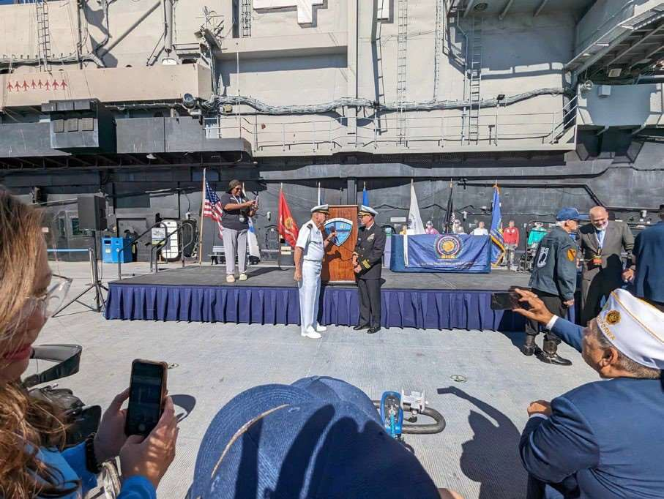
Veteran attendees introduce themselves

November Meeting Guest Speakers
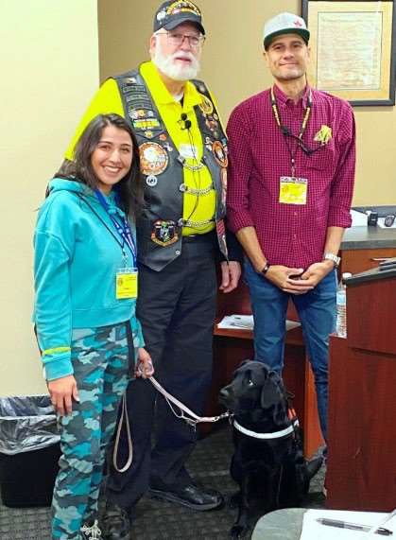
Representatives from the Freedom Service Dogs of America presented their program of services. They partner people with custom- trained assistance dogs. Their clients include veterans with PTSD, children and teens with autism and other neurocognitive disabilities, and individuals with physical challenges. Note: even if the VA denies authorizing you a service dog, you should contact this

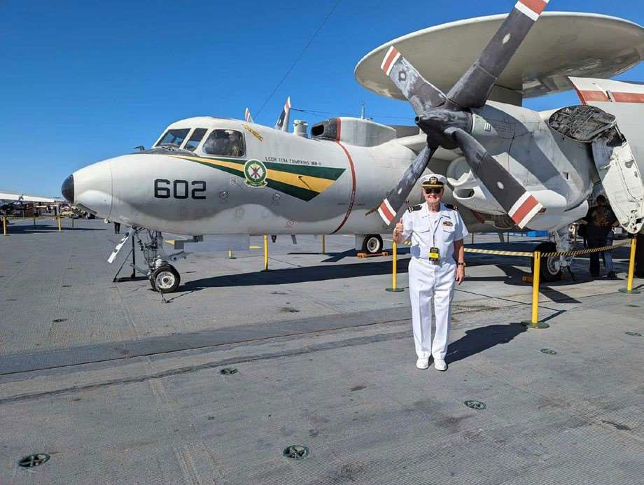
LtoR: Karen Perez, Mr. President, Ailbe Astor and Fernie
organization and they will assign a consultant to

work with you to try and get you a service dog. Freedom Service Dogs is an accredited member of Assistance Dogs International (ADI). They are a non-profit 501(c)(3) organization located in Englewood, CO. You can reach them at (303) 922-6231.

Bob in front of an E2C Hummer (Northrop Grumman E-2 Hawkeye)
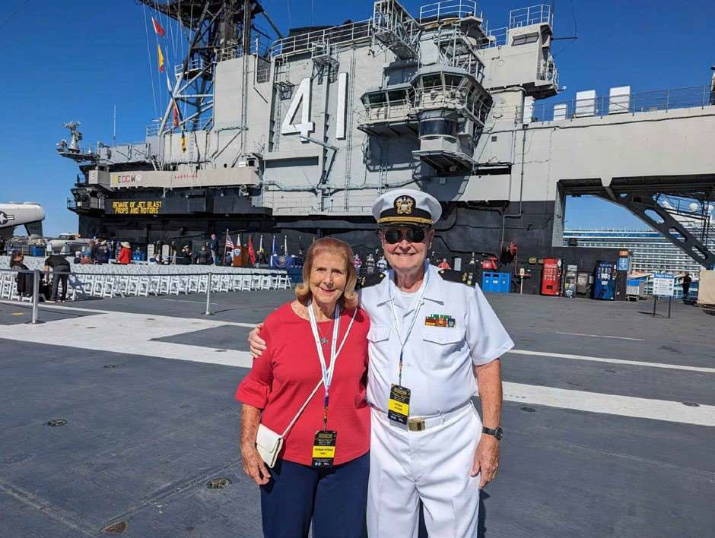
Barbara and Bob on the USS Midway

Bob stated that that the uniform changed to winter dress blues on November 1st but he didn't get the word!

Military Trivia
“Stubby” (answer on page 9)

December Guest Speaker
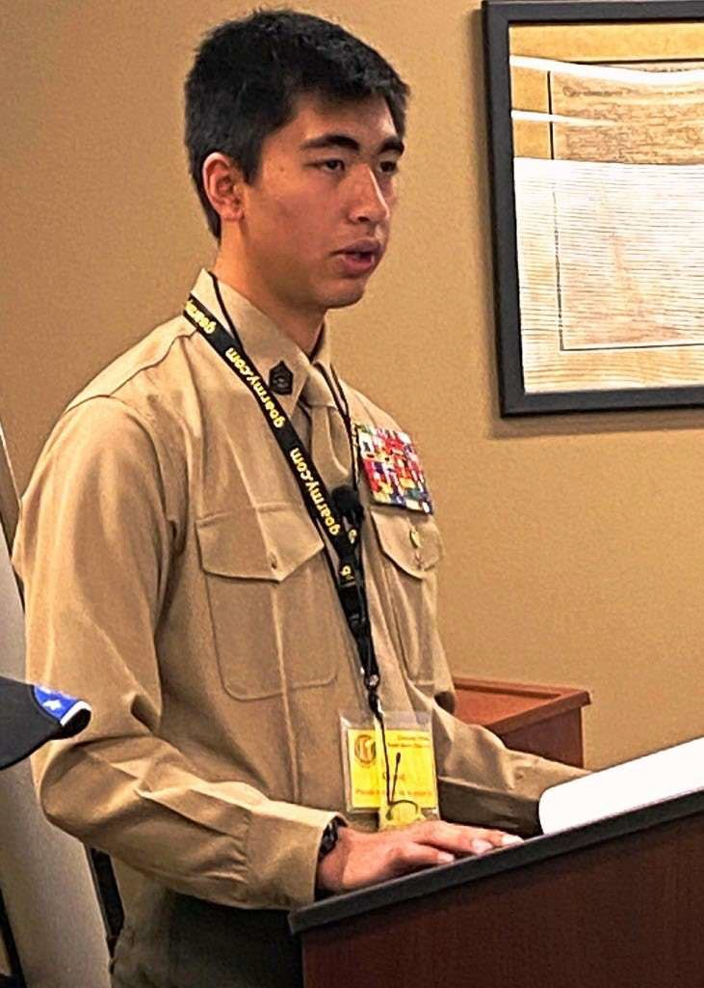
Gunnery Sergeant Sheehan

Our December meeting guest speaker was Gunnery Sergeant Sheehan of the Young Marines who presented a history of the Young Marines, a discussion of the organization’s Drug Demand Reduction program,and a Drug Demand Reduction discussion, a message specifically on Fentanyl use targeted to our youth.

Membership! (As of 11/04/2023) VVA 203
AVVA 43
TOTAL: 246
New Members:

Meetings/Events Calendar – 2023
Nov 4, 2023 – VVA Chapter 1106 Membership Mtg Nov 11, 2023-- Veteran’s Day “Poppy Drive”
Nov 26, 2023 – Chapter Board of Director’s Mtg Dec 3, 2023 – VVA Chapter 1106 Membership Mtg Dec 9, 2023 – Chapter Holiday Luncheon
Dec 30, 2023 – Chapter Board of Director’s Mtg

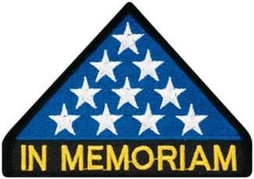

In Memoriam
Mike Vallow (US Air Force) Chapter Member and David Andersen (US Air Force)

November Meeting Events:

The Girl Scouts Brought Cookies
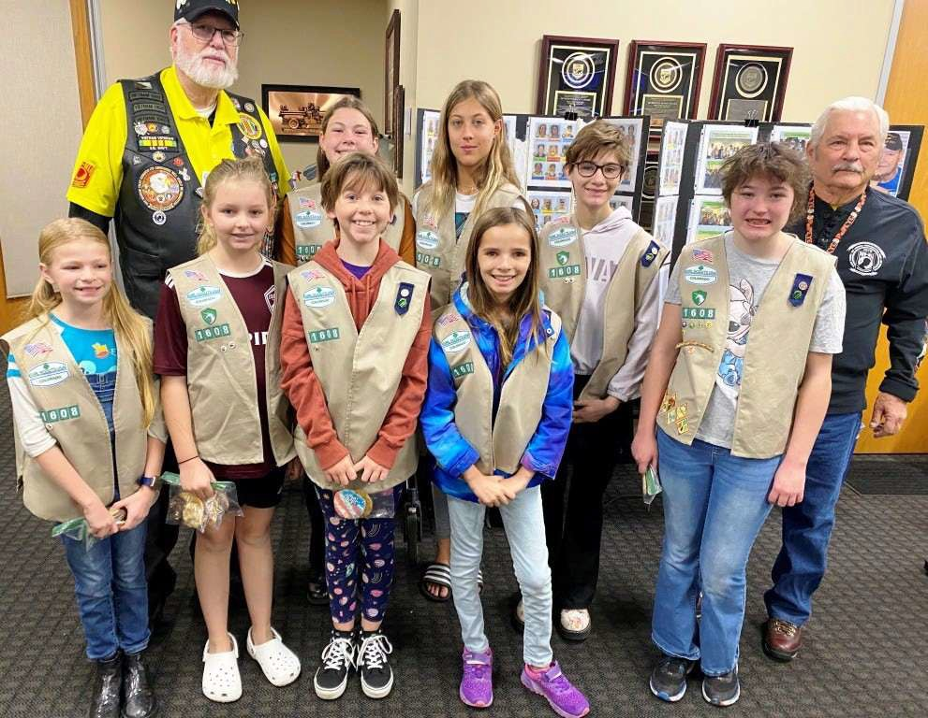
Members of Girl Scout Troop 1608 brought homemade cookies to our November Membership meeting. Grandpa Gary Palka has a granddaughter in the troop and invited them to our meeting. Thank you girls. The cookies were delicious.

Member Bio for November Mtg Randy Reed – U.S. Army

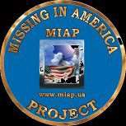
As of: 4/19/2023
Total Funeral Homes Visited – 2,622 Cremains Found – 29,894
Veterans Cremains Identified – 6,344 Veterans Interred – 5,959
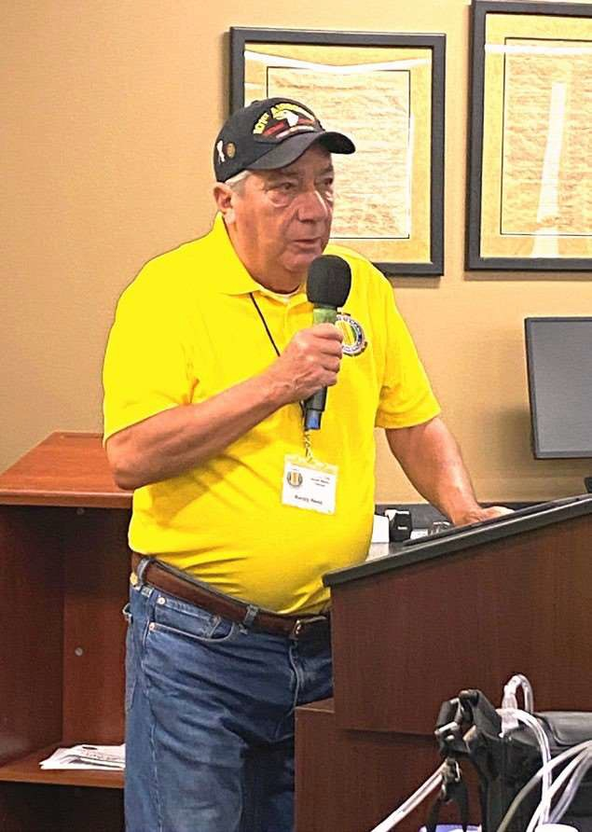

Member Randy Reed
Randy Reed shared his experiences while in college and prior to getting drafted by Uncle Sam. He shared his US Army military experience during boot camp and overseas. He was with the 101st Airborne Division in Vietnam.

November Chapter Events
Celebrating 30 years
The Vietnam Women’s Memorial, unveiled on Nov. 11, 1993, is the first monument to honor the efforts of military women at the National Mall. Our own Patti Ehline, Nurse and Vietnam Veteran, attended the 30th anniversary of the memorial’s unveiling. Patti, thank you for your service and welcome home!

Ben Franklin Academy Veterans Day Celebration
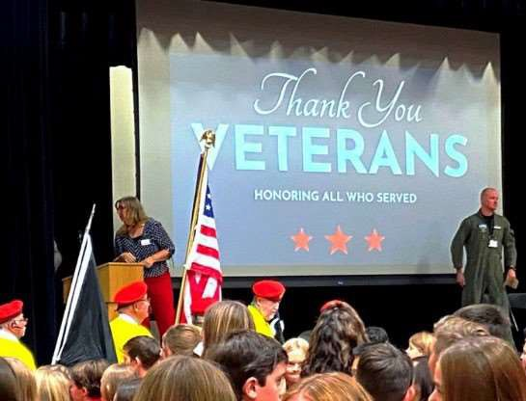
Ben Franklin Academy Veterans Day

Ben Franklin Academy once again honored veterans and active military at this year’s Veterans Day celebration. The entire school mobilizes for this event, with students attending in two separate sessions. The Chapter’s color guard presented the Colors at both sessions.

Veterans Day at Texas Roadhouse
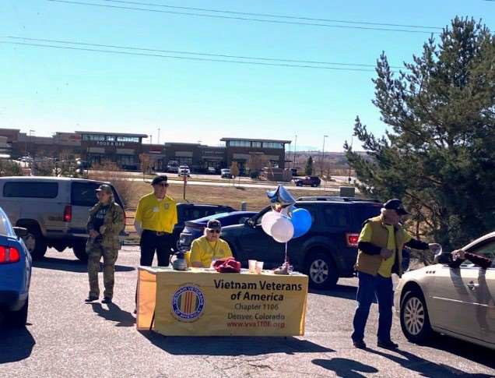
Chapter 1106 at Texas Roadhouse

Chapter 1106 members helped hand out free meal coupons and information about the Chapter at Texas Roadhouse Parker on Veterans Day. A long line of cars continued to drive through to receive a coupon. Thank you to members who came out to help.

Veterans Day Poppy Drive
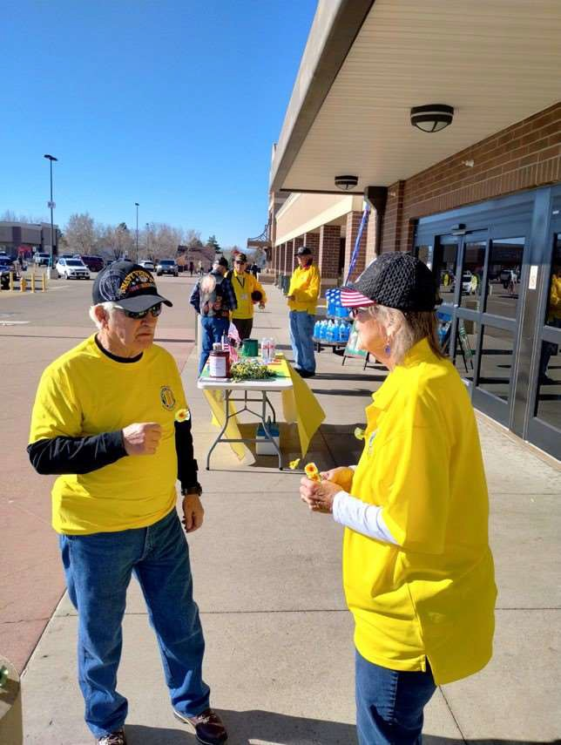
Chapter 1106 at King Soopers

Chapter 1106 members handed out Poppys to King Sooper customers at several locations on Veterans Day. Many customers responded in kind with donations to the Chapter. Thank you to members who came out to help.

December Meeting Events:
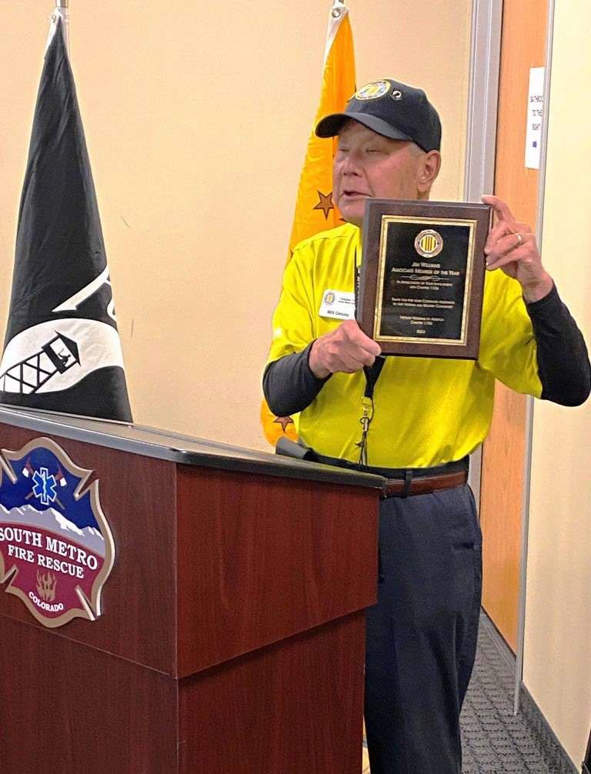
Milt Omoto with Jim William’s Award

Milt presented the Chapter’s 2023 AVVA Member of the Year award to Jim Williams, virtually. Jim hosts the monthly Zoom meeting capabilities for both Board and Membership meetings. He was on-line.
Congratulations Jim!

December Meeting Highlights
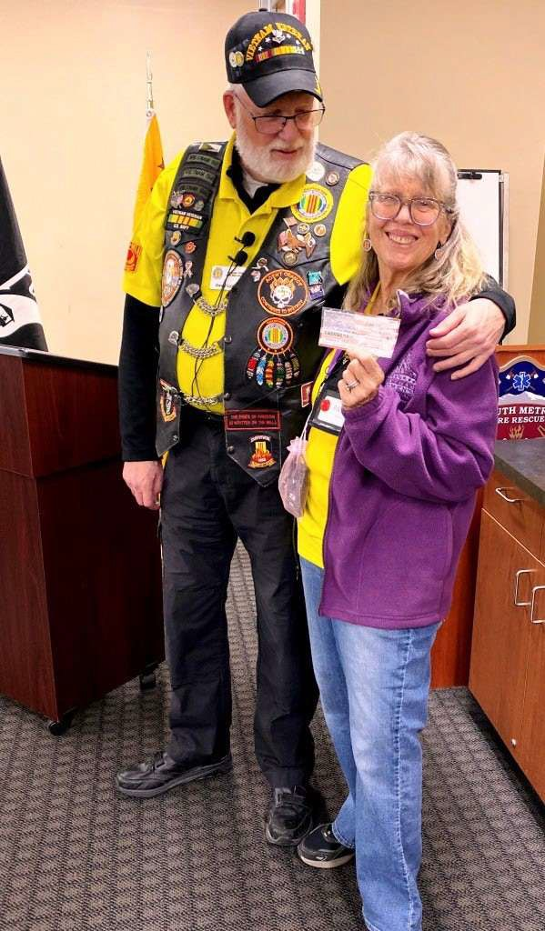
Patti Ehline and President Dave

The Chapter awarded Patti Ehline with a check to help pay for her Washington DC trip to the 2023 Veterans Day celebration at the Mall.
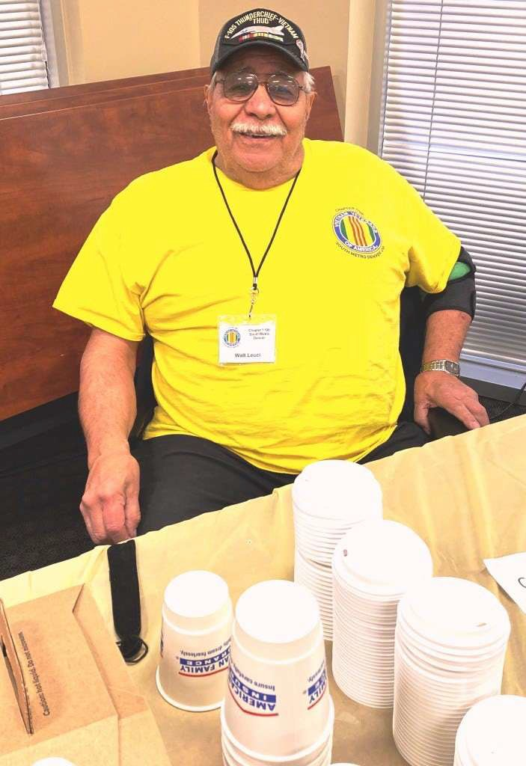
Walter Leuci

Walter has faithfully provided coffee and cold water at our monthly membership meetings all year. Thank you Walt!

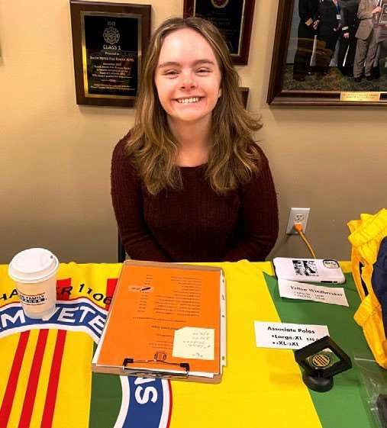
Kaitlyn McGullan

AVVA member Kaitlyn helping at the December meeting, on the promotional items table. Thank you Kaitlyn.
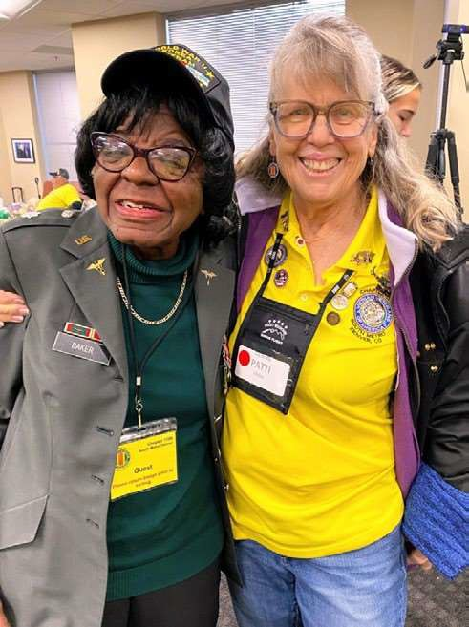
Martha Baker

A special guest at our December meeting was Martha Baker, US Army nurse, who served from 1951 through 1971. She is a Vietnam War veteran and is 96 years young! She is featured in the September/October 2023 issue of the VVA Veteran magazine along with the Chapter Color Guard.
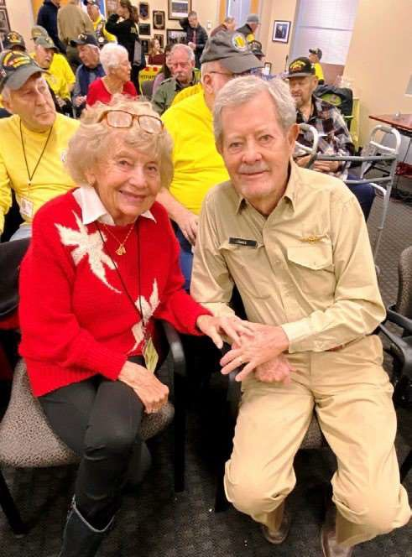
Doris and Loy Oakes

Another set of special guests were Doris and Loy Oakes. Lay served in the US Navy. They are residents of Heather Garden.

December Chapter Events

Holiday Lunch Highlights
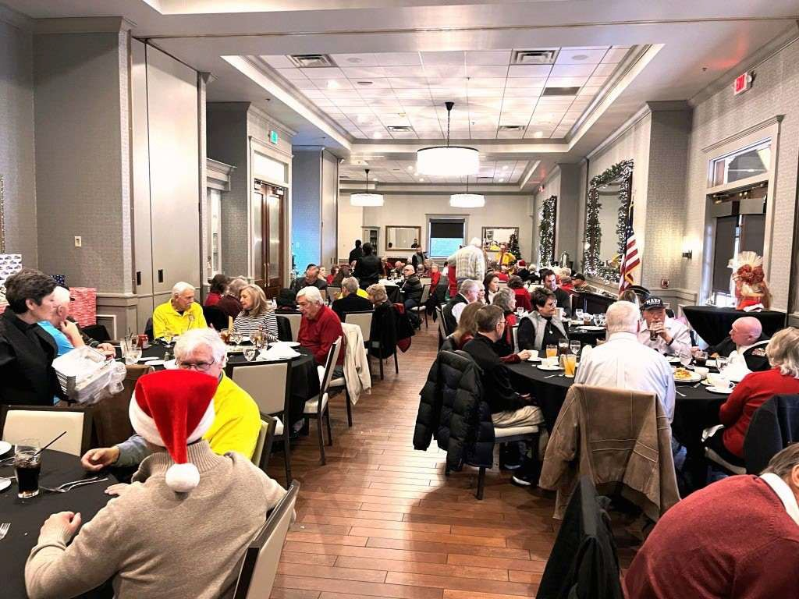
Great Attendance by Members and Spouses
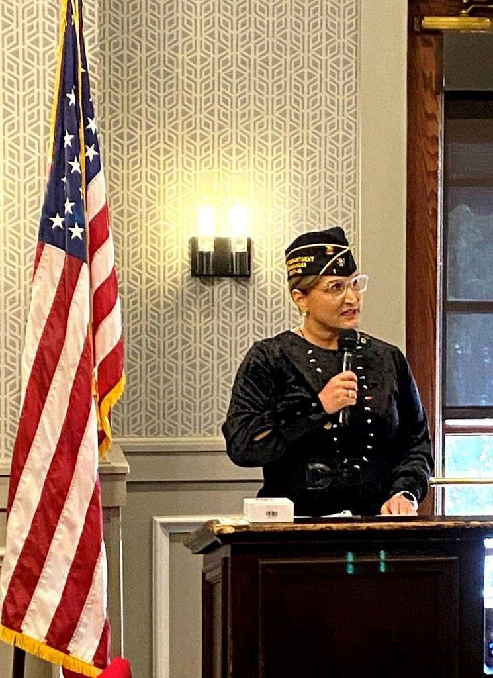
Guest Speaker Terri Clinton
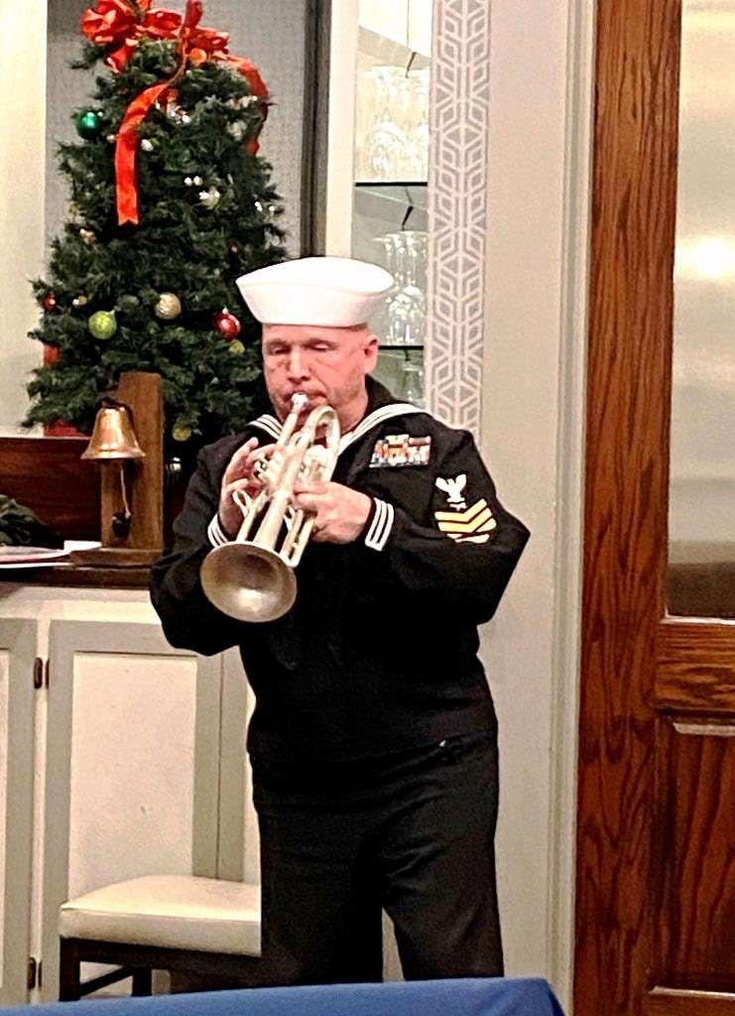
Trumpeter Mark Stallins

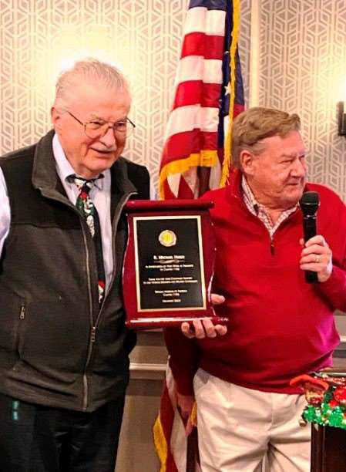
Chapter Member of the Year Mike Huber
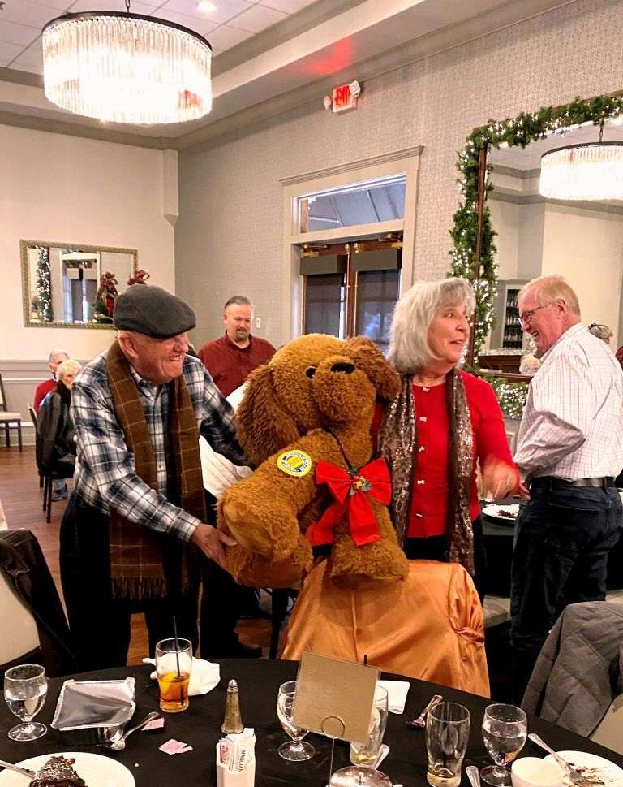
Proud Winners of the Surprise Gift!
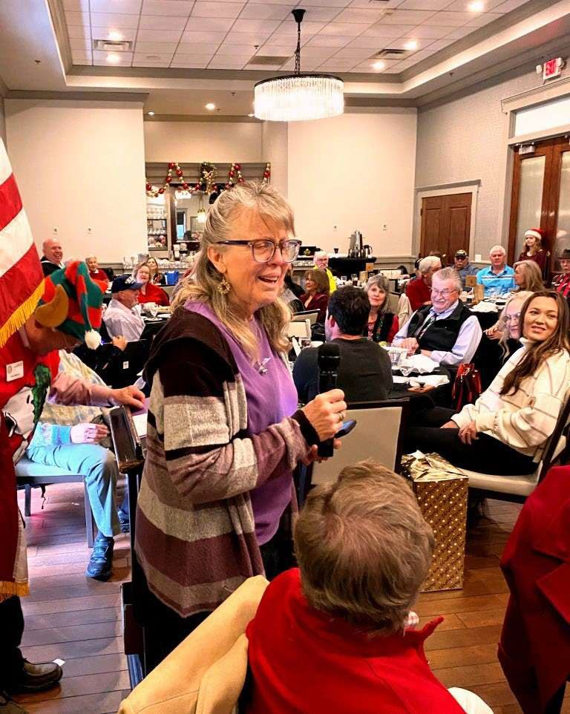
Patti Closing the Event with a Christmas Carol

2023 VVA Chapter 1106 Highlights

VVA National Convention
At the 2023 VVA National Convention held in Orlando, FL August 8 through 12, Chapter President Dave Lyons presented Chapter 1106 challenge coins to Grant Coates and Mokie Porter of VVA National. Grant is Chair of the VVA POW/MIA Committee, and Mokie Porter is VVA Director of Communications.

Chapter of the Year!
Chapter 1106 was awarded “Chapter of the Year” at the 2023 VVA National Convention in Orlando, FL, on August 10, 2023. This is a prestigious award for a Chapter, considering that VVA has over 650 active chapters throughout the United States, Puerto Rico, the Virgin Islands, Guam and the Philippines.

Member of the Year!
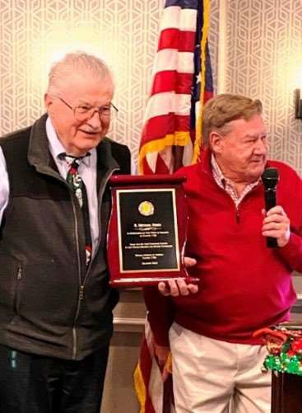

Mike Huber is presented the Chapter Member of the Year Award at the Holiday Lunch. Mike, thank you for all you do for the Chapter.

Veterans Emergency Assistance Program
Dozens of Veterans have been helped directly by the assistance program led by Joe Plant. As of March 1, 2023, over $22,000 had been provided to Veterans the previous fiscal year. To date, we are on track to provide the same level of support. Joe, thank you, for all you do. It can’t be easy fielding calls from so many people in need.

Buddy Checks
Hats off to all our Buddy callers. It is always nice to know that someone has your well being on their list of to do’s.

Chapter Social Events
Social events are important to the wellbeing of any organization. The Chapter Pic Nic and Holiday Lunch are no exceptions. Thank you to all the Members who spent many additional volunteer hours insuring these
activities went off with out a hitch (maybe just a couple of hiccups).

Chapter Color Guard
The Chapter Color Guard provides the most profound representation of this Chapter. These Men have provided significant additional volunteer hours to attend many events throughout the year on behalf of our Chapter. It is an activity that can be both emotionally and physically challenging. Thank you all for your contribution to such an important activity.

Honor Flight
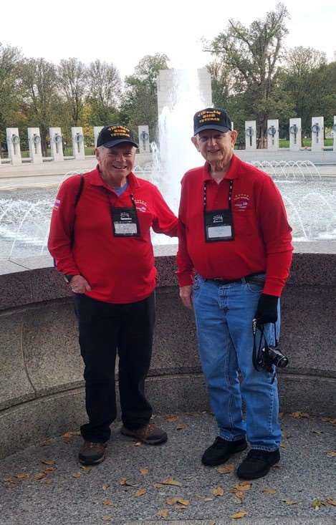
Joe Dempsey and Ed Seiler in Washington, DC

2023 Scholarship Winners
Chapter 1106 awarded six $2,000 scholarships to winners of this year’s scholarship program. Out of fourteen submissions, these graduating students demonstrated their understanding of the Vietnam War.

Forgotten Heroes Campaign July 8, 2023
The Forgotten Heroes Campaign honored three VVA 1106 Chapter members at their July 8th awards ceremony. John Vargas, Lew Woods and Richard Lewis were 3 of the 65 awards presented. Brigadier General David Warner conducted the honors.

Poppy Drives
Another year for the Memorial Day and Veterans Day Poppy Drives. Our biggest fund raisers of the year. For Chapter Members, an easy way to participate in helping the Chapter maintain financial stability while enlightening the public on the importance of these two National Holidays!

Books/Articles
I received my first notification from the Department of Veteran Affairs that I was approved for 70% disability soon after. The VA was still evaluating a new heart condition that was discovered during the medical testing and would provide an additional decision at a later date. That decision came in August. I had been reclassified at 100% with special compensation. The medical review team had discovered that I also was suffering from left ventricular systolic dysfunction (LVSD). The cause being attributed to my exposure to herbicides in Vietnam while on active duty. The irony for me is that the LVSD was not in the original
filing. Nor had it ever been diagnosed by either of the two civilian cardiologists I was seeing at the time.

I owe a great debt to the VA as I am now able to retire from my existing job of 40 years and address a medical condition that would have, otherwise, gone untreated indefinitely. I am being provided a second chance to live out my days in a more meaningful way, something I would not be able to
do had I continued to listen to the negative press about the VA and not paid attention to a young VSO who embraced his job and love for other Veterans.

It concerns me that there are other Vets out there, like I was, who are not taking full advantage of what their country has to offer because they are not getting the right information. My hope is that I can find a way to help you change that situation in some small way.
Editor’s Note: The following article was published in the VA/News https://news.va.gov on January 11, 2018. It was submitted by Mark Nickell.

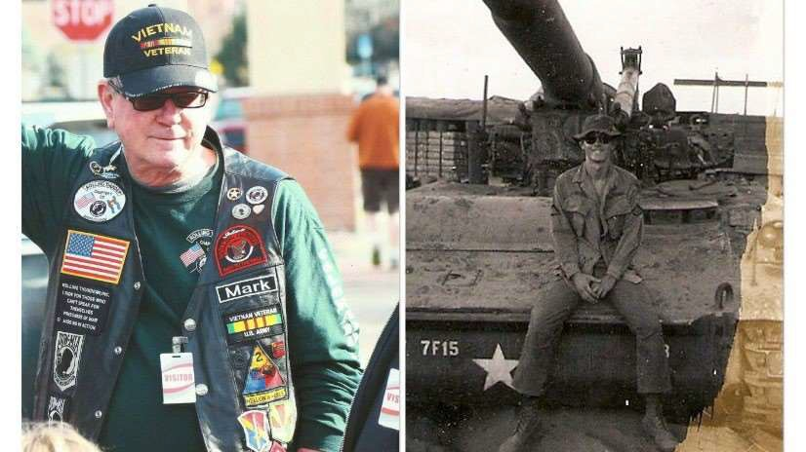
“Veteran Thanks Veterans Administration”

I have been a member of Rolling Thunder, the VFW and the VVA for the past several years after I decided to become engaged in Veteran organizations. This after not discussing any aspects of my military service, including Vietnam, for over 47 years. My contact with the VA has been superficial until this last year.

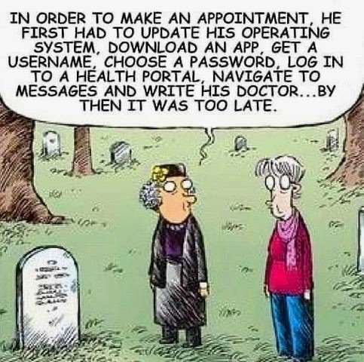
Until then, my opinion of the VA was primarily based on word of mouth critiques from other Veterans in these organizations. It was almost always negative feedback especially when concerning benefits. So much so that I declined to file for my own benefits for several years thinking it would not be a good use of my time. And besides, I was holding down a job and getting by just fine, at least up to about a year ago when I started to experience a significant loss of energy and began experiencing new heart issues on top of what I already had.

As luck would have it, a young Veteran service officer gave our VVA chapter [1106] a presentation on the services his team provided to Vets. He was from a neighboring county Veterans Service Office. I was smitten with his energy and genuine interest in helping us out. This was back in January 2017. His name is David Fry and he worked for Tim Westphal at the Arapahoe County Veteran Services here in Littleton, Colorado.

I made an appointment with him and we began the claims process, filing in February. I was contacted by a VA contract group within 45 days about attending medical evaluations within the next few weeks. The process was painless and the administration and medical employees were great. They were very caring and very respectful. I came to look forward to the evaluations.

Trivia Answer
“Stubby” – The nickname for an 8” SP (self propelled) howitzer that fired a 200lb. HE round up to 11 miles.

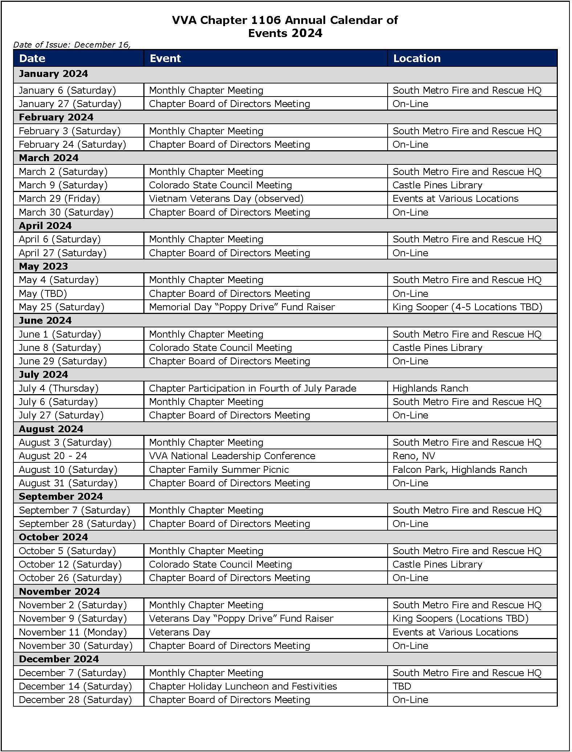

FRIENDS OF CHAPTER 1106

South Metro Denver Fire & Rescue  9195 E Mineral Ave Centennial, CO 80112 | TREA: The Enlisted Association - HQ Phone - (303) 752-0660  12200 E. Briarwood  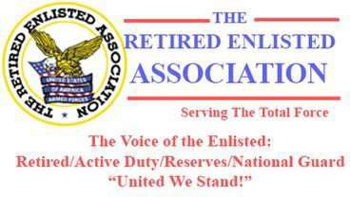  Avenue, Suite 250, Centennial CO 80112
Spradlin Printing, Inc. 11903 S. Parker Road Parker, CO 80134 | Alycia Carmin PO Box 233  Kersey, CO 80644  (970) 352 8802
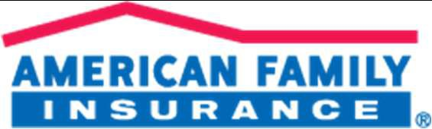  3989 E. Arapahoe Road #20  Centennial, CO 80122  720-361-0155 | 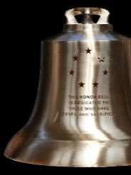  The Honor Bell Foundation  PO Box 1432  Englewood CO 80150  720.282.9182  www.honorbell.org
9137 E Mineral Cir Ste 100
Englewood, CO 80112-3422
 | Qualified Listeners:
King Soopers | PO Box 563
9551 S. University Blvd., Highlands Ranch, CO 80126 | Dacono, CO 80514  Tel: 720-600-0860
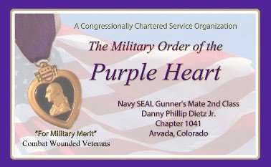  Military Order of Purple Heart, Chapter 1041, Arvada, CO | 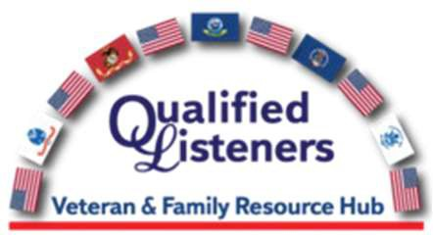  CHERRY CREEK SCHOOL DISTRICT  4700 South Yosemite Street Greenwood Village, CO 80111
President | PARKER MEDICAL SUPPLY STORE  9845 S Parker Rd  . Parker, CO 80134 303-840-4444
Dale Goulette
cell 303-547-7850
2212 Diamond Creek Drive, Colorado
Springs, CO, 80921
dalegoulette@rockymountainhonorflight.org

Texas Roadhouse
11205 S. Parker Road, Parker, CO 80134

THANK YOU FOR REACHING OUT AND HELPING VETERANS
ERC Management, LLC
791 Southpark Dr., Suite 600
Littleton, CO 80120
720.328.3299
www.FreddysUSA.com

