**Inside this issue:**

Notes from the President

[Member Feature](#Memberfeature)

[Military Trivia](#Militarytrivia)

[Guest Speaker](#Guestspeaker)

[Membership](#Membership)

[Board of Directors/Officers](#Boardofdirectors)

[Working Committees](#Workingcommittees)

[Meetings/Events Calendar](#Meetingsevents)

[Announcement Corner](#Announcementcorner)

[Books/Articles Published by Mbrs.](#Booksarticles)

[From the Editor](#Fromtheeditor)

[Light Side](#Lightside)

[Trivia Answer](#Militarytrivia)

**Notice:**

If you have moved or changed your address, PLEASE notify us immediately! Contact: Dave Lyons, Membership Chair

E-mail: [Snoyldavid@centurylink.net](mailto:Snoyldavid@centurylink.net)

Phone:  303 690 8776

###### COPYRIGHT NOTICE: In accordance with Title 17 U.S.C. Section 107, any copyrighted material in this newsletter is distributed under fair use without profit or payment to those who have expressed a prior interest in receiving the included information for nonprofit use and educational purposes only.

**Facebook: Vietnam Veterans of America Chapter 1106**

***Editor’s Note:***



[This Photo](https://storytellerurdaneta.blogspot.com/) by Unknown Author is licensed under [CC BY-NC](https://creativecommons.org/licenses/by-nc/3.0/)

This version of the newsletter is in Microsoft Document (.DOCX) format so that the links will work. Put your cursor over the link, depress your Control Key (ctrl) and depress your left mouse button and it will take you to the listed link position. PDF format, the links will not work.

The comments and editorial input does not necessarily reflect the opinion of the membership of our chapter. I would appreciate any feedback that you might have, items you liked or if you find offensive or derogatory in anyway. ([bobrotruck73@gmail.com](mailto:bobrotruck73@gmail.com)) Thank you for allowing me to be your editor.

***Notes from the President***

Lee White

I cannot believe that 2020 is rapidly coming to a close. Our last “NEWSLETTER” for 2020, and a fine job by our producer/editor, Bob Rotruck. When Covid-19 arrived in early March, I had no idea what impact it would have on our chapter members, with some event cancellations. Guess what? We continued to find ways to support our fellow members and community. With the tremendous support of our Board Members, Committee Members, and many others, we accomplished many goals in 2020:

\*Increased membership from 144 VVA to 160, and AVVA from 36 to 40

\*Produced and introduced a new chapter video

\*Never missed a publication of our chapter NEWSLETTER

\*Awarded six $2000 scholarships (received 58 applications)

\*Implemented monthly “Buddy Check Calls”

\*Supported the Veterans Emergency Assistance Program (Approx. $1000 per month.

\*Held elections – New treasurer, Mike Huber, New Secretary, Milt Omoto. All remaining officers, and Board Members ran unopposed.

\*First Board Meeting held on April 18, 2020 via Zoom.

\*Regular Board and Membership Meetings are held monthly via Zoom

I want to take this time to wish all members and their families a Happy Holiday Season. Please stay safe.

THANK YOU ALL!!

Lee

***Member Feature***

**LCDR Coy D. Ritchie, USN (Ret)**

After graduating from high school in 1955, I enlisted in the U.S. Navy and, upon completion of recruit training, attended electronics training at Treasure Island, CA. followed by Fire Control Technician A School in San Diego. After “A” School, my first ship was the USS Carpenter (DDE-825), home ported in Pearl Harbor. I loved the Navy life. While aboard the Carpenter, I attained the rank of FT2 and reenlisted. This was followed by duty in the USS Frontier (AD-25), USS Morton (DD-948), and USS Mahan (DLG-11). I was advanced to FT1 in 1960 while aboard the Mahan and then was transferred in 1962 to instructor duty at the FT/A School at Great Lakes where I was promoted to Chief Fire Control Technician (FTC). I also attended Roosevelt University in Chicago during the evening sessions and graduated with a BS degree in 1965.

After appointment to Warrant Officer status on 1/1/1966, I attended Officer Candidate School at Newport, R.I., and reported for duty as Ordnance Repair Officer in the USS Frontier (AD-25), serving as division officer of the same division in which I had served as an FT2 in 1959-60. In 1968, as a Chief Warrant Officer, I was assigned as Director of the FT/A School, Great Lakes, once again serving as director of the same school in which I had been an instructor during a previous tour. I was “promoted” to Ensign in 1968 and to this day I am not sure that going from CWO to Ensign was really a promotion. In 1969, as a LTJG, I was assigned to the USS Wainwright (CG-28), a newly commissioned guided missile cruiser, where I served as both gunnery officer and missile officer in two consecutive tours spending a total of three years primarily deployed to the Western Pacific and Viet Nam areas. As a LT, I reported to the Defense Language Institute (DLI), Monterey, CA in 1972, for a year of training in the Greek language which I learned to read, write, and speak at a professional level. Following DLI there was a two year stint as an exchange officer in the Greek Navy. In 1975, I was promoted to LCDR and assigned as Director of the Navy Electronics School at Norfolk, VA. In 1977, with two sons in high school and planning to go to college, I decided that it was time to change my occupation and I transferred to the retired list on 12/31/1977, exactly 22 years after I originally enlisted.

After retiring from the Navy, I worked for the Educational Services subsidiary of ITT Corporation for 18 years. In my spare time, utilizing GI Bill benefits, I went back to school and earned an MBA from City University and a Doctorate in Management from Colorado Technical University. After retiring from ITT Corporation in 1996, I took a position as vice president and chancellor of Colorado Technical University. After retiring from the University in 2003, I started a management consulting firm, Ritchie Management Services, of which I am currently general manager and owner. For five years (2004-2009), I served as the Training Officer and leadership instructor for the U.S. Naval Sea Cadet Corps, Lexington Division. I am currently past-president and board member of the Mile-High Military Officers’ Association and commander of the Denver Chapter, The Military Order of the World Wars (MOWW). I am treasurer of Region XIII (Southwest Region) of MOWW. I have also served on the Board of the Denver Council of the Navy League and Board of Trustees of the Rocky Mountain Youth Leadership Foundation.

Juanita (Pat) Domingo and I were married in Hawaii in June 1959 and we have two sons and one granddaughter living in Colorado. Pat and I spend most of our spare time at our ranch in the Rockies near Guffey, Colorado where I pursue my hobbies of restoring classic cars, gardening, and genealogy, while Pat devotes her time to photography, sketching, Bunka, and painting.

***“History Corner”***

By Chapter Historian: John Vargas

As we continue researching our VVA chapter’s 1106 young but fact filed history, here is a collage of the founding members.

Top row: Marty Smith, Jack Hunter, William Purcell, Hazel Simeon, and Jerry Simmons

Center: John Williams, Paul Seppo and Suzanne Sigona

Bottom row: Lee White, Pat Surrena, Doug Henning and Milt Omoto

***Military Trivia***

**ASW** [Click here for end of the Newsletter Trivia Answer](#Militarytrivia)

***Guest Speaker – Aug* -** Cliff Lawson – Portraits

Showing our Chapter Recruitment Video

***Special Speaker – Sep* -** "Qualified Listeners" - Greg Goettsch

***Guest Speaker – Oct*** – Josh Medina – Arapahoe County Veterans Services Officer

**Sep Bio Speaker - None**

**Oct Bio Speaker - None**

***Membership!*** (As of 10-12-20)

VVA - 158

AVVA - 40

Total - 198

Welcome New Members:

**VVA**

James Parker

Coy Richie

Ed Hruscik

**AVVA**

None

***Board of Directors/Officers***

Lee White – President

Dave Lyons – Vice-president

Mike Huber – Treasurer

Secretary – Milt Omoto

Board Members – Patti Ehline, Glen Payne, Tom Werzyn, Ron Smith, John Vargas, Dan Green, Joe Plant, Rev. Garry Turks

***Special Chapter Positions***

AVVA Liaison to chapter Board of Directors – Litta Plant-Schaper

Chaplain – Rev. Garry Turks

Chapter Historian – John Vargas

Database/Audio – Jack Hunter

Government Affairs – Tony Nickerson

Sergeant-at-Arms – Rob Senatore

Chapter Nurse – Patti Ehline

***Working Committees***

* Agent Orange/PTSD: Patti Ehline
* Color Guard: Jay Quiring (Command Sergeant),
* Don McNeely, Dan Green, Thom Frey, Clarence Rebolledo, Robert Senatore, Tony Nickerson, Ron Smith, Leann Stelzer, Alexis Winemiller
* Event Coordinator: Ron Smith – Chair, Lee White, Michelle Mallin
* Fundraising/Grants: Milt Omoto
* Marketing/Media/Events: Tom Werzyn, Michelle Mallin
* Membership: Dave Lyons – Chair, Lee White
* Mental Health: Patti Ehline, Warren Harrison, Joe Plant
* Name Tags: Litta Plant-Schaper
* Newsletter Editor: Bob Rotruck
* Promotional Items: Leann Stelzer, Clarence Rebolledo
* Refreshments: Alexis Winemiller, Jason Longmore
* Scholarship Program: Mike Karsh and Jim Marcille – Co-chairs, Glen Payne, Gary Weston, Mike Vallow, Rebecca Webb, Cliff Butler, Lou Grounds, Tom Werzyn
* Social –Barry Fiore, Glen Payne, Milt Omoto, Mike Karsh, John Vargas
* Speakers Bureau Tom Werzyn – Chair, Bob Easter, Bob Mallin, Glen Payne, Roger Lanphier, Donna Chaney
* Veteran Emergency Assistance Committee: Joe Plant, Dave Lyons, Dan Green, Bruce Arndt, Lee White
* Voices for Veterans: Warren Harrison, Patti Ehline, Joe Plant, John Vargas
* Webmaster: Bob Rotruck
* Women Veterans: Patti Ehline

**Meetings/Events Calendar - 2020**

November 3, 2020 - Election Day

November 7, 2020 - VVA Chapter 1106 Monthly Meeting (Zoom)

November 11, 2020 - Veterans Day

November 12, 2020 - Ben Franklin Academy Veterans Appreciation (Drive/Parking Lot)

November 14, 2020 - Veterans Day Poppy Drive - Cancelled

November 26, 2020 - Happy Thanksgiving

December 5, 2020 - VVA Chapter 1106 Monthly Meeting (Zoom)

December 12, 2020 - CO State Council Meeting - Castle Rock

December 2020 - SPECIAL YEAR END EVENT VIA ZOOM (Date to be announced)

December 25, 2020 - Merry Christmas

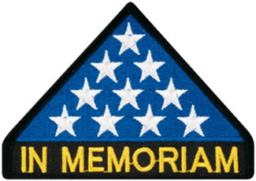

***In Memoriam***

**Green Beret Captain Calvin “Butch” Smith’s Blanke**t

VVA Chapter 1106 has recently received a donation, for our Speakers Bureau and other display uses, of a standard OD, wool Army blanket that has been adorned with a variety of unit patches, badges of rank, locations and other patches- they’ve been sewn on, by hand, over the career of US Army Green Beret Captain Calvin “Butch” Smith. B. 5/14/44 – D. 11/14/2003; he resided in Arvada and was a member of Rolling Thunder Chapter 1, here in Denver. Capt. Smith is interred at Ft. Logan National Cemetery.

Butch on his motorcycle!

Capt. Smith served in the south Vietnam Delta area during ’69 – ’70 with the 5th Special Forces, the 1st Special Forces, as well as Mike Forces, where he was awarded a Bronze Star for Heroism, for actions on Nov. 23, 1969. During his career he as well served with the 101st Airborne. He joined the Army in 1964 and was medically retired in 1981.

Through the course of his Army career, Capt. Smith collected patches from units he was assigned to, locations where he was deployed, units he worked with and his rank insignia. These were hand-sewn onto that Army blanket- perhaps the one he carried with him while deployed in Southeast Asia

.

After his death in 2003, the blanket ended up in the hands of a friend, and it was stored/forgotten until just recently. His friend, Layne Jacobson, and his wife Billie located a daughter, Nicole Reeves, in Florida, and a sister, Jennifer Green, in Arvada. These two ladies agreed to donate Butch’s blanket to our VVA 1106 chapter for use as a display item, and an artifact for our Speakers Bureau- as well as other chapter activities. John Vargas has created, and forwarded, certificates of appreciation and thanks, to both ladies.

We do appreciate that they thought of us as a worthy organization to receive the blanket and make the best use of it- in service to other veterans and to the public we serve.

Billie Jacobson told us that she found our chapter via our Web Site- so we know it works!!



As of: 8/21/2020

Total Funeral Homes Visited - 2,402

Cremains Found – 21,501

Veterans Cremains Identified – 5,043

Veterans Interred – 4,625

***Events:***

**Milt Omoto Honored at October Meeting**

Chapter member Milt Omoto was awarded a recognition plaque for his support of Chapter 1106 at the recent virtual October meeting. Milt is a founding member of the Chapter, serves at the Secretary, and Chairs Grants and Fundraising. In addition, he is Secretary for the Colorado VVA State Council.

Milt was surprised when he opened a package during the October Chapter Zoom meeting.

The package!

And the surprise!!!

The text!!! Well-deserved Milt!!!

**PFC Brodin – WWI Veteran**

VVA Chapter 1106 members attended this ceremony:

Lee White, Patti Ehline, Bob and Barbara Rotruck. PFC Brodin now lives in Castle Rock at the young age of 97. Patti was able to take some pics of the ceremony as well as Nick Lucy of Castle Rock and a former Marine.

Photo Courtesy of Patti Ehline

Presenter Command Sergeant Major Bill Woods.

Seated front row L to R: Congressman Ken Buck, PFC Arthur Brodin, and others.

Photo Courtesy of Patti Ehline

Command Sergeant Major Bill Woods holding up the display case of the awards.

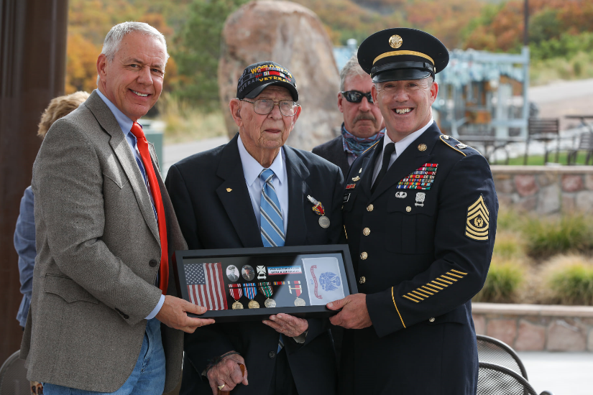

Photo courtesy of Nick Lucy

He was awarded:

Good Conduct Medal

American Campaign Medal

European-African-Middle Eastern Campaign Medal & Bronze Star Attachment (Triple)

WW2 Victory Medal

Army Occupation Medal & Germany Clasp

Honorable Service Lapel Button WWII

Marksman Badge & Rifle Bar

Photo Courtesy of Nick Lucy

PFC Brodin inh is personalizde Army Jeep.

***Did You Know***

Each newsletter, you will see a different service branch to help you know the naming differences between the different services!

**Air Force Officer Ranks**

Second Lieutenant (1LT) (01)

First Lieutenant (2LT) (02)

Captain (CPT) (03)

Major (MAJ) (04)

Lieutenant Colonel (LTC) (05)

Colonel (COL) (06)

Brigadier General (BG) (07)

Major General (MG) (08)

Lieutenant General (LTG) (09)

General (GEN) (010)

**Warrant Officer Ranks**

None

**Air Force Enlisted Ranks**

Airman Basic (E1)

Airman (E2)

Airman First Class (E3)

Senior Airman (E4)

Staff Sergeant (E5)

Technical Sergeant (E6)

Master Sergeant (E7)

Senior Master Sergeant (E8)

Chief Master Sergeant (E9)

***Announcement Corner***

**Vietnam Veterans Memorial Fund**

During this challenging time for our country, VVMF is announcing that the Veterans Day Ceremony at The Wall will be an online ceremony only.

We wanted to make this call now – at least 60 days out – to give those who planned to travel to Washington, D.C., ample time to adjust their schedules and travel plans as needed. There WILL be a Veterans Day Ceremony, but it will be a live webcast — NOT in person at The Wall.

We did not make this decision lightly, and like all of you, we hope this national health crisis ends soon. But we did not want people to make travel plans to attend in person, only to arrive and find out social distancing requirements have cancelled the event. Washington, D.C. remains in Phase 2 of its COVID-19 recovery plan and gatherings are still limited to 50 people.

We will observe Veterans Day 2020 with a virtual commemoration, and we hope you will join us online at 1:00 p.m. ET on Wednesday, November 11th. Visit https://www.vvmf.org/honorservice for more details.

We must take the necessary precautions to keep our attendees, volunteers, and staff safe at this time. We certainly hope we can get back on our usual in-person ceremony schedule in 2021 as we look forward to welcoming you all back to The Wall as soon as we can safely gather in large numbers again. We appreciate your understanding during this difficult time.

– Jim Knotts

***Books/Articles***

**What Is Your Story?**

From the Editor

What is your story? Yes, you **all** have special stories about your time in the military, serving our country! Some are happy and some profoundly serious. I know you have stories because I hear you sharing them before and after our meetings. It is time you shared those stories with all of us. If you will just take the time to sit down at your computer or use your “smart” phone or even a pencil and paper and write your story and send or hand it to me, you will end up with a $5.00 gift card for a cup of coffee!

**A Backseat View from the Phantom:**

A Memoir of a Marine Radar Intercept Officer in Vietnam

by Col USMCR (Ret) Lentz, Fleet S., Jr. | Jun 18, 2020

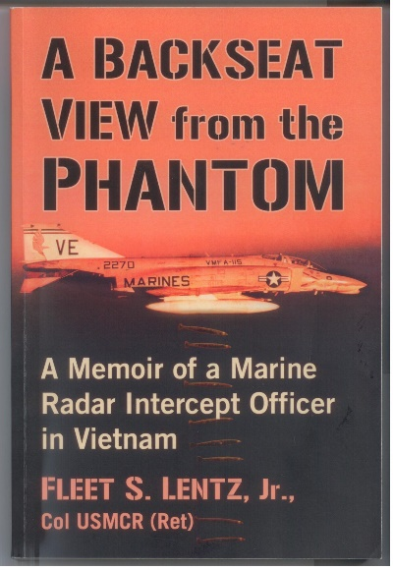

Fleet is a chapter member

Comment from Robert Crago: My good friend, Fleet Lentz, has been very busy on Sat. driving veterans to the VA hospital. He has not been able to attend the Zoom meetings yet. Meanwhile, Fleet a month ago published his new book, attached. Fleet told me, he did not want to promote the book to the chapter, because he did not join to do so. So, I'm doing for him! I'd like the members to know about the book. It’s a great read.

**Vietnam War Veterans Statistics**

Submitted by John Vargas

Here is one for all of you Vets but especially so for the Vietnam vets!

Only 31.4% of VN vets still alive.

A statistic not included is the number of people who claim to have served in RVN. That number is 3 or 4 times the 3 Million who did.

In case you haven't been paying attention these past few decades after you returned from Vietnam, the clock has been ticking. The following are some statistics that are at once depressing yet in a larger sense should give you a HUGE SENSE OF PRIDE.

"Of the 2,709,918 Americans who served in Vietnam, Less than 850,000 are estimated to be alive today, with the youngest American Vietnam veteran's age approximated to be 60 years old." So, if you're alive and reading this, how does it feel to be among the last 1/3rd of all the U.S. Vets who served in Vietnam?! I don't know about you guys, but this gives me the chills, considering this is the kind of information I'm used to reading about WWII and Korean War vets. For the last 14 years we have been dying too fast, only a few will survive by 2025... if any. If true, 390 VN vets die each day. In 2190 days from today, lucky to be a Vietnam veteran alive... in only 6-10 years. These statistics were taken from a variety of sources to include: The VFW Magazine, the Public Information Office, and the HQ CP Forward Observer - 1st Recon April 12, 1997.

STATISTICS FOR INDIVIDUALS IN UNIFORM AND IN COUNTRY VIETNAM VETERANS:

\* 9,087,000 military personnel served on active duty during the Vietnam Era (August 5, 1964 - May 7, 1975).

\* 8,744,000 GIs were on active duty during the war (Aug 5, 1964-March 28,1973).

\* 2,709,918 Americans served in Vietnam. This number represents 9.7% of their generation.

\* 3,403,100 (Including 514,300 offshore) personnel served in the broader Southeast Asia Theater (Vietnam, Laos, Cambodia, flight crews based in Thailand, and sailors in adjacent South China Sea waters).

\* 2,594,000 personnel served within the borders of South Vietnam (Jan.1, 1965 - March 28, 1973). Another 50,000 men served in Vietnam between 1960 and 1964.

\* Of the 2.6 million, between 1-1.6 million (40-60%) either fought in combat, provided close support or were at least fairly regularly exposed to enemy attack.

\* 7,484 women (6,250 or 83.5% were nurses) served in Vietnam.

\* Peak troop strength in Vietnam: 543,482 (April 30, 1968).

\*Agent Orange is taking a huge toll on Vietnam Veterans with most deaths somehow related to Agent Orange exposure. No one officially dies of Agent Orange, they die from the exposures which causes Ischemic Heart Disease and failure, Lung Cancer, Kidney failure or COPD related disorders.

CASUALTIES: The first man to die in Vietnam was James Davis, in 1958. He was with the 509th Radio Research Station. Davis Station in Saigon was named for him.

Hostile deaths: 47,378

Non-hostile deaths: 10,800

Total: 58,202 (Includes men formerly classified as MIA and Mayaguez casualties). Men who have subsequently died of wounds account for the changing total.

8 nurses died - 1 was KIA.

61% of the men killed were 21 or younger.

11,465 of those killed were younger than 20 years old.

Of those killed, 17,539 were married.

Average age of men killed: 23.1 years

Total Deaths: 23.11 years

Enlisted: 50,274; 22.37 years

Officers: 6,598; 28.43 years

Warrants: 1,276; 24.73 years

E1: 525; 20.34 years 11B MOS: 18,465; 22.55 years

Five men killed in Vietnam were only 16 years old. The oldest man killed was 62 years old. Highest state death rate: West Virginia - 84.1% (national average 58.9% for every 100,000 males in 1970). Wounded: 303,704 - 153,329 hospitalized + 150,375 injured requiring no hospital care. Severely! disabled: 75,000, - 23,214: 100% disabled; 5,283 lost limbs; 1,081 sustained multiple amputations. Amputation or crippling wounds to the lower extremities were 300% higher than in WWII and 70% higher than Korea. Multiple amputations occurred at the rate of 18.4% compared to 5.7% in WWII. Missing in Action: 2,338, POWs: 766 (114 died in captivity). As of January 15, 2004, there are 1,875 Americans still unaccounted for from the Vietnam War.

DRAFTEES VS. VOLUNTEERS:

25% (648,500) of total forces in country were draftees. (66% of U.S. armed forces members were drafted during WWII). Draftees accounted for 30.4% (17,725) of combat deaths in Vietnam. Reservists killed: 5,977, National Guard: 6,140 served: 101 died. Total draftees (1965 - 73): 1,728,344. Actually, served in Vietnam: 38%. Marine Corps Draft: 42,633. Last man drafted: June 30, 1973.

SOCIO-ECONOMIC STATUS: Vietnam veterans have a lower unemployment rate than the same non-vet age groups. Vietnam veterans' personal income exceeds that of our non-veteran age group by more than 18 percent. 76% of the men sent to Vietnam, were from lower-middle/working class backgrounds. Three-fourths had family incomes above the poverty level; 50% were from middle income backgrounds. Some 23% of Vietnam vets had fathers with professional, managerial or technical occupations. 79% of the men who served in Vietnam had a high school education or better, when they entered the military service. 63% of Korean War vets and only 45% of WWII vets had completed high school upon separation. Deaths by region per 100,000 of population: South - 31%, West -29.9%; Midwest - 28.4%; Northeast - 23.5%.

DRUG USAGE & CRIME:

There is no difference in drug usage between Vietnam Veterans and non-Vietnam Veterans of the same age group. (Source: Veterans Administration Study) Vietnam Veterans are less likely to be in prison - only one-half of one percent of Vietnam Veterans have been jailed for crimes. 85% of Vietnam Veterans made successful transitions to civilian life.

WINNING & LOSING:

82% of veterans who saw heavy combat strongly believe the war was lost because of lack of political will. Nearly 75% of the public agrees it was a failure of political will, not of arms.

HONORABLE SERVICE:

97% of Vietnam-era veterans were honorably discharged. 91% of actual Vietnam War veterans and 90% of those who saw heavy combat are proud to have served their country. 74% say they would serve again, even knowing the outcome. 87% of the public now holds Vietnam veterans in high esteem.

***Light Side***

**Subject: Riots in The Villages in Florida**

The rioting in major cities across the U.S. has spread to The Villages, Florida, a retirement community of over 100,000. Looters in Florida’s friendliest hometown have especially broken into stores that sell items like laxatives, vitamins, hearing aids, reading glasses, energy drinks and surgical stockings. The Seniors were easily caught and arrested since they were using their walkers and golf carts to flee. The protests have been limited to the evening hours because most of the lawbreakers either had doctor’s appointments during the day or rioting would have interfered with their naps. The marches didn’t last that long because many of the demonstrators had to get home to pee. In many cases, the demonstrators simply forgot why they were even there. Officials considered a curfew starting at 9 p.m. but since that’s the time when most of the residents go to bed anyway, it was decided that it wasn’t needed.

Community leaders concluded that part of the problem was that residents were restless because they had too much time on their hands since the recreation centers, pools, theaters, boutique stores and especially the bars were closed due to the corona virus. Community officials wanted to form a committee to look further into the problem, but the next day no one could remember why they needed a committee!



**Tyrone**

Tyrone was having trouble in school. His teacher constantly yelling at him, "You're driving me crazy, Tyrone! Can't you learn anything?” Tyrone's mama decided to meet with his teacher to discuss the situation. The teacher told her Tyrone was a disaster, getting the lowest marks of any of her students. She had never had such unmotivated and ignorant boy in her teaching career. Tyrone's mama, shocked at the feedback, withdrew her son and moved from Detroit to Cleveland. Twenty years later, the teacher was diagnosed with a brain tumor. Her doctors advised surgery and recommended that she go to Cleveland to have the best surgeon at The Cleveland Clinic perform the surgery. The teacher decided to have the procedure which was remarkably successful. In the recovery room, she saw the doctor who headed her surgical team smiling down at her. She wanted to thank him, but instead her face turned blue as she tried to speak, and she quickly died. The doctor was shocked, wondering what suddenly went wrong. When the doctor turned to leave the room, he saw that Tyrone, the janitor had unplugged the life-support equipment in order to plug in his vacuum cleaner. Now if you thought for one second that Tyrone had become a brain surgeon, there is a good chance you thought like I did!!! Editor!

**Sad Story**

This is a sad story of the depression that can haunt a man. Marcel was sick and tired of the world; of COVID-19, Brexit, Russian belligerence, global warming, racial tensions, and the rest of the disturbing stories that occupy media headlines. Marcel drove his car into his garage and then sealed every doorway and window as best he could. He got back into his car and wound down all the windows, selected his favorite radio station and started the car. Four days later, a worried neighbor peered through his garage window and saw him in the car. She notified the emergency services, and they broke in, pulling Marcel from the car. A little sip of water and, surprisingly, he was in perfect condition, but his Tesla had a dead battery.

**Ship's New Female Quarters Regulation . . .**

Department of the Navy is now assigning females to quarters in a separate private "OFF LIMITS" area on all aircraft carriers. While addressing all personnel at Pearl Harbor, CINCPAC advised, "Female sleeping quarters will be "out-of-bounds" for all males. Anyone caught breaking this rule will be fined $50 the first time." And the Admiral continued, "Anyone caught breaking this rule the second time will be fined $150. Being caught a third time will cost you a fine of $500. Are there any questions?" At this point, a US Marine from the security detail assigned to a ship stood up in the crowd and inquired: "How much for a season pass?" God bless the Marines! **Semper Fi**



**Drafting Men Over 70!!**

I am over 80 and the Armed Forces thinks I'm too old to track down terrorists. You can't be older than 42 to join the military. They've got the whole thing ass-backwards. Instead of sending 18-year old’s off to fight, they ought to take us old guys. You shouldn't be able to join a military unit until you're at least 55. For starters, researchers say 18-year-olds think about sex every 10 seconds. Old guys only think about sex a couple of times a month, leaving us more than 280,000 additional seconds per day to concentrate on the enemy. Young guys haven't lived long enough to be cranky, and a cranky soldier is a dangerous soldier. 'My back hurts! I can't sleep, I'm tired and hungry.' We are bad-tempered and impatient, and maybe letting us kill some a..hole that desperately deserves it will make us feel better and shut us up for a while. An 18-year-old doesn't even like to get up before 10 am. Old guys always get up early to pee, so what the hell. Besides, like I said, I'm tired and can't sleep and since I'm already up, I may as well be up killing some fanatical SOB. If captured, we couldn't spill the beans because we'd forget where we put them. In fact, name, rank, and serial number would be a real brainteaser. Boot camp would be easier for old guys. We're used to getting screamed and yelled at and we're used to soft food. We've also developed an appreciation for guns. We've been using them for years as an excuse to get out of the house, away from the screaming and yelling. They could lighten up on the obstacle course, however. I've been in combat and never saw a single 20-foot wall with rope hanging over the side, nor did I ever do any pushups after completing basic training. Actually, the running part is kind of a waste of energy, too. I've never seen anyone outrun a bullet. An 18-year-old has the whole world ahead of him. He's still learning to shave, to start a conversation with a pretty girl. He still hasn't figured out that a baseball cap has a brim to shade his eyes, not the back of his head. These are all great reasons to keep our kids at home to learn a little more about life before sending them off into harm's way. Let us old guys track down those terrorists. The last thing an enemy would want to see is a couple million pissed off old farts with bad attitudes and automatic weapons who know that their best years are already behind them. HEY!! How about recruiting Women over 50... in menopause!!! You think MEN have attitudes?? Ohhhhhhhhhhhh my God!!! If nothing else, put them on border patrol. They'll have it secured the first night!

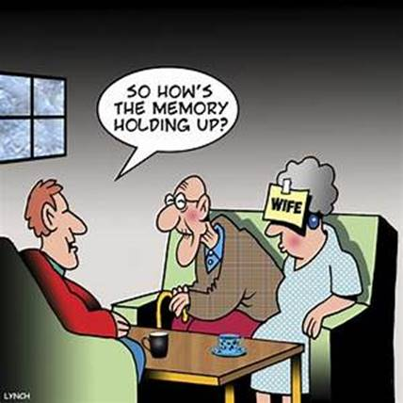

***Trivia Answer***

**ASW**: Anti-Submarine Warfare

**Upcoming Events of Interest**

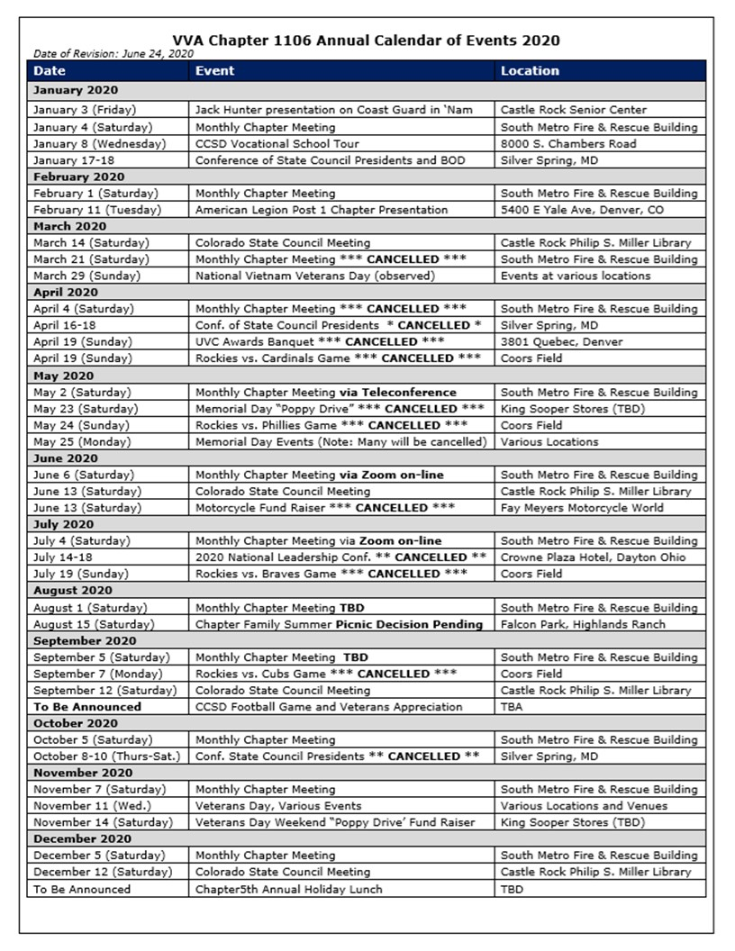

**FRIENDS OF CHAPTER 1106**

|  |  |
| --- | --- |
| **South Metro Denver Fire & Rescue**  9195 E Mineral Ave  Centennial, CO 80112 | **American Legion Post 1260**  **E:\Documents\ALP1187\images\AmericanLegion_logo.jpg** |
| **Spradlin Printing, Inc.**  11903 S. Parker Road Parker, CO 80134 |  |
| American Family Insurance  3989 E. Arapahoe Road #20  Centennial, CO 80122  720-361-0155 | A FULL-SIZE REPLICA OF THE HONOR BELL  **The Honor Bell Foundation**  PO Box 1432  Englewood CO 80150  720.282.9182  [www.honorbell.org](http://www.honorbell.org/) |
| 9137 E Mineral Cir Ste 100  Englewood, CO 80112-3422 | Logo of The Home Depot  **Home Depot Foundation**  8477 S Yosemite St  Lone Tree, CO 80124 |
| King Soopers logo.svg  King Soopers  9551 S. University Blvd., Highlands Ranch, CO 80126 | http://www.cruisin1430.com/sites/g/files/giy711/f/KEZW_Header_Large_Logo_0.png  **STUDIO 1430 Main Office:** 4700 South Syracuse Street, Suite 1050 Denver, CO 80237 |
| https://scontent.fapa1-2.fna.fbcdn.net/v/t31.0-8/10575197_682186265194110_4051472928662048560_o.jpg?oh=2630b186dcf3a20f1d7fc8fa25e0a5ba&oe=5A17C4AB  **Military Order of Purple Heart**, Chapter 1041, Arvada, CO | ZILLOW GROUP  10771 E. Easter Ave  Centennial CO 80112 |
| American Home Agents  Brian Karsh, Broker Associate  720-327-1562 | PARKER MEDICAL  SUPPLY STORE  9845 S Parker Rd  . Parker, CO 80134  303-840-4444 |