Inside this issue:
Notes from the President
Member Feature
Military Trivia
Guest Speaker
Membership
Board of Directors/Officers
Working Committees
Meetings/Events Calendar
Events
Books/Articles Published by Mbrs.
From the Editor
Light Side
Trivia Answer
Notice:
If you have moved or changed your address, PLEASE notify us immediately! Contact: Dale Creason, Membership Chair Email creason38sp@gmail.com
Phone: 303720-2948

COPYRIGHT NOTICE: In accordance with Title 17 U.S.C. Section 107, any copyrighted material in this newsletter is distributed under fair use without profit or payment to those who have expressed a prior interest in receiving the included information for nonprofit use and educational purposes only.
Facebook: Vietnam Veterans of America Chapter 1106


Editor’s Note:
This version of the newsletter is in Microsoft Document (.DOCX) format so that the links will work. Put your cursor over the link, depress your Control Key (ctrl) and depress your left mouse button and it will take you to the listed link position. PDF format, the links will not work.
The comments and editorial input do not necessarily reflect the opinion of the membership of our chapter. I would appreciate any feedback that you might have, items you liked or if you find offensive or derogatory in anyway. (bobrotruck73@gmail.com) Thank you for allowing me to be your editor.

Notes from the President - Dave Lyons:
We are in the “dog days” of Summer with warmer weather and longer daylight. Summer is a great time to get out and enjoy the outdoors. We have several activities I encourage you to attend. The Highlands Ranch Fourth of July parade is a time when our Chapter can participate in this annual patriotic event. This year we are fortunate to partner with the Central Colorado Corvette Club who will bring their cars as part of their “Vettes for Vets” program. You’ll have a chance to ride in one of these beautiful cars. No need to walk! However, you also have the option to walk if you wish. The parade route is a short one-mile course. The crowd is always appreciative of veterans. More information is in the forthcoming flyer.
The second outdoor activity is our annual summer picnic, scheduled for Saturday, August 12 at Falcon Park in Highlands Ranch. The Social Committee is working to make this another enjoyable event, with good food, activities, and fun. Come out and enjoy the food and fellowship. A flyer with information will be sent out to all members.
Finally, I encourage every veteran to participate in events that honor our veterans and active military. When the youth see how our Nation honors veterans, they are more likely to consider military service. So, it’s important that they see you! We’ll keep you informed of events that you can attend.
Thank you everyone for your continued support of Chapter 1106. Please continue to stay in touch with each other.

Member Feature
Jim Blumberg – U.S. Army – 1969-70, E-5. I was a Computer Operator (MOS -74E). After bootcamp I got orders to an Army school for computer training and then orders to Long Binh, Vietnam in 1970. My most memorable experience was my arrival and departure of Vietnam through Cam Ranh Bay. Arriving in country, I looked at the troops waiting to board our Freedom Bird plane. I was shocked that they all looked so old even though they may have been 1-2 years older than me. For me, waiting in line to board the Freedom Bird to go home, I looked at the troops deplaning, and I thought they all looked like high school students about to enter a war. I still see some of the faces and hope they made it back alive! I’m glad I finally joined our VVA Chapter. I really like that we are kept up to date on VA issues and I hope our chapter can continue doing the great things they are doing for us and all veterans.

Military Trivia
COB
Click here for end of the Newsletter Trivia Answer

May Guest Speaker – Brenda Standke, Regent, Toll Gate Creek Chapter DAR
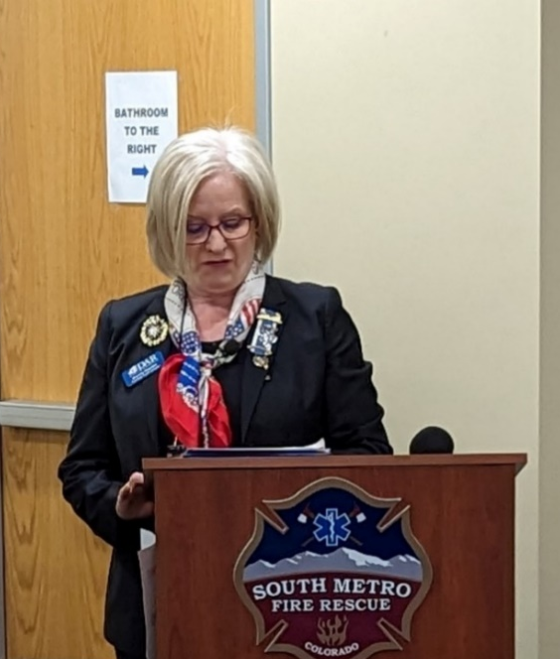
She thanked and praised our chapter members for our service to our country and continued service to our community veterans.
June Guest Speakers - Vieng Vongsakoun
We had two speakers at our June 3rd Membership meeting. The first was member Vieng Vongsakoun, Associate Member, Chapter 1106. Vieng was a combat medic who served in Iraq. He presented information on VA house loans and reverse mortgages. He emphasized the benefits of VA loans and reverse mortgages.
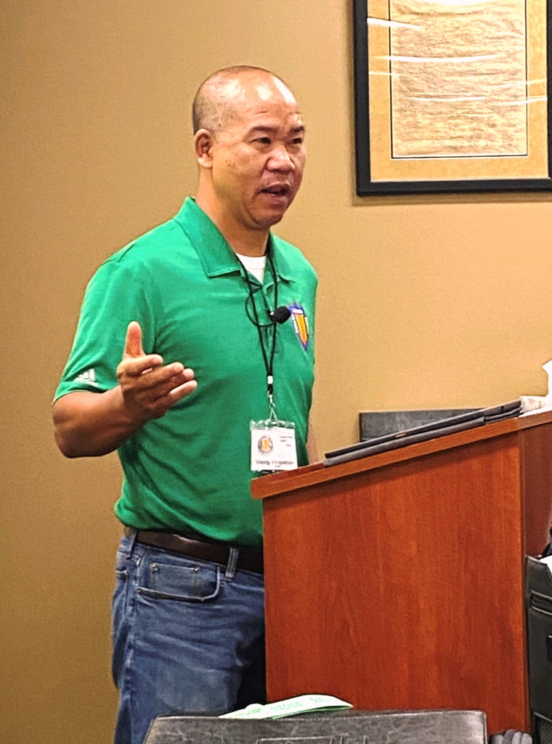
Vieng Vongsakoun, Member Chapter 1106

Second June Guest Speaker – Dan Strathman.
Dan is a former US Army Special Forces infantry solder and served four tours in Iraq. He spoke from personal experience regarding the journey back from traumatic brain injuries (TBI) and the accompanying PTSD issues. His wife (who could not be at the meeting) is Dr. Elizabeth Stevens, D.O., a Board-Certified Psychiatrist and a retired Air Force Major. She is the author of a book titled “UNSHACKLED.” Together they established a Christian ministry (Eden Psychiatry) to help veterans everywhere who suffer from TBI and PTSD to spread hope and support.
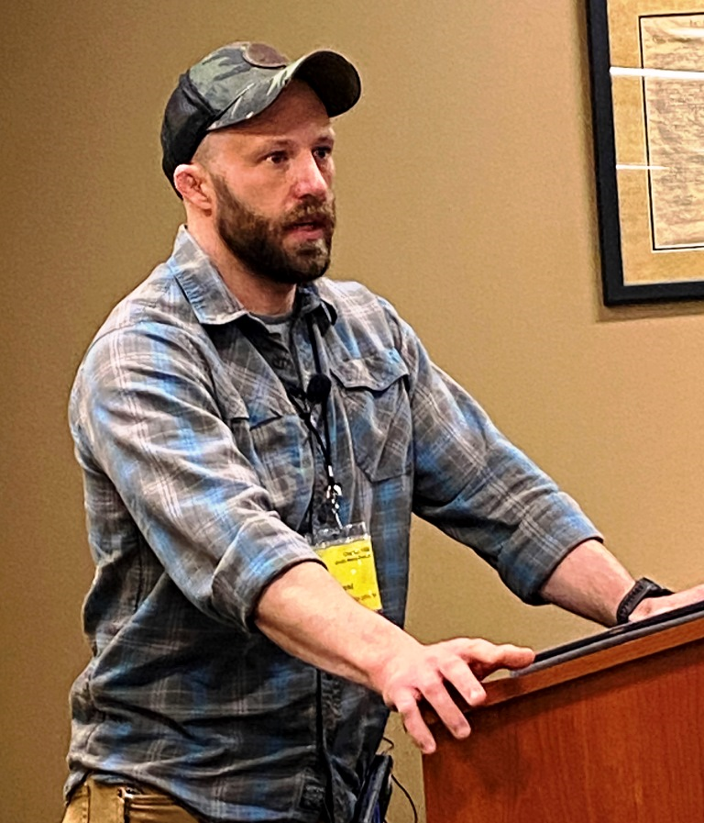
Dan Strathman

Membership! (As of /18/2023)
VVA 200
AVVA 44
TOTAL: 244
New Members:
Glen R. Struemph
John Polidori
Alan Ebert
James Ponzi
Christopher Cook
Randy Reed
Jim Blumberg
Craig Fargerness
James Dorrough
Glenn Mallory
Carol Brautigam
Pat Hammon
Wain Stowe
Elijah Mitchell
Byron Daniels
Rockie Cuppari
William Evans

Board of Directors/Officers
Dave Lyons – President
Milt Omoto – Vice-president
Mike Huber – Treasurer
Sally Eaves – Secretary
Board Members – Patti Ehline, Tom Werzyn, John Vargas, Joe Plant, Rev. Garry Turks, Joe Dempsey, Joseph Robinson.

Special Chapter Positions
AVVA Liaison to chapter Board of Directors – Litta Plant-Schaper
Chaplain – Rev. Garry Turks
Chapter Historian – John Vargas
Database/Audio – Jack Hunter
Government Affairs – Tony Nickerson
Sergeant-at-Arms – Dan Green
Chapter Nurse – Patti Ehline
Email Blaster – Bob Rotruck

Working Committees
- Agent Orange/PTSD: Patti Ehline
- Color Guard: Dale Creason (Command Sergeant),
- Ron Smith (Asst. Command Sergeant) , Don McNeely, Dan Green, Clarence Rebolledo, Harry Montgomery, John Sheadel,
- Event Coordinator: Joseph Robinson
- Fundraising/Grants: Milt Omoto – Chair
- Information Blaster – Bob Racetrack Rotruck
- Marketing/Media/Events: Tom Werzyn
- Membership: Dale Creason – Chair, Lee White, Litta Plant-Schaper (AVVA Roster Updates
- Memorial Committee: John Vargas-Chair. Garry Turks, Joe Plant, Lee White, Alan Jaffe, Milt Omoto
- Mental Health: Patti Ehline, Warren Harrison, Joe Plant
- Name Tags: Litta Plant-Schaper
- Newsletter Editor: Bob Rotruck
- Promotional Items: Leann Stelzer, Joe Dempsey, Ita Dempsey
- Refreshments: Walt Leuci, Dave Lyons
- Scholarship Program: Gary Weston, Chair, Jim Marcille, Litta Plant-Schaper, Mike Karsh (At-Large, Consultant)
- Social – Chairman – Vacant, Joe Plant, Tom Werzyn, and Litta Plant-Shaper
- Speakers Bureau Tom Werzyn – Chair, Bob Mallin, Dave Lyons
- Veteran Emergency Assistance: Joe Plant, Dave Lyons
- Voices for Veterans: Warren Harrison, Patti Ehline, Joe Plant
- Webmaster: Bob Rotruck
- Women Veterans: Patti Ehline

Meetings/Events Calendar – 2022
Jul 1, 2023 – VVA Chapter 1106 Membership Meeting
July 4, 2023 – Highlands Ranch Parade (Vetts for Vets)
Jul 29, 2023 – VVA Chapter 1106 Board Meeting
Aug 5, 2023 – VVA Chapter 1106 Membership Meeting
Aug 8-12,2023 – VVA National Convention, Orlando, FL
Aug 12, 2023 – Chapter Annual Summer Picnic
Aug 26, 2023 – VVA Chapter 1106 Board Meeting

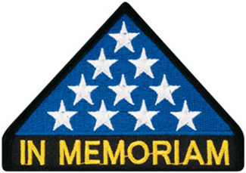
In Memoriam

As of: 4/19/2023
Total Funeral Homes Visited – 2,622
Cremains Found – 29,894
Veterans Cremains Identified – 6,344
Veterans Interred – 5,959

Events:
Vietnam Vets Commemoration Pin Presentation
At our May Membership meeting, representatives from the Daughters of the American Revolution (DAR) presented the Vietnam War Commemoration Pin and certificate to fifteen members. They also presented an Honorary Partner Distinction flag and certificate to President David Lyons for the Chapter. Attending were Brenda Standke, Regent, Toll Gate Creek Chapter DAR, Meaghan Sweeney, Vice Regent, Lynne Evans, National Chair, Myra Meverden, DAR Service to Veterans Chapter Chair, and Louetta Smith, DAR Service to Veterans Chair, Colorado State Society.
Commemoration Pin
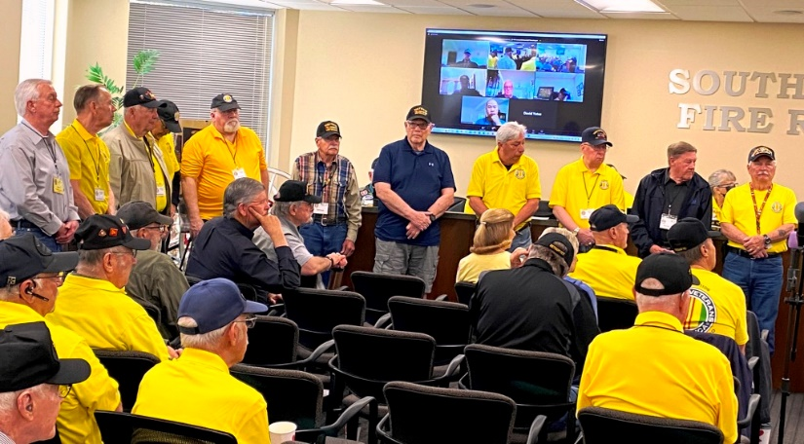
Recipients!

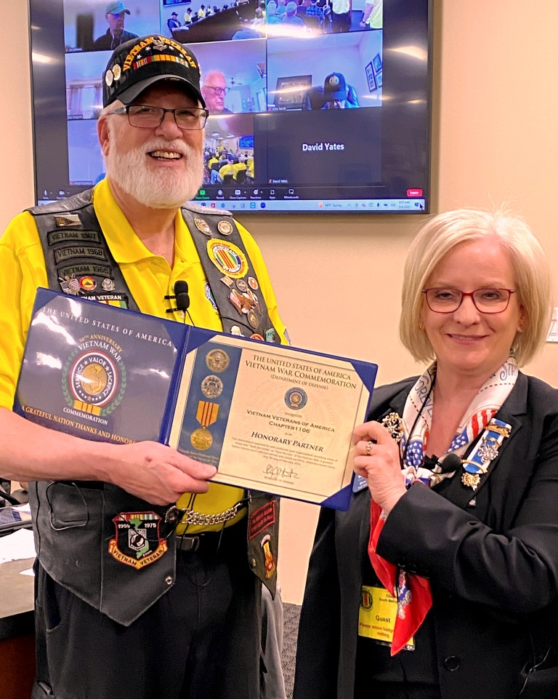
Presentation of the Commemoration Certificate
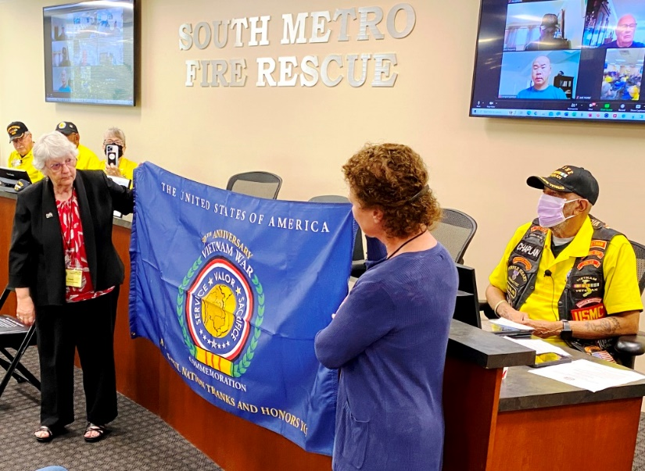
DAR representatives display the Commemoration flag presented to the Chapter

Member Bio
Chapter member, Bob Mallin presented his background, military experience and professional career as a medical doctor at our May Membership meeting. After graduating from medical school, he served in Vietnam as a field medical officer.
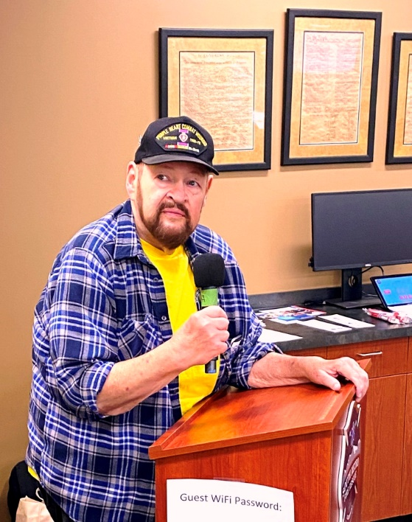
Dr. Bob Mallin at the podium!

Forgotten Heroes Campaign and VVA 1106
Submitted by John Vargas
The FHC, started by General Sal Valvano, recently deceased, and currently being chaired by Barry Fiore, have been true supporters of our 1106 Chapter. This is a list of the Veterans, from our Chapter alone, that they have interviewed, located missing medals/ribbons, and placed them into very artful shadow boxes. The Veteran receives the shadow box, a certificate, and a personal binder at a formal but individual presentation. This is at no cost to the veteran. All funds come from donations.

Warren Harrison Bob Easter
Gary Steinhoff Charles Smith
Jerome Springs Gary Weston
Mike Katich Alan Jaffe
Murray Sallenbach Barry Fiore
Leland Eagleson Mike Huber
Tom Werzyn Leo Greunke
Dan Green Ed Seiler
Jim Chisel Lew Woods
Dave Lyons *John Vargas
Joe Robinson Richard Lewis
*To be awarded.
Award ceremonies to take place on July 8, 2023.
Thank you to FHC Chair Barry Fiore and his Team for their on-going support to the Veterans’ community.

Arlington National Cemetery announces second Flowers of Remembrance Day
Arlington National Cemetery will hold its second Flowers of Remembrance Day, on Sunday, May 28, 2023, from 9 a.m. until 5 p.m. During the event, the public is invited to place a flower at the Tomb of the Unknown Soldier.
“We received such a tremendous response from the public during our inaugural Flowers of Remembrance Day event last year. We wanted to again allow our visitors the special opportunity to honor and respect the sacrifice of the Unknown Soldiers by placing flowers at the Tomb,” said Army National Military Cemeteries and Office of Army Cemeteries Executive Director Karen Durham-Aguilera in a release. Flowers of Remembrance Day pays homage to the first official, national Decoration Day, now known as Memorial Day. This ceremony first took place at Arlington National Cemetery on May 30, 1868, to honor U.S. service members who died in the Civil War. At 10 a.m. in the outdoor bowl of Memorial Amphitheater, ANC historians will offer a program on the history of Decoration Day/Memorial Day, this holiday’s importance to ANC and its connections to the Flowers of Remembrance Day event. Following the talk, they will lead an optional, supplemental walking tour to the James Tanner Amphitheater, the Tomb of the Civil War Unknowns and other locations related to the
official Decoration Day commemoration at ANC. No registration is necessary for participation. “Every day is Memorial Day at Arlington National Cemetery,” said Superintendent of Arlington National Cemetery Charles “Ray” Alexander, Jr. “This day will provide the American public the special opportunity to see this iconic memorial up close and to reflect on the service, valor and sacrifice it represents.” Flowers will be provided by the Memorial Day Flowers Foundation and visitors should not bring their own flowers. During this event, visitors will also have an opportunity to place a flower on headstones throughout the cemetery.

Motivating our Youth to Serve in the Military
Submitted by Milt Omoto
Currently, there are about 1.3 million active-duty personnel, or less than one-half of 1 percent of the U.S. population. Ronald Reagan once said, “Freedom is never more than one generation away from extinction. We didn’t pass it on to our children in the bloodstream. It must be fought for, protected, and handed on for them to do the same.”
In his book “Grateful American,” Gary Sinise states, “There is an unfortunate disconnect between most Americans and our military. Unless we have a family member or close friend who is serving, most of us go about our daily lives with little understanding of who is actually defending us.”
So how do we motivate our youth to serve? One way as Vietnam veterans is to attend and participate in events that recognize and honor veterans and active military. As Chapter President Dave Lyons states in his “Notes from the President” in this newsletter, we need to participate and be seen in events that honor veterans and active military. When the youth see how our Nation honors veterans, they are more likely to consider military service.
There are a number of events that honor veterans. Start by marching in this year’s Fourth of July parade. If you’ve never done so, you’ll be surprised at the enthusiastic appreciation that parade watchers along the route will bestow upon you! In addition, every year the Cherry Creek School District has their Veterans and Military Appreciation Community Celebration in the Fall. It’s a great event to interact with our youth. And, around Veterans Day, many schools invite veterans to their events. Ben Frankin Academy always invites veterans to their Veterans Day ceremony. Many other schools do the same around Veterans Day. Finally, the Chapter’s Speaker’s Bureau gives you the opportunity to share your military experience with school students.
So, get out and participate in these events. In a small way, you just might motivate a youth to consider joining the military. The Chapter Board will keep you apprised of these and other events throughout the year.
Also, check out our chapter members booklet. Author Bob Rotruck: "Why Serve". Some chapter members contributed to the contents of the booklet!

POW/MIA News
DPAA holds first honorable carry ceremony at Offutt since runway reopened!
The Defense POW/MIA Accounting Agency held its first honorable carry ceremony since the runway reopened April 4, 2023, at Offutt Air Force Base, Nebraska. An Alaska Air National Guard C-17 Globemaster delivered nine transfer cases containing the remains of World War II service members disinterred from an American cemetery in France and from excavation sites across Europe to the lab during the ceremony.
“It is humbling to think about the sacrifices these soldiers made, and I am proud to see the effort being made to reunite them with their families” said Rep. Mike Flood, who attended the event along with Nebraska Governor Jim Pillen and other local elected officials and base leadership. An honorable carry is a ceremony that pays tribute to the Unknown service members who are returning to American soil for the first time since their conflict-related death. The Agency laboratory will now begin the extensive process to identify the remains, which can take anywhere from a few months to several
years based on the state of the remains recovered. “DPAA appreciates the extensive support shown by the local community, the state of Nebraska and the base, not only for today’s ceremony, but also for our daily work in providing the fullest possible accounting of missing personnel from previous conflicts,” said Fern Sumpter Winbush, DPAA principal deputy director. An additional example of close community ties cited by DPAA Officials was the partnership with University of Nebraska-Lincoln for both research and field work, UNO College of Information Science and technology, and the UNMC School of Dentistry. The 33,000 square foot lab at Offutt has helped identify more than 500 service members since opening in 2013 and together with its partner lab in Hawaii have accounted more than 1,000 missing Americans since DPAA stood up in 2015.

Cherry Creek Innovation Campus (CCIC)
Military Service Celebration
Submitted by John Vargas – Chapter Attendee
Melissa Lyubenko sent me your information after talking with her today. We are happy to hear you were part of our celebration last weekend at the CCIC for our class of 2023 military enlistees. This was our third annual celebration. When we opened the CCIC in fall of 2019, we committed to recognizing our students for all pathways after high school. We saw a gap in recognition for our military-enlisting students. We worked with Larry Beer, Education Services Specialist from the Department of the Army, to organize this event for the spring of 2020. Unfortunately, as you know our schools and graduation ceremonies were impacted in the spring of 2020 by the pandemic. Fortunately, we were able to start this celebration in the spring of 2021 at our Stutler Bowl stadium and then move it to the CCIC in the spring of 2022. We are thrilled to have the support of all six branches of the military.

In Cherry Creek Schools, we have a long tradition of recognizing our active military service members and veterans throughout the year. This was the natural next step in recognizing our students as they made a military commitment at graduation. Let me know if you would like any additional information about this event. We hope to see you there every year to support our graduates.
Sarah L.C. Grobbel - Assistant Superintendent
Career, Innovation & Student Engagement
Career & Innovation and Performance Improvement
Instructional Support Facility
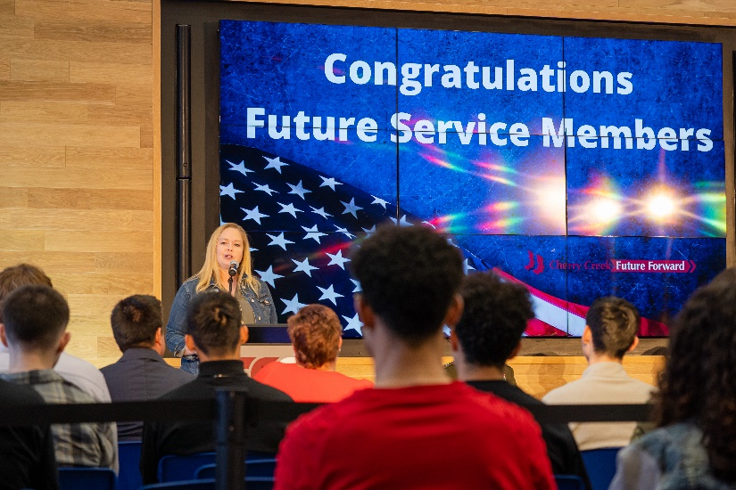
Presentation!
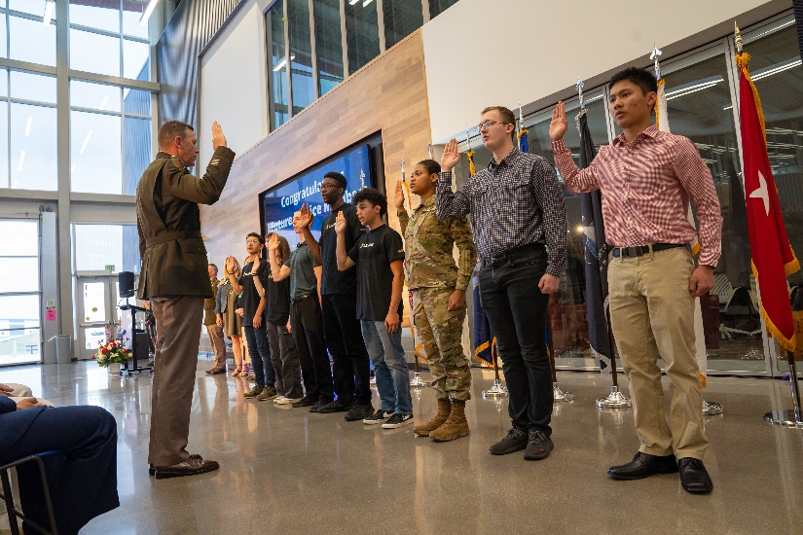
Swearing In Ceremony
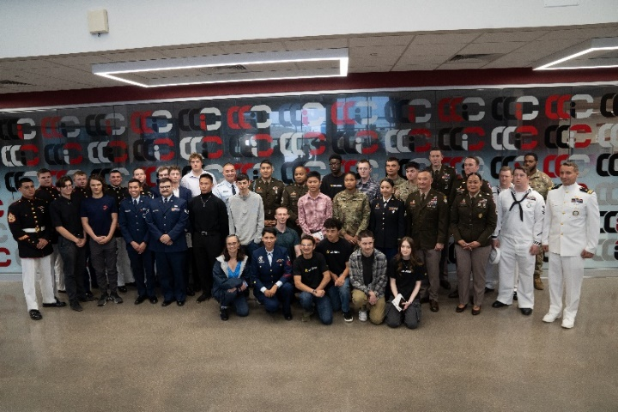
The entire ceremony group!

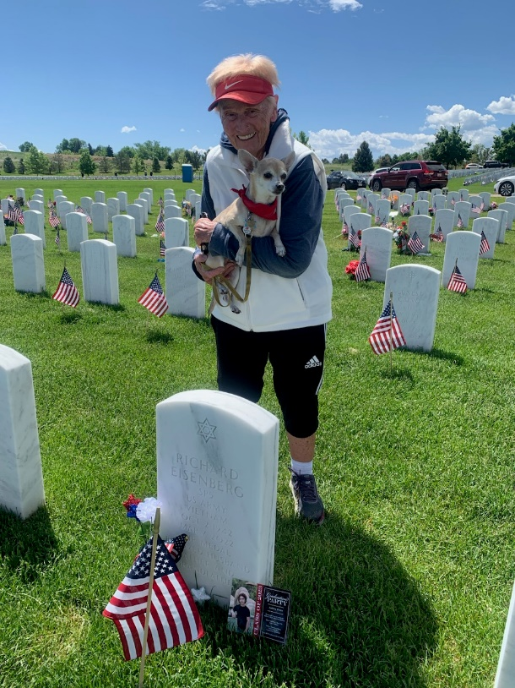
Jean Eisenberg paying homage to Richard Memorial Day weekend.

May Chapter Poppy Drive
Ron Smith LZ -1 $1,430.39
Joe Plant LZ-2 $1,353.72
Dave Lyons LZ-3 $1,141.00
Dale Creason LZ4 - $1,859.95
Coins – 7.44
Total – $5,792.50

Chapter’s Sock Drive Donation Delivery
Summitted by Milt Omoto
Chapter members John Vargas and Milt Omoto delivered socks that were generously donated by Chapter members to the Valor Point VA Domiciliary in Lakewood. The Socks were collected during the Chapter’s Fallen Heroes Sock Drive in early Spring, to honor those Chapter members who have passed. Valor Point is a Veterans Administration facility that provides temporary housing to homeless veterans. It is a satellite of Denver’s Veterans Affairs and is part of the continuum of care veterans have access to after their service is finished. Residents of the facility expressed their sincere appreciation and thanks for the socks. Thank you, Chapter members, for your kind donations!
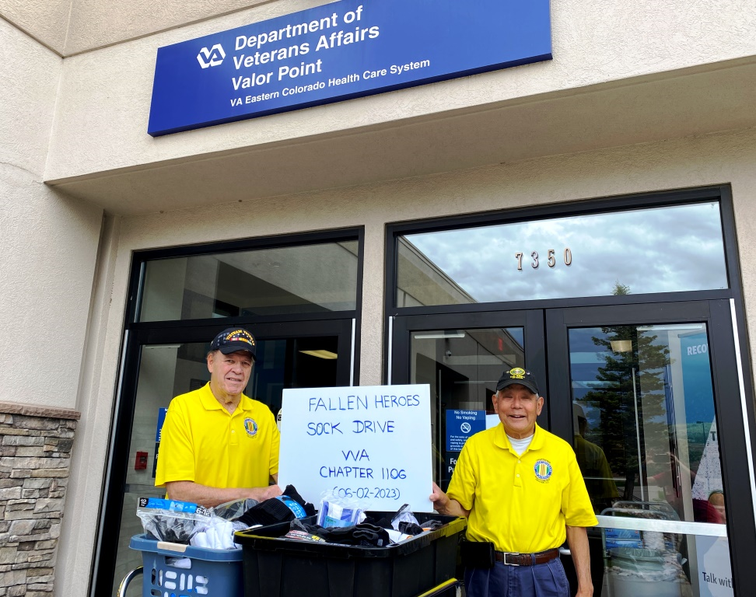
John and Milt in front of Valor Point

Scholarship Fund Donation
Summitted by Milt Omoto
The Jim Bishop family has consistently and generously donated $2,000 to the Chapter’s Scholarship Fund each year. We are grateful to Jim and his family. The check was presented to Gary Weston, Chairman of the Scholarship Committee at the June Membership meeting. Thank you, Jim!
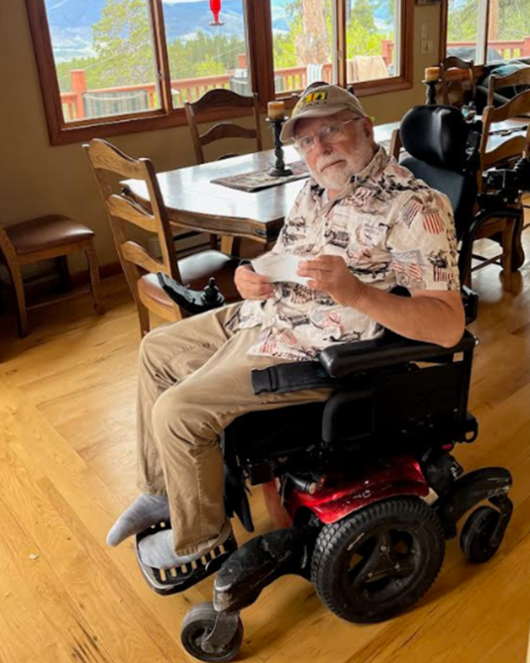
Jim Bishop, Member Chapter 1106
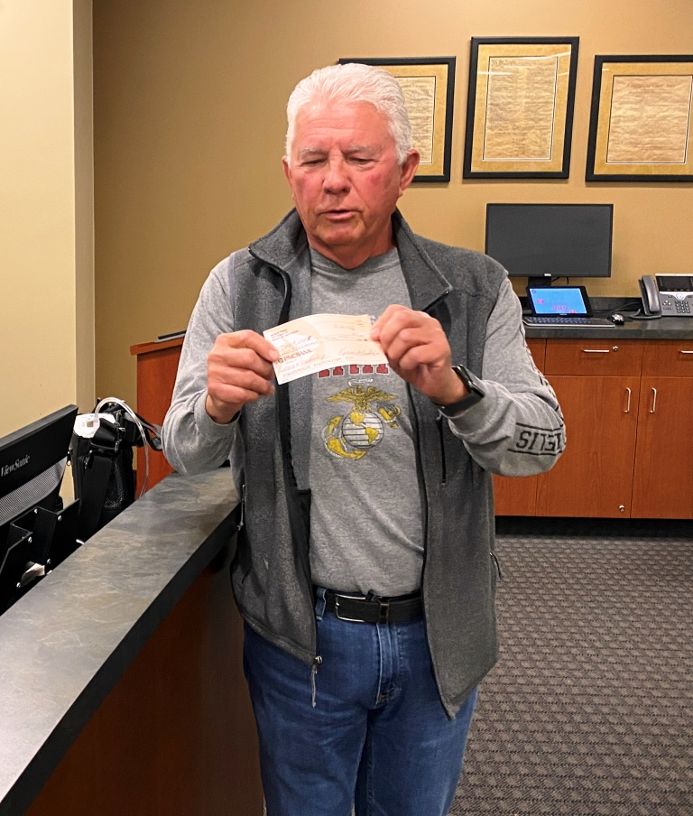
Gary Weston, Chair Scholarship Committee

Books/Articles
United State Marines
A former Sergeant in the Marine Corps took a new job as a high school teacher. Just before the school year started, he injured his back, and he was required to wear a plaster cast around the upper part of his body. Fortunately, the cast fit under his shirt and wasn’t noticeable. On the first day of class, he found himself assigned to the toughest students in the school. The smart punks, having already heard the new teacher was a former Marine, were leery of him and he knew they would be testing his discipline in the classroom. Walking confidently into the classroom, the new teacher opened the window wide and sat down at his desk. When a strong breeze made his tie flip, he picked up a stapler and stapled the tie to his chest.
Dead silence…… The rest of the year went smoothly!!!

The perils of vanity....
A 54-year-old woman had a heart attack and was taken to the hospital. While on the operating table she had a near death experience. Seeing God, she asked "Is my time up?" God said, "No, you have another 43 years, 2 months and 8 days to live." Upon recovery, the woman decided to stay in the hospital and have a face-lift, liposuction, breast implants and a tummy tuck. She even had someone come in and change her hair color and brighten and whiten her teeth! Since she had so much more time to live, she figured she might as well make the most of it. After her last operation, she was released from the hospital. While crossing the street on her way home, she was killed by an ambulance. Arriving in front of God, she demanded: What happened? "I thought you said I had another 43 years to live? Why didn't you pull me from out of the path of the ambulance?" God replied: "I didn't recognize you."
Submitted by John Vargas

Hilarious - Sad but True
Submitted by Joe Dempsey
1. When one door closes and another door opens, you are probably in prison.
2. To me, "drink responsibly" means don't spill it.
3. Age 60 might be the new 40, but 9:00 pm is the new midnight.
4. It's the start of a brand-new day, and I'm off like a herd of turtles.
5. The older I get, the earlier it gets late.
6. When I say, "The other day," I could be referring to any time between yesterday and 15 years ago.
7. I remember being able to get up without making sound effects.
8. I had my patience tested. I'm negative.
9. Remember, if you lose a sock in the dryer, it comes back as a Tupperware lid that doesn't fit any of your containers.
10. If you're sitting in public and a stranger takes the seat next to you, just stare straight ahead and say, "Did you bring the money?"
11. When you ask me what I am doing today, and I say "nothing," it does not mean I am free. It means I am doing nothing.
12. I finally got eight hours of sleep. It took me three days, but whatever.
13. I run like the winded.
14. I hate when a couple argues in public, and I missed the beginning and don't know whose side I'm on.
15. When someone asks what I did over the weekend, I squint and ask, "Why, what did you hear?"
16. When you do squats, are your knees supposed to sound like a goat chewing on an aluminum can stuffed with celery?
17. I don't mean to interrupt people. I just randomly remember things and get really excited.
18. When I ask for directions, please don't use words like "east."
19. Don't bother walking a mile in my shoes. That would be boring. Spend 30 seconds in my head. That'll freak you right out.
20. Sometimes, someone unexpected comes into your life out of nowhere, makes your heart race, and changes you forever. We call those people cops.
21. My luck is like a bald guy who just won a comb."

ARLINGTON CEMETERY
Submitted by Randy Reed
Jeopardy Question: On Jeopardy the other night, the final question was:
"How many steps does the guard take during his walk across the tomb of the Unknowns?"
All three contestants missed it!
This is really an awesome sight to watch if you've never had the chance.
Fascinating. Tomb of the Unknown Soldier
1. How many steps does the guard take during his walk across the tomb of the Unknowns and why?
21 steps: It alludes to the twenty-one-gun salute which is the highest honor given any military or foreign dignitary.
2. How long does he hesitate after his about face to begin his return walk and why?
21 seconds for the same reason as answer number 1.
3. Why are his gloves wet?
His gloves are moistened to prevent his losing his grip on the rifle.
4. Does he carry his rifle on the same shoulder all the time and, if not, why not?
He carries the rifle on the shoulder away from the tomb. After his march across the path, he executes an about face and moves the rifle to the outside shoulder.
5. How often are the guards changed?
Guards are changed every thirty minutes, twenty-four hours a day, 365 days a year.
6. What are the physical traits of the guard limited to?
For a person to apply for guard duty at the tomb, he must be between 5' 10' and 6' 2' tall and his waist size cannot exceed 30". They must commit 2 years of life to guard the tomb, live in a barracks under the tomb, and cannot drink any alcohol on or off duty for the rest of their lives. They cannot swear in public for the rest of their lives and cannot disgrace the uniform or the tomb in any way. After two years, the guard is given a wreath pin that is worn on their lapel signifying they served as guard of the tomb. There are only 400 presently worn. The guard must obey these rules for the rest of their lives or give up the wreath pin. The shoes are specially made with very thick soles to keep the heat and cold from their feet. There are metal heel plates that extend to the top of the shoe in order to make the loud click as they come to a halt. There are no wrinkles, folds, or lint on the uniform. Guards dress for duty in front of a full-length mirror.
The first six months of duty a guard cannot talk to anyone nor watch TV. All off duty time is spent studying the 175 notable people laid to rest in Arlington National Cemetery. A guard must memorize who they are and where they are interred. Among the notables are: President Taft, Joe Lewis (the boxer), Medal of Honor winner Audie L. Murphy, the most decorated soldier of WWII and of Hollywood fame. Every guard spends five hours a day getting his uniforms ready for guard duty.
ETERNAL REST GRANT THEM O LORD AND LET PERPETUAL LIGHT SHINE UPON THEM.
In 2003 as Hurricane Isabelle was approaching Washington, DC, our US Senate/House took 2 days off with anticipation of the storm. On the ABC evening news, it was reported that because of the dangers from the hurricane, the military members assigned the duty of guarding the Tomb of the Unknown Soldier were given permission to suspend the assignment. They respectfully declined the offer, "No way, Sir!" Soaked to the skin, marching in the pelting rain of a tropical storm, they said that guarding the Tomb was not just an assignment, it was the highest honor that can be afforded to a service person. The tomb has been patrolled continuously, 24/7, since 1930.
God Bless and keep them.

Tears
Moms and dads have so many tears,
Their child has volunteered, creating fears.
They took an oath to defend,
Swearing they will never bend.
They depart wearing a uniform so proud,
Their parents want to proclaim it out loud.
My child has made a life changing step,
Why is my heart in such a terrible fret?
To see them wave goodbye with such pride,
They chose for our country and did not hide.
Off they go to a foreign land filled with hate,
To offer hope to those that seek freedom’s gate.
Most will come home declaring they did their best,
But a few come home to lay their body at rest.
And moms and dads watch the flag covered casket,
Tears flow down their cheeks that would fill a basket.
Their son or daughter has given all,
Parents have thousands of tears that fall.
Why did our child have to volunteer?
We wanted to see them come home to cheer!
But they sit and listen to Taps played in the rain,
And the grief in their hearts gives them much pain.
For to serve their country their child did chose,
Never for a moment considering they might lose.
And for the remainder of a parent’s life,
Tears will be a daily part of their strife.
God bless our children who serve,
Please God give them the peace they deserve.
AMEN!
ROTRUCK – ‘15





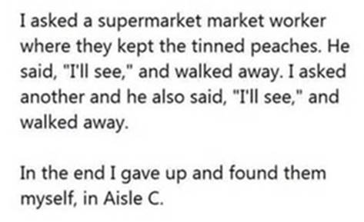

















Trivia Answer
COB -- Chief of the Boat. The senior chief petty officer on board a ship.
Upcoming Events of Interest
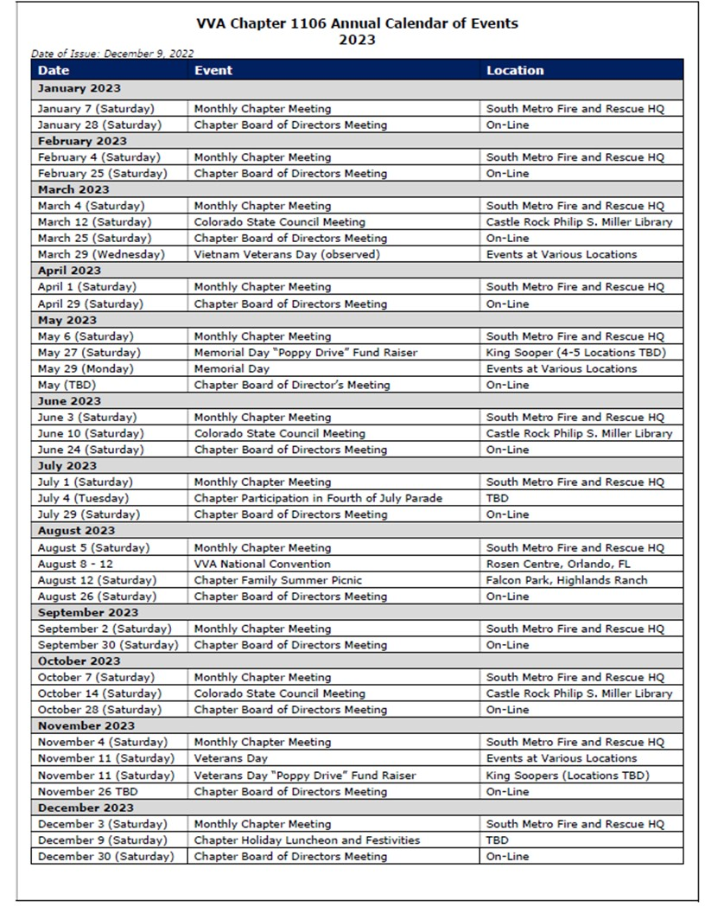

FRIENDS OF CHAPTER 1106
  South Metro Denver Fire & Rescue  9195 E Mineral Ave  Centennial, CO 80112 | 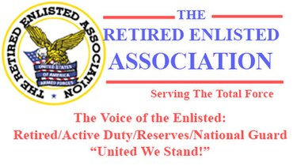  TREA: The Enlisted Association - HQ  Phone - (303) 752-0660  12200 E. Briarwood Avenue, Suite 250, Centennial CO 80112
  Spradlin Printing, Inc.  11903 S. Parker Road  Parker, CO 80134 |   Alycia Carmin  PO Box 233  Kersey, CO 80644  (970) 352 8802
  3989 E. Arapahoe Road #20  Centennial, CO 80122  720-361-0155 | 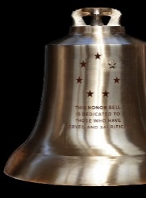  The Honor Bell Foundation  PO Box 1432  Englewood CO 80150  720.282.9182  www.honorbell.org
  9137 E Mineral Cir Ste 100  Englewood, CO 80112-3422 |   
  King Soopers  9551 S. University Blvd., Highlands Ranch, CO 80126 |   Qualified Listeners:  PO Box 563  Dacono, CO 80514  Tel: 720-600-0860
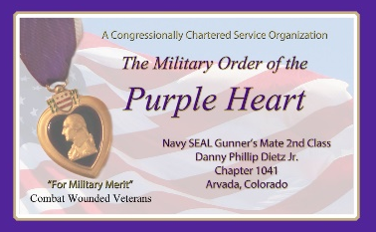  Military Order of Purple Heart, Chapter 1041, Arvada, CO | CHERRY CREEK SCHOOL DISTRICT    4700 South Yosemite Street  Greenwood Village, CO 80111
  President  Dale Goulette  cell 303-547-7850  2212 Diamond Creek Drive, Colorado Springs, CO, 80921  dalegoulette@rockymountainhonorflight.org |   PARKER MEDICAL  SUPPLY STORE  9845 S Parker Rd  . Parker, CO 80134  303-840-4444


ERC Management, LLC
791 Southpark Dr., Suite 600
Littleton, CO 80120
720.328.3299
www.FreddysUSA.com

Texas Roadhouse
11205 S. Parker Road, Parker, CO 80134

THANK YOU FOR
REACHING OUT AND
HELPING VETERANS

