**Inside this issue:**

Notes from the President

[Member Feature](#Memberfeature)

[Military Trivia](#Militarytrivia)

[Guest Speaker](#Guestspeaker)

[Membership](#Membership)

[Board of Directors/Officers](#Boardofdirectors)

[Working Committees](#Workingcommittees)

[Meetings/Events Calendar](#Meetingsevents)

[Announcement Corner](#Announcementcorner)

[Books/Articles Published by Mbrs.](#Booksarticles)

[From the Editor](#Fromtheeditor)

[Light Side](#Lightside)

[Trivia Answer](#Triviaanswer)

**Notice:**

If you have moved or changed your address, PLEASE notify us immediately! Contact: Dave Lyons, Membership Chair

E-mail: [Snoyldavid@centurylink.net](mailto:Snoyldavid@centurylink.net)

Phone:  303 690 8776

###### COPYRIGHT NOTICE: In accordance with Title 17 U.S.C. Section 107, any copyrighted material in this newsletter is distributed under fair use without profit or payment to those who have expressed a prior interest in receiving the included information for nonprofit use and educational purposes only.

**Facebook: Vietnam Veterans of America Chapter 1106**

**HAPPY EASTER**

******

***Editor’s Note:***

This version of the newsletter is in Microsoft Document (.DOCX) format so that the links will work. Put your cursor over the link, depress your Control Key (ctrl) and depress your left mouse button and it will take you to the listed link position. PDF format, the links will not work.

The comments and editorial input does not necessarily reflect the opinion of the membership of our chapter. I would appreciate any feedback that you might have, items you liked or if you find offensive or derogatory in anyway. ([bobrotruck73@gmail.com](mailto:bobrotruck73@gmail.com)) Thank you for allowing me to be your editor.

***Notes from the President***

Lee White

March 2020 holds a very special day for all Vietnam Veterans. Sunday, March 29, 2020 is National Vietnam Veterans Day.

Our VVA Chapter 1106 will hold a special ceremony at our March 21, 2020 membership meeting. “Vietnam War Commemoration Awards presentation” to recognize Vietnam Veterans for their service.

A special Vietnam commemoration lapel pin will be presented in a dignified manner to each Vietnam veteran. (Please see flyer attached to our newsletter)

News flash – VVA Chapter 1106 has an opportunity to host “the Wall that Heals” in 2021. Stay tuned.

***“Member Feature”***

Gary Weston – HM3, USN – 1968-72, Hospital Corpsman – NEC - 8404 Field Medical Technician. I joined the Navy because I thought that living aboard a ship would provide a clean safe working environment while serving my country in the medical field. Little did I know that after completing basic Hospital Corp School, I would be sent to Field Medical School at Camp Pendleton for special training as a combat corpsman to serve the Marine Corps. Upon completion of my training at Camp Pendleton I was attached to the Balboa Naval Hospital in San Diego. My next assignment was to the Fleet Marine Force, Hotel Company, Second Battalion, 7th Marine Regiment as a combat corpsman in Vietnam in 1969-1970. Upon my return from Vietnam I was stationed at the Naval Weapons Test Center, China Lake, CA. My most memorable experience; my time and service to the Marine Corps. I earned the Navy Achievement Medal with Combat Distinguishing Device. Chapter 1106 has given me much insight in navigating through the VA System.

***Military Trivia***

**BTDTBTTS.** [Click here for end of the Newsletter Trivia Answer](#Triviaanswer)

***Guest of Honor – January***

**Quilts of Valor**

Alycia Carmin, Colorado Coordinator for the Quilts of Valor Foundation made another presentation of quilts with the help of her husband and Dave Lyons. She spoke briefly about the wonderful work being done to honor and help veterans. The mission of the Quilts of Valor Foundation is to cover service members and veterans touched by war with comforting and healing Quilts of Valor. Quilts of Valor Foundation began in 2003 with a dream, literally a dream. Founder Catherine Roberts’ son Nat was deployed in Iraq.

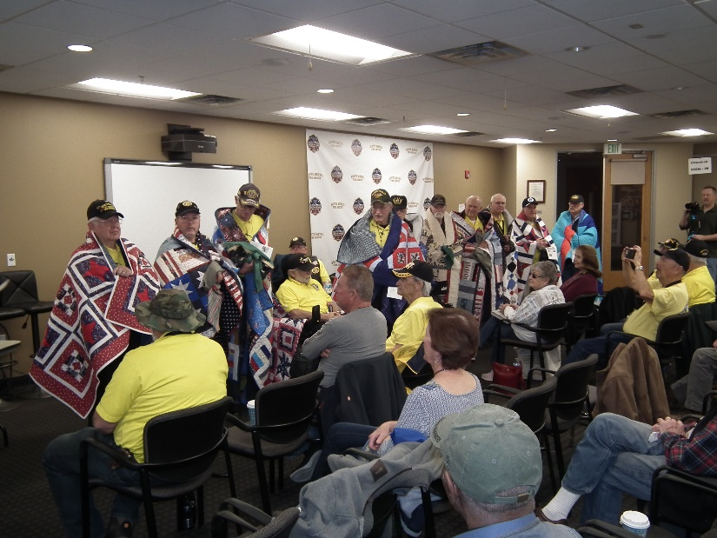

L/R: Tom Werzyn, Robert Crago, Marvin Lich, Jim Bishop, Mike Huber, Bob Lee, Roger Lanphier, Dan Graham, Joe Dempsey, Cliff Butler, Bruce Arndt

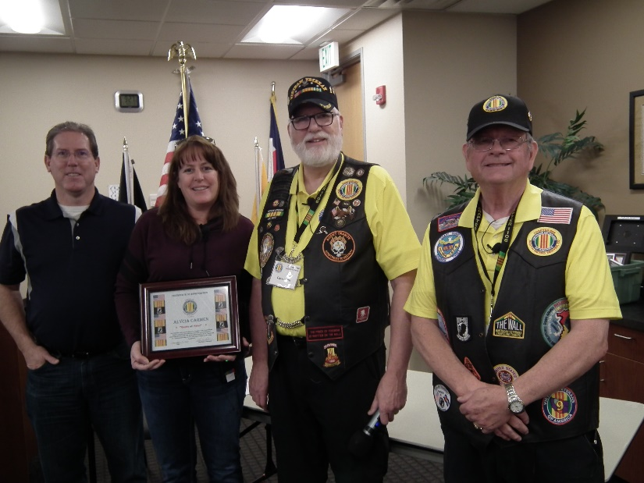

Certificate of Appreciation was awarded to Alicia by Dave Lyons and Lee White

***Special Speaker – February***

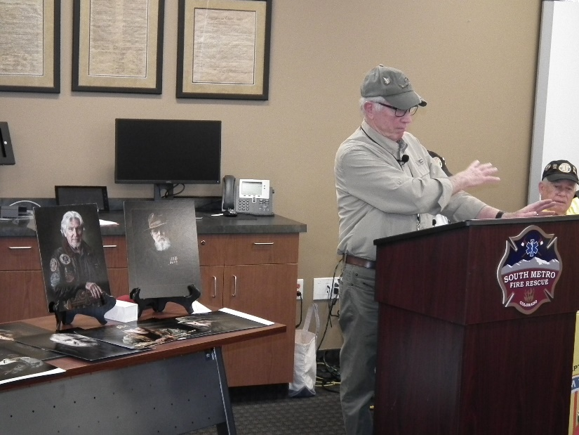

Cliff Lawson, Vietnam Vet, Huey Pilot, and Photographer. The Veterans Project includes vets from WWII up through recent, but mainly the WWII, Korea, and Vietnam era. Here is a sample of one of Cliff’s veteran photos.

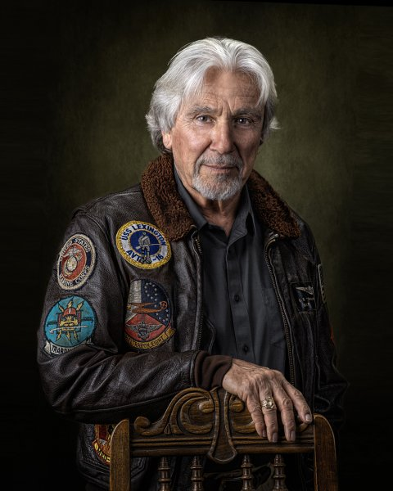

**January Bio Speaker – Richard Lewis (the rest of the story).**

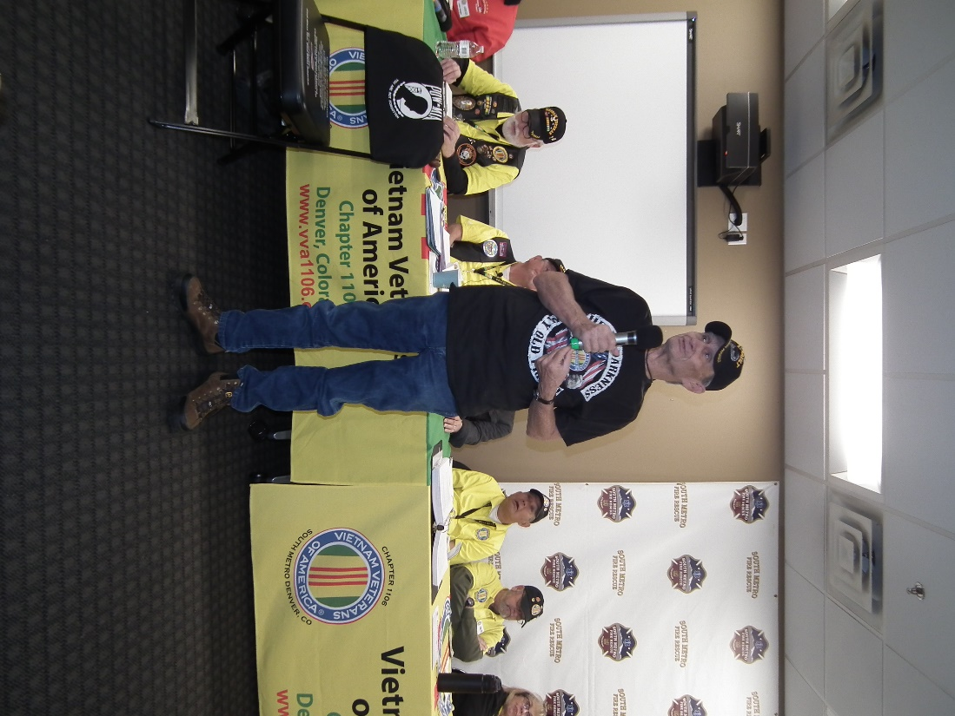

**February Bio Speaker – Jim Henderson**

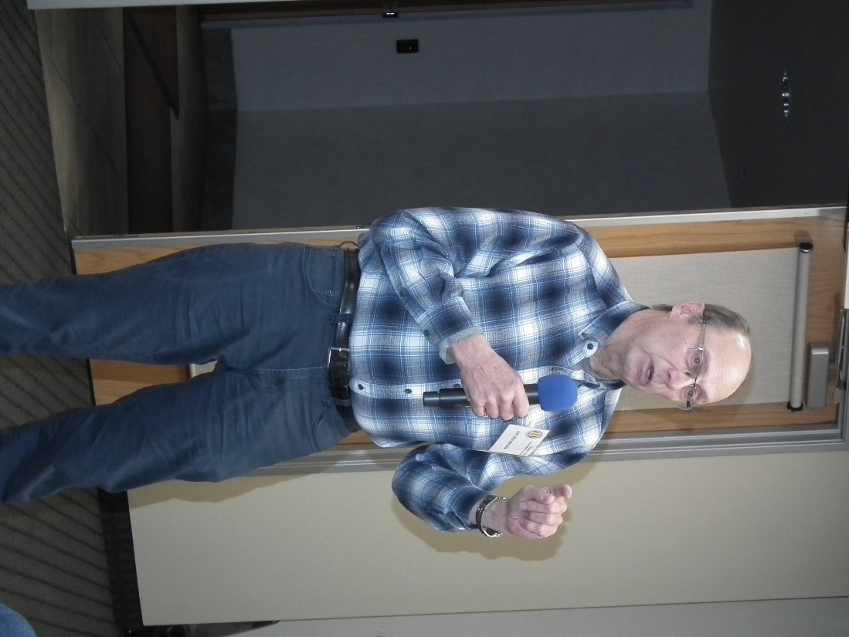

Jim Henderson, Corporal, US Army July 30, 1968 to June 1, 1970. Served in Vietnam from September 1969 to late May 1970. MOS: scout dog handler. One of my more memorable service experiences was my trip to and introduction to Vietnam. As a scout dog handler I worked with one dog - a German shepherd named Loki. Our mission was to find booby traps and ambushes before it was “too late”. A half dozen other scout dog handlers and I were ordered to take 50 trained scout dogs to Vietnam. We were all loaded into the back of a C-5 air transport. We flew from Fort Benning, Georgia to Dover, Delaware to Anchorage, Alaska, to Osaka, Japan and finally to Bien Hoa, Vietnam.

Editor’s note: Jim was our dog sitter over the holidays and was wonderful. Now I know why!!

**Special Presentation for the Honor Bell**

Shirley Patenaude and family in honor of her father, presented a $1,000 check to the Honor Bell Foundation for the wonderful ceremony provided for her Veteran Father, John R. Smith. The check was presented to Heidi Olivera, Honor Bell Board Member.

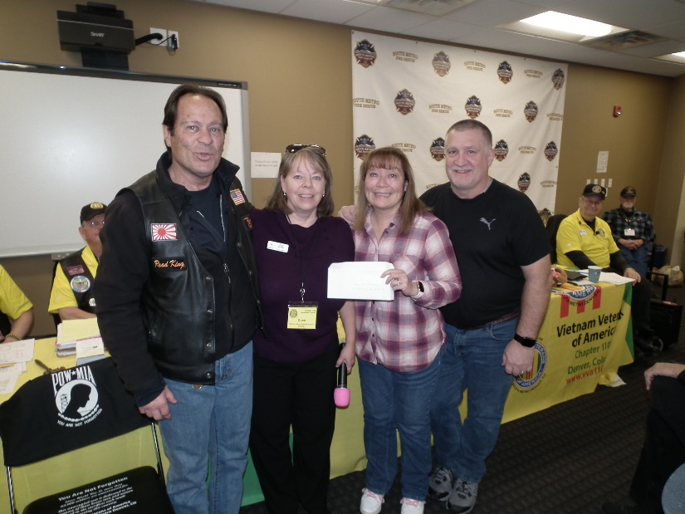

L/R: Ted Patenaude, Heidi Olivera, Shirley Patenaude, Alan Smith (brother)

***Membership!*** (As of 2-17-20)

VVA 149

AVVA 38

Total: 187

Welcome New Members:

**VVA**

Jerome Springs

Alexander Brown

Alan Jaffe

Jim Bishop

Doug Frasher

Fleet Lentz

Jon Miller

**AVVA**

Ita Dempsey

Rebecca Webb

***Board of Directors/Officers***

Lee White - President

Dave Lyons - Vice-president

Joe Plant – Treasurer (need volunteer replacement)

Glen Payne - Secretary

Board Members - Milt Omoto, Patti Ehline, Dave Lyons, Tom Werzyn, Ron Smith, John Vargas, Dan Green

***Special Chapter Positions***

AVVA Liaison to chapter Board of Directors - Litta Plant-Schaper

Chaplain – Rev. Garry Turks

Government Affairs – Tony Nickerson

Sergeant-at-Arms – Rob Senatore

***Working Committees***

* Agent Orange/PTSD – Patti Ehline
* Color Guard – Jay Quiring (Command Sergeant), Don McNeely, Dan Green, Thom Frey, Clarence Rebolledo, Robert Senatore, Tony Nickerson, Ron Smith, Leann Stelzer, Alexis Winemiller
* Event Coordinator – Ron Smith – Chair, Lee White, Michelle Mallin
* Fundraising/Grants – Milt Omoto
* Marketing/Media/Events – Tom Werzyn, Michelle Mallin
* Membership – Dave Lyons – Chair, Lee White
* Mental Health: Patti Ehline, Warren Harrison, Joe Plant
* Name Tags – Litta Plant-Schaper
* Newsletter Editor - Bob Rotruck
* Promotional Items: Leann Stelzer, Clarence Rebolledo
* Refreshments: Alexis Winemiller, Jason Longmore
* Scholarship Program - Jim Marcille, Chairs, Glen Payne, (supporter) John Vargas, Brian Karsh (supporter), Bob Mallin (supporter)
* Social –Barry Fiore, Glen Payne, Milt Omoto, Mike Karsh, John Vargas
* Speakers Bureau – Tom Werzyn – Chair, Bob Easter, Bob Mallin, Glen Payne, Roger Lanphier, Donna Chaney
* Veteran Emergency Assistance Committee - Joe Plant, Dave Lyons, Dan Green, Bruce Arndt, Lee White
* Voices for Veterans - Warren Harrison
* Webmaster – Bob Rotruck
* Women Veterans - Patti Ehline

**Meetings/Events Calendar - 2020**

March 14, 2020 - CO State Council Meeting - Castle Rock

March 21, 2020 - Chapter 1106 Monthly Membership Meeting

March 29, 2020 - Vietnam War Veterans Day

April 4, 2020 - Chapter 1106 Monthly Membership Meeting

April 16-18, 2020 Conference of State Council Presidents - Silver Spring, MD

April 19, 2020 - United Veterans Coalition Banquet - Denver

April 19, 2020 - Rockies vs Cardinals Baseball

May 2, 2020 - Chapter 1106 Monthly Membership Meeting

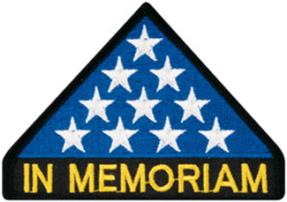

***In Memoriam***

Plaque dedicating Charles Kelly Boulevard in front of the Fitzsimons Building, University of Colorado Anschutz Medical Campus, School of Medicine, Aurora CO.

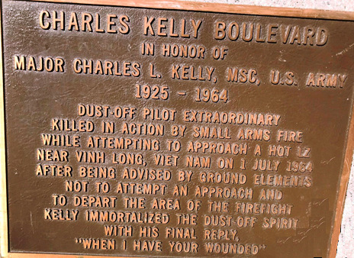

Submitted by: Milt Omoto



As of: 2/17/2020

Total Funeral Homes Visited - 2,392

Cremains Found – 20,250

Veterans Cremains Identified - 4,630

Veterans Interred – 4,277

***Events:***

**A Great Christmas Story**

Submitted by: Dan Green

It started last Christmas, when Bennett and Vivian Levin were overwhelmed by sadness while listening to radio reports of injured American troops. "We have to let them know we care," Vivian told Bennett. So they organized a trip to bring soldiers from Walter Reed Nation Military Medical Center, in Bethesda, MD to the annual Army-Navy football game in Philly, on December 14, 2019.

The cool part is, they created their own train line to do it. Yes, there are people in this country who actually own real trains and Bennett Levin, a native Philly guy and a self-made millionaire is one of them. He has three luxury rail cars. Think mahogany paneling, plush seating and white-linen dining areas. He also has two locomotives, which he stores at his Juniata Park train yard. One car, the elegant Pennsylvania, carried John F. Kennedy to the Army-Navy game in 1961 and '62. Later, it carried his brother, Bobby's body to D.C. for burial. "That's a lot of history for one car," says Bennett. He and Vivian wanted to revive a tradition that endured from 1936 to 1975, during which trains carried Army-Navy spectators from around the country directly to the stadium where the annual game is played. The Levin’s could think of no better passengers to reinstate the ceremonial ride than the wounded men and women recovering at Walter Reed in D.C. and Bethesda, in Maryland. "We wanted to give them a first-class experience," says Bennett. "Gourmet meals on board, private transportation from the train to the stadium, perfect seats – real hero treatment."

Through the Army War College Foundation, of which he is a trustee, Bennett met with Walter Reed's commanding general, who loved the idea. But Bennett had some ground rules first, all designed to keep the focus on the troops alone:

No press on the trip, lest the soldiers' day of pampering devolve into a media circus.

No politicians either, because, says Bennett, "I didn't want some idiot making this trip into a campaign photo op" and no Pentagon suits on board, otherwise the soldiers would be too busy saluting superiors to relax.

The general agreed to the conditions, and Bennett realized he had a problem on his hands. "I had to actually make this thing happen," he laughs. Over the next months, he recruited owners of 15 other sumptuous rail cars from around the country into lending their vehicles for the day (these people tend to know each other). The name of their temporary train? The Liberty Limited. Amtrak volunteered to transport the cars to D.C. – where they'd be coupled together for the round-trip ride to Philly – then back to their owners later. Conrail offered to service the Liberty while it was in Philly. And SEPTA drivers would bus the disabled soldiers 200 yards from the train to Lincoln Financial Field, for the game. A benefactor from the War College ponied up 100 seats to the game – on the 50-yard line – and lunch in a hospitality suite. And corporate donors filled, for free and without asking for publicity, goodie bags for attendees.

From Woolrich, stadium blankets,

From Wal-Mart, digital cameras,

From Nikon, field glasses, and

From GEAR, down jackets.

There was booty not just for the soldiers, but for their guests, too, since each was allowed to bring a friend or family member. The Marines, though, declined the offer. "They voted not to take guests with them, so they could take more Marines," says Levin, choking up at the memory.

Bennett's an emotional guy, so he was worried about how he'd react to meeting the 88 troops and guests at D.C.'s Union Station, where the trip originated. Some GIs were missing limbs. Others were wheelchair-bound or accompanied by medical personnel for the day. "They made it easy to be with them," he says. "They were all smiles on the ride to Philly. Not an ounce of self-pity from any of them. They're so full of life and determination."

At the stadium, the troops reveled in the game, recalls Bennett. Not even Army's lopsided loss to Navy could deflate the group's rollicking mood. Afterward, it was back to the train and yet another gourmet meal – heroes get hungry, says Levin – before returning to Walter Reed and Bethesda. "The day was spectacular," says Levin.

It was all about these kids. It was awesome to be part of it."

The most poignant moment for the Levin’s was when 11 Marines hugged them goodbye, then sang them the Marine Hymn on the platform at Union Station. One of the guys was blind, but he said, “I can't see you, but man, you must be beautiful!” says Bennett. "I got a lump so big in my throat, I couldn't even answer him."

It's been three weeks, but the Levin’s and their guests are still feeling the day's love. "My Christmas came early," says Levin, who is Jewish and who loves the Christmas season. "I can't describe the feeling in the air." Maybe it was hope. As one guest wrote in a thank-you note to Bennett and Vivian, "The fond memories generated last Saturday will sustain us all – whatever the future may bring."

God bless the Levin’s ... and God bless the troops, every single one.

**Veterans Day – Elks Club – Chapter Color Guard**

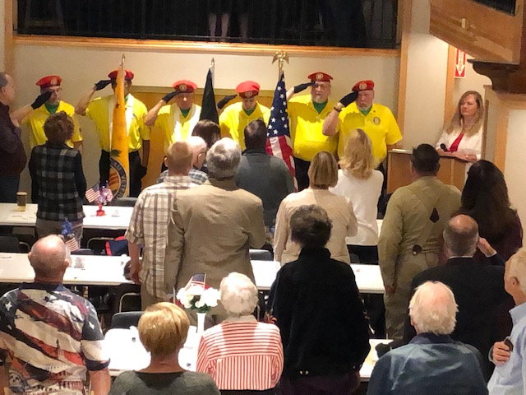

(Editor: I forgot to post this picture provided by Ron Smith in 2019)

**Christmas Party Appreciation**

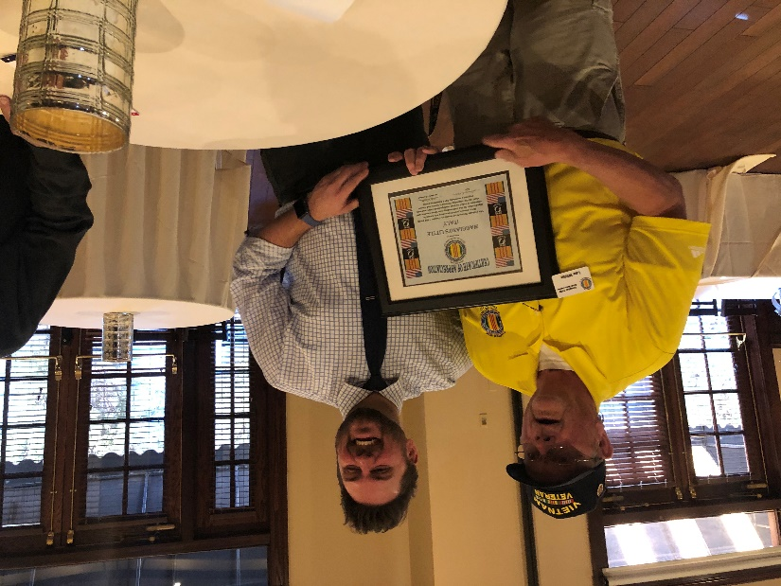

Lee White presenting Bradley Runtas, Maggiano’s Sales Mgr, with a VVA 1106 Certificate of Appreciation.

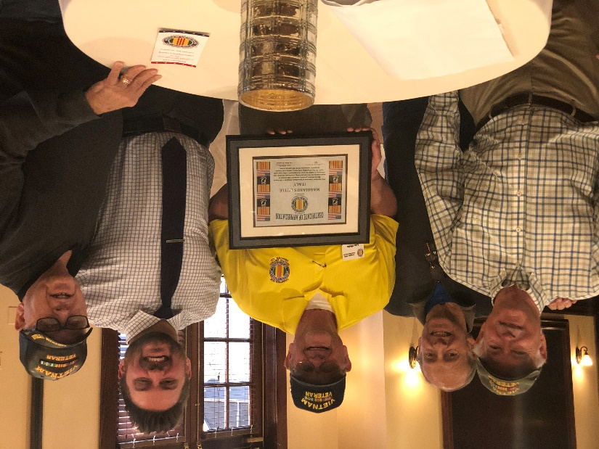

Representing our Social Committee is Glen Payne, Jim Marcille and Mike Karsh. This took place on January 6, at Maggiano’s Little Italy.

**A wee bit o’Irish from Tom Werzyn**

Flyer announcing a new chapter of Irish Veterans, to be opened in Rhode Island...

Submitted as an info item - with possible mention in next newsletter, maybe? At any rate, those of us wit'a wee bit'a blood line from the ol'sod might at least like to be aware that the IRISH ARE COMING!!!

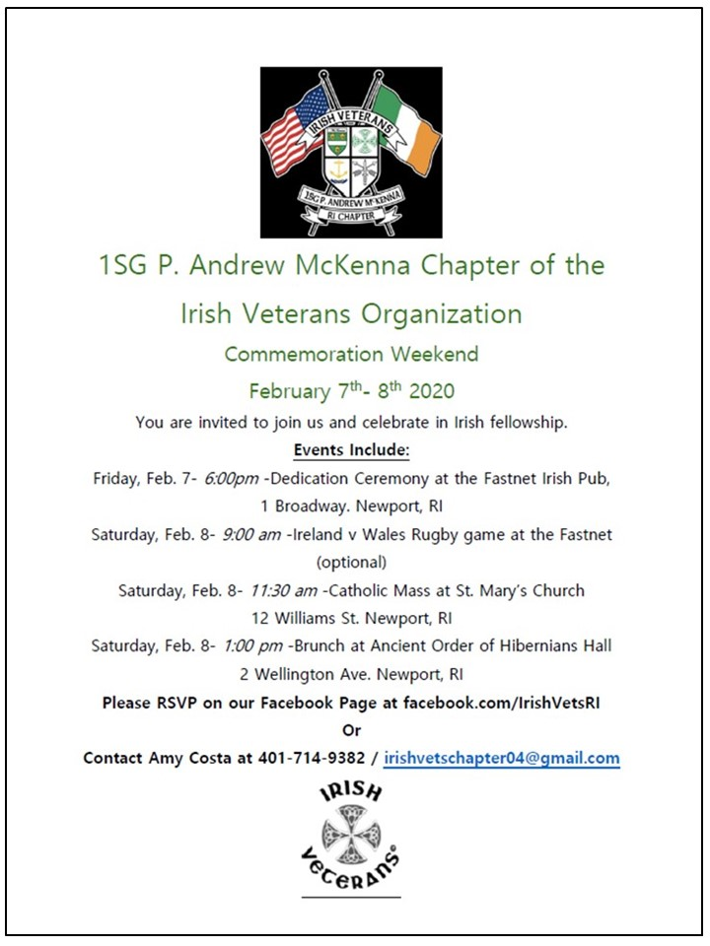

***Books/Articles Published by Members***

**More NARA Info**

Tom Werzyn spoke about the **National Archives and Records Administration** at the December meeting and how easy it is to research your personnel records or search for others. Here is more additional info:

**National Archives and Records Administration**

* National Personnel Records Center
* Records held here and available for search
* Official Military Personnel Folders - OMPF’s
* Service Treatment Records - STR’s

Out-patient & Treatment Records for Dependents & Retirees

* Draft Registration Cards
* Deceased Personnel Files
* Organizational Records -
* Morning Reports, Unit Rosters, etc.
* Clinical (Hospital) Records
* Pay Vouchers
* Auxiliary Records
* Electronic Records
* Archival Records

Military and civilian records are presently being held in separate facilities

* Nara programs
* Archival Preservation
* Records Management
* Information Security Oversight
* National Declassification

Government Information Services

THINGS WE CAN ACCOMPLISH WITH A SEARCH

* Replacement Medals
* Correction/Copies of Records – i.e. DD-214, etc.
* Emergency Requests – i.e. funerals, etc.
* Historical Searches

1973 Fire at St. Louis Facility

80% loss of Army records – 1912 thru 1960

75% loss of Airforce records – 1947 thru 1964 - (Hubbard to Z)

Records are being held for all five service branches here at the national archives. VA claim records are also being held in archives. Typical turn-around time for a standard, researchable E-mail request is about 10 working days. All of this can be accessed thru: <archives.gov>

There are boxes, drop-downs and prompts to take you directly to most all of your needs and search requirements …

Customer Service for NPRC: Phone: 314-801-0800

For Burials – Fax request to: Fax: 314-801-0764

Urgent/Emergency Requests for Records: Phone: 314-801-0800, Fax: 314-801 0764

NARA Presenter was: Scott Levin, 314-801-0587; if you call him, Reference his presentation to VVA National Convention in Seattle, WA 7/20/2019, scott.levins@nara.gov

Archival Records are Subject to Public Access. There is a copy fee for these records. This is where you can research and/or just noodle through the files/archives of available military records: i.e. JFK, Steve McQueen, Lee Marvin, Barry Sadler, etc. …

Contact Tom for more details:

Email: [werzyn@comcast.net](mailto:werzyn@comcast.net)

Phone: (720) 339-3428 • Mobile

***Book Report***

Submitted by Milt Omoto

Former Veterans Administration Secretary Dr. David Shulkin served as Under Secretary for VA under the Obama Administration (2015 to 2017) and as the VA Secretary under the Trump Administration (2017 to 2018). In this book, he describes his tempestuous term as Secretary of the Veterans Administration, the second largest Federal Administration with an annual budget of $220 Billion. Dr. Shulkin describes the very toxic political environment of the Trump Administration in his attempts to correct VA issues and to focus on veteran health services. As a medical doctor, he understood and strove to address the many conditions that prevent veterans from getting proper and timely health care, more often, health care unique to veterans. He implemented best practices in health care and worked to create a team environment where VA administrators would take leadership to work together in addressing issues specific to their areas of responsibility.

Unfortunately, President Trump has many “outside the gate” political influencers who are not official staff members, are friends of Mr. Trump with significant financial stature, and can “buy” political favors (his Mar-A-Lago Club). These outside the gate influencers, like Ike Perlmutter (CEO of Marvel Entertainment), have a strong say as to what goes on with the Federal Government, and in this case, with the VA. Dr. Shulkin was also continually blind sighted by inside the VA personnel (“politicals”) who had their own agendas to rid him of the Secretary position by leaking information, oftentimes false, to the press. Case in point, his Europe trip to a conference that was a focus of the press for agedly costing US taxpayers excessive funds for what they described as a European vacation. As you well know, the press is extremely biased, sensationalists, and often print false information without their own investigation in order to promote their own agendas.

Dr. Shulkin also describes the very dysfunctional Federal Government, Congress, and political appointees who do not have veteran care in mind, but want to further their own agendas. Example, Congressman Jim Marshall and Senator Jerry Moran, among others who want to privatize the VA. They are aligned with Concerned Veterans of America (CVA), a political advocate group funded by the Koch Brothers (of Koch Industries). The Koch Brothers use their wealth to promote their own toxic agendas, in this case, the privatization of the VA for their own financial gains (one of Koch Industries manufactures medical equipment). The Koch Brothers formed CVA for the sole purpose of funding political appointees who would support their agenda (called “Dark Money” because as a 501 non-profit, funds donated by CVA are not reportable nor trackable). Despite the name, CVA is NOT concerned with veteran care.



Author: David Shulkin, Published: 2019

Fortunately, our organization, the Vietnam Veterans of America, under the leadership of John Rowan and our Legislative group is very much involved with and understands this political brew. He regularly testifies to the House and Senate Veterans’ Affairs Committees (his testimonies can be read on the National VVA website) on behalf of all veterans. Veteran organizations like VVA, VFW, DAV and the American Legion do continue to have influence on the “Hill.”

**Military Officers Association of America**

**Mile High Chapter January Speaker – Lou Zoghby**

Lou Zoghby was born in Middletown, NY in 1924. After graduating high school, he was drafted in March 1943 and did his basic training in the Combat Engineers.



Lou was in the Battle of the Bulge with the 17th Airborne Division. In March 1945 he did the last airborne drop of WWII, called Operation Varsity. Lou occupied Berlin with the 82nd Airborne and did the Victory Day Parade in New York City on Jan 10, 1946. Lou had a varied work history with self and corporate employment. In his mid-life, he earned three Master's degrees. He has been married to Patricia for 67 years and they have four children, six grandchildren and four great grandchildren. In November 2015, at the Colorado Capital, Lou received the French Legion of Honor medal, France's highest military award.

(Editor: I was able to attend that presentation.)



**OPERATION VARSITY**

**Just another unsung hero!**

The Silver Osprey Squadron #64, Association of Naval Aviation. The speaker for this meeting was CAPT Richard J. Petrucci, USN (Ret.). His topic was US Naval Aviation Surveillance Activity during the Cuban Missile Crisis. CAPT Petrucci participated in surveillance of Russian ships attempting to bring missile batteries and related equipment to Cuba. President John F. Kennedy ordered a blockade of the island nation to prevent a buildup of Russian missiles after the discovery of Russian ICBM emplacements in Cuba. The picture above shows CAPT Petrucci standing in front of a picture of the Lockheed Martin P-3 Orion aircraft, one of several aircraft in which he served as pilot.

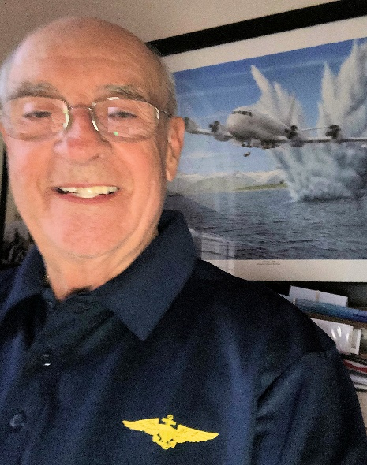

Captain Richard J. Petrucci U.S.N. (retired). Richard ("Dick") Petrucci hails from Westport, CT. He graduated from the Naval Academy in 1961 with a bachelor's degree in engineering. Dick was designated a Naval Aviator in 1963 and served in the Navy for 25 years. His flying assignments included four tours of duty in Patrol Squadrons including command of Patrol Squadron 26 in Brunswick, ME. While a member of Patrol Squadron 10, he flew shipping surveillance missions during the Cuban Missile Crisis. Dick also graduated from the Naval Postgraduate School in Monterey, CA with a master's degree in Computer Science, and attended the Naval War College in Newport, RI. Following his command tour, Dick reported to Washington, D.C. where he completed three tours of duty in senior staff positions. During his career in the Navy he earned subspecialty designations in Computer Science, Computer Systems Management, Anti-Submarine Warfare Operations, and Weapons Systems Acquisition Management. Dick retired from the Navy in 1986 and joined Lockheed Martin Aeronautics in Marietta, GA as a senior engineer. He was on the concept development team for the C-5 World-Wide Airborne Command Post, flight station design team for the C-130J, a proposal writer on three major projects and was a Program Manager on two classified customer programs. He retired in 1998 and moved to Tampa, Florida. In 2002 he joined the faculty at the Sarasota Military Academy (SMA), the country's first charter military high school, where he was Chairman of the Math & Science Department for three years. Dick also holds the rank of Lieutenant Colonel in the Civil Air Patrol where he served as Deputy Squadron Commander, Aviation Safety Officer, Aerospace Education Officer and Character Development Instructor for Cadets. His qualifications include: Mission Pilot, Transport Pilot, Instructor Pilot, and Cadet Orientation Pilot. He is an FAA rated Airline Transport Pilot and Certified Flight Instructor with both Instrument and Multiengine ratings. He has over 7,500 hours of pilot time. Dick is also the President of Our Next Mission – a veterans’ group that rehabs veterans’ homes and trailers. His is also a member of the Sarasota-Manatee Council of the Navy League, a member of the Silver Osprey Squadron of the Association for Naval Aviation, the Naval Academy Alumni Association, and is a Naval Academy Blue & Gold Officer. He mentors and counsels students who apply for an appointment to USNA and assists them with the nomination and application processes.

Editor’s note: CAP’N Dick was my flight instructor in Sarasota, FL following my solo flight license in a Cessna 172 (N217JA) keeping me on the **“centerline and nose up”** on landings! Thanks Shipmate!)

**Always On Watch**

The following was written January 17, 2020 after our return from a visit to San Diego, CA with our two sons and daughter-in-law for the Christmas/New Year’s holidays. While there, we drove to Point Loma for the sunset and were blessed with being next to the Ft. Rosecrans National Cemetery. The editor!

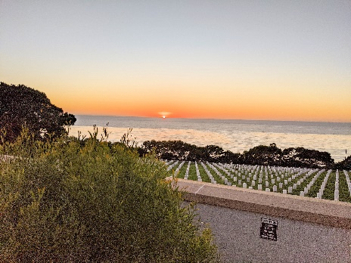

**Ft. Rosecrans National Cemetery, San Diego, CA**

**Always On Watch**

My body lays here watching over the open sea,

There is a marker for my family to see.

They kneel and say a prayer or two,

Not seeing the ocean so clear and blue.

But that was my turf as a Navy man,

And I served my country with a plan.

That one day I would be home,

And see how my children had grown.

But luck wasn’t with me on that day,

And now the enemy has made me lay.

For the Vietnam War was my playground,

And little did I know that my boat would be found.

But that mortar shell from the Hán River beach,

I had no idea that it could reach.

But the explosion took my boat and crew,

Never to see home again was true.

Because I’m a believer in God our Father,

I can look down each day and not look farther.

For there, my family stands proud,

And I can hear their voices out loud.

We are so proud of your service Dad,

But Vietnam Veterans have been treated so bad!

We know you did your very best for our land,

And so each day we can beat the band.

Shouting out loud, we gave our father’s life,

So the rest of you could live without strife.

Enjoy the freedom that’s been given to you,

And stand and respect the Red, White and Blue.

God bless the USA and Welcome Home!

ROTRUCK – ‘20

**Celebrity Veterans**

Before they became celebrities and superheroes, they served their country!

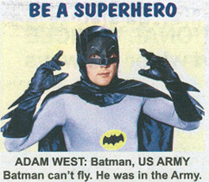

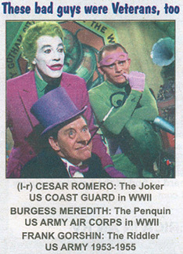

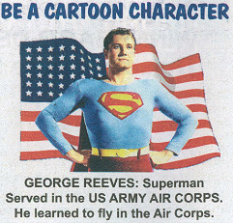

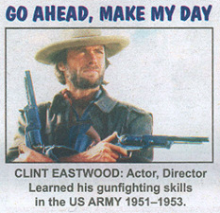

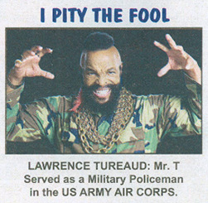

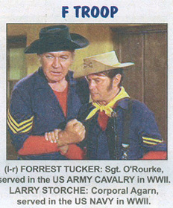

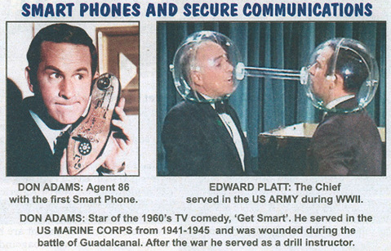

***Light Side***

**Sometimes, life takes an odd turn!**

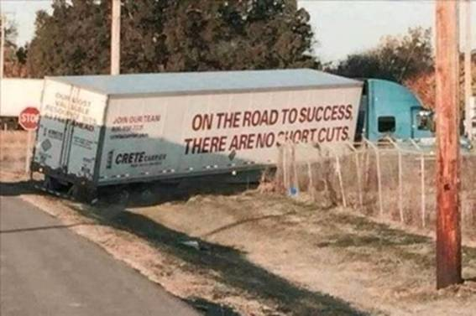

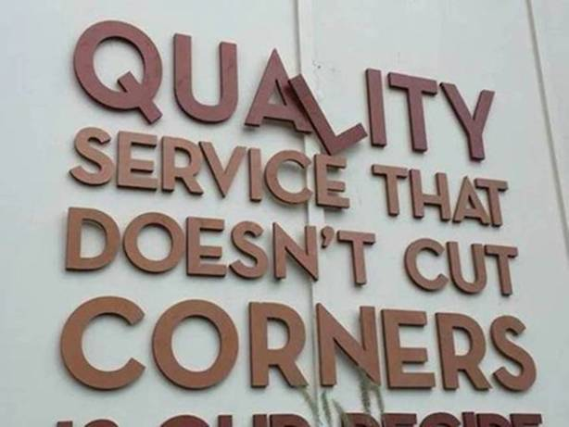

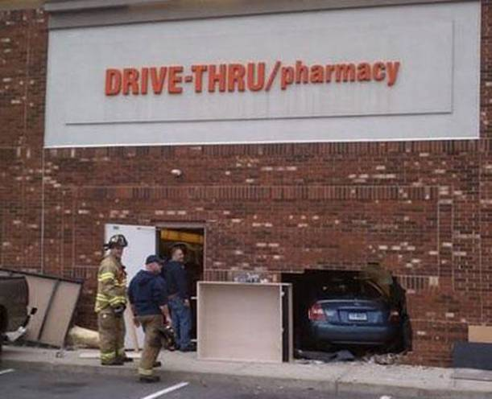

**Anti-depressants!**





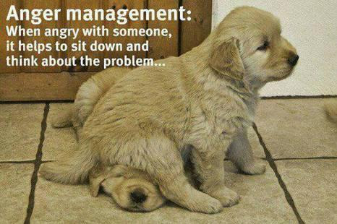



**Signs to giggle at!**



**Men who lack female supervision!**



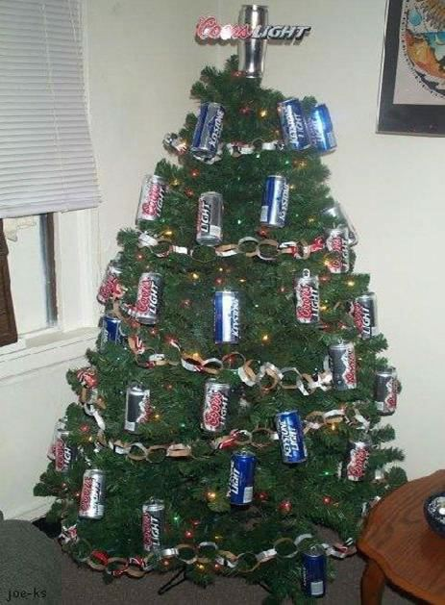



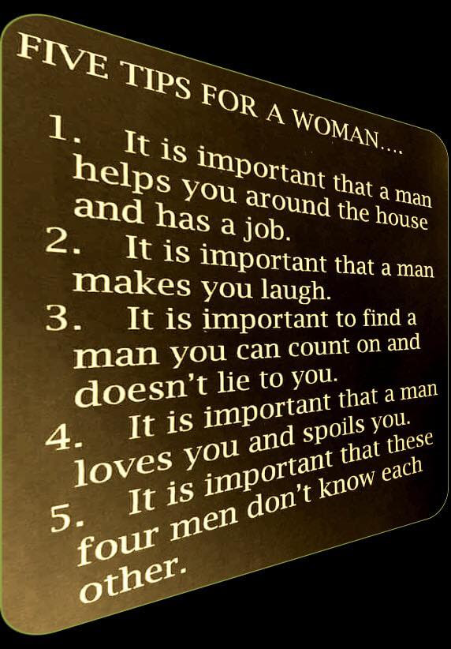



***Trivia Answer***

**BTDTBTTS** - **B**een **T**here, **D**one **T**hat, **B**ought **T**he **T**-**S**hirt

.

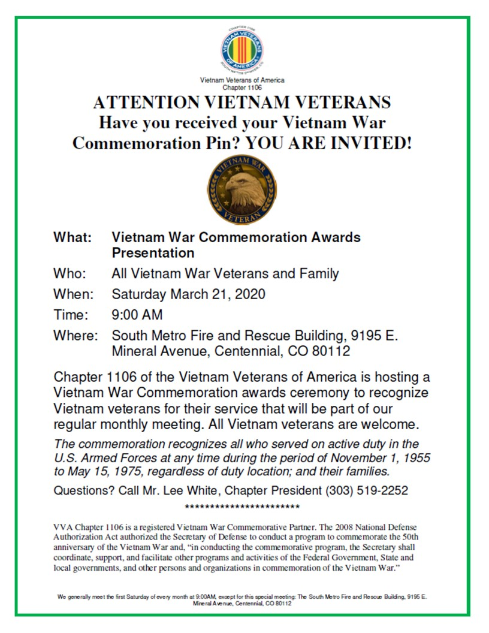

**Upcoming Events of Interest**

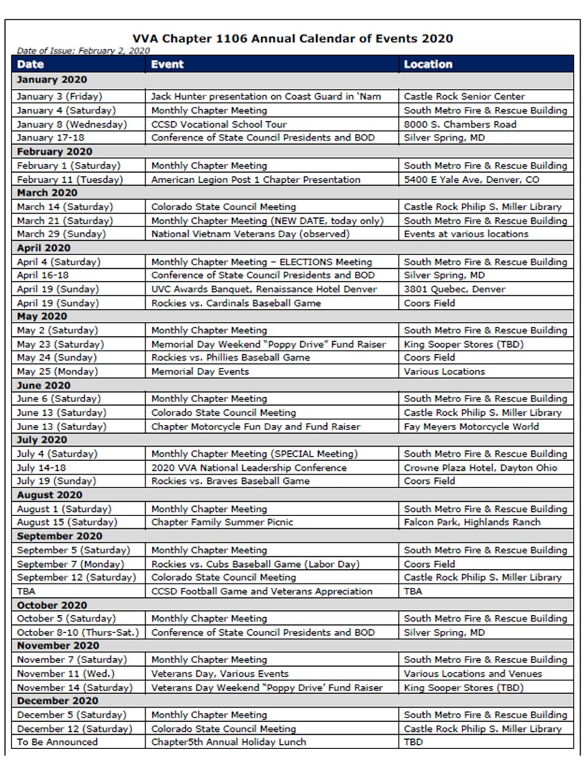

**FRIENDS OF CHAPTER 1106**

|  |  |
| --- | --- |
| **Panera Bread**  9579 S. University Blvd. Highlands Ranch, CO 80126  720-348-1112 | **American Legion Post 1260**  **E:\Documents\ALP1187\images\AmericanLegion_logo.jpg** |
| **Spradlin Printing, Inc.**  11903 S. Parker Road Parker, CO 80134 | **South Metro Denver Fire & Rescue**  9195 E Mineral Ave  Centennial, CO 80112 |
| American Family Insurance  3989 E. Arapahoe Road #20  Centennial, CO 80122  720-361-0155 | A FULL-SIZE REPLICA OF THE HONOR BELL  **The Honor Bell Foundation**  PO Box 1432  Englewood CO 80150  720.282.9182  [www.honorbell.org](http://www.honorbell.org/) |
| 9137 E Mineral Cir Ste 100  Englewood, CO 80112-3422 | American Home Agents  Brian Karsh, Broker Associate  720-327-1562 |
| King Soopers logo.svg  King Soopers  9551 S. University Blvd., Highlands Ranch, CO 80126 | http://www.cruisin1430.com/sites/g/files/giy711/f/KEZW_Header_Large_Logo_0.png  **STUDIO 1430 Main Office:** 4700 South Syracuse Street, Suite 1050 Denver, CO 80237 |
| https://scontent.fapa1-2.fna.fbcdn.net/v/t31.0-8/10575197_682186265194110_4051472928662048560_o.jpg?oh=2630b186dcf3a20f1d7fc8fa25e0a5ba&oe=5A17C4AB  **Military Order of Purple Heart**, Chapter 1041, Arvada, CO | ZILLOW GROUP  10771 E. Easter Ave  Centennial CO 80112 |