

**Inside this issue:**

Notes from the President

[Member Feature](#Memberfeature)

[Military Trivia](#Militarytrivia)

[Guest Speaker](#Guestspeaker)

[Membership](#Membership)

[Board of Directors/Officers](#Boardofdirectors)

[Working Committees](#Workingcommittees)

[Meetings/Events Calendar](#Meetingsevents)

[Announcement Corner](#Announcementcorner)

[Books/Articles Published by Mbrs.](#Booksarticles)

[From the Editor](#Fromtheeditor)

[Light Side](#Lightside)

[Trivia Answer](#Triviaanswer)

**Events**

Saturday, March 3, 2018 - Chapter Meeting

Saturday, April 7, 2018 - Chapter Meeting

S. Metro Denver Fire & Rescue Board Room 9195 E. Mineral Ave. Centennial, CO. The Board of Director’s meeting will follow 30 minutes following the regular mtg.

Next CO State Council meeting March 10,2018.

***Editor’s Note:***

**Notice:**

If you have moved or changed your address, PLEASE notify us immediately! Contact: Lee White, Membership Chair

E-mail: <mailto:flyboy51@q.com>

Phone:  303-519-2252

###### COPYRIGHT NOTICE: In accordance with Title 17 U.S.C. Section 107, any copyrighted material in this newsletter is distributed under fair use without profit or payment to those who have expressed a prior interest in receiving the included information for nonprofit use and educational purposes only.

This version of the newsletter is in Microsoft Document (.docx) format so that the links will work. Put your cursor over the link, depress your Control Key (ctrl) and depress your left mouse button and it will take you to the listed link position. PDF format, the links will not work.

The comments and editorial input does not necessarily reflect the opinion of the membership of our chapter.

I would appreciate any feedback that you might have, items you liked or if you find offensive or derogatory in anyway. ([bobrotruck73@gmail.com](mailto:bobrotruck73@gmail.com))

Thank you for allowing me to be your newsletter editor.

***Notes from the President***

Lee White

We want to **reach out** and help veterans and we need your help to do it. If you know of a veteran in need of assistance, contact us so we can help our fellow brothers and sisters. Members of the Veteran Emergency Assist- ance Committee: Joe Plant, Bob Rotruck, Lee White, and Dave Lyons. Remember our motto: **“*Never Again Will One Generation of Veterans Abandon Another”***

Also, be sure to pick up new Chapter brochure to hand out to Vietnam Vets so they are aware of who we are and we want them to be part of our brother/sisterhood.

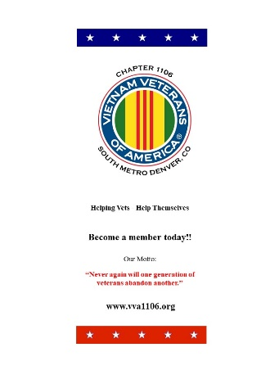

Tree roots extend across a gap to the mainland

for nutrients! VVA Chapter 1106 is the “mainland”.

***“******Member Feature”***

Jim Henderson, Corporal, US Army July 30, 1968 to June 1, 1970. Served in Vietnam from September 1969 to late May 1970. MOS: scout dog handler.

One of my more memorable service experiences was my trip to and introduction to Vietnam. As a scout dog handler I worked with one dog - a German shepherd named Loki. Our mission was to find booby traps and ambushes before it was “too late”. A half dozen other scout dog handlers and I were ordered to take 50 trained scout dogs to Vietnam. We were all loaded into the back of a C-5 air transport. We flew from Fort Benning, Georgia to Dover, Delaware to Anchorage, Alaska, to Osaka, Japan and finally to Bien Hoa, Vietnam. A segment of the flight I recall vividly was from Dover to Anchorage. We had left Dover in the late afternoon. After an hour or so into the flight, the pilots invited us into the cockpit just as they were about to fly cross the Great Lakes. At 35,000 plus feet the curvature of the earth was clearly visible in the light of the setting sun and the Great Lakes below were so dark they appeared a stark black. It was simply an awesomely beautiful sight.

Upon landing in Bien Hoa, we delivered our scout dogs to units waiting for them, then Loki and I reported to our 7th Cavalry Unit. After finding a place for Loki, I went to meet my new unit. I was pointed to a bunk in a hooch but no one would talk to me. There was a palpable tension in the air. After a couple of hours, which seemed much longer than that, the Captain of the unit came by and said “Hey, new guy…let’s go for a walk.” On that walk I soon learned why the atmosphere was taunt. Just the night before my arrival, the sergeant for the unit went out in the middle of the night to take a leak at a piss tube behind the barracks. Someone flipped a grenade and killed him. Except it wasn’t the sergeant. but the company clerk who happened to have about the same stocky build as the sergeant. The disliked sergeant had been rapidly reassigned and members of my unit was grieving the senseless loss of a well-liked company clerk. I lay awake that night thinking – “So this is Vietnam…what next.”

Chapter 1106 over the past year has been of great service to me. It has introduced me to many resources I did know about for Vietnam Veterans. Most importantly it has introduced me to other Vietnam Veterans who I now value as dear friends.

***Military Trivia***

What is a **Bitchin' Betty** See answer at the [end of the Newsletter](#Triviaanswer).

***January Guest Speaker***

Our guest speaker was John Rossie, former Executive Director of the Blue Water Navy Vietnam Veterans Association ([www.bwnvva.org/](http://www.bwnvva.org/)). He spoke about the work the association has been doing to insure that blue water military veterans are eligible for VA benefits as Vietnam Veterans.

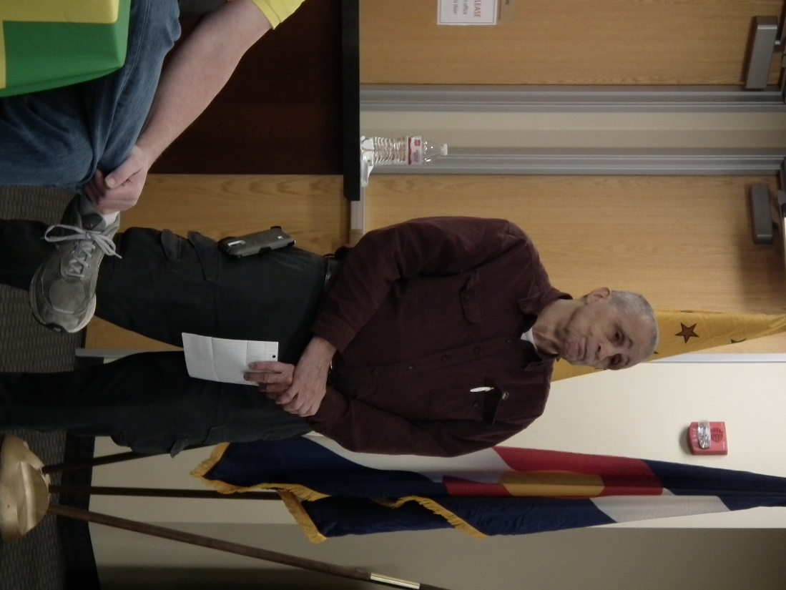

***February Guest Speakers***

Michelle Mallin is the owner and principal of MGM Solutions, a nonprofit consulting firm in Highlands Ranch, Colorado. She has also been deeply involved in the Honor Bell Foundation and had spoken to our chapter months ago regarding the progress of the Honor Bell project. She presented a special autographed poster of the recently released movie – *Twelve Strong.* Dave Lyons, Lee White and Wendy White (Lee’s daughter) were part of the color guard at the movie’s premier. It is a must see!!!

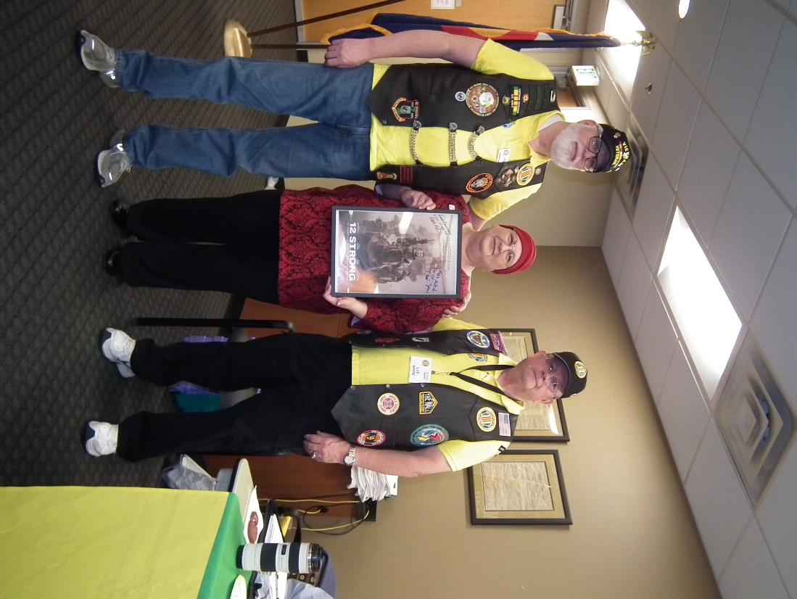

Dave Lyons, Ms. Michelle Mallin, Lee White

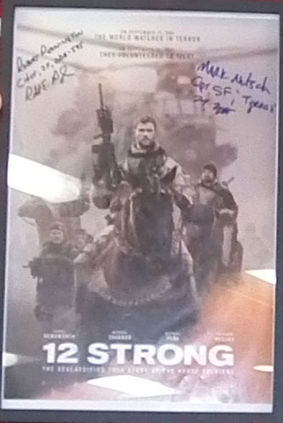

12 Strong Poster

**Roger Edwards – Conservative Candidate Colorado 6th District and a Vietnam Veteran!**

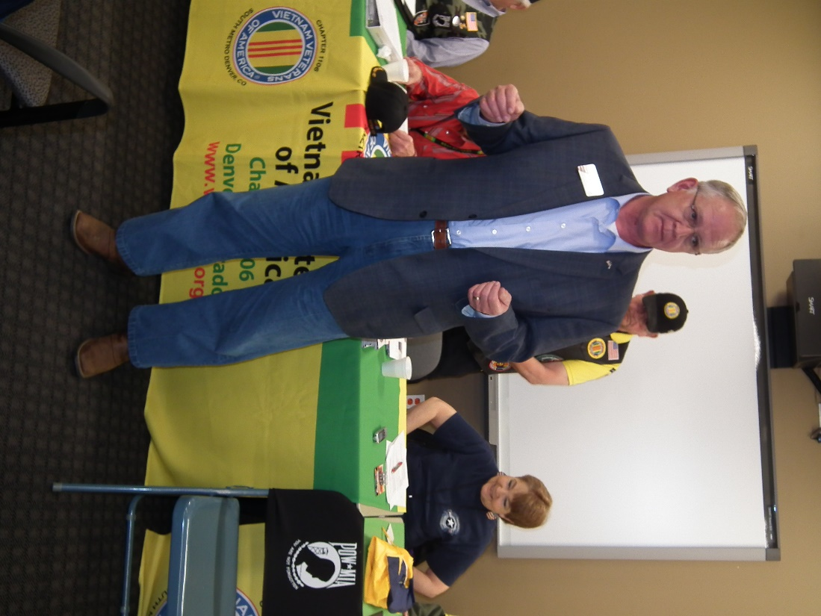

In 1969, Edwards enlisted in the U.S. Army at the height of the Vietnam protest. He attended advanced training at Ft. Huachuca, AZ as an Airborne Sensor Specialist (17L). After completing his training Edwards was assigned to a unit testing a prototype aircraft designated as YO3A. The YO3A was an early stealth aircraft designed for acoustic silence. The plane flew in Vietnam, only at night at an altitude of approximately 1500 feet and a speed of 80 KTS. As the Observer of the two-crew aircraft, he spotted enemy activity using advanced night vision capability and called in supporting artillery, helicopter gunships, and naval bombardment. Edwards earned the Air Medal for combat flight hours.

**Quang Pham**

Quang Pham – A U.S. citizen, but born in Vietnam, shared some of his experience growing up during the Vietnam War. He came to the U.S. at age 21 and has a degree in Civil Engineering. Thanks for sharing your stories.

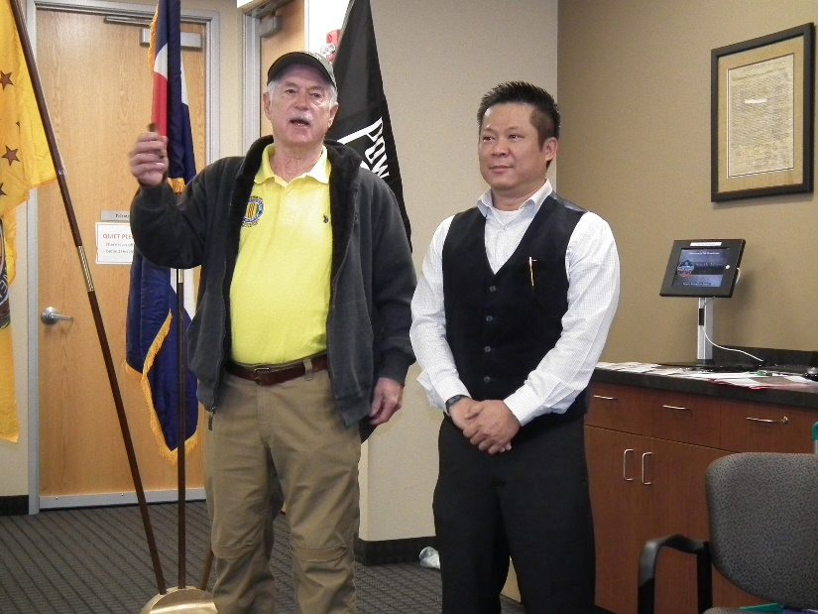

Quang Pham

***Membership!***

VVA Chapter 1106 Membership as of: (2-10-2018)

VVA - 98

AVVA - 23

Total: 121

New VVA members:

John Spradlin - Lifetime

Robert Larson - Lifetime

Richard Price - 3 year membership

Bob Palmi - 1 year membership

Roger Edwards - Lifetime

New AVVA Members

Laura Larson - 3 year membership

Brian Karsh - 3 year membership

***Board of Directors/Officers***

Lee White - President

Bob Easter - Vice-president

Joe Plant - Treasurer

Hazel Simeon - Secretary

Board Members - Milt Omoto, Patti Ehline, Dave Lyons, Tom Werzyn

***Working Committees***

Sergeant-at-Arms – John Vargas

Chapter Chaplain – Garry Turks

Agent Orange/PTSD - Patti Ehline

Membership – Chair: Dave Lyons, Tom Werzym, Lee White

Mental Health: Patti Ehline, Warren Harrison

Newsletter Editor - Bob Rotruck

Fundraising/Grants - Milt Omoto

POW/MIA – Gary Meyers

Webmasters – Robert Senatore. Bob Rotruck

Women Veterans - Patti Ehline

Scholarship Program - Hazel Simeon, Bob Easter, Joe Langran, Bob Rotruck, John Vargas, Mike Karsh, Glen Payne, Jim Marcille, Tom Werzyn

Veteran Emergency Assistance Committee - Joe Plant, Bob Rotruck, Lee White, Dave Lyons

Speakers Bureau – Bob Easter, Glen Payne, Bob Mallin, Roger Lanphier, Tom Werzyn

Social – John Vargas, Barry Fiore, Glen Payne, Milt Omoto, Hazel Simeon

***Meetings/Events Calendar - 2018***

* Saturday, March 3, 2018 - VVA Chapter 1106 Monthly Meeting
* Saturday, March 10, 2018 - Colorado State Council Meeting - Castle Rock, CO
* Saturday, April 7, 2018 - VVA Chapter 1106 Monthly Meeting
* March 24, 2018 - All Member Open Breakfast - Location: To Be Determined
* March 29, 2018 - National Vietnam Veterans Day
* April 12-14, 2018 - Conference of State Council Presidents Meeting - Silver Spring, MD
* April 22, 2018 - Colorado Rockies vs. Chicago Cubs, Coors Field

**Citizen Hero - The Wall**

Submitted by John Vargas

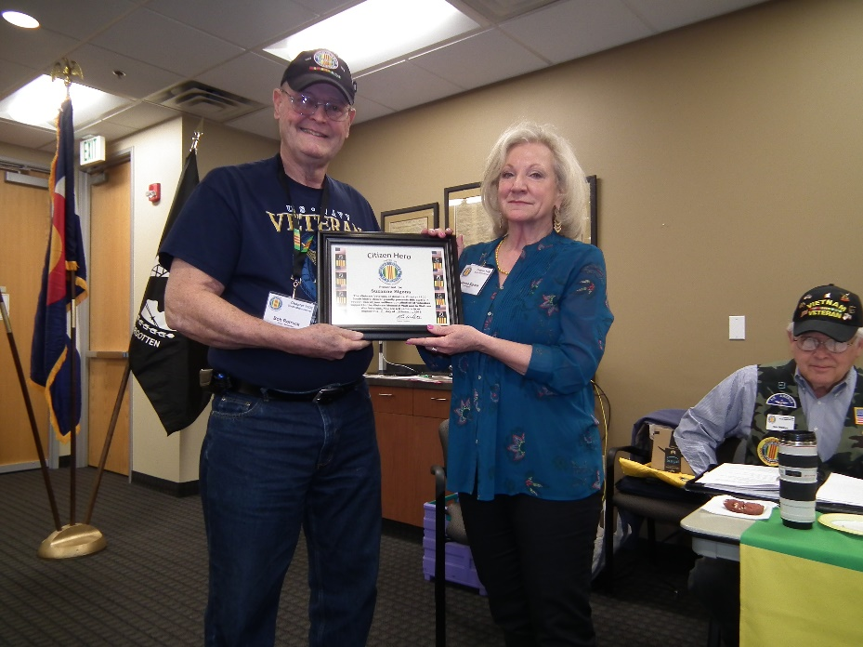

Bob Rotruck presenting the certificate Suzanne

I first met Suzanne at a VVA Chapter 1106 meeting. In a soothing voice, she asked Vietnam Veterans that had not received the Vietnam 50 Anniversary Pin to stand and walk to the front of the room. She proceeded to say "A grateful nation thanks and honors you. Thank you for your service." shook our hand as she handed us a pin.

No fanfare, drum rolls or long speeches. Thankful dignity to a Veteran! That in a nutshell is Suzanne Sigona. Her mannerisms and soft vocal tones makes one feel very important. Not everyone, possesses these traits.

Suzanne, has been a Volunteer at The Wall for over 29 years! It began while she lived in Washington D.C. and friends came to visit. After the customary DC tours, she took them to The Vietnam Veterans Memorial. The Volunteer history of Suzanne and dedication to all Veterans and The Wall began!

Her friends were moved by its beautiful artwork of solemn remembrance. Suzanne was immediately impacted both emotionally and physically. In the early days of her service the impact was so strong that she found that her shift ended with going home and passing out from exhaustion. The emotional experiences were so profound and there were few places to discuss the impact. Over time it gave her the inner strength, energy and resolve to keep going.

She became a National Park Service volunteer in September of 1988. It is her personal choice to be assigned to The Wall. Frequent visitors would recognize the soft smiling lady in the Yellow hat. She would stand and watch as puzzled visitors search for a name. She would slowly walk over and simply state, "If I can help you locate a name or time frame, let me know." At times, visitors would only have part of a name, a combat company or state of residence. Suzanne, would diligently search her data for clues. More often than not, she found the name. She is deliberate to leave each veteran with the words, "Glad you're here." (understanding that it has several meanings to the person hearing the words).

In her early years of working at the Wall, she coined the phrase “Wall Magic”. They are the unexplainable circumstances of connecting people, situations and circumstance. They happen in ways that have no other explanation. An example is a day when she responded to an urge to stay a bit longer, rather than leave for the airport. She stood at an area that is familiar and saw someone touching the name of Karl Culp – a casualty she had come to know through his buddies and his parents. She approached the couple. The husband asked, “Did you go to school with him?” She responded, “No, but I know Spud Butt and Bridgette.” He immediately asked, “Where are they?” She went on to tell them her connections.

It should be noted that Suzanne has been to Vietnam 9 number of times. Although, she lives in Denver, frequent trips to The Wall are common and all are self-paid. This past Christmas, she placed a holiday ornament on behalf of VVA Chapter 1106 and several ornaments for members of VVA chapter 1075. The Christmas tree is placed near the Wall each year and decorated by volunteers who travel from all over the country.

Many of us are fortunate to have the privilege of personally knowing this beautiful lady. Her contributions to assist Vietnam Veterans and their loved ones at our Wall cannot be measured.

It is with great pleasure and much gratitude that today VVA Chapter 1106 recognizes Suzanne Sigona “Citizen Hero.”

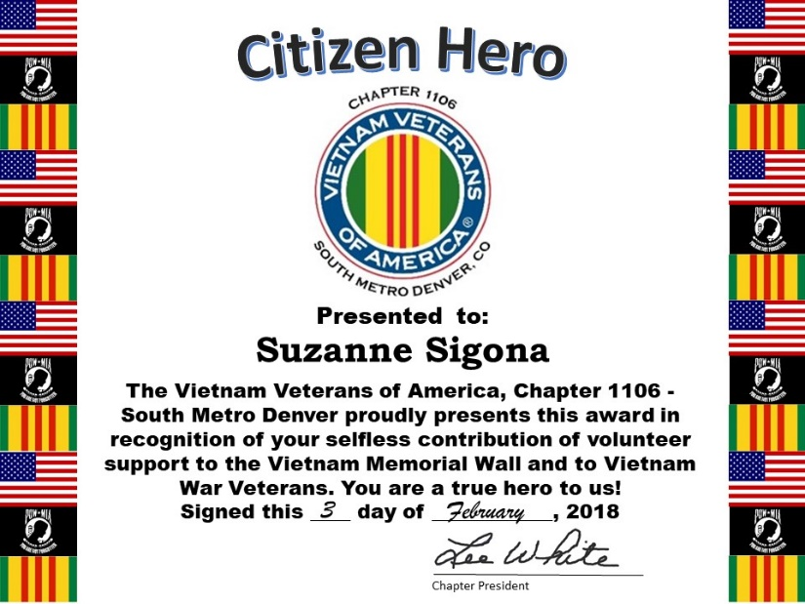

***In Memoriam***

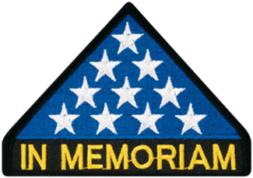

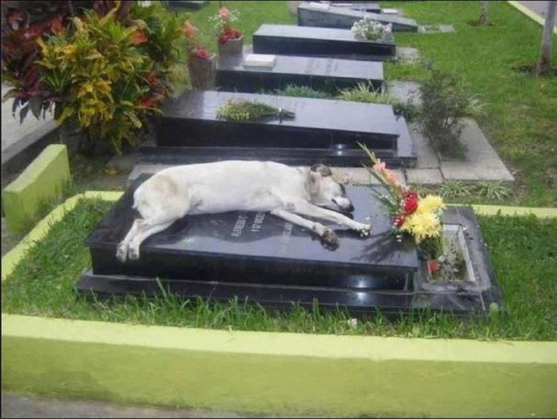

Loyalty



As of: 1/21/2017

Total Funeral Homes Visited - 2,186

Cremains Found - 15,711

Veterans Cremains Identified - 3,640

Veterans Interred - 3,330

**Chapter Visit to PAMVETS**

Proud American Military Veterans - or PAMVETS

Lee White, Milt Omoto, Tom Werzyn and Dave Lyons visited the Golden Corral in Loveland on Saturday, January 20, 2018 in an effort to encourage starting a VVA Chapter in Loveland.

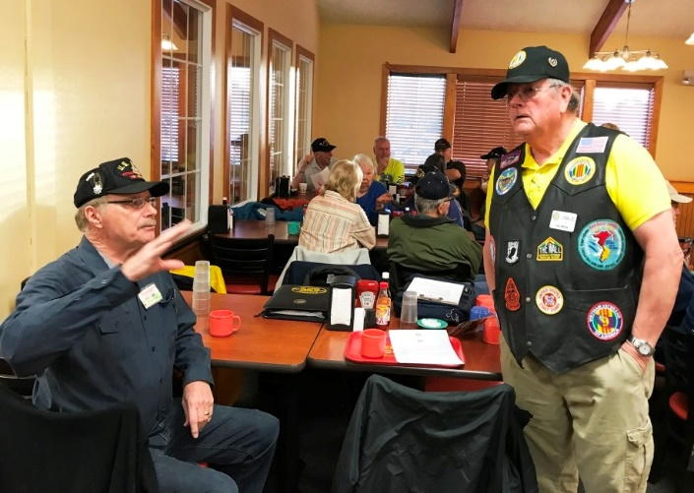

Lee and Gary Camp

Gary Camp was the PAM Vet contact who introduced the group. Lee had met Gary at the New Orleans Airport after the VVA National Convention last year. Charlie Nash is the host of PAM Vets.

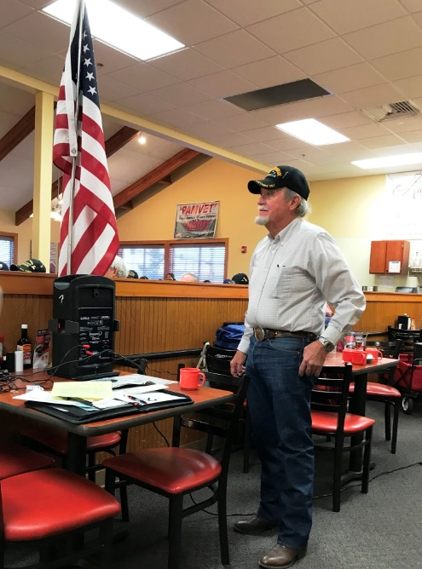

Charlie Nash – PAMVETS Hostr

They meet every Saturday at 7:30AM at the Golden Corral in Loveland. There was significant interest in starting a VVA chapter in the Loveland area.

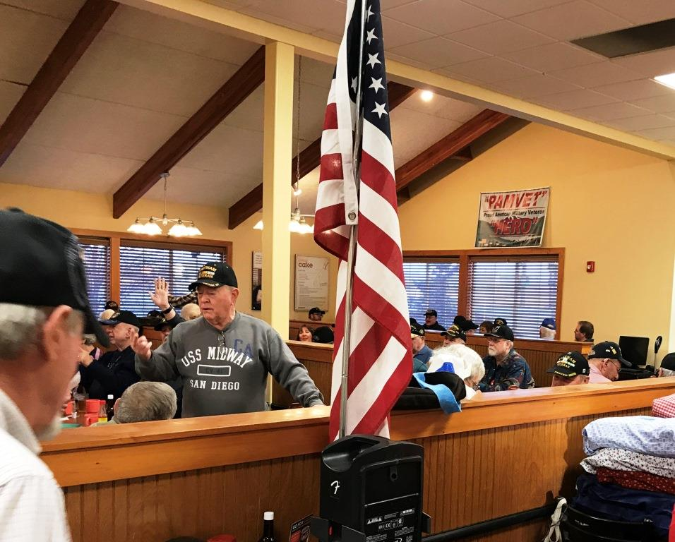

There were 118 veterans in attendance that day.

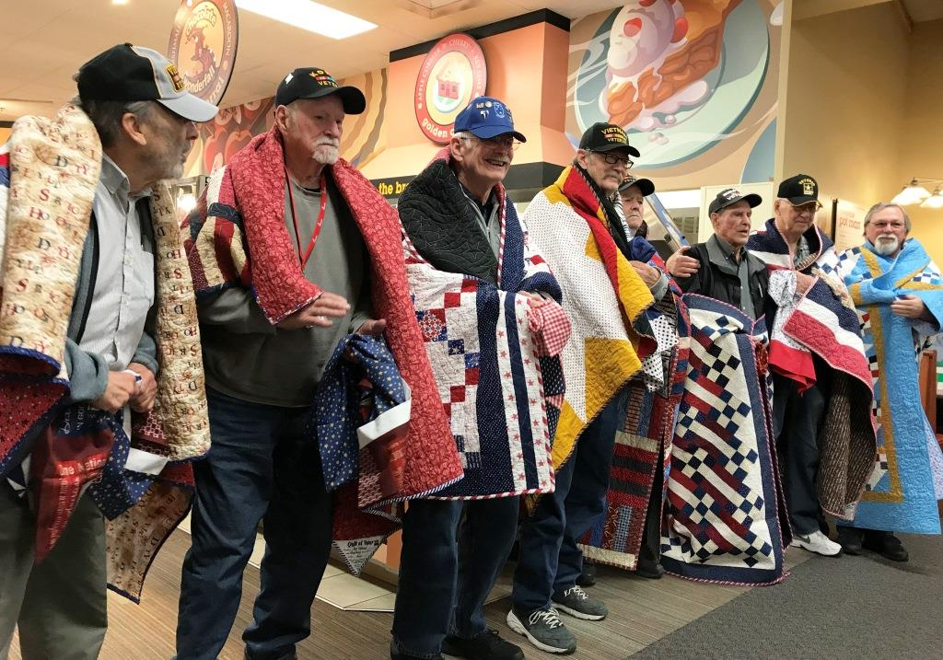

Eight veterans were presented with handmade quilts.

See 9News event that was videoed December 9, 2017. [Click here for link](http://www.9news.com/news/local/next/at-this-breakfast-in-loveland-colorado-no-veteran-sits-alone/499322087).



Photo: Nick Lucey <www.nicklucey.com>

Douglas County Veterans Monument Eagle

(Editor: if you could only look closer at the DCVM Eagle, you would see unbelievable detail.)

***Announcement Corner***

**Run for the Fallen**

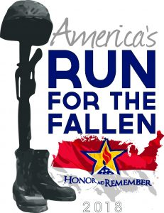

#### April 7 ~ August 5, 2018.

On Memorial Day of 2008 in Norfolk Virginia, the Honor and Remember Flag was publicly unveiled to become a nationally recognized symbol of remembrance. This flag was established as a tangible reminder to all Americans of the high price paid for the freedoms we enjoy. It represents all generations of fallen heroes from all wars, all branches of service and all causes of death. It is a daily visual celebration of the lives it represents and a sign of appreciation to the thousands of grieving families left behind. Three weeks later on the west coast .....

On Flag Day, June 14, 2008, a dedicated team of runners ran across America from Fort Irwin, CA to Arlington National Cemetery, one mile for every Soldier, Sailor, Airmen, and Marine killed since the War on Terror began. For ten weeks, team members marked each mile with an American flag and biographical sign card in an apolitical reflection of remembrance of each service member.

During the course of these historic events the founders of these organizations met and instantly realized that their missions were perfectly aligned. Since that moment they began a lasting friendship and a goal to continue a parallel path.

Each year since the first run across America, runners from around the world have joined Run for the Fallen in remembering our fallen. Over 50,000+ participants and over 200,000+ miles have been collectively run in remembrance of those heroes, organized in over 26 states. But more still needed to be done. A plethora of state runs continue to exist with additional being added yearly.

In hopes of combining resources in 2014 Honor and Remember and the Run for the Fallen organizations were officially merged, dedicated to continuing and consistently growing the mission to pay tribute to more military fallen heroes and their families across the country.

Since their inaugural beginnings were both in 2008, rapidly approaching is the combined tenth anniversary.  In memory of that first event and to include the subsequent increase in military casualties they are preparing to launch a second organized run across the United States, closely duplicating the original 2008 event.  Creating, Spring of 2018 “America’s Run for the Fallen”.  The run will begin in San Diego, California and conclude approx 100 days later in Arlington National Cemetery. This time including nearly 20,000 service members in 19 states over 6,000 miles.

The needs are many, including overnight stays every day, food, planned ceremonies and more. We will be looking for dedicated runners and volunteers to assist in managing particular areas of the country we will be running through. One mile for each hero lost since the War on Terror began in 2000 with the USS Cole.

Due to the extreme temperatures during the summer months along much of the route. The timeframe will shift to spring with a finish when all service members have been honored.  
Scheduled Dates April 7th - August 5th, approx. 120 days

Stand by for additional information, visit [www.runforthefallen.org](http://www.runforthefallen.org/) to help or write [Run2018@HonorandRemember.org](mailto:Run2018@HonorandRemember.org)

**To donate text USRUN to 71777 or use this link** [**http://igfn.us/vf/usrun**](http://igfn.us/vf/usrun)

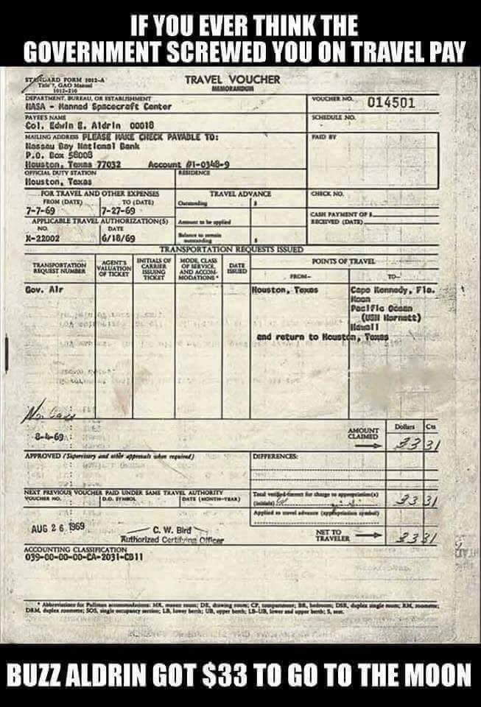

***Books/Articles Published by Members***

Sharing the Foxhole by John Vargas

**PATTI EHLINE, NC, USA**

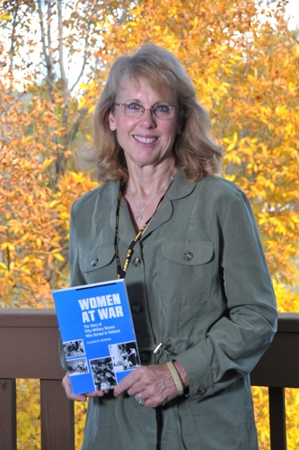

This was my second attempt to chat with Patti Ehline. My first visit with Patti and husband, David was spent reminiscing over our military experiences. We sat in her comfortable Castle Rock home with coffee and cookies. Their home was adorned with the spirit of the Christmas Holiday Season and with displays of David’s masterful hand crafted artwork.

Patti was born in Omaha, Nebraska. Her father was in WW II and later held the rank of Major during the Korean War. As a 19-year old nursing school student, Patti joined the Army to assist with the cost of her education. A visit by two young handsome male recruiters promised she could choose wherever in the world she wanted to serve, including Hawaii. Only six months after her commission, Patti received orders for Vietnam. This was 1968 and her first airplane trip outside the USA. Uncle Sam “welcomed” her in a way she did not expect.

In her mandatory non-combat uniform of nylons, heels, black purse and cap, Uncle Sam “welcomed” this 21 year old to the hells of war. Instructed to disembark the aircraft immediately due to the possibility of attack by rocket, mortar, or sniper, she learned quickly that the enemy particularly wanted medical staff killed. This meant less medical attention for the wounded. The local heat, face smacking humidity and rain made every day a physical challenge. Only the best accommodations for our combat nurses! Their living spaces had the barest of furnishings, no air conditioning, no fans nor heaters. At times, the temperature rose to a suffocating 120 degrees!

The trip to Chu Lai in 1 Corps from Bien Hoa was in a Huey gunship. Now, dressed in fatigues, jungle boots, helmet and flak jacket, she stared down with some curiosity and disbelief at the number of bomb craters and jungle destruction (defoliation) the landscape was painting. The door gunners sat with intent stares and ready to return fire. The realities of warfare were penetrating her body and soul.

Due to the rapid escalation of the war, the 125–surgical bed hospital quickly grew to a 400-evacuation hospital. The wounded arrived at all hours and seven days a week. The staff worked 12-hour shifts plus night shifts. Days off were a rare occurrence. Among her worst experiences was working Triage. Patti had to decide very quickly who was going to be treated and those who were not! Being a highly skilled nurse she consistently assisted doctors and in some cases she was the doctor.

On many occasions, she was a mother, sister, the loved one or just a pretty nurse with a friendly smile holding a wounded or dying hero’s hand. The average age of our wounded was a mere 19 years old.

These valiant combat nurses treated bullet and shrapnel wounds, soldiers that had arms or legs amputated. Soldiers with rotted feet from being wet for prolonged periods of time. She witnessed more blood, more tears, more pain and more death in her one year in Vietnam than all her renaming 42 years of nursing! Patti had to shut down all emotions and not allow herself the feeling of sadness, fear, guilt, anxiety or even empathy. The hospital was under constant enemy mortar attacks. Lt Sharon Ann Lane was oriented by Patti and eventually became her replacement. Sharon was the first nurse killed in Vietnam as a result of hostile action. During TET of 1969 they treated over 10,000 men, women and children.

In all wars many of the casualties are children. Patti will not forget a little paralyzed boy she treated and always wondered what became of him after being returned to his Vietnamese village. This way of living was detrimental to the health of all those affected by the war in Vietnam. During the Christmas Holidays, the nurses and medical staff would go caroling throughout the hospital trying to bring a bit of cheer and happy memories of home.

Patti wanted to remain in the military or reserves. She had to accept her honorable discharge because Women weren’t allowed to have children while serving. She returned to Omaha and resumed her nursing career. She vowed to herself never to talk about her war experiences, but Vietnam had taken its pound of flesh and much more. Patti suffered all the symptoms of PTSD. As a workaholic she attempted to bury those horrible memories but the nightmares kept them surfacing. After almost suffering a stroke, she began PTSD treatment.

Patti’s military and civilian experiences would make a must see documentary. She is a true fighter for female and male Veteran rights. Someone once described her as: Patricia Carlson Ehline - “The Spirit of Excellence’.” I’ll just simply add; A Champion before, during and after Vietnam.

VVA Chapter 1106 is very proud and honored to have Patti Ehline as an Executive Board Member. Her dedication and selfless contributions to nursing, the military, our community and all Veterans are beyond reproach. If you see Patti at the VA, a parade, a meeting or as a guest speaker, walk up to her and shake her hand.

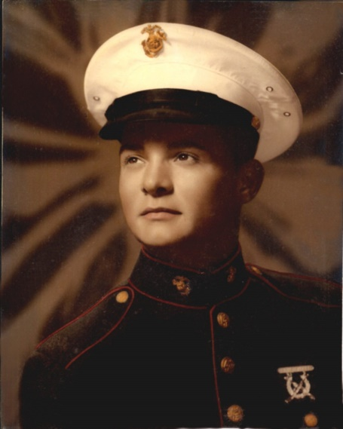

**“FIRST LIGHT”**

First Light Starlight – star bright – shadows in the night.

I pray that calm will be, that we may see the next first light.

Moonlight – too bright, we fear will bring a firefight.

If that must be – I pray to thee that we survive ‘til next first light.

A distant sound brings chills of fright Eyes open wide – no sleep tonight.

The sounds so slight are amplified It’s long away from next first light.

We’re young, and strong – this starlit night But do not boast with great delight.

Hold back the tears – I must for years if I survive to see first light.

This patrol we must complete the enemy we must defeat.

And later time to eat – we might If we may see the next first light

Old we wish to grow to be – we dream of wives, of kids, and family.

We pray to thee with all our might – that we walk softly through the night.

And make no sound – we know the enemy is all around- Intent to keep us from the sight of morning next – and new first light.

Complete our mission – on we go Searching for enemy – our hearts pound so.

And time stands still it seems – so slow. When is first light? – We want to know.

Our prayers we whisper – silently this night Once again please Jesus – let this end.

Please get us back among our friends Where there we rest and dry our feet and thank you for the grand first light.

Along this treacherous ground we move – then suddenly a clicking noise

And then the unmistakable explosive sound from point to six – the sudden chill.

I’m falling down I – pray the fluid on my brow is sweat – not blood. And that the fragments stinging so are dirt and mud.

Is this all a dream? – the noise is deafening – this cannot be A flash so bright – is our war over on this night?

Is that our friend lying wounded there – why him not me?

This is insane – it isn’t right – we only asked to see first light.

Starlight, star bright, a brilliant flash. The evening sky we see and fear and now the only sound we hear Is but the ringing in our ears.

Our nostrils fill with smell of fire and flesh. This is too soon, too young are we.

Most are but teens – I’m not twenty. Another morning please.

Not much to ask – that all come home. We’ve done our task – brothers we – yet each feels all alone.

And memories of that and other days after many years won’t go away. The sacrifices others paid – not I.

A lifelong grief – a heart to cry.

Unanswered questions why you had to die.

We hide the tears that none shall see.

We hide away in woods or room – The haunting thoughts of doom – why him not me?

Eyes open wide – we look about.

Not a word, not a shout.

But silently for all we plead

We share with each – there is no greed – we really have a simple need.

Our prayer was answered – but not for all.

And those of us who lived shall always wonder why – the simple prayer to last the night.

To take away the tears and fright – was granted me –not thee my friend.

And so…I pray that when my life must end, as brothers we will walk again.

Softly though – we’ll make no sound.

Our buddies know that still – with them we are around.

Our final comfort we have found.

No longer will we have to fight, the war has gotten dim.

And finally peace may come to us when God has called us home to him

to see the beauty of First Light.

With love He gives to us when time has come what we had prayed for all along.

With a warming smile and gentle song to us He gives our last First Light.

John J. Freeman SSgt. USMC 1964-1971 –

Dedicated to all who served with the 1st Battalion, 9th Marines

“The Walking Dead”

SEMPER FIDELIS is Forever

Submitted by Roger Lanphier

**WWII Fact**

In World War II, the youngest serviceman in the United States military was Calvin Leon Graham - age 12 (April 3, 1930 – November 6, 1992).

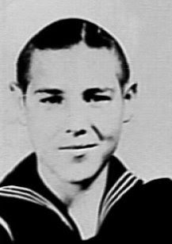

Graham lied about his age when he enlisted in the US Navy. He enlisted in the Navy on August 15, 1942 and was sent to boot camp in San Diego, California for six weeks, and afterwards was sent to Pearl Harbor at Oahu, Hawaii where he was assigned to USS South Dakota in September. His real age was not discovered until after he was wounded. (Unbelievable)

***From the Editor!***

**Hoorah!** (Editor: If this offends you, tough!)

It is said that the two places where people find God the fastest are in a prison cell and in a fox hole. Got to love the Marines, language and all. God Bless Colonel Jack Fessender.

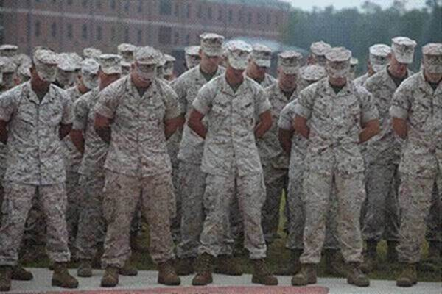

Marines have a wonderful way with words - clear, concise and to the point. If you look closely at the picture above, you will note that all the Marines pictured are bowing their heads. That's because they're praying. This incident took place at a recent ceremony honoring the birthday of the corps, and it has the ACLU up in arms.

"These are federal employees," says Lucius Traveler, a spokesman for the ACLU, "on federal property and on federal time... For them to pray is clearly an establishment of religion, and we must nip this in the bud immediately."

When asked about the ACLU's charges, Colonel Jack Fessender, speaking for the Commandant of the Corps said, “To hell with ACLU! GOD Bless Our Warriors. Send the ACLU to Afghanistan! Then watch those SONS OF BITCHES pray."

May God Bless America, One Nation Under GOD!

What's wrong with the picture? ABSOLUTELY NOTHING!

**From the desk of The Landlocked Sailor**

Bob Rotruck, CWO3, USN (RET)

**Testing Your Mettle**

How do you evaluate your character? Strong, determined, mild, introverted, bully, short tempered! We are all different as God intended. Over the period of a lifetime, strength of character (mettle) is tested again and again. Do we burst into a fit of rage when a passing motorist cuts us off in traffic? Do we weep (male or female) when we hear the Star Spangled Banner? Do we smile with American pride when we see a military person in an airport?

This is a description of a test that most of us will never have to make and hopefully you will never have to make. Imagine yourself in Afghanistan at an American outpost in the southern part of the country. You are part of a Forward Surgical Team, supplying emergency medical treatment to our military personnel and many Afghani civilians. Imagine that you have already put in a long day of surgical procedures when a military team brings two Afghani men through the gate of the Forward Operating Base (FOB). They both have severe wounds on their body, but especially their legs are in terrible shape. The initial report says that they were in a truck and were blown up by an IED (Improvised Explosive Device). You and your surgical team immediately begin lifesaving care and surgery. Their clothes are removed and turned over to the FOB security personnel for examination and forensic analysis.

One of the patients is conscious and he is interrogated by the security. You are working hard to save their lives and their limbs. There is sweat on your brow and you focus to keep your hands steady as wounds are cleaned and sewn closed. Bones are reconnected and casts are beginning to be applied when one of the senior security people advise your medical team that there is very strong evidence that these two men were not driving a truck, but in the process of setting up the IED. Something went wrong and the IED prematurely exploded. These two men are the enemy. These two men want to see Americans dead. These two men hate you.

Now you test your mettle! You put aside your feelings and continue to apply the massive amount of medical training you have endured to learn to save the lives of fellow human beings. Is it a struggle? Of course it is, but you persevere because it is the right thing to do and you are a proud American. Doing your job to the best of your ability! Your mettle has been tested and you passed with flying colors. God bless you and God bless America!

**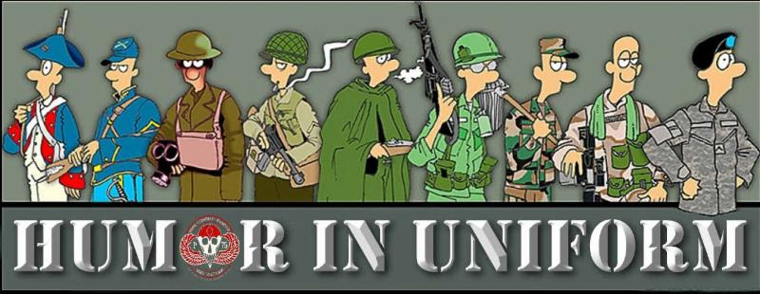**

**Bagpiper**

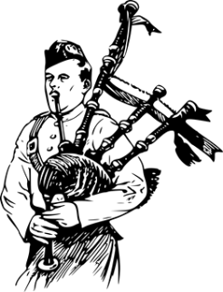

Very moving.....

As a bagpiper, I play many gigs. Recently I was asked by a funeral director to play at a graveside service for a homeless man. He had no family or friends, so the service was to be at a pauper's cemetery in the Nova Scotia back country.  As I was not familiar with the backwoods, I got lost and, being a typical man, I didn't stop for directions. I finally arrived an hour late and saw the funeral guy had evidently gone and the hearse was nowhere in sight. There were only the diggers and crew left and they were eating lunch. I felt badly and apologized to the men for being late. I went to the side of the grave and looked down and the vault lid was already in place. I didn't know what else to do, so I started to play. The workers put down their lunches and began to gather around. I played out my heart and soul for this man with no family and friends. I played like I've never played before, for this homeless man. And as I played "Amazing Grace", the workers began to weep. They wept, I wept, and we all wept together. When I finished, I packed up my bagpipes and started for my car. Though my head was hung low, my heart was full. As I opened the door to my car, I heard one of the workers say, "I never seen anything like that before, and I've been putting in septic tanks for twenty years." Apparently, I'm still lost… it's a man thing.

**From the Cynical Professor**

Read this carefully and really think about each statement on its own merits........

1. Just read that 4,153,237 people got married last year, not to cause any trouble but shouldn't that be an even number?

2. Today a man knocked on my door and asked for a small donation towards the local swimming pool. I gave him a glass of water.

3. I want to die peacefully in my sleep, like my grandfather. Not screaming and yelling like the passengers in his car.

4. If I had a dollar for every girl who found me unattractive, they would eventually find me attractive.

5. I find it ironic that the colors red, white, and blue stand for freedom until they are flashing behind you.

6. When wearing a bikini, women reveal 90% of their body... men are so polite they only look at the covered parts.

7. A recent study has found that woman who carry a little extra weight, live longer than the men who mention it.

8. Relationships are a lot like algebra. Have you ever looked at your X and wondered Y?

9. America is a country which produces citizens who will cross the ocean to fight for democracy but won't cross the street to vote.

10. You know that tingly little feeling you get when you like someone? That's your common sense leaving your body.

11. Did you know that dolphins are so smart that within a few weeks of captivity, they can train people to stand on the very edge of the pool and throw them fish?

12. My therapist says I have a preoccupation with vengeance. We'll see about that.

13. I think my neighbor is stalking me as she's been googling my name on her computer. I saw it through my telescope last night.

14. Money talks... but all mine ever says is good-bye.

15. You're not fat, you're just... easier to see.

16. If you think nobody cares whether you're alive, try missing a couple of payments.

17. I always wondered what the job application is like at Hooters. Do they just give you a bra and say, "Here, fill this out?"

18. I can't understand why women are okay that JC Penny has an older women's clothing line named, "Sag Harbor."

19. My therapist said that my narcissism causes me to misread social situations. I'm pretty sure she was hitting on me.

20. My 60 year kindergarten reunion is coming up soon and I'm worried about the 175 pounds I've gained since then.

21. Denny's has a slogan, "If it's your birthday, the meal is on us" If you're in Denny's and it's your birthday, your life sucks!

22. The pharmacist asked me my birth date again today. I'm pretty sure she's going to get me something.

23. On average, an American man will have sex two to three times a week. Whereas, a Japanese man will have sex only one or two times a year. This is very upsetting news to me. I had no idea I was Japanese.

24. The location of your mailbox shows you how far away from your house you can be in a robe before you start looking like a mental patient.

25. I think it's pretty cool how Chinese people made a language entirely out of tattoos.

26. Money can't buy happiness, but it keeps the kids in touch!

27. The reason Mayberry was so peaceful and quiet was because nobody was married. Andy, Aunt Bea, Barney, Floyd, Howard, Goober, Gomer, Sam, Earnest T Bass, Helen, Thelma Lou, Clara and, of course, Opie were all single. The only married person was Otis, and he stayed drunk.



“You need some dental work!”

**Sad Passing**

Please join me in remembering a great icon of the entertainment community.

The Pillsbury Dough boy died yesterday of a yeast infection and trauma complications from repeated pokes in the belly. He was 71. Dough boy was buried in a lightly greased coffin. Dozens of celebrities turned out to pay their respects, including Mrs. Butterworth, Hungry Jack, the California Raisins, Betty Crocker, the Hostess Twinkies, and Captain Crunch. The grave site was piled high with flours. Aunt Jemima delivered the eulogy and lovingly described Doughboy as a man who never knew how much he was kneaded. Doughboy rose quickly in show business, but his later life was filled with turnovers. He was not considered a very smart cookie, wasting much of his dough on half-baked schemes. Despite being a little flaky at times he still was a crusty old man and was considered a positive roll model for millions. Doughboy is survived by his wife Play Dough, two children, John Dough and Jane Dough, plus they had one in the oven. He is also survived by his elderly father, Pop Tart. The funeral was held at 350 for about 20 minutes.

We are all getting there! (Editor)



**Ten Dollars**

Fred and his wife Edna went to the state fair every year. Every year Fred would say, “Edna, I’d like to ride in that there airplane.” And every year Edna would say, “I know Fred, but that airplane ride costs ten dollars, and ten dollars is ten dollars.”

One year Fred and Edna went to the fair and Fred said, “Edna, I’m 71 years old. If I don’t ride that airplane this year, I may never get another chance.” Edna replied, “Fred that there airplane ride costs ten dollars, and ten dollars is ten dollars.”

The pilot overheard them and said, “Folks, I’ll make you a deal. I’ll take you both up for a ride. If you can stay quiet for the entire ride and not say one word, I won’t charge you, but if you say one word its ten dollars.”

Fred and Edna agreed and up they go. The pilot does all kinds of twists and turns, rolls and dives, but not a word is heard. He does all his tricks over again, but still not a word. They landed and the pilot turns to Fred, “By golly, I did everything I could think of to get you to yell out, but you didn’t.

Fred replied, “Well, I was gonna say something when Edna fell out, but then ten dollars is ten dollars.”



“Did you hear about this nutcase?”

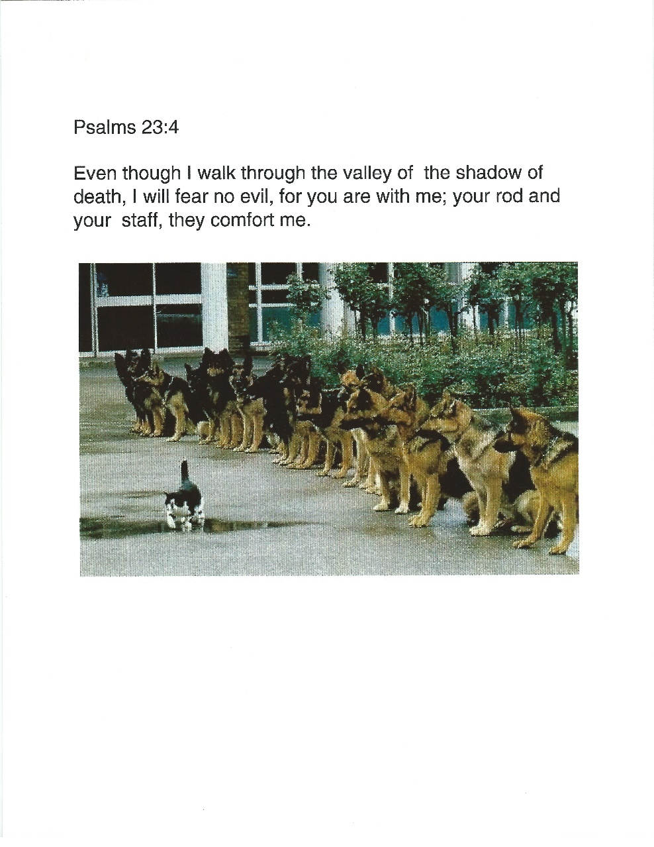

**Vintage Wine**

On the first day of school, the children brought gifts for their teacher.

The supermarket manager's daughter brought the teacher a basket of assorted fruit.

The florist's son brought the teacher a bouquet of flowers.

The candy-store owner's daughter gave the teacher a pretty box of candy.

Then the liquor-store owner's son brought up a big, heavy box. The teacher lifted it up and noticed that it was leaking a little bit. She touched a drop of the liquid with her finger and tasted it. "Is it wine?" she guessed. "No," the boy replied. She tasted another drop and asked, "Champagne?" "No," said the little boy............."It's a puppy!"

**OBVIOUS SIGNS THAT HUMANITY IS REGRESSING?**

****

****

****

****

**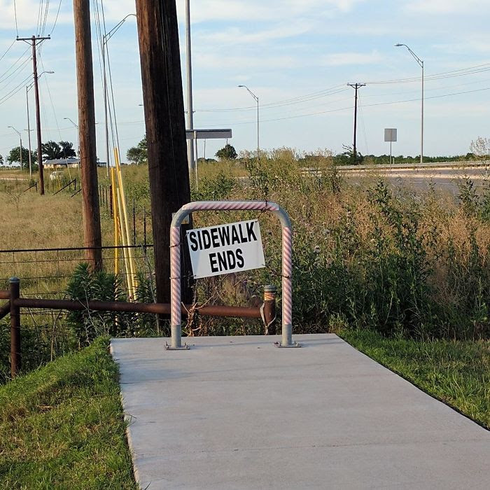**

****

**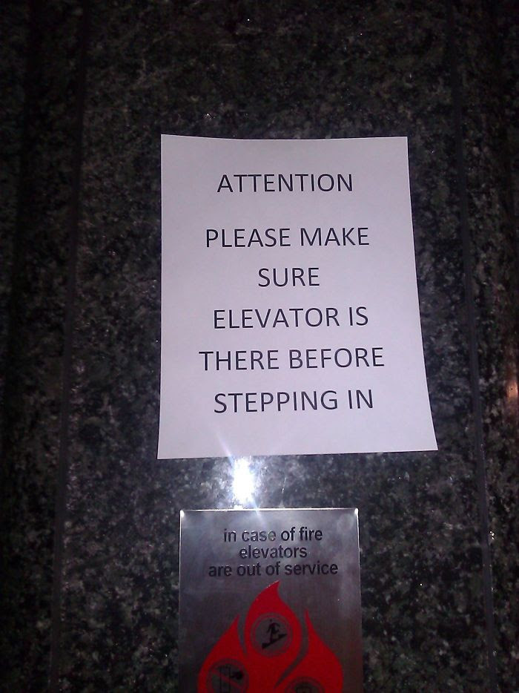**

****

***Trivia Answer***

**Bitchin' Betty** – Most U.S. military aircraft feature warning systems that frequently utilize female voices. Bitchin' Betty's alert pilots to life-threatening situations.

From the editor ☺

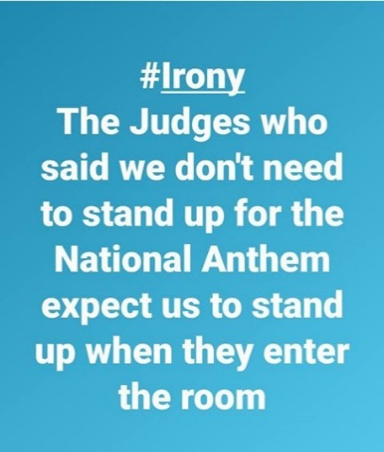

**What do you suppose would happen if they came into the courtroom and everyone "took a knee"? Just asking………**

**Newsletter articles/stories/photos**

Any articles, stories and/or photos submitted for the newsletter must be received by the cutoff date which for our newsletter is the 20th of the month preceding publication. Photos must be accompanied by text which describes the event, names, dates, credits and any other pertinent facts so our readers understand the story behind the photo(s). Due to space availability, the editor reserves the right to include or exclude information or photos for a given two month period of publication.

**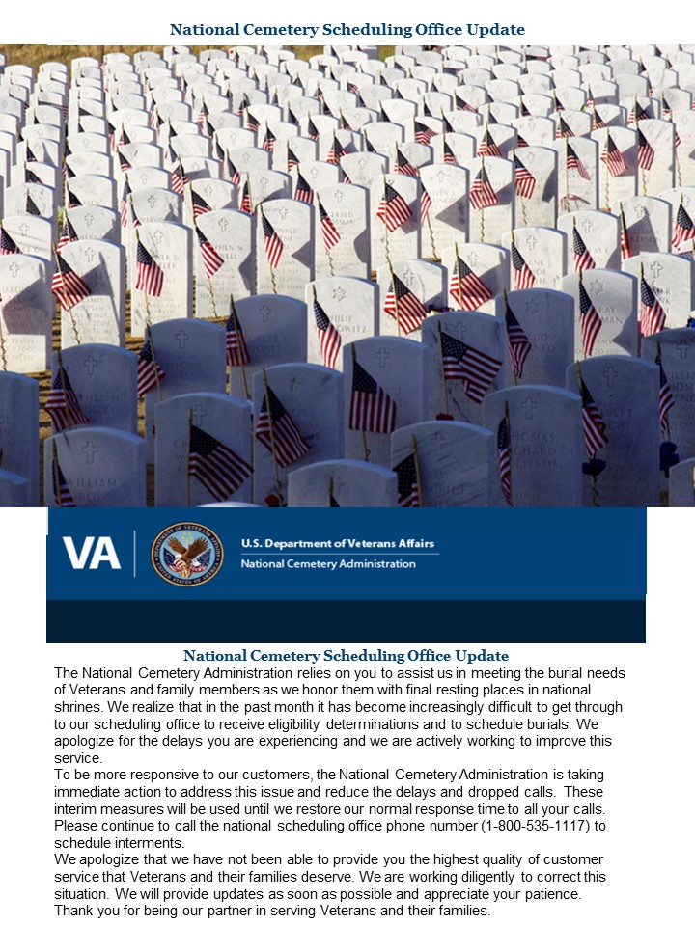**

**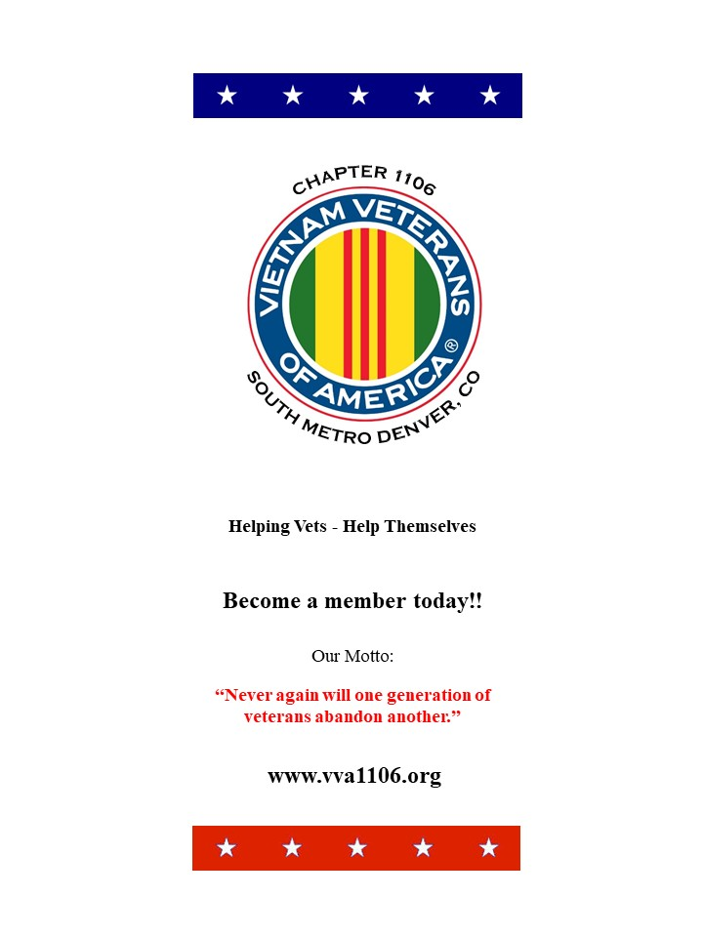**

**COVER PAGE OF NEW CHAPTER BROCHURE**

**FRIENDS OF CHAPTER 1106**

|  |  |
| --- | --- |
| **ERC Management, LLC**  791 Southpark Dr., Suite 600  Littleton, CO 80120  [720.328.3299](tel:720.328.3299)  [www.FreddysUSA.com](http://www.freddysusa.com/) | |
| **Panera Bread**  9579 S. University Blvd. Highlands Ranch, CO 80126  720-348-1112 | **American Legion Post 1260**  **E:\Documents\ALP1187\images\AmericanLegion_logo.jpg** |
| **Spradlin Printing, Inc.**  11903 S. Parker Road Parker, CO 80134 | **South Metro Denver Fire & Rescue**  9195 E Mineral Ave  Centennial, CO 80112 |
| Monthly Membership Meetings VISITORS ARE ALWAYS WELCOME!   3rd Saturday of each month at 10:00a.m.   Our meetings are held at: [VFW Post 2461](http://www.vfwpost2461.com/) 1350 S Broadway, Denver, CO 80210 | [http://www.applewoodfixit.com/wp-content/themes/applewood/images/header-logo.png](http://www.ApplewoodFixIt.com)  Applewood Plumbing Heating & Electric  **Main Billing Office:** 5000 W 29th Ave.  Denver, CO 80212 **Phone:** 303-232-6611 **Fax:** 303-477-4310 **Email:** [custservice@applewoodfixit.com](mailto:custservice@applewoodfixit.com) |
| 9137 E Mineral Cir Ste 100  Englewood, CO 80112-3422 | South Metro – Instant Imprints  6882 S. University Blvd.  Centennial, CO 80122  [303-771-2244](tel:303-771-2244) |
| https://scontent.fapa1-2.fna.fbcdn.net/v/t1.0-9/11755678_1048713308485999_8302677469177969743_n.jpg?oh=7f29d6fe26e879d42add098d5cded1fa&oe=5A27AD2B  VFW Post 2461, 1350 S. Broadway, Denver, CO 80210 | http://www.cruisin1430.com/sites/g/files/giy711/f/KEZW_Header_Large_Logo_0.png  **STUDIO 1430 Main Office:** 4700 South Syracuse Street, Suite 1050 Denver, CO 80237 |
| https://scontent.fapa1-2.fna.fbcdn.net/v/t31.0-8/10575197_682186265194110_4051472928662048560_o.jpg?oh=2630b186dcf3a20f1d7fc8fa25e0a5ba&oe=5A17C4AB  **Military Order of Purple Heart**, Chapter 1041, Arvada, CO | **Veteran’s Puppy for Life**  [https://scontent.fapa1-2.fna.fbcdn.net/v/t1.0-9/19060085_1943219205919091_2430547914200531885_n.jpg?oh=2442c16b113594f4bdc40eec81330246&oe=59EB9F66]( http://www.vetpuppyforlife.org)  <http://www.vetpuppyforlife.org> |
| Logo of The Home Depot  **Home Depot Foundation**  8477 S Yosemite St  Lone Tree, CO 80124 | Golden Corral  **Golden Corral**  15775 E. Arapahoe Rd  Centennial, CO 80016 |
| A FULL-SIZE REPLICA OF THE HONOR BELL  **The Honor Bell Foundation**  P.O. BOX 12400 DENVER, COLORADO 80212  720.282.9182 | **The UPS Store**  10940 S. Parker Road  Parker, CO 80134  P: 303-841-8483  F: 303-841-8685  E: store1548@theupsstore.com |