**Inside this issue:**

Notes from the President

[Member Feature](#Memberfeature)

[Military Trivia](#Militarytrivia)

[Guest Speaker](#Guestspeaker)

[Membership](#Membership)

[Board of Directors/Officers](#Boardofdirectors)

[Working Committees](#Workingcommittees)

[Meetings/Events Calendar](#Meetingsevents)

[Announcement Corner](#Announcementcorner)

[Books/Articles Published by Members.](#Booksarticles)

[From the Editor](#Fromtheeditor)

[Light Side](#Lightside)

[Trivia Answer](#Triviaanswer)

[Flyers and publicity](#Flyers)

[Region 8/9 Pre-Convention Conf.](#PCC)

**Events**

The next Chapter meetings will be May 6, 2017 & June 6, 0900 S. Metro Denver Fire & Rescue Board Room 9195 E. Mineral Ave. Centennial, CO. The Board of Director’s meeting will follow 30 minutes following the regular mtg.

Next CO State Council meeting June 10th.Phillip S. Miller Library, Castle Rock

***Editor’s Note:***

**Notice:**

If you have moved or changed your address, PLEASE notify us immediately! Contact: Lee White, Membership Chair

E-mail: <mailto:flyboy51@q.com>

Phone:  303-519-2252

###### COPYRIGHT NOTICE: In accordance with Title 17 U.S.C. Section 107, any copyrighted material in this newsletter is distributed under fair use without profit or payment to those who have expressed a prior interest in receiving the included information for nonprofit research and educational purposes only.

This version of the newsletter is in Microsoft Document (.docx) format so that the links will work. Put your cursor over the link, depress your Control Key (ctrl) and depress your left mouse button and it will take you to the listed link position. PDF format the links will not work.

***Notes from the President***

Lee White

**REMEMBERING MEMORIAL DAY**

Spring is here and Memorial Day will be observed and remembered on Monday, May 29, 2017.

Memorial Day, originally referred to as Decoration Day, is a day of remembrance for those who have died in service for the United States of America. Over two dozen cities/towns claim to be the “birthplace” of Memorial Day. While Waterloo, New York, was officially declared the birthplace of Memorial Day by President Lyndon Johnson in May 1966.

Regardless of the exact date or location of its origin, Memorial Day was borne out of the Civil War era with a desire to honor its dead.

On the first Decoration Day, Gen. James Garfield made a speech at Arlington National Cemetery and 5,000 participated and decorated the graves of 20,000 Union and Confederate soldiers buried there.

The first state to officially recognize the holiday was New York in 1873. By 1890, it was recognized by all the Northern States. The South refused to acknowledge the day, honoring their dead on separate days until after World War I.

It is now observed in almost every state on the last Monday in May with the passage of the Congressional National Holiday Act of 1971.

LET’S ALL REMEMBER THEIR SACRIFICES

***“******Member Feature”***

Doc Robert (Bob) Mallin, MC, Capt. USA is a Vietnam Veteran and served 1966-68 in Tây Nguyên (Vietnam Highlands) and Ft. Eustis, VA. His most memorable experience was getting “shot” and we’re not talking a medical needle! He is a Purple Heart recipient along with Bronze Star, Vietnam Cross of Gallantry and the Combat Medical Badge and others. He was Buffalo Soldier as member of the 1st Squadron – 10th Division Calvary. He is blessed with two children, ten grandchildren and two great grandchildren. His wish is for the chapter to engage with other veteran groups and provide input to our Federal Government regarding our veterans and military through the Military Officers Association of America and lobbying politicians. Thanks for your service Doc!!!

***Military Trivia***

What is a **Mustang**? Answer at the [end of the Newsletter](#Triviaanswer).

***March Special Guest***

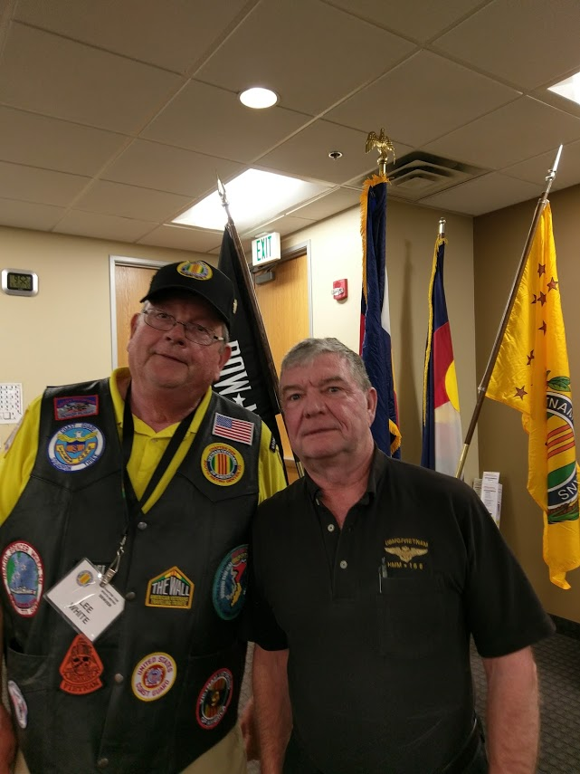

Mike Shea, Adjunct Professor, University of Denver Sturm College of Law, and Veterans Advocacy Project spoke to our group primarily about how we and all veterans can get assistance for claims with the VA. Thank you Mike for a very informative presentation. Contact info for Mike: Email: [mshea@law.du.edu](mailto:mshea@law.du.edu), email VAP office: [vap@law.du.edu](mailto:vap@law.du.edu) or phone: 303-660-6421.

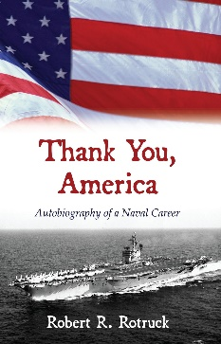***April Speaker***

Bob Rotruck spoke to the Chapter about writing their stories. He volunteered to assist any member if they had issues with writing. Bob proclaimed that, “None of you are going to live forever!” Four hands went up of those that said they were going to live forever!!! Good luck!!

***Membership!***

VVA Chapter 1106 Membership: 72 (as of 4-15-17)

AVVA: 20

TOTAL: 92

Welcome new VVA members:

Glen Payne

Barry Fiore

Ted Ulrich

Ronald Smith

Transfers from "At Large" status to Chapter 1106:

Carl Brockwell

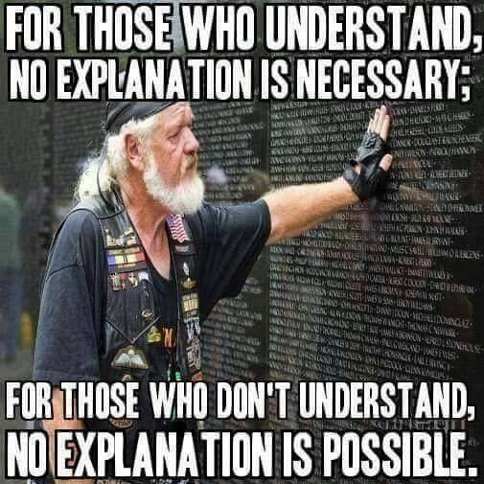

***Board of Directors/Officers***

Lee White - President

Bob Easter - Vice-president

Joe Plant - Treasurer

Hazel Simeon - Secretary

Board Members - Milt Omoto, Patti Ehline, Paul Seppo, Dave Lyons

***Working Committees***

(Folks are needed to fill some spots!)

Sergeant-at-Arms – John Vargas

Agent Orange/PTSD - OPEN

Membership - Lee White

Membership outreach – Dave Lyons

Mental Health: Patti Ehline, Warren Harrison

Newsletter Editor - Bob Rotruck

Fundraising/Grants - Milt Omoto

Marketing/Media/Events – Pat Surrena

POW/MIA – Mike Messenger

Webmaster – Robert Senatore

Women Veterans - Patti Ehline

Scholarship Program - Hazel Simeon, Bob Easter, Joe Langran, Paul Seppo, Mary Seppo, Bob Rotruck

Veteran Emergency Assistance Committee - Joe Plant, Bob Rotruck, Lee White, Dave Lyons

Speakers Bureau – Bob Easter, Glen Payne, Bob Mallin, Mike Messenger, Roger Lanier, Mark Lanphier, Tom Werzyn

***Meetings/Events Calendar - 2017***

April 29th. - Agent Orange/PTSD/Hep-C Town Hall Meeting

May 6th- VVA Chapter 1106 Monthly Meeting

May 20th. - "Gasoline & Caffeine Car Show

May 26th. - Sky Sox Baseball - POW/MIA Chair Dedication

May 27th. - Chapter Poppy Drive

May 28th. - Englewood High School Memorial Day Event

June 3rd. - VVA Chapter 1106 Monthly Meeting

June 10th. - Colorado State Council Meeting

June 23rd. & 24th. - Region 8/9 Pre-Convention Conference

July 1st. - VVA Chapter Monthly Meeting

July 4th. - Annual Highlands Ranch July 4th. Parade

***The Origin of Chu Lai***

Rick Armstrong writes, “I served there during my first deployment but I cannot recall the Hill but had a commanding view of the ‘ville, RMK-BRJ compound and surrounding countryside. I also did duty at the massive ammo dump in the middle of a “desert” with an M-67A2 in support of the 7th Marines. I didn’t know the following but I found it in the SGT Grit newsletter.”

Until the Marines landed on the beach in Quang Tin Province in 1965, Chu Lai didn’t even exist. There were no towns in the vicinity, and the area that was chosen to be an expeditionary airfield had no designation on any of the maps. As it turns out, the name “Chu Lai” isn’t even a Vietnamese name – it’s Chinese! Here is how it happened.

*“Although few things were named in Vietnam for living serviceman, there is a known story of one location named for a living Marine in Vietnam. Chu Lai, in Quang Tin Province, was not even a town when the U.S. Marines constructed a major base there. When the MajGen Victor H. Krulak selected the site for an airfield, a naval officer accompanying him remarked that the site was not marked on the maps. Krulak replied that the name was Chu Lai, giving the officer his (own) name in Mandarin Chinese – thus General Victor Krulak named Chu Lai for himself.”* (This from the book *“Vietnam Military Lore, Legends, Shadows and Heroes*”, **by MSgt Ray Bows, USA (RET)**.

This same reference to the origin of the name given to the area now known as “Chu Lai” (which today is currently maintained by the Vietnamese as an International airport), can also be found in **Robert Corman’s** book, “*Brute: The Life of Victor Krulak. U.S. Marine.”*

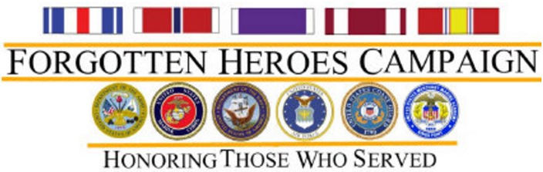

***Forgotten Heroes Campaign***

**Mission:** Forgotten Heroes Campaign (FHC) directs searches for veterans who have honorably served their country and present them or their family member(s), medals, awards, ribbons and badges earned but never received.

**Honoring Those Who Served**

Founded in 1998, the FHC helps men and women who served in the armed forces receive the medals they earned but never received. To date, the FHC has helped over 500 veterans and their families get the recognition so long overdue to them. The FHC especially seek out veterans who served in combat zones and were authorized an award. These are presented in a special ceremony.

***Speakers Bureau***

Bob Easter, Chapter Vice President has put together a group to reach out to students and community organizations to discuss the Vietnam War. They had an initial planning meeting Saturday, February 18, to discuss objectives, target audiences, presentations, content (subject, allotted time, personal perspective, handouts, etc.), biography (military background {prior to deployment and in the Republic of Vietnam}), audio Visual aid requirements, dress code, exhibits, and clients.

Since the initial meeting, evaluation forms for students and for [client] instructors have been designed as well as "For further reading..." listings of Vietnam war-related books, both hardback and paperback have been produced.

The next planning/development meeting was conducted for March 18.  Each presentation is designed to be one hour in length, the normal duration of an academic class period. The intent is to have three presenters for each session drawn from a pool of seven.  The speakers will deliver at the client's convenience.  It remains to be seen, however, how active each participant will be, or has the time to be. Hopefully, our group will grow so it can reach out to more people/organizations. Contact Bob Easter if you have an interest in this endeavor.

***Camp Lejeune Update***



1950s through the 1980s, people living or working at the U.S. Marine Corps Base Camp Lejeune, North Carolina, were potentially exposed to drinking water contaminated with industrial solvents, benzene, and other chemicals. Health benefits Veterans and family members who served on active duty or resided at Camp Lejeune for 30 days or more between January 1, 1957 and December 31, 1987 may be eligible for medical care for 15 health conditions:

* Esophageal cancer
* Breast cancer
* Kidney cancer
* Multiple myeloma
* Renal toxicity
* Female infertility
* Scleroderma
* Non-Hodgkin’s lymphoma
* Lung cancer
* Bladder cancer
* Leukemia
* Myelodysplastic syndromes
* Hepatic steatosis
* Miscarriage
* Neurobehavioral effects

VA published a proposed regulation September 11, 2013, which discusses how the VA will improve health care to eligible Veterans. You may comment on the proposal by October 11, 2013.

The VA is working on regulations for family member care and will publish these separately.

**Veteran health Care**

You can receive care now if you’re eligible. You don’t need to wait for the proposed regulation to become final. If you’re already enrolled in VA health care, contact your local VA health care facility to receive care.

Family member health care reimbursement

VA will be able to reimburse you for eligible out-of-pocket expenses for the 15 covered conditions after they publish regulations. The VA can only pay for claims after you have re-ceived payment from all your other health plans.

You will be able to continue to receive health care from your providers. VA won’t be providing you direct health care. What you can do now if you have one of the covered conditions:

Call 1–877–222–8387 and ask to be added to VA’s Camp Lejeune database. The VA will contact you when regulations are published.

**Gather documents showing:**

Your relationship to a Veteran who served at Camp Lejeune, such as marriage license or birth certificate. You lived on the base for 30 days or more between Jan. 1, 1957 and Dec. 31, 1987, such as copies of orders or base housing records. Keep receipts for health care expenses you paid for a covered condition on or after March 26, 2013. This is the date when Congress began to fund this program. Hold on to your documents and receipts. We’ll let you know when to submit these after regulations are published. Don’t cancel your health insurance. This program only covers the 15 health conditions listed above. It doesn’t meet the minimum standard for health coverage under the Afford-able Care Act.

**Compensation Benefits**

The August 6, 2012 law applies to health care, not disability compensation. At this time, there is insufficient scientific and clinical evidence to establish a presumptive association between service at Camp Lejeune during the period of water contamination and the development of certain diseases.

VA is closely monitoring new research. VA representatives regularly attend the quarterly Community Action Panel meetings hosted by The Agency for Toxic Substances and Dis-ease Registry (ATSDR).

Veterans may file a claim for disability compensation for health problems they believe are related to exposure to contaminated water at Camp Lejeune. VA decides these claims on a case-by-case basis.

***Announcement Corner***

**Colorado Auto Club’s**

**Gasoline & Caffeine**

Submitted by Jim Hemphill

**Colorado Auto Club** is pleased to announce the first **Gasoline & Caffeine** car show for 2017.  Responding to member and sponsor suggestions, the first show is scheduled May 20th, the third Saturday of May, later than the weather that so compromised our shows last year. **Gasoline & Caffeine** events are planned each month May through October, weather permitting, at the Colorado Entertainment District in Lone Tree.  Initial 2017 attendance objective is 100 vehicles with plans to grow through the season.  Emphasis vehicles (such as Hellcat, Hot Rods, Corvette, Mustang, Trucks, Slingshots) will be selected for shows.

As you can see from the Calendar page on the **Colorado Auto Club** website (www.coloradoauto.club), the dates for the 2017 **Gasoline & Caffeine** car shows are as follows:

May 20

June 17

July 15

August 19

September 16

October 21

Continuing their 2016 sponsorships, the area restaurants’ support for **Gasoline & Caffeine** 2017 car shows is appreciated.  Panera Bread and Mimi’s Café will have complimentary coffee to all attendees, car owners and admirers.  Several restaurants plan to offer car show attendees “**come back**” discount coupons.

Responding to the concern for awareness of dates and times or **Gasoline & Caffeine**shows, perhaps the most advancing input that **Colorado Auto Club** received from the end of 2016 assessment was the recommendation to broaden the awareness of **Gasoline & Caffeine** through social media communications with car clubs.  As a compliment to other activities of car clubs, not in competition with them, **Colorado Auto Club**welcomes their participation in **Gasoline & Caffeine**.  Where your car club websites allow, please make the following **Gasoline & Caffeine** poster available for your website.  Please let the **Club** know of situations where we can support your efforts and work with you for website postings.  The earlier car clubs came take the show schedule into consideration the greater their availability to participate. Contact:

Jim Hemphill, **Colorado Auto Club,** 6203 Lions Point, Littleton, Colorado 80124, ([720) 810-2234](mailto:720)%20810-2234) [jimhemphill@coloradoauto.club](mailto:jimhemphill@coloradoauto.club)

[See flyer click here!](#Gasoline)

Submitted by Barry Fiore:

**Forgotten Heroes Campaign of Denver**

Two Golf Tournament Fundraisers are scheduled: Sunday, May 21, 2017 and Sunday June 25, 2017. Both events will be held at **“The Links Golf Course”** 5815 Gleneagles Parkway, Highlands Ranch We will be giving away prizes for closest to the pin, longest putt and longest drive. For more information or registration, contact Barry Fiore at (303) 507-6034.

**Message from Mike Messenger:**

It’s Official… MLB Official!! The “Honor Chair” is here, our negotiations with the Colorado Springs Sky Sox are in full swing and attached is the official flyer for this event. I will also have a poster made in time for the Colorado Springs Swap meet.

There is a tremendous amount of excitement by the Sky Sox in making this event an evening of HONOR, THANKS and CELEBRATION to those who served and our chapter will be at the heart of it all. Although we are still working out some of the logistics of the event, I can tell you we already have interests from other military organizations in Colorado Springs like ours to assist and more importantly, BUY TICKETS.

We will be selling our tickets for $12.00 (two dollar discount) and for each ticket we sell we will receive $4.00. As everybody else works for a living, I and Terry will manage ticket sales. Our chapter is charged with selling 150 tickets, but have no limit beyond the 150. We already have a section reserved in the stadium next to the chair for those who buy tickets from us. We are also hoping to set up our Missing Man Table (no ceremony), and are waiting for a confirmation.

Gary and Karen Myers, Randy and myself have a meeting with the Sky Sox on February 23rd. We should have more event details afterwards. This is exciting everyone as we have an opportunity to honor our Colorado POW/MIA’s at every home game for the Sky Sox. We are expecting a lot of press and air time coverage before and on game day. The Sky Sox are the Milwaukee Brewers Triple AAA farm team so I’m hoping they will get a “tickler” out to their fans.

So start thinking about the POW/MIA Honor Chair Ceremony as it’s going to take all of us to get involved.

**Englewood High School Memorial Day Event**

Englewood has a very patriotic High School. They have annual Veterans Day and Memorial Day celebrations. Don't miss the May 28th (Sunday) event. Come Early 1:30 for per ceremony events. Program starts in Fisher Auditorium at 2:00. The honor bell foundation program follows outside at 4:00. The honor bell foundation will have a live bugler, a rifle salute and present an American Flag to one of our Gold Star family members. [See flyer at the bottom of the newsletter](#Englewood).

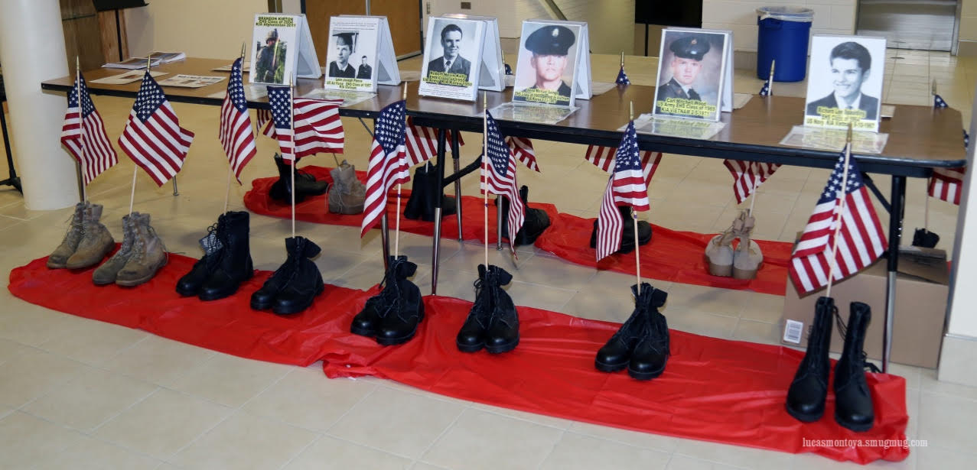

Honor table for former students of EHS

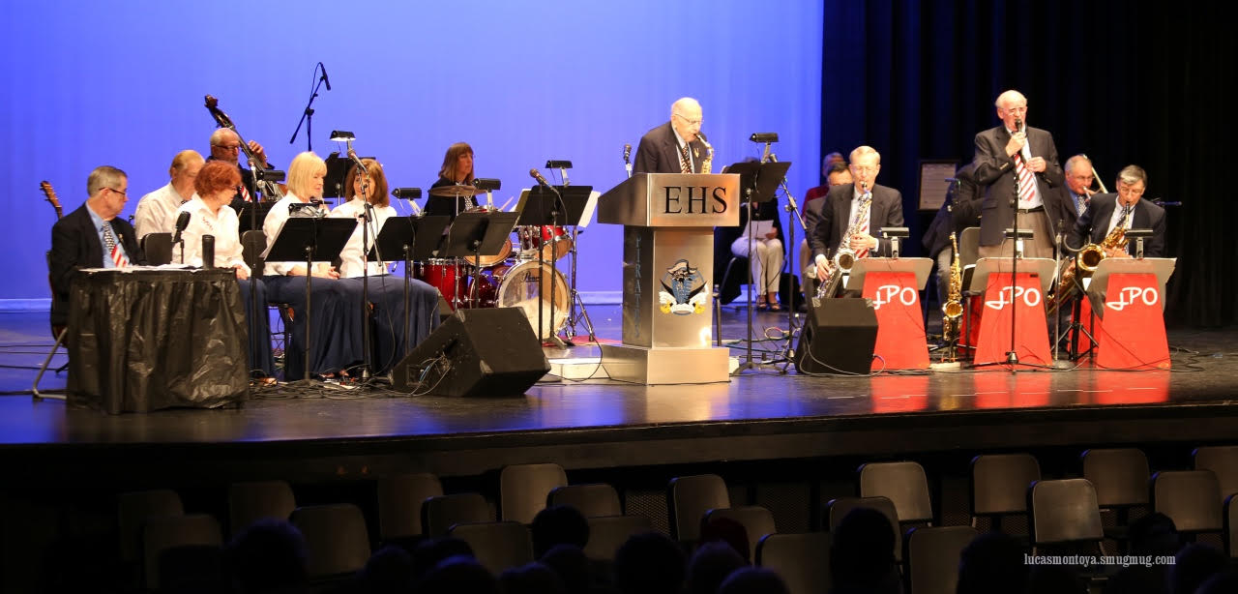

Stage for event!

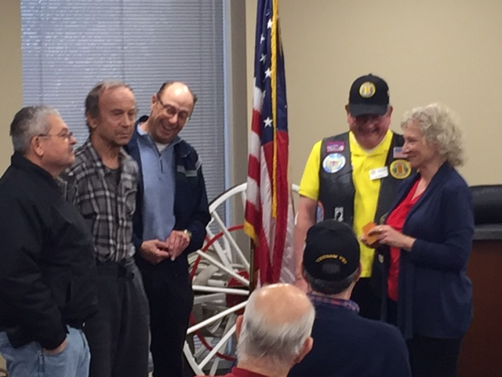

At the April meeting, Suzanne Sigona presented VV Commerative lapel pins to (right to left).Jim Henderson, Mike Burzynski, and Ronald Smith

**Best shot from a M1911 .45 ACP**

**Submitted by Roy Miller, Lt. Col. USAF (Ret)**

Owen John Baggett was born in 1920 in Graham, Texas. By 1941 he graduated from college and went on to work on Wall Street, but by the following year, he enlisted in the Army Air Corps (now USAF) when the United States entered the war.

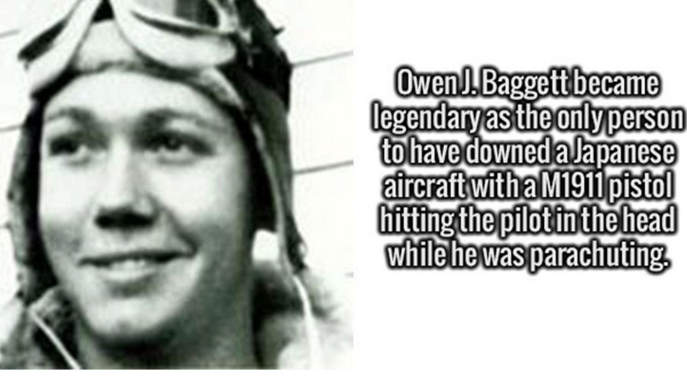

A studious man, he graduated from pilot training in just five months and was sent to Burma, flying a B-24 Liberator. What happened the following year is one of those stories hard to describe. On March 31st, 1943, Baggett and his squadron were sent on a mission to destroy a bridge of strategic importance. On their way, the B-24s got intercepted by Japanese Zeros which hit the squadron hard. Baggetts' plane was riddled with bullets to such an extent that the crew was forced to bail out. While parachuting, a Japanese pilot decided that downing the plane wasn't enough. He circled around and started shooting at the bailed out pilots, killing two of the crew. Seeing this, Baggett did the only thing he could. He played dead. Not convinced Baggett was dead, the Zero pulled up to him at near stall speed, the pilot opening his canopy to check on his horrendous work. Not wasting any time and thinking on his feet (no pun intended), Baggett pulled out his pistol and shot the pilot right in the head.

This is considered the best shot by a Caliber .45 M911 pistol of ALL TIME.

The last thing he saw was the Zero spiraling toward earth.

When he landed, he and the other bailed out crew members were captured and sent to a POW camp where they remained till the end of the war. They were liberated by OSS agents (World War II version of the modern CIA) and Baggett was recognized as the only person during the war to shoot down a Zero with a pistol.

<https://www.truthorfiction.com/owen-john-baggett-killed-japanese-pilot-mid-air/>   Reported as Truth!

**2017 Soldier Stone Trip**

From Hazel Simeon

A Chapter trip is planned for August 18-19 to Soldier Stone near Salida, Colorado. This is a very secluded but very special place where all those countries are recognized for their support and losses during the Vietnam War. The Gateway Inn & Suites in Salida have reserved 20 rooms for our adventure at a cost of $99.00 per night for single, double, queen, and queen double. The actual trip to the monument will be conducted on Saturday the 19th, but if you haven’t visited this part of Colorado you are encouraged to site see Friday afternoon and Sunday morning. Reservations must be made by July 15th. Call them at 719-539-2895. The reservations are being held under the name: Soldier Stone Vets. The hotel website is: <http://salidagatewayinnandsuites.com>.

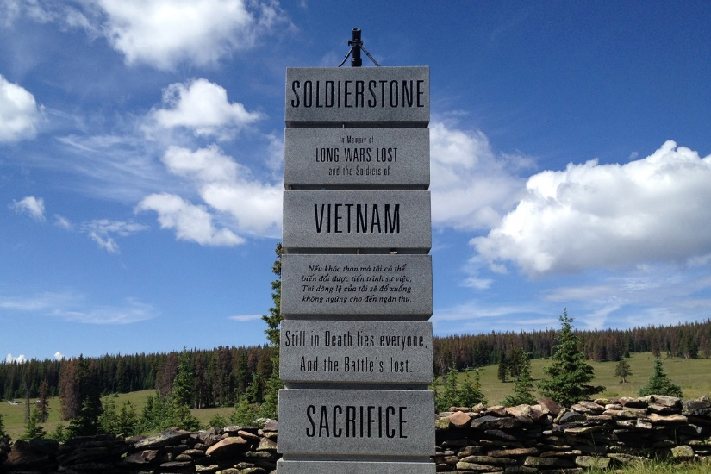

Soldier Stone

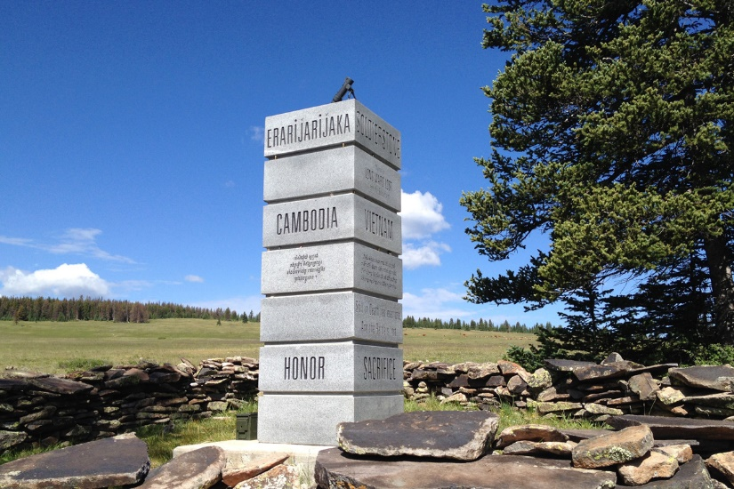Soldier Stone

*From National League of POW/MIA Families*

**Americans Recently Accounted for**

**On March 7th, DPAA released an announcement that Captain Daniel W. Thomas, USAFR, listed as MIA on July 6, 1971 in South Vietnam, had been accounted for. Remains were recovered by a Vietnamese Unilateral Recovery Team (URT) in August, 2014, that were identified in August, 2015, as those of Major Donald G. Carr, USA, the other person in the OV-10A piloted by Capt Thomas. Subsequent recovery efforts by the URT and repatriation of additional remains and material in April, 2016, brought the more recent ID of Capt Thomas. DPAA also listed on its website, under Statistics, the accounting for Colonel William E. Campbell, USAF, listed as MIA in Laos January 29, 1969. His remains were recovered April 17, 2014, identified August 29, 2016, and placed on the DPAA website this past week. On February 22nd, DPAA announced the ID of Capt Robert R. Barnett, USAF, listed as KIA/BNR on April 7, 1966 while piloting a B-57B over Laos. His remains were recovered June 18, 2015 and identified August 16, 2016. Earlier this year, a Marine Corps Reserve officer, 1st Lt William C. Ryan, was the first person since June of 2016 announced as accounted for from the Vietnam War. 1st Lt Ryan was listed KIA/BNR in Laos on May 11, 1969. His remains were recovered January 27, 2016, and identified December 7, 2016. The number still missing and otherwise unaccounted-for from the Vietnam War is now 1,614.

Of the 1,614 still missing (POW/MIA) and unaccounted-for (KIA/BNR), 90% were lost in Vietnam or in areas of Cambodia and Laos under Vietnam’s wartime control: Vietnam-1,260 (VN-463, VS-797); Laos-298; Cambodia-49; PRC territorial waters-7. These country-specific numbers can and do fluctuate when investigations result in changes to loss locations. Since formation in 1970, the League has sought the return of all POWs, the fullest possible accounting for those still missing, and repatriation of all recoverable remains.

The total accounted for since the end of the Vietnam War in 1975 is now 969. There follows a breakdown by country of the 969 Americans accounted for since the April 30, 1975 end of the Vietnam War: Vietnam – 658, Laos – 268, Cambodia – 40, and the PRC, 3. In addition, 63 US personnel were accounted for between 1973 and 1975, for a grand total of 1,032. Of the 63, 9 were from Laos, 53 from Vietnam, and 1 from Cambodia. These Americans were accounted for by unilateral US effort in areas where access was possible, not due to cooperation with the post-war governments of Vietnam, Laos or Cambodia. Added together, a total of 277 have been recovered and identified from Laos, 711 from Vietnam, and 41 from Cambodia.

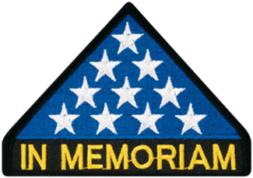

***In Memoriam***

From Lee White. Is with profound sadness that I share this news that Manuel (Manny) Pedraza lost his daughter Rachel on March 19 in a skiing accident. She was only 48, a wife, mother and teacher. From the family: “Despite all of her impressive accomplishments, those are not what we remember most about Rachel. We remember her as a lover and disciple of Jesus; and amazing wife; a deeply devoted mom to Marco, Jacob, and Aaron; a loving daughter, and cherished friend. We remember her as one who loved and lived life to its fullest, inviting us to do the same. “

I ask that you to pray for Manny, his family and his daughter’s family. Manny Chartered VVA Chapter 1075 Feb.05, 2013 and VVA Colorado State Council  April 19, 2013 and is the past President of the Colorado State Council and current President of VVA Chapter 1075 in Colorado Springs, Colorado.

***Book/Articles Published by Members***

**And I call it “Wall Magic”**

By Suzanne Sigona

Remarkable things happen on a regular basis at the Vietnam Veteran’s National Memorial in Washington, DC. I first noticed this Wall Magic after I started my work there in 1988.

In those days before websites and online databases, our sole resource was the Directory of Names. It allows you to search the names alphabetically, but in a world of nicknames, this large book has limits. A guide in the front of the book lists timeframes. This allows those who suffered losses to locate a date, the names of those lost, and hopefully, nudge a memory. I was determined and often reached for more avenues of information.

I learned very early how many of us were carrying baggage from the Vietnam experience and I quickly became aware of the weight of that baggage. My interaction with family members taught me how important it is to fit all the pieces together. It is as though if we gather enough pieces, the loved one will magically become whole again. I saw how critical it is for family members to connect with someone who saw, touched, or spoke with their loved one in those last hours of life.

I was always amazed by a woman named Corky. She was a volunteer with endless energy and commitment. Her father was a Navy Seal and his name was on The Wall. In the early days of The Wall some professed to have served in Vietnam when in fact they had not. Corky had also run into a number of phonies, many of whom violated decency even more by claiming to have known her father.

I typically worked on Sundays. In the fall of 1990I was working on one those quiet mornings where every footstep along the path could be heard and each visitor seemed so purpose-filled. One in particular appeared to be a Native American man who was burning something that was braided. One of the lessons I have learned as a volunteer is that there is a fine line between helping and interfering.

I watched as he took his time and eventually walked back toward the enclosure chain to observe his panels. When the time seemed right I asked what he was burning. He shared his experience and described the purpose of sweet grass. His ceremony was to draw in the spirits for healing. Eventually he explained that he had been in the city for an AA meeting, and this trip to The Wall “was the last door he had to walk through” before his journey home. We spoke for a while and discovered that we had mutual acquaintances in his home state 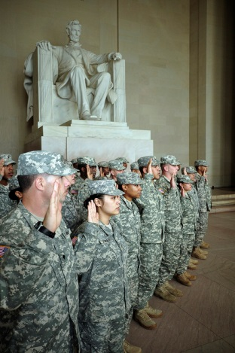of Maine. He gave me his phone number so I could eventually establish contact with the mutual friend.

Within half an hour of his leaving, there was another man with his wife at The Wall’s apex. He stood almost at attention as he studied the panels. His head was pitched back as though this tilting could keep the tears from flowing down his face. I slowly approached him and said, “If I can locate information for you, please let me know.” I noticed the Trident of a Navy Seal on his ball cap.

After a period of time I returned to the apex. He explained that he was “on a pilgrimage”. He had been to Coronado, to Biloxi (where a buddy gave him the ball cap), and now The Wall was one of his stops.

I acknowledged his Trident and told him about Corky, the daughter I had come to know and how she struggled to learn more about her father. He asked her father’s name and when I responded his wife spoke up, and said,, “That was his C.O.”

Knowing that everyone’s space needs protection I let him know that if he was ever ready to contact this daughter that it would be very important to her. I then left him in his experience. He approached me later and spoke words that seemed oddly appropriate and so important. He asked for information on the daughter and said, “I would like to pay my respects.”

I immediately contacted Corky to let her know what was happening. In the midst of her shock for what was heading her way and relief for finally finding answers, she commented that this was unbelievable. I countered, “It’s Wall Magic.” With equal levels of excitement and anxiety, they met. Corky finally connected to someone who knew her dad.

Shortly after this incident I called the Native American man in Maine and told him what had happened. All he said was, “Pay attention because much more will happen there.”

**The Enlistment Oath**

**By Hazel Simeon**

"I, (state name of enlistee), do solemnly swear (or affirm) that I will support and defend the [Constitution of the United States](https://en.wikipedia.org/wiki/Constitution_of_the_United_States) against all enemies, foreign and domestic; that I will bear true faith and allegiance to the same; and that I will obey the orders of the President of the United States and the orders of the [officers](https://en.wikipedia.org/wiki/Officer_%28armed_forces%29) appointed over me, according to regulations and the [Uniform Code of Military Justice](https://en.wikipedia.org/wiki/Uniform_Code_of_Military_Justice). [So help me God](https://en.wikipedia.org/wiki/So_help_me_God)."

If you were an enlisted person in the military you took this oath. You were probably in your late teens or early 20’s and it may not have had the depth of meaning to you then as it does now. When I took it at 18, I just wanted to leave the farm in Minnesota and the military was my way out, now though, this oath that I took is more important to me today than ever.

As I read it now in preparation for writing this article I realize that the words have been a very real part of my character development. I am who I am in large part because of my time in the military and because of my continuing relationship with veterans who have served our country with honor and dedication. As I ponder on this oath, I think about what the words mean to me. For example, the words support and defend mean that even at my age I would be willing to give my life in service of my country, defending it from all enemies, foreign and domestic. The phrase “true faith and allegiance to the same” means that I will stay firm in my belief that no matter what is going on around me, the politics, the corruption in government, the lust for power some have, I will remain strong in my commitment to my country. This oath says “I will obey the orders of the President of the United States…not an optional thing, even at my age and no longer being in the military. He is still my Commander in Chief and will be until I take my last breath and go onto glory. I have lived in many places in this world, both in other countries and in the United States. I think we all shake our heads and think, after watching the news, “What is happening to our country?” In all my experience and travels I can firmly and without a shadow of a doubt, say “We are the greatest nation on earth bar none!” But we each must continue to do our part to ensure that our country stays strong by our attitudes and the words we speak. Let us all continue to live out our oath of enlistment each day for our nation and its people.

**Certificate of Appreciation**

Presented to the Castle Rock Black-Eyed Pea!

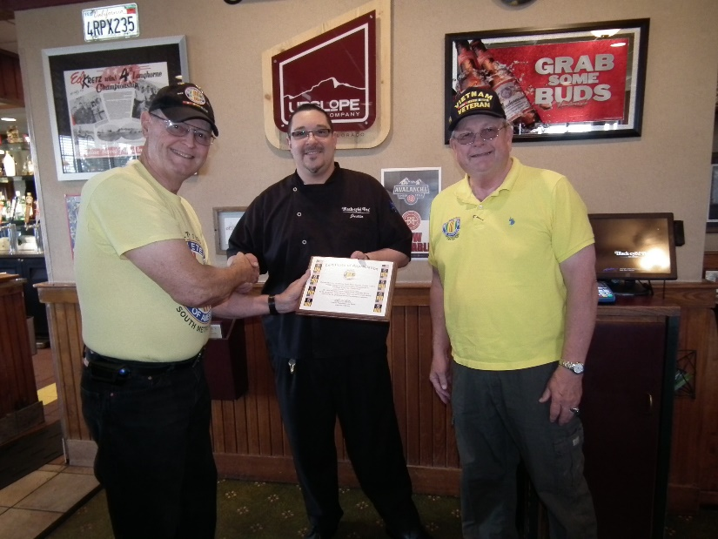

L to R: Bob Rotruck Justin Gurule, Lee White

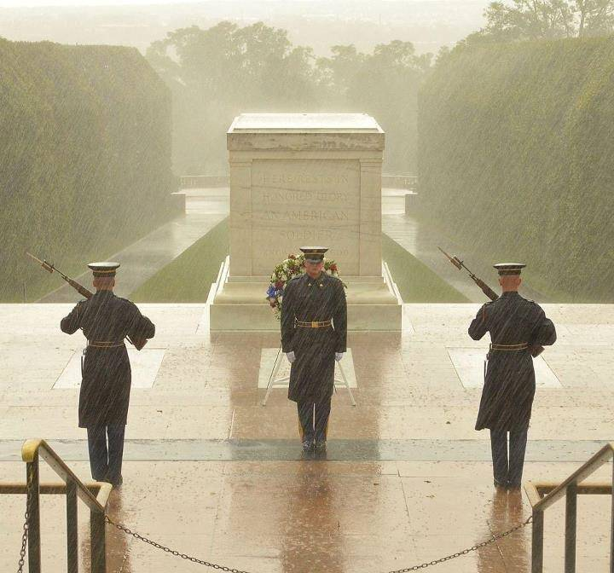

***NEVER ALONE – NEVER FORGOTTEN***

I have thought about being alone,

Thrown away like a pebble or stone.

Into a lake, never again to be found,

No one cares to see my feet on the ground.

But there is a group who will never forget,

To safeguard my memory is a sure bet.

I’m talking about my brothers and sisters,

Who walk 24/7 even with blisters.

They wear the military uniform proud,

Never a grumble or complaint out loud.

At the Tomb of the Unknown they do their best,

To watch over me as I lay there to rest.

Holding their face straight ahead,

Rendering honor to those now dead.

Rain or shine they do their walk,

I never hear one moan or squawk.

Doing the honor of remembering me,

“We do the best we can do,” is their decree.

Thank you Honor Guard for giving your best,

God is looking down and you passed the test.

AMEN!

ROTRUCK – ‘15

***From the Editor!***

I hope this doesn’t offend anybody, I think it is well worth the read!

**Subject: Love and Respect**

This type of service to our country and freedom is being borne by fewer and fewer Americans - shameful and disturbing for sure, but the trend continues downward....

For those who have served in the U.S. armed forces, please accept my congratulations and respect. For those who haven't, I hope this helps you understand why they do.

**General Petraeus: About Our Military Today** - Thanks to my fellow veterans: I remember the day I found out I got into West Point. My mom actually showed up in the hallway of my high school and waited for me to get out of class. She was bawling her eyes out and apologizing that she had opened up my admission letter. She wasn't crying because it had been her dream for me to go there. She was crying because she knew how hard I'd worked to get in, how much I wanted to attend, and how much I wanted to be an infantry officer. I was going to get that opportunity.

That same day, two of my teachers took me aside and essentially told me the following: "David, you're a smart guy. You don't have to join the military. You should go to college, instead." I could easily write a theme defending West Point and the military as I did that day, explaining that USMA is an elite institution, that it is actually statistically much harder to enlist in the military than it is to get admitted to college, that serving the nation is a challenge that all able-bodied men should at least consider for a host of reasons, but I won't. What I will say is that when a 16 year-old kid is being told that attending West Point is going to be bad for his future, then there is a dangerous disconnect in America, and entirely too many Americans have no idea what kind of burdens our military is bearing.

In World War II, 11.2% of the nation served in four (4) years. During the Vietnam era, 4.3% served in twelve (12) years. Since 2001, only 0.45% of our population have served in the Global War on Terror. These are unbelievable statistics. Over time, fewer and fewer people have shouldered more and more of the burden and it is only getting worse. Our troops were sent to war in Iraq by a Congress consisting of 10% veterans with only one person having a child in the military. Taxes did not increase to pay for the war. War bonds were not sold. Gas was not regulated. In fact, the average citizen was asked to sacrifice nothing, and has sacrificed nothing, unless they have chosen to out of the goodness of their hearts. The only people who have sacrificed are the veterans and their families. The volunteers. The people who swore an oath to defend this nation. You stand there, deployment after deployment and fight on. You've lost relationships, spent years of your lives in extreme conditions, years apart from kids you'll never get back, and beaten your body in a way that even professional athletes don't understand. Then you come home to a nation that doesn't understand. They don't understand suffering. They don't understand sacrifice. They don't understand why we fight for them. They don't understand that bad people exist. They look at you like you're a machine - like something is wrong with you. You are the misguided one -- not them.

When you get out, you sit in the college classrooms with political science teachers that discount your opinions on Iraq and Afghanistan because YOU WERE THERE and can't understand the macro issues they gathered from books, because of your bias. You watch TV shows where every vet has PTSD and the violent strain at that. Your Congress is debating your benefits, your retirement, and your pay, while they ask you to do more. But the amazing thing about you is that you all know this. You know your country will never pay back what you've given up. You know that the populace at large will never truly understand or appreciate what you have done for them. Hell, you know that in some circles, you will be thought as less than normal for having worn the uniform.

But you do it anyway. You do what the greatest men and women of this country have done since 1775. YOU SERVED. Just that decision alone makes you part of an elite group. "Never in the field of human conflict has so much been owed by so many to so few." --Winston Churchill. Thank you to the 11.2% and 4.3% who have served and thanks to the 0.45% who continue to serve our Nation.

General David Petraeus West Point Class 1974

***Light Side***

**Florida woman stops alligator attack using a small Beretta pistol!**

This is a story of self-control and marksmanship by a brave, cool-headed woman with a small pistol against a fierce predator. What is the smallest caliber that you would trust to protect yourself?

A Beretta Jetfire testimonial.... Here is her story in her own words:

"While out walking along the edge of a pond just outside my house in The Villages with my soon to be ex-husband discussing property settlement and other divorce issues, we were surprised by a huge 12-ft. alligator which suddenly emerged from the murky water and began charging us with its large jaws wide open. She must have been protecting her nest because she was extremely aggressive. If I had not had my little Beretta Jetfire .25 caliber pistol with me, I would not be here today!"

"Just one shot to my estranged husband's knee cap was all it took.... The 'gator got him easily and I was able to escape by just walking away at a brisk pace. It's one of the best pistols in my collection! Plus the amount I saved in lawyer's fees was really incredible. "His insurance was the big bonus. I'm comfortable now."

Not what you were expecting.

**Class Reunion**

Submitted by John Vargas

A husband takes the wife to her high school reunion. After meeting several of her friends and former school mates, they are sitting at a table where he is yawning and overly bored. The band cranks up and people are beginning to dance. There's a guy on the dance floor living it large, break dancing, moon walking, back flips, buying drinks for people, the works.

Wife turns to her husband and says, "See that guy?  25 years ago he proposed to me and I turned him down. Husband says: "Looks like he's still celebrating!!!"

**Hearing Issue**

An elderly couple were attending church and during the sermon, the wife leans over to her husband and whispers, “I just let a quiet fart!” The husband leans over and whispers, “You need new batteries in your hearing aids!”

***Trivia Answer***

**Mustang** – Term referring to any officer who was promoted from the enlisted ranks. Can be used respectfully or pejoratively.



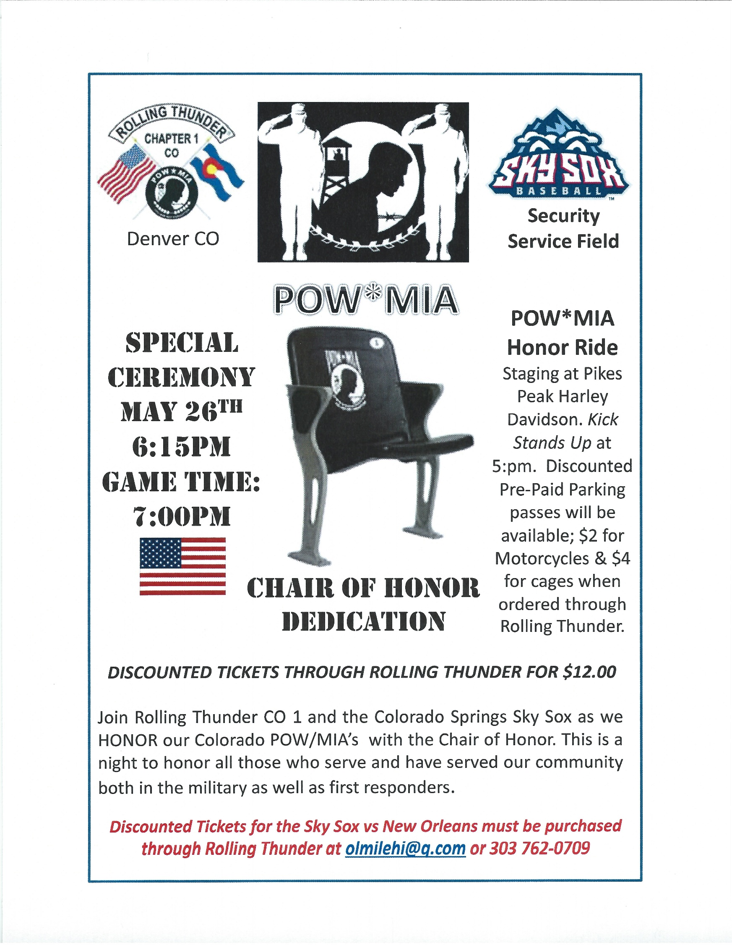

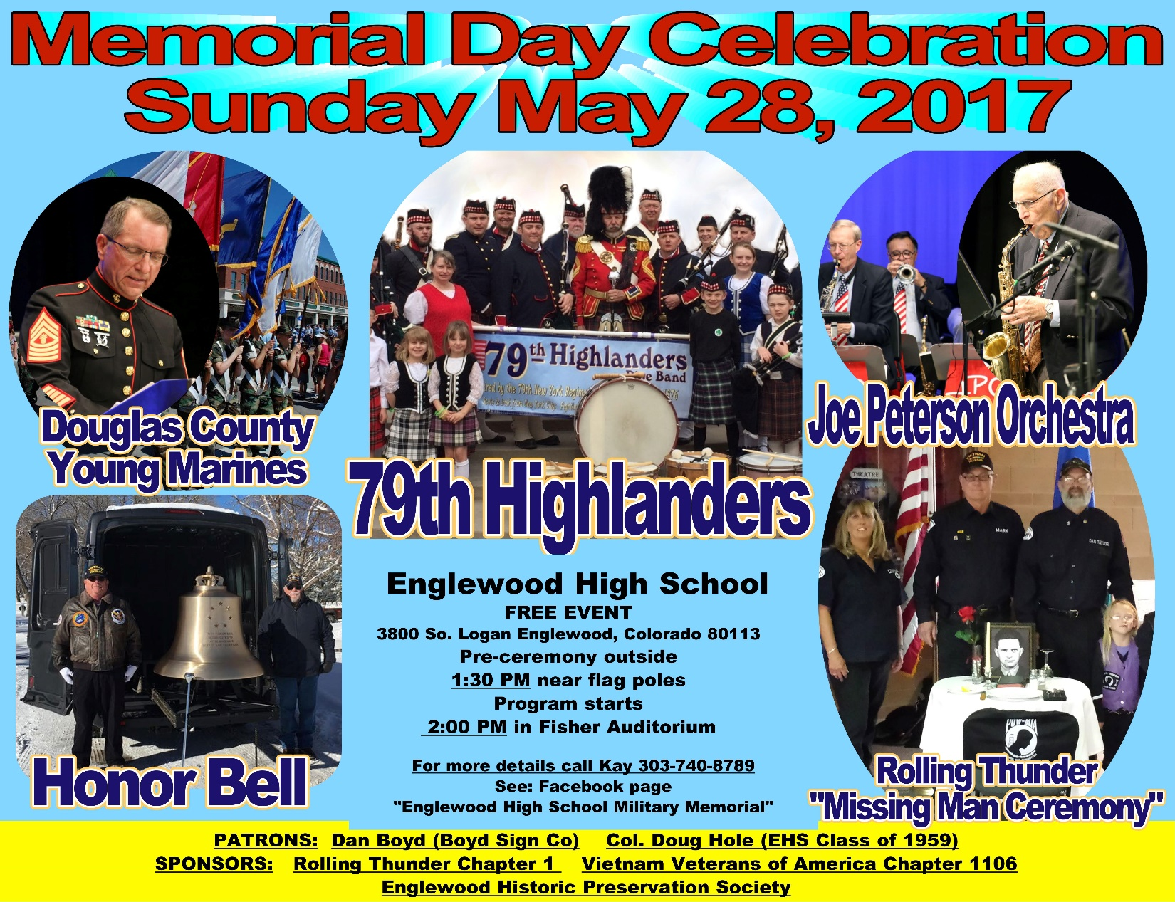

**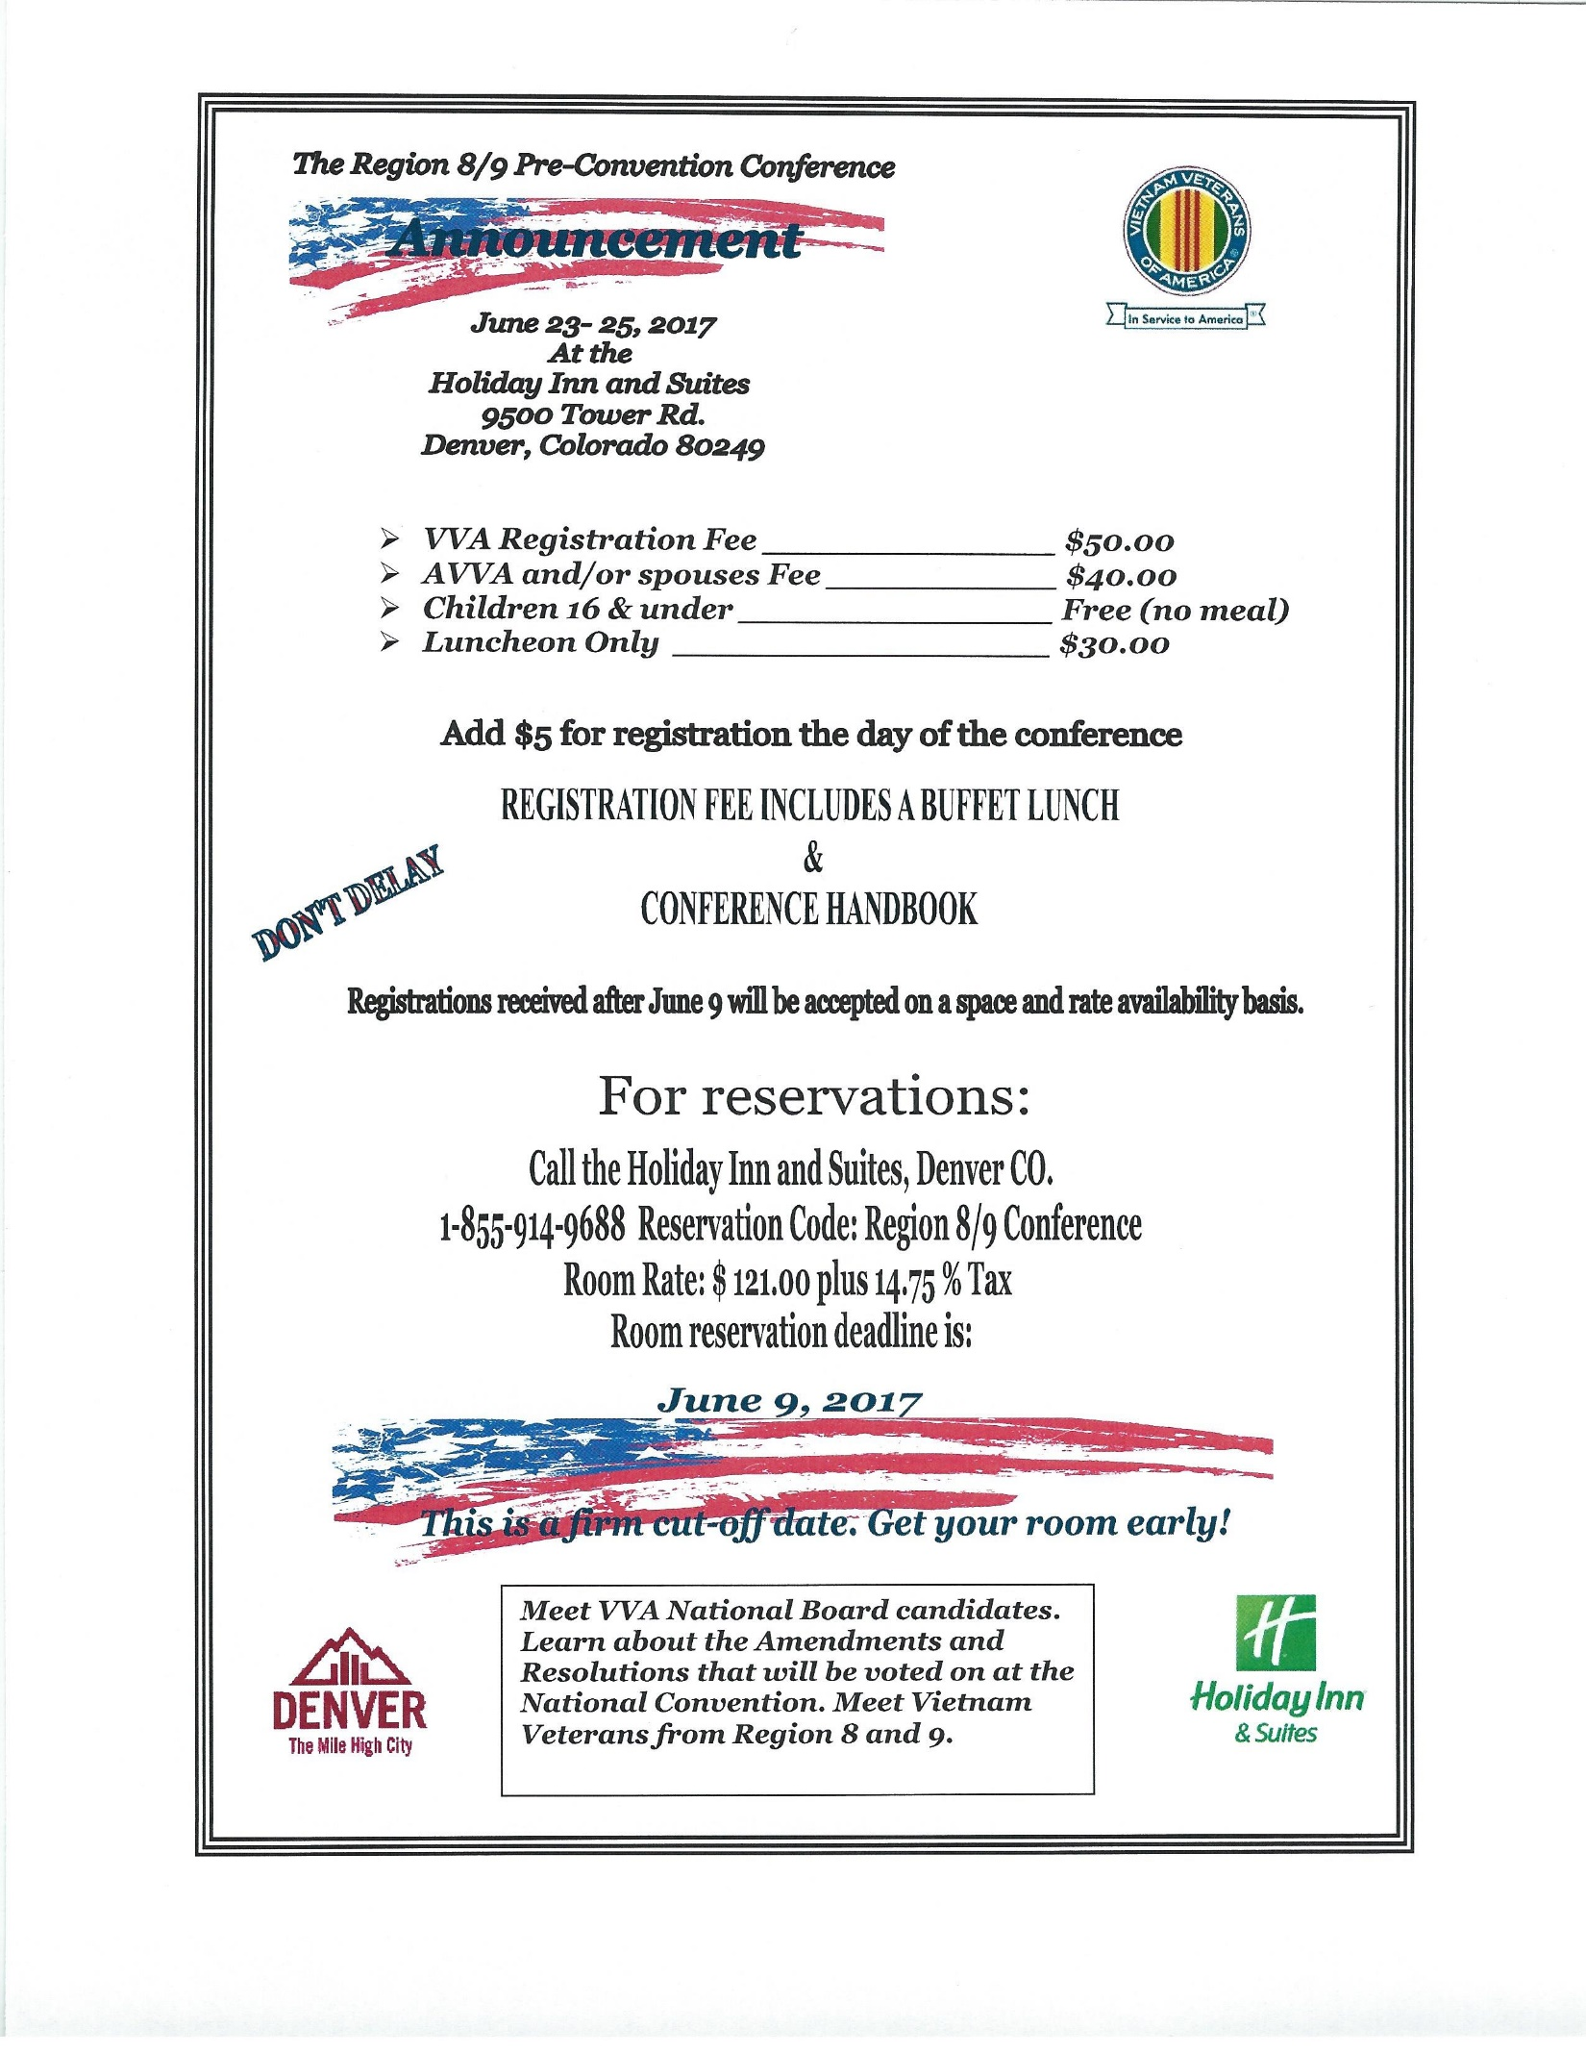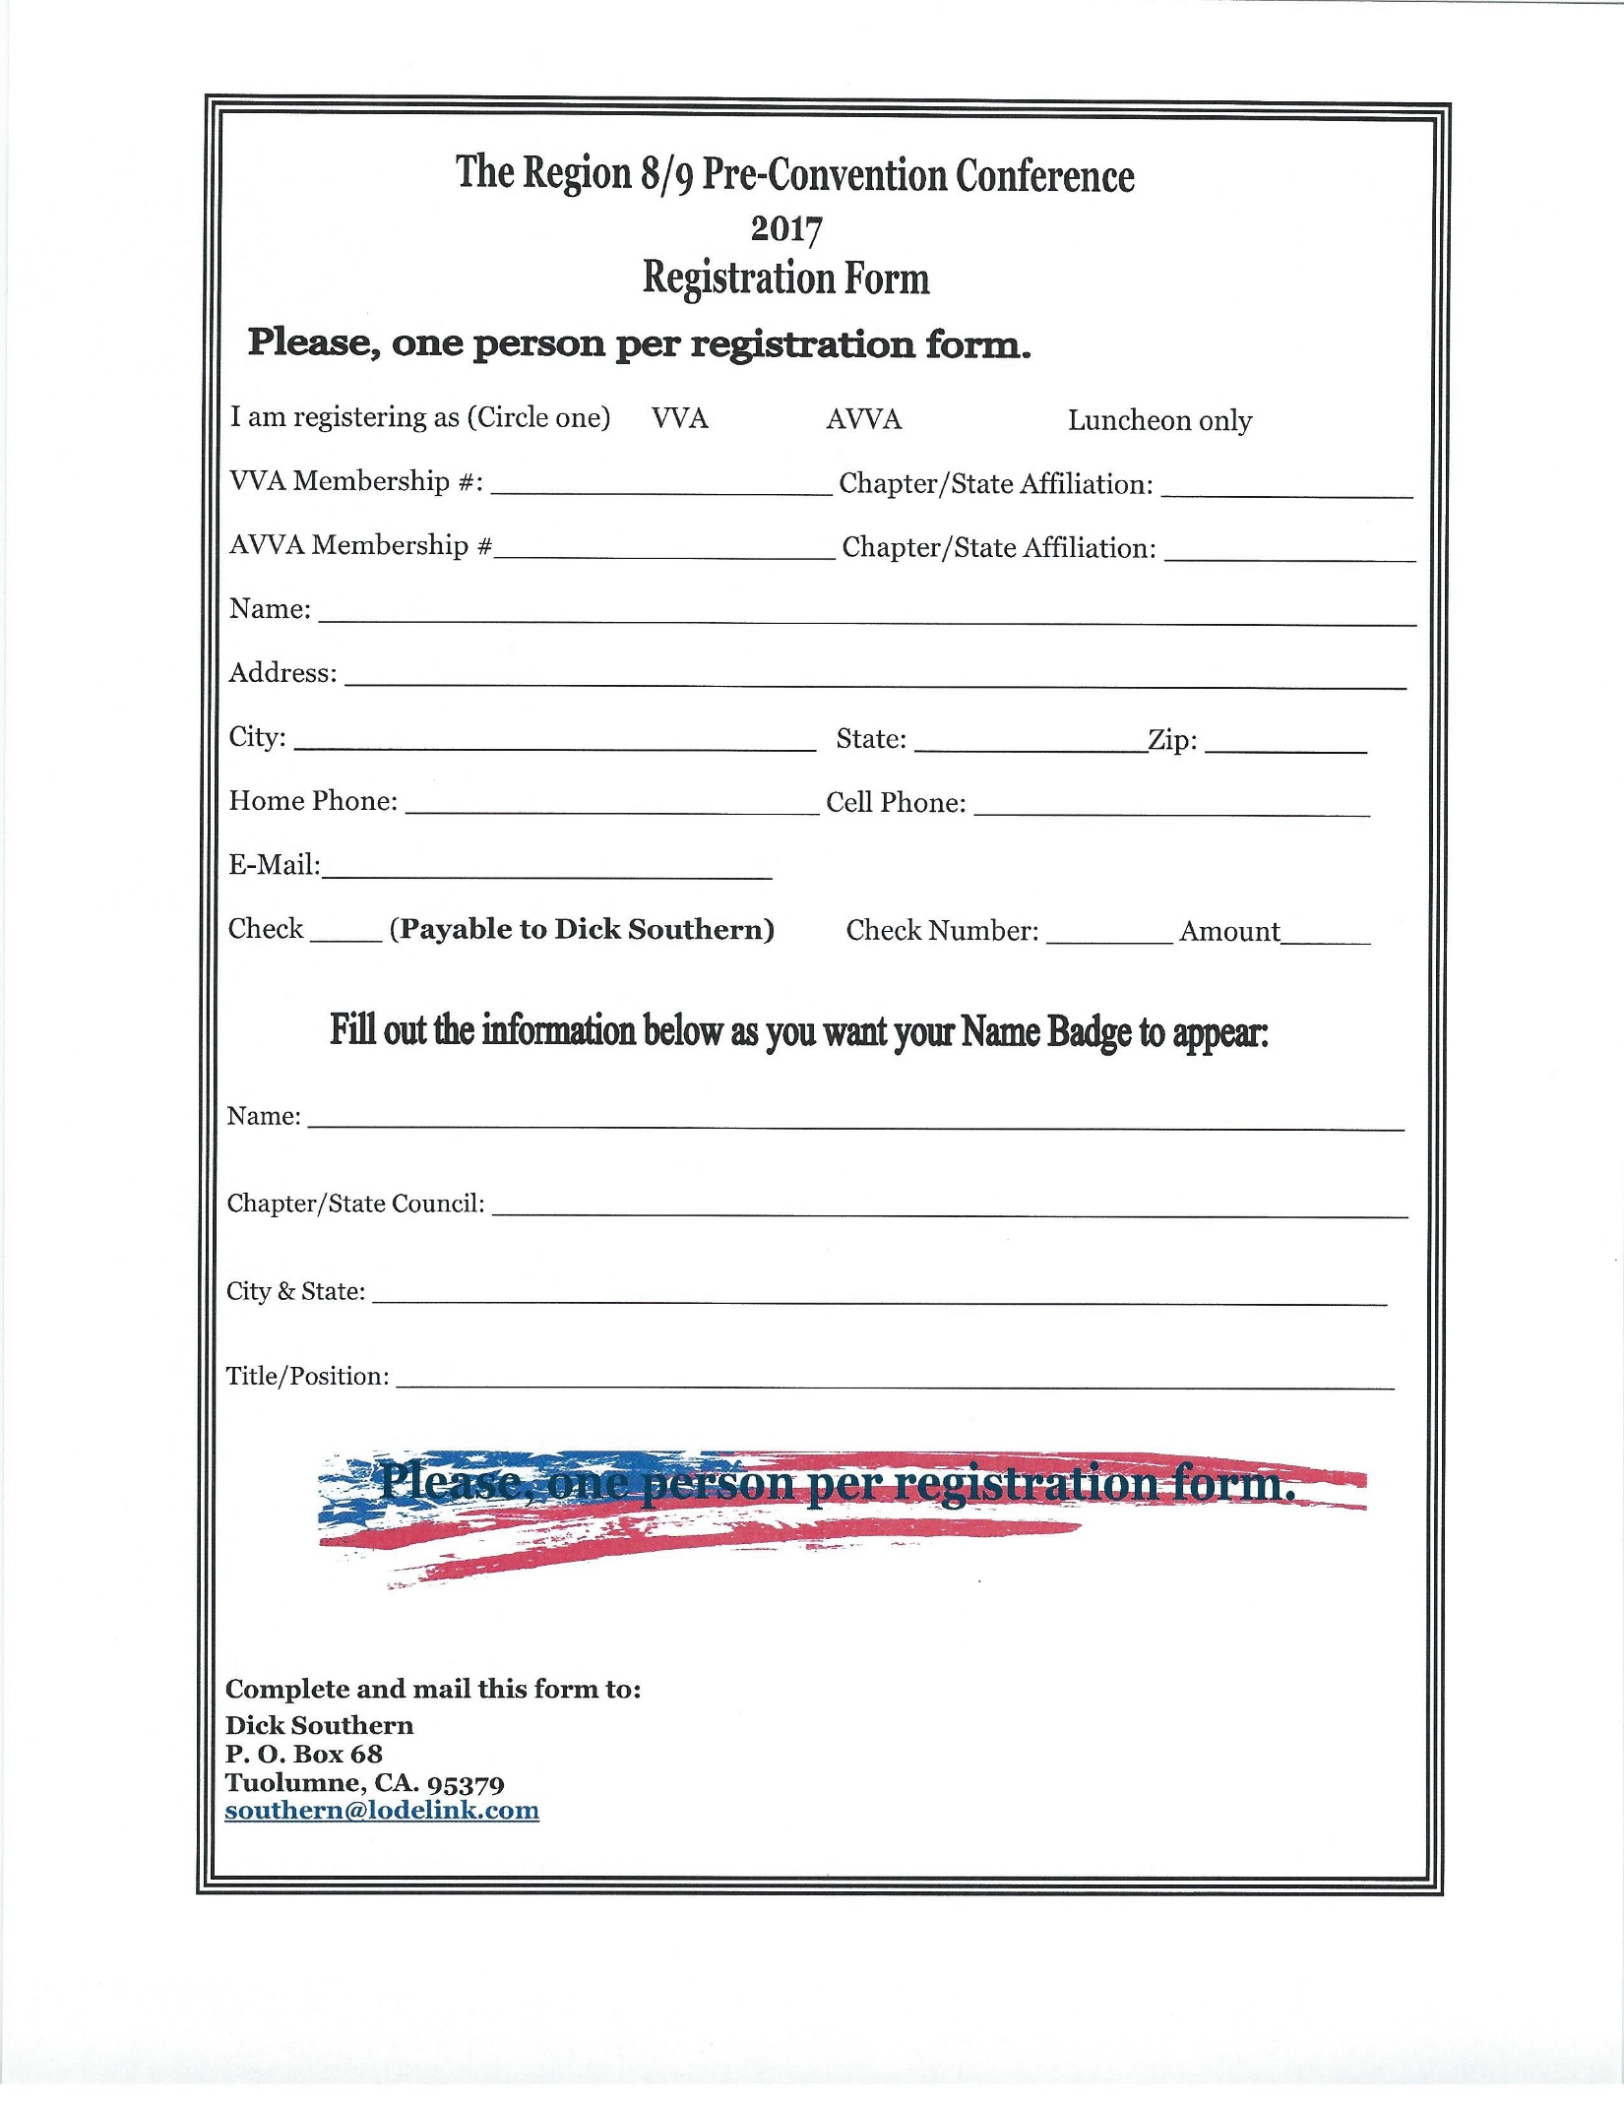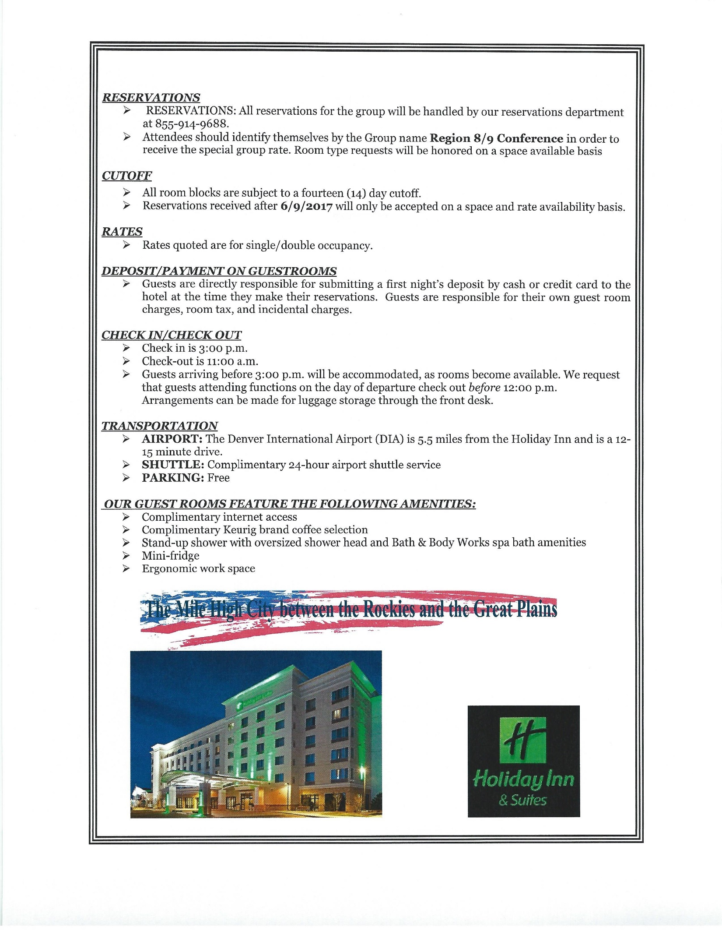**

**FRIENDS OF CHAPTER 1106**

|  |  |
| --- | --- |
| **ERC Management, LLC**  791 Southpark Dr., Suite 600  Littleton, CO 80120  [720.328.3299](tel:720.328.3299)  [www.FreddysUSA.com](http://www.freddysusa.com/) | |
| **Caribou Coffee**  12501 E Lincoln Ave  Englewood, CO 80112  303-799-1258 | **American Legion Post 1260**  **E:\Documents\ALP1187\images\AmericanLegion_logo.jpg** |
| Logo of The Home Depot  **Home Depot Foundation**  8477 S Yosemite St  Lone Tree, CO 80124 | **South Metro Denver Fire & Rescue**  9195 E Mineral Ave  Centennial, CO 80112 |
| Monthly Membership Meetings VISITORS ARE ALWAYS WELCOME!   3rd Saturday of each month at 10:00a.m.   Our meetings are held at: [VFW Post 2461](http://www.vfwpost2461.com/) 1350 S Broadway, Denver, CO 80210 | [http://www.applewoodfixit.com/wp-content/themes/applewood/images/header-logo.png](http://www.ApplewoodFixIt.com)  Applewood Plumbing Heating & Electric  **Main Billing Office:** 5000 W 29th Ave.  Denver, CO 80212 **Phone:** 303-232-6611 **Fax:** 303-477-4310 **Email:** [custservice@applewoodfixit.com](mailto:custservice@applewoodfixit.com) |
| 9137 E Mineral Cir Ste 100  Englewood, CO 80112-3422 | 6882 S. University Blvd.  Centennial, CO 80122  [303-771-2244](tel:303-771-2244) |
| **Jersey Mikes Subs**  1390 S. Colorado Blvd. Denver | **STUDIO 1430 Main Office:** 4700 South Syracuse Street, Suite 1050 Denver, CO 80237 |