Inside this issue:
Notes from the President
Member Feature
Military Trivia
Guest Speaker
Membership
Board of Directors/Officers
Working Committees
Meetings/Events Calendar
Announcement Corner
Books/Articles Published by Mbrs.
From the Editor
Light Side
Trivia Answer
Notice:
If you have moved or changed your address, PLEASE notify us immediately! Contact: Dave Lyons, Membership Chair
E-mail: Snoyldavid@centurylink.net
Phone: 303 690 8776

COPYRIGHT NOTICE: In accordance with Title 17 U.S.C. Section 107, any copyrighted material in this newsletter is distributed under fair use without profit or payment to those who have expressed a prior interest in receiving the included information for nonprofit use and educational purposes only.
Facebook: Vietnam Veterans of America Chapter 1106
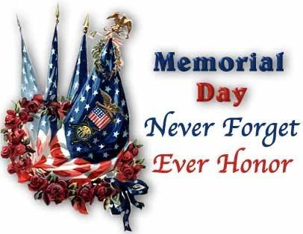
Editor’s Note:
This version of the newsletter is in Microsoft Document (.DOCX) format so that the links will work. Put your cursor over the link, depress your Control Key (ctrl) and depress your left mouse button and it will take you to the listed link position. PDF format, the links will not work.
The comments and editorial input does not necessarily reflect the opinion of the membership of our chapter. I would appreciate any feedback that you might have, items you liked or if you find offensive or derogatory in anyway. (bobrotruck73@gmail.com) Thank you for allowing me to be your editor.

Notes from the President
Lee White
In my last “Notes” in the March/April newsletter, I mentioned that spring was just around the corner, and here we are with snow a couple of days ago.

It appears we are starting to see the light at the end of the tunnel with Covid-19. I hope most of our members have received their vaccinations by now.

Some good news coming forward is the opening of our meeting place at South Metro Fire and Rescue Building, although with some restrictions. Our Chapter 1106 will have our first in person (face to face) monthly membership meeting scheduled for Saturday, June 5, 2021. HURRAY!! It’s been over a year that we have not been able to see everyone in person.

Our Chapter 1106 worked hard to communicate with members, making “Buddy Check” calls and using “Zoom” for our monthly meetings. You are all to be commended for your efforts and concerns for our members.

We will be organizing and scheduling events over the next few months.

Thank you for all your support.

Member Feature
Joe Dempsey – Senior Airman – USAF 1969 – 73
I was awarded the USAF Good Conduct medal, National Defense Service medal, and the Vietnam Service medal. I was stationed at David Monthan, AZ, Guam (Anderson), Bergstrom, TX, and Takhli, Thailand (TDY). My AFSC Classification -A90150 Scientific Applications Specialist (Aero Medical Tech). I had additional duty as a Flight Medic assigned to HH-43 Rescue Helicopter. I went with a detachment to reopen Takhli. We were the first American on the base. I’m thankful our Chapter for allowing me to be a part of this fine group of people who served out country in difficult times!

Military Trivia
Butter Bar Click here for end of the Newsletter Trivia Answer

Mar Guest Speaker –

Feb Guest Speaker –

Membership! (As of 4 20-2021)
VVA 161
AVVA 37(Lost 3)
TOTAL: 198
.
Board of Directors/Officers
Lee White – President
Dave Lyons – Vice-president
Mike Huber – Treasurer
Secretary – Milt Omoto
Board Members – Patti Ehline, Glen Payne, Tom Werzyn, Ron Smith, John Vargas, Dan Green, Joe Plant, Rev. Garry Turks

Special Chapter Positions
AVVA Liaison to chapter Board of Directors – Litta Plant-Schaper
Chaplain – Rev. Garry Turks
Chapter Historian – John Vargas
Database/Audio – Jack Hunter
Government Affairs – Tony Nickerson
Sergeant-at-Arms – Rob Senatore
Chapter Nurse – Patti Ehline

Working Committees
- Agent Orange/PTSD: Patti Ehline
- Color Guard: Jay Quiring (Command Sergeant),
- Don McNeely, Dan Green, Clarence Rebolledo, Robert Senatore, Tony Nickerson, Ron Smith, Leann Stelzer, Alexis Winemiller
- Event Coordinator: Ron Smith – Chair, Lee White, Michelle Mallin
- Fundraising/Grants: Milt Omoto
- Marketing/Media/Events: Tom Werzyn, Michelle Mallin
- Membership: Dave Lyons – Chair, Lee White, Litta Plant-Schaper (AVVA Roster Updates)
- Mental Health: Patti Ehline, Warren Harrison, Joe Plant
- Name Tags: Litta Plant-Schaper
- Newsletter Editor: Bob Rotruck
- Promotional Items: Leann Stelzer, Clarence Rebolledo
- Refreshments: Alexis Winemiller, Jason Longmore
- Scholarship Program: Mike Karsh and Jim Marcille – Co-chairs, Glen Payne, Gary Weston, Rebecca Webb, Cliff Butler, Lou Grounds, Tom Werzyn
- Social – Jim Marcille, Glen Payne, Mike Karsh, John Vargas
- Speakers Bureau Tom Werzyn – Chair, Bob Mallin, Glen Payne, Dave Lyons
- Veteran Emergency Assistance Committee: Joe Plant, Dave Lyons, Dan Green, Lee White
- Voices for Veterans: Warren Harrison, Patti Ehline, Joe Plant
- Webmaster: Bob Rotruck
- Women Veterans: Patti Ehline

Meetings/Events Calendar - 2021
April 28, 2021 - June 5, 2021 - "NECESSITIES DRIVE" for Help & Hope Center, Castle Rock
May 1, 2021-VVA Chapter 1106 Monthly Meeting (Zoom)
May 22, 2021-VVA Chapter 1106 Board Meeting (Zoom)
May 29, 2021-Poppy Drive - King Soopers - To be decided
May 31, 2021-MEMORIAL DAY
June 5, 2021-VVA Chapter 1106 Monthly Meeting - "IN PERSON/FACE TO FACE" - South Metro Fire & Rescue Bldg.
June 5, 2021-"NECESSITIES DRIVE" ends. Final Collection
June 20, 2021-"Rockies vs Brewers" Baseball Game
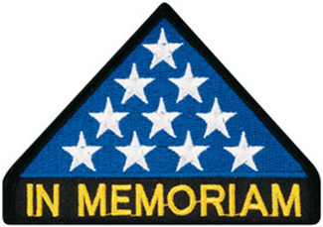

In Memoriam
Prudence Mildred Lyons (Dee)
Chapter member and Vice President, Dave Lyons, and our Chapter lost a beloved member March 8th, 2021. Chaplains Garry Turks and Joe Plant presided over the service held at Fort Logan National Cemetery March 24th, 2021 – 1:30 PM. Approximately thirty or so supporters attended the ceremony. She was an extremely sweet and caring member of our chapter and will be sorely missed. God bless you and rest in peace Dee!
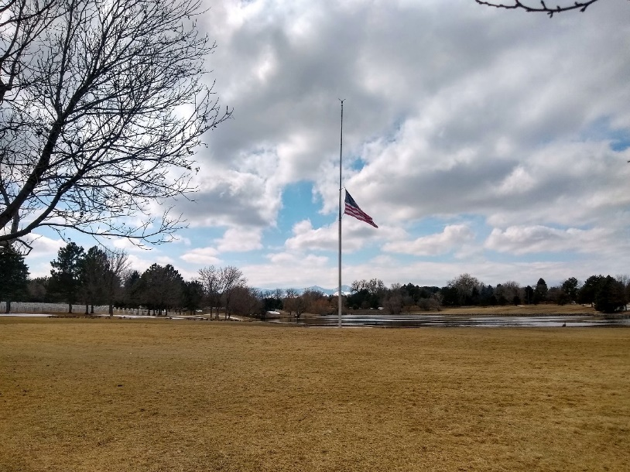
Picture by Suzanne Segona
Flag at half-staff the day at FT. Logan.

As of: 4/20/2021
Total Funeral Homes Visited - 2,480
Cremains Found – 25,401
Veterans Cremains Identified – 5,388
Veterans Interred – 4,829

Events:
SURPERISE – SURPRISE – SURPRISE
The Fed-X man rang the doorbell, placed a box by the front door and drove away. David looked at it and immediately handed the box to Patti. No return addresses! Hmmm. Patti carefully opened the box and gently cut the bubble wrap and gift wrapping. What could it be? To hear pleasant surprise, it was a ZZZ Bear dressed in nurse’s blue scrubs. The little bear’s cap said PATTI. Accompanying this little fuzzy nurse was a card that read, “Thank you for all you do for us Veteran’s from your friends, that love you! It was signed by Cliff Butler, Rich Eisenberg, Richard Lewis, Glen Payne, and John Vargas.
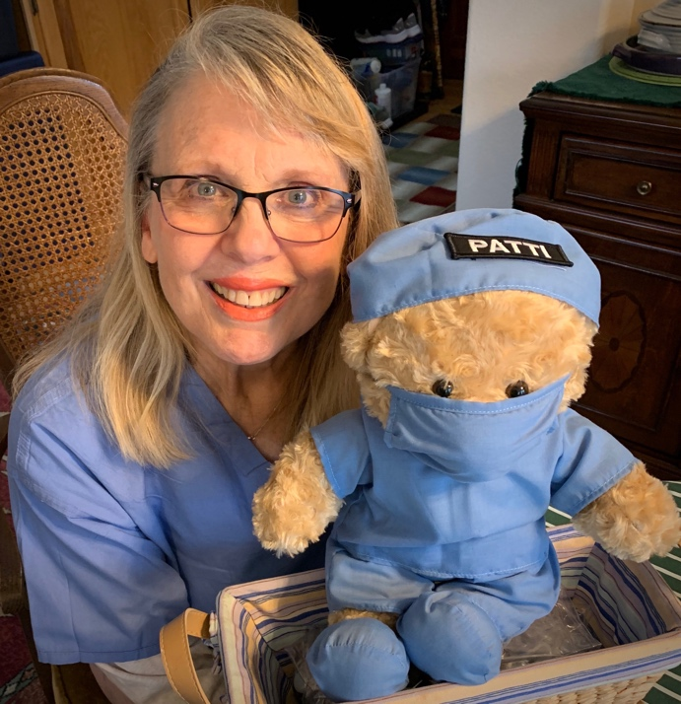

Announcement Corner
From Nurse Patti
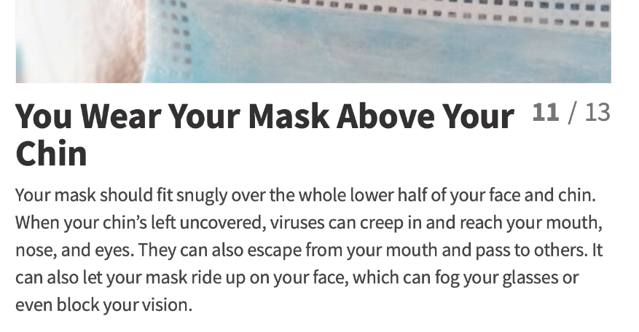

?

Awards
At our March VVA Chapter meeting, President Lee White, surprised Suzanne Sigona with a custom designed acrylic award displaying our Chapter Challenge Coin and adorned by two Vietnam Anniversary Pins.
Suzanne has been generously volunteering for more than 30 years at The Vietnam Wall, in Washington D.C as a *Yellow Hat. She methodically helps visitors search for names on the Wall. She has participated in our Chapter Recruitment Video describing the benefits of joining VVA 1106. Suzanne is an active volunteer with the Traveling Wall when it comes to Colorado. She also continues to honor Vietnam Veterans at Chapter Meetings and throughout our state by personally handing them “The Vietnam 50th Anniversary Pin” along with a heartwarming phrase from the back of the coin: A Great-full Nation Thanks and Honors You. Suzanne completes it with warm handshake. Adding to her esteem resume, she is also volunteer with the Honor Flight of Colorado assisting Nam Vets preparing for their very memorable flight. This is a lady of many talents with tireless energy and invaluable dedication and deserves a world of gratitude! Congratulations Suzanne
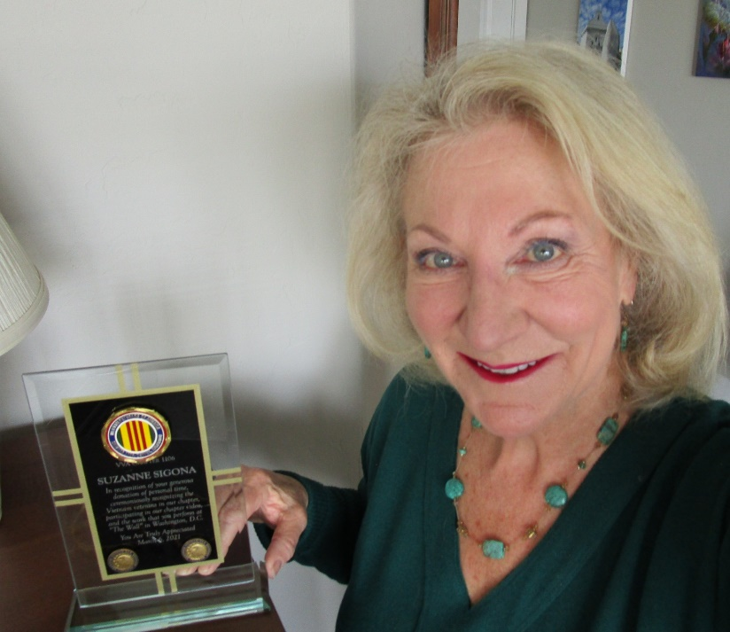

President Lee White had yet another surprise award at the March virtual Chapter Meeting. This one was honoring Tom Werzyn with a beautiful acrylic plaque. Over the years Tom has continuously made selfless contributions to VVA 1106. He has lead the way with the Speakers Bureau by scheduling, presenting and heading a team of guest speakers visiting high school students. His continuous involvement with the Cherry Creek School District opened the door to a flourishing relationship with their executive team and teachers. He was instrumental coordinating the Chapter Recruitment video and is currently and aggressively leading the tedious process helping us obtain a 501C3, non-profit status. In his spare time, Tom edits books for the now online Vietnam Veteran’s Magazine. Tom is also a Chapter Board Member. He also has a great sense of humor and a welcoming attitude. Well done and congratulations Tom.
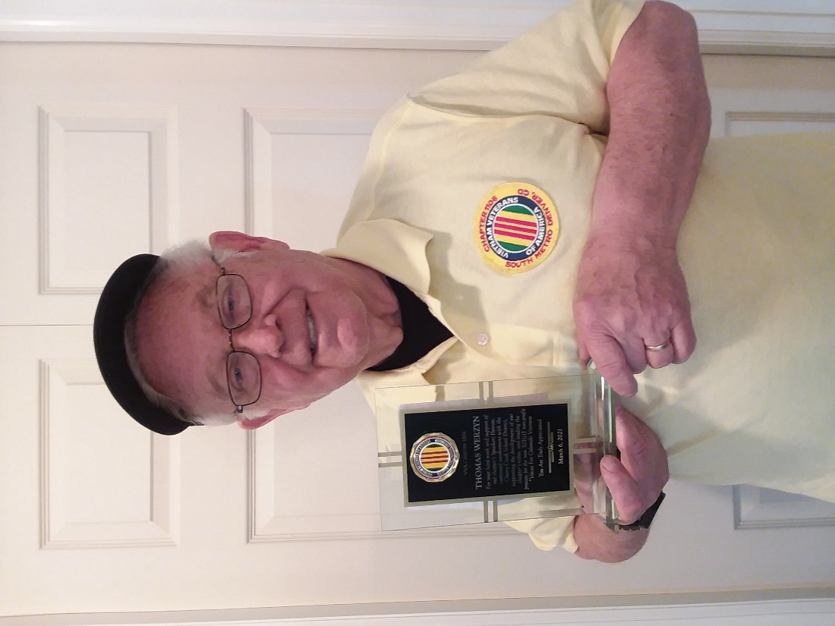

CCSD Heroes Profile: John Vargas
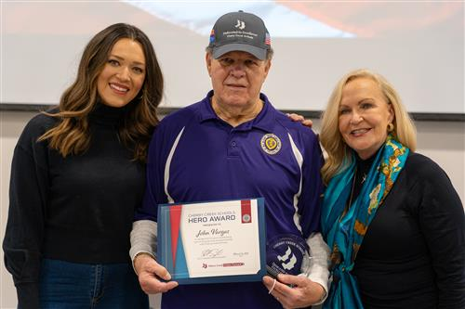
John Vargas during the CCSD Heroes ceremony. John Vargas has plenty of personal reasons to make sure that students across the Cherry Creek School District honor the sacrifices of veterans.

Vargas received the Purple Heart, the military’s highest honor, and the Distinguished Flying Cross awards for his heroism serving in the Vietnam War. He’s held several significant positions in veterans’ organizations across the Denver metro area, including as a current trustee with the Military Order of the Purple Heart.

Even so, Vargas’s consummate efforts on behalf of the district’s annual veterans’ celebrations aren’t self-centered. Vargas works tirelessly on organizing Cherry Creek Schools’ annual Veterans and Military Appreciation game, its Quilts of Valor celebrations and other events designed to pay veterans their proper due. Those who know him, however, insist that all of that work comes on behalf of others.

“John Vargas is an amazing individual, and he’s as humble as anyone you’ll ever meet,” said Larry Bull, CCSD’s Director of Athletics and Activities. Bull works closely with Vargas in organizing annual events designed to pay tribute to veterans and service members in the community. “He has been an asset to our district; he’s a remarkable individual who cares deeply about others and is always willing to help with any aspect of our celebrations.”

This unfailing kindness and dedication recently earned Vargas the Cherry Creek Heroes Award, an honor that recognizes those in the community who commit extraordinary actions on behalf of Cherry Creek Schools. According to CCSD Superintendent Dr. Scott Siegfried, Vargas qualified for the award because of the generosity, commitment and investment that’s been consistent over many years.

“John has never hesitated in giving his all to celebrate our community’s veterans and service members,” Siegfried said. “Though he’s earned awards for his own heroism in the service of our country, John is focused on giving credits to others and making sure their contributions are recognized. This dedication has benefitted our students directly; year after year, they see firsthand just how much our veterans have given to our community and our country.”

Vargas’s wife Kathleen is liable to speak about her husband’s skills as a cook, his support of her artistic endeavors and his passion as a world traveler. All of these qualities are part of a bigger pattern of selflessness that have benefitted the entire CCSD community and far beyond.

“There are many attributes I could offer to describe John. But so many people from all walks of life know him for his kindness, authenticity, and generosity,” Kathleen Vargas said. “Not surprisingly, he makes friends wherever we visit.”

The Cherry Creek School District is definitely on that list.

Books/Articles
Noodle
In the Jan/Feb 2021 newsletter, captured the story of a service dog by the name of Noodle. The Quilts of Valor honored him with a quilt.
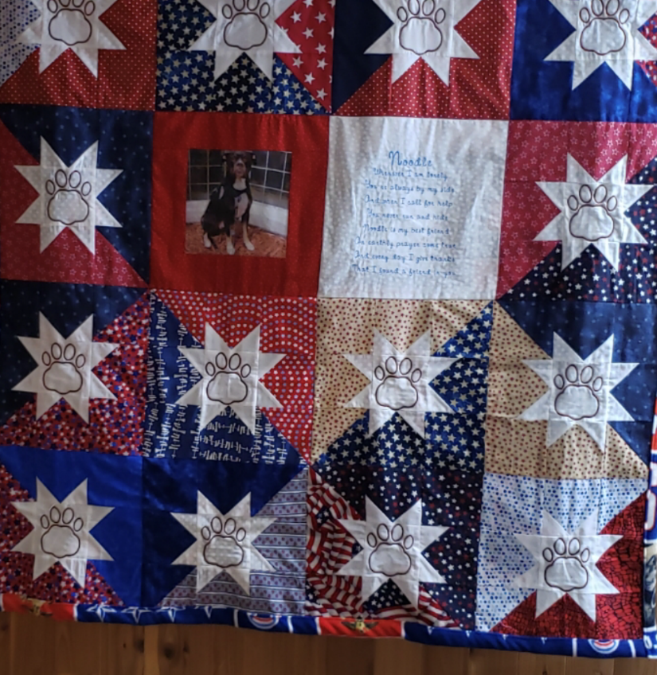

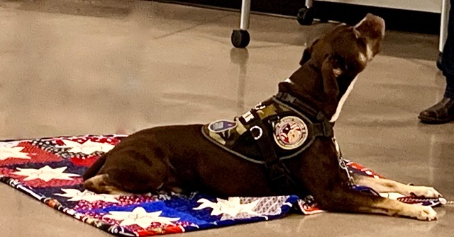
Noodle on his quilt!

The Noodle poem reads:
Noodle
Whenever I am lonely,
You're always by my side.
And when I call for help,
You never run and hide.
Noodle is my best friend,
An earthly prayer come true.
And every day I give thanks,
That I found a friend in you.

Ruffo gets a home
by David Harper and John Vargas
An Army Veteran, David Harper and his wife Melissa were on vacation at a friend’s condo in Cozumel, Mexico. As they approached the front gate and everyday thereafter, they saw a scraggly little dog hanging around the guard shack. The guards had befriended him and gave him leftovers from their meals. The called him Ruffelos because he loved Ruffle potato chips. David and Melissa began to call him Ruffo, and he responded with a gentle look and a sweet disposition. He had no owner and was simply a stray dog. The guards noticed that Melissa was feeding Ruffo daily and called out “adoptalo - adoptalo”. Hearing those magic words, and being a dog lover, she searched her computer and found a lady named Lisa, an ex-patriot, who helps people adopt dogs and also arranges with the human society for their physical exams.
During his appointment, they found that Ruffo’s blood test revealed severe Dirofilarial immitis (Heartworms). Unfortunately, Mexico does not have access to the medicine to treat heart worms. Lisa had a connection with a Veterinarian in Estes Park Colorado. They provide the medicine at cost and found someone traveling to Cozumel who was willing to deliver it no extra charge. The next hurdle for the Harpers was to find a temporary foster family for Ruffo. They found willing friends and a temporary sanctuary from the outside elements. This turned out to be several months! Another visit to the vet revealed that he also had parasites. No surprise for a creature living his 24-hour outdoor lifestyle. Poor little guy was so sick from the medical treatments that he couldn’t walk. He had to be carried for his potty times and had to be given water by straw and hand fed. Death was knocking at the door. Ruffo had a strong will to survive and after a couple of weeks he began to walk.
Due to the pandemic most airlines ceased transporting pets. Again, Ms. Lisa came to the rescue by asking a friend, Michaela, who was returning to Ft. Collins, to bring Ruffo with her. He went from Cozumel to Dallas and spent the night, then on to Denver. The next day, the airlines refused to transport Ruffo or any pet in the cargo area. Michaela didn’t take no for an answer and her quick thinking displayed Ruffo’s therapy vest (a little white lie since the paperwork was for her family dog still in Mexico). After an apology from American Airlines, she and the little guy were upgraded to first class. Ruffo has been with the David and Melissa since February 2nd. Once again, the love from ordinary folks comes shining through! If Ruffo had not received the heartworm medication, he would have died before the end of 2020. He now lives comfortably with two other dogs. After a small adjustment period he has adapted to his new family. Ruffo is now safe, cared for and very loved by the Harper family. The caring of two strangers and the courage of a two-year-old homeless pup to survive, is now bringing mutual love to the Harper’s home. Welcome home little guy
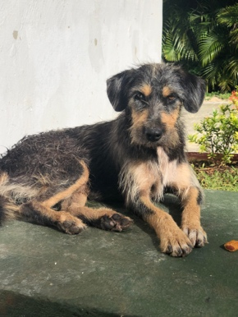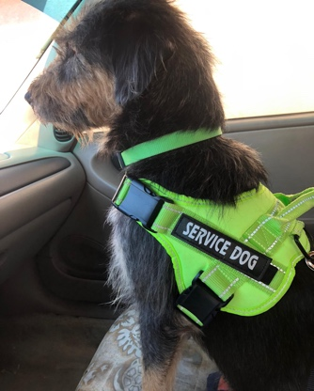

Honors Burial 2021
Submitted by Milt Omoto
VVA Chapter 1071 (Lakewood, CO) has been conducting Honors Burial events since 2016. Recently, 1071 Chapter members worked with Fairmount Cemetery to identify potential veterans within the Cemetery’s unclaimed cremains. Cremains are unclaimed for a variety of reasons. Chapter members undertake a painstaking process of recording all available information on each cremains, then sends the data to the Veterans Administration Records Management Center to verify those listed as honorably discharged veterans.

This process resulted in 19 veteran unclaimed cremains authorized to be interned at a National Cemetery. The 19 veterans include two from WWI, twelve from WWII, and two from Vietnam service. One veteran served both during WWII and Korea, and one served both during Korea and Vietnam.

An Honors Burial event will take place on Saturday, May 29th at Fairmount Cemetery (430 S Quebec St, Denver) to honor these veterans. The event will begin at 9:50AM with the procession of urns into the Chapel. The event is scheduled for an hour. After this event, the urns will be transported to Fort Logan for internment.

Chapter Baseball Fans
Submitted by Milt Omoto

Chapter 1106 member Barry Fiore has been working with the Rockies front office to secure tickets for the 2021 season. Here are the games he has tickets for:
•June 20th (Sunday) @ 1:10PM, Rockies vs. Milwaukee Brewers
•July 4th (Sunday) @1:10PM, Rockies vs. St. Louis Cardinals
NOTE: Nolan Arenado will be back at Coors field (in Cardinal’s uniform) for this game
•August 3rd (Tuesday) @6:40PM, Rockies vs. Chicago Cubs
•August 21st (Saturday) @6:10PM, Rockies vs. Arizona Diamondbacks
NOTE: There will be a Larry Walker Celebration at this game to retire #33 (Larry is the first Rockies player to be inducted into the MLB Hall of Fame)
There are four (4) handicap seats available for each game (with eight for the August 21st game). Cost of tickets are $40.00 each except for the August 3rd game against the Cubs at $48.00 per ticket. Proceeds from ticket sales are shared between VVA Chapter 1106, American Legion Post 1, and Forgotten Heroes Campaign. Call Barry at 303-507-6034 to reserve your tickets. Note that the July 4th and August 21st games will sell out quickly!

Artist in the House!!
John Vargas has a wonderful artist in his house, his incredibly talented wife, Kathleen Meyer Vargas. She painted this in 2019 and it was displayed on the CBS Sunday Morning show on March 14th with Jane Pauley.
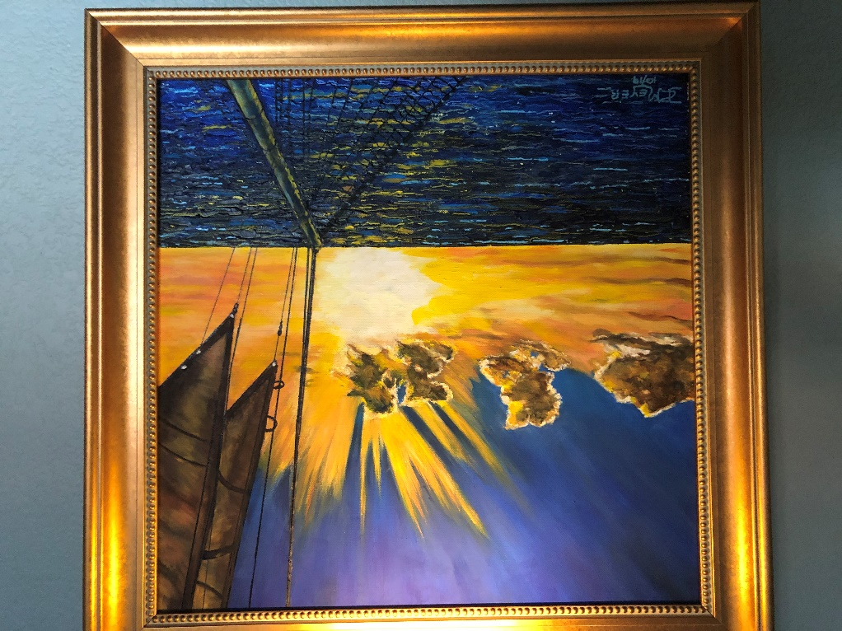
Into the Sunset!

Erwin Dreiling Estate Fund
Submitted by Milt Omoto
Since 2019, the Colorado State Council of the VVA has been the recipient of the Erwin Dreiling Estate Fund. Erwin was a Vietnam Veteran who served with the Marine Corps in Vietnam. He also served eight years in the Navy. His Will stipulated that a certain amount of his estate shall go to a Vietnam Veterans organization in Colorado. Erwin’s nephew, James Dreiling, executor, contacted Lee White (then State Council President) and requested a meeting with Council members. As a result of the meeting, the Colorado State Council was selected to be the recipient of a portion of Erwin’s estate. Funds are distributed to each of the three Colorado Chapters by the State Council every Spring. At the recent State Council meeting, funds disbursement was made to each Chapter for the 2021/22 Fiscal Year by State Council Treasurer Dave Ramey.
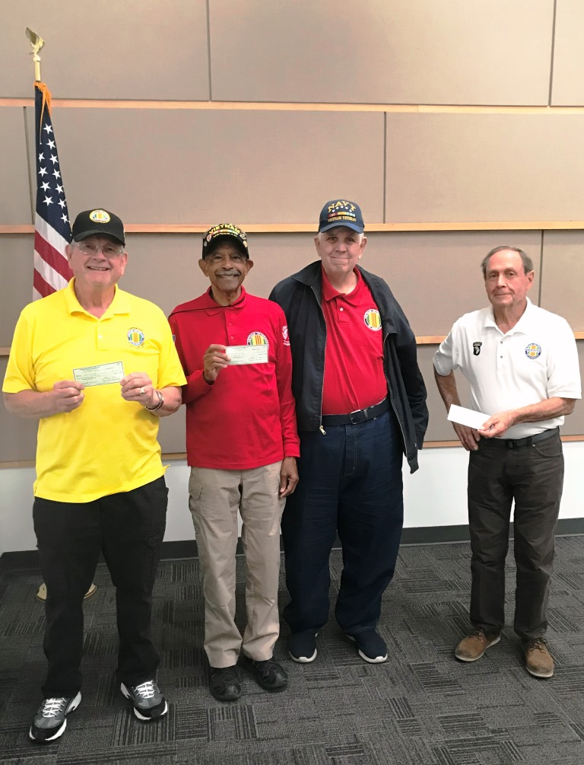
L to R Lee White (1106), Tom Dowell (1075) Dave Ramey, and Stan Paprocki (1071)

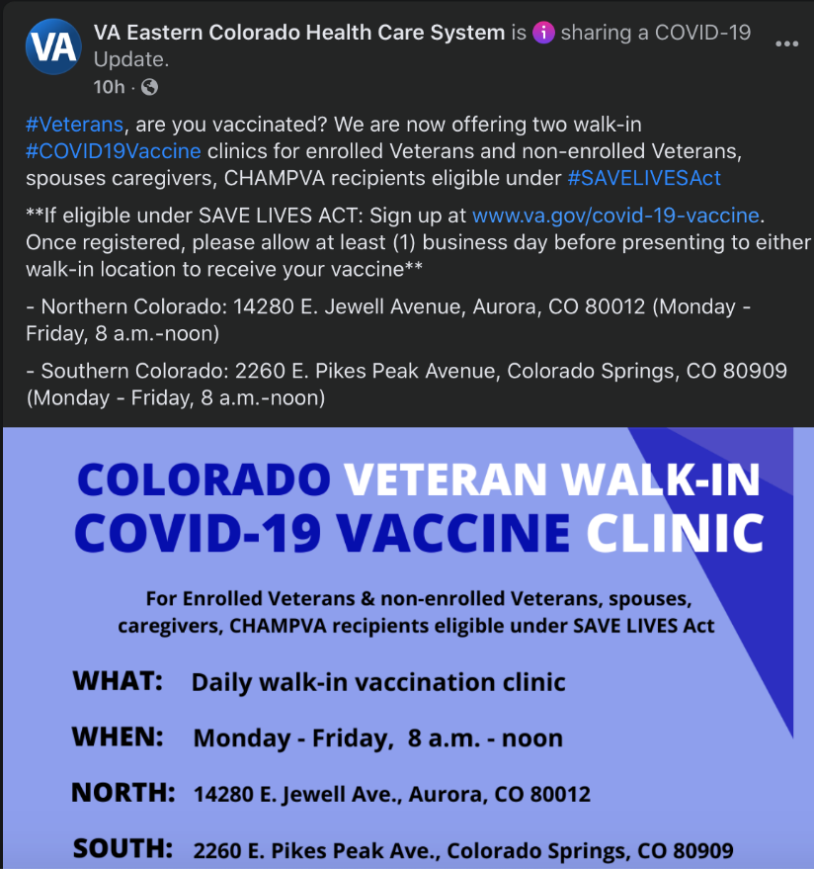
Submitted by Nurse Patti

Photo Quiz
Can you identify any of these Chapter Member Veterans? Answers at end of newsletter!
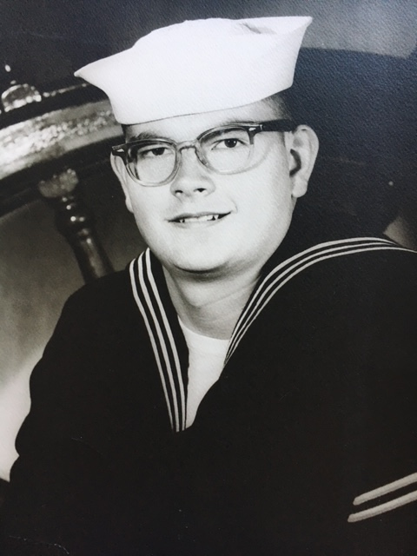
1
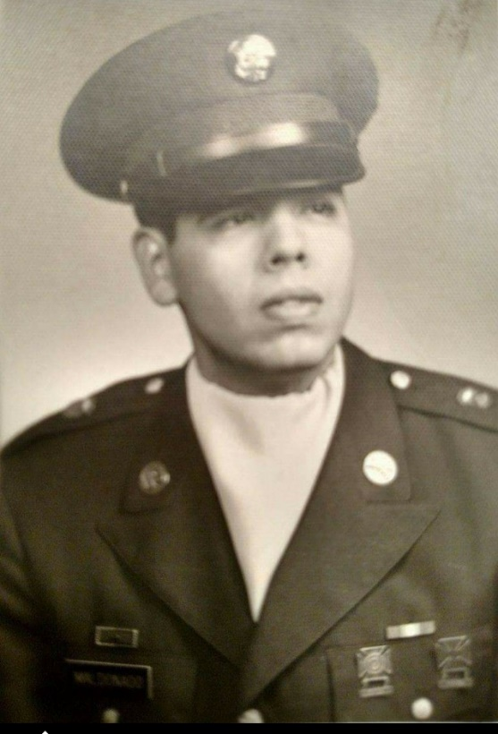
2
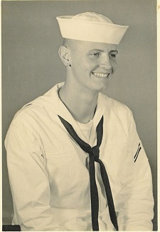
3
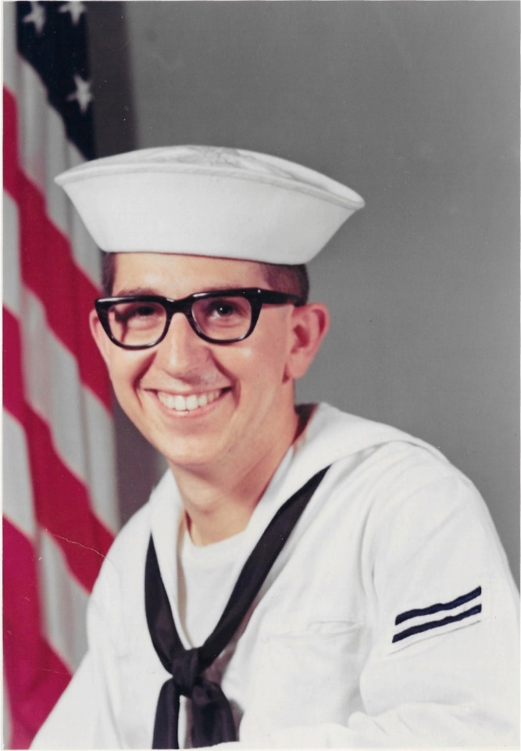
4
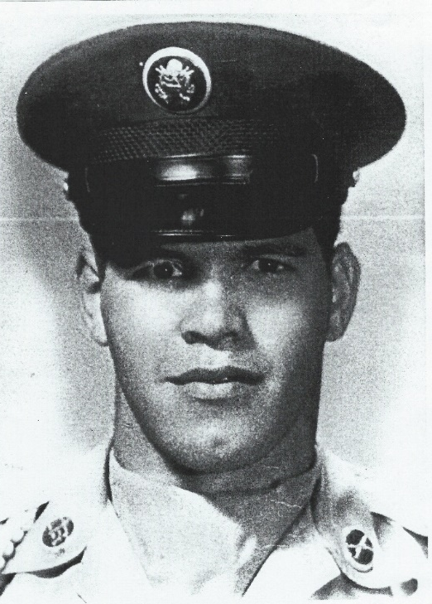
5
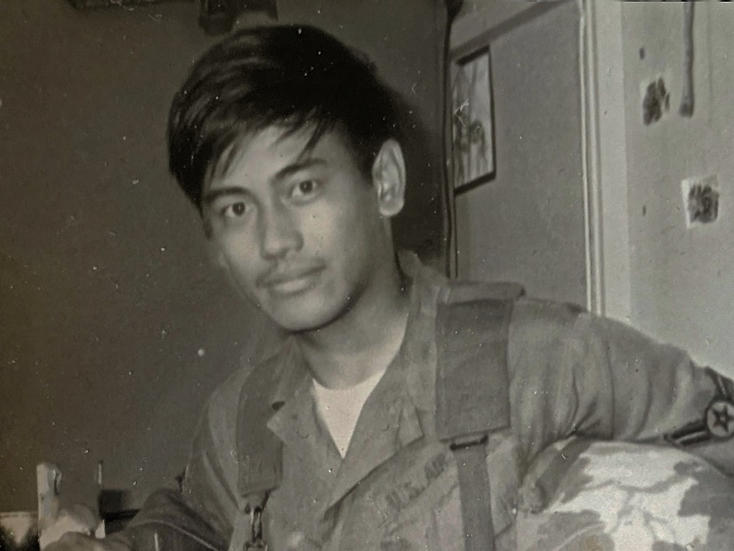
6

BEWARE OF THAT UNDERWEAR DUST!!!!!!
Submitted by John Vargas
One evening a husband, thinking he was being funny, said to his wife, "Perhaps we should start washing your clothes in 'Slim Fast'. Maybe it would take a few inches off your butt!!" His wife was not amused and decided that she simply couldn't let such a comment go unrewarded. The next morning, the husband took a pair of underwear out of his drawer. "What the heck is this?" he said to himself as a little 'dust' cloud appeared when he shook them out. "April," he hollered into the bathroom, "Why did you put talcum powder in my underwear?" She replied with a snicker. "It's not talcum powder, it's 'Miracle Grow'!!!!!" You guys just never learn, do not tick off the woman.

Ball Point Pens
Submitted by Lou Zoghby – WWII Veteran
When NASA started sending astronauts into space, they quickly discovered that ball-point pens would not work in zero gravity. To combat this problem, Congress approved a program and NASA scientists spent a decade and over $165 million developing a pen that writes in zero gravity, upside down, on almost any surface and at temperatures ranging from below freezing to over 300 C. The Russians used a pencil...
Your taxes are due again in April.

Light Side
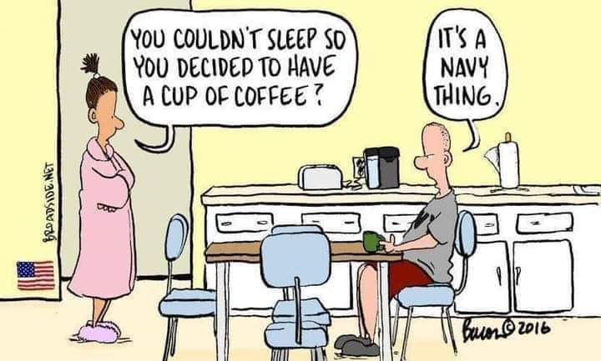

AMAZING TWO LETTER WORD
KNOW YOU’LL ENJOY THIS ONE!!
! reminder that one word in the English language that can be a noun, verb, adjective, adverb and preposition. UP! This two-letter word in English has more meanings than any other two-letter word, and that word is 'UP.' It is listed in the dictionary as an [adv.], [prep.], [adj.], [n] or [v]. It's easy to understand UP, meaning toward the sky or at the top of the list, but when we awaken in the morning, why do we wake UP? At a meeting, why does a topic come UP? Why do we speak UP, and why are the officers UP for election and why is it UP to the secretary to write UP a report? We call UP our friends, brighten UP a room, polish UP the silver, warm UP the leftovers and clean UP the kitchen. We lock UP the house and fix UP the old car. At other times, this little word has real special meaning. People stir UP trouble, line UP for tickets, work UP an appetite, and think UP excuses. To be dressed is one thing but to be dressed UP is special. And this UP is confusing: A drain must be opened UP because it is stopped UP. We open UP a store in the morning, but we close it UP at night. We seem to be pretty mixed UP about UP!
To be knowledgeable about the proper uses of UP, look UP the word UP in the dictionary. In a desk-sized dictionary, it takes UP almost 1/4 of the page and can add UP to about thirty definitions. If you are UP to it, you might try building UP a list of the many ways UP is used. It will take UP a lot of your time, but if you don't give UP, you may wind UP with a hundred or more. When it threatens to rain, we say it is clouding UP. When the sun comes out, we say it is clearing UP. When it rains, the earth soaks it UP. When it does not rain for a while, things dry UP. One could go on and on, but I'll wrap it UP, for now . . . my time is UP! Oh . . . one more thing: What is the first thing you do in the morning and the last thing you do at night?
U
P
Did that one crack you UP? Don't screw UP. Send this on to everyone you look UP in your address book . . . or not…. it's UP to you. Now I'll shut UP!



The Love Dress
Submitted by Dave Lyons
A woman stopped by, unannounced, at her son's house. She knocked on the door then immediately walked in. She was shocked to see her daughter-in-law lying on the couch, totally naked. Soft music was playing, and the aroma of perfume filled the room. "What are you doing?!" she asked. "I'm waiting for Mike to come home from work," the daughter-in-law answered. "But you're naked!" the mother-in-law exclaimed. "This is my love dress," the daughter-in-law explained. "Love dress? But you're naked!" "Mike loves me and wants me to wear this dress," she explained. "It excites him to no end. Every time he sees me in this dress, he instantly becomes romantic and ravages me for hours on end. He can't get enough of me." The mother-in-law left. When she got home, she undressed, showered, put on her best perfume, dimmed the lights, put on a romantic CD, and lay on the couch, waiting for her husband to arrive. Finally, her husband came home. He walked in and saw her lying there so provocatively. "What are you doing?" he asked. "This is my love dress," she whispered sensually. "Needs ironing," he said. "What's for dinner?
He never heard the gunshot.
-------------------------------------------------------------------------
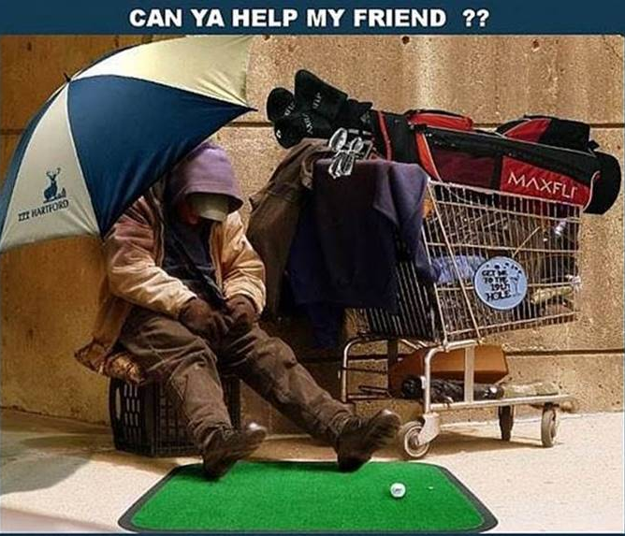I’m reaching out on behalf of a friend of mine who needs some help who wishes to remain anonymous. His wife told him to go out and get some of those pills that would help him get an erection. When he came back, he handed her diet pills. ANYWAY, he’s looking for a place to live. CAN YOU HELP HIM?
Submitted by Lou Zoghby, WWII Vet.

Sense of Smell
I went for a walk with my new girlfriend, and we saw dogs mating. She said: “How does the male know when the female is ready for sex?” I replied: “He can smell she is ready. That’s how nature works.” We then walked past a sheep field and the ram was mating the ewe. Again, my girlfriend asked: “How does the ram know when the ewe is ready for sex?” I replied: “It’s nature. He can smell she is ready.” We then went past a cow-field and the bull was mating with the cow. My girlfriend said: “This is odd. They are really going at it. Surely the bull can’t smell when she is ready?” I said: “Oh, yes; it’s nature. All animals can smell when the female is ready for sex.” Anyway, after the walk, I dropped her home and kissed her goodbye. She said: “Take care and get yourself checked out for Covid-19.” Surprised, “Why do you say that?” I asked her. She replied: “You seem to have lost your sense of smell.”




(Editor: I sure hope they were all wearing DEPENDS!!!)

Little Johnny
Little Johnny sees his daddy's car drive into the woods. Curious, he follows the car. He sees daddy and Aunt Jane sharing a passionate moment. Johnny can barely contain himself as he runs home and tells his mother excitedly “Mommy, mommy, I was at the playground and I saw daddy and..." Mommy tells him to slow down, that she wants to hear the story. So, Johnny tells her, I was at the playground and I saw daddy's car go in the woods with Aunt Jane. I went to look, and daddy was giving Aunt Jane a big kiss, then he helped her take off her shirt, then Aunt Jane helped daddy take off his pants then daddy…" Mommy cut him off and said, "You can tell the rest of the story at dinner. I want to see the look on daddy's face when you tell it tonight. At the dinner table, mommy asked Johnny to tell his story. “I was at the playground and I saw daddy's car go in the woods with Aunt Jane. I followed them to see what they were doing and then I saw daddy was giving Aunt Jane a big kiss, then he helped her take off her shirt, then Aunt Jane helped daddy take off his pants off. Then Aunt Jane and daddy did the same thing mommy and Uncle Jack used to do when daddy was in the Army.” Then mom fainted. The moral of the story is, listen to the whole story before you interrupt.

Senior Discount
Lying around, pondering the problems of the world, I realized that, at my age, I don't really give a rat's ass anymore. If walking is good for your health, the mailman would be immortal. A whale swims all day, only eats fish, and drinks water, but is still fat. A rabbit runs, and hops, and only lives 15 years, while a tortoise doesn't run, and does mostly nothing, yet it lives for 150 years.
And they tell us to exercise? I don't think so. Now that I'm older, here's what I've discovered:
1. I started out with nothing, and I still have most of it.
2. My wild oats are mostly enjoyed with prunes and all-bran.
3. Funny, I don't remember being absent-minded.
4. Funny, I don't remember being absent-minded.
5. If all is not lost, then where the heck is it?
6. It was a whole lot easier to get older, than it was to get wiser.
7. Some days, you're the top dog, some days you're the hydrant.
8. I wish the buck really did stop here; I sure could use a few of them.
9. Kids in the back-seat cause accidents.
10. Accidents in the back-seat cause kids.
11. It is hard to make a comeback when you haven't been anywhere.
12. The world only beats a path to your door when you're in the bathroom.
13. If God wanted me to touch my toes, he'd have put them on my knees.
14. When I'm finally holding all the right cards, everyone wants to play chess.
15. It is not hard to meet expenses . . . They're everywhere.
16. The only difference between a rut and a grave is the depth.
17. These days, I spend a lot of time thinking about the hereafter . . . I go somewhere to get something, and then wonder what I'm "here after".
18. Funny, I don't remember being absent-minded.
19. It is a lot better to be seen than viewed.
20. Have I sent this message to you before...or did I get it from you!?

It was entertainment night at the Senior Citizens' Center. After the community sing-along led by Alice at the piano, it was time for the star of the show - Claude the Hypnotist! Claude explained that he was going to put the whole audience into a trance. "Yes, each and every one of you and all at the same time," said Claude. The excited chatter dropped to silence as Claude carefully withdrew, from his waistcoat pocket, a beautiful antique gold pocket watch and chain. "I want you to keep your eyes on this watch" said Claude, holding the watch high for all to see. "It's a very special and valuable watch that has been in my family for six generations," said Claude. He began to swing the watch gently back and forth while quietly chanting, "Watch the watch --- watch the watch ---- watch the watch." The audience became mesmerized as the watch swayed back and forth. The lights were twinkling as they were reflected from its gleaming surfaces. A hundred and fifty pairs of eyes followed the movements of the gently swaying watch. They were all hypnotized. And then, suddenly, the chain broke!!! The beautiful watch fell to the stage and burst apart on impact. "SHIT," shouted Claude. It took them three days to completely clean up the Senior Citizens' Center and Claude was never invited back again.
Submitted by John Vargas

Trivia Answer
Butter Bar: 2nd Lieutenant/Ensign. Refers to the gold bar of rank.

Picture Quiz
1. Lee White USCG - 1965
2.Jesse Maldonado – Army – age 23
3. Bob Rotruck – Navy – 1959 boot camp
4. Alan Jaffe – Navy – 1968 boot camp
5. John Vargas – Army – 1965
6. Clarence Rebolledo – Air Force – 1971

If any chapter member got all these names correct, you will be awarded a gift certificate for a wind powered electric generator guaranteed to stop when the Colorado temperature reaches 32 degrees Fahrenheit. YOUR EDITOR!!!

Upcoming Events of Interest
Date of Revision: April 12, 2021
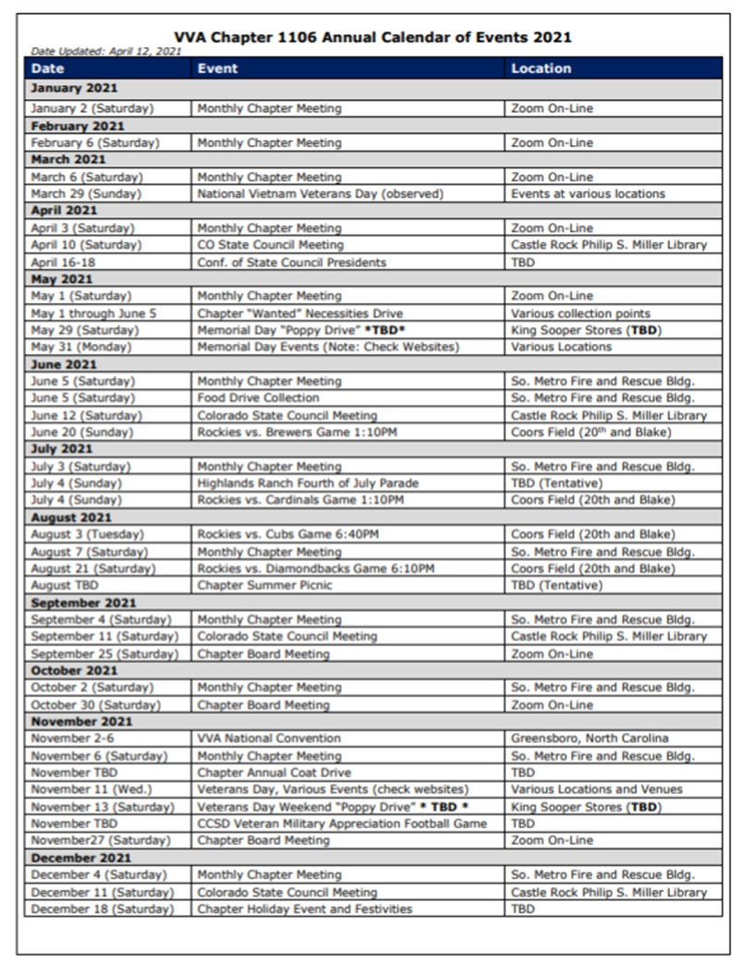

FRIENDS OF CHAPTER 1106
  South Metro Denver Fire & Rescue  9195 E Mineral Ave  Centennial, CO 80112 | American Legion Post 1260  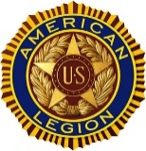

Spradlin Printing, Inc.
11903 S. Parker Road
Parker, CO 80134
  American Family Insurance  3989 E. Arapahoe Road #20  Centennial, CO 80122  720-361-0155 | 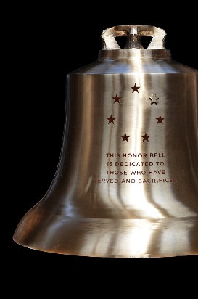  The Honor Bell Foundation  PO Box 1432  Englewood CO 80150  720.282.9182  www.honorbell.org
  9137 E Mineral Cir Ste 100  Englewood, CO 80112-3422 |   Home Depot Foundation  8477 S Yosemite St  Lone Tree, CO 80124
  King Soopers  9551 S. University Blvd., Highlands Ranch, CO 80126 |   Qualified Listeners:  PO Box 563  Dacono, CO 80514  Tel: 720-600-0860
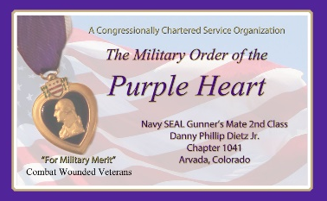  Military Order of Purple Heart, Chapter 1041, Arvada, CO |   ZILLOW GROUP  10771 E. Easter Ave  Centennial CO 80112
99 Inverness Drive - #275 Ennglewood, CO    C-303-653-5020  O-303-779-1420  www.printconnection.com  troy@ printconnection.com |   PARKER MEDICAL  SUPPLY STORE  9845 S Parker Rd  . Parker, CO 80134  303-840-4444

